K-MEANS CLUSTERING ALGORITHM

AIM
To understand the K-Means clustering algorithm by grouping the Iris flowers into clusters for a given data set.

PROGRAM
import numpy as np
import pandas as pd
import matplotlib.pyplot as plt
from sklearn.cluster import KMeans
from sklearn.metrics import silhouette_score

df = pd.read_csv('Iris.csv')
print(df.head())
features = df.iloc[:, :-1].values # label is not used for clustering

# Elbow method
wcss = []
for k in range(1, 11):
km = KMeans(n_clusters=k, init='k-means++', n_init=10, random_state=23)
km.fit(features)
wcss.append(km.inertia_)
print(f"K = {k:<3} WCSS = {km.inertia_:.2f}")

plt.plot(range(1, 11), wcss, marker='o')
plt.title('Elbow method')
plt.xlabel('Number of clusters (K)')
plt.ylabel('WCSS')
plt.show()

# Final model with K = 3
kmeans = KMeans(n_clusters=3, init='k-means++', n_init=10, random_state=23)
labels = kmeans.fit_predict(features)

print("\nCluster centres:\n", kmeans.cluster_centers_.round(3))
print("Cluster sizes :", np.bincount(labels))
print("Silhouette score:", round(silhouette_score(features, labels), 4))

# Comparison with the actual species
print("\nClusters vs actual species:")
print(pd.crosstab(df['variety'], labels, colnames=['cluster']))

# Visualization (petal length vs petal width)
fig, ax = plt.subplots(1, 2, figsize=(11, 4))
ax[0].scatter(features[:, 2], features[:, 3], c=labels, cmap='viridis')
ax[0].scatter(kmeans.cluster_centers_[:, 2], kmeans.cluster_centers_[:, 3],
s=200, c='red', marker='X', label='Centroids')
ax[0].set_title('K-Means clusters')
ax[0].set_xlabel('petal.length')
ax[0].set_ylabel('petal.width')
ax[0].legend()
actual = df['variety'].astype('category').cat.codes
ax[1].scatter(features[:, 2], features[:, 3], c=actual, cmap='viridis')
ax[1].set_title('Actual species')
ax[1].set_xlabel('petal.length')
ax[1].set_ylabel('petal.width')
plt.tight_layout()
plt.show()

OUTPUT
sepal.length sepal.width petal.length petal.width variety
0 5.1 3.5 1.4 0.2 Setosa
1 4.9 3.0 1.4 0.2 Setosa
2 4.7 3.2 1.3 0.2 Setosa
3 4.6 3.1 1.5 0.2 Setosa
4 5.0 3.6 1.4 0.2 Setosa
K = 1 WCSS = 681.37
K = 2 WCSS = 152.35
K = 3 WCSS = 78.85
K = 4 WCSS = 57.23
K = 5 WCSS = 46.45
K = 6 WCSS = 39.04
K = 7 WCSS = 34.41
K = 8 WCSS = 32.10
K = 9 WCSS = 28.32
K = 10 WCSS = 26.81

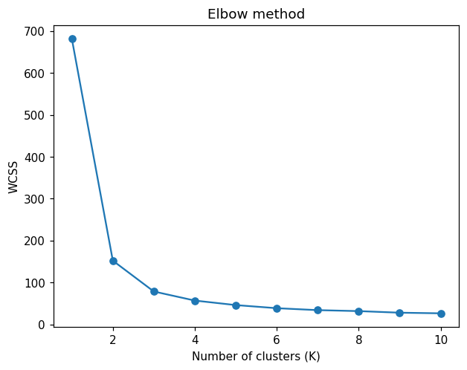

Cluster centres:
[[5.902 2.748 4.394 1.434]
[5.006 3.428 1.462 0.246]
[6.85 3.074 5.742 2.071]]
Cluster sizes : [62 50 38]
Silhouette score: 0.5528

Clusters vs actual species:
cluster 0 1 2
variety
Setosa 0 50 0
Versicolor 48 0 2
Virginica 14 0 36

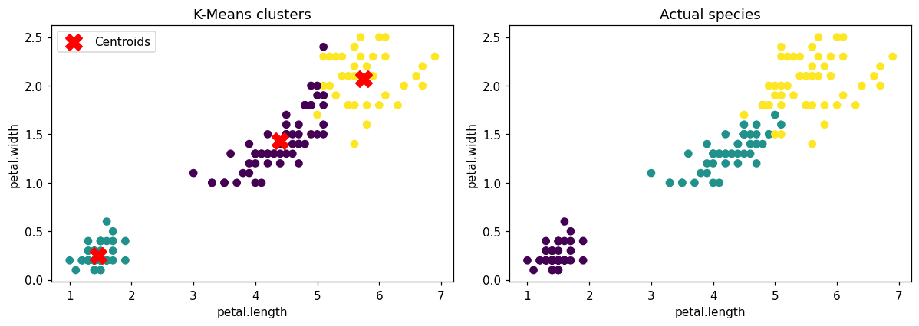

RESULT
Thus the K-Means clustering algorithm was implemented on the Iris data set. The Elbow method gave K = 3 and the clusters closely match the three actual species.

