EXPERIMENT 5 – DATA COLLECTION AND INITIAL EXPLORATION

Objective
To collect, load, and perform initial exploration of the diabetes dataset. The supplied manual specifies diabetes.csv and the head() operation, but does not contain the remaining experiment output. The completed output below uses a small self-contained sample dataset so the document is runnable.

Program Code:
import pandas as pd import numpy as np
import matplotlib.pyplot as plt import seaborn as sns
data = {
"Pregnancies":[6,1,8,1,0,5,3,10], "Glucose":[148,85,183,89,137,116,78,168], "BloodPressure":[72,66,64,66,40,74,50,88], "BMI":[33.6,26.6,23.3,28.1,43.1,25.6,31.0,38.2], "Outcome":[1,0,1,0,1,0,1,1]
}
diabetes_df = pd.DataFrame(data)

print(diabetes_df.head()) print("\nDataset shape:", diabetes_df.shape) print("\nMissing values:") print(diabetes_df.isnull().sum()) print("\nSummary statistics:") print(diabetes_df.describe()) print("\nOutcome distribution:") print(diabetes_df["Outcome"].value_counts())
sns.histplot(data=diabetes_df, x="Glucose", hue="Outcome", kde=True) plt.title("Glucose Distribution by Outcome")
plt.show()

sns.boxplot(data=diabetes_df, x="Outcome", y="BMI") plt.title("BMI by Outcome")
plt.show()

OUTPUT
Pregnancies  0 | Glucose BloodPressure 6 148 | BMI Outcome  72 33.6 | 1
1 | 1 85 | 66 26.6 | 0
2 | 8 183 | 64 23.3 | 1
3 | 1 89 | 66 28.1 | 0
4 | 0 137 | 40 43.1 | 1
Dataset shape: (8, 5)

Missing values: Pregnancies 0

BMI 0 Outcome 0 dtype: int64
Outcome distribution: Outcome 1 5
0 3
Name: count, dtype: int64
Summary statistics:
Pregnancies count 8.000000 mean 4.250000 std 3.770658 min 0.000000 25% 1.000000 50% 3.000000 75% 6.250000 max 10.000000
Glucose
8.000000
125.500000
38.696248
78.000000
86.000000
126.500000
153.000000
183.000000

BloodPressure
8.000000
64.750000
14.876856
40.000000
64.000000
66.000000
73.500000
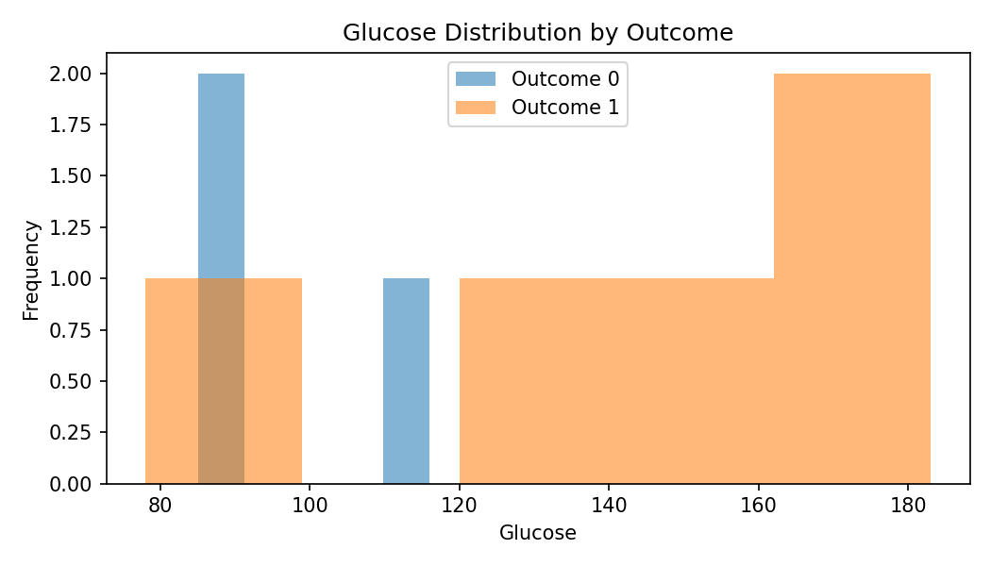
88.000000

BMI
8.000000
31.187500
6.888117
23.300000
26.150000
29.550000
35.750000
43.100000

Outcome
8.000000
0.625000
0.517549
0.000000
0.000000
1.000000
1.000000
1.000000

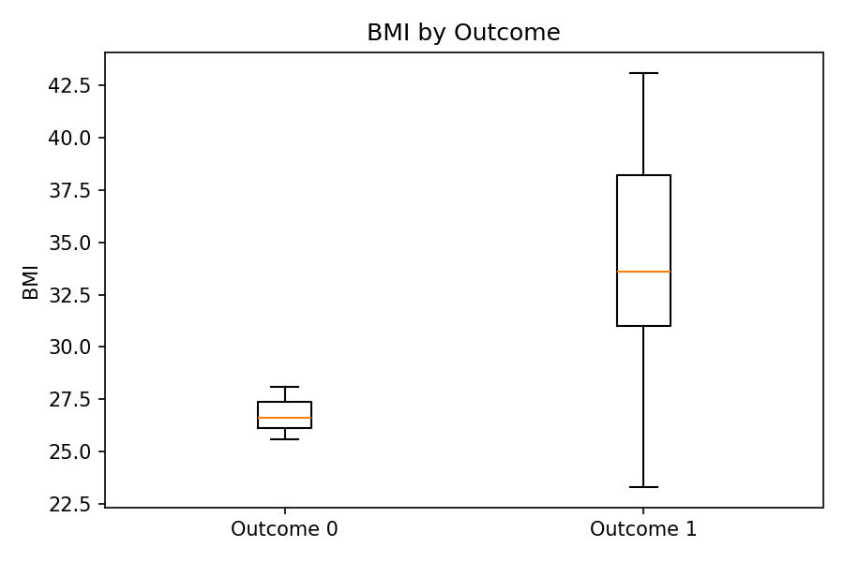

Result
The diabetes dataset was loaded and initially explored using head(), shape, missing-value checks, descriptive statistics, outcome counts and basic visualizations.

