Arduino IDE
Open the GABOT2-*.ino file.

Manage Libraries
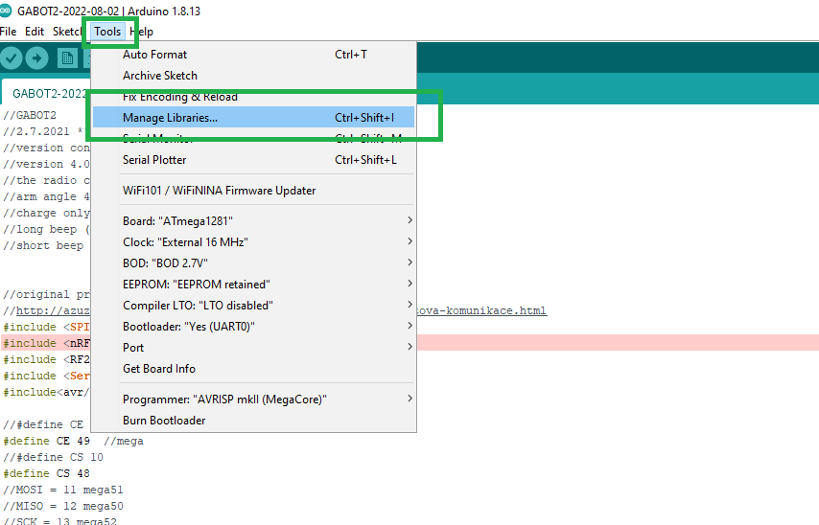

Add RF24 Library
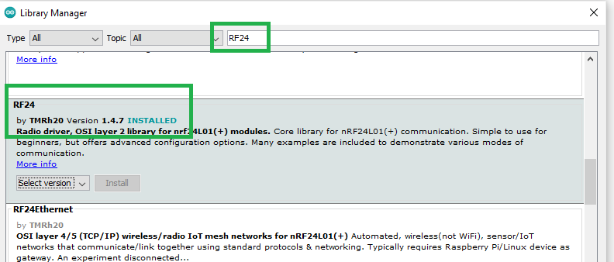
In DeviceManager Find the COM port created by the Connected Mega Board
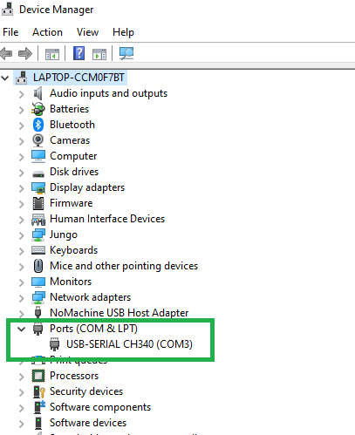

Set the COM port in Arduino IDE

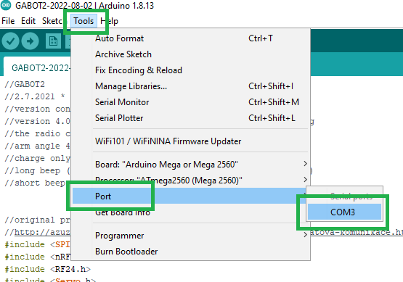

Select Arduino Mega 2560
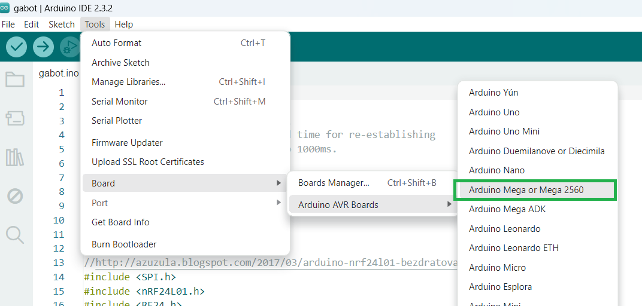

Compile the Scatch

Compile the scatch (the by Icon ) - it shall result in no error and message similar like this:
Sketch uses 11004 bytes (4%) of program storage space. Maximum is 253952 bytes.
Global variables use 589 bytes (7%) of dynamic memory, leaving 7603 bytes for local variables. Maximum is 8192 bytes.

