GabotApp Readme

1. How to install Android Studio

Copilot said: To install **Android Studio** on **Kubuntu 24.04**,
To install Android Studio on Kubuntu 24.04, follow these steps:

Option 1: Install Android Studio via Snap (Simplest Method)
- Update the System:
bash
- sudo apt update
sudo apt upgrade
- Install Snap if Not Already Installed:
bash
- sudo apt install snapd
- Install Android Studio Using Snap:
bash
- sudo snap install android-studio --classic
- Run Android Studio: You can launch it from the application menu or with the command:
bash
- android-studio

Option 2: Install Android Studio from the Official Website
- Download Android Studio: Visit the official download page and download the latest Linux version (usually a .tar.gz file).
- Extract the Downloaded File: Navigate to the directory where you downloaded the file, then extract it:
bash
tar -xvf android-studio-*.tar.gz -C ~/
Move the extracted folder to a permanent location (e.g., /opt):
bash
- sudo mv ~/android-studio /opt/android-studio
- Run Android Studio Installer: Navigate to the extracted directory and run the installer script:
bash
- /opt/android-studio/bin/studio.sh
- Add Android Studio to the Application Menu (Optional): Create a .desktop entry:
bash
sudo nano /usr/share/applications/android-studio.desktop
Add the following:
plaintext
- [Desktop Entry]
Version=1.0
Type=Application
Name=Android Studio
Exec=/opt/android-studio/bin/studio.sh
Icon=/opt/android-studio/bin/studio.png
Categories=Development;IDE;
Terminal=false
Save and exit. Android Studio will now appear in the application menu.

Option 3: Install via Flatpak (Optional)
- Install Flatpak:
bash
- sudo apt install flatpak
- Add Flathub Repository:
bash
- flatpak remote-add --if-not-exists flathub https://flathub.org/repo/flathub.flatpakrepo
- Install Android Studio via Flathub:
bash
- flatpak install flathub com.google.AndroidStudio
- Run Android Studio:
bash
- flatpak run com.google.AndroidStudio

Post-Installation Steps
- Open Android Studio and complete the setup wizard.
- Install all necessary SDK components and tools.
- Make sure to install Java Development Kit (JDK):
bash
- sudo apt install openjdk-17-jdk
You’re now ready to develop Android apps! Let me know if you encounter any issues. 😊

2. Open and build project

A. Open project
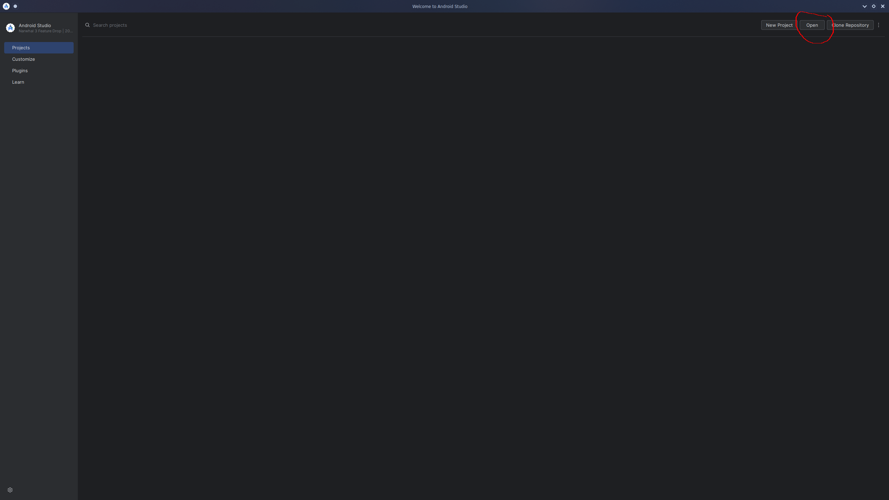

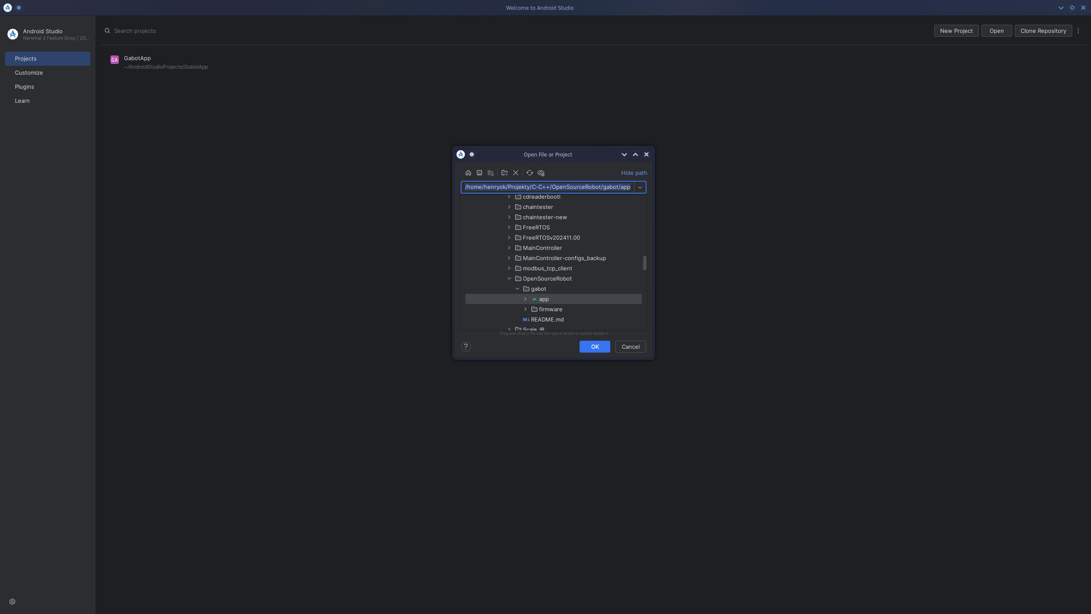

B. Build project
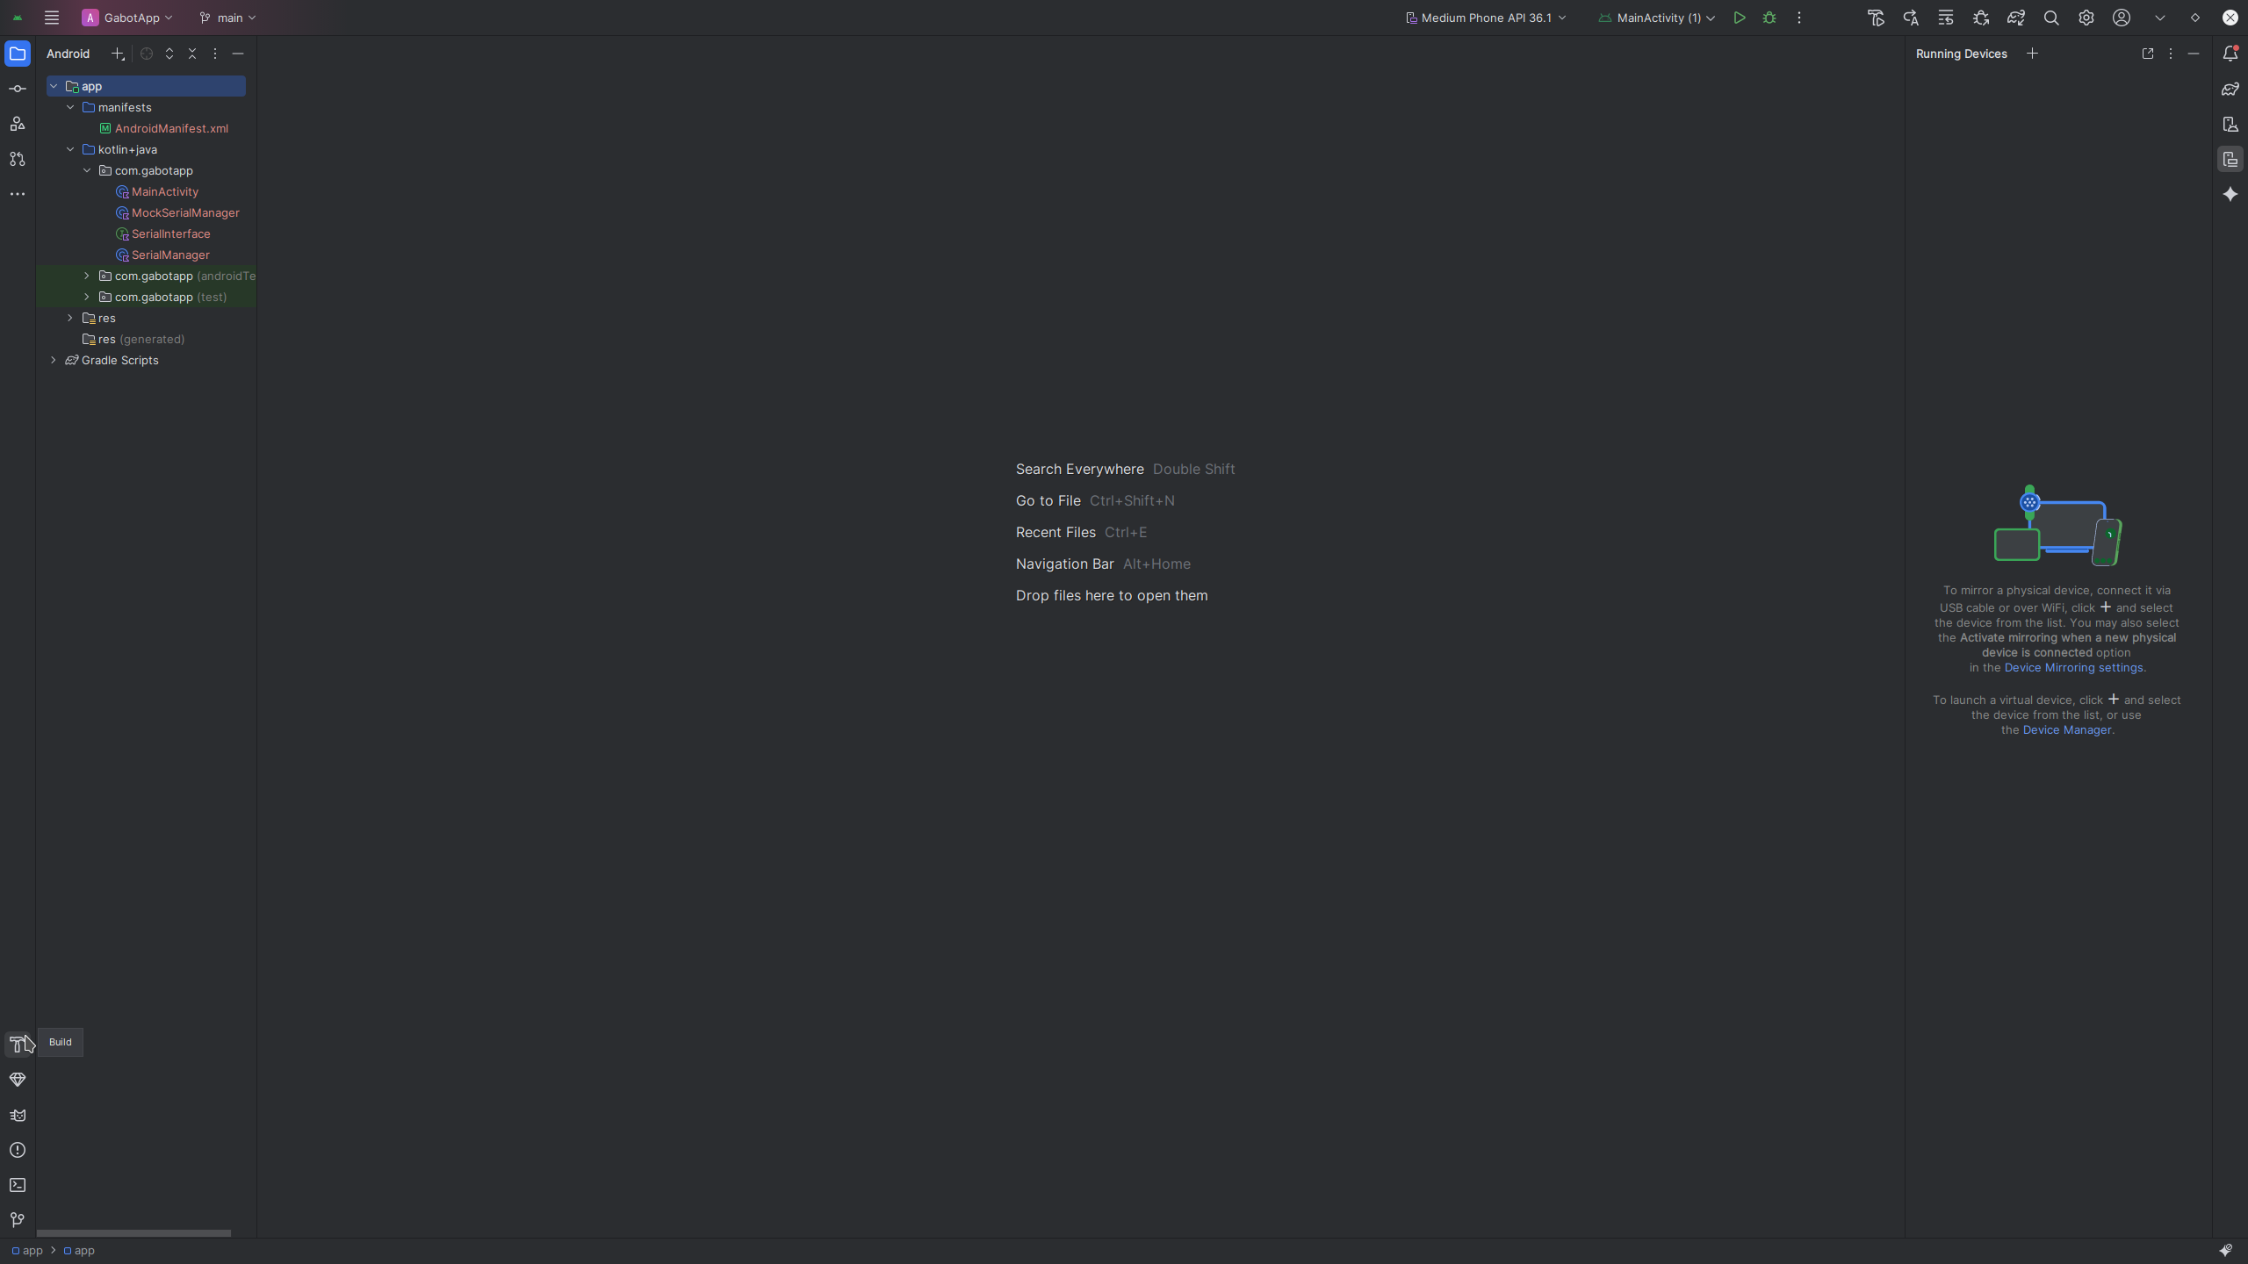
When you build project, let studio download all dependecies.

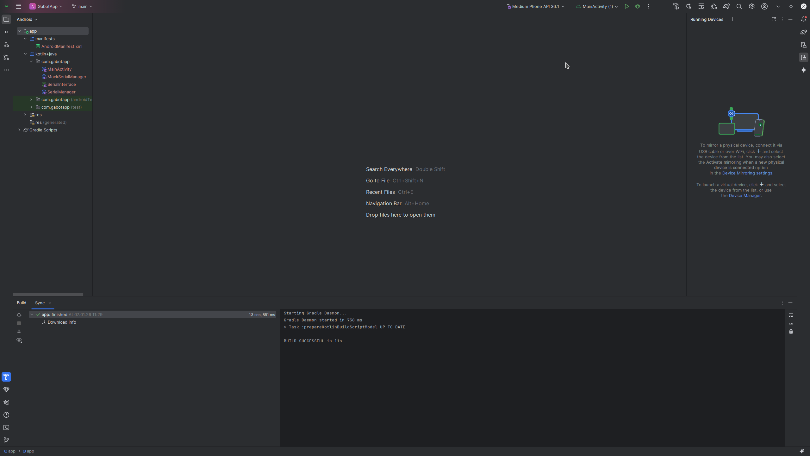
Path to package:
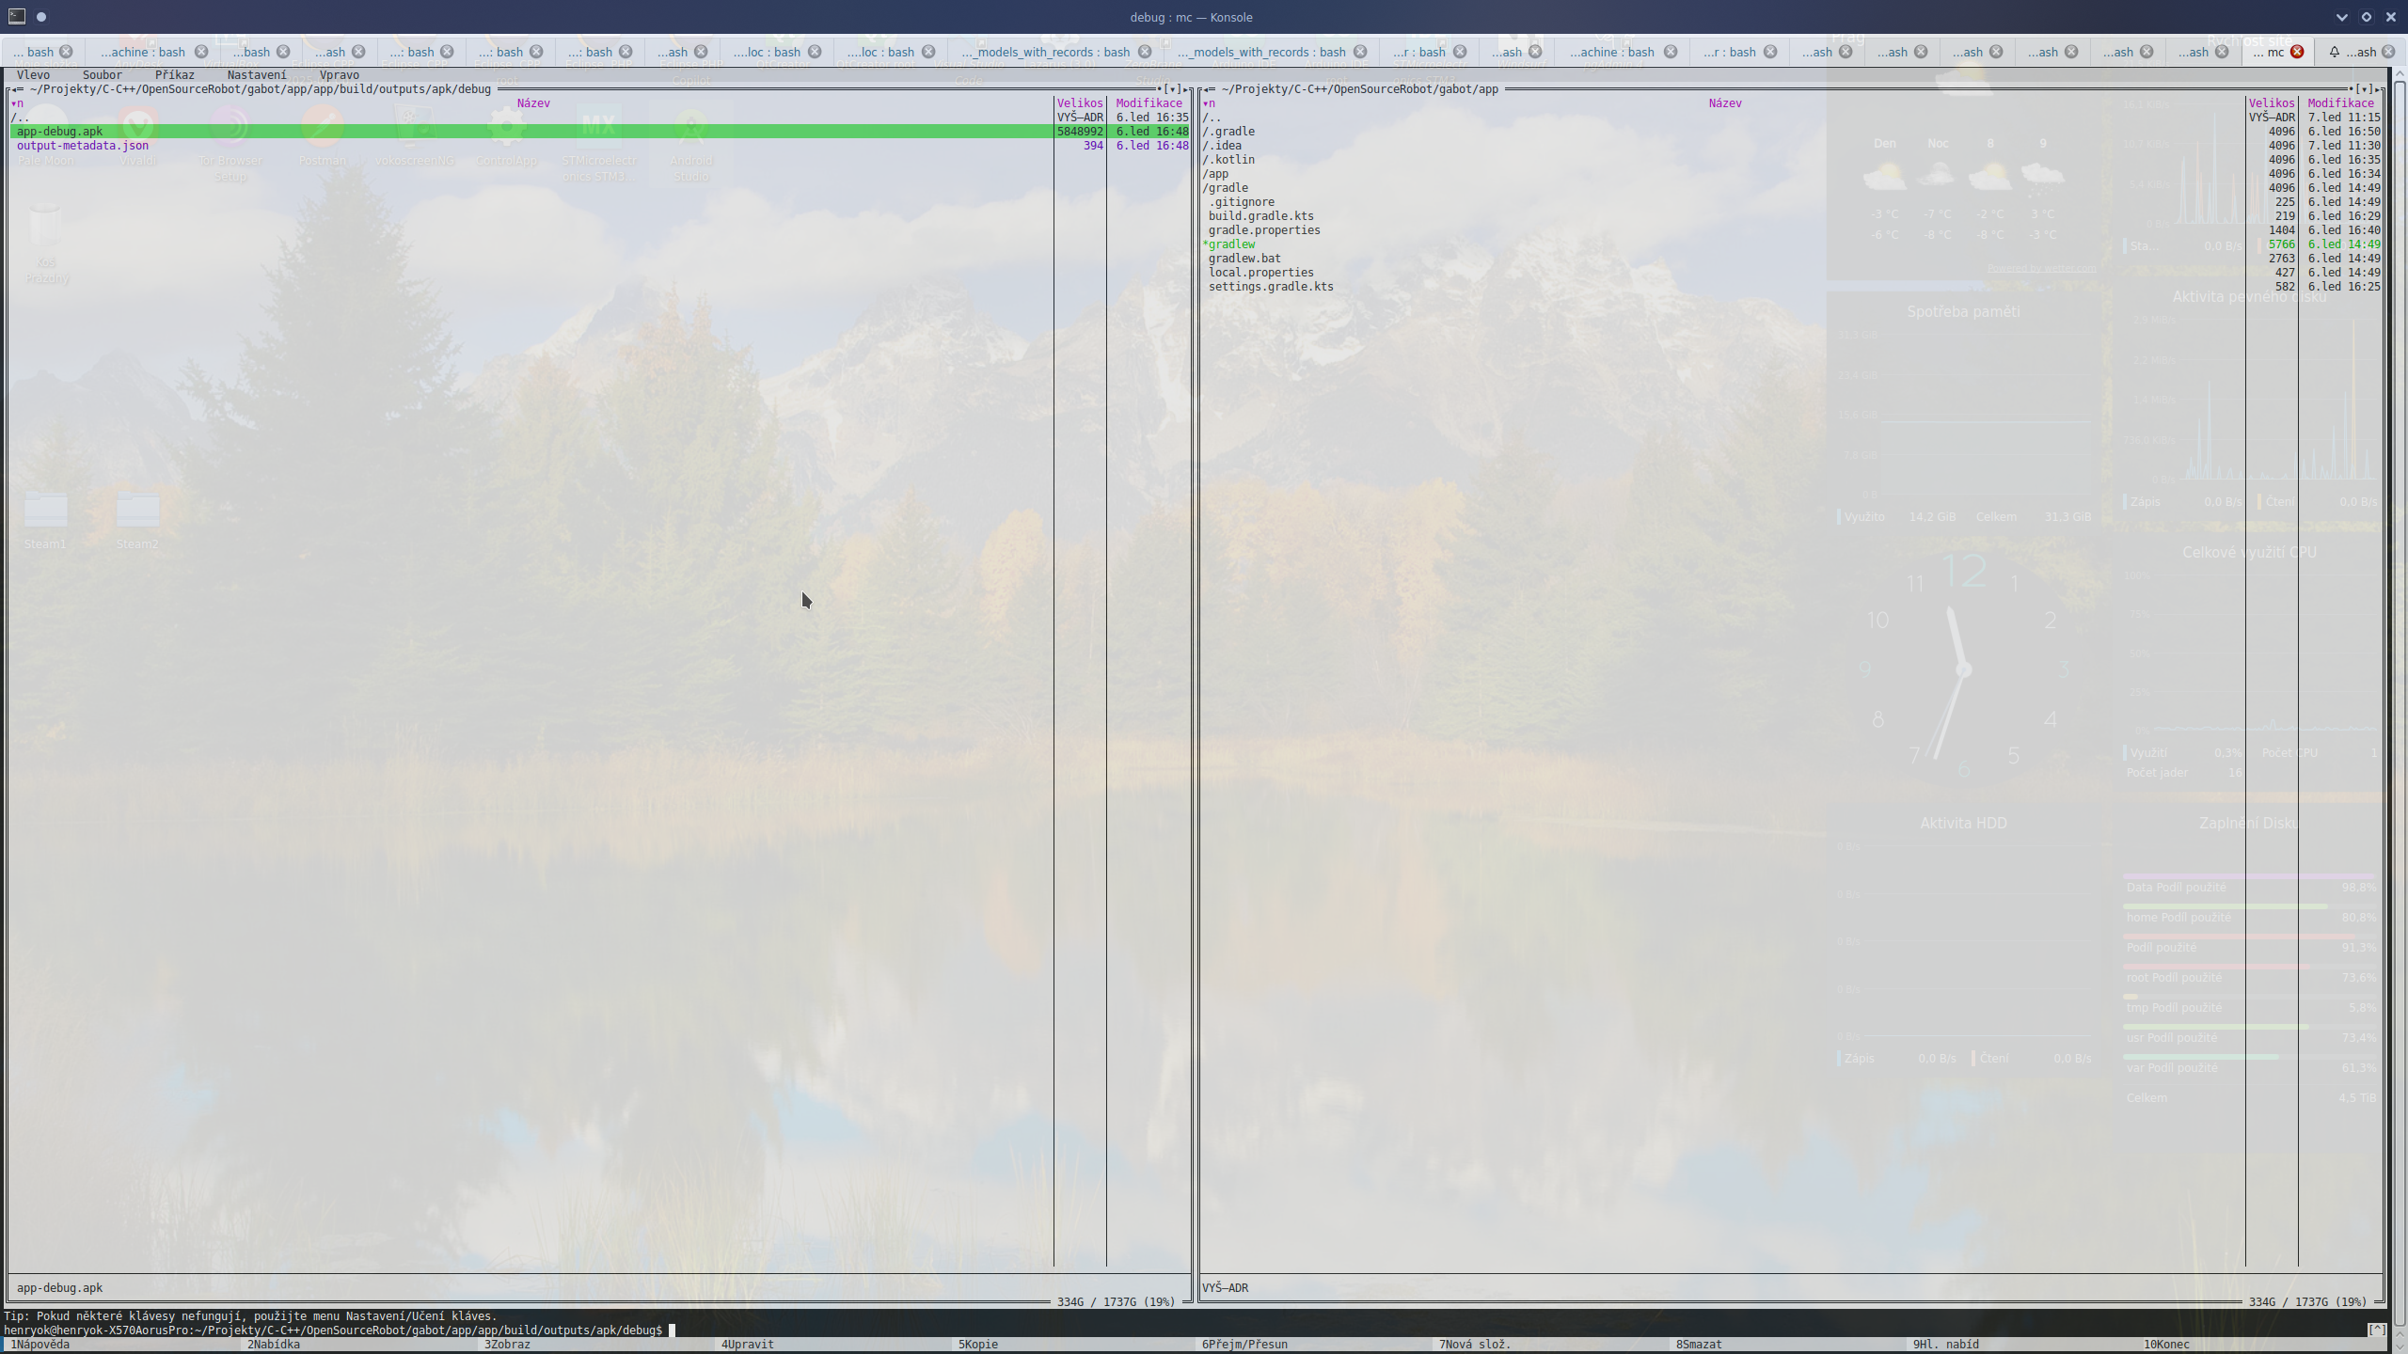
This package download to android phone, go to it by filemanager, tap on it, and install. Allow all settings for which you are asked. Then you can run app.

