AI POWERED AUTISM DETECTION USING FACIAL EXPRESSION AND EYE TRACKING FEATURES

ABSTRACT:
Autism spectrum disorder (ASD) is a neurodevelopmental condition that affects communication, social interaction, and behavior. Early detection and intervention are crucial for improving outcomes, but traditional diagnostic methods often rely on subjective assessments and lengthy observations. This project introduces an AI-powered solution for autism detection, leveraging facial expressions and eye-tracking data. The system utilizes advanced machine learning algorithms to identify patterns and characteristics that are indicative of autism.
The project integrates facial expression recognition using deep learning models such as Convolutional Neural Networks (CNN), MobileNet, DenseNet, and ResNet. These models are trained on a dataset of facial expressions from children with autism and non-autistic children. Additionally, eye-tracking features, such as gaze points and fixation durations, are analyzed using machine learning techniques, including Support Vector Machines (SVM), RandomForestClassifier, CNN, and AdaBoostClassifier.
By using these two distinct modalities, the system aims to provide an efficient, accessible, and non-invasive method for autism detection. The web-based platform enables users to upload facial expressions and eye-tracking data, which are then classified to provide predictions about autism. This tool has the potential to assist professionals in identifying early signs of autism, providing timely support for children and their families. The system is built with a user-friendly interface, using HTML, CSS, and JavaScript for the front-end, and Python with Flask for the back-end.
Keywords: Autism, Early detection, Facial expressions, Eye-tracking, Machine learning, CNN, MobileNet, DenseNet, ResNet, SVM.

OBJECTIVE OF PROJECT:
The primary objective of this project is to develop an AI-powered system that detects autism by analyzing facial expressions and eye-tracking data. The system aims to leverage deep learning models such as Convolutional Neural Networks (CNN), MobileNet, DenseNet, and ResNet for facial expression recognition, and machine learning algorithms like Support Vector Machines (SVM), RandomForestClassifier, CNN, and AdaBoostClassifier for analyzing eye-tracking features. The goal is to provide a user-friendly web platform that allows users to upload facial images and eye-tracking data for automated analysis and autism prediction. The system is designed to be intuitive, offering a seamless experience for both users and professionals. By using Python with Flask for the back-end, the platform will ensure secure, fast, and scalable processing of the input data. This project aims to improve early autism detection, helping to identify potential cases more quickly, facilitating timely interventions, and supporting professionals in making informed decisions. Furthermore, the system will be evaluated and optimized to ensure high accuracy, making it a reliable tool for early autism diagnosis.

PROBLEM STATEMENT:
Autism spectrum disorder (ASD) is often diagnosed through lengthy and subjective clinical observations that require expert judgment, which can lead to delayed diagnosis and treatment. The complexity of autism symptoms and the diverse ways in which they manifest make it challenging to identify the condition early in its development. Traditional methods rely heavily on human observation, which can result in errors and inconsistency. This project seeks to address these challenges by developing an AI-driven system that uses facial expressions and eye-tracking data to predict autism. By automating the detection process, the system aims to provide a faster, more objective method for identifying autism at an early stage, thus enabling timely intervention and support for children with ASD.

MOTIVATION:
Autism spectrum disorder (ASD) is a condition that affects a significant number of children worldwide, and its early detection is essential for timely intervention. However, traditional methods of diagnosis can be lengthy, subjective, and reliant on clinical observations. This project was motivated by the need to develop an automated, efficient, and non-invasive method for identifying autism early through facial expressions and eye-tracking features. These behavioral indicators have been shown to carry significant information about a child’s developmental stage, and leveraging machine learning models to analyze such data can help identify potential autism cases much earlier. The motivation for this project stems from the growing demand for diagnostic tools that can provide accurate predictions without the need for specialized medical expertise, thereby supporting families and professionals in making informed decisions.

SCOPE:
The scope of this project extends to the development of an AI-powered platform that can detect autism based on two primary input features: facial expressions and eye-tracking data. The system is designed to be web-based, making it accessible from any device with an internet connection. The project leverages advanced machine learning algorithms, such as CNN, MobileNet, DenseNet, ResNet, SVM, RandomForestClassifier, and AdaBoostClassifier, to analyze facial expressions and eye-tracking features and provide predictions of autism. This solution targets children who may exhibit early signs of autism but have not yet been diagnosed. The scope includes data preprocessing, model training, and evaluation, as well as the creation of a user-friendly front-end and a robust back-end that integrates machine learning models. The system will allow users to upload image and eye-tracking data, analyze it, and receive autism predictions. While the primary focus is on autism detection, the approach can be adapted for other neurodevelopmental conditions as well.

INTRODUCTION:
Autism Spectrum Disorder (ASD) is a complex neurodevelopmental condition that affects an individual’s ability to communicate, socialize, and behave in typical ways. Early diagnosis and intervention are critical in improving the quality of life for individuals with autism, yet traditional diagnostic methods often rely on subjective behavioral observations, which can be time-consuming and prone to errors. This project aims to address these challenges by developing an AI-powered system that detects autism based on facial expressions and eye-tracking data, leveraging the power of machine learning and deep learning techniques.
Facial expressions and eye-tracking features are vital components of non-verbal communication and have been shown to provide valuable insights into the social and emotional behaviors of individuals with autism. Children with autism often exhibit atypical patterns of facial expressions and eye movements, making these features a promising source of data for autism detection. By applying advanced algorithms like Convolutional Neural Networks (CNN), MobileNet, DenseNet, ResNet, and machine learning techniques such as Support Vector Machines (SVM), RandomForestClassifier, and AdaBoost, the system can analyze these data points to identify patterns indicative of autism.
The system will be implemented as a web application, providing a user-friendly interface where users can upload facial expression images and eye-tracking data for automatic analysis and prediction. By automating the detection process, this system offers a faster, more objective, and scalable alternative to traditional diagnostic methods. Ultimately, this project aims to enhance early detection, providing valuable support for families, educators, and healthcare professionals in managing and intervening at an earlier stage in the lives of children with autism.

EXISTING METHOD:
The existing systems for autism detection primarily rely on behavioral assessments conducted by professionals, using methods such as the Autism Diagnostic Observation Schedule (ADOS) and the Autism Diagnostic Interview-Revised (ADI-R). Some systems use traditional machine learning algorithms such as Decision Trees, K-Nearest Neighbors (KNN), and Naive Bayes to analyze behavioral data or video analysis of facial expressions and eye movements. These methods still require significant manual input and expert judgment, which makes the process time-consuming and subjective.

Disadvantages of Existing Systems:
- Subjective: Highly reliant on expert judgment and manual observation.
- Time-consuming: The diagnostic process can take multiple sessions, making it slow.
- Limited accuracy: Traditional algorithms and methods may not detect subtle or early signs of autism effectively.
- Expensive: Requires specialized professionals and extensive testing, which increases costs.
- Limited scalability: These methods are not easily scalable or accessible for large-scale use.

PROPOSED SYSTEM:
The proposed system aims to automate the detection of autism using machine learning models, focusing on facial expressions and eye-tracking features. For facial expression analysis, deep learning models such as Convolutional Neural Networks (CNN), MobileNet, DenseNet, and ResNet are employed to recognize patterns that are indicative of autism. These models are trained on facial images from children with autism and neurotypical children. For eye-tracking analysis, machine learning algorithms like Support Vector Machines (SVM), RandomForestClassifier, CNN, and AdaBoostClassifier are used to examine the gaze patterns and fixation durations that are linked to autism. The system will be designed as a web application, where users can upload facial expression images or eye-tracking data for automatic analysis. This approach ensures a non-invasive, efficient, and scalable method for detecting autism, offering a user-friendly platform for both professionals and parents. By combining facial and eye-tracking data, the system provides a more comprehensive prediction model for autism detection.

Advantages of the Proposed System:
- Automated Process: Reduces human error and dependency on subjective assessments.
- Fast Predictions: Provides quick, accurate predictions without the need for multiple testing sessions.
- Improved Accuracy: Advanced deep learning and machine learning models improve prediction reliability.
- Cost-Effective: Reduces the need for expensive consultations and prolonged evaluation processes.
- Scalable and Accessible: A web-based platform enables access to a wide range of users, from professionals to parents.
- Non-Invasive: Utilizes easily accessible data like facial expressions and eye-tracking features, eliminating the need for invasive procedures.

PROJECT FLOW:

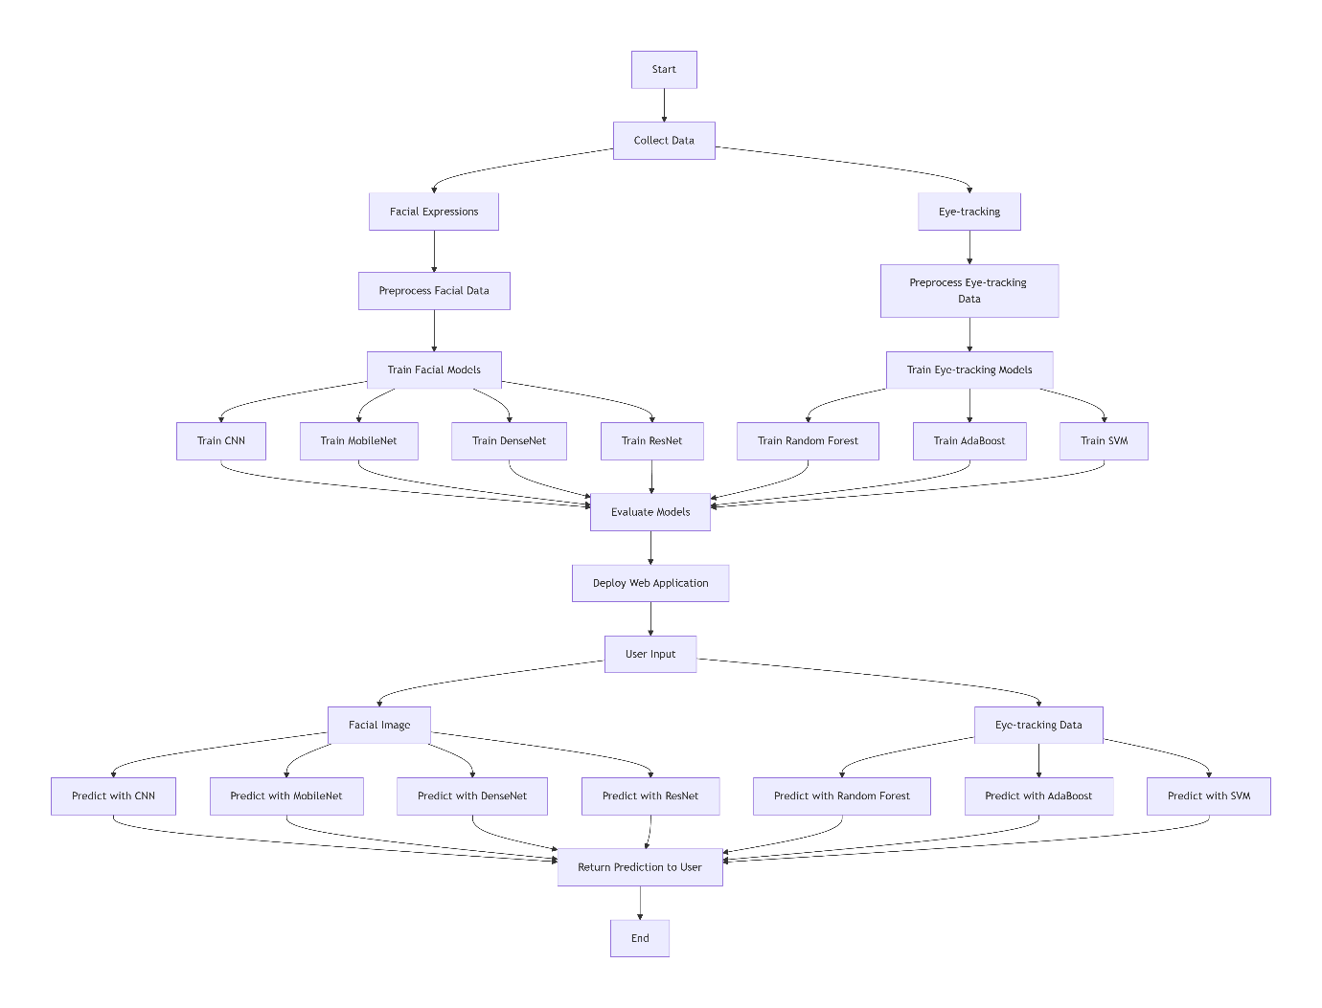

REQUIREMENTS ANALYSIS

HARDWARE REQUIREMENTS
- Processor - I5/Intel Processor
- RAM - 8GB (min)
- Hard Disk - 160 GB
- Key Board - Standard Windows Keyboard
- Mouse - Two or Three Button Mouse
- Monitor - Any

SOFTWARE REQUIREMENS
- Operating System : Windows 7/8/10
- Server side Script : HTML, CSS, Bootstrap & JS
- Programming Language : Python
- Libraries : Flask, Pandas, Mysql.connector, Os, Numpy,
Scikit-learn.
- IDE/Workbench : VS-Code
- Technology : Python 3.10+
- Server Deployment : Xampp Server
- Database : MySQL

ARCHITECTURE:
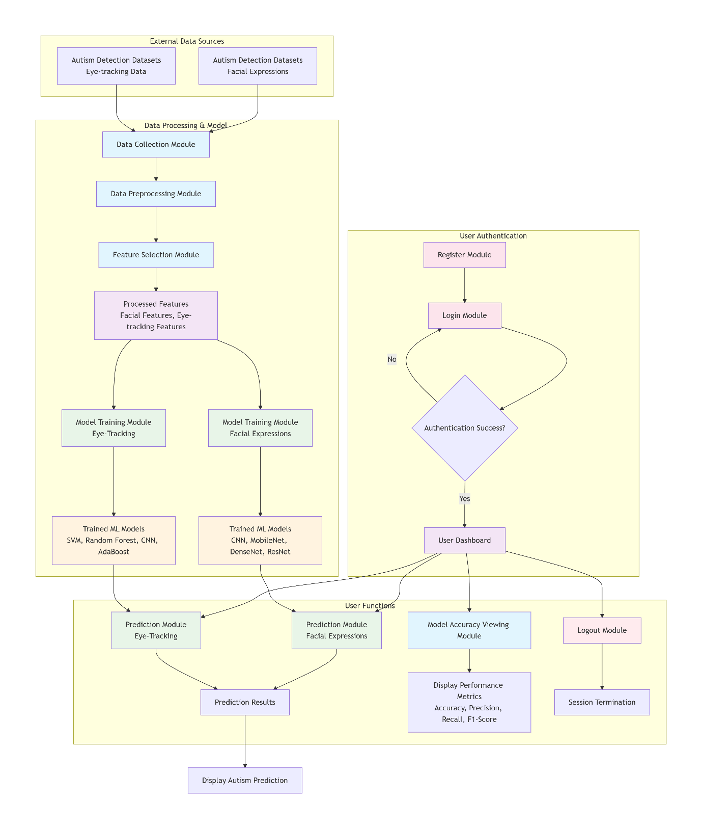

Modules

System Modules
The system modules in this project are responsible for processing input data, training machine learning models, and providing accurate predictions for autism detection based on facial expressions and eye-tracking features. Below is the breakdown of the modules designed for the system:
- Data Collection Module
  - Purpose: To gather and preprocess the autism detection datasets (facial expressions and eye-tracking data).
  - Functionality:
    - Collects facial images from children with autism and neurotypical children for training facial expression models.
    - Gathers eye-tracking data that includes gaze patterns, fixation points, and pupil sizes.
    - Organizes and structures the data for preprocessing, including image resizing, normalization, and encoding.
    - Prepares data for further analysis, ensuring a balanced dataset for the machine learning models.
- Feature Selection Module
  - Purpose: To identify and select the most relevant features from the facial expression and eye-tracking datasets.
  - Functionality:
    - Uses Random Forest to evaluate feature importance and selects the top features that contribute most to the classification task.
    - Focuses on the most significant attributes related to autism detection, such as pupil size, gaze vector, and facial features.
    - Reduces the dimensionality of the data by eliminating irrelevant or redundant features, ensuring better model performance and computational efficiency.
- Model Training Module (Facial Expressions)
  - Purpose: To train multiple deep learning models for facial expression-based autism detection.
  - Functionality:
    - Trains Convolutional Neural Networks (CNN), MobileNet, DenseNet, and ResNet models using the preprocessed and feature-selected facial expression data.
    - Evaluates model performance using metrics like accuracy and loss to ensure the best classification results.
    - Saves the trained models for future use in prediction tasks.
- Model Training Module (Eye-Tracking)
  - Purpose: To train machine learning models for autism detection using eye-tracking features.
  - Functionality:
    - Trains classifiers such as Support Vector Machines (SVM), Random Forest, CNN, and AdaBoost using the eye-tracking dataset.
    - Evaluates models based on accuracy, precision, and recall, ensuring effective detection of autism patterns from gaze and eye movements.
    - Stores the trained models for use in the prediction module.
- Prediction Module (Facial Expressions)
  - Purpose: To predict autism detection based on facial expression images.
  - Functionality:
    - Users upload facial expression images of children.
    - The system uses the trained facial expression model (CNN, MobileNet, DenseNet, ResNet) to process the uploaded images and classify the data as autistic or non-autistic.
    - Provides accurate prediction and displays the result on the user's interface.
- Prediction Module (Eye-Tracking)
  - Purpose: To predict autism detection based on eye-tracking data.
  - Functionality:
    - Users input eye-tracking data, which includes features such as gaze points, fixation durations, and pupil size.
    - The system processes the input using machine learning models (SVM, RandomForestClassifier, CNN, AdaBoost) trained on eye-tracking data.
    - Provides accurate prediction and displays the result on the user’s interface.

User Modules
The User Modules allow authorized users (such as healthcare professionals or parents) to interact with the autism detection system, view predictions, and monitor system performance.
- Register Module
  - Purpose: To enable new users to create an account and access the system.
  - Functionality:
    - Collects user details such as name, email, and password.
    - Stores user credentials securely using encryption for authentication.
    - Ensures that only authorized users can register and access the system.
- Login Module
  - Purpose: To authenticate users and provide secure access to the system.
  - Functionality:
    - Allows registered users to log in using their email and password.
    - Ensures that only authenticated users can access the system’s features, including model results and predictions.
- Prediction (Facial Expression) Module
  - Purpose: To allow users to input facial expression images and receive autism predictions.
  - Functionality:
    - Users upload facial expression images of children.
    - The system uses the trained models (CNN, MobileNet, DenseNet, ResNet) to process the uploaded images and predict whether the child is autistic or not.
    - Provides accurate results based on the classification and displays the prediction on the user's interface.
- Prediction (Eye-Tracking) Module
  - Purpose: To allow users to input eye-tracking data and receive autism predictions.
  - Functionality:
    - Users input eye-tracking data, such as gaze points, fixation durations, and pupil size.
    - The system uses machine learning models (SVM, RandomForestClassifier, CNN, AdaBoost) to process the input and predict autism based on the data.
    - Displays the result of the prediction.
- Logout Module
  - Purpose: To ensure secure session termination and protect user privacy.
  - Functionality:
    - Allows users to safely log out of the system, ending their session.
    - Ensures that unauthorized users cannot access the system after logout, maintaining data security and privacy.

