Game Design Document

Fill up the Following document

1. Write the title of your project.

Strong Girl Bong-Soon

1. What is the goal of the game?

To kill the enemies with the playing character’s supernatural strength

1. Write a brief story of your game?

Bong-Soon is a girl who is the protagonist of the game. She has inherited her supernatural strength from her forefathers. This blessing is given only to the girls of her family. But she can lose that strength if she hurt an innocent person. In this game the playing character have to throw rocks at her enemy who have held some innocent people as hostages. The game ends if she hits an innocent person, meaning she has lost her power.

1. Which are the playing characters of this game?

* Playing characters are the ones which respond to the user based on the input from the user
* Cars, monkeys, dinos, wizards etc, are the playing characters in the game.

|  |  |  |
| --- | --- | --- |
| Number | Character Name | What can this character do? |
| 1 | Bong soon | throw rocks at her enemy (using her strength) who have held some innocent people as hostages |
| 2 | Ahn Min-hyuk | he is a substitute player who can play in place of bong-soon if the user pay extra coins (he is bong- soon’s best friend) although he is a normal human being only! |
| 3 |  |  |
| 4 |  |  |
| 5 |  |  |
| 6 |  |  |
| 7 |  |  |
| 8 |  |  |

1. Which are the Non Playing Characters of this game?

* Non Playing characters are the ones which don't have an action or a behaviour when the user interacts with the game.
* Hurdles, stones, bananas, coins, etc are non playing characters in the game.

|  |  |  |
| --- | --- | --- |
| Number | Character Name | What can this character do? |
| 1 | Enemy | Hold the hostages |
| 2 | Hostages | Do nothing |
| 3 | Coins | User earn coins by saving hostages! |
| 4 |  |  |
| 5 |  |  |
| 6 |  |  |
| 7 |  |  |

Draw your imagination of this game. What does this game look like?

* Draw the game either on your computer or on paper,
* Add images of scenes of the game to show each of the playing and non-playing characters at least once.

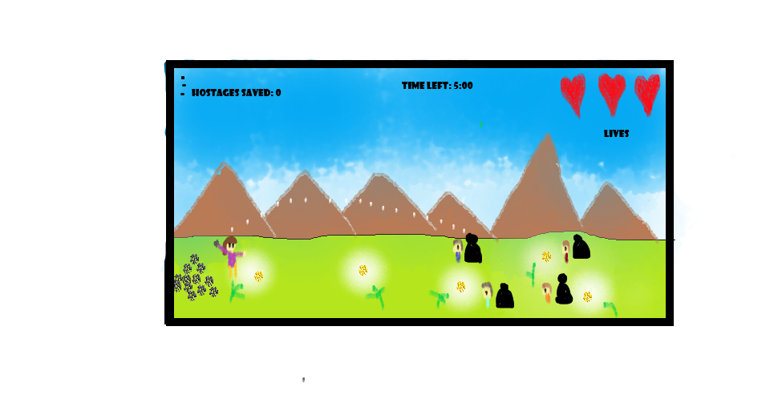

How do you plan to make your game engaging?

As the user will advance, he can unlock many more features like: a new map, more dangerous enemies, upgradation of weapons, better clothes for bong- soon and min hyuk, etc. Also, this game will give a battlefield simulation to the user (which many people tend to enjoy now-a-days) and at the same time this game will inculcate a sense of responsibility in the user (as bong soon will loose her power if she hurts an innocent hostage).