**DIFFERENT TYPES OF REGRESSION**

1. SIMPLE LINEAR REGRESSION: One of the most basic types of regression in machine learning, linear regression comprises a predictor variable and a dependent variable related to each other in a linear fashion.You should use linear regression when your variables are related linearly. For example, if you are forecasting the effect of increased advertising spend on sales. However, this analysis is susceptible to outliers, so it should not be used to analyze big data sets. Generally used to predict outputs in continuous spectrum.

EQUATION: where β₀ is a **bias** and β₁ is the **weight** of the model.

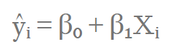

GRAPH:

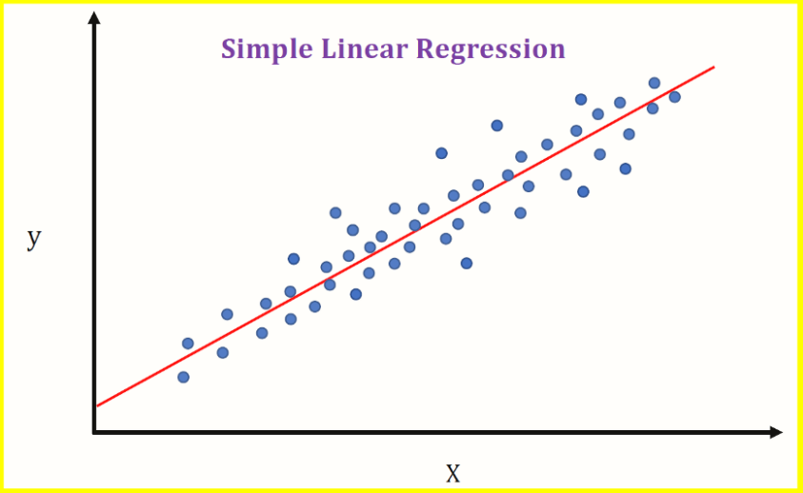

REFERENCE LINK: <https://www.geeksforgeeks.org/linear-regression-python-implementation/>

1. LOGISTIC REGRESSION: It predicts a binary output with two possible values “0” or “1” . Logistic regression uses a sigmoid curve to show the relationship between the target and independent variables. However, caution should be exercised: logistic regression works best with large data sets that have an almost equal occurrence of values in target variables. The dataset should not contain a high correlation between independent variables (a phenomenon known as multicollinearity), as this will create a problem when ranking the variables.

EQUATION:

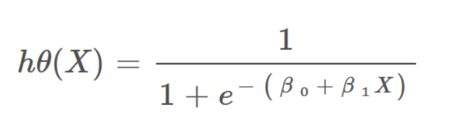

GRAPH:

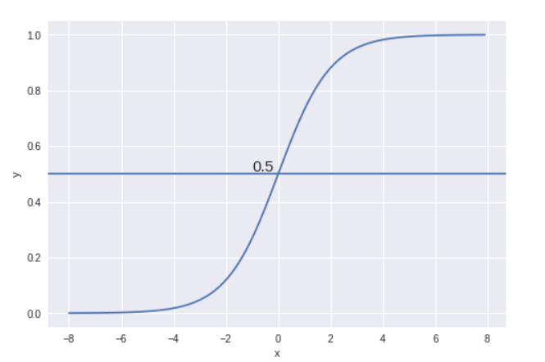

VIDEO LINK: <https://www.youtube.com/watch?v=yIYKR4sgzI8>

1. RIDGE REGRESSION: If, however, you do have a high correlation between independent variables, ridge regression is a more suitable tool. It is known as a regularization technique, and is used to reduce the complexity of the model. It introduces a small amount of bias (known as the ‘ridge regression penalty’) which, using a bias matrix, makes the model less susceptible to overfitting.

EQUATION:

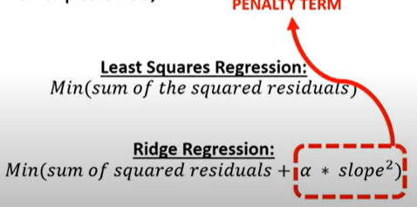

GRAPH:

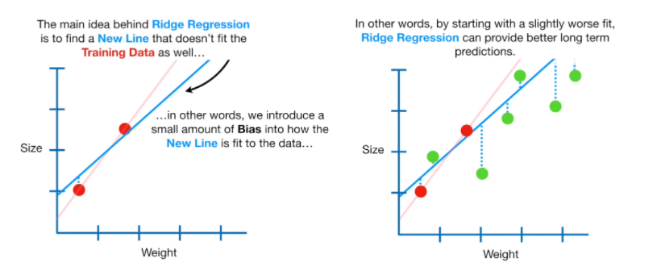

VIDEO LINK: <https://www.youtube.com/watch?v=OEU22e20tWw>

1. LASSO REGRESSION: Like ridge regression, lasso regression is another regularization technique that reduces the model’s complexity. It does so by prohibiting the absolute size of the regression coefficient. This causes the coefficient value to become closer to zero, which does not happen with ridge regression.The advantage is it can use feature selection, letting you select a set of features from the dataset to build the model. By only using the required features – and setting the rest as zero – lasso regression avoids overfitting.

EQUATION:

**PENALTY TERM**

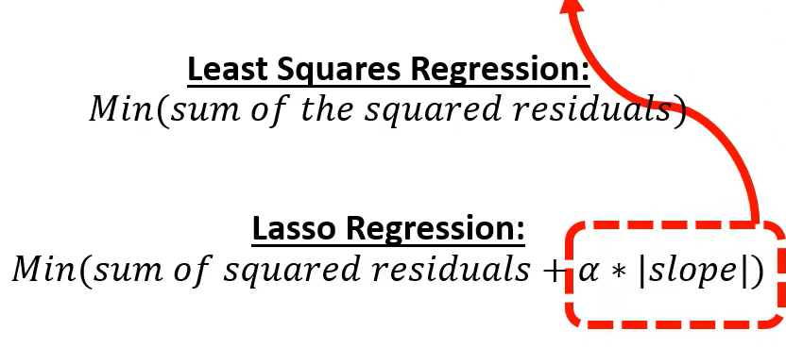

GRAPH:

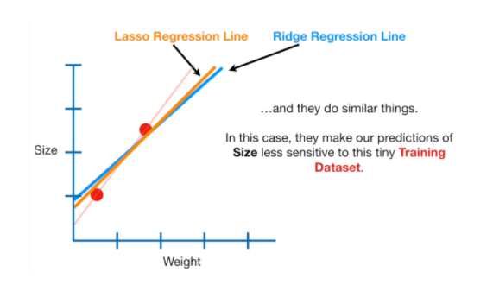

VIDEO LINK: <https://www.youtube.com/watch?v=eGXw9n7AnV4&t=1s>

1. POLYNOMIAL REGRESSION: Polynomial regression models a non-linear dataset using a linear model. It is the equivalent of making a square peg fit into a round hole. It works in a similar way to multiple linear regression (which is just linear regression but with multiple independent variables), but uses a non-linear curve. It is used when data points are present in a non-linear fashion.The model transforms these data points into polynomial features of a given degree, and models them using a linear model. This involves best fitting them using a polynomial line, which is curved, rather than the straight line seen in linear regression. However, this model can be prone to overfitting, so you are advised to analyze the curve towards the end to avoid odd-looking results.

EQUATION:



GRAPH:

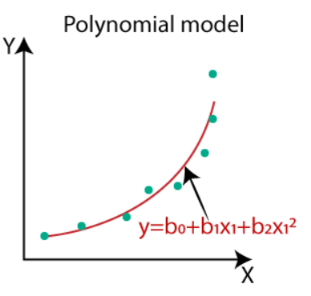

REFERENCES:

