**DAY-3 [19-09-2021] Subject Vector Machines:**

**Subject Vector Machines:**

In machine learning, support-vector machines are supervised learning models with associated learning algorithms that analyse data for classification and regression analysis.

1. Support vectors: Support vectors are **data points that are closer to the hyperplane and influence the position and orientation of the hyperplane**. Using these support vectors, we maximize the margin of the classifier. Deleting the support vectors will change the position of the hyperplane. These are the points that help us build our SVM.
2. Maximum Margin Hyperplane: The best or optimal line that can separate the two classes is the line that as the largest margin. This is called the Maximal-Margin hyperplane. The margin is **calculated as the perpendicular distance from the line to only the closest points**
3. The SVM finds the maximum margin separating hyperplane. Setting: We define a linear classifier: h(x)=sign(wTx+b) and we assume a binary classification setting with labels {+1,−1}.

**Resources:**

Intuition and Introduction to SVMs : <https://www.youtube.com/watch?v=1NxnPkZM9bc>

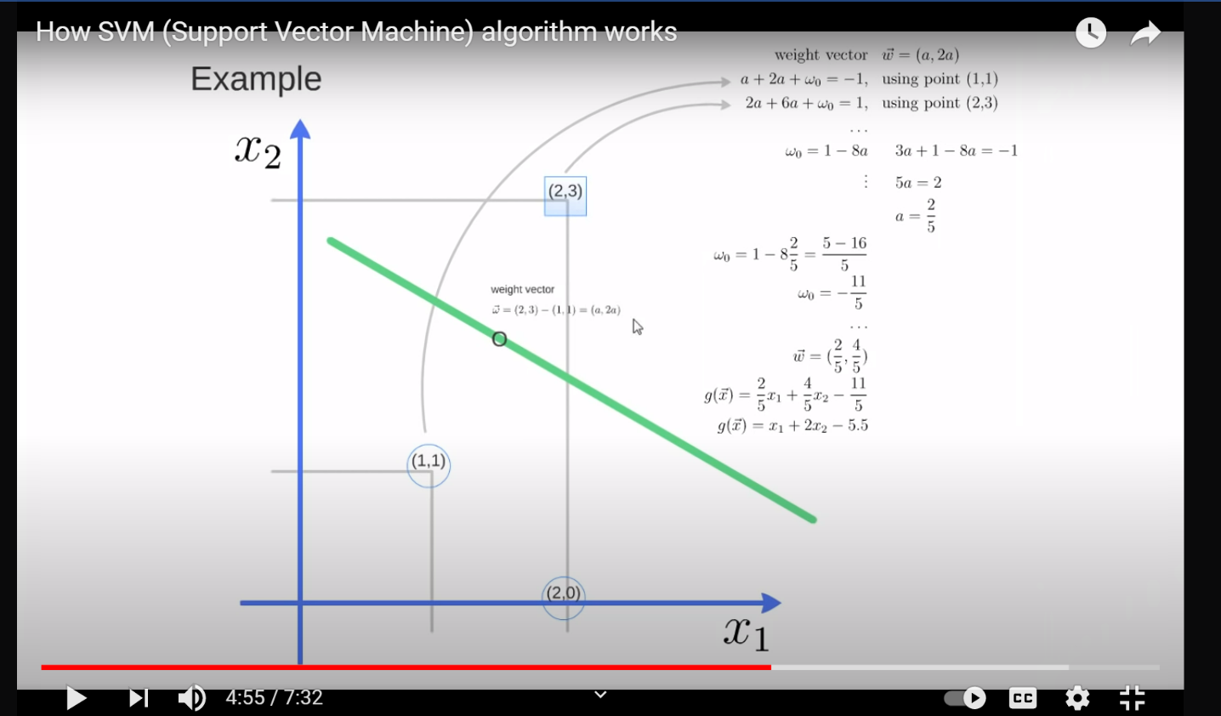

<https://www.youtube.com/watch?v=YS20BYYOor4>

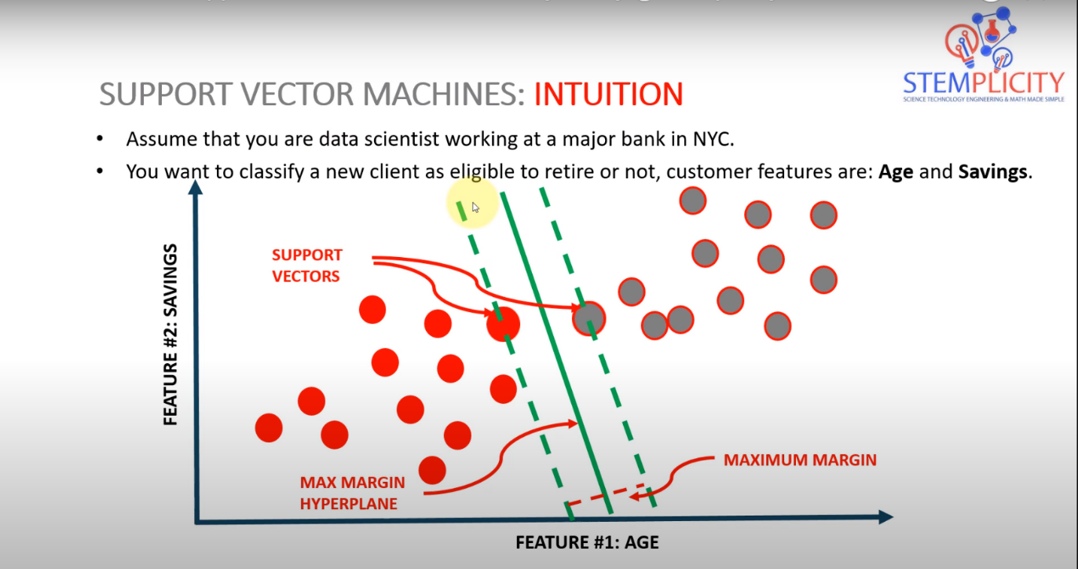

Bank-Retirement Classification: <https://www.youtube.com/watch?v=ojY9OrTHEcU>