# **NAIVE BAYES CLASSIFIER**

Naive Bayes is a classification algorithm for binary (two-class) and multiclass classification problems. It is called Naive Bayes or idiot Bayes because the calculations of the probabilities for each class are simplified to make their calculations tractable. Rather than attempting to calculate the probabilities of each attribute value, they are assumed to be conditionally independent given the class value.

**BAYES THEOREM**

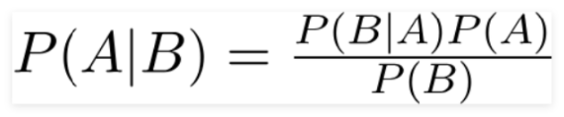

1. **Gaussian Naive Bayes:**

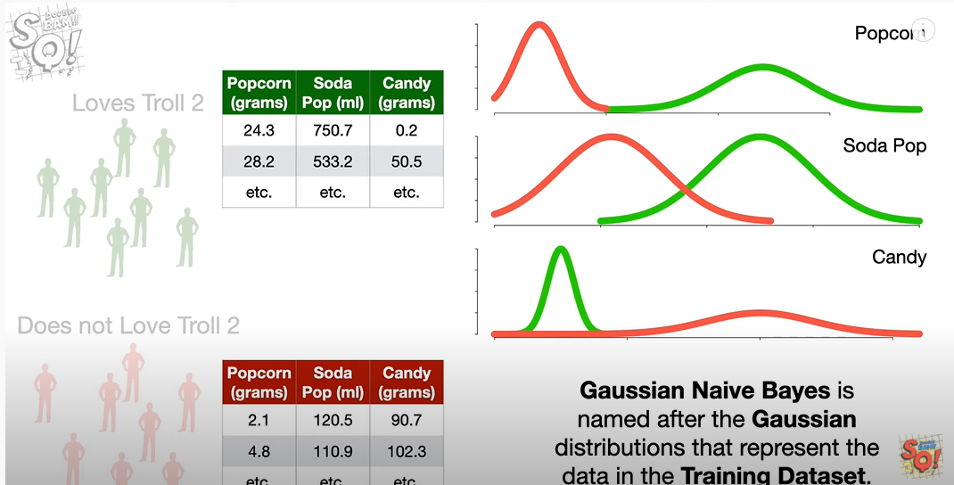

**Video Link:** [**https://www.youtube.com/watch?v=H3EjCKtlVog**](https://www.youtube.com/watch?v=H3EjCKtlVog)

1. **Multinomial Naive Bayes:**

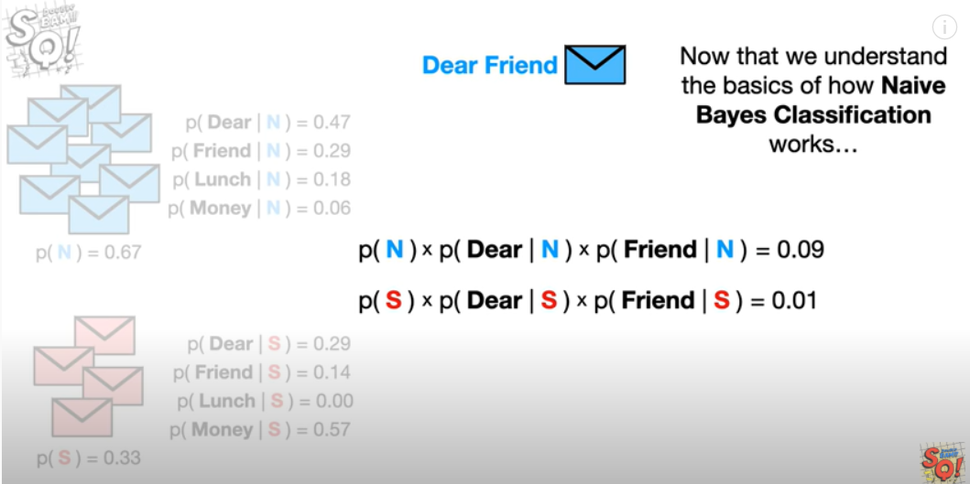

**Video Link:** [**https://www.youtube.com/watch?v=O2L2Uv9pdDA**](https://www.youtube.com/watch?v=O2L2Uv9pdDA)

**REFERENCE:**

[**https://machinelearningmastery.com/naive-bayes-classifier-scratch-python/**](https://machinelearningmastery.com/naive-bayes-classifier-scratch-python/)