**DAY-8 [11-10-2021] Kernels:**

**KERNEL FUNCTIONS**

In machine learning, a “kernel” is usually used to refer to the kernel trick, a method of using a linear classifier to solve a nonlinear problem.The kernel function is what is applied on each data instance to map the original nonlinear observations into a higher-dimensional space in which they become separable.

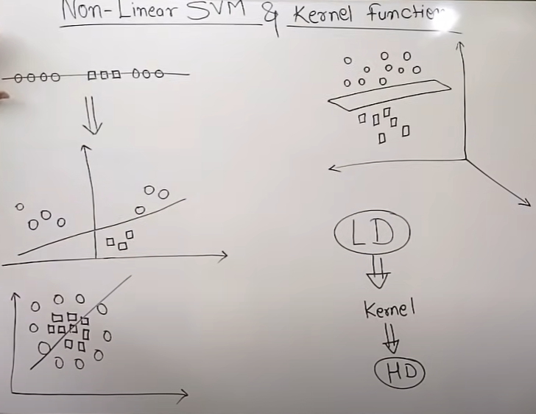

**KERNELS IN IMAGE CLASSIFICATION**

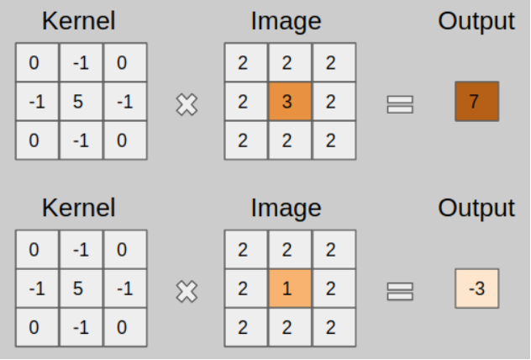

**TYPES OF KERNELS**

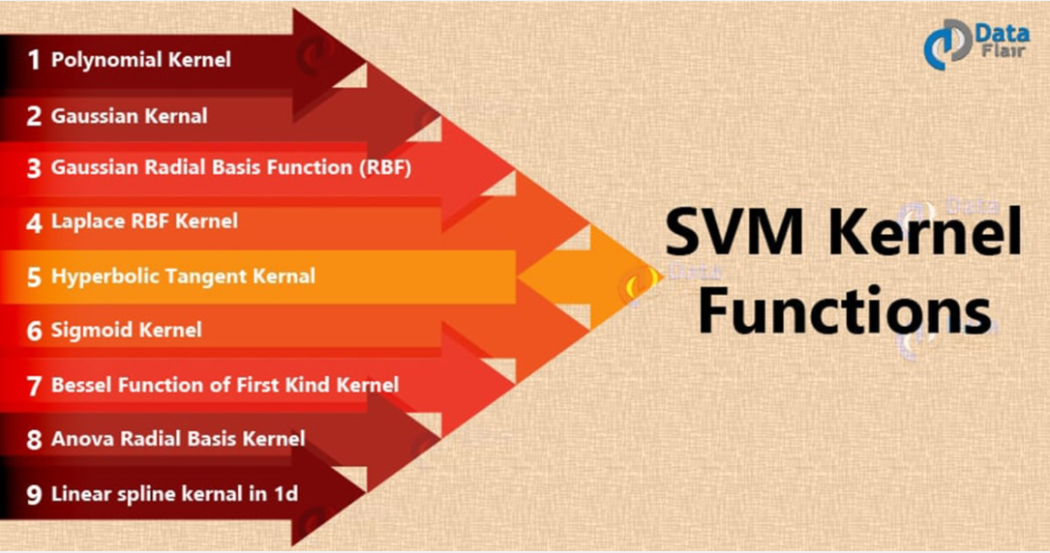

**Reference:**

<https://data-flair.training/blogs/svm-kernel-functions/>

**VIDEO LINKS**

1. Part 1: <https://www.youtube.com/watch?v=mTyT-oHoivA>

Part 2: <https://www.youtube.com/watch?v=XfyR_49hfi8>

1. <https://www.youtube.com/watch?v=8NYoQiRANpg&list=PLoROMvodv4rMiGQp3WXShtMGgzqpfVfbU&index=9>

**REFERENCE**

1. <https://towardsdatascience.com/svm-and-kernel-svm-fed02bef1200>