**DAY-9 [12-20-2021] Kernels Continued:**

**Polynomial Kernel:**

In machine learning, the polynomial kernel is a kernel function commonly used with support vector machines and other kernelized models, that represents the similarity of vectors in a feature space over polynomials of the original variables, allowing learning of non-linear models.

References: https://www.youtube.com/watch?v=Toet3EiSFcM

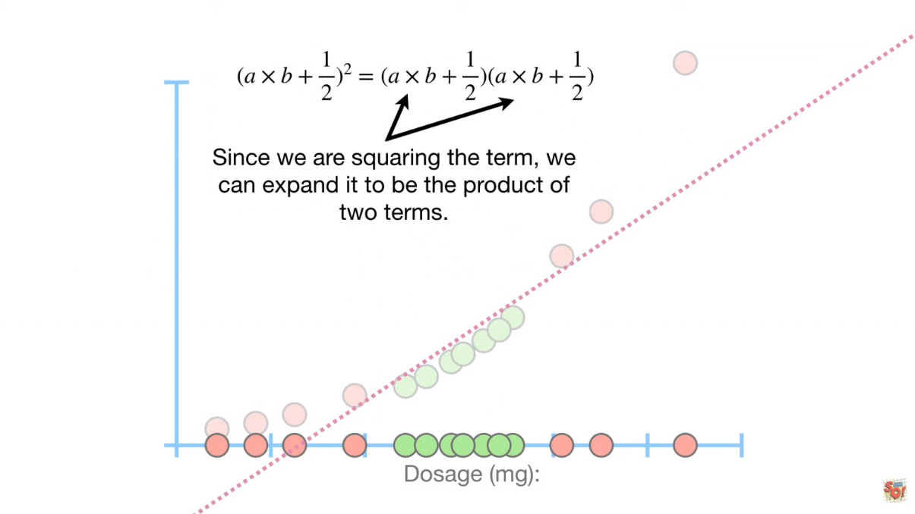

**Radial Kernel:**

In machine learning, the radial basis function kernel, or RBF kernel, is a popular kernel function used in various kernelized learning algorithms. In particular, it is commonly used in support vector machine classification.

**Radial Bias Function:**

Radial basis functions are means to approximate multivariable (also called multivariate) functions by linear combinations of terms based on a single univariate function (the radial basis function). This is radialised so that in can be used in more than one dimension.

References: https://www.youtube.com/watch?v=Qc5IyLW_hns

**Kernels for Image Processing:**

In image processing, a kernel, convolution matrix, or mask is a small matrix used for blurring, sharpening, embossing, edge detection, and more. This is accomplished by doing a convolution between the kernel and an image.

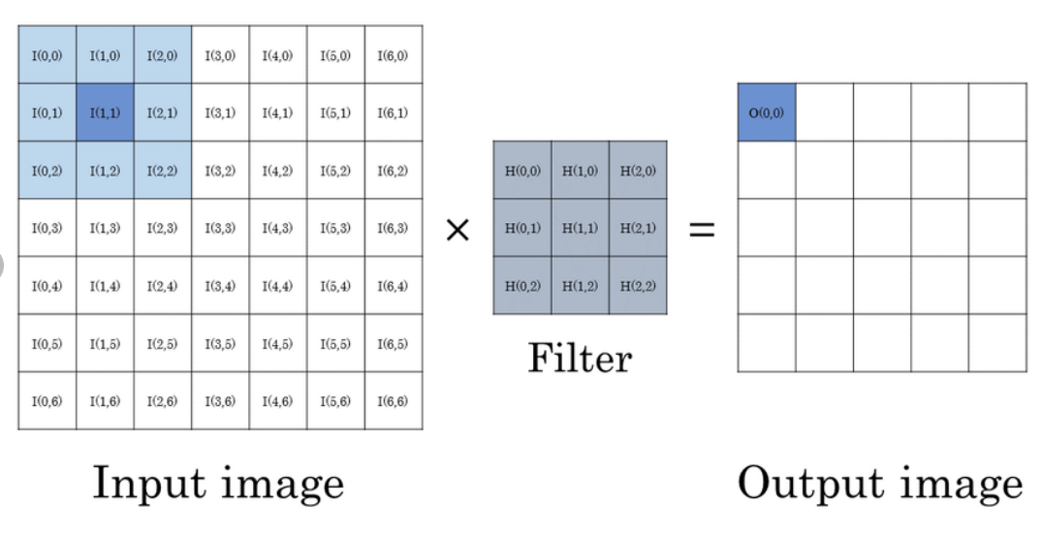

References: https://www.youtube.com/watch?v=mbXtzv1syCc