**IOT LAB**

# EXP2

1. Code:

void setup()

{

pinMode(13, OUTPUT);

}

void loop()

{

for (int i=0;i<255;i++)

{

analogWrite(13,i);

delay(10);

}

for (int i=255;i>0;i--)

{

analogWrite(13,i);

delay(10);

}

}

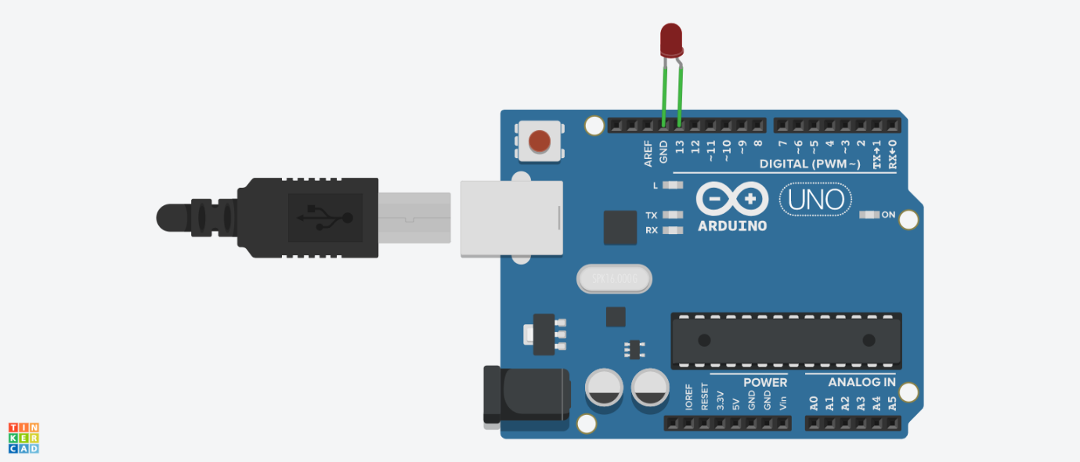

1. Code:

void setup()

{

pinMode(7, OUTPUT);

pinMode(6, OUTPUT);

}

void loop()

{

for (int i=0; i<255; i++)

{

analogWrite(7, 255-i);

analogWrite(6,i);

delay(10);

}

for (int i=255; i>0; i--)

{

analogWrite(7, 255-i);

analogWrite(6, i);

delay(10);

}

}

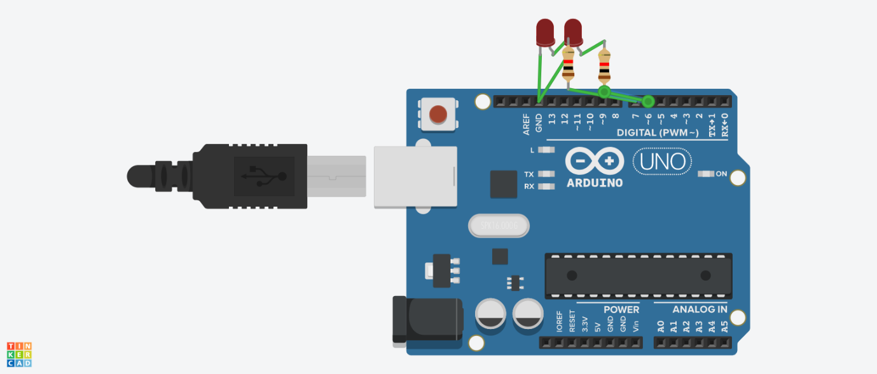

1. Code:

void setup()

{

pinMode(A0, INPUT);

Serial.begin(9600);

}

void loop()

{

int read = analogRead(A0);

Serial.println(read);

delay(10);

}

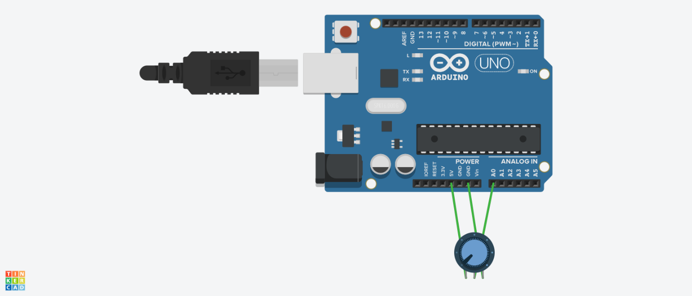

1. Code:

int read = 0;

void setup()

{

pinMode(A0, INPUT);

pinMode(8, OUTPUT);

Serial.begin(9600);

}

void loop()

{

read = analogRead(A0);

if(read>512)

{

digitalWrite(8,HIGH);

Serial.println(read);

}

else

{

digitalWrite(8,LOW);

Serial.println(read);

}

delay(10);

}

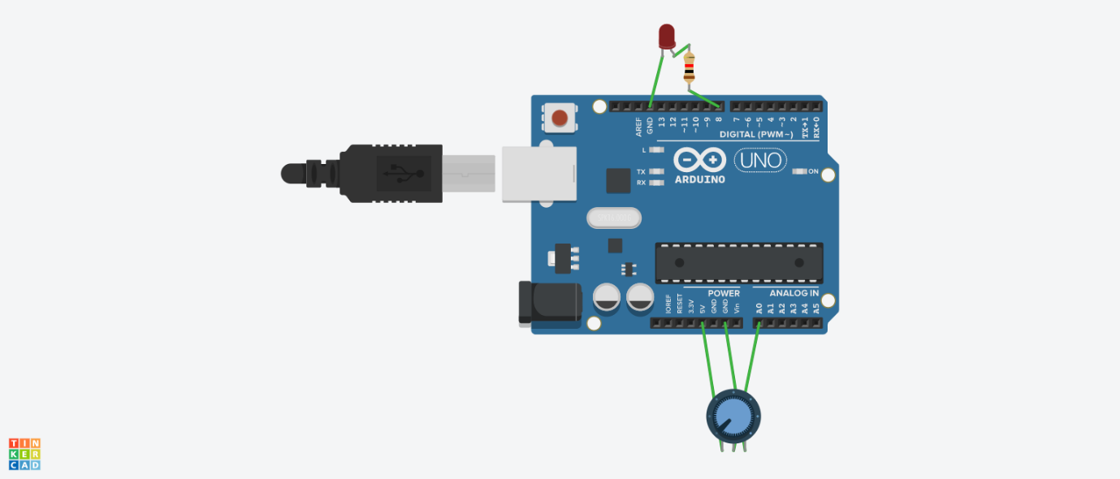

1. Code:

int SV = 0;

void setup()

{

pinMode(A0, INPUT);

pinMode(8, OUTPUT);

Serial.begin(9600);

}

void loop()

{

SV = analogRead(A0);

analogWrite(8,map(SV, 0,1023,0,255));

Serial.print("\n");

Serial.print(SB);

delay(2);

}



1. Code:

int SV = 0;

void setup()

{

pinMode(A0, INPUT);

pinMode(9, OUTPUT);

Serial.begin(9600);

}

void loop()

{

SV = analogRead(A0);

analogWrite(9,map(SV, 0,1023,0,255));

Serial.print("\n");

Serial.print(SB);

delay(2);

}



1. Code:

int switchPin = 2;

int led1Pin = 7;

int led2pin = 9;

int led3pin = 5;

int val;

int val2;

int buttonState;

int Mode = 0;

void setup() {

pinMode(switchPin, INPUT);

pinMode(led1Pin, OUTPUT);

pinMode(led2pin, OUTPUT);

pinMode(led3pin, OUTPUT);

buttonState = digitalRead(switchPin);

}

void loop() {

val = digitalRead(switchPin);

delay(10);

val2 = digitalRead(switchPin);

if (val == val2) {

if (val != buttonState) {

if (val == LOW) {

if (Mode == 0) {

Mode = 1;

} else {

if (Mode == 1) {

Mode = 2;

} else {

if (Mode == 2) {

Mode = 3;

} else {

if (Mode == 3) {

Mode = 0;

}

}

}

}

}

}

buttonState = val;

}

if (Mode == 0) { // all-off

digitalWrite(led1Pin, LOW);

digitalWrite(led2pin, LOW);

digitalWrite(led3pin, LOW);

}

if (Mode == 1) {

digitalWrite(led1Pin, HIGH);

digitalWrite(led2pin, LOW);

digitalWrite(led3pin, LOW);

}

if (Mode == 2) {

digitalWrite(led1Pin, LOW);

digitalWrite(led2pin, HIGH);

digitalWrite(led3pin, LOW);

}

if (Mode == 3) {

digitalWrite(led1Pin, LOW);

digitalWrite(led2pin, LOW);

digitalWrite(led3pin, HIGH);

}

}

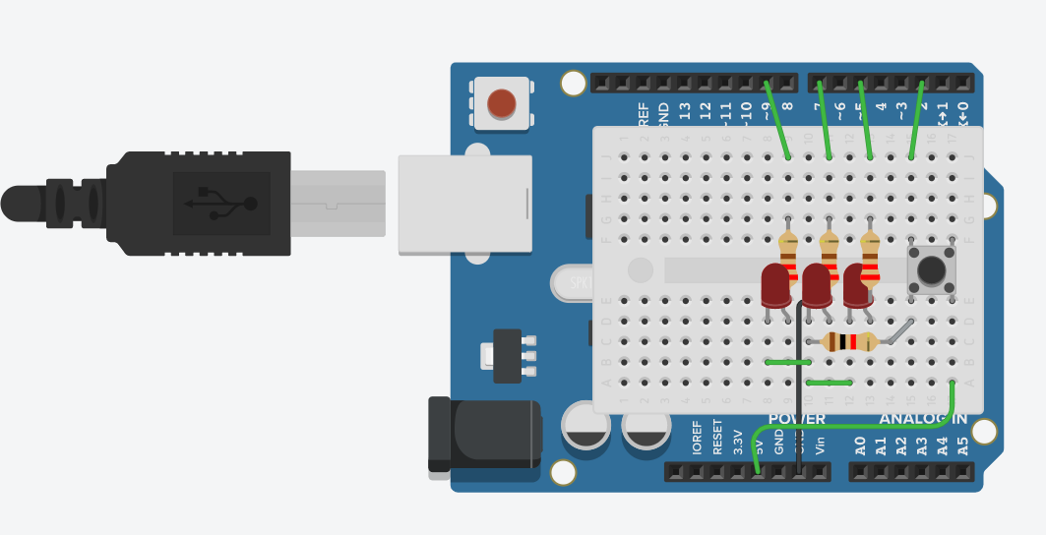

1. Code:
2. Code:

void setup()

{

pinMode(2, INPUT);

Serial.begin(9600);

}

void loop() {

int stateButton = digitalRead(2);

if(stateButton == 1) {

Serial.println("PRESSED");

} else {

Serial.println("RELEASED");

}

delay(20);

}

1. Code:

int pushButton = 2;

void setup()

{

Serial.begin(9600);

pinMode(pushButton, INPUT);

}

void loop()

{

int buttonState = digitalRead(pushButton);

Serial.println(buttonState);

delay(1);

}