**DATA OVER GSM VOICE CHANNEL**

## **Objective:**

## To achieve end to end data communication over mobile voice channel.

## **Problem Statement:**

In various scenarios there is requirement of sending data using the GSM voice channel, specifically in cases where availability of data channel is not guaranteed. To overcome this there is a requirement of sending **low bit rate** data communication over GSM **voice channel**.

To achieve this a separate **module** need to be developed which can get **interfaced** to voice port of any mobile phone and send the data using voice channel. This module is referred as “Universal Data Communication Module (UDCM)”. A Use case diagram of the same is mentioned in Fig 1.

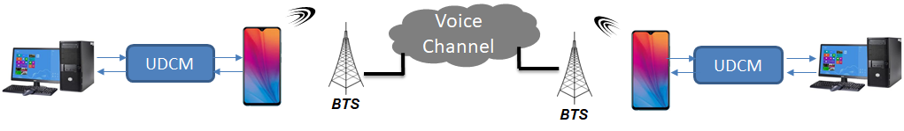

Fig 1. Use case of Universal Data Communication Module

**PROCESS:**

1. Encryption
2. Ofdm
3. GSM
4. Decryption

**Encryption:**

* The first step involves encryption of audio input.
* We are using fernet encryption algorithm.
* The key is generated for encryption. Since it is symmetric key encryption, both the sender and receiver will use the same key.
* The key is then stored in the filekey.
* The key is read and it is used to encrypt the audio.
* The encrypted audio so generated is sent over the gsm channel.

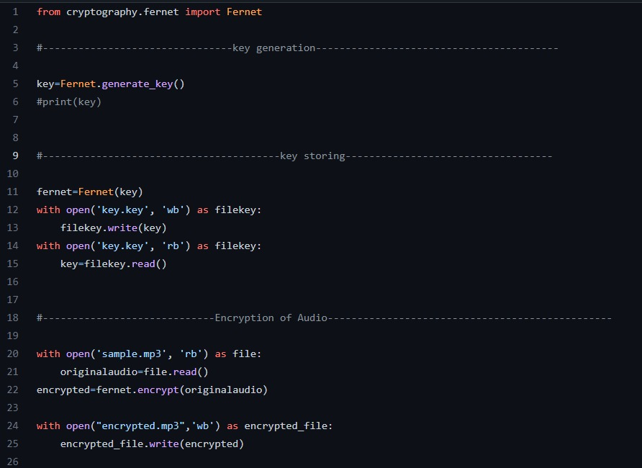

**OFDM/GSM:**

* The encrypted audio is fed as sine waves along with the clock to the multiplexer.
* Multiplexer selects several select lines in this case sine waves and clock input and combines them into one output (sinewave).
* The obtained sine wave is then passed through the FM modulator of 100 Mhz. It encodes information on a particular signal by varying the carrier wave frequency in accordance with the frequency of the modulating signal.
* After modulation it is passed through the digital filter band.

Digital filters are used for two general purposes:

* + separation of signals that have been combined
  + restoration of signals that have been distorted in some way.
  + After passing through the channel, it is first filtered again and then passed to the demodulator where it does the opposite task as that of the frequency modulator.
  + The audio waves are received by the RX (receiver component).

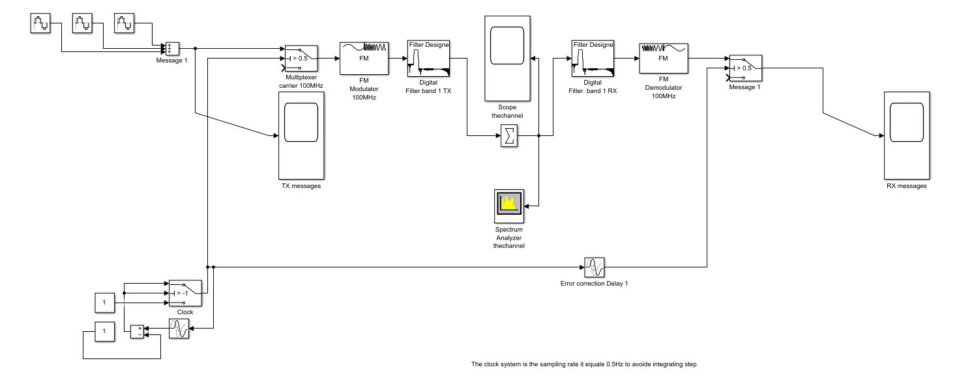

GSM Voice channel simulink:

<https://drive.google.com/drive/folders/1eBnmTkgt7tSpPSRjy2KOOa-v6qNZbEpB?usp=share_link>

**Decryption:**

The received encrypted audio is decrypted using fernet’s algorithm and the key generated.