1. The survey results are showed in the following graph:

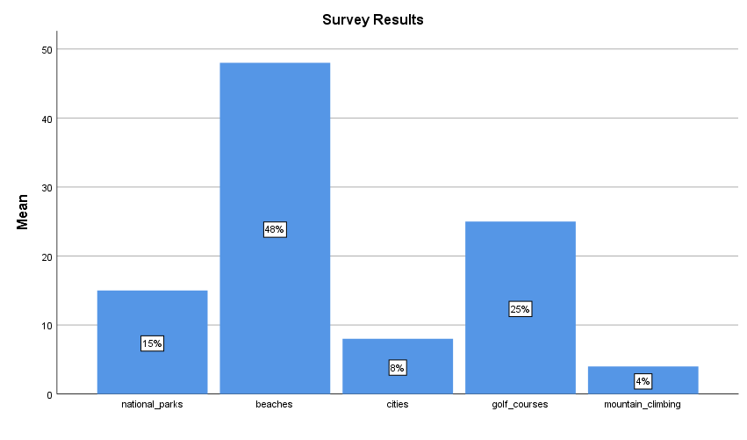

The interpretations are as below:

1. Beaches are the most attractive sites for tourism.
2. Golf courses are the second attraction of the country.
3. National parks are more attractive than cities and mountain climbing but still less attractive than beaches and golf courses.

The implications are as below:

1. From the chart we can see that beaches are far more attractive than any other sites. This gives us a very strong implication that the country is in the tropics which can provide all-year tourism and has many coastal waters including islands.
2. Golf is popular in this country, otherwise it cannot provide high standard courses to attract tourism. Beach golf can be provided easily by this country because it has many beaches. Beach golf is very suitable for team building while in vacation. Many companies provide vacations and do team building workshop at the same time. In this case, this country is the most attractive destination. The country develops golf courses because it has a natural advantage to do so. Beaches and golf courses help each other.
3. Natural scenery and resources are sufficient and well maintained but there are not many famous mountains in the country.
4. Cities only get 8% to attract tourism. That means the cities are not historical with many old buildings or advanced with many new famous buildings. So the economy maybe relies on tourism heavily.
5. Given the information we can see that the country should not be too tiny such as Maldives or relatively big such as Thailand, so it could be Dominican Republic, Bahamas, etc.
6. The two variables chosen are Q8 and Q22, the frequencies and descriptive statistics are as below:

**Frequency Table**

|  |  |  |  |  |  |
| --- | --- | --- | --- | --- | --- |
| **Work interferes with my social life** | | | | | |
|  | | Frequency | Percent | Valid Percent | Cumulative Percent |
| Valid | Strongly Disagree | 19 | 23.8 | 23.8 | 23.8 |
| Disagree | 7 | 8.8 | 8.8 | 32.5 |
| Tend to Disagree | 11 | 13.8 | 13.8 | 46.3 |
| Unsure | 5 | 6.3 | 6.3 | 52.5 |
| Tend to Agree | 21 | 26.3 | 26.3 | 78.8 |
| Agree | 9 | 11.3 | 11.3 | 90.0 |
| Strongly Agree | 8 | 10.0 | 10.0 | 100.0 |
| Total | 80 | 100.0 | 100.0 |  |

|  |  |  |  |  |  |  |  |  |  |
| --- | --- | --- | --- | --- | --- | --- | --- | --- | --- |
| **I can handle whatever comes my way** | | | | | | | | | |
|  | | | | Frequency | | Percent | | Valid Percent | Cumulative Percent |
| Valid | | Disagree | | 2 | | 2.5 | | 2.5 | 2.5 |
| Tend to Disagree | | 2 | | 2.5 | | 2.5 | 5.0 |
| Unsure | | 9 | | 11.3 | | 11.3 | 16.3 |
| Tend to Agree | | 23 | | 28.7 | | 28.7 | 45.0 |
| Agree | | 28 | | 35.0 | | 35.0 | 80.0 |
| Strongly Agree | | 16 | | 20.0 | | 20.0 | 100.0 |
| Total | | 80 | | 100.0 | | 100.0 |  |
| **Statistics** | | | | | | |
|  | | | Work interferes with my social life | | I can handle whatever comes my way | |
| N | Valid | | 80 | | 80 | |
| Missing | | 0 | | 0 | |
| Std. Deviation | | | 2.058 | | 1.158 | |
| Minimum | | | 1 | | 2 | |
| Maximum | | | 7 | | 7 | |

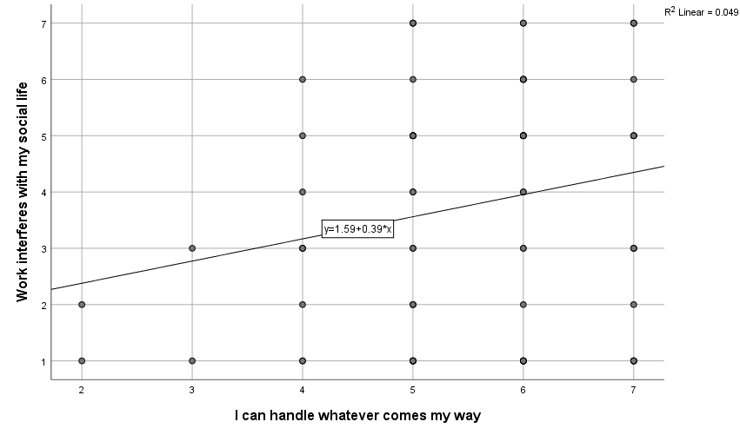

From the graph, we can find that there is a positive relationship between “I can handle whatever comes my way” and “Work interferes with my social life”. The more an employee handles whatever comes his/her way, the more the work will interfere with his/her social life. The relationship makes sense because the more one wants to handle whatever comes the way, the more resources and time the one will need to use on the things comes, and eventually will affect one’s social life