**CS223 Laboratory Project**

**Game of Codes**

**PROGRESS REPORT**

**Course Name:** CS-223 Digital Design

**Code Number:** 1

**Student Name:** Asuman Aydın

**Student’s ID:** 21502604

**Date:** 27.10.2017

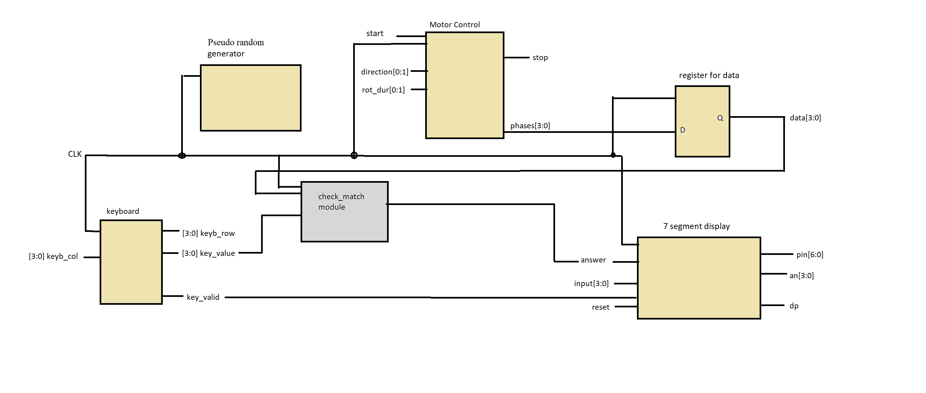

**Check_ match module**: Functionality of it is checking if key_value digits (row[1:0], col[1:0]) and data that comes from d-latch stored, matching or not. Digit by digit comparison will be main function of the module that I will write.

**DIRECTIONS:**

1. 🡪 SR SL
2. 🡪 SR SR
3. 🡪 SL LL
4. 🡪 LL SL
5. 🡪 SL LR
6. 🡪 LR LR
7. 🡪 LR LL
8. 🡪 LL LR
9. 🡪 LR SR
10. 🡪 SR LR

A 🡪 SR LL

B 🡪 LL SR

C 🡪 LL SL

D 🡪 LR SL

E 🡪 SL SL

F 🡪 SL SR