ARCHITECTURE BRIEFING
One application architecture for Azure, hybrid, and on-premises
Prepared for Security, Monitoring, and department leadership
1 October 2026
This briefing explains the architecture we intend to build, why each component is there, and why we preferred it to the practical alternatives. Technical specifications remain in the architecture set. This document is the version to present.
Security  Identity, edge, secrets, supply chain, and audit | Monitoring  One view of both sites, from the door to the ERP | Architecture  The same process in Azure and on premises
What we are asking
Endorse the architecture and the component choices in this briefing. Security is asked to own identity, edge, secret, and supply-chain policy. Monitoring is asked to own the shared service view and the alert thresholds. Neither department is asked to accept a different design on premises.

Architecture
Callers reach a gateway and nothing behind it. The gateway checks the caller and routes to services this program owns. Those services call a small number of outside systems when the work leaves our boundary. Azure and the premises run the same services. They do not run a different process.
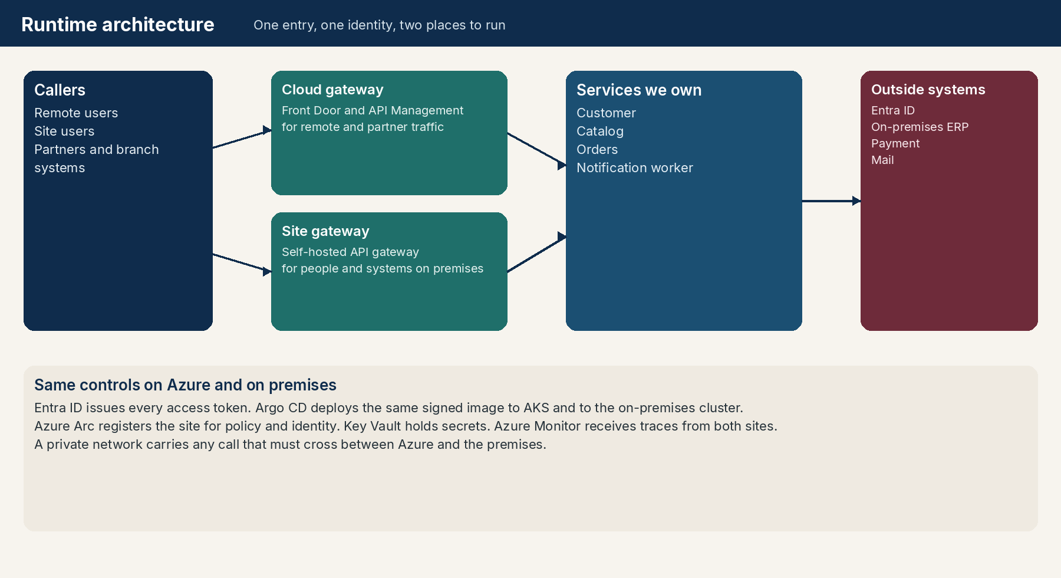
Figure 1. Callers, gateways, services we own, and systems outside the application.
Three placements, one process
Placement | Who calls | Where services run | What stays the same
Azure | Remote users and partners | AKS | Gateway policy, tokens, image, approvals
On premises | People and systems on the site | Kubernetes on Azure Local or Azure Stack Hub | The same policy, tokens, image, and approvals
Hybrid | Either caller, routed to the site that can serve them | Both clusters | A private link when a call must cross

A site user is served by the self-hosted gateway and the local services. A remote user is served by Front Door and the cloud gateway. A call crosses to the other site only when the data or the upstream system is there. Cross-site traffic uses ExpressRoute or a site-to-site VPN.

How a request is handled
• The caller signs in with Entra ID and receives a short-lived access token.
• The caller sends the request to the gateway for that site.
• The gateway applies firewall, quota, and schema controls, then validates the token.
• A failed check stops at the gateway. The service is not called.
• The service validates the same token, applies ownership rules, and does the work.
• If the work needs the ERP or a payment, only the Orders service makes that call.
• Mail and other slow work are queued. The caller is not held for them.
The gateway is a control point, not a place for business rules. Whether a customer may buy a product is decided by Orders, because that decision needs the order record and the ERP. Whether the caller may attempt the call is decided by the gateway.
Words used in this briefing
Term | Meaning
Gateway | The only supported door. Cloud gateway in Azure, self-hosted gateway on premises.
Downstream service | A service this program owns and runs behind the gateway.
Upstream service | A system outside the program. Inbound upstream calls us. Outbound upstream is called by us.
Site | One cluster: AKS, or Kubernetes on Azure Local or Azure Stack Hub.
Promotion | Moving the same image digest to the next environment after approval.

Components, and why these ones
Each component below states what it is, why the architecture includes it, and why we preferred it to the alternative we would otherwise have to operate. The Security and Monitoring columns say what that department receives from the choice.
Azure Front Door and web application firewall
The public front door for remote users and partners.
Why it is in the architecture  It terminates TLS close to the caller, filters common web attacks, and presents one global address for the cloud gateway. | Why we preferred it  We preferred a managed global entry with a firewall over publishing the API gateway directly to the internet. Site users do not travel this path. They use the gateway on the premises, so local traffic stays local.
What Security gains  Attack traffic is reduced before it reaches application code. Firewall policy is a Security control, separate from business releases. | What Monitoring gains  Front Door provides the outside view of availability and latency, before the request enters the gateway.

Cloud API gateway
Azure API Management enforces the API contract for callers who enter through Azure.
Why it is in the architecture  It checks the access token, applies quota and size limits, selects the version, and hides every service behind one contract. | Why we preferred it  We preferred a managed gateway over letting each service publish its own endpoint. One policy set is easier to audit. The same definition is published to the on-premises gateway, so the two sites do not drift apart in behavior.
What Security gains  Authentication, quota, and schema rejection happen before a service is contacted. Denied calls are logged at one place. | What Monitoring gains  Every accept and reject carries a correlation id that Monitoring can follow through the services.

Self-hosted gateway on premises
The same API Management rules, running on Azure Local or Azure Stack Hub.
Why it is in the architecture  People and systems on the site call a local gateway. Policy still comes from the Azure control plane. Local services stay on the local network. | Why we preferred it  We preferred this over sending every site call to Azure. Latency and data-placement expectations are met, while Security still has one policy source. A custom site proxy was set aside because it would create a second set of rules.
What Security gains  The site has the same token rules as the cloud. A disconnected site keeps the last published policy and fails closed when signing keys can no longer be trusted. | What Monitoring gains  Site traffic is visible in the same workspace as cloud traffic, tagged by site.

Microsoft Entra ID
The only issuer of access tokens for this application.
Why it is in the architecture  People, partners, and services prove who they are to Entra ID. The gateway and each service trust that issuer and no other. | Why we preferred it  We preferred Entra ID over API keys stored per service, and over a private user database inside the application. Revocation, conditional access, and tenant control stay with Security. Services do not invent their own login.
What Security gains  One issuer, one tenant, and an allow list of client applications. Conditional access can be tightened without a software release. | What Monitoring gains  Sign-in failures and token rejections are distinguishable from application defects.

Active Directory and Entra Connect
The existing site directory remains the source for employee accounts.
Why it is in the architecture  Entra Connect publishes site accounts and groups into Entra ID. A federated domain can still check the password in Active Directory. The access token is issued by Entra ID. | Why we preferred it  We preferred to use the directory the company already runs, rather than asking every site user to hold a second account. The application does not connect to Active Directory on each request.
What Security gains  Account disablement in the site directory reaches the application through Entra ID. There is no shadow account list to drift. | What Monitoring gains  Directory sync health matters. A broken sync is an identity incident, not an application defect, and should be alarmed separately.

Downstream services
Customer, Catalog, Orders, and the notification worker. These are the systems this program owns.
Why it is in the architecture  Each service owns its data and one business capability. The gateway is the only public route to them. The same image runs in Azure and on premises. | Why we preferred it  We preferred separate services over one large application so a catalog change has a small blast radius and a service can run next to the data it uses. We preferred the same image on both sites over maintaining two code lines.
What Security gains  Each service checks the token again. A caller who bypasses the gateway still cannot act. Ownership rules, such as seeing only your own orders, live here. | What Monitoring gains  Each service reports liveness and readiness. Readiness includes its database, so Monitoring and deployment share one health signal.

Upstream systems
Systems outside this application: the on-premises ERP, the payment provider, and mail.
Why it is in the architecture  Orders is the only service that calls the ERP and payment. The notification worker is the only service that calls mail. Timeouts and retries are explicit. | Why we preferred it  We preferred one client per outside system over allowing every service to integrate directly. Credentials, audit, and failure behavior stay in one place. A slow ERP cannot take down Catalog.
What Security gains  Outbound credentials live in Key Vault. Egress is allow-listed. Payment and ERP calls are attributable to a user or a partner application. | What Monitoring gains  Upstream latency and errors are measured apart from our own errors, so an ERP incident is not reported as an application outage without evidence.

Argo CD
The only tool that deploys this application onto a cluster.
Why it is in the architecture  Git holds the approved image digest. Argo CD makes each cluster match that Git revision. Production does not move on a pipeline script. It moves on a manual sync after approval. | Why we preferred it  We preferred Argo CD over manual deployment and over ad-hoc scripts. We also preferred it as the single reconciler. Azure Arc can run Flux, and we leave that extension off for these namespaces so two deployers cannot overwrite each other.
What Security gains  Approvers see the exact change before production sync. Drift after that sync is returned to the approved revision. There is a record of who synced production. | What Monitoring gains  A failed sync or a failed readiness check is an alert. Deployment health is part of the monitoring view, not a side channel.

Azure Arc
Registration of the on-premises cluster in Azure for inventory, policy, and identity.
Why it is in the architecture  The site cluster is visible in the same tenant as AKS. Workload identity and Azure Policy can apply there. Arc does not deploy the application. | Why we preferred it  We preferred a registered cluster over an unmanaged server room. Security and Monitoring can see the site without a separate inventory. We did not prefer Arc's Flux deployment for this program because Argo CD already owns release control.
What Security gains  Policy compliance for the site is reported next to Azure. Identity for site workloads uses the same tenant. | What Monitoring gains  Arc closes the visibility gap. A site cluster that falls out of registration is an operational alert.

AKS and on-premises Kubernetes
The two places the services run. AKS in Azure. Kubernetes on Azure Local or Azure Stack Hub.
Why it is in the architecture  Both sites run the same kind of cluster, so probes, network policy, and admission rules mean the same thing everywhere. | Why we preferred it  We preferred one runtime over App Service in Azure and virtual machines on premises. Two different runtimes would split Security baselines and Monitoring agents. Kubernetes is the common substrate that hybrid placement needs.
What Security gains  Network policy and admission control are enforceable on both clusters. The service is not reachable except from the gateway and its allowed peers. | What Monitoring gains  The same agent model ships logs, metrics, and traces from both clusters.

Container Registry and the site cache
One registry in Azure, and a connected registry or pull-through cache on premises.
Why it is in the architecture  The pipeline pushes one signed image. Production on either site pulls that digest. The site cache lets the premises pull without a second build. | Why we preferred it  We preferred build-once over building again on the site. A rebuild would mean production might not be the bits that were approved. A local cache is preferred over depending on a wide-open pull from Azure during a site release.
What Security gains  Only the pipeline can publish the production repository. Pulls are authenticated. The digest is what promotion approves. | What Monitoring gains  Replication lag to the site cache is visible, so a promotion does not start on a site that does not yet have the image.

Image signing and admission
The pipeline signs the image. Each cluster rejects an image that does not carry that signature.
Why it is in the architecture  This binds what is running to the pipeline that tested and scanned it. It applies on AKS and on the on-premises cluster. | Why we preferred it  We preferred admission that refuses unsigned images over a written rule that people should only deploy from the pipeline. A registry credential alone cannot prove the image was approved.
What Security gains  This is the supply-chain control. A substituted or side-loaded image does not start. Security can audit the signature identity. | What Monitoring gains  An admission rejection is a deploy failure with a clear reason, surfaced in Argo CD and in the cluster log.

Key Vault and workload identity
Secrets stay in Azure Key Vault. A workload receives a short-lived identity to read the secrets it needs.
Why it is in the architecture  No password is stored in Git or in the image. The same pattern works for AKS and for an Arc-enabled cluster. Rotation does not require a new release. | Why we preferred it  We preferred workload identity over long-lived connection strings in configuration. A secret in a file spreads, and rotation becomes a release. Vault access is limited to the workload that needs it.
What Security gains  Security can revoke a workload, rotate a secret, and see who read it. Developers do not handle production passwords. | What Monitoring gains  Vault access failures show up as readiness or dependency errors, separate from user-facing defects.

Policy on the cluster and Azure Policy
Kyverno or Gatekeeper enforces baseline rules on every cluster. Azure Policy reports Azure and the Arc site together.
Why it is in the architecture  Required health probes, resource limits, and signed images are enforced at deploy time. Organizational policy is visible for both sites. | Why we preferred it  We preferred enforcement in the cluster over a checklist in a wiki. We preferred one admission engine on both sites so a rule written for Azure is meaningful on premises. Azure Policy remains the executive compliance view.
What Security gains  Exceptions are recorded. A release that skips probes or runs as an unrestricted account is refused. | What Monitoring gains  Policy failures are deploy events. They should page the releasing team, not appear a week later in an audit.

OpenTelemetry and Azure Monitor
Services emit traces, metrics, and logs with the gateway correlation id. Both sites export to Azure Monitor.
Why it is in the architecture  A request can be followed from the door, through Orders, to the ERP. Remote and site traffic use one workspace. | Why we preferred it  We preferred one telemetry pipeline over a separate monitoring stack on premises. Two stacks would force the Monitoring department to reconcile incidents by hand. OpenTelemetry keeps the application independent of a single vendor agent inside the code.
What Security gains  Security receives the audit stream: denied tokens, use of privileged roles, and sensitive business actions. | What Monitoring gains  This is the system of record for service health. Dashboards and alerts for both sites live here.

Queue for work that can finish later
A durable queue between Orders and the notification worker.
Why it is in the architecture  The caller receives an order id when the order is stored. Mail can retry without holding the user on the line. | Why we preferred it  We preferred a queue over sending mail inside the order request. A mail outage should not fail a sale that has already been recorded. The queue also gives Monitoring a visible backlog.
What Security gains  Messages do not carry raw credentials. The worker uses its own identity toward the mail provider. | What Monitoring gains  Queue age and dead letters are operational signals. A growing backlog is an early warning before users complain.

Private network between Azure and the site
ExpressRoute or a site-to-site VPN for traffic that must cross.
Why it is in the architecture  Service-to-service calls and the path from Azure to the on-premises ERP do not travel the public internet. | Why we preferred it  We preferred a private path over public endpoints between the sites. The ERP remains on the site network. Callers still use only the gateway.
What Security gains  The private path is an allow-listed route, not a flat network. Platform firewalls still separate the clusters. | What Monitoring gains  Link health is a dependency of hybrid calls. Monitoring treats the circuit as a component with its own alert.

APIOps for gateway configuration
API routes, token policies, and backends are stored in Git and published to API Management after review.
Why it is in the architecture  A gateway change uses the same pull request discipline as a service change. Publishing happens after the new services are healthy. | Why we preferred it  We preferred reviewed configuration over editing the API portal by hand. Hand edits do not show in the promotion record and are easy to make on one site only.
What Security gains  Token policy and quota changes are visible to Security before they are published. The previous revision remains available for rollback. | What Monitoring gains  A publish is an event. Monitoring can correlate an error spike with a gateway revision the same way it correlates one with an image digest.

Security
Security’s outcome is a single control model. A caller is identified the same way in Azure and on premises. A service cannot be reached except through the gateway. A release cannot start unless it was built and signed by the pipeline. A production change has an approver.
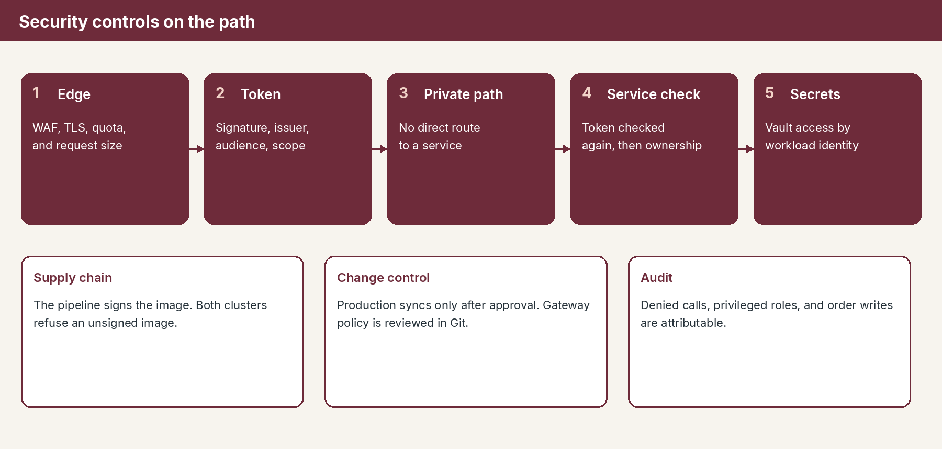
Figure 2. Controls from the edge through the service, plus supply chain, change, and audit.
Identity and access
• People use authorization code with PKCE. The application never sees the password.
• Partners and branch systems use client credentials. They do not share a person’s login.
• Workloads use workload identity to reach Key Vault. There is no long-lived password in Git.
• Delegated scopes for people include Catalog.Read, Orders.Read, Orders.Write, and Customer.Read.
• Application roles include Orders.Submit and Orders.ReadAll. Orders.ReadAll is limited to operations clients.
• The gateway and the service both check signature, issuer, audience, tenant, expiry, and the required scope or role.
• The service then checks ownership. A valid Orders.Read token still returns only that caller’s orders.
What is deliberately refused
Practice set aside | Reason
Passwords inside the application | Entra ID and Active Directory already own them.
A separate user store on premises | It would drift from the corporate directory.
API keys as the main application identity | They are hard to scope and easy to copy.
Trusting an identity header without a token | A header can be forged if a path around the gateway appears.
Editing production gateway policy by hand | It would bypass review and the promotion record.
Unsigned or rebuilt-on-site images | Production must be the digest that was approved.

Decisions requested from Security
Decision | Recommendation
Entra ID is the only token issuer | Endorse
Token checks run at the gateway and again in the service | Endorse
Front Door web application firewall protects the cloud entry | Endorse, and own the firewall policy
Secrets live only in Key Vault and are read with workload identity | Endorse
Both clusters refuse unsigned images | Endorse, and own the signing identity
Privileged role Orders.ReadAll is tightly held | Endorse the role list and the client allow list
Production deploy requires the recorded approvals | Endorse

Monitoring
Monitoring’s outcome is one operational picture. Azure and the premises report to Azure Monitor. A correlation id assigned at the gateway ties the caller’s request to the service trace and, when needed, to the ERP or payment call.
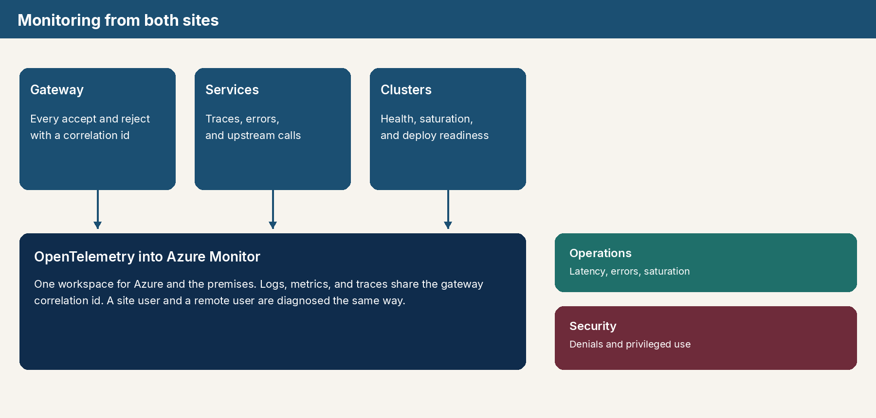
Figure 3. Signals from the gateway, the services, and the clusters land in one workspace.
What is measured
Signal | Where it starts | Why leadership should see it
Availability and latency | Gateway | This is the caller’s experience, on each site.
Token and quota rejects | Gateway | Separates abuse or identity issues from defects.
Service errors | Each downstream service | Shows which capability is failing.
Upstream errors and latency | Orders and the worker | Shows an ERP, payment, or mail incident.
Readiness and sync result | Argo CD and probes | Shows whether a promotion is safe to expose.
Queue age and dead letters | Notification queue | Shows work accepted but not yet finished.
Private link health | ExpressRoute or VPN | Shows whether hybrid calls can complete.
Audit events | Gateway and services | Denied access, privileged reads, and order writes.

Proposed starting targets
These targets are a starting point for Monitoring to confirm. They are measured at the gateway for the site that received the call. Caller errors, such as a missing token, do not count against availability.
Target | Proposal
Order API availability | 99.9 percent of calls succeed in a month
Catalog read latency on the local site | 95 percent complete within 300 milliseconds
Gateway server errors | Alert when they exceed 1 percent for five minutes
Production readiness | Alert when a production sync is not healthy
Entra signing-key retrieval | Alert when validation can no longer refresh keys
Notification backlog | Alert when queue age exceeds the agreed business window

We preferred one Azure Monitor workspace over a second monitoring product on premises. The department should not have to learn two consoles to answer “is the site healthy?” Security’s audit queries use the same correlation id, with a retention period Monitoring and Security agree together.
Decisions requested from Monitoring
Decision | Recommendation
Azure Monitor is the system of record for both sites | Endorse
Dashboards cover availability, latency, errors, saturation, and gateway rejects | Own the dashboard set
Alerts include failed production readiness, token-failure spikes, and ERP errors | Own the paging route
The proposed targets above | Confirm or replace before go-live
Audit retention | Agree the period with Security

Release control
Speed comes from building the image once. Safety comes from refusing to rebuild it for production and from requiring approval before a higher environment moves. Both sites receive the same digest. A failed site does not force the other site to roll back.
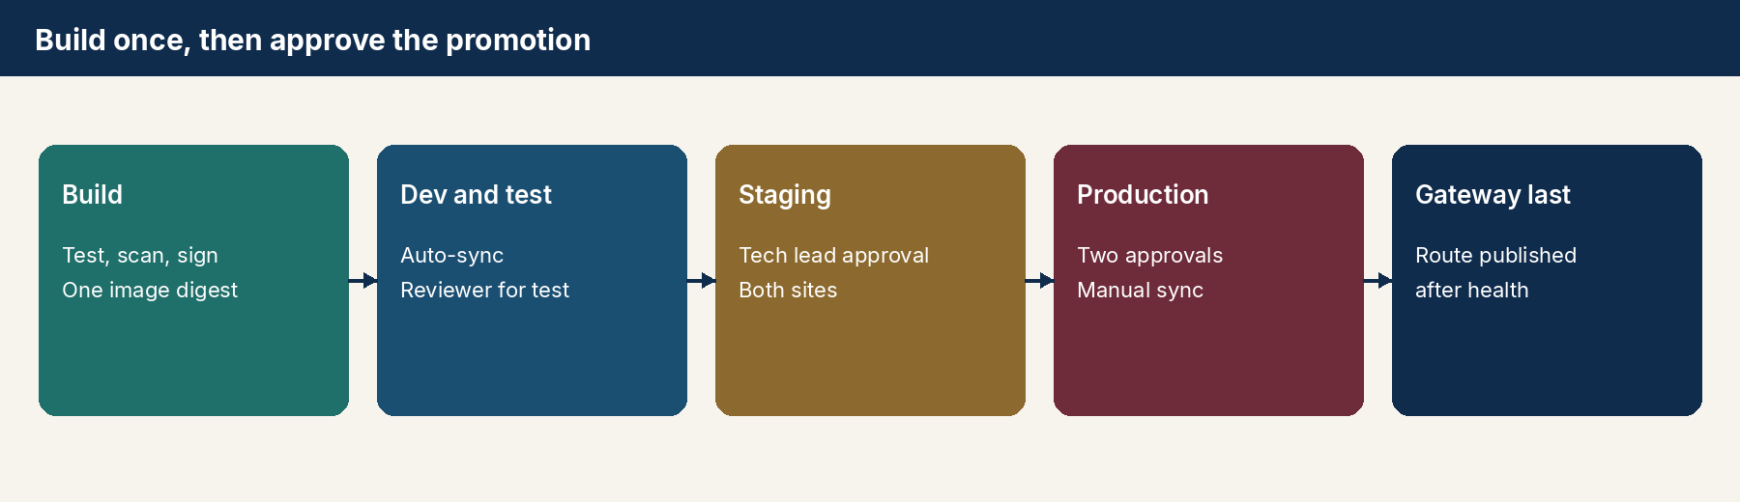
Figure 4. The digest is promoted. Production and the gateway route wait for approval and health.
Step | Approval | What moves
Build on main | Pull request review | A signed digest in the registry
Dev | None beyond the merge | Both sites auto-sync
Test | One reviewer | Both sites auto-sync
Staging | Tech lead | Both sites
Production | Release manager and operations | Manual Argo CD sync, per site
Gateway route | Published only after service health | Cloud and site gateways

Rollback returns Git to the previous digest and syncs again. There is no emergency rebuild. The previous gateway revision is still available and becomes current if the route must be withdrawn.
Why this release model
• Approvers look at a diff of the approved digest, not at a new build of unknown content.
• Dev and test stay fast because they auto-sync. Staging and production stay gated.
• Each site is a separate deployment, so an on-premises fault does not take Azure with it.
• The gateway route is last. Callers are not sent to services that are not ready.
• Feature flags let a build be deployed and kept dark until the business is ready to expose it.

Decisions to record
If the departments accept this briefing, the following choices become the architecture baseline. A later change is a new decision, not a local exception on one site.
Choice | Baseline
Entry | Gateway only. Front Door for remote callers. Self-hosted gateway for the site.
Identity | Entra ID tokens. Site accounts arrive through Entra Connect.
Authorization | Scopes and roles at the gateway and the service. Ownership inside the service.
Runtime | The same image on AKS and on on-premises Kubernetes.
Deploy | Argo CD. Arc is for inventory, policy, and identity, not a second deployer.
Promotion | Build once. Approve to promote. Manual sync in production.
Secrets | Key Vault and workload identity.
Supply chain | Signed images. Admission on both clusters.
Observation | OpenTelemetry to Azure Monitor from both sites.
Gateway change | Reviewed in Git and published after service health.

What happens next
• Security confirms the role list, the partner client list, firewall ownership, and signing identity.
• Monitoring confirms the workspace, the alert routes, and the starting targets.
• Architecture keeps the component set stable and writes any exception as a decision.
The supporting architecture set in this repository holds the interaction diagrams for placement, authentication, and Argo CD. This briefing is the document to present.

