**European sectors/companies that have been rallying or suffering and the implications on japan/asia stocks**

The EU-Japan Economic Partnership Agreement (EPA) started in 2019

* Japan is EU’s second largest trading partner in Asia
* In 2023, EU’s trade deficit with Japan was reported to be ~ €11.8bn
* Rare policy divergence between a dovish ECB and hawkish BOJ, resulted in depreciation of EUR/JPY -1.47% YTD. Historically EUR has strengthened against JPY, +34.88% in the past 5 years. This new regime improves export competitiveness of European exports to Japan.

Based on 2023 figures of EU and Japan’s trade, EU’s main exports to Japan consisted of machinery(33,4%), chemicals (29,7%) and miscellaneous articles (14,8%). Japan mostly exported machinery & transport equipment (65.3%), chemicals (10.5%) and manufactured goods (8,1%). Europe and Japan's duality of cooperation and rivalry is evident in these key sectors.

**Europe’s Equity Market has a stellar performance of +9.01% YTD.** Key sectors driving equity performance include banks +24.88%, Construction and materials +14.24% and Industrial Goods and services +12.51%. Other key industries with strong 1-year performance includes Telecomm, Insurance and personal and household goods.

Recent catalysts for strong Euro equities performance includes re-armament and $860bn defence spending.

**Japan will benefit from Europe’s strong performance in construction and Industrials**, due to their large volumes of exchanges in machinery. Construction and industrial sectors are deeply interconnected, relying on each other for essential materials, equipment, and infrastructure. This dynamic extends across global players in key regions including between Europe and Japan - in their exchange of machinery and expertise.

Europe’s construction industry was the second largest contributor to the Euro Stoxx 600 strong performance, whilst contributing about 9% of EU’s GDP. Strong performance in construction and manufacturing is attributed to Germany’s recent €500bn infrastructure fund, improvement in order books for EU contractors and growth in monthly construction volume data.

Cooperation between Japan and Europe creates opportunities for more advanced construction machinery and systems. Europe’s success in construction/industrials will translate to greater opportunities for key Japanese partners. EU’s growth in these areas will impact 2 key sectors in Japan, a) Heavy machinery and Equipment, b) Raw materials (e.g. Steel, Aluminium).

**Figure 2: Key drivers and players**

| **Construction and materials (+14.24%)** | | **Industrials goods and services (+12.51%)** | |
| --- | --- | --- | --- |
|  |  |  |  |
|  |  |  |  |
|  |  |  |  |
|  |  |  |  |
|  |  |  |  |

Heidelberg Materials displayed exceptional performance of +39.85% return YTD. In the heavy machinery and equipment space, Mitsubishi Heavy Industries (MHI) stands to benefit due to outstanding collaborations in the xxxxx. Heidelberg Materials UK has awarded Japan-based Mitsubishi Heavy Industries (MHI) a front end engineering design (FEED) contract for an upcoming carbon capture installation at its Padeswood cement plant in Flintshire.

*Komatsu (Japanese)* and *Siemens* (German) joint forces on building electric drive systems for mining trucks and control software for manufacturing. Merged Komatsu's mechanical components and Siemens's electrical technology. Most recent collaboration at the end of 2024, combined effort to develop an electric motor-power drive system.

Raw materials (e.g. steel, iron, aluminium)

* Japan is the third largest steel producer in the world and the second largest steel exporter. Japan produced around 87 million tons of crude steel in 2023.
* Key players: Nippon steel, JFE holdings, Kobe steel, Tokyo steel manufacturing
* The EPA, effective from February 2019, eliminated or reduced tariffs on many steel products traded between Japan and the EU.
* Nevertheless the combined effect of talks on steel tariffs alongside overproduction of steel(surplus of roughly half a billion tonnes depressing prices) results in an uncertain outlook for the steel industry globally

**Europe’s biggest loser in the past 1-year was Autos and parts with -16.85% returns**

Globally, key trends in the autos industry towards EV and autonomous vehicles.

Nevertheless, Europe has committed to improving their autos industry. The European commission will invest €1.8 billion to create a secure and competitive supply chain for battery raw materials. Autonomous vehicles sector will also receive a joint public-private investment of around €1 billion backed by the Horizon Europe Programme over the 2025-2027 period.

Most European companies are still [lagging behind](https://www.europarl.europa.eu/thinktank/en/document/IPOL_STU(2021)695457) in electric vehicle innovation. European incumbent companies are struggling to make profitable and [affordable](https://www.bcg.com/publications/2023/reducing-the-electric-vehicle-manufacturing-costs) electric vehicles, particularly due to the high cost of batteries. [Only one](https://content.rolandberger.com/hubfs/Roland_Berger_Mastering_cost_efficient_automotive_production_ENG.pdf) of the world’s top 15 battery electric vehicles is made in the EU.

In 2023, 24% of cars in Europe were an Asian brand. Highlighting Asian auto companies' significant presence in Europe. Demand for Asian brand autos in Europe: Japanese (54%), Koreans (36%), China (10%).

On the EV battery front,

* Japan/Asia receives strong competition from Europe in the Autos industry each with a xx% market share
* Japan and Europe has
  + Europe: Volkswagen, BMW, Renault.
  + Japan: Toyota, Nissan, Honda.
  + Auto tariffs

Most European companies are still [lagging behind](https://www.europarl.europa.eu/thinktank/en/document/IPOL_STU(2021)695457) in electric vehicle innovation. European incumbent companies are struggling to make profitable and [affordable](https://www.bcg.com/publications/2023/reducing-the-electric-vehicle-manufacturing-costs) electric vehicles, particularly due to the high cost of batteries. [Only one](https://content.rolandberger.com/hubfs/Roland_Berger_Mastering_cost_efficient_automotive_production_ENG.pdf) of the world’s top 15 battery electric vehicles is made in the EU.

* + <https://ec.europa.eu/commission/presscorner/detail/en/ip_25_635>
  + EUropean EV demand boost s Japnese battery and component suppliers

**Trade Idea: Mitsubishi Heavy Industries (MHI)**

Mitsubishi Heavy Industries (MHI) (7011.T) presents a strong growth opportunity, leveraging its deep connections to Europe’s industrial and renewable energy markets. MHI has a significant footprint in Europe through its subsidiaries, joint ventures, and partnerships. It provides advanced industrial machinery, energy solutions, and infrastructure projects across the region. The company is involved in key European industries, including aerospace, energy, and transportation, aligning with Europe's focus on industrial growth and sustainability.

MHI has established joint ventures and collaborations with European companies, such as its partnership with Siemens in gas turbine technology and its involvement in the European Space Agency (ESA) projects.

- These collaborations enhance MHI's ability to tap into Europe's industrial growth and innovation ecosystem.

- MHI is a leader in hydrogen energy and carbon capture technologies, areas where Europe is heavily investing to achieve its Green Deal objectives.

- The company's expertise in sustainable solutions aligns with Europe's push for industrial modernization and environmental sustainability.

The stock is currently trading near its 52-week high, having surged significantly over the past year, showcasing strong investor confidence. While its PE ratio of 32.68 is above industry norms, this reflects its leadership in high-growth areas like energy solutions, aerospace, and advanced machinery, which align with Europe’s push for sustainability and industrial modernization. The dividend yield of 0.88% may not appeal to income-focused investors, but MHI’s focus on innovation and global infrastructure projects makes it an attractive pick for those seeking long-term growth potential.

1Y

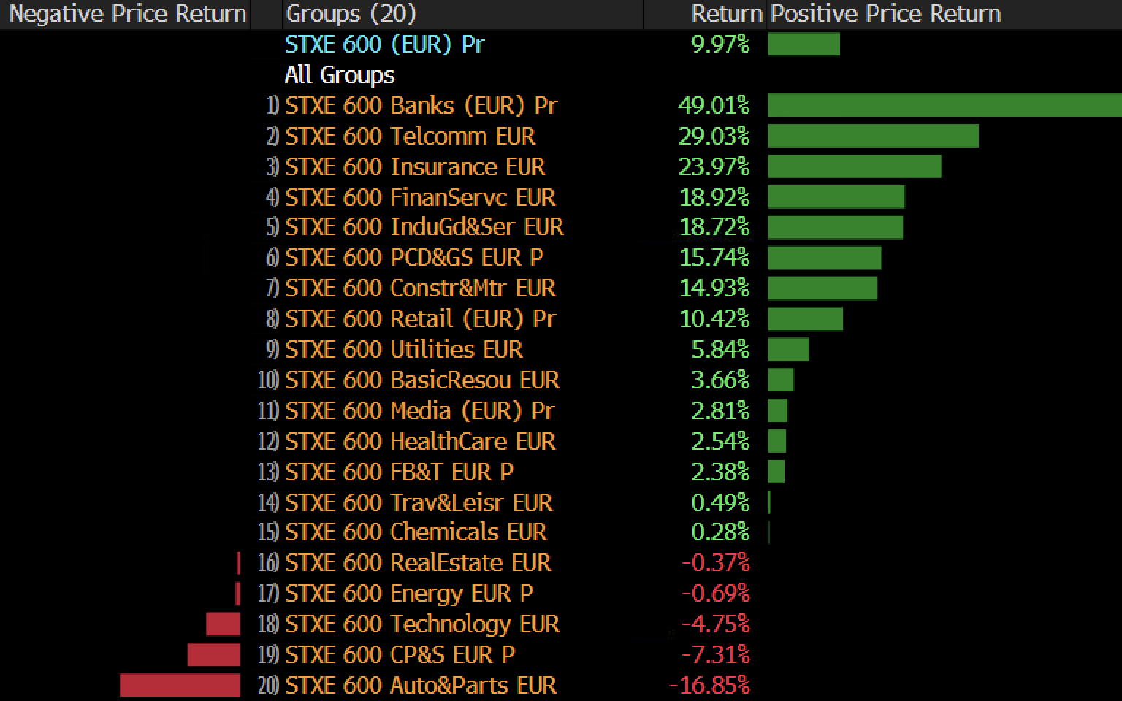

YTD

