

Science of the Total Environment 870 (2023) 162018
Contents lists available at ScienceDirect

Science of the Total Environment
journal homepage: www.elsevier. com/locate/scitotenv

Review

Anaerobic zone Functionality, Design and Conﬁgurations for a Sustainable EBPR process: A Critical Review
Parnian Izadi ^{a,}⁎, Mehran Andalib ^{b}
ª Stantec Consulting Ltd, Stantec Institute for water Technology and Policy, Waterloo, ON, Canada
^{b} Stantec Consulting Ltd, Stantec Institute for water Technology and Policy, Boston, MA, United States

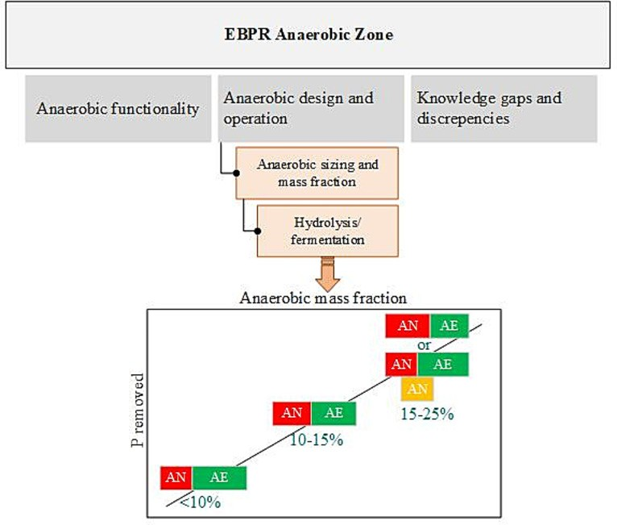
H I G H L I G H T S G R A P H I C A L A B S T R A C T

- Conventional EBPR design hold doubtful concepts to be addressed to enhance efﬁ- ciency.
- Promoting anaerobic hydrolysis and fermentation boost EBPR performance and stability.
- Diverse approach to hydrolysis is for insight gap in metabolism, design, and operation.
- Side-stream EBPR is an alternative method to promote hydrolysis and fer- mentation.
- Adequate anaerobic design may promote hydrolysis without any mediation plan needed.

A R T I C L E I N F O

Editor: Yifeng Zhang

Keywords:
EBPR
Anaerobic zone PAO
Hydrolysis and fermentation Mass fraction
Side-stream
A B S T R A C T

Stringent discharge phosphorus limits and rising urge to reach very low efﬂuent total phosphorus concentrations have challenged the available technologies to further remove phosphorus. The signiﬁcance of Enhanced Biological Phos- phorus Removal (EBPR) process may have been overshadowed by the design and operation limitations. These scarci- ties mainly root back to the lack of knowledge and understanding of fundamental mechanisms, design standards, and operational guidance. Anaerobic biomass fraction design and operation as a primary driving force for biological phos- phorus removal process is commonly outweighed by aerobic and total plant sludge retention operation and design criteria. This paper tends to critically review the different perspectives of mainstream and side-stream EBPR processes and to particularly target contrasting views on hydrolysis and fermentation rates as well as anaerobic condition imple- mentation and magnitude. Subsequently, from distinct point of views, knowledge gaps are comprehensively discussed to eventually recognize the advances and drawbacks aimed to reach a sustainable EBPR process.

Contents
- Introduction 2
- Biological phosphorus removal overview 2
- Anaerobic zone functionality 2
  - Anaerobic cycle and metabolic pathways 2
⁎ Corresponding author.
E-mail addresses: parnian.izadi@stantec.com (P. Izadi), mehran.andalib@stantec.com (M. Andalib).

http://dx.doi.org/10.1016/j.scitotenv.2023.162018
Received 23 November 2022; Received in revised form 15 January 2023; Accepted 31 January 2023 Available online 3 February 2023
0048-9697/© 2023 Elsevier B.V. All rights reserved.
- Anaerobic design and operation 4
  - Anaerobic hydrolysis and fermentation design and operation 5
    - Side-stream EBPR (S2EBPR) framework 5
    - Conventional anaerobic zone with adequate design 8
    - Conventional and side-stream EBPR practices: process design and operation 8
- Knowledge discrepancies to intuition development 11
  - Knowledge gap in fate and activity of EBPR functional populations 11
    - Is GAO competition a myth? 12
  - Knowledge gap in kinetics, stoichiometry, and process modeling 13
    - Anaerobic hydrolysis rate, how much do we know? 13
- Discussion: anaerobic zone all around 14
- Conclusion 14
Data availability 15
Declaration of competing interest 15
Acknowledgement 15
References 15

- Introduction

Enhanced biological phosphorus removal (EBPR) process is considered to be a more cost effective and environmentally sustainable alternative than chemical precipitation of phosphorus from wastewater, due to the lack of chemical utilization, less sludge wastage and susceptibility to phosphorus recovery (Chen et al., 2020; Mihelcic et al., 2003; Wang, 2018; Tooker et al., 2018; Daneshgar et al., 2018; Tomei et al., 2020). EBPR performance relies on sequential anaerobic and aerobic conditions along with various parameters including carbon availability, adequate sludge retention time, pH and temperature (Coats et al., 2021). In the absence of volatile fatty acids (VFA) EBPR systems that promote the generation of VFAs via fermen- tation of readily biodegradable COD (RBCOD) and from decay, hydrolysis and fermentation of sludge within the activated sludge system have been recognized to improve stability and process performance (Li, 2020). Not- withstanding, due to contradicting proposals on the effectiveness of well- designed conventional EBPR system, various doubtful perceptions are yet to be addressed regarding carbon source availability, anaerobic mass frac- tion and the kinetics of hydrolysis and fermentation at the presence and ab- sence of inorganic electron acceptors (Dold and Conidi, 2019). Therefore, mediation plans are introduced to overcome possible process instabilities and failures.
Side-stream EBPR (S2EBPR) as an innovative modiﬁcation and alterna- tive to conventional EBPR systems, is hypothesized to promote anaerobic bi- ological sludge hydrolysis and fermentation to address the challenges in EBPR process operation stability (Daneshgar et al., 2018; Wang et al., 2019). Although when it comes to full-scale systems, occasionally anaerobic functionality of conventional systems is overshadowed by the general overview on the design and operation of the process and conservative de- sign of the aerobic process to ensure full nitriﬁcation at different opera- tional conditions. Thus, quite commonly, conventional anaerobic zones may be undersized and inappropriately designed (Dold and Conidi, 2019). Nonetheless, the question is that if a properly designed anaerobic zone in a conventional system can help to overcome the operational and

stability challenges to reach a competing stage with novel biological nutrient removal (BNR) technologies? To aid in developing a better understanding of EBPR, this paper integrates the knowledge and observations on anaerobic zone functionality, design, and conﬁguration in EBPR systems. Investigation was conducted on carbon source availability, anaerobic mass fraction and current knowledge of hydrolysis and fermentation. This critical review portraits the technology of conventional EBPR as well as S2EBPR, to assess the signiﬁcance of anaerobic mass fraction and anaerobic hydrolysis and fermentation on metabolism, microbial pathways, as well as process design, operation, and optimization.

- Biological phosphorus removal overview

Excess biological phosphorus uptake phenomenon was initially observed back in late 1950's, but it was not until 1960's that scientiﬁc

development were slowly introduced, to deal with the vital role of phospho- rus in eutrophication of aquatic environment (Henze et al., 2008; Barnard et al., 2017). The basis of biological phosphorus removal and different EBPR plant conﬁgurations, most used up to date are all part of Barnard's re- search and evolution initiating from Bardenpho plant to more reliable P- removal systems such as 5-stage Bardenpho and Phoredox system (Seviour et al., 2003).
With the initial realization of anaerobic zone requirement for phospho- rus removal by Barnard et al. in 1974, Fuhs and Chen proposed the ﬁrst model for biological phosphorus uptake. Later, several researchers in par- ticular Comeau et al. (1986), Wentzel et al. (1986) and Mino et al. (1987) developed and improved the model by highlighting the need for VFA (acetic acid and propionic acid) as the only carbon source/substrate (Comeau et al., 1986; Fuhs and Chen, 1975; Wentzel et al., 1985; Arun et al., 1988; Metcalf and Eddy, 2003; Gebremariam et al., 2011a).
An anaerobic zone receiving the carbon and energy source incorporated with anoxic zones for controlling nitrate concentration, and subsequent aerobic phase along with biomass recycle through alternating anaerobic/ aerobic conditions have been integrated in most of the designs (Seviour et al., 2003).
Yet, the design parameters for sizing of anaerobic and aerobic basins have been subjected to a wide range of criteria and empirical values (Seviour et al., 2003; Nielsen et al., 2019; Brower, 2021). The importance and overall operation of anaerobic zone in EBPR systems has been widely recognized. Yet, its inﬂuence on the process performance is not yet fully understood and recognized in engineering design practice. Discrepancies are observed when EBPR mechanism, fate, and activity of functional groups and carbon source availability by return activated sludge (RAS) hydrolysis and fermentation rates were assessed. Therefore, EBPR technology may not meet its true potential until a profound insight of biological mechanisms including hydrolysis and fermentation, operational parameters, and kinet- ics is met.

- Anaerobic zone functionality

Successful EBPR process is dependent on identifying and understanding the factors of importance. In anaerobic zone, inﬂuent waste water (WW) characteristics and carbon substrates, anaerobic contact time, nitrate/ nitrite presence, pH, temperature, and inhibition factors all effect the phos- phorus accumulating organisms (PAO) growth and microbial competition which consequently effect EBPR performance (Zhao et al., 2021; Yuan, 2023; Oehmen et al., 2007). This work, however, tends to only target factors inﬂuencing anaerobic design, sizing and fractionation, focusing on carbon source availability and impact on hydrolysis and fermentation process.

  - Anaerobic cycle and metabolic pathways

The generally accepted theory for successful EBPR is incorporation of anaerobic conditions as a primary driving force for phosphorus release

and following internally stored polyphosphate under aerobic phase, which is known as a contact zone for carbon source uptake by PAOs in absence of inorganic electron acceptors. Various proposed metabolic models attempt to describe the chemical reactions, considering the overall activities of PAO population. It is mainly assumed every single PAO shares the same characteristics, yet it is unlikely to occur, based on the very complex ecology of EBPR (Seviour et al., 2003).
PAOs in an EBPR system are the responsible microorganisms with generally three different internal storage compounds to perform phospho- rus accumulating metabolism (PAM), polyphosphate for excess storage of phosphorus and energy production via conversion of Adenosine triphosphate (ATP) to adenosine diphosphate (ADP), glycogen and polyhydroxyalkanoates (PHA), for generation of reducing power (in form of nicotinamide adenine dinucleotide, NADH), and as carbon building blocks and additional energy production via ATP. PAOs compete with other groups of microorganisms for organic electron donors depending on the external parameters. Under polyphosphate accumulating metabo- lism (PAM) in the anaerobic zone (feast) that serves as a “selector” VFAs are taken up and through several metabolic pathways, are stored as polyhydroxyalkanoates (PHA), which is directly linked to soluble phosphate release and glycogen breakdown. In the following aerobic zone (famine), PHAs are utilized for growth, maintenance, glycogen replenish- ment and uptake of phosphate. With higher VFA sequestration, higher PAO population can be attained. The general judgement, views PAOs dominance due to their ability to thrive under the exposure to “feast- famine” conditions, with a capability to assimilate and store phosphorus, carbon and energy (Seviour et al., 2003; van Loosdrecht et al., 1997; Schuler and Jenkins, 2002).
Acetic acid has been extensively researched as the proposed sole exter-
nal substrate utilized in anaerobic zone in which polyhydroxybutyrate (PHB) is suggested as the exclusive terminal storage compound. Two models were initially hypothesized for acetate-fed EBPR with a main differ- ence on the reducing power requirement. In the Comeau-Wentzel model, NADH is hypothesized to be generated by parallel acetate metabolism through the tricarboxylic acid (TCA) cycle while the Mino model includes simultaneous intracellular glycogen consumption as a source of energy and reducing power production (Carucci et al., 1999). Later on, metabolic models were proposed accounting for various internal storage compounds and a mixture of PAOs and glycogen accumulating microorganism (GAOs), a non-PAM competing microorganism for VFAs uptake cultures shown in Fig. 1-1 (Yagci et al., 2003). Table S1, Supplemental Material, represents the overall proposed anaerobic stoichiometric reactions for PAOs with various organic electron donors. GAOs anaerobic metabolism has shown considerable similarities to PAOs in acetate-fed systems. No phosphorus proﬁle and polyphosphate accumulation/degradation are observed in GAOs anaerobically. For cross-membrane charge stabilization purposes, cations Mg²⁺, and K⁺ as metals (Me⁺) are consumed and released in appropriate ratios.
Moreover, extensive attention has been devoted to the anaerobic metab- olism of EBPR with propionate as the main substrate (Fig. 1-2). Several studies have suggested considerable selective advantage for PAOs over other heterotrophic organisms including GAOs in a propionate-fed system (Oehmen et al., 2005). The literature suggests that putative GAOs from Gammaproteobacteria class called Candidatus Competibacter Phosphatis show very slow propionate uptake while others including members of Alphaproteobacterial class are capable of propionate uptake. The high propionate-fed EBPR efﬁciency is linked to slow rate of propionate uptake by competitors in addition to less competition for acetate uptake in mixed substrate (acetate-propionate) conditions (Izadi et al., 2021). The initial propionate metabolic models focused on glycogen consumption as the source of energy and reducing power. PAOs take up and convert propionate to propionyl co-enzyme (propionyl-CoA) through energy produced from polyphosphate degradation and glycogenolysis (glycogen hydrolysis). Subsequently, orthophosphate is released, and glycogen is hydrolyzed to acetyl-co-enzyme (Acetyl-CoA) and propionyl-CoA. The co-enzymes will be reduced and converted to PHA, utilizing NADH generated by

glycogenolysis (Oehmen et al., 2005). Further research on the source of re- ducing power agreed on the TCA cycle contribution in producing reducing power besides glycolysis pathway (Majed and Gu, 2019).
Activated sludge systems face much more complex substrate composi- tion than short-chain fatty acids (SCFA) such as acetate, which can exacer- bate the complexity of carbon uptake in an EBPR process. Various studies have shown EBPR performed through substrates other than VFAs, with no pre-conversion to VFA nor storage compounds as PHA required. In these cases, the stored polymer was proposed to be mostly glycogen while the energy source was either polyphosphate hydrolysis or lactic fermentation (Carucci et al., 1999). Glucose as a carbon source that is metabolized by al- most all microorganisms, has been widely investigated for EBPR system. There are inconsistent observations on effect of glucose as carbon source for PAOs, with several studies claiming a stable EBPR performance while others report EBPR deterioration with high GAO proliferation. With contradicting views on effect of glucoseas carbon source, two models were proposed for anaerobic PAO metabolism (Fig. 1-3, Table S1). The ini- tial model proposed the presence of lactic acid producing organisms (LPO) and PAOs, where lactic acid is produced by LPOs and utilized by PAOs. Fur- ther studies lead to a more enhanced model, proposing active cytoplasmic membrane transport and phosphorylation of glucose and direct conversion of phosphorylated glucose to glycogen within the PAOs cell (Izadi et al., 2021; Wang et al., 2001; Jeon and Park, 2000). Glycogen uptake indicates the PAOs ability for hydrolysis and fermentation of substrates including the non-VFA organics.
Nevertheless, the true complexity of the system may have been dimmed by only considering speciﬁc and putative PAOs such as Accumulibacter Phosphatis. In addition to known PAOs, there are multiple reports on uncon- ventional PAOs, such as Tetrasphaera, with ambiguity in their metabolism in EBPR process (Lanham et al., 2014). Tetrasphaera as a unique trait of PAOs with three diverse clades have shown variability in metabolism and can ferment complex organic molecules including glucose, carbohydrates and amino acids which will produce stored carbon within the process. For instance, clade 1 speciﬁcally T. elongata (strain LP2 and ASP12) has shown dependence on anaerobic uptake of amino acid and glucose (similar to Fig. 1-3). While clade 2, such as T. australiensis, T. veronensis and ﬁlamen- tous “Candidatus Nostocoida Limicola, seems more diverse with substrate utilization pathways (similar to Fig. 1-4) (Nguyen et al., 2011a). Clade 3 mainly consist of uncultured strains that have not been grown in standard laboratory media and there is no designed probes to cover the sequences (Liu et al., 2019a; Marques et al., 2017). Generally, Tetrasphaera's fermenta- tion capability is hypothesized to allow them to survive in more dynamic environment and favor EBPR stability by producing VFA including succinate, lactate, and propionate supply to Accumulibacter. Polyphosphate intracellular storage has been found in all isolates. As proposed in Fig. 1-4, PHA while of vital inﬂuence in conventional PAOs, is not the only polymer cycled and stored in Tertrasphaera, instead likely other fermentation products are anaerobically stored. Studies have shown the presence of PHA in some Tetrasphaera isolates of clade 2. The energy generated from fermentation of these substrates accounts for almost all energy required for P-uptake, glycogen production and anaerobic maintenance. Suggesting anaerobic Poly-P hydrolysis is not necessary to occur, which may be the reason for minimal P-release observed in different cases. With higher ability to ferment and produce VFA, longer uptake period, and exposure, Tetrasphaera further contributes to EBPR functional redundancy and stabil- ity (Barnard et al., 2017; Kristiansen et al., 2013; Close et al., 2021).
In general, various anaerobic uptake and storage of substrates may be
supportive of or harmful to EBPR, which necessitates deeper insight on the mechanisms to improve design and operation of EBPR plants (Gebremariam et al., 2011b; Izadi et al., 2020). Not only the known PAOs but other groups of microorganisms have been identiﬁed for polyphosphate storage. Isolates of ﬁlamentous bacteria “M. Parvicella” which are morphol- ogically deﬁned as gram-positive ﬁlaments are known for their versatile and adaptive characteristics to various operational conditions (Mcilroy et al., 2013). The slow growth, high climate tolerance and competence for carbon substrates in unbalanced growth conditions makes M. Parvicella

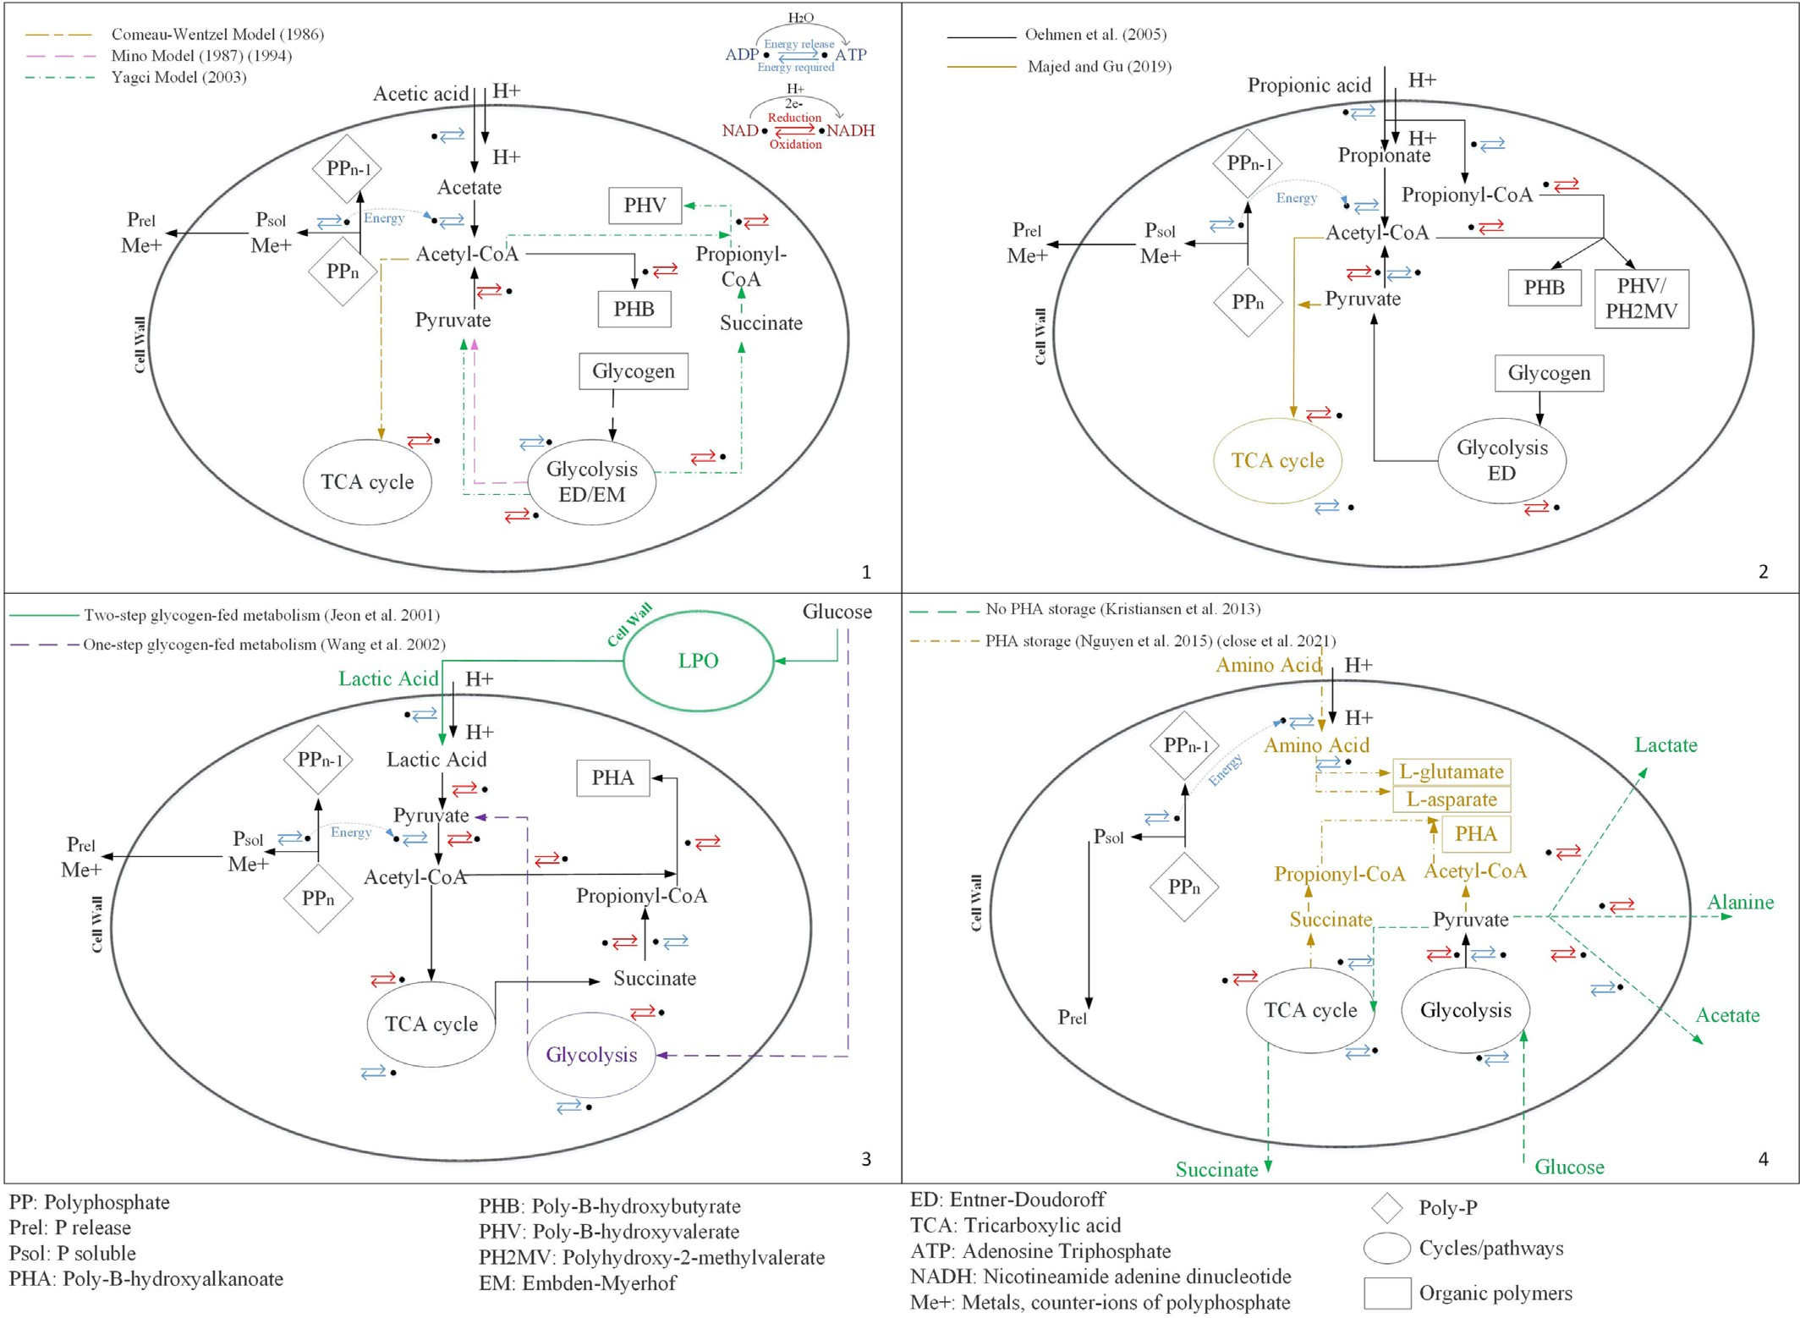

Fig. 1. Schematic description of anaerobic metabolism in 1. Acetate-fed PAO 2. Propionate-fed PAO 3. Glucose-fed PAO 4. Tetrasphaera isolates.

suited for anaerobic/anoxic/aerobic sequences in BNR. M. Parvicella has shown ability of polyphosphate storage with lipid uptake as a source of energy which can eventually contribute to P-removal (Fig. 2). Yet with all the research effort only basic information is available on the metabolism of M. Parvicella with many missing points such as its signiﬁcance and role in polyphosphate storage, the energy source for carbon source (lipid) uptake/storage and overall metabolic potential (Mcilroy et al., 2013).
As mentioned, the models explaining EBPR anaerobic metabolism have been subject of much debate. All metabolic models tend to include the gen- eral features of PAOs uptake, storage and utilization proﬁle but are differen- tiated by various key metabolic reactions not to mention the non-PAO metabolisms that take part in BNR (Nielsen et al., 2019). Therefore, the his- torical understanding of EBPR microbiology have changed through time by not only relying on PAOs capability to uptake VFA but to understand the hydrolysis and fermentation capacity of fermentative PAOs and other abun- dant fermenters. While the fermenters compete for sugars and amino acids, the commonly known PAOs compete for fermentation by-products such as VFAs (Nielsen et al., 2019). Yet, obtaining a thorough understanding of the metabolic potential and expand on the available existing information will be beneﬁcial for EBPR commercial applications.

- Anaerobic design and operation

Traditionally accepted a successful EBPR process relies on the character- istics of the inﬂuent wastewater, principally adequate RBCOD and VFA to phosphorus and nitrogen ratios. Assuming a cell yield of 0.3 g VSS/g acetate for PAOs, an average cell phosphorus content of 0.3 g P/g VSS and
fermentation yield of 1.06 g acetate/g biodegradable soluble COD (bsCOD) with low biomass yield for fermenters, about 10 g RBCOD will be stoichiometrically required to remove 1 g of phosphorus by the biologi- cal storage mechanisms (Metcalf and Eddy, 2003). Mainly the COD/N and COD/P ratios are used as empirical indexes for indicating the carbon bal- ances for every process to satisfy the stoichiometric requirements. (Ubay- Cokgor et al., 2005). Generally, a wide range of COD/P ratio, as high as 40 COD g/g P, is reported as the amount required for phosphorus removal, with less emphasizes on the type of carbon. The VFA/P ratio of 6 to 14 g VFA/g P is commonly accepted as the required range to remove phospho- rus. Since it is assumed that majority of RBCOD is converted to VFA, the VFA concentration shall not be the concern while a minimum ratio of 16:1 for RBCOD:P is demanded for achieving low level efﬂuent P concen- trations (Barnard and Abraham, 2006). it is noteworthy that designing EBPR processes with low anaerobic zone retention time has not been an un- common engineering practice and tends to rely mostly on the available VFAs and also the fermentation of the RBCOD, rather than leveraging the hydrolysis and fermentation of more complex organic substrates. Some re- searchers suggest that these conventional conﬁgurations likely accepted for EBPR, select for less efﬁcient PAOs while alternative conditions such as S2EBPR may allow the proliferation of other PAOs (Barnard, 2014).
The design of anaerobic zone is based on advantaging PAOs in their uptake and storage of carbon. While the aim and importance of this matter is well-understood, the design speciﬁcs and parameters can be incompati- ble. Therefore, in the design of anaerobic zone there is still uncertainty regarding the size of the basin and if it is better described by HRT expressed as anaerobic mass fraction or other operational parameters such as ORP.

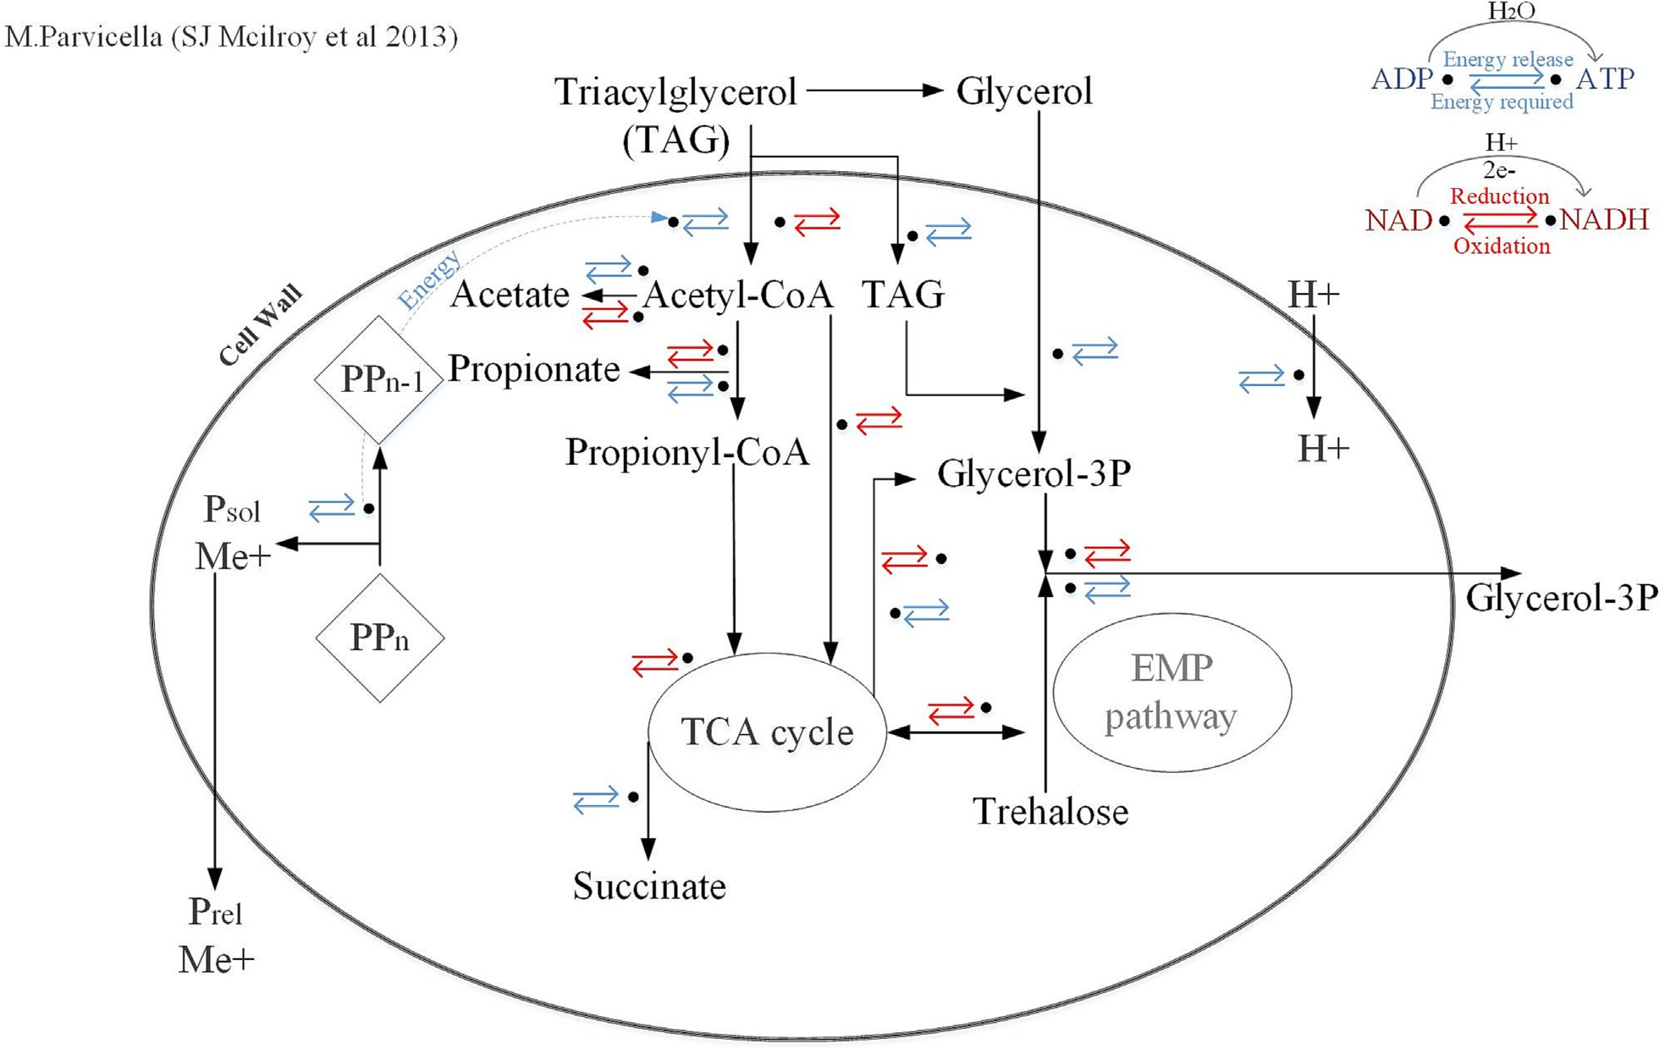

Fig. 2. Metabolic Model of M. Parvicella in EBPR activated sludge.

Many conventional BNR systems have an anaerobic mass fraction of less than 10 %, where too little anaerobic exposure ends in limited an- aerobic phosphorus release and lower P-removed in value (Barnard et al., 2017).
Processes involving sludge hydrolysis and fermentation with either inﬂuent substrate or RAS fermentation are claimed to enhance EBPR by increasing the anaerobic mass fraction. As a recommendation, RAS fermentation conﬁguration has been widely studied and implemented for increased anaerobic contact time with improved PAO enrichment (Barnard et al., 2012). It is also claimed that RAS fermentation picks for organisms with higher afﬁnity for fermentation which increases P- removal performance. The importance of reaching an ORP value of
−300 mV and below, also called “deep anaerobic” zone, a terminology used in the literature for environments with low ORPs, implies the im- portance of attainting adequate hydrolysis and fermentation under an- aerobic condition to ensure sustainable enhance phosphorus removal (Nguyen et al., 2011a; Barnard and Abraham, 2006).
On the other hand, it is proposed that a well-designed anaerobic basin provides all the beneﬁts that a RAS hydrolysis and fermentation process can offer. Well-established EBPR systems have shown that VFA generation through decay, hydrolysis and fermentation of sludge biomass within the activated sludge system shall promote phosphorus removal (Barnard, 1975). Providing the speciﬁc parameters for an opti- mal anaerobic state is the key element. An anaerobic mass fraction of 15–25 % with an anaerobic HRT of 0.5–4 h are mainly declared as re- quired parameter for a healthy anaerobic zone. Yet despite this proposi- tion, speciﬁc process implementation is occasionally lacking for EBPR process design and operation. For instance, the application of ORP is mainly described for RAS fermentation process and not accordingly ap- plied for standard anaerobic reactor design (Brower, 2021). And most conventional systems show inability to reach a “deeper” anaerobic con- dition with low ORP levels due to overmixing, addition of excessive amount of primary efﬂuent to anaerobic zone, or general design failure due to under-sizing (Barnard et al., 2016).
  - Anaerobic hydrolysis and fermentation design and operation

Insufﬁcient RBCOD in the inﬂuent WW to reach the strict efﬂuent total phosphorus and nitrogen standards is traditionally viewed as the limiting factor for design and operation of biological phosphorus re- moval (BPR) processes and the main driver of supplementing additional carbon by either adding soluble organic compound or generating inter- nal VFA/RBCOD (Houweling et al., 2010). Organic carbon addition increases the operational cost and sludge production, which is not favor- able due to high cost of disposal (Ucisik and Henze, 2008). Therefore, promotion of biological hydrolysis and fermentation seems to be a promising approach to ensure a sustainable carbon availability for PAOs, to comply with the low efﬂuent phosphorus limits as well as attain a lower sludge yield.

    - Side-stream EBPR (S2EBPR) framework
In most conventional plants, the required RBCOD for EBPR is supplied by the incoming wastewater relying on the inﬂuent organic carbon. There- fore, when the wastewater contains insufﬁcient organic loads, there is a need for organic substrate addition or a method to increase the levels of VFA. Biological hydrolysis of activated sludge, results in formation of degradable organic substrates, which are an attractive source of carbon for nitrogen and phosphorus removal (Andreasen et al., 1997). It is also suggested that hydrolysis and fermentation of activated sludge in anaerobic zone may be encouraged by speciﬁc microorganisms. This provides a potential for running simultaneous nitrogen and phosphorus removal without creating a competing environment for RBCOD (Barnard et al., 2017).
Production of carbon source from hydrolysis and fermentation of solids either the primary sludge (PS), the mixed liquor suspended solids (MLSS) from anaerobic/anoxic zones, or the return and waste activated sludge (RAS and WAS), tends to improve biological nutrient removal. The fermentation of the sludge biomass within the activated sludge (AS) however, is more complicated compared to primary sludge due to biomass decay and phosphorus and nitrogen release prospect (Houweling et al., 2010).

      - Side-stream EBPR past and present operational experiences. Based on the historical events gathered in the literature, the course of S2EBPR tech- nology development timeline is summarized and presented in Fig. 3. One of ﬁrst attempts on sludge hydrolysis and fermentation dates to 1977, where primary sludge fermentation was implemented in Kelowna and Okanagan Lake, BC, Canada to full-scale plants to overcome cold climates and low VFA availability. In that study, the fermenter supernatant of the

primary sludge holding tanks streamed to the anaerobic zone, while primary efﬂuent passed to anaerobic and anoxic zones (Barnard et al., 2017). In 1985, a pilot-scale study, in Daspoort, Pretoria, South Africa, observed the hydrolysis and fermentation of mixed liquor in an unmixed “dead zone”, resulting in the generation of VFAs, where the ability of PAOs to survive and ﬂourish in “deep anaerobic zones” were detected (Barnard et al., 2017). Orange Water and Sewage Authority (OWASA),

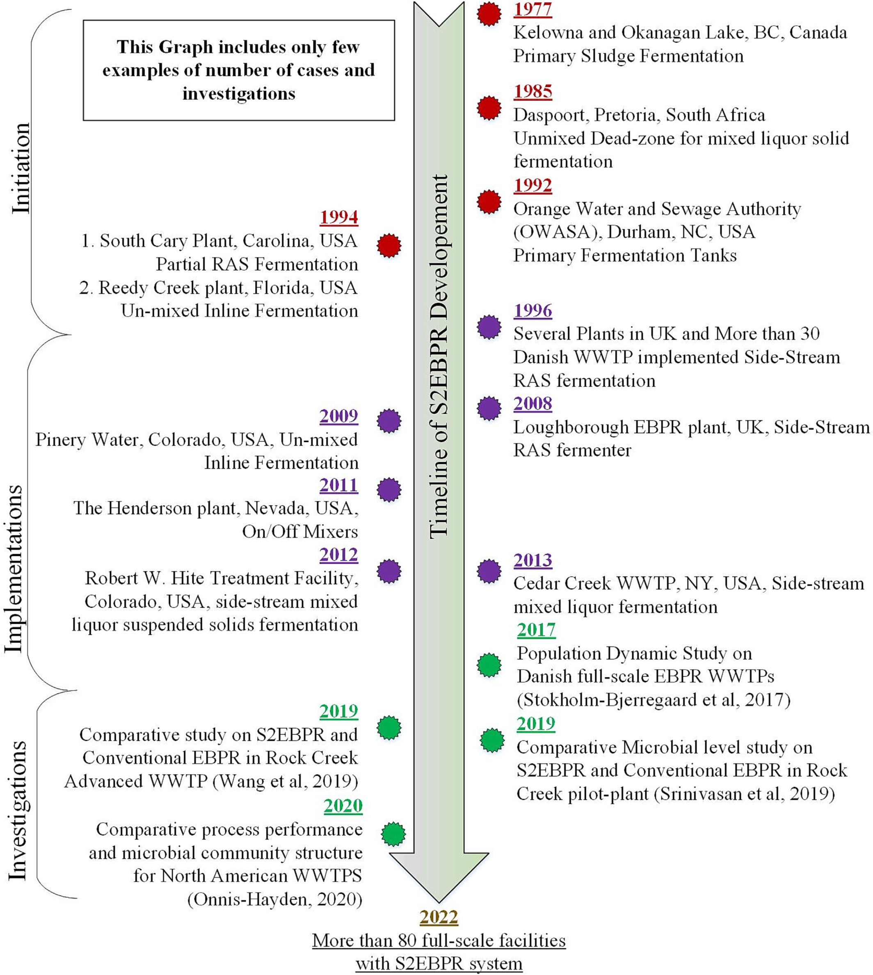

Fig. 3. Timeline of S2EBPR initiation, implementation, and investigations.

NC, USA was then upgraded and transformed from trickling ﬁlter to EBPR system with primary fermentation tanks (contact with RAS) back in 1992. Within the same era, South Cary, NC, USA plant was also upgraded to include partial RAS fermentation (Lamb, 1994). In addition, Reedy Creek plant, FL, USA and later Pinery Water, CO, USA applied unmixed inline fermentation (UMIF) described in Section 4.1.1.2. resulting in successful P-removal (Sedlak, 2018).
Since 1996, more than 30 Danish plants have implemented side-stream RAS hydrolysis and fermentation from the clariﬁer to go through anaerobic hydrolysis (Vollertsen et al., 2006). Denmark typically faces low levels of VFAs in raw wastewater with a RBCOD of 150 mgCOD/L but a VFA of lower than 1 mg/L, in which EBPR tends to rely on other forms of RBCOD or on hydrolysis and fermentation that takes place in anaerobic condition. In Denmark S2EBPR cases, a portion of returned activated sludge (about 6 %) is recycled through side-stream fermentation process for roughly 48 h to decay, hydrolyze and ferment biomass and prevent the growth of methanogens. Further studies on Denmark side-stream EBPR plants, indicated a high abundance of Tetrasphaera suggesting its important role in fermentation and VFA production. The higher abundance comparing to other putative PAOs might have been related to its nature of fermenting complex organics, therefore, longer anaerobic residence times are beneﬁ- cial (Nguyen et al., 2011b).
Up to date, S2EBPR has been widely implemented world-wide with more than 80 full-scale facilities (60 plants in Europe, 13 in U.S, 2 in Canada, one in India and four in Australia) running with modiﬁed conﬁgu- rations that in essence involves an enhanced anaerobic zone with biological sludge hydrolysis and fermentation to address the challenges regarding inﬂuent wastewater and process stability (Onnis-Hayden et al., 2020; Gu, 2019), especially under wet weather conditions when the possible washout of PAOs is mitigated.

      - S2EBPR design and conﬁgurations. Production of VFA on-site is a common practice worldwide. In PS hydrolysis and fermentation, pre- fermenter called side-stream pre-fermenters are mainly fed with primary sludge. The phrase “primary sludge” is called for the concentrated underﬂow of the primary clariﬁer that will be held for several days in pri- mary sedimentation tanks for fermentation process to occur. Operational conditions to consider include SRT, HRT and pH. A SRT of 3–5 days in warmer temperature and 4–8 days in colder months, and an acidic pH below 6.5 are desirable. Then the supernatant will be discharged to the anaerobic zone while the sludge is moved to anaerobic digestion process. There are various conﬁgurations in use including activated primary sedi- mentation tanks, complete mix fermenters, single-stage static fermenter/ thickener, two-stage mixed fermenter/thickener, uniﬁed fermentation and thickening fermenter. PS fermentation, however, may not be always reliable due to longer residence times and higher temperatures in sewer systems (Ferguson, 2019).
Secondary sludge fermentation on the other hand takes place when a portion of RAS or mixed liquor is fermented for excess RBCOD and VFA formation and then returns to the mainstream process. The reactors may be designed within the mainstream or as a side-stream process. In the side-stream process an anaerobic reactor is employed for additional RBCOD production by cell lysis to promote P-uptake by recycling the over- ﬂow liquid to mainstream (Zhang et al., 2017). Another alternative is WAS fermentation, where mostly bacterial mass is hydrolyzed and fermented. WAS must perform cell lysis through hydrolysis prior to fermentation process, thus it requires longer periods comparing to primary sludge fer- mentation (Ferguson, 2019). Additionally, side-stream processes may be an attractive method for P-recovery, in forms of struvite and brushite for commercial use as fertilizers (Daneshgar et al., 2018; Daneshgar et al., 2022). A study by Gu et al. (Narayanan et al., 2014), showed a conversion of a high-rate Pho-strip plant to a high-rate Phoredox plant with a side- stream fermentation of a part of the RAS. Approximately 15 % of the RAS was fermented in the fermenter (stripper), where both the underﬂow and supernatant of the fermenter were returned to the anaerobic zone. With

no nitrate production and low aerobic SRT, the efﬂuent soluble phosphorus was reduced to less than 0.1 mg/L.
RAS/WAS fermentation have lower COD and VFA yields compared to primary sludge fermentation regardless of the sludge origin. In a study by Andreasen et al. (Andreasen et al., 1997), it was indicated that hydrolysis and fermentation of primary sludge (PS) at ambient temperature yields to 9–16 SCOD to TCOD ratio while this amount decreases to 2.5 % for RAS hydrolysis and fermentation in the same operating conditions. Yet due to substantial amount of activated sludge production in wastewater treatment plant (WWTPs), still considerable amount of VFAs is produced by RAS hydrolysis and fermentation (Ucisik and Henze, 2008).
Furthermore, the mixed liquor fermentation can be differentiated from RAS/WAS hydrolysis and fermentation through the allowance of sludge to settle and accumulate in the side-stream reactor or the mainstream which results in decay, hydrolysis, and fermentation of settled sludge. A simpliﬁed version of various S2EBPR conﬁgurations are depicted in Fig. 4 (Tooker et al., 2018; Barnard, 2014; Houweling et al., 2010).
Various side-stream technologies applying secondary sludge and mixed liquor fermentation are currently in use worldwide. Table 1 summarizes number of pilot and full-scale S2EBPR plants layouts and operational spec- iﬁcations. Side-stream RAS fermentation (SSR) as the most common S2EBPR conﬁguration operating in Denmark and the UK, performs with a small RAS portion of about 4 to 7 % in a side-stream reactor for a period of 16 to 48 h (Vollertsen et al., 2006; Vale et al., 2008).
The side-stream RAS fermentation with supplemental carbon (SSRC) has mostly been pilot-tested and also implemented in a few full-scale treatment plants.
In the side-stream mixed liquor suspended solids fermentation (SSM), around 5 to 15 % of the anaerobic Mixed liquor suspended solids (MLSS) is redirected to side-stream reactor with intermittent mixing for an HRT of 5–15 h and SRT of about 2 days. The supernatant is then going back to the anaerobic and anoxic zones in the mainstream.
In the UMIF, mixing is reduced or completely omitted in mainstream anaerobic zone which decouples anaerobic SRT and HRT to enhance fer- mentation in the settling zone (Gu, 2019). Intermittently mixing unaerated zone in the UMIF conﬁguration allows for accumulation at the bottom of the reactor which promotes the hydrolysis and fermentation in the reactor and seems to be a straightforward operational strategy with minimal pro- cess changes. However, occasional mixing is required to prevent continual solid accumulation on the ﬂoor or corners of the basin. Performing a side- stream process with a sludge blanket enables a longer SRT without consid- erable volume increase. However, the effectiveness of such strategy may differ case by case and upon the nominal anaerobic mass fraction of the process (Houweling et al., 2010).
For instance, Pinery Wastewater plant in Colorado, USA with 1.6 MGD capacity was initially designed as a 5-stage Bardenpho plant with no pri- mary settling tank or fermentation. With very limited RBCOD available in the inﬂuent, low phosphorus removal was observed. Adjustments to one of the anaerobic zones (second of the two) to intermittent mixing with 5 to 10 min daily mixing for solid compaction prevention, resulted in less than 0.5 mg P/L in the efﬂuent (Barnard et al., 2012). Operating an UMIF zone in The Henderson Wastewater Plant, Nevada, USA with an average ﬂow of 21.5 MGD also aided to reach an average less than 0.03 mg P/L in efﬂuent. In the settlement process, hydrolysis and fermentation occurs in the settled sludge. The incoming mixed liquor slides over the settled sludge that is going through hydrolysis and fermentation. With no mixing, the VFA formed through fermentation of mixed liquor in the bottom is transferred to the ﬂoating mixed liquor (Barnard et al., 2012).
Generally, with all the proposed beneﬁts related to side-stream EBPR, the bio-chemical mechanism and microbial ecology behind the process is still quite unclear (Onnis-Hayden et al., 2020). Moreover, there are limited comparative studies that focuses on S2EBPR processes and conventional systems in parallel to understand the advantages, drawbacks, and potential future developments. Yet few recent studies have focused on comparative EBPR activities, rates, and microbial populations between S2EBPR and con- ventional systems. The results of various studies in pilot or full-scale

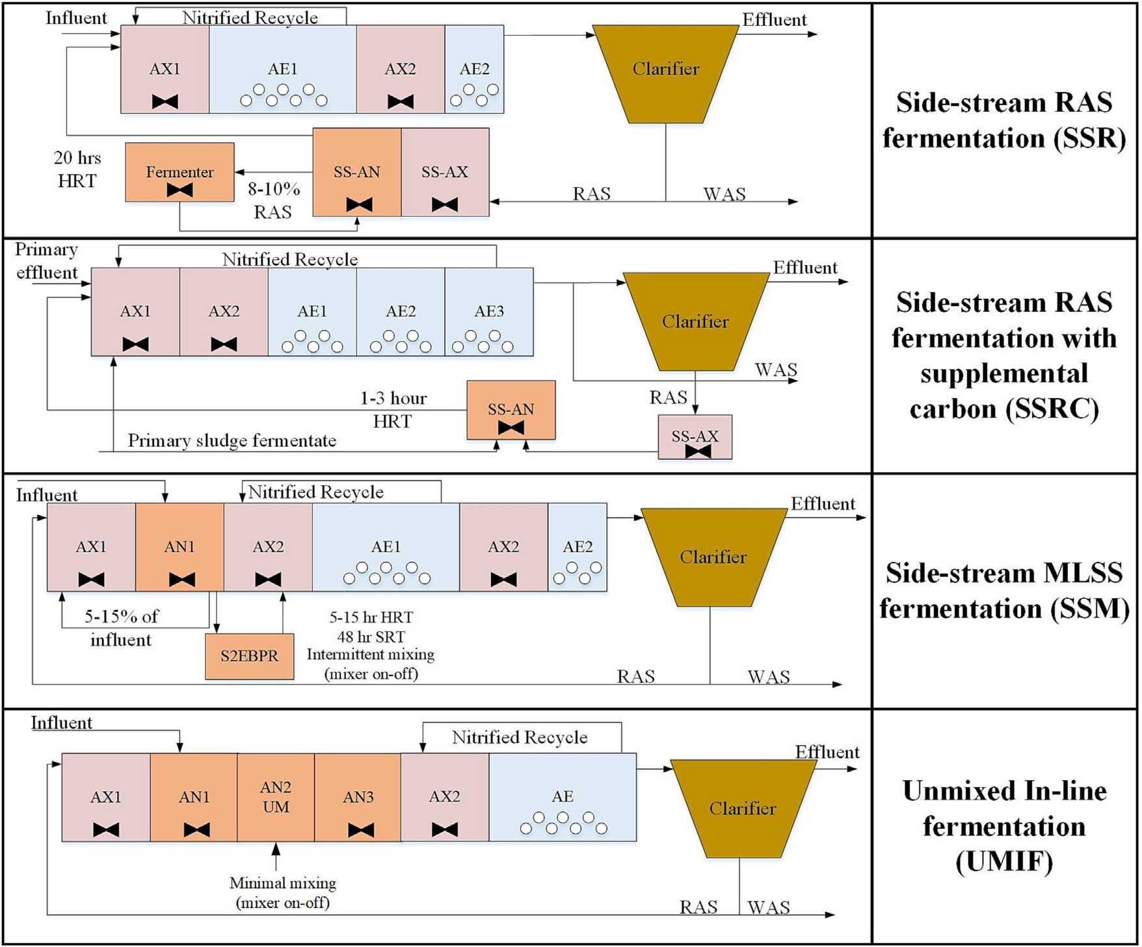

Fig. 4. Conﬁgurations of S2EBPR biological treatment processes.

systems have been contradictory in terms of microbial population and eco- logical structure. In a study on 20 Danish WWTPs, low levels of Tetrasphaera and Accumulibacter were identiﬁed while other studies observed higher abundance of both Tetrasphaera and Accumulibacter in S2EBPR systems (Onnis-Hayden et al., 2020; Stokholm-Bjerregaard et al., 2017).
These matters hamper the wider application and implementation of S2EBPR worldwide. Elucidating the P-removal performance and microbial community structure aids in enhancing the system's design and operation for further application (Onnis-Hayden et al., 2020).

    - Conventional anaerobic zone with adequate design
EBPR is an effective process for achieving phosphorus removal in WWTPs. However, occasionally there is an industry perception that con- ventional EBPR performance is not reliable and stable, and it take various process “enhancements” as mediation factor to reach the desired reliability level (Dold and Conidi, 2019).
It is an indication of good BPR in which the VFA is produced through decay, hydrolysis and fermentation of sludge biomass in AS systems (Houweling et al., 2010; Hu et al., 2012). Reaching efﬁcient BPR produces high quality efﬂuent along with less carbon footprint and operational cost. (Houweling et al., 2010). Yet, it is perceived that conventional systems can- not support the required carbon source for reaching low level P-efﬂuents. Modifying the system by implementing changes such as RAS fermentation or intermittent mixing improves P-removal.
Dold et al. (Dold and Conidi, 2019) though, suggest that standard EBPR conﬁgurations can reach high P-removal if designed properly. Adequate an- aerobic design allows for hydrolysis of slowly biodegradable particulate COD (Xsp) along with inﬂuent RBCOD and VFA availability. Therefore, it is believed that VFA availability still drives EBPR. It is best to take into
consideration that Xsp hydrolysis is a slow rate process, immediately avail- able in the anaerobic zone and mediated by heterotrophic organisms. Therefore, higher mixed liquor concentration increases the hydrolysis rate. To support and promote the Xsp hydrolysis though, an adequately sized anaerobic zone is needed, otherwise the fermentation process may not be complete (Wentzel et al., 1990).
When it comes to EBPR anaerobic zone sizing there are very few guide- lines that are available. Based on a comprehensive study by Water Research Commission WRC (1984) (University of Capetown and City Council of Johannesburg and CSTR- WRC Report, 1984), the raw COD strength in mu- nicipal wastewater indicates the required anaerobic mass fraction in which high-strength WW requires a 10 to 15 % while low strength WW needs at least 20 % of anaerobic mass fraction. A mass fraction of 15–20 % supports medium strength wastewaters. Essentially the sizing is dependent on the overall SRT of the process. An example of reliable conventional EBPR plant is the Southwest Water Reclamation Facility, Petersburg, Florida, USA. The anaerobic/aerobic conﬁguration with 24 % of anaerobic mass fraction reaches an efﬂuent total inorganic nitrogen and total phosphorus of 0.2 mgN/L and 0.5 mgP/L respectively (Onnis-Hayden et al., 2020).
However, when it comes to BNR systems that must support various pro- cesses, the SRT of anaerobic zone is frequently overshadowed by the aero- bic SRT and the plant size. Therefore, in many cases undersized un-aerated zones cannot support a reliable PAO growth (University of Capetown and City Council of Johannesburg and CSTR- WRC Report, 1984).

    - Conventional and side-stream EBPR practices: process design and operation
To date, various aspects of EBPR has been studied in detail, however
little effort has been drawn to the sizing of anaerobic zone. Most available

Table 1
Summary of conditions and performance for pilot and full-scale S2EBPR systems (Vollertsen et al., 2006; Gu, 2019).
Facility Location  [Reference] | S2EBPR  conf. | Temp. (°C) | Chemical P removal | Flowrate (MGD) | Side-stream mixing | Anaerobic Mass Fraction Addition | SRT  (summer) (day) | SRT  (winter) (day) | Average inf. TP (mg/L) | Average inf. COD/P ratio | Average eff. TP (mg/L)
Lamb 1994 – | SSR | 21–33^{b} | No | 8 | continuous | 19 % | 13^{d} | 13^{d} | 2.63–4.17^{f} | 40^{g} | 0.2–0.29
Pilot-study (Lamb, 1994)
Aalborg East Denmark | SSR | 8–18 | No | 11 | continuous | 9 % | 20–25 | 25–30 | 8.6 | 78 | 0.38
(Vollertsen et al., 2006)
Aalborg West Denmark | SSR | 10–18 | Yes | 13.2 | continuous | 9 % | 20–25 | 25–30 | 4.9 | 65 | 0.27
(Vollertsen et al., 2006)
Skive Denmark | SSR | 8–18 | No | 2.05 | continuous | N/A | 20–25 | 25–30 | 5.7 | N/A | 0.89
(Mielczarek et al., 2012)
Ega Denmark | SSR | 10–18 | No | 5.8 | continuous | N/A | 20–25 | 25–30 | 8.8 | 66 | 0.18
(Mielczarek et al., 2012)
Loughborough 3^{j}
UK | SSR | 16^{b} | Yes-Iron | 6.3 | continuous | 10 % | 12^{d} | 12^{d} | 7.3 | 43.1;11.8^{h}

(Vale et al., 2008) |  |  |  | Salts
Randers | Denmark | SSR | 9–18 | Yes | 5 | continuous | N/A | 25–30 | 30–35 | 5.6 | 89 | 0.39
(Gu, 2019)
Ringkobing | Denmark | SSR | 9–13 | Yes | N/A | continuous | N/A | 25–30 | 30–35 | 4.6 | 70 | 0.16
(Mielczarek et al., 2012)
Soholt | Denmark | SSR | 9–17 | Yes | 2.45 | continuous | N/A | 20–25 | 25–30 | 17 | 59 | 0.12
(Mielczarek et al., 2012)
Viby | Denmark | SSR | 8–17 | No | 6–8 | continuous | N/A | 20–25 | 25–30 | 6.7 | 40 | 0.22
(Mielczarek et al., 2012)
Aby | Denmark | SSR | 12–20 | Yes | N/A | continuous | N/A | 20–25 | 25–30 | 8.6 | 42 | 0.28
(Mielczarek et al., 2012)
McDowell Creek | USA | SSM | N/A | N/A | 5 | continuous-1 | N/A | N/A | N/A | N/A | N/A | N/A
(Tremblay et al., 2005)  Sacramento Regional | USA | SSM | N/A | No | 0.2^{c} | h/day  10 min/day | N/A | N/A | N/A | N/A | N/A | N/A
(Gu, 2019)  South Cary | USA | SSR | 21.8ª | No-can add | 5.2 | continuous | 16 % | 7.3e | 7.3e | 7.1 | 39^{i} | 0.43
(Gu, 2019)  Westside Regional | Canada | SSRC | 17.2ª | Ferric sulfate  Yes-Alum | 2.6 | continuous | 15 % | 10e | 10e | 7.7 | 38.4 | 0.06^{k}
(Gu, 2019)  Cedar Creek | USA | SSM | 16.2ª | No-can add | 2.95 | N/A | 19 % | 13e | 13e | 2.7 | 102 | 0.82
(Gu, 2019) |  |  |  | Ferric
Henderson East | USA | UMIF | 24.4ª | Chloride  Yes-Ferric | 20.9 | N/A | 4 % | 5.2e | 5.2e | 5.7 | 46.5 | 0.45^{k}
(Gu, 2019)  Henderson West | USA | UMIF | 24.4ª | Chloride  Yes-Ferric | 20.9 | N/A | 3 % | 6.5e | 6.5e | 5.7 | 46.5 | 0.46^{k}
(Gu, 2019) |  |  |  | Chloride
ª Wastewater temperature (°C).
^{b} Average temperature (°C).
^{c} Pilot-scale.
^{d} Average aerobic SRT.
^{e} Average SRT.
^{f} Primary efﬂuent TP concentration.
^{g} Primary efﬂuent BOD/TP.
^{h} RBCOD/TP.
^{i} BOD/P.
^{j} Secondary efﬂuent, 1 mg/L improvement from conventional system.
^{k} Orthophosphate, secondary efﬂuent.

information is based on experience gained through observation. Yet, one very detailed study focusing on the importance of anaerobic zone, dates back to early 90's (Wentzel et al., 1990). This study covered a wide range of EBPR conﬁgurations, SRTs, anaerobic mass fractions and inﬂuent WW characteristics. The feature that makes this study highly valuable is the ex- cess phosphorus input that clearly shows the actual potential of P-removal systems. As shown in Fig. 5, ﬁve different conﬁgurations including 3-stage Bardenpho, Phoredox, Johannesburg (JHB), University of Cape Town (UCT) and Modiﬁed UCT (MUCT) were tested. For the sake of this review and comparison with WRC study, 8 full-scale S2EBPR treatment plants and one conventional full-scale EBPR process with adequate anaerobic mass fraction sizing are also included in (Fig. 5). Phosphorus response as TP removed per inﬂuent COD was evaluated based on mass fraction and SRT. Fig. 5a indicates a general linear increase in phosphorus re- moval with increasing the anaerobic mass fraction. Considering the con- ﬁgurations, UCT has shown a clear improvement in P-removal with changing the anaerobic mass fraction from 10 % to 40 %. Phoredox was only tested at high anaerobic mass fraction of 50 %, showing
enhanced P-removal. MUCT however, was only experimented at anaer- obic mass fractions lower than 25 % but indicating high P-removal even at relatively lower anaerobic mass fractions of 10–15 %. As shown in Fig. 5b, a wide range of SRT was tested from 3 to 25 days. As demon- strated, very long SRTs generally should be avoided, as longer SRTs de- crease P-removal due to lower removal by P-synthesis in WAS, leaving higher amounts of phosphorus to be discarded in the mainstream (Dold and Conidi, 2019).
Despite these data, many WWTPs have an anaerobic mass fraction of about 10 % or lower which seems to be inadequate with low to medium strength inﬂuent WW characteristics. This is where mediating methods such as S2EBPR come into play to aid with improved process performance by promoting the overall anaerobic mass fraction. As previously men- tioned, it is claimed that RAS fermentation in side-stream conﬁguration re- duces the impact of inﬂuent ﬂuctuation while the only source of VFA production in this case is biomass decay, if the only available anaerobic zone is on side-stream. Whereas the inﬂuent includes a combination of VFA, RBCOD and slowly biodegradable COD that are not available in

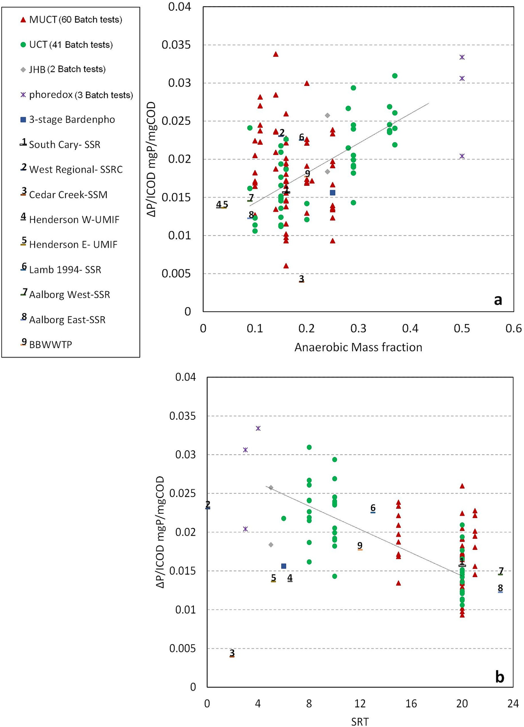

Fig. 5. Mass fraction and SRT effect on P removed (Dold and Conidi, 2019; Gu, 2019; Wentzel et al., 1990).

fermentation zone. Therefore, it is still questionable whether a RAS fermen- tation process could compete with a properly designed EBPR system (Dold and Conidi, 2019; Barnard et al., 2017).
Not all eight S2EBPR facilities shared in our analysis included an anaer- obic zone in the ﬁrst place nor excess phosphorus input was available for the testing period. The results may not be easily interpreted the same way

of conventional systems due to considerable differences in inﬂuent waste- water characteristics, retention times, conﬁguration, and operation. As an example, Cedar Creek facility represented as point 3 in Fig. 5, has shown limited ΔP (TP removed)/ICOD (inﬂuent COD) ratio. This is because of low inﬂuent phosphorus concentration of less than 3 mg/L rather than a low P-removal efﬁciency (Gu, 2019).
Generally, though, this work indicated improved performance at the full-scale and pilot-scale with implementation of side-stream technol- ogy. Almost all plants have shown higher P-removal with increasing the anaerobic mass fraction (the S2EBPR anaerobic mass fraction shown in Fig. 5 is the increased amount from conventional system to side-stream conﬁguration). Adding the side-stream technology pro- vided VFA generation by RAS fermentation, additional to the VFA and RBCOD available in inﬂuent. The extended anaerobic condition which increases the anaerobic mass fraction tends to favor PAOs as a selector zone. However still, the complexity related to operation and mechanism involved is rather unknown.
Bonnybrook wastewater treatment plant located in Calgary; Canada was also investigated as a conventional mainstream EBPR. This plant in- cludes four secondary treatment sections. The newly enhanced, Second- ary D as a BNR plant (no chemical addition) has an anaerobic mass fraction of approximately 17 % (does not include side-stream technol- ogy) (Izadi et al., 2022). Secondary D can be facilitated with additional carbon if required but the performance results of the plant has shown very low dependence on external carbon to reach low Efﬂuent-P concen- trations. This plant has shown an effective P-removal of 0.018 mgP/ mgCOD inﬂuent without implementation of any mediation plans. The SRT of the system was kept at 10–12 days with an average yearly tem- perature of 15 °C and low temperature of 10 °C, known as a cold climate WWTP. This underlines the importance of anaerobic zone design in TP removal performance (Izadi et al., 2022).
The results of Fig. 5 reiterate the importance of anaerobic zone sizing and mass fractionation in the design of the total plant where instances of well-designed conventional EBPR systems with proper factors in effect can reach high removal efﬁciencies in the same magnitude of novel BNR processes such as S2EBPR. More speciﬁcally these studies point out:
- Importance of anaerobic mass fraction. Anaerobic sludge mass fraction of 15 % to 25 % is optimal to reach effective P-removal of 0.02 mgP/ mgCOD inﬂuent. Anaerobic mass fraction shows a linear positive corre- lation with P-removal (Dold and Conidi, 2019).
- SRT shows a linear negative correlation with P removal, considering the minimum SRT requirement for EBPR (approximately 3 days). Longer SRTs result in less P removed in the mainstream EBPR.
- S2EBPR results fall into the same trend of conventional mainstream EBPR systems, regarding the effect of SRT and anaerobic mass fraction on EBPR performance (Dold and Conidi, 2019).

In a report by Gu et al (Gu, 2019), various full-scale EBPR systems were experimented and tested including South Cary (SC), Westside regional (WR), Cedar Creek (CC) and Henderson (HEN) facilities. On average all fa- cilities showed high levels of EBPR performance although it is difﬁcult to compare the four facilities as the permit limits and operational goals are different. A reliability and variability assessment of efﬂuent phosphorus concentrations on all four facilities were thus performed, available in Fig. 6a which indicates each facility compliance to the TP limit. For compar- ison purposes, although the limit of efﬂuent phosphorus differs for all treat- ment plants, baselines of 0.2 mg/L and 1 mg/L were investigated. SC, WR and CC facilities with higher than 15 % anaerobic mass fraction increase, showed 35 %, 95 % and less than 10 % efﬂuent P-concentration frequency lower than 0.2 mg/L limit. Looking at 1 mg/L efﬂuent limit, SC and WR both showed higher than 90 % reliability and CC hitting an 85 % efﬂuent P-concentration frequency lower than 1 mg/L. It is noteworthy that all three facilities comply to their own speciﬁc TP efﬂuent requirement with more than 90 % of frequency. HEN facility on the other hand with a UMIF conﬁguration and a 3–4 % anaerobic mass fraction increase and a

TP limit of 0.22 mg/L, showed low reliability of approximately 30 %. HEN, however, showed a more than 90 % reliability with regards to 1 mg/L TP efﬂuent requirement.
As a relative analysis, the performance of a conventional EBPR process with an adequate anaerobic mass fraction of 17 % (BBWWTP) (Izadi et al., 2022) was compared to the S2EBPR case studies. As shown in Fig. 6b, the conventional EBPR demonstrated 70 % frequency with efﬂuent TP of less than 0.2 mgP/L and 90 % frequency with discharged TP of less than 1 mgP/L. The result illustrates the high ability of the conventional EBPR process as a treatment unit to produce a consistent efﬂuent quality under varying inﬂuent characteristics, which deﬁnes the resiliency of the system and its ability to recover from any dynamic event.
With the existing WWTPs imaginably interventions such as S2EBPR is an opportunity to enhance BPR. Although with future treatment if designed properly, same level of efﬁciency may be reached. This is a point of discus- sion to acknowledge where the knowledge gaps must be properly under- stood and addressed.

- Knowledge discrepancies to intuition development

In practice there is an evident disagreement on the ability of differ- ent WWTPs on removing phosphorus, where plants designed for P- removal fail to reach low P-efﬂuents while other plants without speciﬁc EBPR design, reach high P-removal and low efﬂuent phosphorus. There may be various reasons to not reach high performance such as lack of understanding of the process and attention to the details in design. Moreover, the bio-chemical mechanisms and microbial ecology behind the EBPR process is still quite vague. This has led to formation of distinc- tive perceptions on EBPR design and operation, in which as mentioned they may contradict with each other on number of aspects. This section focuses on certain inconsistencies.

  - Knowledge gap in fate and activity of EBPR functional populations

Presently, it is known that EBPR sludge is a microbial consortia consisting of a diverse population both phylogenetically and morphologi- cally with different metabolic capabilities which may only comprise a minor part of the biomass (Gebremariam et al., 2011a). The observations under anaerobic conditions lead to question the dominant type of metabo- lism in full-scale EBPR system and whether one contributes more over the other. There is a scarcity of research on understanding the metabolic distri- bution over different plants, considering the conﬁguration, microbial diver- sity and links to operational parameters (Lanham et al., 2013).
Early work on genus isolation on conventional EBPR systems, resulted in identiﬁcation of Acinetobacter as the candidate PAOs. Thoughts on dominancy of Acinetobacter strains as the primary bacterium responsible for EBPR continued until late 90's before realizing Acinetobacter does not show any of the EBPR sludge features known as three basic assumptions of: 1. Polyphosphate as the energy reserve by acetate uptake in anaerobic conditions. 2. Ordinary heterotrophs outcompeted by PAOs and 3. Sequen- tial anaerobic and aerobic processes provide the preferred condition for PAOs growth (Fuhs and Chen, 1975). Although this speciﬁc genus appears to include various required key enzymes for phosphorus-accumulation, yet it misses the anaerobic carbon uptake, PHA synthesis and phosphorus re- lease. With all the questionable observations regarding γ-Proteobacteria, the contribution of this culture cannot be completely ruled out.
The more recent molecular techniques, indicate the PAO classiﬁcation based on taxonomic afﬁliation. The application of these techniques has shown the dominancy of different bacterial phyla including Proteobacteria (α, β and γ) and gram-positive high G + C Actinobacteria, Planctomycetes, and Bacteriodetes. In which the proportions and diversity changes based on the operational factors and conditions. β-Proteobacterial-afﬁliated organ- isms, related to genus Rhodocyclus named as Candidatus Accumulibacter Phosphatis has been conﬁrmed as a polyphosphate-accumulating pheno- type. However, still there are doubts on whether this organism is the

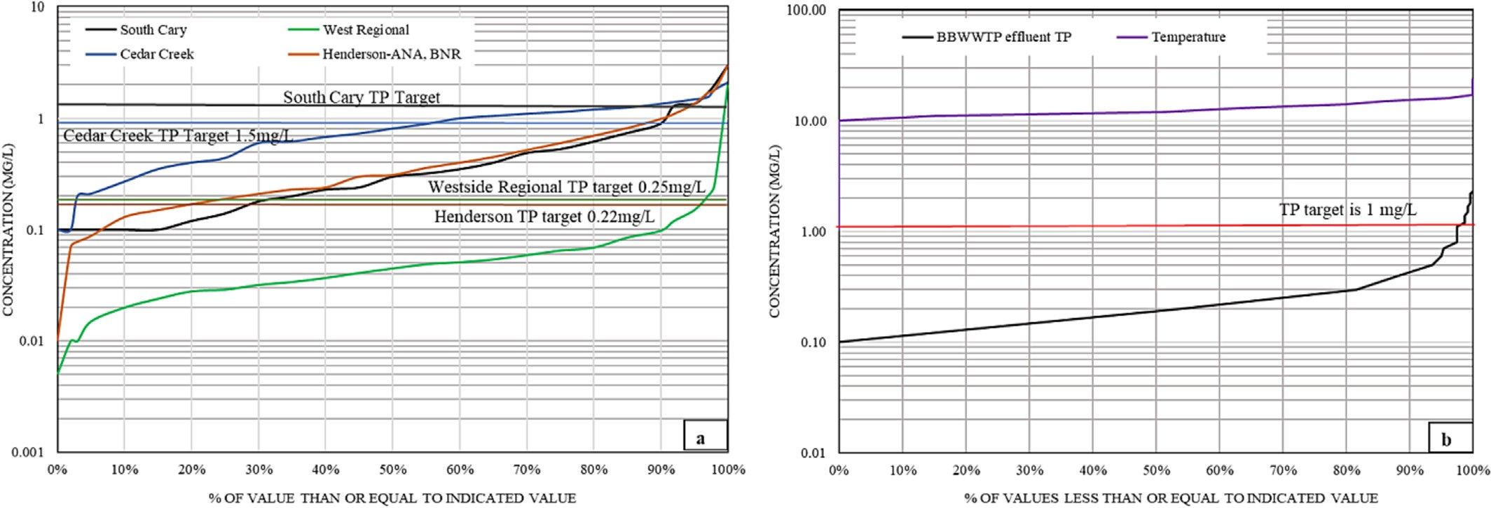

Fig. 6. Probability plot for P-efﬂuent concentration of all four S2EBPR plants for a period of 2 years and on BBWWTP for a period of 1 year.

primary phosphorus removing agent in full-scale systems (Seviour et al., 2003; Oehmen et al., 2007).
When it comes to side-stream EBPR processes the mechanism behind it is mainly unclear. There is a perception that extended anaerobic mass frac- tion potentially favors PAOs over other heterotrophic organisms. This is due to the maintenance energy difference, sequential intracellular polymer utilization and different decay rates between PAOs and other microorgan- isms. In a study by Wang et al. (Wang et al., 2019), a comparison of an A2O conﬁguration (anaerobic, anoxic and oxic) with S2EBPR system showed PAO-dominated metabolism in S2EBPR system with primary reli- ance on glycolysis pathway. Moreover, it was proposed that Tetrasphaera- like PAOs beneﬁt from the system conﬁguration through their capability in fermenting various organic substrates that leads to a prolonged PAO ac- tivity while other organisms including OHOs, and GAOs will go through decay process. Therefore, Tetrasphaera with more functional biochemical pathway endures for longer in S2EBPR condition favoring P-removal pro- cess. Surveys on different plants in Australia, USA, Japan, Denmark, and Netherlands showed an approximately 20 % PAO abundance of the total bacterial population (Liu et al., 2019b). Actinobacteria was widely present in a survey study on 20 WWTPs in Denmark which showed higher abundancy compared to Accumulibacter. This was in-line aligned with another study on Australian WWTPs (Nielsen et al., 2019), showing very scarce presence of Accumulibacter. A survey of 32 full-scale EBPR plants in 12 countries have also shown higher Tetrasphaera abundance globally (Saunders et al., 2003a). Most of the evidence display the important role of Accumulibacter and Actinobacteria in EBPR systems while other putative PAOs including genera Dechloromonas and Tessaracoccus have shown consistent presence in EBPR system. Up to date, only the two genera Tetrasphaera and Accumulibacter have shown steady P-removal behavior in EBPR systems while, there are other unknown bacteria with P-reserves that require further identiﬁcation and characterization (Nielsen et al., 2019).
Yet, there are conﬂicting evidence available in this case. An investiga- tion on Rock Creek treatment plant, Missouri, USA, for a conventional A2O and a RAS fermentation process showed no signiﬁcant difference for Tetrasphasera abundance between the two systems. Moreover, in a bench- scale activity test conducted by Lanham et al. (Lanham et al., 2013), no dif- ference was indicated for P-proﬁle between A2O, and RAS fermentation sludge and the glycogen and polyphosphate contents were quite compara- ble (Dold and Conidi, 2019; Gu, 2019). These inconsistencies rise from disputes on the physiology, metabolic pathways and intracellular com- pounds of Tetrasphaera (Liu et al., 2019a). Besides, their doubtful effect on P-removal, Tetrasphaera's versatile physiology and metabolism generates burden on how to handle and maintain the appropriate operational condi- tions for them.
Dold et al. (Dold and Conidi, 2019) yet, suggested that directing substantial attention to role of Tetrasphaera has resulted in neglecting the importance of other putative PAOs such as Accumulibacter and their ability in P-uptake and denitriﬁcation. Moreover, there has been an increased reli- ance on fermentation ability of Tetrasphasera for S2EBPR systems, while it is worth mentioning that PAOs/GAOs may only comprise 10–15 % of the total heterotrophic organisms. Therefore, still, EBPR may highly rely on OHOs contribution, as the dominant species in fermentation.
Therefore, understanding on stoichiometry and kinetics of anaerobic biochemical conversions, uptake, and storage procedures, substantially aids in optimizing operational conditions and assists in identifying the parameters of effect.

    - Is GAO competition a myth?
GAOs are reportedly present in EBPR systems. Originally, they were considered as true competitors of PAOs and reason for P-removal perfor- mance failure. Although, it is now well-understood that the ecological role of GAOs is more diverse than just being PAOs competitor (Rubio- Rincón et al., 2017). When it comes to GAOs, there are still questions to be answered, whether PAOs and GAOs are the same microorganisms with adaptive response to different conditions? if not, does GAO negatively impact EBPR system?
Early culture-based studies connected the failure of EBPR system to proliferation of tetrad-forming organisms with accumulating PHA and gly- cogen, but not Poly-P morphology originally known as “G-bacteria”. There- fore, historically GAO is known as a cause of EBPR failure by outcompeting PAOs. Different reports have described how the presence of GAO led to ineffective and deteriorated EBPR performance followed by failure in ex- treme cases (Saunders et al., 2003b; Mino et al., 1994; Filipe et al., 2001). Favorable conditions to GAOs have been listed as low pH values, high temperatures, P-limitation, higher glucose content and longer SRTs (Tu and Schuler, 2013). GAOs as one of the non-polyphosphate organisms have very similar metabolic behavior compared to PAOs. Various GAO phenotypes identiﬁed, are afﬁliated with α, β and γ-Proteobacteria and Actinobacteria. Candidatus Competibacter Phosphatis, a novel cluster- forming coccobacilli-γ-Proteobacterial organism is known for having the GAO phenotype. Other GAO phenotypes spotted are mostly afﬁliated with α-Proteobacteria, including the Deﬂuviicoccus-related organisms.
The very similar mechanism of PAOs and GAOs started the investigation on differentiating the two phenotypes. Glycogen is a key component of PAO metabolism during the anaerobic period to provide reducing power and additional energy for substrate uptake and PHA synthesis. Therefore, some believe that glycogen accumulating metabolism (GAM) as an integral part of PAO metabolism may be the dominant process in speciﬁc conditions such as when phosphorus is limited. This leads to similar anaerobic reaction

stoichiometry of PAOs and GAOs under poly-p limitation (Zhou et al., 2008). Studies conducted by Zhou et al., and Acevedo et al., (Zhou et al., 2008; Acevedo et al., 2012) indicated that EBPR cultures with high PAO abundance can show partial GAO metabolism under stoichiometrically limiting Poly-P for anaerobic substrate uptake when the PAO metabolism is not available. Various studies conﬁrmed different clades of PAO, able to perform a metabolic shift to gradually adapt to observed conditions (Welles et al., 2015). Stress conditions including temperature, pH and carbon source availability regulate and lead the metabolic shift, showing capability of EBPR microorganisms to later and adapt their biochemical me- tabolism with environmental changes, which still deserves more investiga- tion (Erdal et al., 2008).
More recent approaches using genomics has helped enhancing the understanding of PAO and GAO models, where the two phenotypes encom- pass diverse organisms phylogenetically and metabolically. These studies have indicated proton motive force generation for VFA uptake as a vital phenomenon but not exclusive to PAO phenotype. Moreover, key pathways including glycogen, PHA and polyphosphate cycles are present in many non-PAO bacteria including GAOs (Seviour et al., 2003; Albertsen et al., 2016).
Nevertheless, studies thought to be important for EBPR microbiology have mainly experimented VFA-fed lab-scale systems with speciﬁc opera- tional conditions, while the full-scale systems carry a much more complex operation, substrate composition and a diverse niche of organisms. Many full-scale studies have reported no or very limited abundance of the proposed GAOs and PAOs present in lab-scale systems (Nielsen et al., 2019). Up to now, there is minimal well-documented studies on full-scale EBPR systems with high GAO abundance. A study on 7 full-scale plants by Saunders et al. (Saunders et al., 2003b) showed presence of both Candidatus Accumulibacter and Competibacter while the likelihood of GAO outcompeting PAO was not clearly discussed. Although there are studies showing mixed cultures of PAOs and GAOs may exist without any clear competition (Sabba, 2023). On the other hand, several studies have proposed an overemphasis on GAO abundance due to lab-scale studies with induced acetate concentrations compared to full-scale systems. There- fore, various research state no convincing report on coincidence of GAO presence with poor performance in full-scale systems (Albertsen et al., 2016). In a study by Rincon et al., it was stated that in anoxic environment, GAOs may not act as competitors but supply the required electron acceptor for PAOs, showing syntrophic relationship (Rubio-Rincón et al., 2017). These studies claim the presence of moderate amount of GAOs as a sign of efﬁcient EBPR with excess organic availability (Tu and Schuler, 2013), since low P-efﬂuent shows limitation of PAO activity due to scarce P- concentration and GAOs growth on organics present in excess of PAO requirement.
All in all, the ﬁndings reveal the need for further detailed investigations
on full-scale EBPR systems to identify the abundance and effect of GAOs and their presence correlation to EBPR performance.

  - Knowledge gap in kinetics, stoichiometry, and process modeling

Three approaches are taken into consideration when it comes to model- ing BNR activated sludge systems, the metabolic model, and the Activated Sludge Model (ASM), and a combination of both models (Santos et al., 2020).
In metabolic models, the metabolic pathways, biochemical transforma- tions, yield coefﬁcients and stoichiometric yields are well estimated and de- ﬁned. The only parameters in these models, requiring calibration are kinetic parameters. With limited number of parameters requiring calibra- tion these models tend to show higher consistency and reliability (Santos et al., 2020).
Not the same capability is observed with ASM models, where models may need extensive stoichiometric and kinetic parameter adjustment to predict EBPR performance in long-term manner which reduces their predic- tion potential (Santos et al., 2020).

For instance, in case of endogenous respiration, there are two ap- proaches taken for modeling. The ﬁrst is based on lysis concept where bio- mass degrades and forms particulate inert material and particulate substrate. The lysis concept is complicated as it leads to internal substrate recycle as the limiting process. The other approach considers no particulate matter and substrate formation by recognizing all available substrate as readily available COD (Meijer, 2004). The second approach seems unrealis- tic as all microorganisms in the activated sludge include inert materials and extracellular polymeric substances (EPS). The second approach limits are mainly compensated by ﬁtting the inﬂuent inert material/particulate sub- strate ratio to measured solids balance. Although with all the ﬁtting and compensations, yet both approaches lack quantitative and mechanistic in- formation on the inert and inactive material generation (Meijer, 2004).
Moreover, the model integration is further lacking when it comes to anaerobic substrate uptake rates. Adjustment of the default hydrolysis and fermentation rates, which consequently impact the PHA utilization and phosphorus uptake rates seem to be necessary. Under anaerobic condi- tions, EBPR is reliable and sensitive to fermentation and hydrolysis rates as they specify substrate availability. Wastewaters usually contain relatively high amounts of soluble substrate where the fermentation rate is sensitive. Therefore, determining the modelled rate is imperative, although there is very little or no experimental proof for the modelled fermentation and hy- drolysis process. This is due to an unclear understanding on the modelled inﬂuent COD fractions and their relations as well as the actual wastewater composition (Meijer, 2004). Moreover, anaerobic hydrolysis rate is vari- able and challenging to predict, where various factors such as substrate composition, directly effects the value and subsequently the RBCOD and VFA production rate. Again, inadequate data to complete mass balances and characterize sludge components tends to limit deep perception on this subject matter (Vale et al., 2008). There are examples where calibration of process models has shown the improvement of BNR systems with RAS fermentation through higher VFA generation for EBPR (Barnard et al., 2012).
Therefore, a common matter for both ideas supporting conventional and novel EBPR processes, is their belief on a lack of process modeling to support all aspects of EBPR system, speciﬁcally on the hydrolysis and fermentation. In case of S2EBPR these shortcomings in modeling are more deﬁnitive and major adjustments are required to reach the proper pre- diction level. S2EBPR have reported higher ratios which has been suggested that stimulates glycolysis pathway activity in PAOs. From modeling per- spective, most existing simulators have shown drawbacks since there is no adjustment for a more efﬁcient and deep anaerobic condition to grow PAOs. In most cases, the model simulators seem to under-predict the perfor- mance of EBPR system, when RBCOD availability is limited. The overall re- sults of different studies indicate that modeling RAS fermentation processes using default values lead to results inconsistent with facilities observations (Barnard et al., 2017).
Therefore, for designing an adequate anaerobic zone, a model that captures the complex chemical and biological nature of the process by including various factors helps to determine the true characteristics of each treatment phase. There should be a model available that reﬂects on all factors as well as the deﬁciencies regarding the existing ones to allow greater ﬂexibility in the design concept for all the different biological phos- phorus removal scenarios (Dold and Conidi, 2019; Barnard et al., 2017; Houweling et al., 2010). Practically these matters create a need for complex and extensive research to understand the behavior of EBPR based on kinet- ics and stoichiometry of process (Onnis-Hayden et al., 2020).

    - Anaerobic hydrolysis rate, how much do we know?
The mixed composition of substrates entering treatment plants include a considerable fraction of biodegradable organic matter of dissolved and colloidal macromolecules and ﬁnely dispersed particulate material. Extra- cellular hydrolysis/solubilization by enzymes are required to prepare them for organism's uptake. Yet due to various aspects namely, the cellular location of hydrolytic enzymes, effect of time on enzymatic activity/decay rate, and the simultaneous presence of various substrates, these

extracellular processes are not widely understood. Moreover, the effect of electron acceptor presence in aerobic and anoxic conditions as well as an- aerobic environmental regime with no energy yield via electron transport chain is a matter of investigation. In this regard, the general agreement has been that either no hydrolysis takes place under anaerobic condition, or it is reduced to only 40 % of aerobic conditions. These ﬁnding are questioned by the various studies and research on well-performed EBPR processes and side-stream systems that have shown higher RBCOD and VFA production rates than predicted (Dold and Conidi, 2019; Barnard et al., 2017; Dold et al., 1991).
A study on carbohydrate hydrolytic process (α (1–4) glucan bond) by Dold et al. (Dold et al., 1991), was conducted to establish the difference of hydrolysis rates in different environmental regimes. The ﬁndings showed that the hydrolytic enzymes were either attached to the cell surface or situated in the periplasmic space or bound to non-cellular solid material and were not free in the bulk liquid solution. The results also indicated very little variation between anaerobic (average 2.55 mg/h.mgTSS *10³) and aerobic hydrolysis rates (average 2.45 mg/h.mgTSS *10³) while the an- oxic hydrolysis rate (average 6.73 mg/h.mgTSS *10³) was in magnitude of 3 times higher than the other two conditions. The anoxic rate found in the study was unexpected from the metabolic point of view. The author suggested further investigation on this matter to determine the accuracy of results.
In further research by Dold et al., (Dold et al., 1995) macromolecule carbohydrate, α-amylase with ecto and endo α (1–4) glucan bonds was studied for hydrolytic activity in mixed culture of activated sludge. In this study, the aerobic hydrolysis rate (average 0.6 μmole/h.mgTSS) was found to be the lowest while the rate was the highest in anaerobic conditions (average 3.09 μmole/h.mgTSS), while anoxic showing an inter- mediate rate (average 0.91 μmole/h.mgTSS). These ﬁndings are more aligned with the outcomes observed in well-performed EBPR and Side- stream technology.
Although the results of studies widely differ but do contradict with the idea of lower anaerobic hydrolysis rate comparing to aerobic conditions. However, it suggests that anaerobic hydrolysis rate is sensitive to substrate and speciﬁc linkage within. Reﬂection on these ﬁndings necessitates fur- ther research and testing on hydrolysis rate as an interrelated matter with substrate composition and microbial population structure.

- Discussion: anaerobic zone all around

With the current challenges to reach very low levels of phosphorus in efﬂuent, the questions of how low is possible and what are the limits of technology (LOT) for phosphorus removal is raised. The LOT is mainly associated with the lowest efﬂuent concentrations that can be reached by using a treatment technology or a set of technologies (Jimenez et al., 2012; Neethling et al., 2010).
BPR systems can reach a reliable 1 mg/L of efﬂuent total phosphorus. However, the lowest a biological system theoretically can reach is assumed to be much lower than this level (Neethling et al., 2010). Based on the tech- nologies available, each process has averaged a different level of Efﬂuent-P concentration. Although further studies on various treatment plants with different loadings distinguishes the reliability of P-removal on chemical treatments and ﬁltration rather than just biological treatment which is an indication of less efﬁcient biological systems (Jimenez et al., 2012; Parker et al., 2012; Bott et al., 2012).
The matter to reﬂect on here is the reason behind unreliability of BPR processes and how to address them. There is no “one size ﬁts all” solution but plants indicate the possibility of reaching LOT with conventional biological systems with considering environmental factors (inﬂuent tem- perature, inﬂuent characteristics, organic nitrogen fraction), operational factors (design capacity, phosphorus removal, wasting and aeration con- trol) as well as the metabolism and ecology.
A key parameter to revisit in anaerobic reactor performance is the avail- ability of biodegradable COD. It is historically believed that the system re- lies on RBCOD due to relatively small anaerobic mass fraction leading to

negligible slowly biodegradable COD to be utilized. Moreover, historically, anaerobic hydrolysis rates were calculated as a fraction of aerobic condi- tions. Considering the common anaerobic retention times, reduction of slowly biodegradable particulate COD to VFAs seemed very unlikely. Therefore, it was considered that mass of PAOs depends on mass of VFAs and RBCOD in the inﬂuent. More recent studies have contradicting views on importance of inﬂuent COD, while much research have been proposing the independence of S2EBPR of inﬂuent carbon, yet studies on anaerobic zone design have indicated the importance of RBCOD and VFA amount as a dominant factor. These studies with pinning the importance of organic strength of wastewater, however, suggest the importance of hydrolysis and fermentation for carbon source production in conjunction with VFA and RBCOD sequestration. There is still a debate on anaerobic hydrolysis rate as a variable content that is dependent on the inﬂuent carbon source. Although further experimentations and studies have presented variable results on this rate, but the results display same level or higher values than aerobic rates that contradict with the historical perception.
Active mass in the sludge, efﬁcient P-release and consequent phos- phorus uptake rely on not only inﬂuent COD characteristics but the cor- rect selection of design. Notwithstanding, the importance of anaerobic and anoxic sludge mass fractions have been extensively mentioned for process design which seems to be often neglected in full-scale EBPR, in which S2EBPR conﬁgurations mediates the inadequate design. Even the adverse effect of low readily biodegradable COD concentration may be compensated by increasing the anaerobic mass fraction to a maximum of 25 %. It is believed that larger size anaerobic reactors can promote VFA production (Dold and Conidi, 2019). A 10 % anaero- bic mass fraction may be too small and only reaches 50 %–60 % of P- release potential but again higher than 25 % of anaerobic mass fraction does not lead to much gain (University of Capetown and City Council of Johannesburg and CSTR- WRC Report, 1984).
All in all, although the trends of changes in anaerobic condition may not be easily rooted to a particular parameter as they are intercon- nected yet controlling select parameters including (but not limited to) temperature, recycle ratio, anaerobic mass sludge and fraction, anaero- bic retention times and available carbon source better expresses the anaerobic performance.
It is challenging to understand the pathways associated with micro- bial groups in an EBPR system, while identiﬁcation, and analysis of these pathways, aids in building a robust PAO model by understanding the ﬂexibility of microorganisms to different dynamic conditions in WWTP (Yan et al., 2020). Therefore, it is vital to better understand the mechanism of EBPR and develop processes that reliably and stably ac- count for P-removal and integrates complex microbial metabolisms within the real wastewater environment. This matter will aid in resolv- ing the inconsistencies and knowledge gaps and fully comprehend EBPR activity and performance.
A biological P-removal process that optimizes design, performance, and microbial response to meet very stringent P-limits is highly in demand to diminish the dependency on chemical processes and move towards an over- all sustainable WW treatment process.

- Conclusion

This review summarizes and covers the present views on anaerobic zone functionality of EBPR along with progressing notions for better understand- ing the underlying mechanisms, design, and operation standards. Various research insights including RAS fermentation and hydrolysis as well as conventional system with adequate design has been critically reviewed and discussed. The outcome has shown the importance of anaerobic design and operation, speciﬁcally anaerobic mass fractionation and hydrolysis and fermentation to reach a sustainable EBPR system. Although it is now known that anaerobic zone changes and trends may not be easily rooted to a spe- ciﬁc factor but relies on an interconnected channel of parameters. There- fore, to overcome the inconsistency of results, it is critical to progressively explore various aspects of current perceptions on EBPR.

Supplementary data to this article can be found online at https://doi. org/10.1016/j.scitotenv.2023.162018.

Data availability

Data will be made available on request.

Declaration of competing interest

The authors declare the following ﬁnancial interests/personal relation- ships which may be considered as potential competing interests: Parnian Izadi reports administrative support was provided by Stantec Consulting Ltd. Parnian Izadi reports ﬁnancial support was provided by Mitacs Canada.

Acknowledgement

This research was ﬁnancially supported by the Mitacs Elevate Fellow- ship funding (IT26669). Special thanks to Stantec Institute for water Tech- nology and Policy and Peter Dold for the support and assistance with data collection and review.

CRediT authorship contribution statement

Parnian Izadi: Conceptualization (Lead), Validation (Lead), Investiga- tion (lead), Resources (lead), Writing- original draft (lead), Writing- review and editing (equal), Visualization (lead).
Mehran Andalib: Conceptualization (supporting), Investigation (supporting), Writing-review and editing (equal), Supervision (Lead), Funding Acquisition (Lead).

References
Acevedo, B., Oehmen, A., Carvalho, G., Seco, A., Borrás, L., Barat, R., 2012. Metabolic shift of polyphosphate-accumulating organisms with different levels of polyphosphate storage. Water Res. 46 (6), 1889–1900.
Albertsen, M., McIlroy, S.J., Stokholm-Bjerregaard, M., Karst, S.M., Nielsen, P.H., 2016. ‘Candidatus propionivibrio aalborgensis’: a novel glycogen accumulating organism abun- dant in full-scale enhanced biological phosphorus removal plants. Front. Microbiol. 7 (JUL), 1–17.
Andreasen, K., Petersen, G., Thomsen, H., Strube, R., 1997. Reduction of nutrient emission by sludge hydrolysis. Water Sci. Technol. 35 (10), 79–85.
Arun, V., Mino, T., Matsuo, T., 1988. Biological mechanism of acetate uptake mediated by carbohydrate consumption in excess phosphorus removal systems. Water Res. 22 (5), 565–570.
Barnard, J.L., 1975. Biological nutrient removal without the addition of chemicals. Water Res.
9 (5–6), 485–490.
Barnard, J.L., 2014. Biological nutrient removal: where we have been, where we are going?
Proc. Water Environ. Fed. 2006 (13), 1–25.
Barnard, J.L., Abraham, K., 2006. Key features of successful BNR operation. Water Sci.
Technol. 53 (12), 1–9.
Barnard, J., Houweling, D., Steichen, M., 2012. Fermentation of mixed liquor for removal and recovery phosphorus. Proc. Water Environ. Fed. 2011 (1), 1–17.
Barnard, J., Benisch, M., Falk, M., de Barbadillo, C., 2016. Evaluation of performance and greenhouse gas emissions for plants achieving low phosphorus efﬂuents. Water Intell. On- line 15 (0) pp. 9781780406923–9781780406923, Mar.
Barnard, J.L., Dunlap, P., Steichen, M., 2017. Rethinking the mechanisms of biological phos- phorus removal. Water Environ. Res. 89 (11), 2043–2054.
Bott, C.B., Parker, D.S., Jimenez, J., Miller, M.W., Neethling, J.B., 2012. WEF/WERF study of BNR plants achieving very low N and P limits: evaluation of technology performance and process reliability. Water Sci. Technol. 65 (5), 808–815.
Brower, N.J.T., 2021. Assessing the Effects of Anaerobic Mass Fraction on Enhanced Biologi- cal Phosphorus Removal Process Health and Performance. University of Idaho.
Carucci, A., Lindrea, K., Majone, M., Ramadori, R., 1999. Different mechanisms for the anaer- obic storage of organic substrates and their effect on enhanced biological phosphate re- moval (EBPR). Water Sci. Technol. 39, 21–28.
Chen, K.H., et al., 2020. The application of footprints for assessing the sustainability of waste- water treatment plants: a review. J. Clean. Prod. 277, 124053.
Close, K., et al., 2021. The storage compounds associated with tetrasphaera PAO metabolism and the relationship between diversity and P removal. Water Res. 204 (March).
Coats, E.R., Deyo, B., Brower, N., Brinkman, C.K., 2021. Effects of anaerobic HRT and VFA loading on the kinetics and stoichiometry of enhanced biological phosphorus removal. Water Environ. Res. 93 (9), 1608–1618.
Comeau, Y., Hall, K.J., Hancock, R.E.W., Oldham, W.K., 1986. Biochemical model for en- hanced biological phosphorus removal. Water Res. 20 (12), 1511–1521.
Daneshgar, S., Callegari, A., Capodaglio, A.G., Vaccari, D., 2018. The potential phosphorus cri- sis: resource conservation and possible escape technologies: a review. Resources 7 (2).

Daneshgar, S., Cecconet, D., Capsoni, D., Capodaglio, A.G., 2022. Side-stream phosphorus re- covery in activated sludge processes. Water (Switzerland) 14 (12), 1–19.
Dold, P., Conidi, D., 2019. Achieving enhanced biological P removal: have we forgotten how to design a bioP plant? WEFTEC 2019 - 92nd Annu. Water Environ. Fed. Tech. Exhib. Conf, pp. 1452–1466
Dold, P., Fleit, E., Han, J., 1991. Hydrolysis of α (1–4) glucan bonds in activated sludge mixed bacterial communities. Environ. Technol. 12, 871–879.
Dold, P., Fleit, E., Han, J., Copp, J.B., 1995. Assay for determination of α-amylase activity in activated sludge mixed bacterial communities. Environ. Technol. 16, 181–188.
Erdal, U.G., Erdal, Z.K., Daigger, G.T., Randall, C.W., 2008. Is it PAO-GAO competition or met- abolic shift in EBPR system? Evidence from an experimental study. Water Sci. Technol. 58 (6), 1329–1334.
Ferguson, L., 2019. Sidestream RAS Fermentation for Stable Bio-P Combined With Short Cut Nitrogen Removal in an A/B Process. Old Dominion University.
Filipe, C.D.M., Daigger, G.T., Grady, C.P.L., 2001. pH as a key factor in the competition be- tween glycogen-accumulating organisms and phosphorus-accumulating organisms. Water Environ. Res. 73 (2), 223–232.
Fuhs, G.W., Chen, M., 1975. Microbiological basis of phosphate removal in the activated sludge process for the treatment of wastewater. Microb. Ecol. 2 (2), 119–138.
Gebremariam, S.Y., Beutel, M.W., Christian, D., Hess, T.F., 2011. Research advances and chal- lenges in the microbiology of enhanced biological phosphorus removal—a critical re- view. Water Environ. Res. 83 (3), 195–219.
Gebremariam, S.Y., Beutel, M.W., Christian, D., Hess, T.F., 2011. Research advances and chal- lenges in the microbiology of enhanced biological phosphorus removal-a critical review. Water Environ. Res. 83 (3), 195–219.
Gu, A.Z., 2019. Optimization and Design of a Side-Stream EBPR Process as a Sustainable Ap- proach for Achieving Stable and Efﬁcient Phosphorus Removal.
Henze, D.B.Mogens, van Loosdrecht, Mark C.M., Ekama, G.A., 2008. Biological Wastewater Treatment : Principles, Modelling and Design. IWA Pub.
Houweling, D., Dold, P., Barnard, J., 2010. Theoretical limits to biological phosphorus re- moval: rethinking the inﬂuent Cod:N:P ratio. Proc. Water Environ. Fed. 7044–7059.
Hu, Z., Houweling, D., Dold, P., 2012. Biological nutrient removal in municipal wastewater treatment: new directions in sustainability. J. Environ. Eng. 138 (3), 307–317.
Izadi, P., Izadi, P., Eldyasti, A., 2020. Design, Operation and Technology Conﬁgurations for Enhanced Biological Phosphorus Removal (EBPR) Process: A Review. vol. 19. Springer, Netherlands no. 3.
Izadi, P., Izadi, P., Eldyasti, A., 2021. A review of biochemical diversity and metabolic model- ing of EBPR process under speciﬁc environmental conditions and carbon source availabil- ity. J. Environ. Manag. 288 (November 2020), 112362.
Izadi, P., Danelle, B., Xheko, J., Andalib, M., Umble, A., Gabrielle, J., 2022. The role of an ad- equate anaerobic mass fraction on RAS hydrolysis/fermentation for sustainable EBPR process. WEFTEC Proceeding.
Jeon, C.O., Park, J.M., 2000. Enhanced biological phosphorus removal in a sequencing batch reactor supplied with glucose as a sole carbon source. Water Res. 34 (7), 2160–2170.
Jimenez, J., Madhanagopal, T., Schmidt, H., Bratby, J., Meka, H., Parker, D., 2012. Full- scale operation of large biological nutrient removal facilities to meet limits of tech- nology efﬂuent requirements: the Florida experience. Proc. Water Environ. Fed. 2007 (9), 8412–8427.
Kristiansen, R., et al., 2013. A metabolic model for members of the genus tetrasphaera in- volved in enhanced biological phosphorus removal. ISME J. 7 (3), 543–554.
Lamb, J.C., 1994. Wastewater Treatment with Enhanced Biological Phosphorus Removal and Related Puriﬁcation Processes.
Lanham, A.B., Oehmen, A., Saunders, A.M., Carvalho, G., Nielsen, P.H., Reis, M.A.M., 2013. Metabolic versatility in full-scale wastewater treatment plants performing enhanced biological phosphorus removal. Water Res. 47 (19), 7032–7041.
Lanham, A.B., Oehmen, A., Saunders, A.M., Carvalho, G., Nielsen, P.H., Reis, M.A.M., 2014. Metabolic modelling of full-scale enhanced biological phosphorus removal sludge. Water Res. 6, 283–295.
Li, G., 2020. Modeling Side-Stream Enhanced Biological Phosphorus Removal (S2EBPR) Sys- tem Using Agent-based Model With Adaptive Maintenance, Decay and TCA Metabolism. bioRxiv p. 2020.11.18.387589.
Liu, R., Hao, X., Chen, Q., Li, J., 2019. Research advances of tetrasphaera in enhanced biolog- ical phosphorus removal: a review. Water Res. 166.
Liu, R., Hao, X., Chen, Q., Li, J., 2019. Research advances of tetrasphaera in enhanced biolog- ical phosphorus removal: a review. Water Res. 166.
van Loosdrecht, M.C.M., Pot, M., Heijnen, J., 1997. Importance of bacterial storage polymers in bioprocesses. Water Sci. Technol. 35, 41–47.
Majed, N., Gu, A.Z., 2019. Impact of Inﬂuent Carbon to Phosphorus Ratio on Perfor- mance and Phenotypic Dynamics in Enhanced Biological Phosphorus Removal (EBPR) 2 System-Insights into Carbon Distribution, Intracellular Polymer Stoichiom- etry and Pathways Shifts.
Marques, R., et al., 2017. Metabolism and ecological niche of Tetrasphaera and ca. Accumulibacter in enhanced biological phosphorus removal. Water Res. 122, 159–171.
Mcilroy, S.J., et al., 2013. Metabolic model for the ﬁlamentous ‘Candidatus microthrix parvicella’ based on genomic and metagenomic analyses. ISME J. 7 (6), 1161–1172.
Meijer, S., 2004. Theoretical and Practical Activated Sludge Processes. Delft University of Technology.
Metcalf, Eddy, 2003. Wastewater Engineering : Treatment and Resource Recovery.
Mielczarek, A.T., Thi, H., Nguyen, T., Nielsen, J.L., Nielsen, P.H., 2012. Population dynamics of bacteria involved in enhanced biological phosphorus removal in Danish wastewater treatment plants. Water Res. 47 (4), 1529–1544.
Mihelcic, J.R., et al., 2003. Sustainability science and engineering: the emergence of a new metadiscipline. Environ. Sci. Technol. 37 (23), 5314–5324.
Mino, T., Satoh, H., Matsuo, T., 1994. Metabolisms of different bacterial populations in enhanced biological phosphate removal processes. Water Sci. Technol. 29 (1992), 67–70.

Narayanan, B., et al., 2014. Fermentation of return activated sludge to enhance biological phosphorus removal. Proc. Water Environ. Fed. 2002 (13), 256–262 Jul.
Neethling, J.B., Clark, D., Pramanik, A., Stensel, H.D., Sandino, J., Tsuchihashi, R., 2010. WERF nutrient challenge investigates limits of nutrient removal technologies. Water Sci. Technol. 61 (4), 945–953.
Nguyen, H.T.T., Le, V.Q., Hansen, A.A., Nielsen, J.L., Nielsen, P.H., 2011. High diversity and abundance of putative polyphosphate-accumulating tetrasphaera-related bacteria in acti- vated sludge systems. FEMS Microbiol. Ecol. 76 (2), 256–267.
Nguyen, H.T.T., Le, V.Q., Hansen, A.A., Nielsen, J.L., Nielsen, P.H., 2011. High diversity and abundance of putative polyphosphate-accumulating tetrasphaera-related bacteria in acti- vated sludge systems. FEMS Microbiol. Ecol. 76 (2), 256–267.
Nielsen, P.H., McIlroy, S.J., Albertsen, M., Nierychlo, M., 2019. Re-evaluating the microbiology of the enhanced biological phosphorus removal process. Curr. Opin. Biotechnol. 57, 111–118.
Oehmen, A., Zeng, R.J., Yuan, Z., 2005. Anaerobic Metabolism of Propionate by Polyphosphate- Accumulating Organisms in Enhanced Biological Phosphorus Removal Systems.
Oehmen, A., et al., 2007. Advances in enhanced biological phosphorus removal: from micro to macro scale. Water Res. 41 (11), 2271–2300.
Onnis-Hayden, A., et al., 2020. Survey of full-scale sidestream enhanced biological phospho- rus removal (S2EBPR) systems and comparison with conventional EBPRs in North America: process stability, kinetics, and microbial populations. Water Environ. Res. 92 (3), 403–417.
Parker, D., et al., 2012. WEF/WERF cooperative study of nutrient removal plants: achievable technology performance statistics for low efﬂuent limits. Proc. Water Environ. Fed. 2011 (1), 185–212.
Rubio-Rincón, F.J., Lopez-Vazquez, C.M., Welles, L., van Loosdrecht, M.C.M., Brdjanovic, D., 2017. Cooperation between candidatus competibacter and candidatus accumulibacter clade I, in denitriﬁcation and phosphate removal processes. Water Res. 120, 156–164.
Sabba, F., 2023. Impact of operational strategies on a sidestream enhanced biological phos- phorus removal (S2EBPR) reactor in a carbon limited wastewater plant. Sci. Total Envi- ron. 857 (October 2022), 159280.
Santos, J.M.M., Rieger, L., Lanham, A.B., Carvalheira, M., Reis, M.A.M., Oehmen, A., 2020. A novel metabolic-ASM model for full-scale biological nutrient removal sys- tems. Water Res. 171.
Saunders, A.M., Oehmen, A., Blackall, L.L., Yuan, Z., Keller, J., 2003. The effect of GAOs (gly- cogen accumulating organisms) on anaerobic carbon requirements in full-scale Australian EBPR (enhanced biological phosphorus removal) plants. Water Sci. Technol. 47 (11), 37–43 Jun.
Saunders, A.M., Oehmen, A., Blackall, L.L., Yuan, Z., Keller, J., 2003. The effect of GAOs (glycogen accumulating organisms) on anaerobic carbon requirements in full-scale australian EBPR (enhanced biological phosphorus removal) plants. Water Sci. Technol. 47 (11), 37–43.
Schuler, A.J., Jenkins, D., 2002. Effects of pH on enhanced biological phosphorus removal me- tabolism effects of pH on enhanced biological phosphorus removal metabolisms. Water Sci. Technol. (August).
Sedlak, R., 2018. Phosphorus and nitrogen removal from municipal wastewater : principles and practice. Phosphorus Nitrogen Remov. From Munic. Wastewater Apr.
Seviour, R.J., Mino, T., Onuki, M., 2003. The microbiology of biological phosphorus removal in activated sludge systems. FEMS Microbiol. Rev. 27 (1), 99–127.
Stokholm-Bjerregaard, M., McIlroy, S.J., Nierychlo, M., Karst, S.M., Albertsen, M., Nielsen, P.H., 2017. A critical assessment of the microorganisms proposed to be important to en- hanced biological phosphorus removal in full-scale wastewater treatment systems. Front. Microbiol. 8 (APR), 1–18.
Tomei, M.C., Stazi, V., Daneshgar, S., Capodaglio, A.G., 2020. Holistic approach to phospho- rus recovery from urban wastewater: enhanced biological removal combined with precip- itation. Sustainability 12 (2).

Tooker, N.B., et al., 2018. Side-stream EBPR practices and fundamentals – rethinking and reforming the enhanced biological phosphorus removal process. Proc. Water Environ. Fed. 5, 223–239 Nov.
Tremblay, P.G.Sonia, Hilger, Helene, Barnard, James L., de Barbadillo, Chris, 2005. Phospho- rus accumulating organisms utilization of volatile fatty acids produced by fermentation of anaerobic mixed liquor. WEFTEC Proc. 9, 5971–5986.
Tu, Y., Schuler, A.J., 2013. Low acetate concentrations favor polyphosphate-accumulating or- ganisms over glycogen-accumulating organisms in enhanced biological phosphorus re- moval from wastewater. Environ. Sci. Technol. 47 (8), 3816–3824.
Ubay-Cokgor, E., Oktay, S., Zengin, G.E., Artan, N., Orhon, D., 2005. Effect of primary sludge fermentation products on mass balance for biological treatment. Water Sci. Technol. 51 (11), 105–114.
Ucisik, A.S., Henze, M., 2008. Biological hydrolysis and acidiﬁcation of sludge under anaero- bic conditions : the effect of sludge type and origin on the production and composition of volatile fatty acids. Water Res. 42, 3729–3738.
University of Capetown and City Council of Johannesburg and CSTR- WRC Report, 1984. The- ory, Design and Operation of Nutrient Removal Activated Sludge Processes no. 3.
Vale, P., Barnard, J., Thomas, D., Dold, P., 2008. RAS fermentation to enhance biological phosphorus removal. WEFTEC Proc. 15, 1775–1789.
Vollertsen, J., Petersen, G., Borregaard, V.R., 2006. Hydrolysis and fermentation of activated sludge to enhance biological phosphorus removal. Water Sci. Technol. 53 (12), 55–64.
Wang, D., 2018. A Full-Scale Comparative Study of Conventional and Side-Stream Enhanced Biological Phosphorus Removal Processes Preprint, no. August.
Wang, N., Hill, G., Peng, J., 2001. Mathematical model for the microbial metabolism of glu- cose induced enhanced biological phosphorus removal in an anaerobic/aerobic sequen- tial batch reactor. Environ. Eng. Policy 3 (1), 87–99.
Wang, D., et al., 2019. Side-stream enhanced biological phosphorus removal (S2EBPR) pro- cess improves system performance - a full-scale comparative study. Water Res. 167.
Welles, L., et al., 2015. Accumulibacter clades type I and II performing kinetically different glycogen-accumulating organisms metabolisms for anaerobic substrate uptake. Water Res. 83, 354–366.
Wentzel, M.C., Dold, P.L., Ekama, G.A., Marais, V.G.R., 1985. Kinetics of biological phospho- rus release. Water Sci. Technol. 17 (11–12), 57–71.
Wentzel, M.C., Ekama, G.A., Dold, P.L., Marais, G.V.R., 1990. Biological excess phosphorus removal- steady state process design. Water SA 16 (1), 29–48.
Yagci, N., Artan, N., Çokgör, E.U., Randall, C.W., Orhon, D., 2003. Metabolic model for ace- tate uptake by a mixed culture of phosphate- and glycogen-accumulating organisms under anaerobic conditions. Biotechnol. Bioeng. 84 (3), 359–373.
Yan, P., Shi, H.X., Chen, Y.P., Gao, X., Fang, F., Guo, J.S., 2020. Optimization of recovery and utilization pathway of chemical energy from wastewater pollutants by a net-zero energy wastewater treatment model. Renew. Sust. Energ. Rev. 133 (March).
Yuan, Q., 2023. Impact of emerging pollutant ﬂorfenicol on enhanced biological phosphorus removal process: focus on reactor performance and related mechanisms. Sci. Total Envi- ron. 859 (November 2022), 160316.
Zhang, T., Wang, X., Zhou, J., Zhang, Y., 2017. Enrichments of methanotrophic–heterotrophic cultures with high poly-β-hydroxybutyrate (PHB) accumulation capacities. J. Environ. Sci. Mar. 65, 133–143.
Zhao, J., Yuan, Q., Sun, Y., Zhang, J., Zhang, D., Bian, R., 2021. Effect of ﬂuoxetine on en- hanced biological phosphorus removal using a sequencing batch reactor. Bioresour. Technol. 320 (PB), 124396.
Zhou, Y., Pijuan, M., Zeng, R.J., Lu, H., Yuan, Z., 2008. Could polyphosphate-accumulating or- ganisms (PAOs) be glycogen-accumulating organisms (GAOs)? Water Res. 42 (10–11), 2361–2368.

