MAT282 · INTERMEDIATE STATISTICS · FALL 2026
Midterm Exam Form A
Franklin University Switzerland · Instructor: Assoc. Prof. C. Burke · Friday 9 October 2026 · in class
Name: ______________________________________________
How this exam works
- The blueprint. The exam follows the steps of our analysis blueprint: hypothesis → data → describe → relate and predict → compute in Sheets → interpret.
- Time and points. 50 points, about 45 minutes. The suggested time is printed in each part’s banner.
- Show your work. Partial credit is given for correct steps, even if a final answer is wrong. Round to 1 decimal place unless told otherwise.
- Part A comes first. Do it before you look at the data page.
- What is marked. In Parts A, E and F you are marked on clear, testable thinking and an honest reading of the evidence, not on whether your hypothesis turns out to be right.
- Allowed: pencil or pen, eraser, ruler, calculator (a phone may be used as a calculator only). Not allowed: notes, books, any other use of a phone, talking.
Part | What it covers | Points | Score
A | Hypothesis & prediction (before the data) | 6
B | Describe the data | 11
C | Relate, predict and check the errors | 12
D | Spreadsheets and LINEST | 12
E | Interpret & communicate | 5
F | Your own idea | 4
Total |  | 50

About the data
A seaside café recorded sales and weather for 168 consecutive trading days (7 April–21 September 2025). These are synthetic teaching data, simulated for this course, not real café records. Your exam uses a sample of 10 of those days; Parts D and E also use results from all 168 days. Each row is one day.
Variable | Concept: what we want to know | Operationalization: what was measured
Temperature (X) | How warm (sunny) the day was | Daily mean outdoor temperature in °C during opening hours
Gelato units (Y) | How much gelato customers buy | Number of standard servings of gelato sold that day (no stock-outs or closures)
weekend | Weekend trading | 1 if Saturday or Sunday, 0 otherwise
beach_event | A crowd-pulling event nearby | 1 if an organised public event took place on the nearby beach, 0 otherwise

PART A · Hypothesis & prediction (before the data) | ≈ 5 min · 6 pts

Research question. Across trading days, is warmer weather related to how much gelato the café sells? (Temperature = X, the explanatory variable; Gelato units = Y, the outcome.)
A1 | Write a testable hypothesis about temperature_c and daily gelato units. Your hypothesis must (i) say which direction the relationship goes, and (ii) name the unit of analysis (one trading day). Then (iii) describe a result in the data that would falsify it. | 2 pts

A2 | Predict before you look. On the empty axes, draw the pattern you expect if your hypothesis is true: about 8 dots and your expected trend line. Then name one other variable from the table above that could also push gelato sales up or down on a day, and say which way. | 2 pts
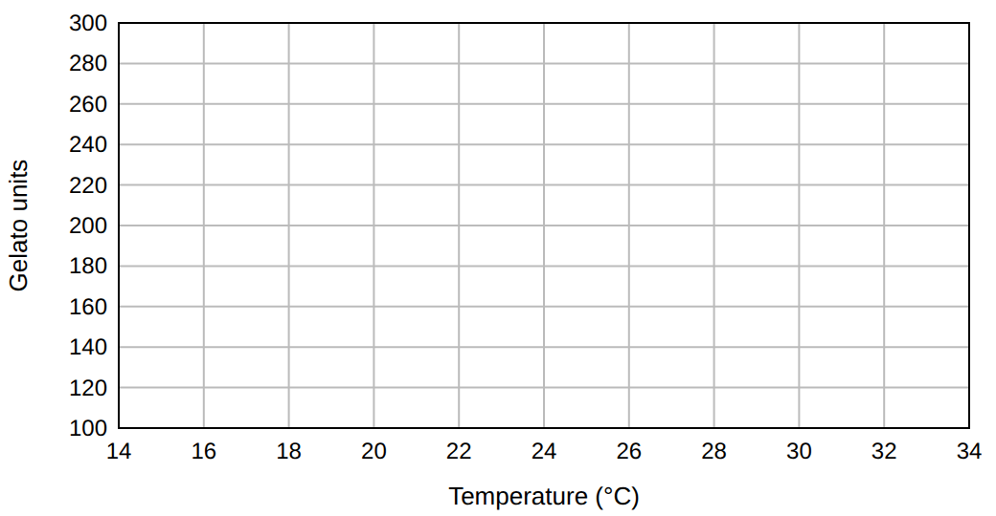

A3 | Data quality. (a) Customers “wanting gelato” is the concept; units sold is the measure. Give one way the measure could be invalid for the concept. (b) In July the weather sensor is moved from a shaded wall to a sunny one. Is this mainly a validity or a reliability / comparability problem? Explain in one sentence. | 2 pts

Stop. Finish Part A before you turn the page.

PART B · Describe the data | ≈ 9 min · 11 pts

The table lists a sample of 10 days in date order. In this part you describe Gelato units (Y). The last two columns are for B2.
# | Date | Temp (°C) | Weekend | Event | Gelato units | Units − mean | (Units − mean)²
1 | Apr 8 | 22.2 | 0 | 0 | 168
2 | Apr 18 | 22.3 | 0 | 0 | 181
3 | May 10 | 21 | 1 | 0 | 227
4 | May 15 | 23.5 | 0 | 0 | 191
5 | May 19 | 27.4 | 0 | 0 | 199
6 | May 21 | 24 | 0 | 0 | 186
7 | May 26 | 23.4 | 0 | 0 | 165
8 | Aug 2 | 30.9 | 1 | 1 | 294
9 | Aug 30 | 21.4 | 1 | 0 | 203
10 | Sep 14 | 19.9 | 1 | 1 | 176

Reference (use on any question)
mean = Σvalues ÷ n · sample sd: s = √[Σ(value − mean)² ÷ (n − 1)] · z = (value − mean) ÷ s · flag a value as an outlier if |z| > 2
slope b = Sxy ÷ Sxx · intercept a = ȳ − b·x̄ · prediction ŷ = a + b·x · r = Sxy ÷ √(Sxx·Syy) · R² = r² (Sxx = Σ(x−x̄)², Sxy = Σ(x−x̄)(y−ȳ), Syy = Σ(y−ȳ)²)
residual = actual − predicted · mean absolute error (MAE) = average of |residual| · weighted mean = Σ(weight × value) ÷ Σweights
difference of means: SE = √(s₁²/n₁ + s₂²/n₂), t = (mean₂ − mean₁) ÷ SE · treat |t| > 2 as statistically significant (5% level)
coefficient t = coefficient ÷ its standard error · LINEST(y, X, TRUE, TRUE) returns, for X columns in order 1…k: Row 1 coefficients in reverse order (column k first … column 1, intercept last) · Row 2 their standard errors · Row 3: R², SE of y (typical size of a residual) · Row 4: F, df · Row 5: SS regression, SS residual
risk = likelihood × consequence

B1 | Centre. Calculate the mean and the median of Gelato units. Σ = ________ ÷ 10 | 2 pts
Mean
Median

B2 | Spread. Use your mean from B1 to complete the last two columns of the table. Then fill in the results below (1 decimal place). | 3 pts
Σ (Units − mean)² (sum of your last column)
Variance = Σ ÷ (n − 1)
s = √variance

B3 | Conditional means (what AVERAGEIFS does). Using the Weekend column, find the number of days and the mean Gelato units for weekend days (Weekend = 1) and for weekdays (Weekend = 0). | 2 pts
Group | Days (n) | Mean Gelato units
Weekend (1)
Weekday (0)

B4 | Weighted average. Over the whole season there were 120 weekdays and 48 weekend days. Use your two group means from B3 to calculate the season-wide weighted mean Gelato units per day. In one sentence, say why this is better than the plain mean of your 10 days. | 2 pts

B5 | Outlier check. Calculate the z-score of the day with the most extreme Gelato units (use your B1 and B2 answers). Using the rule |z| > 2, is it an outlier? If it is a flagged day, would you remove it, keep it, or report results both ways? Justify in one sentence. | 2 pts

PART C · Relate, predict and check the errors | ≈ 10 min · 12 pts

Use the grid below: Temperature on the horizontal axis and Gelato units on the vertical axis. Sheets reports these summary values for the 10 days: x̄ = 23.6, Sxx = 96.88, Sxy = 766.20, Syy = 13028; ȳ is your B1 answer.
C1 | Plot all 10 days as dots. Mark the point of means (x̄, ȳ) with a ×. Then draw the line of best fit by eye: it should pass close to the ×, with about as many dots above the line as below. | 3 pts
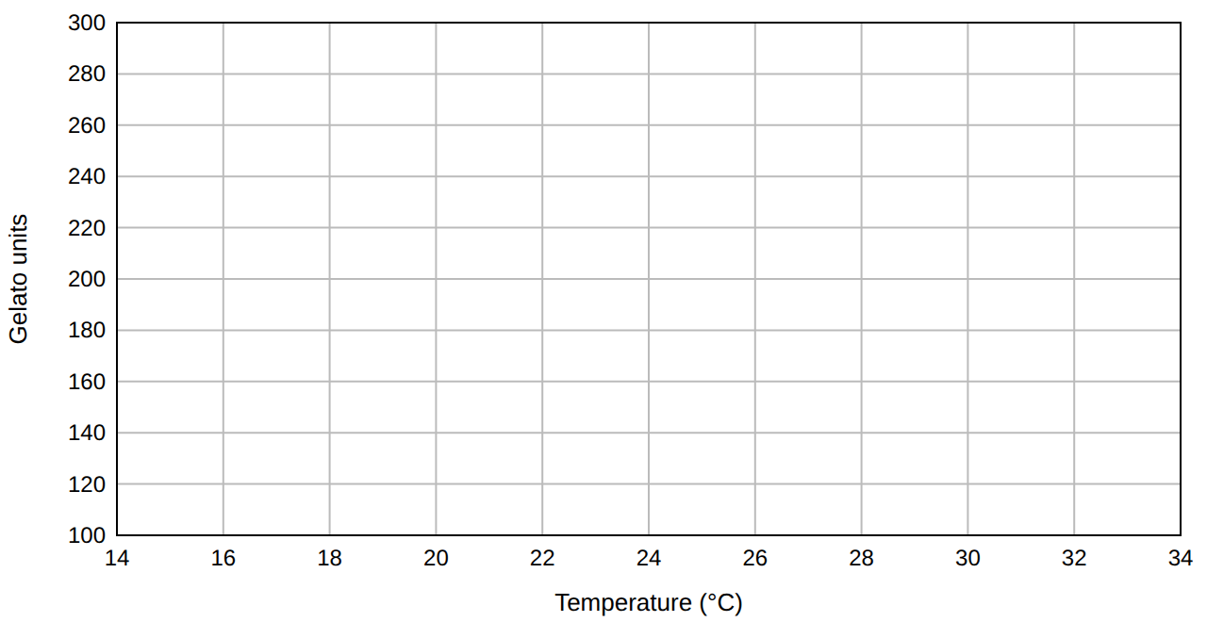
C2 | Regression by hand. Calculate the slope b = Sxy ÷ Sxx (2 decimals) and the intercept a = ȳ − b·x̄. Write the equation ŷ = a + b·x, then complete: “One more °C goes with about ______ servings gelato per day.” | 3 pts

C3 | Correlation. Calculate r = Sxy ÷ √(Sxx·Syy) and R². Say in plain words what R² tells you here (not “the line is right R² of the time”). | 2 pts

C4 | Predictions and residuals. Use your line from C2 (round a and b to 2 decimals). For the four days below, complete the table: predicted Gelato units, residual (actual − predicted) and absolute residual. Then calculate the MAE of the four predictions and name the day the model predicts worst. | 4 pts
Day | Temp | Actual | Predicted ŷ | Residual | |Residual|
Apr 8 | 22.2 | 168
May 10 | 21 | 227
May 15 | 23.5 | 191
May 21 | 24 | 186

MAE of the four predictions
Worst-predicted day

PART D · Spreadsheets and LINEST | ≈ 10 min · 12 pts

The 10 days are in a Google Sheet: row 1 holds headers and rows 2–11 hold the days. Columns: A date, B temperature_c, C weekend, D beach_event, E gelato_units. Part of the sheet is shown.
 | A | B | C | D | E | F | G | H
1 | date | temperature_c | weekend | beach_event | gelato_units |  | Statistic | Value
2 | Apr 8 | 22.2 | 0 | 0 | 168 |  | Mean units, weekend days
3 | Apr 18 | 22.3 | 0 | 0 | 181 |  | Weekend event days (count)
4 | May 10 | 21 | 1 | 0 | 227 |  | Predicted at 26
5 | May 15 | 23.5 | 0 | 0 | 191 |  | Correlation
6 | May 19 | 27.4 | 0 | 0 | 199
7 | May 21 | 24 | 0 | 0 | 186
8 | May 26 | 23.4 | 0 | 0 | 165
9 | Aug 2 | 30.9 | 1 | 1 | 294
10 | Aug 30 | 21.4 | 1 | 0 | 203
11 | Sep 14 | 19.9 | 1 | 1 | 176

D1 | Write the formula to type in each cell. Any correct form is accepted. | 3 pts
Cell | It should calculate… | Formula to type
H2 | the mean of column E on days where weekend = 1
H3 | the number of days where weekend = 1 and beach_event = 1
H4 | the predicted value of E for a day with B = 26, using the 10 days

D2 | Cell H5 should show the correlation between column B and column E, but a student typed =CORREL(B2:B10, E2:E11) and Sheets shows an error. (a) What is wrong? (b) Write the corrected formula. | 2 pts

LINEST output. Using all 168 days, a student fitted a multiple regression of gelato_units on temperature_c, beach_event, weekend (X columns in that order) with =LINEST(y, X, TRUE, TRUE). Sheets returned:
 | Col 1 | Col 2 | Col 3 | Col 4
Row 1 | 34.16 | 25.74 | 5.57 | 48.97
Row 2 | 3.85 | 4.27 | 0.52 | 11.86
Row 3 | 0.61 | 22.52 | #N/A | #N/A
Row 4 | 86.39 | 164.00 | #N/A | #N/A
Row 5 | 131402.67 | 83146.74 | #N/A | #N/A

D3 | Reading the coefficients. (a) Which column of Row 1 holds the temperature_c coefficient, and what is its value? (b) Interpret it in one sentence, holding the other variables constant. (c) What does the number in Row 1, Col 4 represent? | 3 pts

D4 | Evidence and error. (a) Calculate the t-statistic for beach_event and say whether it is statistically significant (|t| > 2). (b) The standard error of y in Row 3 is a typical size of a residual. Say what it means for a day’s gelato forecast. | 2 pts

D5 | Predict and check. On Jul 25: temperature_c = 28.3, beach_event = 1, weekend = 0; the café sold 243 units of gelato. Use the LINEST coefficients to calculate the predicted units and the residual. Is the residual larger than the typical size (Row 3, Col 2)? What does that tell you about this day? | 2 pts

PART E · Interpret & communicate | ≈ 5 min · 5 pts

E1 | On 30 June the café raised the gelato price from €4.00 to €4.50. Daily gelato units over all 168 days: before (n = 85) mean 183.2, sd 36.3; after (n = 83) mean 199.9, sd 33.5. (a) Calculate SE and t for the difference in means; is it statistically significant? (b) Give one reason the t-test alone cannot tell us the price change caused the difference, and name one variable you would add to a LINEST model to help. | 3 pts

E2 | Uncertainty and risk. Tomorrow is a hot (30 °C), event-day weekend (beach_event = 1, weekend = 1). (a) Use the LINEST model to give the predicted units and a range of prediction ± 2 × SE (SE = Row 3, Col 2). (b) Running out costs €4 profit per lost sale; unsold stock wastes €1.20 per serving. Which end of the range would you prepare for, and why? (risk = likelihood × consequence) | 2 pts

PART F · Your own idea | ≈ 4 min · 4 pts

A new variable might help explain gelato sales: rainfall_mm, wind_kmh, humidity_pct, sunshine_hours or the posted price. Choose one and write a mini-blueprint: (i) your hypothesis and why; (ii) the expected sign of its coefficient if added to the LINEST model above; (iii) which numbers in the LINEST output you would check (coefficient, SE, t, R², SE of y, residuals) and what you would look for; (iv) a result that would falsify you. Marked on clear, testable reasoning, not on being right.
F1 | Your mini-blueprint: | 4 pts

