MAT282 · FALL 2026 · MIDTERM FORM A · ANSWER KEY
Answer key Form A
Worked solutions and marking guide · 50 points · instructor copy: do not distribute before the exam
Read this first. Sample = 10 days. Round to 1 decimal place unless told. Apply follow-through (error carried forward) from B1 to C2, from C2 to C4. For C2/C4 accept a, b within ±0.05 of the printed values. Exact values: ȳ = 199.0; Sxx = 96.88; Sxy = 766.20; Syy = 13028; b = 7.909; a = 12.35.

1 · Quick answer sheet
Q | Expected answer | Pts | How the marks split
A1 | Direction + unit (trading day) + a falsifying result. Model: “On days with higher temperature, more gelato units are sold (r > 0); falsified if r ≤ 0 or a flat cloud.” | 2 | 1 direction + unit stated; 1 falsifier that is checkable in the data
A2 | Rising cloud of dots with an upward line; competing variable named with a direction (e.g. weekend ↑ sales, beach_event ↑, rain ↓). | 2 | 1 sketch consistent with hypothesis; 1 variable + direction
A3 | (a) e.g. units sold also reflect stock, price, weekend crowds, not “wanting” only; (b) reliability / comparability: same concept measured under changed conditions. | 2 | 1 + 1
B1 | Mean = 1990 ÷ 10 = 199.0; median = 188.5. | 2 | 1 each
B2 | Σ(Units − mean)² = 13028 · variance = 1447.6 · s = 38.0. (Dividing by 10 → 36.1: lose the variance/s marks only.) | 3 | 1 Σ (follow-through) + 1 variance + 1 s
B3 | Weekend: n = 4, mean 225.0 · Weekday: n = 6, mean 181.7. | 2 | 1 per group
B4 | (120 × 181.7 + 48 × 225.0) ÷ 168 = 194.0. Weekend days are over-sampled (4 of 10 = 40% vs 48/168 = 29%), so the plain mean is biased. | 2 | 1 calculation + 1 reason
B5 | Most extreme day: Aug 2 (294); z = (294 − 199.0) ÷ 38.0 = 2.50; |z| > 2 → outlier. Any defended decision (keep and report both ways is best: day is real and consistent with hot/event day; removal needs a documented error). | 2 | 1 z + flag; 1 justified decision
C1 | 10 dots within one minor grid square; × at (23.6, 199); straight line through ~×, balanced above/below, positive slope. | 3 | 1 dots; 1 ×; 1 line
C2 | b = 766.20 ÷ 96.88 = 7.91; a = 199.0 − 7.91 × 23.6 = 12.4; ŷ = 12.4 + 7.91x; one more unit of X goes with ≈ 7.9 more servings. | 3 | 1 b + 1 a + 1 sentence
C3 | r = 766.20 ÷ √(96.88 × 13028) = 0.68; R² = 0.47 → about 47% of the day-to-day variation in gelato units is associated with temperature; the rest is unexplained. | 2 | 1 r and R²; 1 interpretation (not “percent correct”)
C4 | Apr 8: ŷ 188.0, res −20.0; May 10: ŷ 178.5, res 48.5; May 15: ŷ 198.2, res −7.2; May 21: ŷ 202.2, res −16.2. MAE = 23.0. Worst: May 10 (|res| 48.5). | 4 | 1 predictions + 1 residual signs/values + 1 MAE + 1 worst day
D1 | H2 =AVERAGEIFS(E2:E11, C2:C11, 1) · H3 =COUNTIFS(C2:C11, 1, D2:D11, 1) · H4 =FORECAST(26, E2:E11, B2:B11) (= 218.0); AVERAGEIF is acceptable for H2; FORECAST argument order is x, known_y, known_x. | 3 | 1 each
D2 | (a) The ranges have different lengths (B2:B10 has 9 cells; E2:E11 has 10). (b) =CORREL(B2:B11, E2:E11). | 2 | 1 + 1
D3 | (a) Row 1 is reversed: Col 1 = weekend, Col 2 = beach_event, Col 3 = temperature_c = 5.57, Col 4 = intercept 48.97. (b) Each +1 °C goes with ≈ 5.57 more servings per day, holding the other variables fixed. (c) Intercept: expected units when all X = 0 (extrapolation: not meaningful here). | 3 | 1 mapping + 1 interpretation “holding constant” + 1 intercept
D4 | (a) t = 25.74 ÷ 4.27 = 6.03; |t| > 2 → significant. (b) SE of y = 22.5: a forecast typically misses the actual by about 23 servings; R² = 0.61. | 2 | 1 + 1
D5 | Predicted = 48.97 + … = 232.4; residual = 11 − 232.4 = 10.6; |residual| < 22.5: an ordinary day for the model. | 2 | 1 predicted + residual; 1 comparison/interpretation
E1 | SE = 5.39; difference = 16.7; t = 3.10 → significant. Observational before/after; season/temperature changed over the same dates (add temperature, event, weekend to LINEST). | 3 | 1 SE + 1 t and decision + 1 limitation/variable
E2 | Predicted = 276; range 231 to 321. Lost sale costs more than waste (4.00 vs 1.20) → prepare toward the upper end (accept any consistent likelihood × consequence reasoning). | 2 | 1 range + 1 reasoned choice
F1 | (i) clear hypothesis with a reason; (ii) expected sign; (iii) named LINEST cells (coef, SE, t, R², SE of y / residual pattern); (iv) concrete falsifier. Accept any listed variable. | 4 | 1 each

2 · Worked solutions
# | Date | X | Weekend | Event | Y | Y − mean | (Y − mean)²
1 | Apr 8 | 22.2 | 0 | 0 | 168 | −31.0 | 961.0
2 | Apr 18 | 22.3 | 0 | 0 | 181 | −18.0 | 324.0
3 | May 10 | 21 | 1 | 0 | 227 | 28.0 | 784.0
4 | May 15 | 23.5 | 0 | 0 | 191 | −8.0 | 64.0
5 | May 19 | 27.4 | 0 | 0 | 199 | 0.0 | 0.0
6 | May 21 | 24 | 0 | 0 | 186 | −13.0 | 169.0
7 | May 26 | 23.4 | 0 | 0 | 165 | −34.0 | 1156.0
8 | Aug 2 | 30.9 | 1 | 1 | 294 | 95.0 | 9025.0
9 | Aug 30 | 21.4 | 1 | 0 | 203 | 4.0 | 16.0
10 | Sep 14 | 19.9 | 1 | 1 | 176 | −23.0 | 529.0
 | Total |  |  |  | 1990 | 0.0 | 13028.0

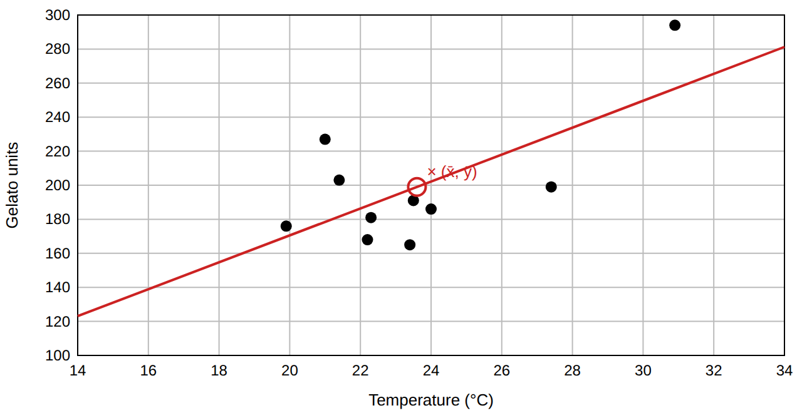
C1 key plot. Red line: ŷ = 12.4 + 7.91x. Residuals sum to ≈ 0 for the least-squares line (they do not for a by-eye line).
LINEST decode (all 168 days). Coefficients: weekend 34.16, event 25.74, temperature_c 5.57, intercept 48.97; R² = 0.61, SE of y = 22.5, F = 86.4, df = 164. Simple regression (temperature only): R² = 0.34, SE of y = 29.3.

