MAT282 · FALL 2026 · MIDTERM FORM B · ANSWER KEY
Answer key Form B
Worked solutions and marking guide · 50 points · instructor copy: do not distribute before the exam
Read this first. Sample = 10 days. Round to 1 decimal place unless told. Apply follow-through (error carried forward) from B1 to C2, from C2 to C4. For C2/C4 accept a, b within ±0.05 of the printed values. Exact values: ȳ = 119.0; Sxx = 99.32; Sxy = 575.00; Syy = 5398; b = 5.789; a = −22.26.

1 · Quick answer sheet
Q | Expected answer | Pts | How the marks split
A1 | Direction + unit (trading day) + a falsifying result. Model: “On days with higher temperature, more iced coffee units are sold (r > 0); falsified if r ≤ 0 or a flat cloud.” | 2 | 1 direction + unit stated; 1 falsifier that is checkable in the data
A2 | Rising cloud of dots with an upward line; competing variable named with a direction (e.g. weekend ↑ sales, beach_event ↑, rain ↓). | 2 | 1 sketch consistent with hypothesis; 1 variable + direction
A3 | (a) e.g. units sold also reflect stock, price, weekend crowds, not “wanting” only; (b) reliability / comparability: same concept measured under changed conditions. | 2 | 1 + 1
B1 | Mean = 1190 ÷ 10 = 119.0; median = 118.5. | 2 | 1 each
B2 | Σ(Units − mean)² = 5398 · variance = 599.8 · s = 24.5. (Dividing by 10 → 23.2: lose the variance/s marks only.) | 3 | 1 Σ (follow-through) + 1 variance + 1 s
B3 | Weekend: n = 3, mean 135.3 · Weekday: n = 7, mean 112.0. | 2 | 1 per group
B4 | (120 × 112.0 + 48 × 135.3) ÷ 168 = 118.7. Weekend days are over-sampled (4 of 10 = 40% vs 48/168 = 29%), so the plain mean is biased. | 2 | 1 calculation + 1 reason
B5 | Most extreme day: Aug 2 (173); z = (173 − 119.0) ÷ 24.5 = 2.20; |z| > 2 → outlier. Any defended decision (keep and report both ways is best: day is real and consistent with hot/event day; removal needs a documented error). | 2 | 1 z + flag; 1 justified decision
C1 | 10 dots within one minor grid square; × at (24.4, 119); straight line through ~×, balanced above/below, positive slope. | 3 | 1 dots; 1 ×; 1 line
C2 | b = 575.00 ÷ 99.32 = 5.79; a = 119.0 − 5.79 × 24.4 = −22.3; ŷ = −22.3 + 5.79x; one more unit of X goes with ≈ 5.8 more cups. | 3 | 1 b + 1 a + 1 sentence
C3 | r = 575.00 ÷ √(99.32 × 5398) = 0.79; R² = 0.62 → about 62% of the day-to-day variation in iced coffee units is associated with temperature; the rest is unexplained. | 2 | 1 r and R²; 1 interpretation (not “percent correct”)
C4 | May 25: ŷ 119.6, res 3.4; Jun 29: ŷ 86.6, res 23.4; Aug 2: ŷ 156.7, res 16.3; Aug 8: ŷ 120.8, res 17.2. MAE = 15.1. Worst: Jun 29 (|res| 23.4). | 4 | 1 predictions + 1 residual signs/values + 1 MAE + 1 worst day
D1 | H2 =AVERAGEIFS(E2:E11, C2:C11, 1) · H3 =COUNTIFS(C2:C11, 1, D2:D11, 1) · H4 =FORECAST(26, E2:E11, B2:B11) (= 128.3); AVERAGEIF is acceptable for H2; FORECAST argument order is x, known_y, known_x. | 3 | 1 each
D2 | (a) The ranges have different lengths (B2:B10 has 9 cells; E2:E11 has 10). (b) =CORREL(B2:B11, E2:E11). | 2 | 1 + 1
D3 | (a) Row 1 is reversed: Col 1 = weekend, Col 2 = beach_event, Col 3 = temperature_c = 3.94, Col 4 = intercept 14.89. (b) Each +1 °C goes with ≈ 3.94 more cups per day, holding the other variables fixed. (c) Intercept: expected units when all X = 0 (extrapolation: not meaningful here). | 3 | 1 mapping + 1 interpretation “holding constant” + 1 intercept
D4 | (a) t = 13.30 ÷ 2.26 = 5.89; |t| > 2 → significant. (b) SE of y = 11.9: a forecast typically misses the actual by about 12 cups; R² = 0.68. | 2 | 1 + 1
D5 | Predicted = 14.89 + … = 139.8; residual = 6 − 139.8 = 6.2; |residual| < 11.9: an ordinary day for the model. | 2 | 1 predicted + residual; 1 comparison/interpretation
E1 | SE = 1.66; difference = −2.5; t = −1.52 → NOT significant. Observational before/after; season/temperature changed over the same dates (add temperature, event, weekend to LINEST). | 3 | 1 SE + 1 t and decision + 1 limitation/variable
E2 | Predicted = 164; range 140 to 188. Lost sale costs more than waste (4.00 vs 1.20) → prepare toward the upper end (accept any consistent likelihood × consequence reasoning). | 2 | 1 range + 1 reasoned choice
F1 | (i) clear hypothesis with a reason; (ii) expected sign; (iii) named LINEST cells (coef, SE, t, R², SE of y / residual pattern); (iv) concrete falsifier. Accept any listed variable. | 4 | 1 each

2 · Worked solutions
# | Date | X | Weekend | Event | Y | Y − mean | (Y − mean)²
1 | May 25 | 24.5 | 1 | 0 | 123 | 4.0 | 16.0
2 | May 27 | 22.2 | 0 | 0 | 101 | −18.0 | 324.0
3 | Jun 10 | 21.5 | 0 | 0 | 80 | −39.0 | 1521.0
4 | Jun 29 | 18.8 | 1 | 0 | 110 | −9.0 | 81.0
5 | Jul 23 | 27 | 0 | 0 | 119 | 0.0 | 0.0
6 | Aug 2 | 30.9 | 1 | 1 | 173 | 54.0 | 2916.0
7 | Aug 8 | 24.7 | 0 | 1 | 138 | 19.0 | 361.0
8 | Aug 12 | 24.8 | 0 | 1 | 122 | 3.0 | 9.0
9 | Aug 25 | 26.4 | 0 | 0 | 118 | −1.0 | 1.0
10 | Sep 17 | 23.2 | 0 | 0 | 106 | −13.0 | 169.0
 | Total |  |  |  | 1190 | 0.0 | 5398.0

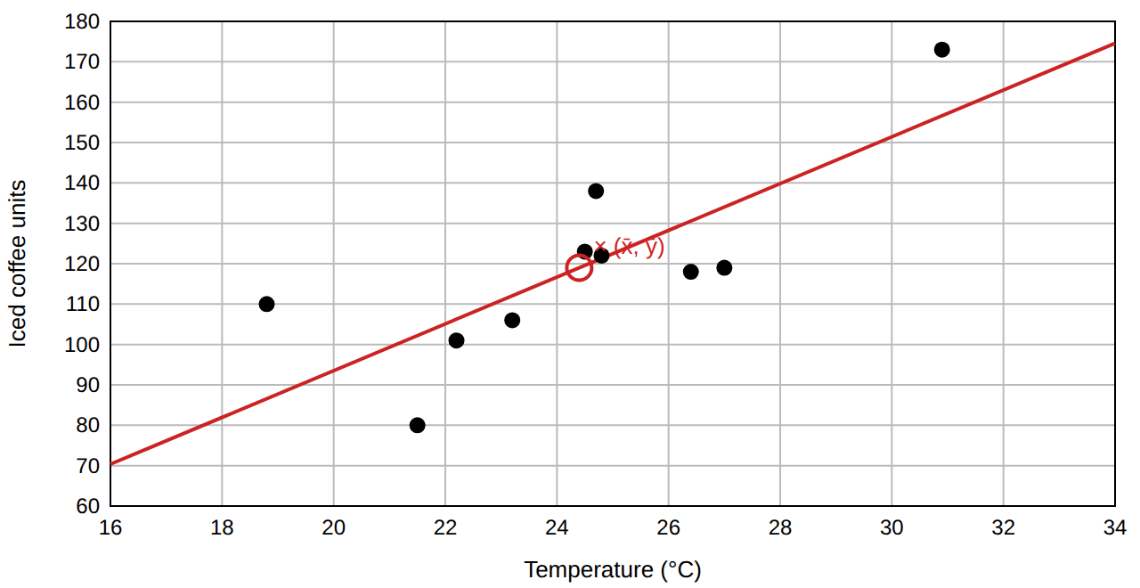
C1 key plot. Red line: ŷ = −22.3 + 5.79x. Residuals sum to ≈ 0 for the least-squares line (they do not for a by-eye line).
LINEST decode (all 168 days). Coefficients: weekend 17.72, event 13.30, temperature_c 3.94, intercept 14.89; R² = 0.68, SE of y = 11.9, F = 118.5, df = 164. Simple regression (temperature only): R² = 0.47, SE of y = 15.4.

