MAT282 · INTERMEDIATE STATISTICS · FALL 2026
Practice Midterm Form P · Practice
Practice for the midterm exam · not graded · use it to time yourself
Name: ______________________________________________
How this practice works
- The blueprint. The exam follows the steps of our analysis blueprint: hypothesis → data → describe → relate and predict → compute in Sheets → interpret.
- Not a copy of the real exam. This practice trains the same skills as the real midterm, but the questions are different and so are the results (for example, the variable you describe here has no outlier and the relationship is only moderate). If you can do every item here and explain why, you are ready. Memorizing these answers will not help.
- Time and points. 50 points, about 45 minutes. The suggested time is printed in each part’s banner.
- Show your work. Partial credit is given for correct steps, even if a final answer is wrong. Round to 1 decimal place unless told otherwise.
- Part A comes first. Do it before you look at the data page.
- What is marked. In Parts A, E and F you are marked on clear, testable thinking and an honest reading of the evidence, not on whether a hypothesis turns out to be right.
- Allowed: pencil or pen, eraser, ruler, calculator (a phone may be used as a calculator only). Not allowed: notes, books, any other use of a phone, talking.
Part | What it covers | Points | Score
A | Hypothesis & prediction (before the data) | 6
B | Describe the data | 11
C | Relate, predict and check the errors | 12
D | Spreadsheets and LINEST | 12
E | Interpret & communicate | 5
F | Your own idea | 4
Total |  | 50

About the data
A seaside café recorded sales and weather for 168 consecutive trading days (7 April–21 September 2025). These are synthetic teaching data, simulated for this course, not real café records. You work with a sample of 10 of those days; Parts D and E also use results from all 168 days. Each row is one day.
Variable | Concept: what we want to know | Operationalization: what was measured
Sunshine (X) | How sunny the day was | Hours of sunshine during opening hours
Iced coffee units (Y) | How much iced coffee customers buy | Number of standard iced coffees sold that day (no stock-outs or closures)
weekend | Weekend trading | 1 if Saturday or Sunday, 0 otherwise
beach_event | A crowd-pulling event nearby | 1 if an organised public event took place on the nearby beach, 0 otherwise
post_change | Before / after the 30 June price policy | 0 up to 30 June, 1 from 1 July

PART A · Hypothesis & prediction (before the data) | ≈ 5 min · 6 pts

Research question. Across trading days, is sunshine related to how many iced coffees the café sells? (Sunshine = X, the explanatory variable; Iced coffee units = Y, the outcome.)
A1 | Below are three hypotheses a student wrote. (a) For each one, write ✓ or ✗ in each row. (b) Rewrite the weakest hypothesis so that it gets three ✓. | 2 pts
 | (i) “Sunshine affects iced coffee sales.” | (ii) “On sunnier days more iced coffees are sold.” | (iii) “People who like the sun drink more iced coffee.”
Says which direction the relationship goes
Is about days (our unit of analysis)
Our daily data could show it wrong

A2 | The hypothesis is: “On sunnier days more iced coffees are sold.” Each plot shows sunshine (horizontal) and iced coffee units (vertical) for different imaginary cafés. (a) Mark each plot supports, falsifies or unclear. (b) For the plot you marked unclear, say what you would do next. | 2 pts
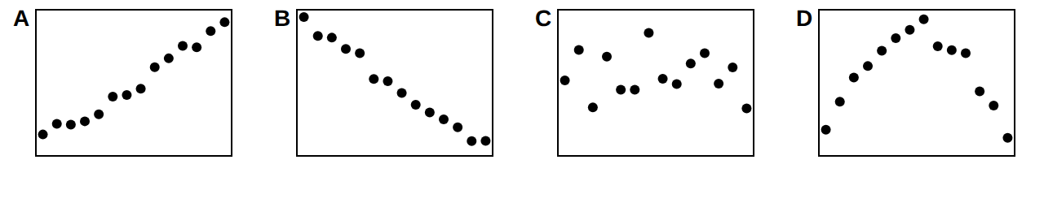
Plot | A | B | C | D
supports / falsifies / unclear

A3 | Classify each scenario as a validity problem (the number does not capture the concept) or a reliability / comparability problem (the number would change if measured again or under different conditions). Then explain one choice in a sentence. | 2 pts
Scenario | Validity or reliability?
1. Two baristas count iced coffees at closing and their counts differ by a few cups most days.
2. The café uses “iced coffees sold” as a measure of how much customers enjoyed the coffee.
3. Sunshine in April is measured by a sensor in the shade; in August by a new sensor in full sun, and the two are compared directly.

Stop. Finish Part A before you turn the page.

PART B · Describe the data | ≈ 9 min · 11 pts

The table lists a sample of 10 days in date order. In this part you describe Iced coffee units (Y). The last two columns are for B2.
# | Date | Sun (h) | Weekend | Event | Iced coffee units | Units − mean | (Units − mean)²
1 | Apr 21 | 5.4 | 0 | 0 | 111
2 | May 7 | 3.2 | 0 | 0 | 91
3 | Jun 1 | 5.9 | 1 | 0 | 107
4 | Jul 12 | 8.7 | 1 | 0 | 146
5 | Jul 13 | 11.2 | 1 | 0 | 136
6 | Jul 16 | 6.4 | 0 | 0 | 126
7 | Jul 28 | 8.3 | 0 | 0 | 103
8 | Jul 29 | 9.9 | 0 | 1 | 117
9 | Aug 3 | 5.8 | 1 | 1 | 131
10 | Aug 12 | 4.2 | 0 | 1 | 122

Reference (use on any question)
mean = Σvalues ÷ n · sample sd: s = √[Σ(value − mean)² ÷ (n − 1)] · z = (value − mean) ÷ s · flag a value as an outlier if |z| > 2
slope b = Sxy ÷ Sxx · intercept a = ȳ − b·x̄ · prediction ŷ = a + b·x · r = Sxy ÷ √(Sxx·Syy) · R² = r² (Sxx = Σ(x−x̄)², Sxy = Σ(x−x̄)(y−ȳ), Syy = Σ(y−ȳ)²)
residual = actual − predicted · mean absolute error (MAE) = average of |residual| · weighted mean = Σ(weight × value) ÷ Σweights
difference of means: SE = √(s₁²/n₁ + s₂²/n₂), t = (mean₂ − mean₁) ÷ SE · treat |t| > 2 as statistically significant (5% level)
coefficient t = coefficient ÷ its standard error · LINEST(y, X, TRUE, TRUE) returns, for X columns in order 1…k: Row 1 coefficients in reverse order (column k first … column 1, intercept last) · Row 2 their standard errors · Row 3: R², SE of y (typical size of a residual) · Row 4: F, df · Row 5: SS regression, SS residual
risk = likelihood × consequence

B1 | Centre. Calculate the mean and median of Iced coffee units. Is there a mode? If no value repeats, write “none”. | 2 pts
Mean
Median
Mode

B2 | Spread. Use your mean from B1 to complete the last two columns of the table. Then fill in the results below (1 decimal place). | 3 pts
Σ (Units − mean)²
Variance = Σ ÷ (n − 1)
s = √variance

B3 | Counting with conditions (what COUNTIF / AVERAGEIF do). (a) How many of the 10 days had at least 8 hours of sunshine? (b) What is the mean Iced coffee units on those days, and on the other days? | 2 pts
Group | Days (n) | Mean units
Sun ≥ 8 h
Sun < 8 h

B4 | Variable weights. To forecast next Saturday’s iced coffee units the manager gives weight 50% to the latest Saturday (131 units), 30% to the one before (124) and 20% to the oldest (118). Calculate the weighted forecast. Would the plain average of the three Saturdays be higher or lower, and why? | 2 pts

B5 | Outliers. (a) Calculate the z-score of the highest and the lowest day in the table. Using |z| > 2, is either an outlier? (b) A new day has 195 units. Calculate its z-score and say whether you would investigate it. | 2 pts

PART C · Relate, predict and check the errors | ≈ 10 min · 12 pts

Use the grid: Sunshine on the horizontal axis and Iced coffee units on the vertical axis. Sheets reports for the 10 days: x̄ = 6.9, Sxx = 58.38, Sxy = 196.10, Syy = 2472; ȳ is your B1 answer.
C1 | Plot all 10 days as dots. Mark the point of means with a ×. Then draw the line of best fit by eye. | 3 pts
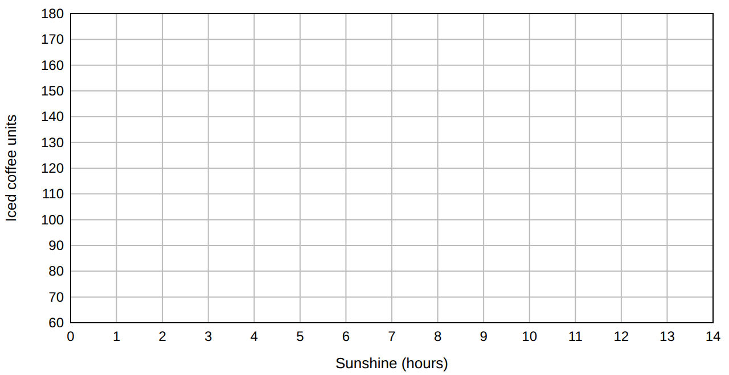
C2 | Regression by hand. Calculate the slope b = Sxy ÷ Sxx (2 decimals) and the intercept a = ȳ − b·x̄. Write ŷ = a + b·x and complete: “One more hour of sunshine goes with about ______ more iced coffees per day.” | 3 pts

C3 | Correlation and a repair. (a) Calculate r = Sxy ÷ √(Sxx·Syy) and R². (b) A student writes: “r = 0.52 means 52% of days show higher sales when it is sunnier.” Correct the claim in one sentence. | 2 pts

C4 | Predictions, residuals and a residual plot. Use your line from C2. (a) Complete the table for the four days. (b) Calculate the MAE. (c) Plot the four residuals (vertical) against sunshine (horizontal) on the grid and say in one sentence what a good model’s residual plot would look like. | 4 pts
Day | Sun | Actual | Predicted ŷ | Residual | |Residual|
Apr 21 | 5.4 | 111
Jul 12 | 8.7 | 146
Jul 28 | 8.3 | 103
Aug 12 | 4.2 | 122

MAE of the four predictions

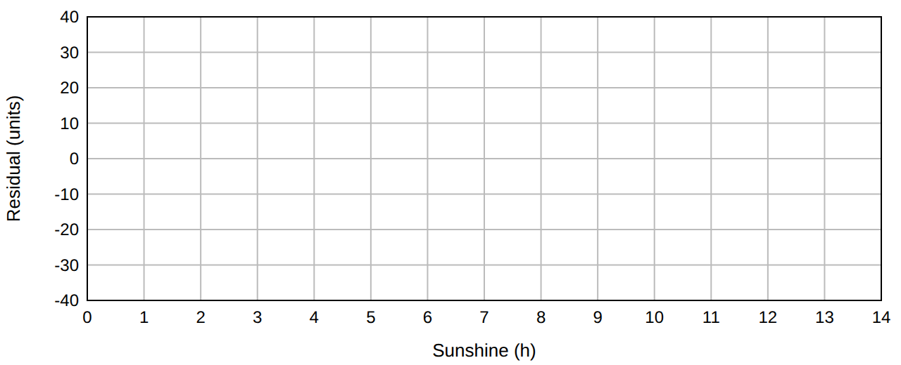

PART D · Spreadsheets and LINEST | ≈ 10 min · 12 pts

The 10 days are in a Google Sheet: row 1 holds headers, rows 2–11 hold the days. Columns: A date, B sunshine_hours, C weekend, D beach_event, E iced_coffee_units.
 | A | B | C | D | E | F | G | H
1 | date | sunshine_hours | weekend | beach_event | iced_coffee_units |  | Statistic | Value
2 | Apr 21 | 5.4 | 0 | 0 | 111 |  | Days with sunshine ≥ 8 h
3 | May 7 | 3.2 | 0 | 0 | 91 |  | Mean units on event days
4 | Jun 1 | 5.9 | 1 | 0 | 107 |  | Correlation, sun and units
5 | Jul 12 | 8.7 | 1 | 0 | 146 |  | Predicted at 8 h
6 | Jul 13 | 11.2 | 1 | 0 | 136
7 | Jul 16 | 6.4 | 0 | 0 | 126
8 | Jul 28 | 8.3 | 0 | 0 | 103
9 | Jul 29 | 9.9 | 0 | 1 | 117
10 | Aug 3 | 5.8 | 1 | 1 | 131
11 | Aug 12 | 4.2 | 0 | 1 | 122

D1 | Write the formula to type in each cell. Any correct form is accepted. | 3 pts
Cell | It should calculate… | Formula to type
H2 | the number of days with sunshine of at least 8 hours
H3 | the mean of column E on days where beach_event = 1
H4 | the correlation between sunshine and iced coffee units

D2 | In H5 a student typed =FORECAST(8, B2:B11, E2:E11) to predict iced coffee units for an 8-hour day. The result is not sensible. (a) What is wrong? (b) Write the corrected formula. | 2 pts

LINEST output. Using all 168 days, a student fitted a regression of iced_coffee_units on sunshine_hours, post_change, weekend (X columns in that order) with =LINEST(y, X, TRUE, TRUE). Sheets returned:
 | Col 1 | Col 2 | Col 3 | Col 4
Row 1 | 17.42 | 16.96 | 3.23 | 76.28
Row 2 | 2.39 | 2.33 | 0.47 | 3.40
Row 3 | 0.56 | 14.01 | #N/A | #N/A
Row 4 | 70.55 | 164.00 | #N/A | #N/A
Row 5 | 41556.68 | 32201.03 | #N/A | #N/A

D3 | Reading the output. (a) Which column of Row 1 holds the sunshine_hours coefficient and what is it? (b) Calculate the t-statistic for sunshine_hours and for post_change (|t| > 2 = significant). Which predictor has the stronger evidence? (c) Interpret the post_change coefficient in one sentence, holding the other variables constant. | 3 pts

D4 | Does adding variables help? A simple regression of iced coffee units on sunshine alone has R² = 0.28 and SE of y = 17.9. Compare these with the LINEST model above (Row 3). What do the changes mean for the typical size of a forecast error? | 2 pts

D5 | Predict and check. On Sep 21: sunshine_hours = 7.6, post_change = 1, weekend = 1; the café sold 144 iced coffees. Calculate the predicted units and the residual. Is it larger than the SE of y? What does that suggest? | 2 pts

PART E · Interpret & communicate | ≈ 5 min · 5 pts

E1 | On 30 June the café cut the iced coffee price from €3.50 to €3.10. Daily iced coffee units over all 168 days: before (n = 85) mean 101.4, sd 18.0; after (n = 83) mean 124.5, sd 17.2. (a) Calculate SE and t for the difference in means. (b) A colleague says: “t is huge, so the price cut caused the extra sales.” Give two reasons that is too strong. | 3 pts

E2 | Risk = likelihood × consequence. Tomorrow the café can stock 150 or 180 iced coffees. Stocking 150: 30% chance of running out (lost profit €120), 70% chance of leftovers (waste €20). Stocking 180: 10% chance of running out (€120), 90% chance of leftovers (waste €45). Calculate the expected loss of each and say which you would choose. | 2 pts

PART F · Your own idea | ≈ 4 min · 4 pts

In the full data the correlation between temperature and pastry units is r = −0.26 (weak and negative). The owner is surprised: “good weather is good for business.”
F1 | Give two different explanations: one about the data or measurement and one about the real world. Choose one to test first and describe (i) the analysis in Sheets (for example adding variables to LINEST), (ii) the numbers you would look at, and (iii) a result that would change your mind. | 4 pts

