MAT282 · INTERMEDIATE STATISTICS · FALL 2026
Midterm Exam Version A
Friday, October 9, 2026 · in class
Name: ____________________________________ Student ID: ____________________
How this exam works
- The scenario. You are the analyst for a seaside café. The owner wants to forecast tomorrow’s gelato units so the café orders the right amount of stock. You will choose variables, check them, compare models built with LINEST, test whether a model forecasts days it has not seen, and advise the owner.
- Reason like a modeller. “All models are wrong, but some are useful.” There is no single correct model. You are marked on whether your choices are sensible and defended with numbers, not on guessing the model I have in mind.
- Stage 1 comes first. It asks what you expect before any data. Finish it before you turn the page and do not change it afterwards; later questions ask you to look back at it.
- Time and points. 50 points. The suggested time for each stage is printed in its banner; together they come to about 55 minutes.
- Show your work. Partial credit is given for correct steps, even if a final answer is wrong. Round to 2 decimal places unless told otherwise. A reference sheet is on the last page.
- Allowed: pencil or pen, eraser, ruler, calculator (a phone may be used as a calculator only). Not allowed: notes, books, any other use of a phone or other devices, talking.
Stage | What it covers | Points | Score
1 | Think first: choose and defend your variables | 9
2 | Check each variable on its own | 7
3 | Check how the variables relate to each other | 7
4 | Build and compare models with LINEST | 13
5 | Does the model forecast unseen days? | 7
6 | Advise the owner and extend the model | 7
Total |  | 50

About the data
The café recorded sales and weather on 168 consecutive trading days (7 April–21 September 2025). The data are synthetic teaching data, simulated for this course, not real café records. The outcome you want to forecast is gelato_units: the number of two-scoop gelato cups sold that day. Assume the café can get a reliable weather forecast and the beach-event calendar the evening before, and that it sets its own prices.
Table 1. Candidate variables you may use to forecast the outcome.
Variable | What it measures
temperature_c | Daily mean outdoor temperature (°C) during opening hours
sunshine_hours | Hours of sunshine during opening hours
rainfall_mm | Rain (mm) during opening hours; 0 means a dry day
wind_kmh | Mean wind speed (km/h) during opening hours
humidity_pct | Mean relative humidity (%) during opening hours
beach_event | 1 if an organised public event is held on the nearby beach, 0 otherwise
weekend | 1 if Saturday or Sunday, 0 otherwise (derive from day_of_week)
gelato_price_eur | Posted price (€) of one standard two-scoop cup. Set by the café; on random days it tries a price ±€0.30 from the usual one
post_change | 0 before 30 June, 1 from 30 June (the day the café’s new price policy began; derive from date)
iced_coffee_units | Number of iced coffees sold that day
gelato_revenue_eur | gelato_price_eur × gelato_units (derive)

STAGE 1 · Think first: choose and defend your variables | ≈ 8 min · 9 pts

Research question. Which variables from the table on page 1 should the café use to forecast tomorrow’s gelato_units? Answer using only the table and your knowledge of how a café works: you have not seen any data yet.
1 | Choose your model. Pick four variables to include. For each, write the expected sign (+ or −) of its effect on gelato units and a short reason that explains how it would change sales. | 4 pts
Variable | Expected sign | Reason (a few words)

2 | Leave some out. Name two variables from the table that you would deliberately not use in a forecasting model, and give one reason for each. Your reasons must come from how the café works (think about when each number becomes known and what causes it), not from correlations, because you have not seen any. | 2 pts

3 | What would prove you wrong? Choose one of your four variables. Describe a LINEST result (a coefficient and/or its t-statistic) that would show your expectation was wrong. | 1 pt

4 | Data quality. beach_event is 1 on any day with an organised public event on the beach and 0 otherwise. (a) Describe one validity problem: how does this coding fail to capture the idea of a crowd-drawing event? (b) Describe one reliability problem: how could two people record the same day differently? | 2 pts

Stop. Finish Stage 1 before you turn the page. Do not change your Stage 1 answers after you see the data.

STAGE 2 · Check each variable on its own | ≈ 7 min · 7 pts

Table 2. Summary of all 168 days (Sheets: AVERAGE, MEDIAN, STDEV.S, MIN, MAX). Rainfall was exactly 0 mm on 133 of the 168 days.
Variable | Mean | Median | Std dev | Min | Max
temperature_c | 22.80 | 22.90 | 3.43 | 12.6 | 31.8
sunshine_hours | 7.17 | 7.35 | 2.48 | 1.0 | 13.0
rainfall_mm | 0.76 | 0.00 | 1.92 | 0.00 | 14.00
wind_kmh | 13.53 | 13.20 | 6.98 | 3.0 | 26.0
humidity_pct | 66.58 | 67.00 | 8.56 | 45.0 | 95.0
gelato_price_eur | 4.27 | 4.30 | 0.39 | 3.70 | 4.80
gelato_units | 191.44 | 192.00 | 35.84 | 106.00 | 294.00

Figure 1. Gelato units against rainfall for each of the 168 days, with the trendline Sheets draws. Many dots sit on top of each other at 0 mm.
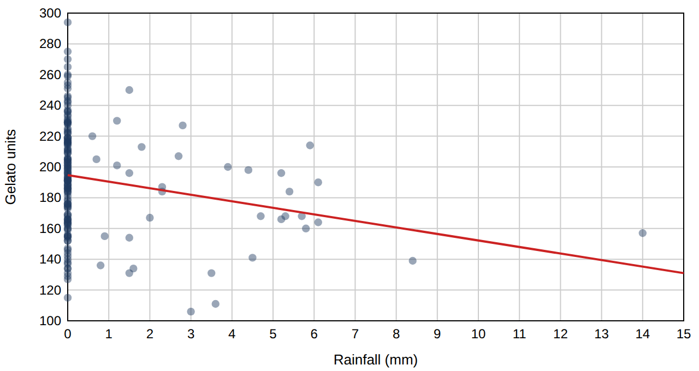
5 | Shape and extremes. (a) Calculate the z-score of the wettest day (rainfall_mm = 14.0) and of the hottest day (temperature_c = 31.8). (b) Use the mean and median in Table 2 to say whether rainfall_mm and temperature_c are symmetric or skewed, and in which direction. | 2 pts

6 | A weak predictor? Your intuition says rain should reduce gelato sales, yet r between rainfall_mm and gelato_units is only −0.23 (R² = 0.05). When rainfall_mm is added to Model 4 (Table 4), its t-statistic is −4.1. When the 11 days with 5 mm or more are removed (n = 157), it becomes −1.6. (a) Use Table 2 and Figure 1 to explain why rainfall_mm, measured in millimetres, is a weak predictor on most days. (b) What does the change in the t-statistic tell you about where the evidence for a rain effect comes from? (c) rainfall_mm is in column E of the sheet. Write the Sheets formula for row 2 that derives rainy_day (1 if there was any rain, 0 otherwise). | 3 pts

7 | An extreme outcome. The highest gelato_units is 294, on Aug 2: temperature_c 30.9, weekend, beach_event = 1, price €4.80. (a) Calculate its z-score. (b) A classmate says: “Delete it, it is an outlier.” Using the facts below, argue whether to delete it. Facts: Model 4 predicts 279 units for that day, and the SE of y for Model 4 is 19.6. Refitting the temperature-only model without that day changes its slope from 6.05 to 5.82. | 2 pts

STAGE 3 · Check how the variables relate to each other | ≈ 8 min · 7 pts

Table 3. Correlations (Sheets: CORREL) between gelato_units and the candidate predictors, all 168 days. Each cell is r for the row variable and the column variable (the table is symmetric, so only the lower half is shown).
 | units | temp | sun | rain | wind | humid | event | wkend | price
temperature_c | 0.58 | 1
sunshine_hours | 0.49 | 0.78 | 1
rainfall_mm | −0.23 | −0.15 | −0.33 | 1
wind_kmh | −0.01 | −0.06 | −0.01 | 0.00 | 1
humidity_pct | −0.36 | −0.46 | −0.42 | 0.47 | 0.10 | 1
beach_event | 0.40 | 0.19 | 0.09 | −0.13 | 0.16 | −0.16 | 1
weekend | 0.42 | −0.02 | −0.02 | 0.10 | −0.08 | 0.05 | 0.01 | 1
gelato_price_eur | 0.02 | 0.45 | 0.32 | −0.12 | 0.05 | −0.21 | 0.21 | −0.03 | 1
post_change | 0.26 | 0.56 | 0.40 | −0.17 | 0.07 | −0.25 | 0.30 | 0.00 | 0.76

8 | Find the patterns. (a) Which one predictor has the strongest linear relationship with gelato_units? Give its r. (b) List every pair of predictors with |r| > 0.7 (ignore the sign). | 2 pts

9 | Overlapping predictors. Take the pair of weather variables you found in 8(b). (a) Calculate r² for the pair and say what it means. (b) Explain why putting both in the same LINEST model is a problem. (c) For each pair in 8(b), say which variable you would keep, using both Table 3 and common sense. | 3 pts

10 | The simplest model, by hand. Use Tables 2 and 3 to build the simple regression of gelato_units on temperature_c: calculate the slope b = r × s_y ÷ s_x and the intercept a = ȳ − b × x̄, then predict gelato_units for a 28 °C day. | 2 pts

STAGE 4 · Build and compare models with LINEST | ≈ 14 min · 13 pts

Table 4. Five models of gelato_units fitted with LINEST(…, TRUE, TRUE) to all 168 days (k = number of predictors).
Model | Predictors | k | R² | SE of y
M1 | temperature_c | 1 | 0.335 | 29.31
M2 | temperature_c, sunshine_hours | 2 | 0.339 | 29.32
M3 | temperature_c, weekend, beach_event | 3 | 0.612 | 22.52
M4 | temperature_c, weekend, beach_event, gelato_price_eur | 4 | 0.707 | 19.63
M5 | temperature_c, sunshine_hours, rainfall_mm, wind_kmh, humidity_pct, beach_event, weekend, gelato_price_eur | 8 | 0.737 | 18.83

Table 5. Coefficients (standard errors) for two predictors in Models 1 and 2.
Model | temperature_c | sunshine_hours
M1 | 6.05 (0.66) | not in model
M2 | 5.28 (1.06) | 1.36 (1.47)

11 | Does adding sunshine help? (a) Calculate the t-statistic for temperature_c in M1 and in M2, and for sunshine_hours in M2. (b) Calculate the adjusted R² for M1 and M2 (n = 168). (c) Use Table 3 to explain what happened to the temperature_c coefficient and its standard error when sunshine_hours was added. | 3 pts

Table 6. The raw LINEST output for Model 4 (gelato_units on temperature_c, weekend, beach_event, gelato_price_eur; X columns in that order), all 168 days.
 | Col 1 | Col 2 | Col 3 | Col 4 | Col 5
Row 1 | −32.47 | 29.83 | 33.47 | 7.12 | 151.66
Row 2 | 4.47 | 3.76 | 3.35 | 0.50 | 17.50
Row 3 | 0.71 | 19.63 | #N/A | #N/A | #N/A
Row 4 | 98.50 | 163.00 | #N/A | #N/A | #N/A
Row 5 | 151763.41 | 62785.99 | #N/A | #N/A | #N/A

12 | Decode the LINEST output. (a) Match each number in Row 1 to its variable (or the intercept). (b) Calculate the t-statistic for the price variable and interpret its coefficient in one sentence, holding the other variables constant. (c) Look back at your Stage 1 answers: name one expectation that LINEST supports, and one that it does not support (or one variable you left out that LINEST says matters). | 3 pts

13 | A price paradox. The café raised the gelato price on 30 June. Daily gelato units: before (n = 84) mean 182.1, sd 35.3; after (n = 84) mean 200.7, sd 34.1. (a) Calculate the SE of the difference and t; is the difference statistically significant? (b) The owner concludes “higher prices raise sales”, yet the price coefficient in Model 4 is −32.47 (t = −7.3). Explain how both can be true. (c) Table 3 shows r ≈ 0.02 between price and gelato_units. Why can a variable that matters have r near 0 with the outcome? | 3 pts

14 | Predict, then check the residual. Use Model 4 (Table 6) to predict gelato_units for each day below and calculate the residual (actual − predicted). Call a day unusual if |residual| > 2 × SE of y (19.6). Then say what you would do about an unusual day. | 2 pts
Day | Model 4 inputs | Actual | Predicted
May 21 | temperature_c = 24, weekend = 0, beach_event = 0, gelato_price_eur = 4.3 | 186
Sep 4 | temperature_c = 25, weekend = 0, beach_event = 0, gelato_price_eur = 4.5 | 127

15 | Let the residuals guide you. Figure 2 plots the residuals of Model 1 (temperature only). Table 7 gives their mean by group. (a) Which one omitted variable should you add first, with what sign, and how can you tell from the figure and the table? (b) On the empty axes, sketch the residual plot you would hope to see for the improved model. | 2 pts
Figure 2. Residuals of Model 1 against temperature, one dot per day: red filled dots are weekend days, hollow dots are weekdays. The dashed line is zero.
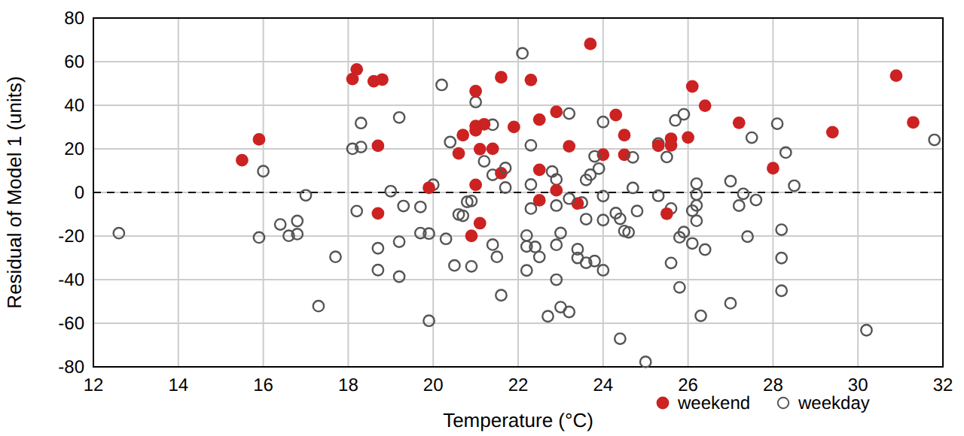
Table 7. Mean residual of Model 1 by group (all 168 days).
Group | Days | Mean residual (units)
weekend = 1 | 48 | +24.7
weekend = 0 | 120 | −9.9
beach_event = 1 | 37 | +19.9
beach_event = 0 | 131 | −5.6
price ≤ €4.00 | 57 | +9.2
price between | 49 | −0.3
price ≥ €4.50 | 62 | −8.2

Space for your sketch in 15(b):
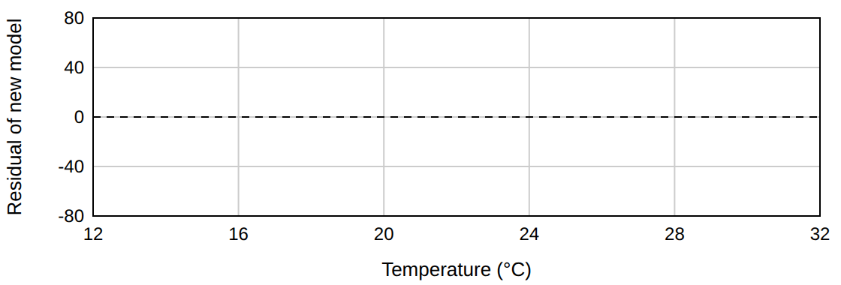

STAGE 5 · Does the model forecast unseen days? | ≈ 8 min · 7 pts

Models 4 and 5 were refitted using only the first 112 days (7 April–27 July). Their R² on those 112 days is 0.708 (M4) and 0.752 (M5). Table 8 shows 4 of the 56 later days that neither model has seen. A third forecaster, the baseline, uses no model: it takes a weighted average of the last three same-weekday sales with weights 0.5 (one week ago), 0.3 (two weeks ago) and 0.2 (three weeks ago).
Table 8. Four unseen days.
Day | Actual | 1 week ago | 2 weeks ago | 3 weeks ago | M4 predicts | M5 predicts
Aug 3 | 205 | 275 | 201 | 233 | 204.8 | 208.6
Aug 8 | 219 | 166 | 243 | 199 | 202.5 | 200.4
Aug 18 | 140 | 224 | 201 | 191 | 161.2 | 161.5
Aug 19 | 212 | 195 | 188 | 246 | 192.0 | 195.1

Table 9. Space for your errors.
16 | Compute the forecast errors. (a) Calculate the baseline forecast for each day. (b) Complete Table 9 with the absolute error of each forecaster on each day, and the MAE of each. (1 mark for the baseline forecasts, 2 for the errors, 2 for the three MAEs.) | 5 pts
Day | Baseline forecast | |error| baseline | |error| M4 | |error| M5
Aug 3
Aug 8
Aug 18
Aug 19
MAE | —

17 | In-sample fit versus forecasting. M5 has the higher R² on the 112 training days. (a) Explain why that does not guarantee that M5 forecasts unseen days better. (b) Which model would you give the owner, and why? Think about what the café would have to know the evening before. | 2 pts

STAGE 6 · Advise the owner and extend the model | ≈ 8 min · 7 pts

18 | Advice for the owner. Write 3–4 sentences to the owner, who has no statistics background. Say which variables you recommend using to forecast gelato units, how far off a typical forecast will be (use a number from this exam, in cups), and one thing the model cannot tell the owner. | 3 pts

19 | Your own idea. The owner can start recording one new column of data tomorrow. Choose a variable that is not in the table on page 1. Tell me: (i) what it is and exactly how it would be measured; (ii) the sign you expect and why; (iii) how you would use LINEST and unseen days to decide whether it earns a place in the model; (iv) a result that would show you were wrong. Your reasoning matters more than being right. | 4 pts

Reference sheet (you may use this on any question)
z-score = (value − mean) ÷ s · treat |z| > 2 as unusual
t-statistic = coefficient ÷ its standard error · treat |t| > 2 as statistically significant (5% level)
r² = share of variation shared by two variables · two predictors with |r| > 0.7 overlap heavily
Simple regression from summaries: slope b = r × s_y ÷ s_x · intercept a = ȳ − b × x̄ · prediction ŷ = a + b × x
Residual = actual − predicted · MAE (mean absolute error) = average of the absolute residuals
Adjusted R² = 1 − (1 − R²)(n − 1) ÷ (n − k − 1), n = number of days, k = number of predictors
Difference of two means: SE = √(s₁²/n₁ + s₂²/n₂), t = (mean₂ − mean₁) ÷ SE
Weighted average = Σ(weight × value) ÷ Σ(weights)
LINEST(y, X, TRUE, TRUE) with k predictor columns returns 5 rows: Row 1 coefficients in reverse order (last X column first, … first X column, intercept last) · Row 2 their standard errors · Row 3: R², SE of y (typical size of a residual) · Row 4: F, df (= n − k − 1) · Row 5: SS regression, SS residual (#N/A fills the empty cells)

Scratch space
Write the question number beside anything you want marked.

— End of exam —

