MAT282 · INTERMEDIATE STATISTICS · FALL 2026
Midterm Exam Version B
Friday, October 9, 2026 · in class
Name: ____________________________________ Student ID: ____________________
40 points | Suggested working time 40 minutes
Use a basic calculator. Show your working. Allow about 7, 10, 7, 10 and 3 minutes for Sections 1–5, plus 3 minutes to read and check. Sections 1 and 5 are marked on clear reasoning, not on matching one “right” answer. The data are synthetic teaching data from a fictional seaside café.
Section | What it covers | Points | Score
1 | Choose the inputs | 8
2 | Read the LINEST output | 12
3 | Errors and outliers | 8
4 | Did the price change sales? | 9
5 | Summary for the owner | 3
Total |  | 40

SECTION 1 · Choose the inputs | 8 points · about 7 minutes

A seaside café wants to predict tomorrow’s iced coffee sales (cups) before it opens. Table 1 lists information it could use. Across 168 days of data, temperature and sunshine are strongly related to each other (r = 0.78). Their correlations with iced coffee sales are 0.68 (temperature) and 0.53 (sunshine).
Table 1. Candidate information.
# | Information
1 | Tomorrow’s temperature forecast (°C)
2 | Tomorrow’s sunshine forecast (hours)
3 | Whether tomorrow is a weekend (yes or no)
4 | Whether a beach event is on the calendar tomorrow (yes or no)
5 | Tomorrow’s planned iced coffee price (€)
6 | Tomorrow’s iced coffee revenue (€), calculated after closing

1a | Choose three inputs for the model. For each, say whether it should push iced coffee sales up or down, and give a one-line reason. | 3 pts
Input (name or number) | Up or down? | Reason (one line)

1b | One candidate in Table 1 is unsuitable for this forecast. Which one, and what is the problem? | 2 pts

1c | Should temperature and sunshine both go into the same model? Explain, and say which one you would keep. | 2 pts

1d | How would you check the model’s prediction errors on days that were not used to fit it? | 1 pt

SECTION 2 · Read the LINEST output | 12 points · about 10 minutes

A model of daily iced coffee sales (cups) was fitted to 168 days with =LINEST(y, X, TRUE, TRUE). The three X columns were entered in this order: X₁ = temperature (°C), X₂ = sunshine (hours), X₃ = weekend (1 = Saturday or Sunday, 0 = weekday). Use Table 2 to read Table 3.
Table 2. How LINEST lays out its results.
Col A (X₃) | Col B (X₂) | Col C (X₁) | Col D (Intercept) | Statistic description
Slope m₃ | Slope m₂ | Slope m₁ | Intercept (b) | Coefficients for: y = m₁x₁ + m₂x₂ + m₃x₃ + b
SE − m₃ | SE − m₂ | SE − m₁ | SE − Intercept | Standard error for each coefficient
R² | SE − Y | Blank | Blank | Quality of the model fit
F-statistic | df | Blank | Blank | Analysis of variance metrics
SS − Reg | SS − Resid | Blank | Blank | Sum of squares metrics

Table 3. LINEST output for the model (shaded cells are blank).
Col A | Col B | Col C | Col D
17.93 | −0.20 | 4.35 | 9.78
2.24 | 0.66 | 0.48 | 7.84
0.62 | 13.11
88.32 | 164
45558.77 | 28198.94

2a | Write the fitted equation, using the numbers in Table 3 and the variable names. | 2 pts

2b | Each statement below misreads the output. Rewrite each one correctly, keeping the units and conditions. | 3 pts
(i) | “Each extra hour of sunshine reduces iced coffee sales by 0.20 cups, so sunny days are bad for business.”
(ii) | “Warm weather makes each customer buy 4.35 more iced coffees for every °C.”
(iii) | “SE − Y = 13.11 means every forecast is wrong by exactly 13 cups.”

2c | A coefficient is clearly different from zero if it is more than 2 standard errors away from zero. (a) Which one predictor is not? Show the comparison. (b) Use Section 1 to suggest why. (c) What would you do with this predictor? | 3 pts

2d | Tomorrow is forecast to be 24 °C with 6 hours of sunshine on a weekend. (a) Predict iced coffee sales. (b) Use SE − Y to give a rough range: prediction ± 2 × SE − Y. (c) Actual sales turn out to be 118 cups. Is that surprising? Explain. | 4 pts

SECTION 3 · Errors and outliers | 8 points · about 7 minutes

3a · Errors. Sales and errors are in cups. These are constructed exercise numbers, not workbook output. Residual = actual − predicted. MAE = (sum of the absolute residuals) ÷ n.
Day | Actual | Predicted | Residual
Tue | 100 | 108
Sun |  | 120 | +10
Thu | 96 |  | +3

3a-i | Fill the blanks in the table. | 1 pt
3a-ii | Calculate the MAE of these predictions. | 1 pt

3a-iii | Model Z has residuals of +5, +5, +5 on the same three days. Which model has the lower MAE? What do the identical signs tell you about Model Z? | 2 pts

3b · Outliers. Table 4 and Figure 1 show iced coffee sales on 8 days (constructed example). Table 5 gives the straight-line results with and without Day 8.
Day | 1 | 2 | 3 | 4 | 5 | 6 | 7 | 8
Temperature (°C) | 16 | 18 | 20 | 22 | 24 | 26 | 28 | 31
Sales (cups) | 80 | 84 | 99 | 100 | 116 | 118 | 131 | 146

Table 5. Results for the straight line (sales against temperature).
 | All 8 days | Without Day 8
Slope (cups per °C) | 4.41 | 4.25
R² | 0.98 | 0.97
SE − Y (cups) | 3.43 | 3.55

Figure 1. The 8 days, with the line fitted to all of them (dashed) and the line fitted without Day 8 (solid).
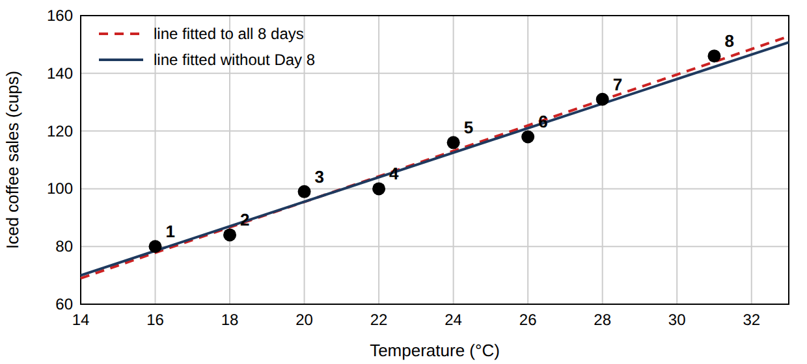
A classmate says: “Delete Day 8, it is an outlier.”
3b-i | Does Day 8 follow the pattern of the other days? How can you tell from Figure 1? | 1 pt
3b-ii | What impact does Day 8 have on the slope and on R²? | 2 pts

3b-iii | Would you delete it? Give a reason. | 1 pt

SECTION 4 · Did the price change sales? | 9 points · about 10 minutes

On 30 June the café cut the iced coffee price from €3.50 to €3.10. Table 6 shows iced coffee sales (cups) on 5 weekdays before (Group 1) and 5 weekdays after (Group 2). The average temperature was 21 °C in the “before” sample and 25 °C in the “after” sample.
Formulas. s = √[ Σ(x − x̄)² ÷ (n − 1) ] · s_p = √[ ((n₁ − 1)s₁² + (n₂ − 1)s₂²) ÷ (n₁ + n₂ − 2) ] · t = (x̄₁ − x̄₂) ÷ [ s_p × √(1/n₁ + 1/n₂) ] · df = n₁ + n₂ − 2
For df = 8 the two-tailed 5% critical value is 2.31. A negative t only means that Group 2 has the larger mean.

Table 6. Worksheet (fill in the blank cells).
Day | Before (x₁) | x₁ − x̄₁ | (x₁ − x̄₁)² | After (x₂) | x₂ − x̄₂ | (x₂ − x̄₂)²
1 | 100 |  |  | 110
2 | 108 |  |  | 118
3 | 92 |  |  | 102
4 | 104 |  |  | 114
5 | 96 |  |  | 126
Sum
Mean x̄
s

4a | Complete Table 6: the two means, the two sums of squared deviations, and s for each group (2 decimals). | 3 pts
4b | Calculate s_p and t (2 decimals). | 2 pts

Sheets gives =T.TEST(B2:B6, C2:C6, 2, 2) = 0.021 (two-tailed, equal variances).
4c | (i) State the null hypothesis in words. (ii) Is the difference statistically significant at 5%? Explain using the p-value and your t. (iii) In plain words, what does p = 0.021 mean? | 3 pts

4d | The “after” days were warmer. What does that do to a conclusion that the price cut caused the rise? | 1 pt

SECTION 5 · Summary for the owner | 3 points · about 3 minutes

5 | Write 3–4 sentences to the café owner, who has no statistics background. Include: (i) which inputs you recommend for forecasting iced coffee sales and the main finding from the LINEST output; (ii) what the price test showed; (iii) one caution. | 3 pts

— End of exam —

