MAT282 · INTERMEDIATE STATISTICS · FALL 2026
Practice Midterm Form P · Practice
Practice for the midterm exam · not graded · use it to time yourself
Name: ____________________________________ Student ID: ____________________
40 points | Suggested working time 40 minutes
Use a basic calculator. Show your working. Allow about 7, 10, 7, 10 and 3 minutes for Sections 1–5, plus 3 minutes to read and check. Sections 1 and 5 are marked on clear reasoning, not on matching one “right” answer. The data are synthetic teaching data from a fictional seaside café. This practice trains the same skills as the real midterm through different questions and different results.
Section | What it covers | Points | Score
1 | Choose the inputs | 8
2 | Read the LINEST output | 12
3 | Errors and outliers | 8
4 | Did the price change sales? | 9
5 | Summary for the owner | 3
Total |  | 40

SECTION 1 · Choose the inputs | 8 points · about 7 minutes

A seaside café wants to predict tomorrow’s pastry sales (pastries) before it opens. Table 1 lists information it could use. Across 168 days of data, the planned price and the new-price-period flag are identical (r = 1.00). Temperature has a correlation of −0.26 with pastry sales and the weekend flag 0.50.
Table 1. Candidate information.
# | Information
1 | Tomorrow’s temperature forecast (°C)
2 | Tomorrow’s wind forecast (km/h)
3 | Whether tomorrow is a weekend (yes or no)
4 | Whether a beach event is on the calendar tomorrow (yes or no)
5 | Tomorrow’s planned pastry price (€)
6 | A “new price period” flag: 0 before 30 June, 1 from 30 June (the day the price rose)
7 | Tomorrow’s gelato sales (cups), counted at closing time

1a | Choose three inputs for the model. For each, say whether it should push pastry sales up or down, and give a one-line reason. | 3 pts
Input (name or number) | Up or down? | Reason (one line)

1b | One candidate in Table 1 is unsuitable for this forecast. Which one, and what is the problem? | 2 pts

1c | Should the planned price and the new-price-period flag both go into the same model? Explain, and say which one you would keep. | 2 pts

1d | How would you check the model’s prediction errors on days that were not used to fit it? | 1 pt

SECTION 2 · Read the LINEST output | 12 points · about 10 minutes

A model of daily pastry sales (pastries) was fitted to 168 days with =LINEST(y, X, TRUE, TRUE). The three X columns were entered in this order: X₁ = temperature (°C), X₂ = wind (km/h), X₃ = weekend (1 = Saturday or Sunday, 0 = weekday). Use Table 2 to read Table 3.
Table 2. How LINEST lays out its results.
Col A (X₃) | Col B (X₂) | Col C (X₁) | Col D (Intercept) | Statistic description
Slope m₃ | Slope m₂ | Slope m₁ | Intercept (b) | Coefficients for: y = m₁x₁ + m₂x₂ + m₃x₃ + b
SE − m₃ | SE − m₂ | SE − m₁ | SE − Intercept | Standard error for each coefficient
R² | SE − Y | Blank | Blank | Quality of the model fit
F-statistic | df | Blank | Blank | Analysis of variance metrics
SS − Reg | SS − Resid | Blank | Blank | Sum of squares metrics

Table 3. LINEST output for the model (shaded cells are blank).
Col A | Col B | Col C | Col D
11.53 | −0.18 | −0.81 | 84.76
1.53 | 0.10 | 0.20 | 4.98
0.33 | 8.95
26.34 | 164
6329.40 | 13133.74

2a | Write the fitted equation, using the numbers in Table 3 and the variable names. | 2 pts

2b | Each statement below misreads the output. Rewrite each one correctly, keeping the units and conditions. | 3 pts
(i) | “The negative temperature coefficient means pastries do not sell on warm days.”
(ii) | “Wind has a coefficient of only −0.18, so wind does not matter at all.”
(iii) | “R² = 0.33 means the model is wrong 67% of the time.”

2c | (a) By how much does predicted sales change on a day that is 5 °C warmer, everything else the same? (b) By how much does it change if the wind is 10 km/h stronger? (c) The temperature coefficient is negative. Give one possible real-world reason. | 3 pts

2d | Tomorrow is forecast to be 20 °C with a 12 km/h wind on a weekend. (a) Predict pastry sales. (b) Actual sales turn out to be 98 pastries: calculate the residual. (c) SE − Y is the typical size of a forecast error. Is your residual smaller or larger than SE − Y, and what does that say about this forecast? | 4 pts

SECTION 3 · Errors and outliers | 8 points · about 7 minutes

3a · Errors. Sales and errors are in pastries. These are constructed exercise numbers, not workbook output. Residual = actual − predicted. MAE = (sum of the absolute residuals) ÷ n.
Day | Actual | Predicted | Residual
Mon | 62 | 66
Sat |  | 74 | +10
Wed | 58 |  | −2
Fri | 65 | 69

3a-i | Fill the blanks in the table. | 1 pt
3a-ii | Calculate the MAE of these predictions. | 1 pt

3a-iii | Model Z has residuals of −3, −3, −3, −3 on the same four days. Which model has the lower MAE? What do the identical signs tell you about Model Z? | 2 pts

3b · Outliers. Table 4 and Figure 1 show pastry sales on 8 days (constructed example). Table 5 gives the straight-line results with and without Day 4.
Day | 1 | 2 | 3 | 4 | 5 | 6 | 7 | 8
Temperature (°C) | 16 | 18 | 20 | 22 | 24 | 26 | 28 | 30
Sales (pastries) | 75 | 74 | 70 | 96 | 66 | 67 | 63 | 61

Table 5. Results for the straight line (sales against temperature).
 | All 8 days | Without Day 4
Slope (pastries per °C) | −1.14 | −0.98
R² | 0.26 | 0.96
SE − Y (pastries) | 10.28 | 1.17

Figure 1. The 8 days, with the line fitted to all of them (dashed) and the line fitted without Day 4 (solid).
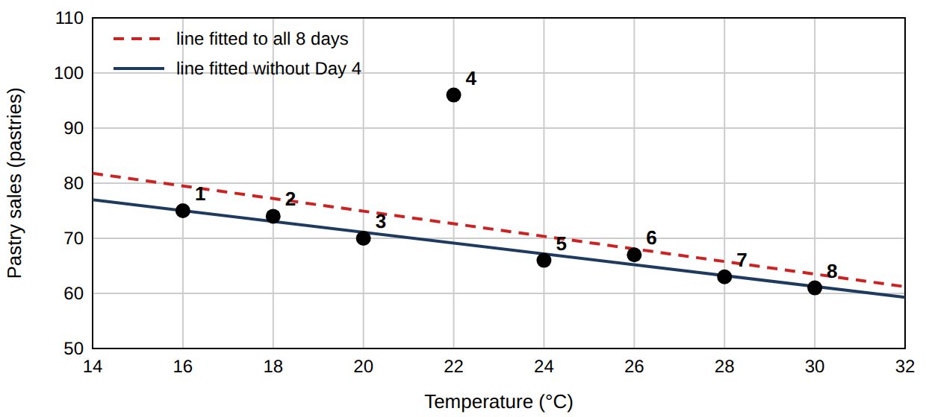
3b-i | Which day does not follow the pattern of the others? | 1 pt
3b-ii | Compare the results with and without that day. What impact does it have on the slope, and what impact on R²? | 2 pts

3b-iii | Before deleting it, what would you do? | 1 pt

SECTION 4 · Did the price change sales? | 9 points · about 10 minutes

On 30 June the café raised the pastry price from €2.50 to €2.75. Table 6 shows pastry sales (pastries) on 5 weekdays before (Group 1) and 5 weekdays after (Group 2). Both samples are weekdays with similar weather.
Formulas (as given in class):
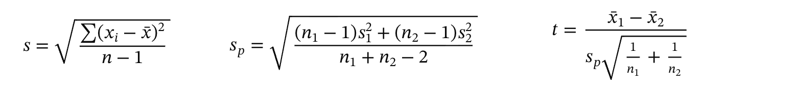
A negative t only means that Group 2 has the larger mean.
Table 6. Worksheet (fill in the blank cells).
Day | Before (x₁) | x₁ − x̄₁ | (x₁ − x̄₁)² | After (x₂) | x₂ − x̄₂ | (x₂ − x̄₂)²
1 | 66 |  |  | 63
2 | 70 |  |  | 67
3 | 62 |  |  | 59
4 | 68 |  |  | 65
5 | 64 |  |  | 61
Sum
Mean x̄
s

4a | Complete Table 6: the two means, the two sums of squared deviations, and s for each group (2 decimals). | 3 pts
4b | Calculate s_p and t (2 decimals). | 2 pts

Sheets gives =T.TEST(B2:B6, C2:C6, 2, 2) = 0.172 (two-tailed, equal variances).
4c | (i) State the null hypothesis in words. (ii) Is the difference statistically significant at 5%? Explain using the p-value. (iii) Does this result prove the price rise had no effect? Explain. | 3 pts

4d | Name one way to make a price effect easier to detect next time. | 1 pt

SECTION 5 · Summary for the owner | 3 points · about 3 minutes

5 | Write 3–4 sentences to the café owner, who has no statistics background. Include: (i) which inputs you recommend for forecasting pastry sales and the main finding from the LINEST output; (ii) what the price test showed; (iii) one caution. | 3 pts

— End of practice —

