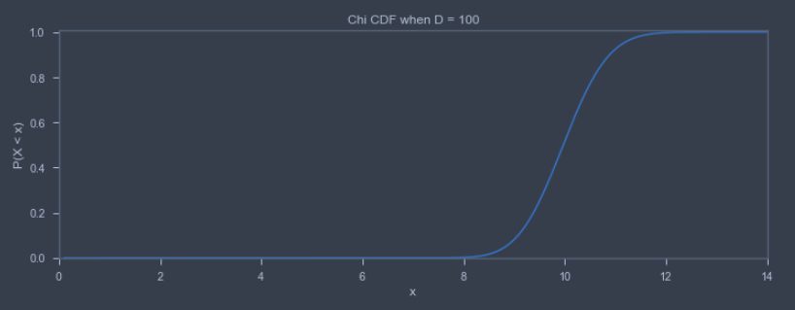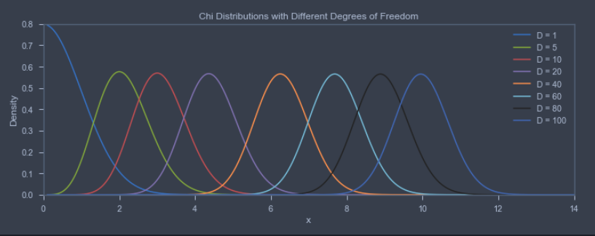**(b)**

**(c)**

**(d)** The mass is centered close to x = 10 and about 90% of the mass falls between 8.8 and 11.2.