2.5.

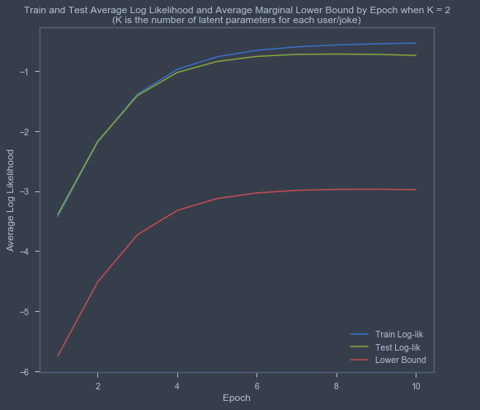

2.6. The shapes of the train and test average log-likelihood curves are pretty much the same-- the log-likelihoods increase as K increases. The average marginal likelihood lower bound decreases as K increases. This makes sense since increasing K increases the number of latent parameters to learn for each user and each joke.

