Chase Arnold
PyTD (Working Title)
Game Design Document

Chase Arnold
Date: (11/19/2015)

Table of Contents
PyTD 2
Technical 3
Hardware 3
Input 3
Output 3
Specifications 3
Software 4
Language 4
Dependencies 4
Game Overview 5
Game Concept 5
Genre 6
Target Audience 6
Game Flow Summary 6
Look & Feel 6
Gameplay and Mechanics 7
Gameplay 7
Game Progression 7
Level Structure 7
Objective 7
Play Flow 7
Mechanics 8
Combat 8
Economy 8
Screen Flow 9
Screen Flow Diagram 10
Game Options 11
Options Menu Options 11
File Options 11
Entities 12
Buildable Structures 12
Keywords 12
Defensive Structures 12
Electrical Structures 12
Enemy Types 13
Keywords 13
Ground 13
Flying 14
Artificial Intelligence 15
Enemy AI 15
Townsfolk AI 15
Keywords 16

PyTD
A unique Tower Defense game.

Technical

Hardware

Input
Mouse and keyboard will be the primary and possibly only input. Gamepad support may come in the future, but originally it will not be designed around gamepad's use.

Output
This should run on most current distributions of GNU/Linux, Windows, and Mac. Any system that supports Python 2.7 and the required libraries should be able to run the game.

Specifications
- | Minimum: | Recommended:
Operating System: | Windows; GNU/Linux; Mac
Resolution: | Any resolution at least 1280 x 720
Processor: | Dual Core | Dual Core @ >= 2.00 Ghz
Graphics: | Integrated | Video Card
Memory (RAM): | 1 GB | 2 GB

Software

Language
The game is written for Python 2.7, specifically, 2.7.10. Other sub-versions of 2.7 should work fine though.

Dependencies
Name: | Tested Version: | Purpose: | To Install:
Pygame | 1.9.1 | Graphics & Sounds Library | http://www.pygame.org/download.shtml
PyYAML | 3.11 | Human-readable serialization  (config files) | $ pip install PyYAML

Game Overview

Game Concept
PyTD is a game in which the player defends a town from being razed by various types of enemies. In each map (level) there will be a city, and the player will be in control of its defenses. The player will order structures to be built, and townsfolk will come out from the city's walls to build them. Townsfolk are effectively invincible as enemies won't attack them, the challenge comes out of having enough of them to build the desired defenses and managing them correctly. The townsfolk are also autonomous; If the player had to order them around it would quickly get tedious.
There are various types of building available to the player and some of these have requirements that must be met after being built in order to be functional. Some buildings must be manned by townsfolk, thus reducing the spare amount of townsfolk. Other buildings may require electric power which can be generated in yet another type of building.
When electric power is generated, it transmits wirelessly as wiring everything together would be a waste of the player's time. Some of the buildings that require power will be automatic, and not need to be manned by a villager at all, but all of the generators need to be manned by a villager to offset this. The more expensive generators will be more efficient and produce more electricity per villager than the cheaper models. Buildings that require power can be turned on or off from the UI. If a building is built that would need more power than the system could put out, it will be unable to be turned on, but the player could turn off another building to temporarily allow it's use.
Enemies come out of predefined enemy strongholds (caves, camps, off-screen, etc.) and head in the most direct path possible to the city. Different types of enemy will travel different speeds and different paths. If the enemies reach the city, the townsfolk die in some as yet undefined ratio. The game ends when there are not any townsfolk left.
The purpose of building the structures is to repel the enemies until all the waves are over and they stop coming. When enemies die they will drop money and building materials. Nearby villagers will run out to collect these, as they can then be used to build and upgrade city defenses. The game is won if the player can hold off long enough to survive all waves, the score is taken from the remaining townsfolk after this point is reached.
It will be easy to pick up, relatively easy to beat, but hard to get a perfect score.

Genre
PyTD is a Tower-Defense game at heart, which is itself a child of the Strategy category. It also fits into the Casual class of games.

Target Audience
Some cursory research has revealed that management and simulation games are a predominantly female market, but the more action oriented games are predominantly male. Casual games on the other hand tend to be played by people of all ages, but older players in particular are interested in them. Therefore, PyTD will be aimed at men above the age of 16 (due to blood, etc).

Game Flow Summary
The game begins with a short opening animation, after this the start menu is displayed. Once the start menu is passed, the game moves on to the level select screen which shows a map of cities (levels) that the player can chose from. Once a level is selected, it loads and the game proper begins. The player can exit from the game to the level select, start menu, or desktop at any time. When the game ends either from success, or failure, the option will be given to retry the level for a better score or to go back to the level select screen.

Look & Feel
The game will have a cartoon-like appearance while also being more adult at the same time. There will be blood. The game will be top-down at a slight angle, and it will not be grid-based. It will feature a minimalist User Interface, with little clutter, and few sub-menus to get lost in.

Gameplay and Mechanics

Gameplay

Game Progression
Each level will get a little tougher as the player moves through the level select screen. New enemies will attack, and they will come in greater numbers. Each level will last roughly as long as the last, so the actual time it takes to complete a level will not inflate, rather the strategy to be successful will need to evolve. In the boundaries of each level, the player will start off with a relatively empty field waiting to be used to build fortifications, and by the end of the level the player will have built and upgraded those defenses many times. Earlier levels will feature more of a village or hamlet, whereas later levels tend to have larger cities to defend.

Level Structure
In every level (map) there is a settlement of a certain size. The size of the settlement determines the number of starting citizens the player has to work with. Around the settlement is a relatively empty field sparsely filled with trees, shrubbery, and other obstacles. Also in the field are enemy spawn points, these are located usually at a distance from the settlement. Townsfolk are not visible when they are in the settlement, but when the need arises they can be seen scurrying along the field towards some end.

Objective
The objective of PyTD is to prevent enemies from reaching the town by killing them en-route. This objective is fulfilled when all the waves of enemies are survived and they stop their attack.
The secondary objective is to lose as few townsfolk as possible to obtain a high score.

Play Flow
At the beginning of every level the player is given starting funds to build the first defenses with, the amount given being dependent on the particular level. There may or may not be prebuilt structures depending again on the particular level. The player is given as much time as he needs to prepare for battle. The player will build defenses by selecting the building they want to buy from a menu, and then placing it on an empty tract of land. Once the player is done setting up defenses, he can initiate the first wave by pressing a button on the UI. In the game world an animation is played that gives a blurb of text saying something to the effect of “Hours pass. Enemies have been sighted in the distance.”
Enemies will begin to shuffle out of their spawn points and towards the city. Along their path, they will encounter the player's defenses and be damaged by them. When the enemies die, the resources they have dropped will accumulate and the player with use them to build additional towers during the attack. If an enemy manages to slip past the player's defenses and into the city, he will slay some townsfolk, and if townsfolk remain, be slain himself. If all of the townsfolk die and an enemy enters the town, he will kill the defensive commander (the player) and the game will end. After each wave ends, a grace period of 60 seconds is given for the player to fix up his defensive situation. This grace period will be able to be skipped using a UI button, and it will also be configurable from the start menu's options sub-menu.
Once the player has successfully defended every wave, the townsfolk will begin to dismantle all of the structures and then return to town. After all of the townsfolk have returned, and all of the structures are dismantled, the score is displayed to the player and achievements are handed out. These achievements have no gameplay value, but can be an incentive to complete particularly difficult challenges for the player. The player is then returned to the level select screen.

Mechanics

Combat
Different types of enemy will have different amounts of health. The player's warriors sent out of the barracks will also have a set amount of health. The player's defenses will hurt the enemies but the enemies will ignore every defense except for the melee warriors, which they will attack. The enemies will stop and fight the warrior until one of them dies due to their health dropping at or below zero. If the warrior dies, he will fall to the ground and slowly drag himself to the barracks where he will heal until he is ready to fight again. If medics from the medic tent are nearby, they will heal the warrior where he fell and he can return to battle much quicker. If the enemy dies, it's AI cycle ends and it will drop various resources.
There is no ammo and no cost beyond the initial cost for the use of medics, warriors, and any other defense that the player builds. The only exception being that electrical structures will always require a specific amount of power.

Economy
The player will start with an amount of money determined by the particular level that he is playing. This starting money will be used to build and upgrade the player's defenses. Those defenses in turn perform actions towards the goal of killing enemies, which drop money in addition to other resources. This forms a cycle of gaining and using money that ideally lasts through the entire level.

Screen Flow
- Shell -
The place the player was before he launched the game.
- Start Menu -
This screen will have buttons to transition into the help screen, the options menu screen, and the level select screen. There will also be a button to allow the player to change which save the game is using.
- Help -
This screen will list a variety of subjects which, when clicked on, will provide short descriptions of how they work.
- Options Menu -
This screen will offer the player a plethora of options that they can customize the game to their liking with.
- Level Select -
This screen will display a map of the region and the cities on the map are the levels offered to the player. When clicked on, the level associated with these cities is loaded into the game screen.
- Game -
This is the screen which the game is played on. Among many other things, there will be a button in the UI to allow the player to pause the game, transition him into the pause menu screen.
- Pause Menu -
This screen is overlaid on top of a paused state of the previous screen, the game screen. The pause menu screen background opacity is around 75%. This is to demonstrate visually to the player that they have not lost any progress, and are merely pausing the game if they so desire. The pause menu can also be used to transition out of the game screen and back to either the level select or the main menu. There will also be a button to quickly allow the player to restart the level.

Screen Flow Diagram
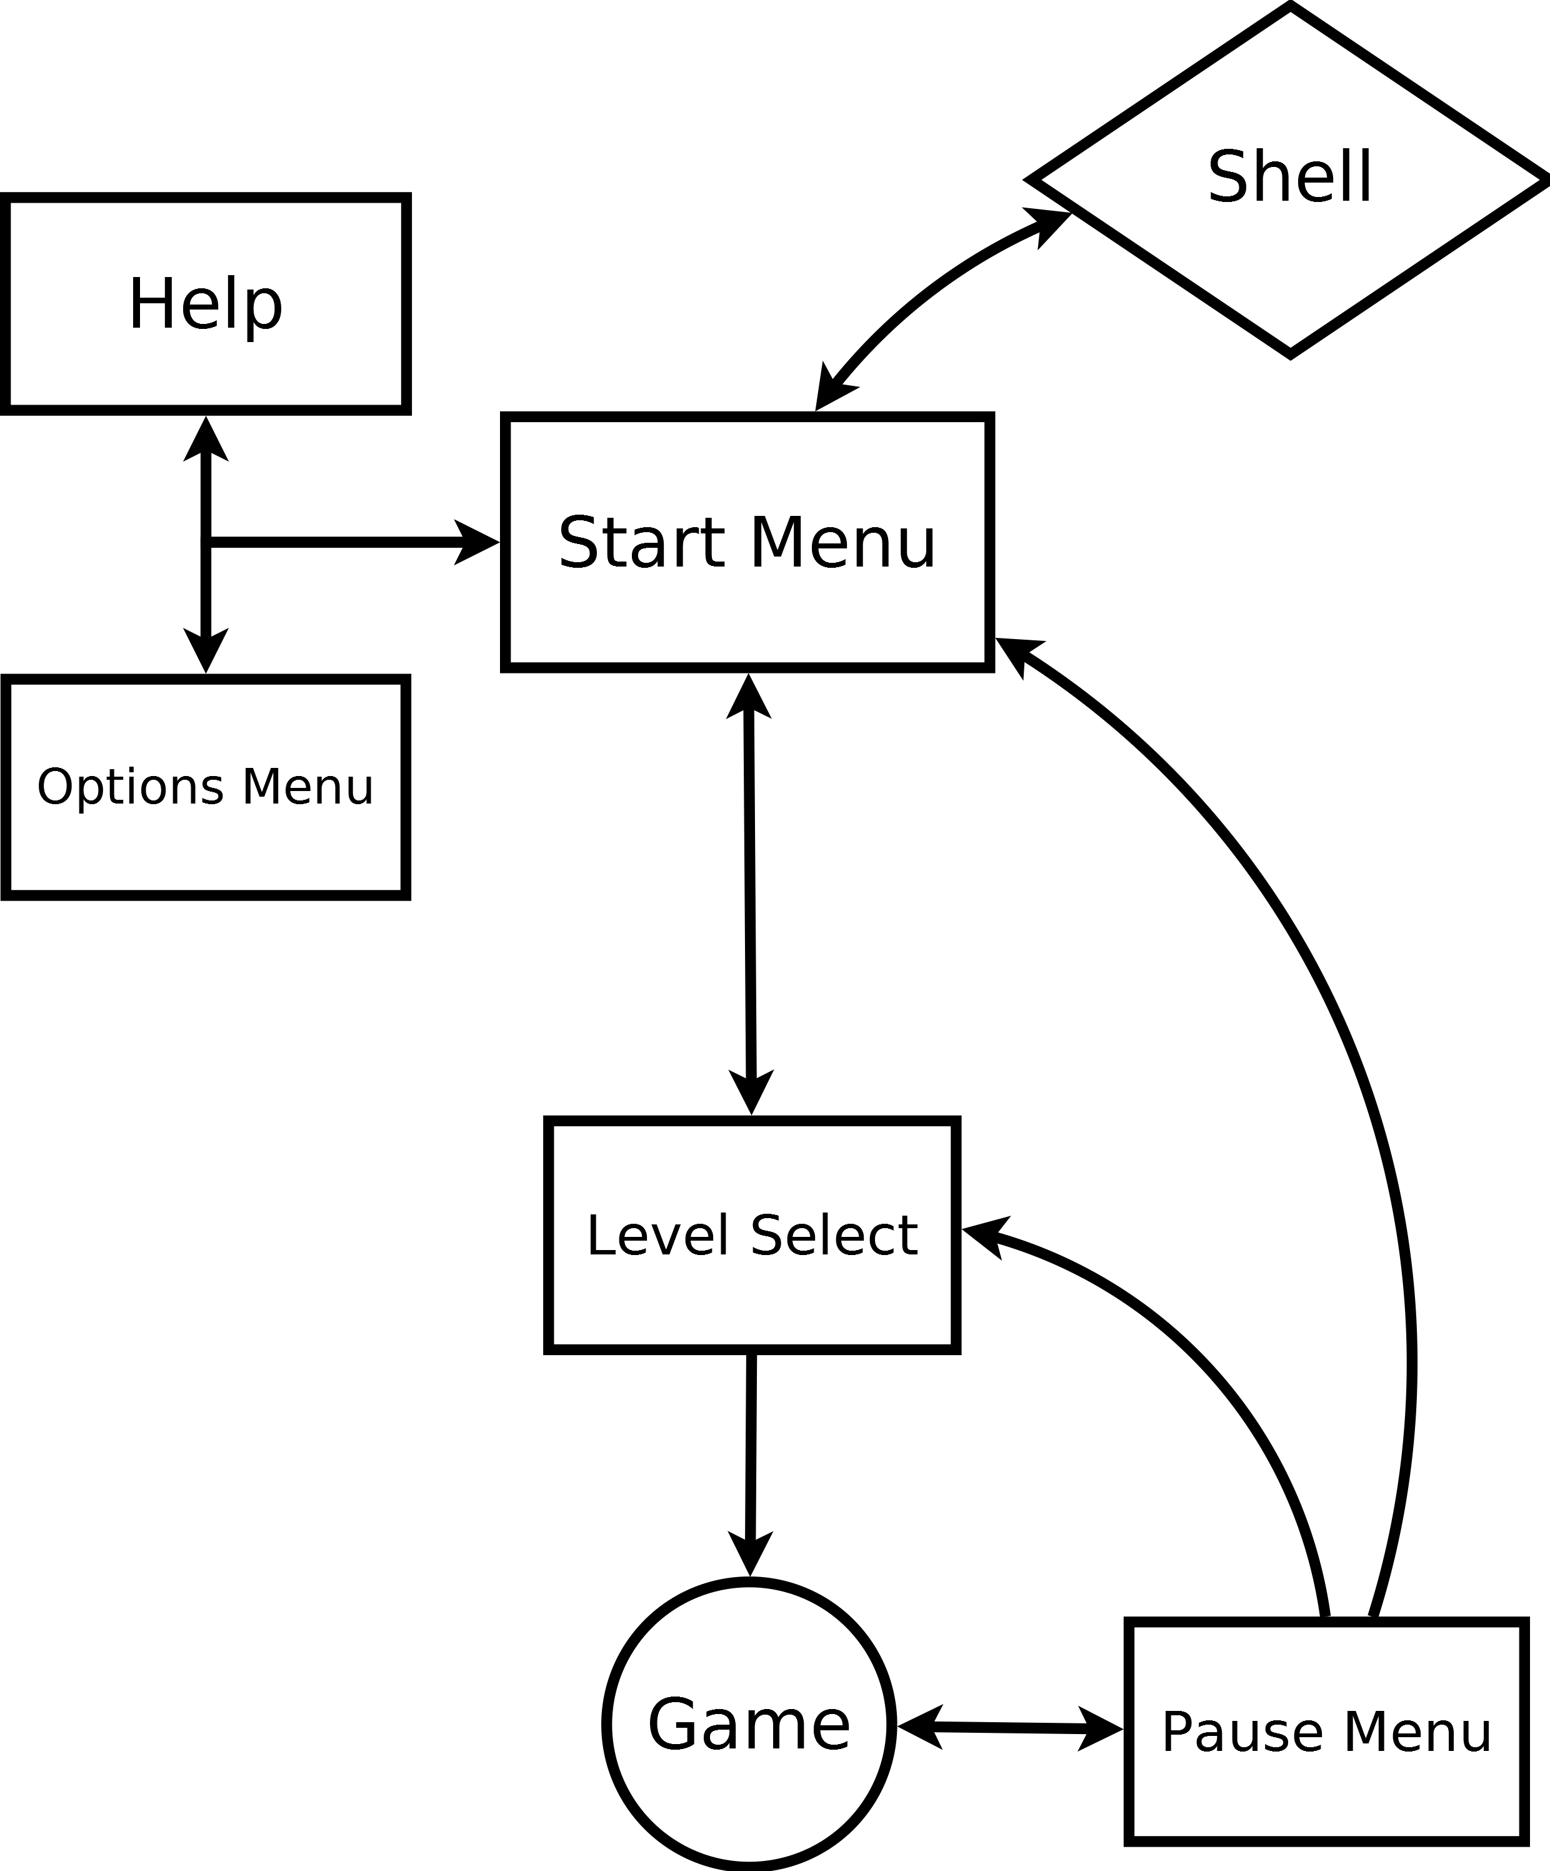

Game Options
Most of these will be contained within the options menu, but a few will be configurable only by way of editing a configuration file. The options contained within the file will be options which do not normally need to be changes, but shouldn't be hard-coded nonetheless.

Options Menu Options
- Resolution (Default: 1280 x 720) -
There will be two fields for the entry of the desired width and height of the game window.
- Full-screen (Default: Off) -
This will be a toggle, On/Off.
- Volume Sliders -
With sliders for:
  - Master Volume
  - Sound Effects
  - Music

File Options
- Debug -
This Boolean will determine whether extra information is visible during gameplay. This includes, but is not limited to, framerate and x & y position of mouse.

Entities

Buildable Structures

Keywords
- Capacity -
If this number is above zero, then this building requires at least one villager to be functional. More townsfolk can be assigned up to this number, and with each villager comes increased output. A value of zero in this field means the structure is autonomous.
- Cost -
The cost to build this structure.
- Electrical Change -
The positive (generating) or negative (draining) change in the electrical system.

Defensive Structures
Name: | Description: | Capacity: | Cost:
Barracks | An armory that equips assigned townsfolk with swords and armor for the purpose of melee combat. When the townsfolk fall on the field of battle, they slowly drag themselves back inside until they are healed enough to rejoin the fight. | 3 | 100
Ranger Tower | A tower that equips assigned townsfolk with guns for the purpose of ranged combat. | 2 | 80
Medic Tent | Townsfolk assigned to this tent are given first aid supplies and they go out and rescue nearby warriors that have fallen and are crawling back to their barracks. | 2 | 50
Watch Station | Has no function except to provide a cheap way to assign villagers to specific locations. | 1 | 20

Electrical Structures
Name: | Description: | Capacity: | Electrical change: | Cost:
Generator | Generates electricity | 3 | +100 | 150
Electric Machine Gun | This functions as an autonomous ranger tower. | 0 | -50 | 100
EM Field Oscillator | This provides area of effect damage to a circle around it. | 0 | -100 | 100

Enemy Types

Keywords
- Ground -
These enemies walk on the ground.
- Flying -
These enemies are always flying, as a result they are insusceptible to melee.
- Weapon -
This has no effect on the game but is rather an instruction for the art and animation of the enemy.
- Speed Multiplier-
The base speed of a human walking multiplied by this is the speed at which the enemy walks.
- Health -
The amount of health the enemy has.

Ground
Name: | Description: | Weapon: | Speed Multiplier: | Health:
Bandit | A human bandit wearing leather armor. | Sword | 1 | 10
Mercenary | A human sell-sword wearing mail armor. | Sword | 1 | 20
Brute | A very large bald strongman, wearing pants. | Fists | 0.75 | 16
Scout | A fast smaller man wearing light clothes. | Dagger | 2 | 8

Flying
Name: | Description: | Weapon: | Speed Multiplier: | Health:
Trained Eagle | An eagle which has been influenced by the enemy. | Beak | 2 | 2

Artificial Intelligence

Enemy AI
The enemy AI is very simple. Every enemy after spawning will be assigned a path to follow. This path consists of points from the enemy's base, to the city, with the last point always being the center of the city (even though the enemy never actually travels to the very center). An angle is followed towards the current point in the list, and once the enemy is within a very short distance from this point, the next point in the list becomes the current point. The angle followed however does not snap to the new point, but rather it slowly transitions until it reaches the desired angle (this causes the enemy to 'overstep' the path a bit, but it is so slight that it is negligible). If the enemy encounters melee resistance along it's path, it will stop to fight the player's warriors. It is of note that the enemy will not attack passing townsfolk. Once the enemy dies or reaches within a short distance of the city center, its AI cycle ends.

Townsfolk AI
The townsfolk begin as just a number on the UI denoting “Townsfolk in City: XX”. When the player requests a building be built, one of them will spawn in at the edge of the city closest to their objective and travel in a straight line towards it. Once construction is complete, they will return to town. If the building requires to be manned however, the villager will remain at the site after construction and man the structure. This behavior can be changed in the options sub-menu. If an enemy dies near a station where a villager resides (the city, or any manned structure or under-construction structure), a villager will spawn to collect the dropped resources. These resources do not need to be delivered to the city to be used, they are simply tallied up in the UI. If a villager runs out to collect a resources, this does not change the status of the structure; If it was manned, it will stay manned even though they are not present. If a building requires more than one villager to be active, the player can request townsfolk to come man it, similarly, the player can request a distance resource be collected. In the case of distant resource retrieval, the villager will not depart the closest station, but rather depart from the city to collect it.
If a villager is en-route back to the city (jobless) and the player requests something be done, if he is closer to the objective than the city center, he will re-route to complete that objective.

Keywords

- AI (Artificial Intelligence) -
The cycle of a game object's behavior towards player influence.
- Boolean -
True or False; Only two values.
- Framerate -
A number representing the amount of images displayed per second resulting in smooth motion.
- Graphics -
Models, art, and animations. Can also refer to the video processing portion of a computer's hardware.
- Memory / RAM (Random Access Memory) -
Temporary storage for a computer's programs.
- Processor -
The part of a computer that processes all of the instructions given by a program with a speed denoted in hertz (hz).
- Resolution -
The width and height of the game window.
- Shell -
The operating system of the user; The place where he launcher the game from.
- Target Audience -
The group of people the game was designed for.
- UI (User Interface) -
The buttons and text overlaid on the game.

