Lab 7 – OLS Linear Regression Analysis

Maternal Weight vs. Birthright
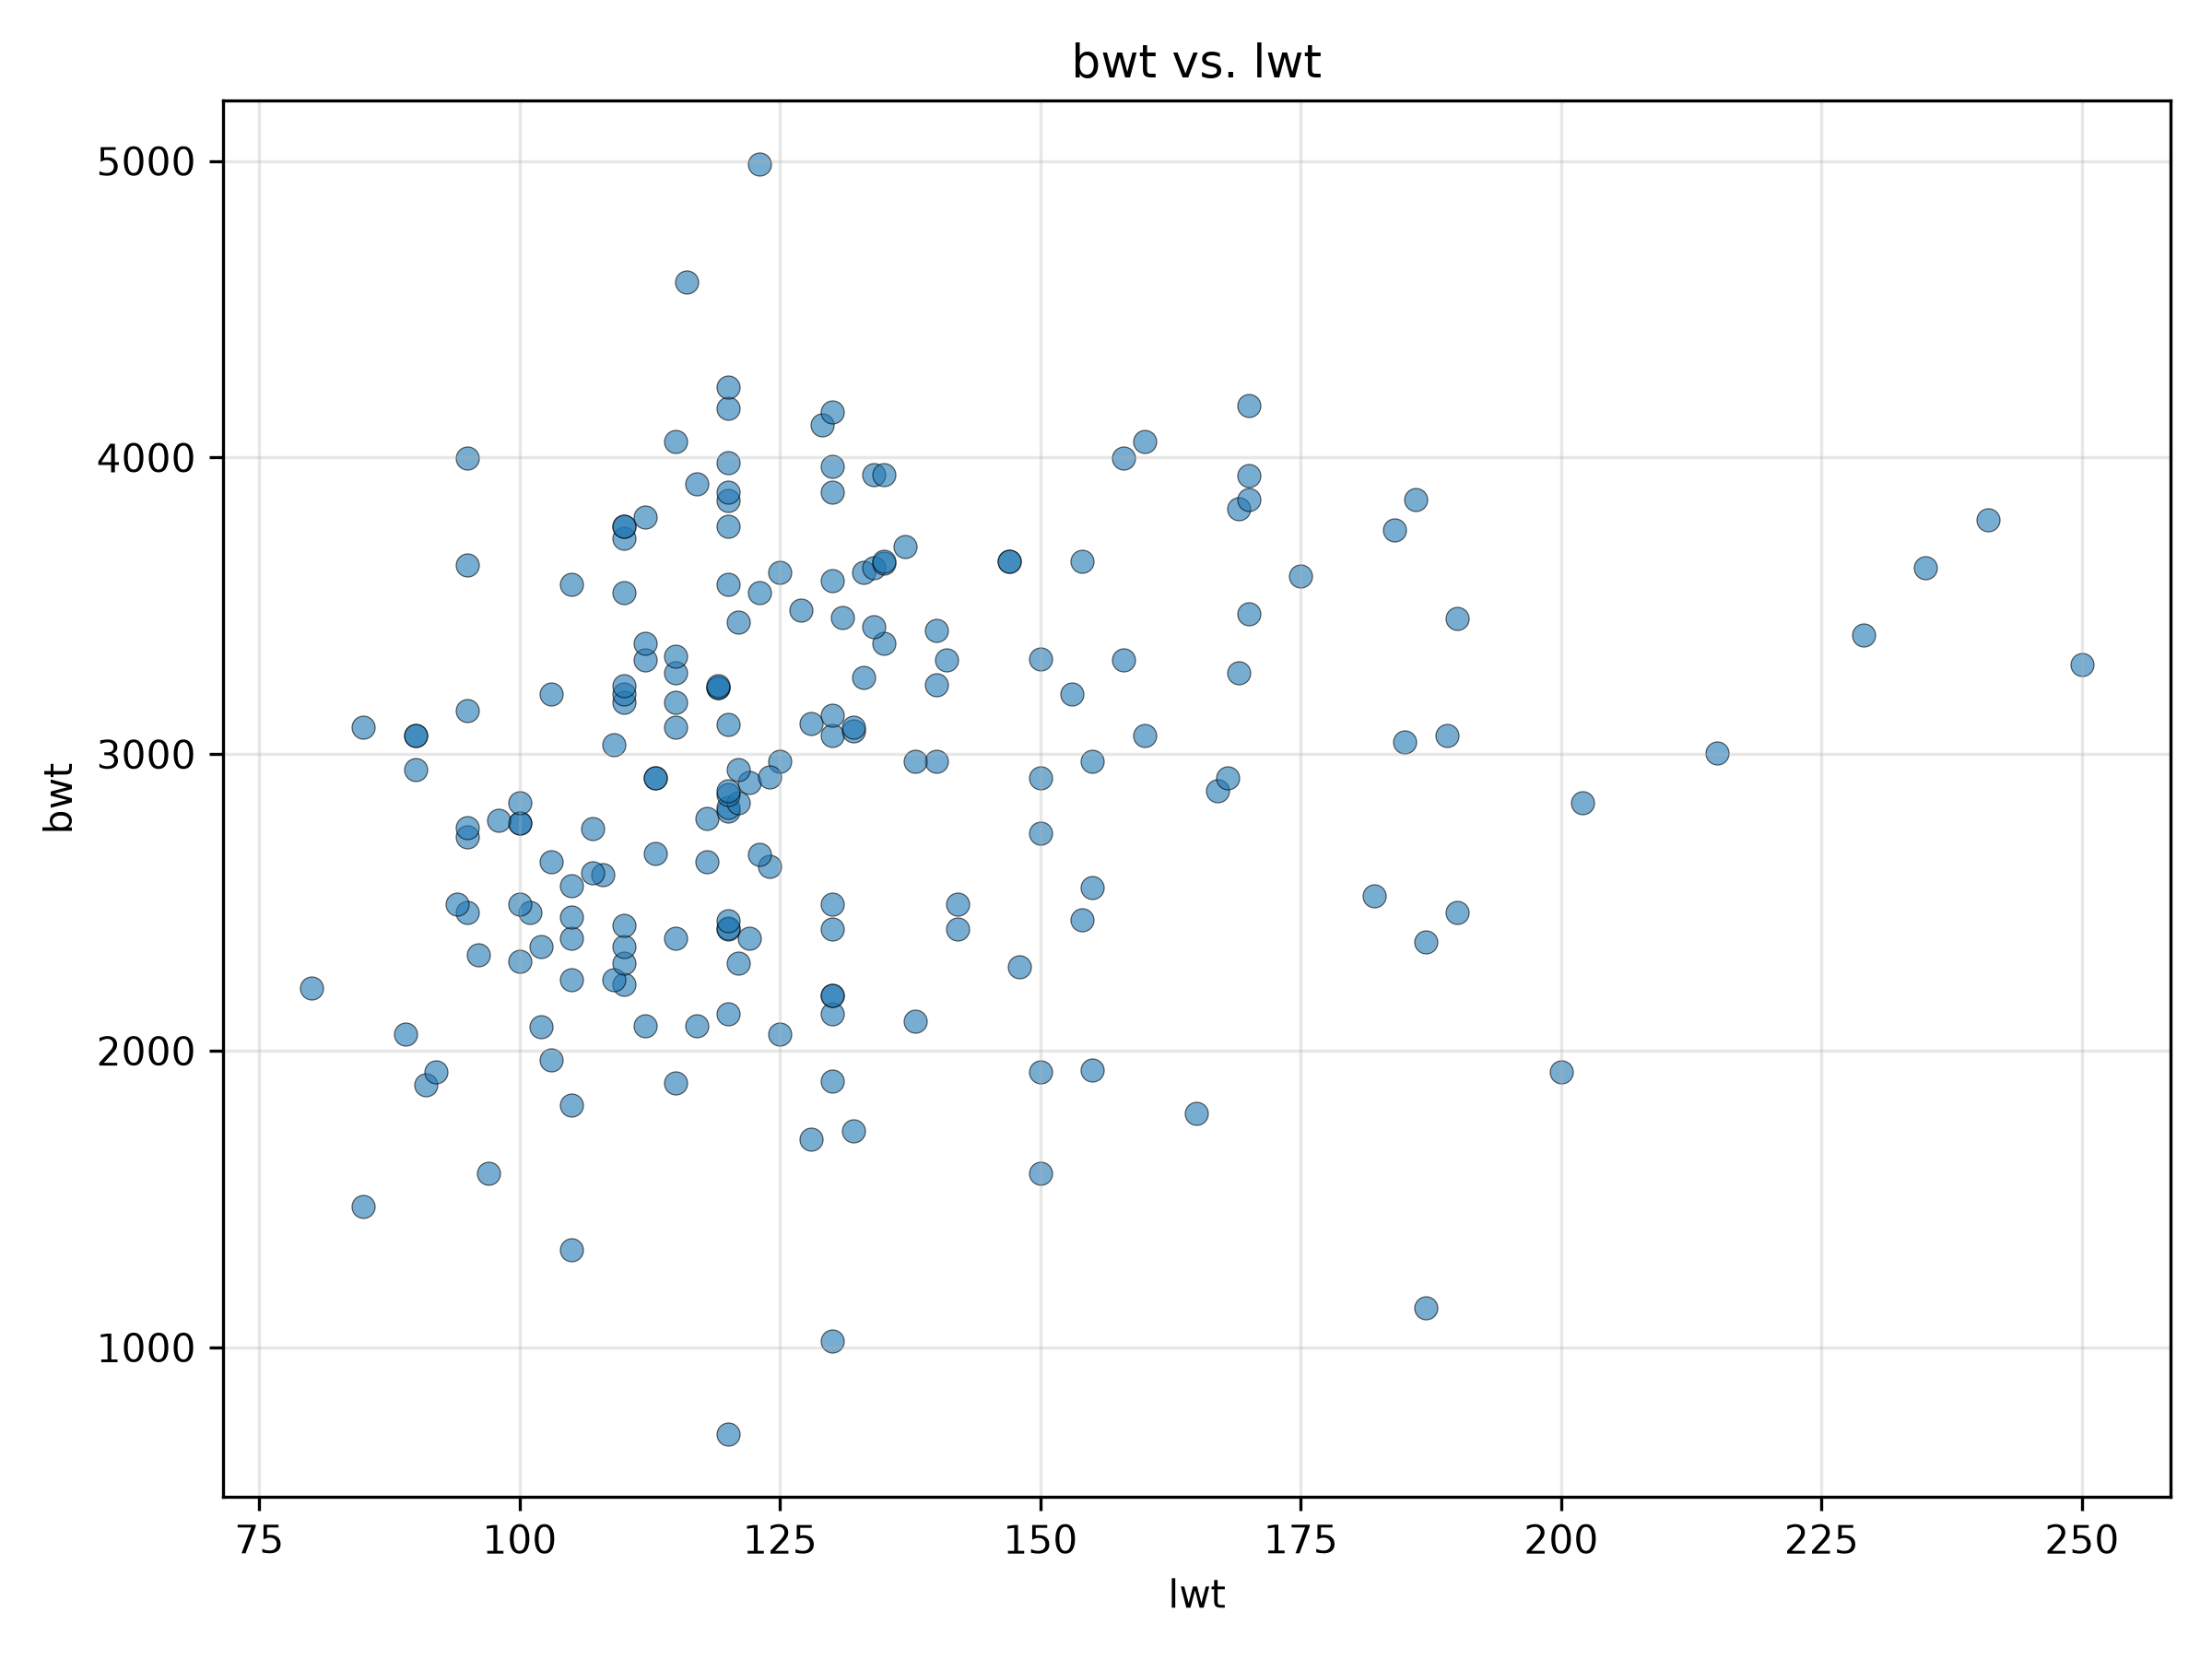
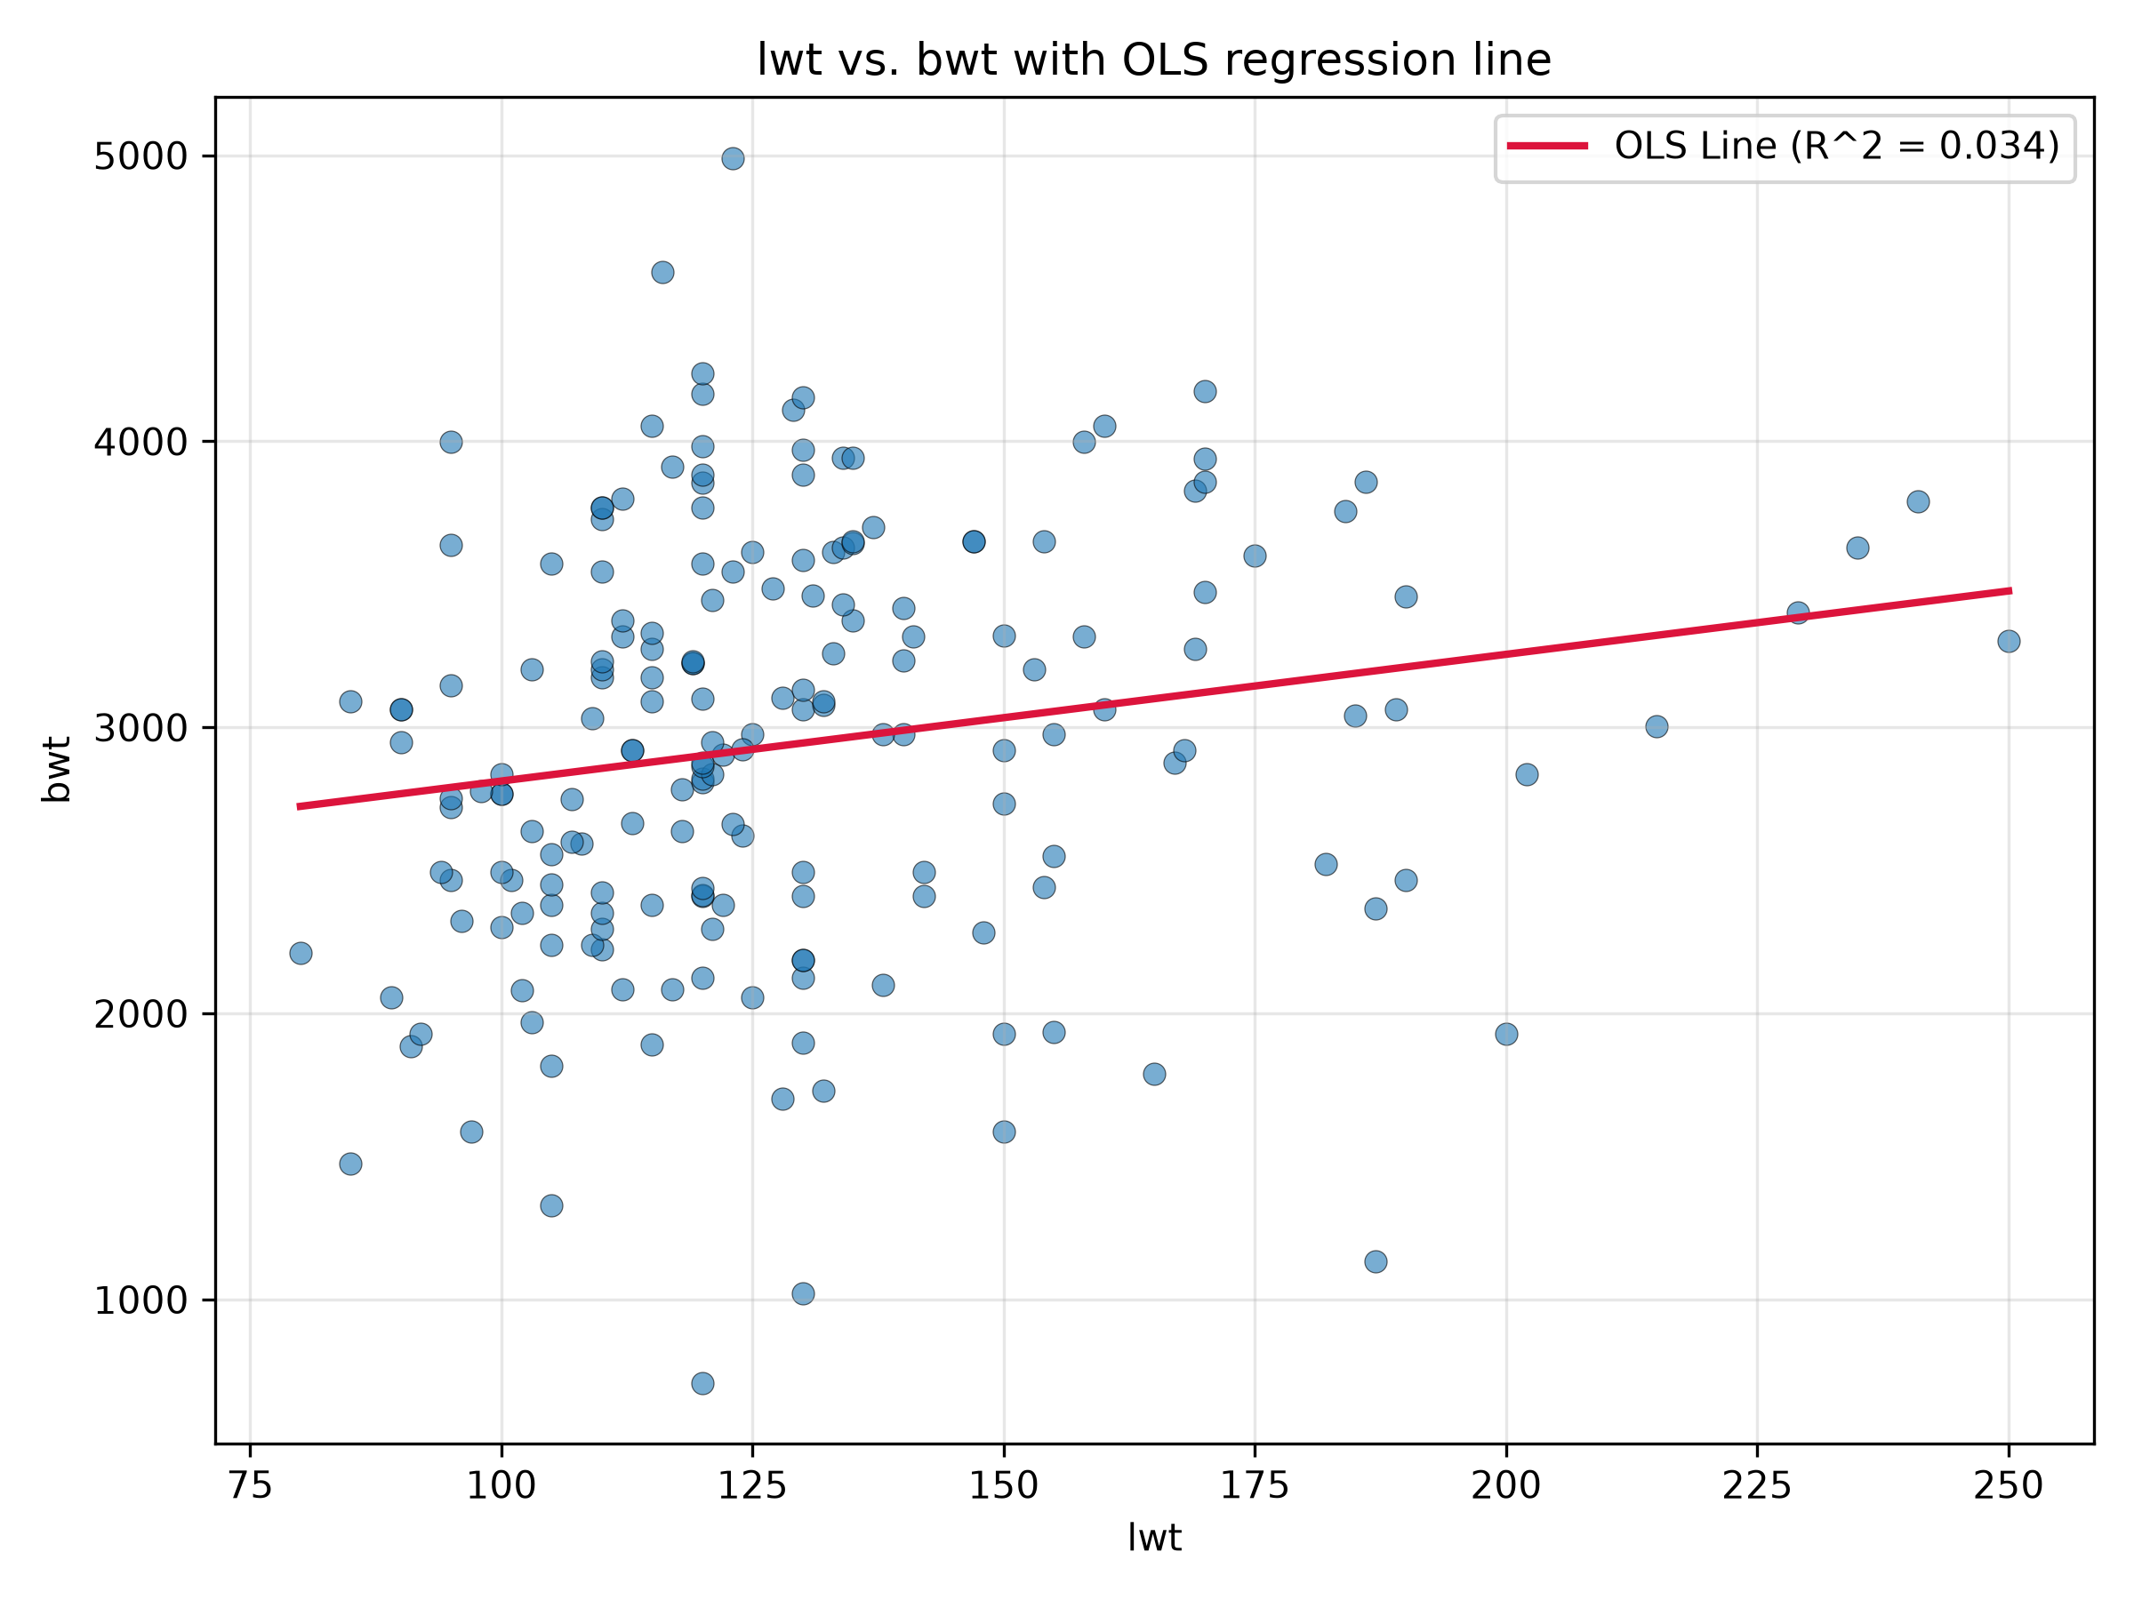
Independent variable (X): Mother's weight in pounds (lwt)
Dependent variable (Y): Birthweight in grams (bwt)
β₀: 2369.6235
β₁: 4.4291
R²: 0.034
Interpretation: There is a very weak positive relationship indicated by the R² value, between maternal weight and infant birthweight, with a predicted increase of approximately 4.43 grams in birthweight for every additional pound of maternal weight.
Total Population vs. Housing Insecurity
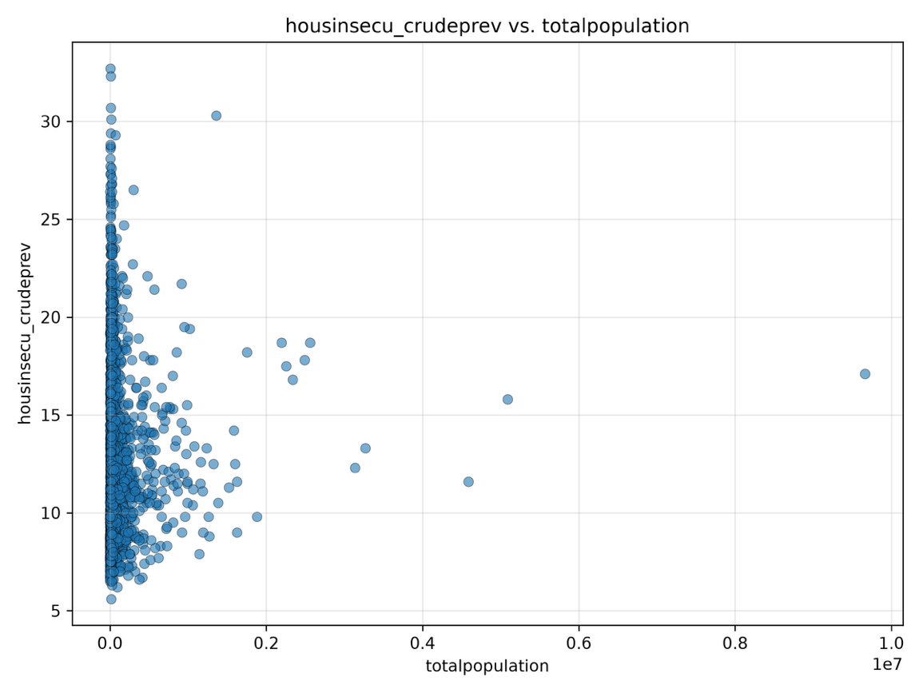

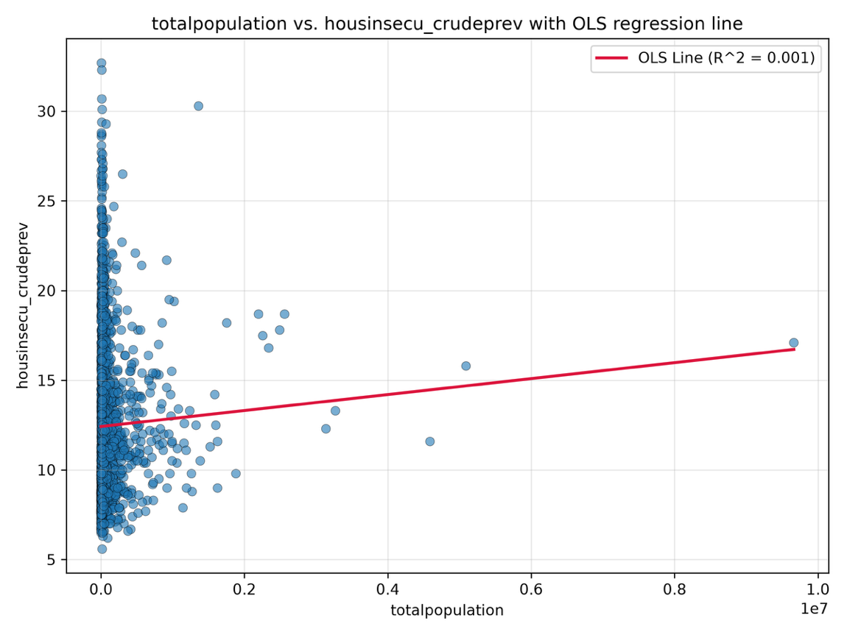
Independent variable (X): Total population (totalpopulation)
Dependent variable (Y): Housing insecurity crude prevalence (housinsecu_crudeprev)
β₀: 12.4181
β₁: 4.45 × 10⁻⁷
R²: 0.001
Interpretation: There is a very weak but positive relationship between total population and housing insecurity prevalence, with a predicted increase of approximately 0.0445 percentage points in housing insecurity prevalence for every additional 100,000 people.

Obesity vs. Mental Health
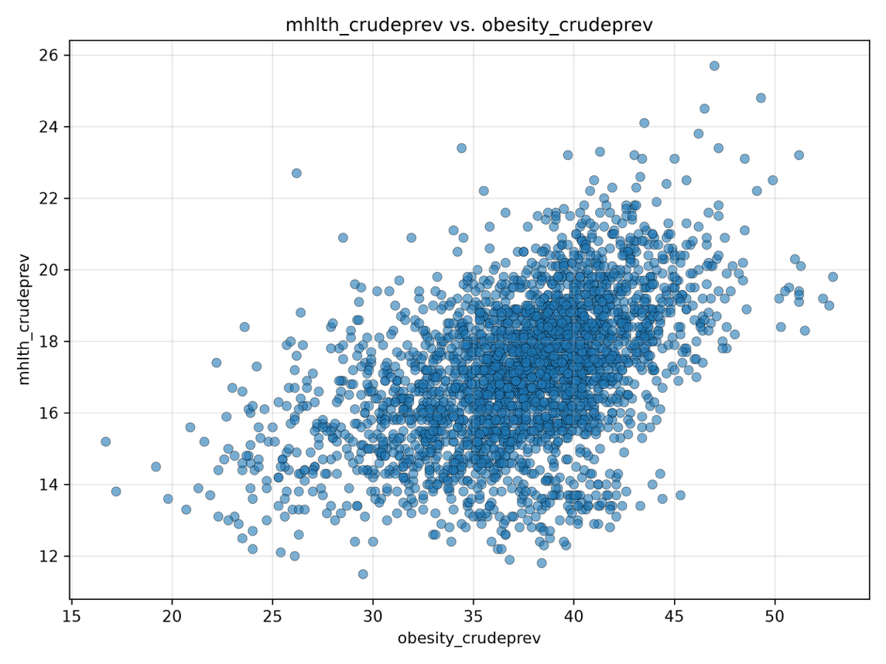

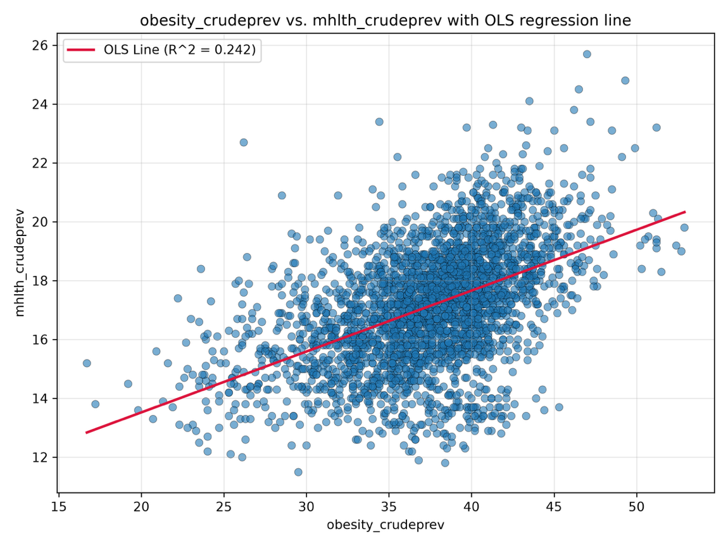
Independent variable (X): Obesity crude prevalence (obesity_crudeprev)
Dependent variable (Y): Poor mental health crude prevalence (mhlth_crudeprev)
β₀: 9.3830
β₁: 0.2069
R²: 0.242
Interpretation: There is a moderate positive relationship between obesity prevalence and poor mental health prevalence, with a predicted increase of approximately 0.207 percentage points in poor mental health prevalence for every 1-percentage-point increase in obesity prevalence.

