Chase Jones
Arad
CSC 142
14 Nov 2018
Assignment #6
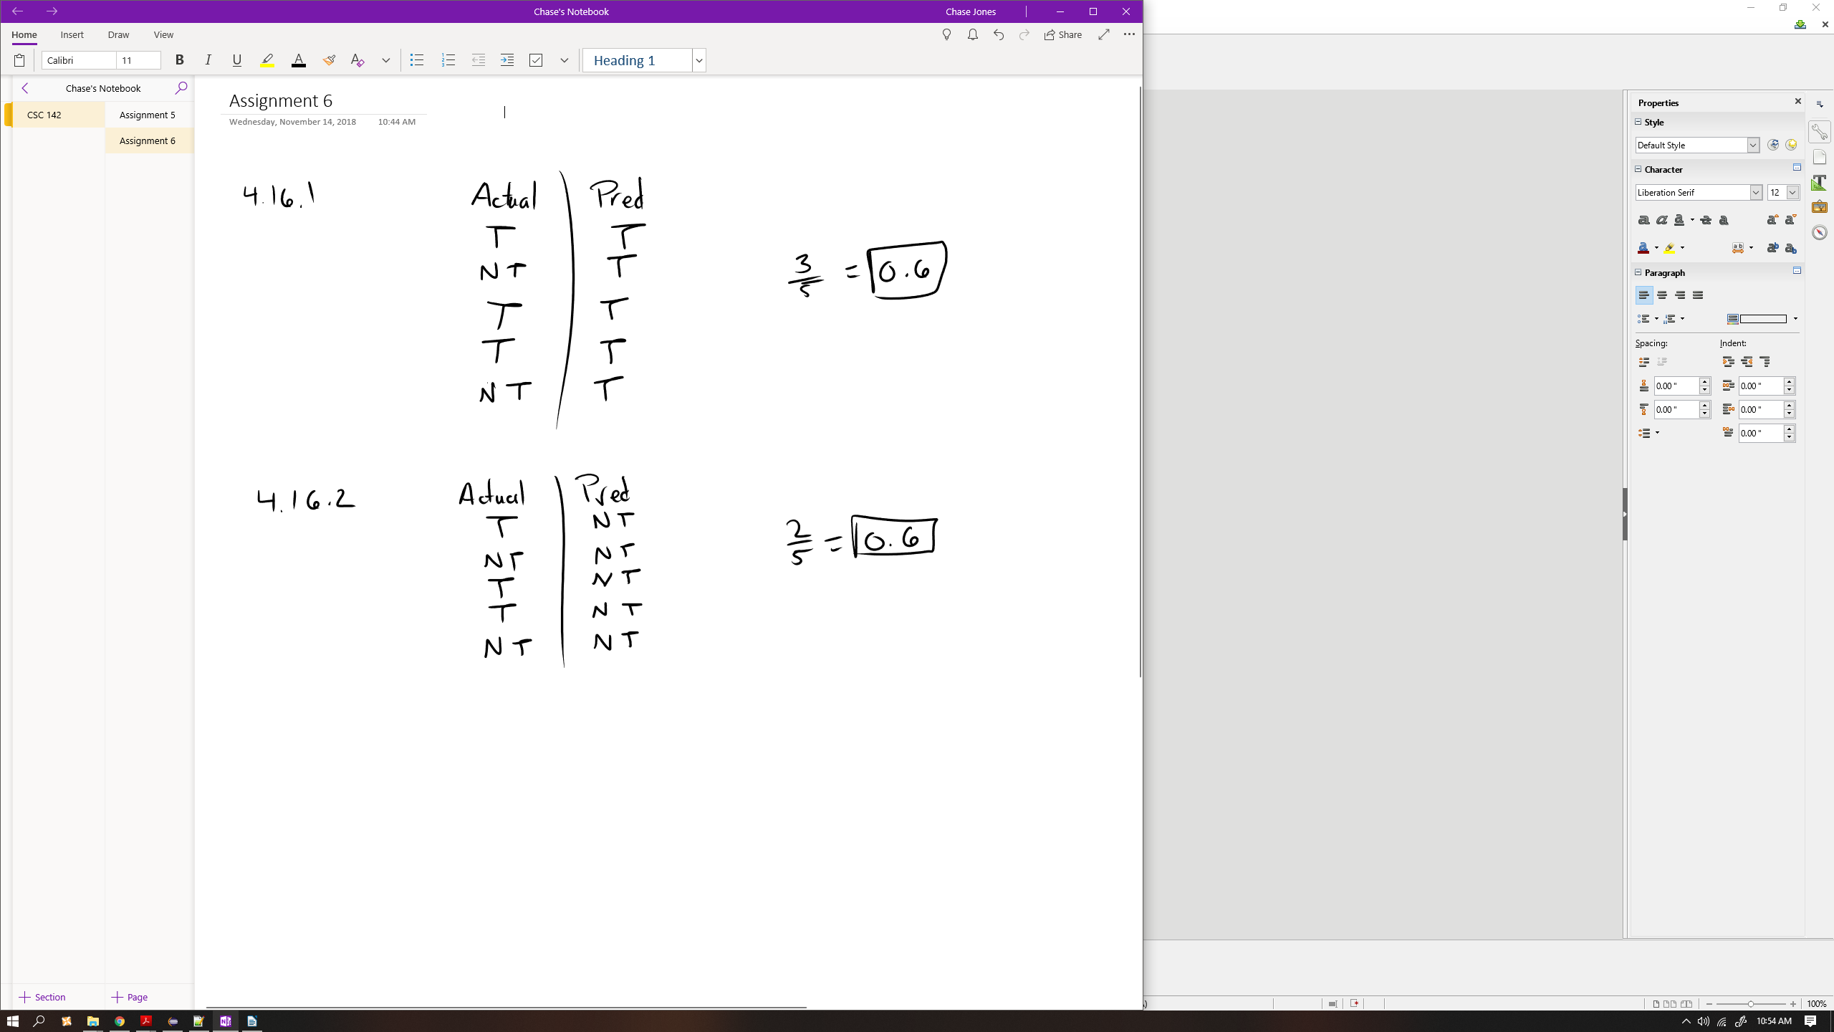
1.

2. We can enhance instruction level parallelism by:
- dynamic multiple-issue instruction
- dynamic scheduling for out-of-order execution

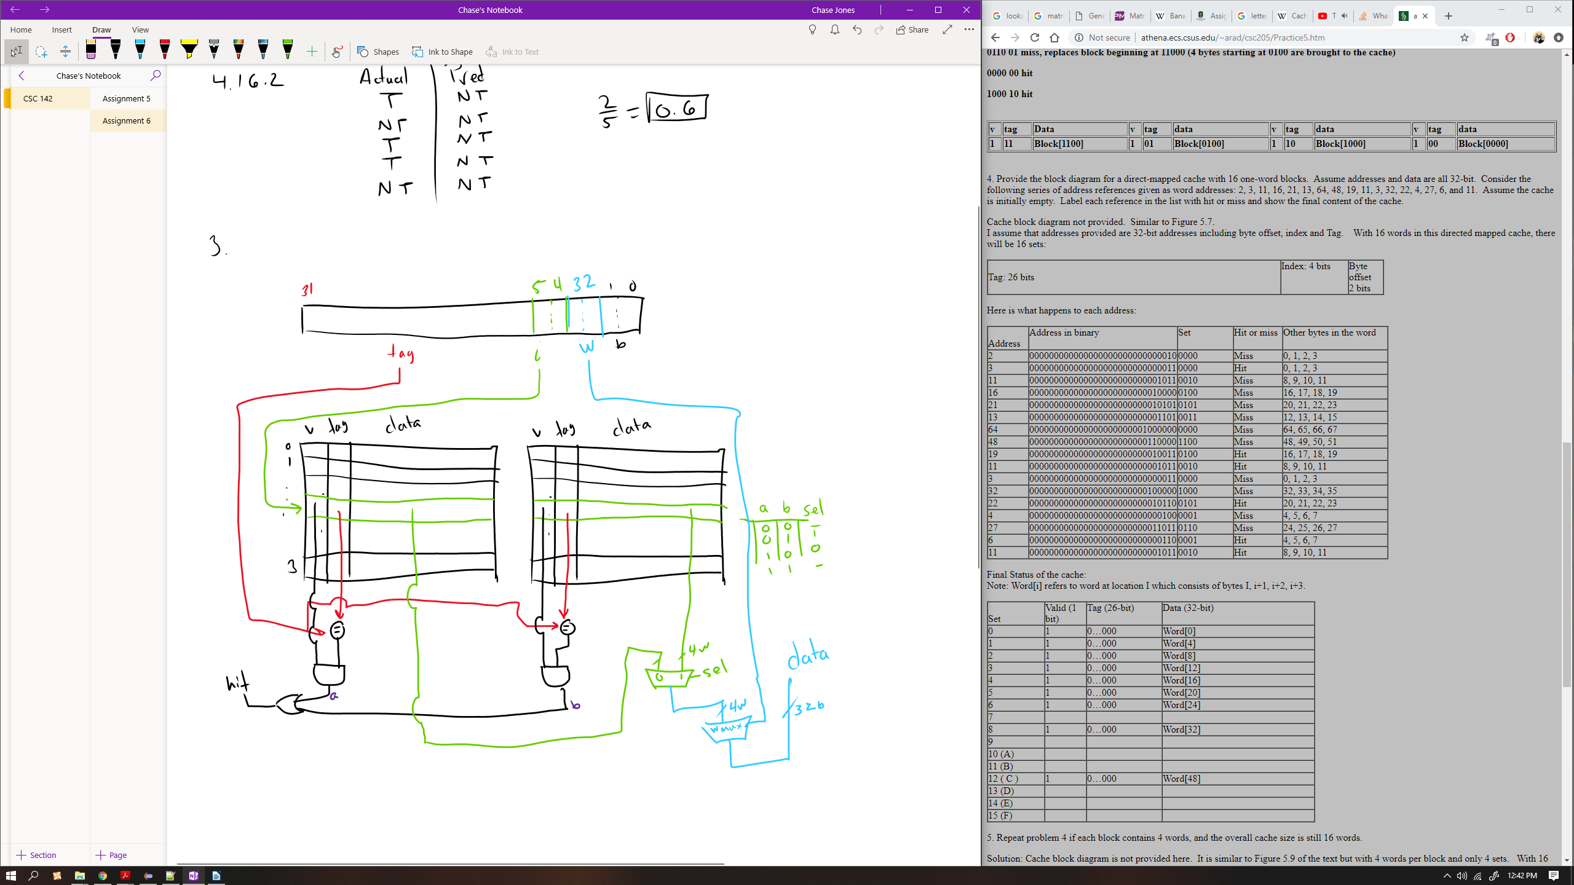
3.

4.
Address of memory block accessed | Address in binary | Set | Hit/miss | Words in Block
2 | 000000000000000000000000000010 | 00 | Miss | 0, 4, 8, 12
3 | 000000000000000000000000000011 | 00 | Hit | 0, 4, 8, 12
11 | 000000000000000000000000001011 | 00 | Hit | 0, 4, 8, 12
16 | 000000000000000000000000010000 | 01 | Miss | 16, 20, 24, 28
21 | 000000000000000000000000010101 | 01 | Hit | 16, 20, 24, 28
13 | 000000000000000000000000001101 | 00 | Hit | 0, 4, 8, 12
64 | 000000000000000000000001000000 | 00 | Miss | 64, 68, 72, 76
48 | 000000000000000000000000110000 | 11 | Miss | 48, 52, 56, 60
19 | 000000000000000000000000010011 | 01 | Hit | 16, 20, 24, 28
11 | 000000000000000000000000001011 | 00 | Hit | 0, 4, 8, 12
3 | 000000000000000000000000000011 | 00 | Hit | 0, 4, 8, 12
32 | 000000000000000000000000100000 | 10 | Miss | 32, 36, 38, 42
22 | 000000000000000000000000010110 | 01 | Hit | 16, 20, 24, 28
4 | 000000000000000000000000000100 | 00 | Hit | 0, 4, 8, 12
27 | 000000000000000000000000011011 | 01 | Hit | 16, 20, 24, 28
6 | 000000000000000000000000000110 | 00 | Hit | 0, 4, 8, 12
11 | 000000000000000000000000001011 | 00 | Hit | 0, 4, 8, 12

Set | Valid (1 bit) | Tag (26-bit) | Block # | Data (32-bit)
0 | 1 | 0...000 | 0 | Word[0], Word[4], Word[8], Word[12]
 | 1 | 0...001 | 1 | Word[64], Word[68], Word[72], Word[76]
1 | 1 | 0...000 | 0 | Word[16], Word[20], Word[24], Word[28]
 | 0 | 0...000 | 1
2 | 1 | 0...000 | 0 | Word[32], Word[36], Word[40], Word[44]
 | 0 | 0...000 | 1
3 | 1 | 0...000 | 0 | Word[48], Word[52], Word[56], Word[60]
 | 0 | 0...000 | 1

5. In a fully-associative cache, we have exactly 1 set.
6. In Direct-Mapped cache there is only 1 block per set.
7. In a 4-way set associative cache we have 4 blocks per set.
8. on next page…
