Chase Capron
ISTM – 650
Assignment 6: Association Rules Mining
Q2
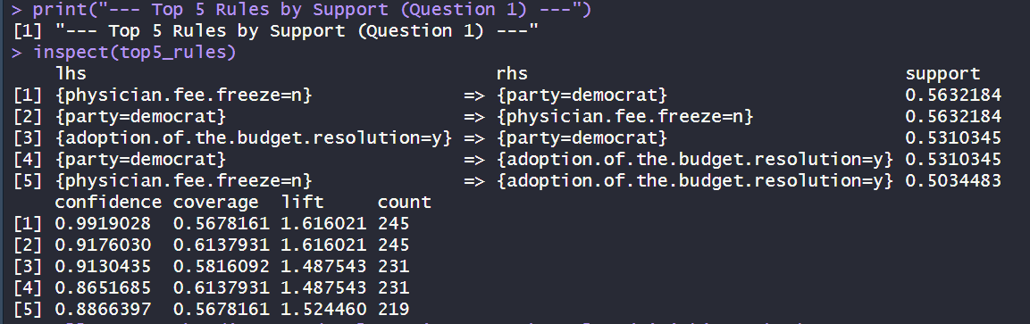
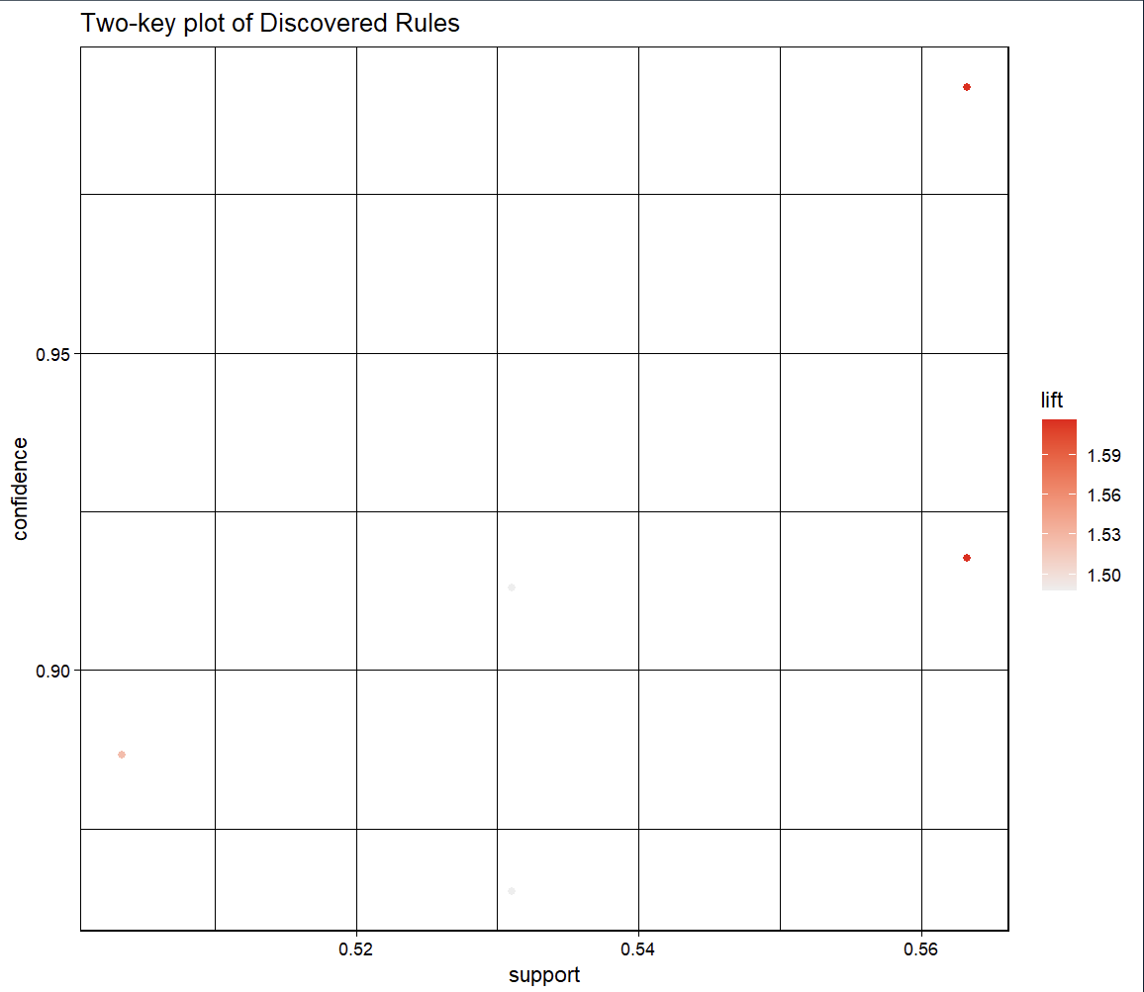
# Generate association rules
all_rules <- apriori(data_trans, parameter = list(supp = 0.1, conf = 0.8))

# Sort by Support and get the top 5
rules_q1_sorted <- sort(all_rules, by = "support", decreasing = TRUE)
top5_rules <- head(rules_q1_sorted, 5)

print("--- Top 5 Rules by Support (Question 1) ---")
inspect(top5_rules)

# Illustrate the discovered rules using a two-key plot (mimicking Lab 8)
plot(top5_rules, shading="lift", control=list(main = "Two-key plot of Discovered Rules"))
Q3
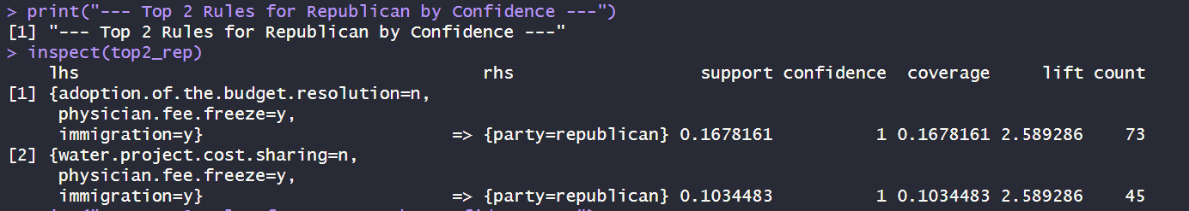
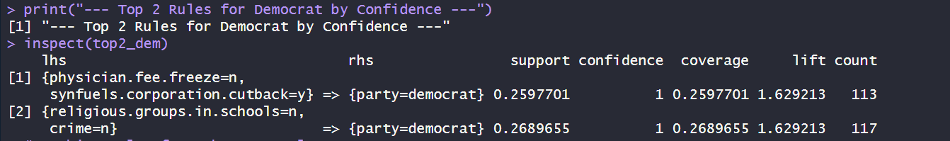
# Republican Rules: Set RHS to Party = Republican
rep_rules <- apriori(data_trans,
parameter = list(supp = 0.1, conf = 0.8),
appearance = list(default = "lhs", rhs = "party=republican"))

# Sort Republican rules by confidence and take top 2
rep_rules_sorted <- sort(rep_rules, by = "confidence", decreasing = TRUE)
top2_rep <- head(rep_rules_sorted, 2)

# Democrat Rules: Set RHS to Party = Democrat
dem_rules <- apriori(data_trans,
parameter = list(supp = 0.1, conf = 0.8),
appearance = list(default = "lhs", rhs = "party=democrat"))

# Sort Democrat rules by confidence and take top 2
dem_rules_sorted <- sort(dem_rules, by = "confidence", decreasing = TRUE)
top2_dem <- head(dem_rules_sorted, 2)

print("--- Top 2 Rules for Republican by Confidence ---")
inspect(top2_rep)
print("--- Top 2 Rules for Democrat by Confidence ---")
inspect(top2_dem)

# Combine rules for subsequent plots
q2_rules <- c(top2_rep, top2_dem)
Q4
# Generate parallel coordinates plot (mimicking Lab 8)
plot(q2_rules, method = "paracoord", shading = "confidence")
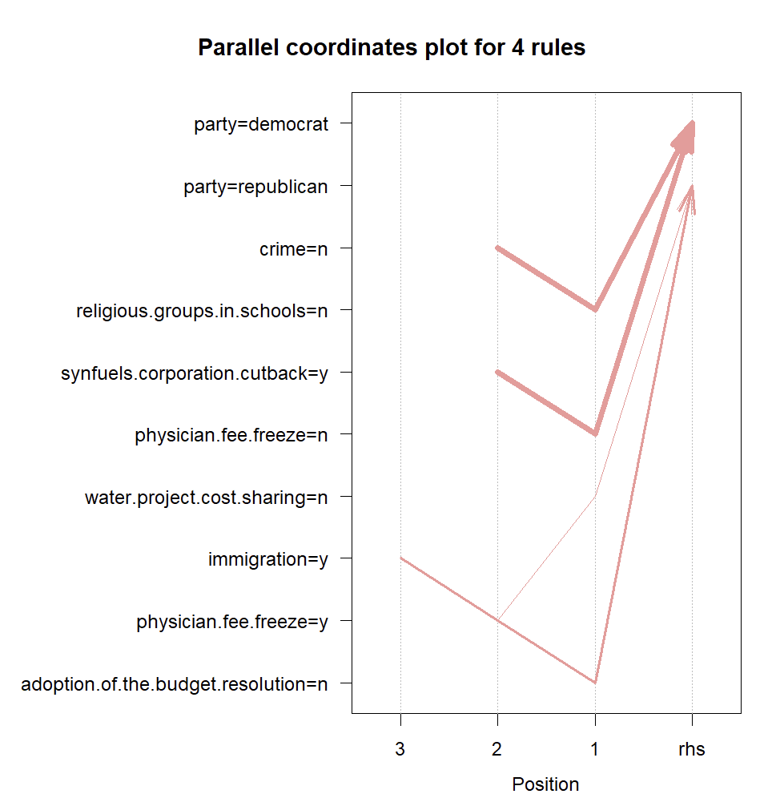
Q5
# Create a basic graph structure using igraph engine (Mimicking Lab 8)
ig <- plot(q2_rules, method = "graph", engine = "igraph")

# Explicitly use igraph::as_data_frame to avoid conflict with dplyr
ig_df <- igraph::as_data_frame(ig, what = "both")

# Generate nodes
nodes <- data.frame(id = ig_df$vertices$name,
# The size of nodes: using support here
value = ig_df$vertices$support,
title = ifelse(ig_df$vertices$label=="", ig_df$vertices$name,
ig_df$vertices$label), ig_df$vertices)

# Generate edges
edges <- ig_df$edges

# Generate network with add-on features matching Lab 8 precisely
network <- visNetwork(nodes, edges) %>%
visNodes(size = 10) %>%
visLegend() %>%
visEdges(smooth = FALSE) %>%
visOptions(highlightNearest = TRUE, nodesIdSelection = TRUE) %>%
visInteraction(navigationButtons = TRUE)

# View the network map
network
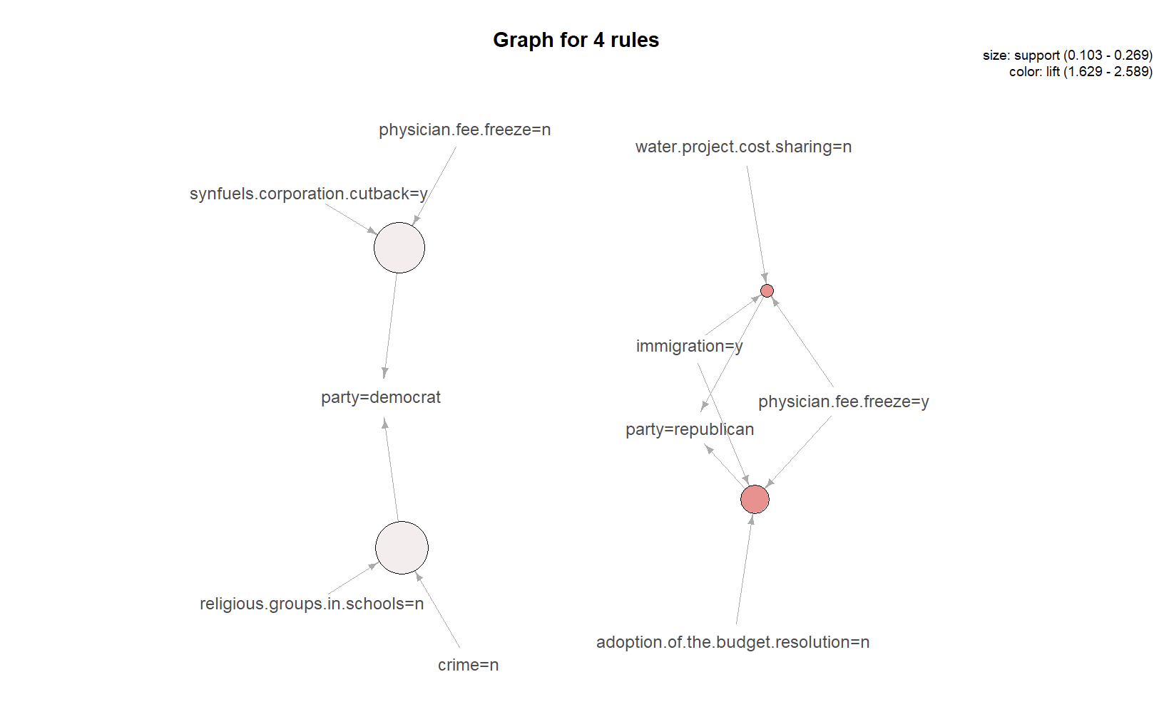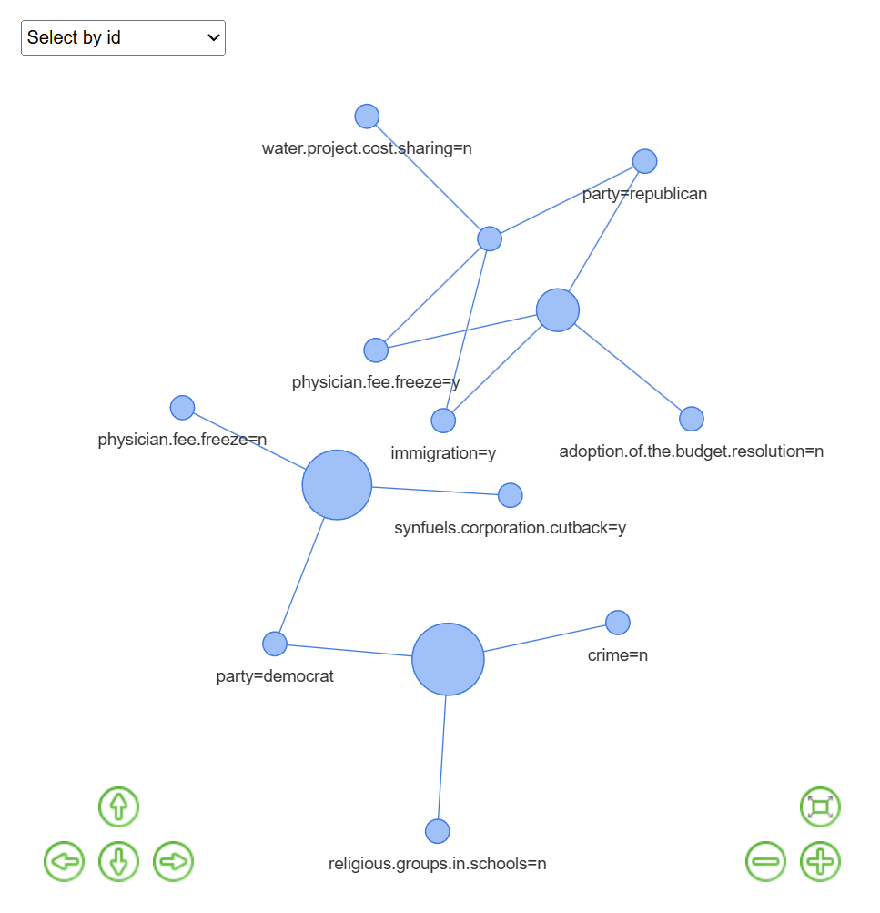
Q6
When looking at association rules, it is important to understand the three big metrics. Those being Support, Lift, and Confidence. Generally, Support measures the frequency of an item appearing in the whole dataset. This gives analysts the ability to filter our rare or insignificant items. Lift oversees figuring out the weight of the association over base chance. Any life over 1 indicates a positive correlation. Finally, confidence measures the reliability of the inference made by the given rule.
Q7
Data can sometimes be misleading, especially when dealing with a high-confidence rule. If 95% of voters support a bill anyway, any random condition will still yield a 95% confidence by chance, determining a false correlation. To prevent this, one must evaluate lift.

