Chase Capron
ISTM 650
Assignment 7
Q1:
The Decision Tree was fit with C50 and a Logistic Regression was fit with glm() using if_affair as the dependent variable and age, yearsmarried, religiousness, and rating as the independent variables
dt <- C5.0(x = train[, var_names], y = train$if_affair,
control = C5.0Control(minCases = 5, CF = 0.5))

reg <- glm(if_affair ~ . , data = train, family = binomial() )

Q2:
2a.
# Fit the model
dt <- C5.0(x = train[, var_names], y = train$if_affair,
control = C5.0Control(minCases = 5, CF = 0.5))
# See the summary of model
summary(dt)
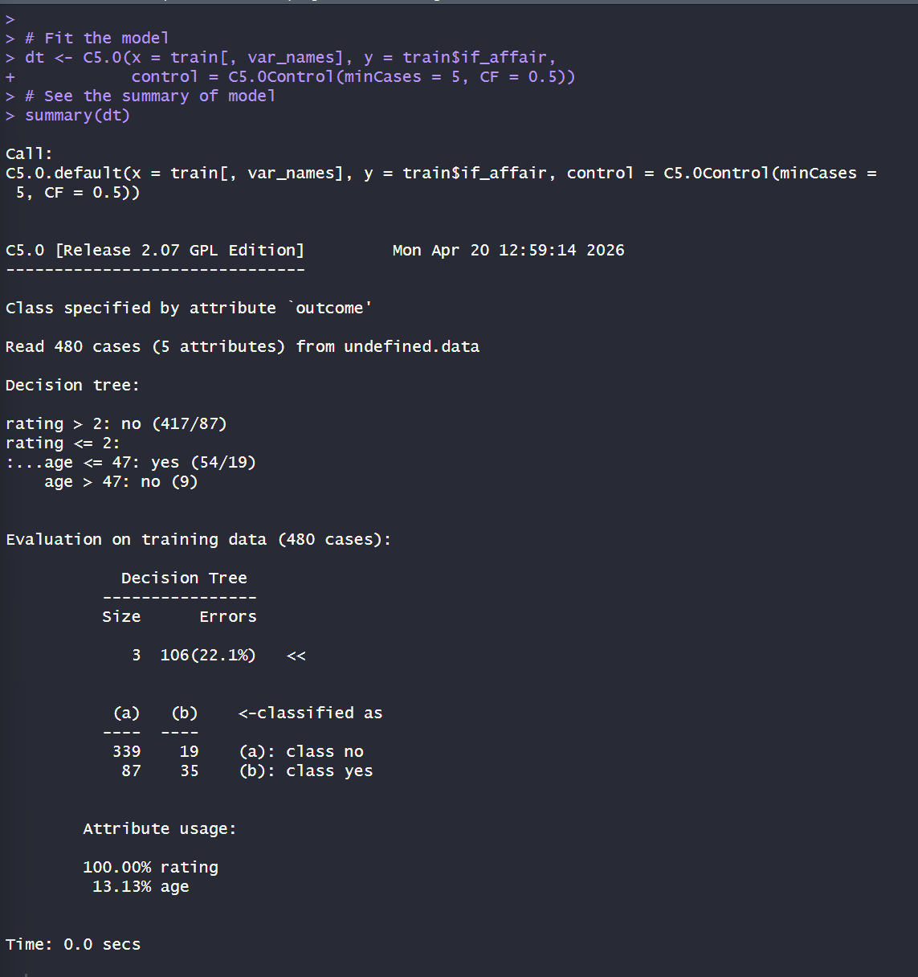
Since decision tree did not have any significant splits, I believe logistic regression is the way to find the most useful attribute. Meaning, rating is the most useful attribute in predicting whether a respondent had an affair.

2b.
## predict() method returns a vector of result
dt_pred <- predict(dt, newdata = test)
### Merge dt_prediction value to test dataset
dt_evaluation <- cbind(test, dt_pred)

### Compare dt_prediction result to actual value
dt_evaluation$correct <- ifelse(dt_evaluation$if_affair ==
dt_evaluation$dt_pred, 1, 0)
### Accuracy rate
sum(dt_evaluation$correct) / nrow(dt_evaluation)

### Confusion matrix
table(dt_evaluation$if_affair, dt_evaluation$dt_pred)

### TPR = count of true positive divided by total positive
TPR <- sum(dt_evaluation$dt_pred == 'yes' & dt_evaluation$if_affair ==
'yes') / sum(dt_evaluation$if_affair == 'yes')

### TNR = count of true negative divided by total negative
TNR <- sum(dt_evaluation$dt_pred == 'no' & dt_evaluation$if_affair == 'no') / sum(dt_evaluation$if_affair == 'no')

### FPR = count of false positive divided by total negative
### = sum(dt_evaluation$dt_pred == 'yes'& dt_evaluation$if_affair == 'no' ) / sum(dt_evaluation$if_affair == 'no')
FPR <- 1 - TNR

### FNR = FN / P = count of false negative divided by total positive
### = sum(dt_evaluation$dt_pred == 'no'& dt_evaluation$if_affair == 'yes' )/ sum(dt_evaluation$if_affair == 'yes')
FNR <- 1 - TPR

### Precision = number of true positive / total predicted positive
dt_precision <- sum(dt_evaluation$if_affair == 'yes' &
dt_evaluation$dt_pred == 'yes') / sum(dt_evaluation$dt_pred == 'yes')
dt_precision

### Recall = number of true positive / total actual positive
dt_recall <- sum(dt_evaluation$if_affair == 'yes' &
dt_evaluation$dt_pred == 'yes') / sum(dt_evaluation$if_affair == 'yes')
dt_recall

### F score
F <- 2 * dt_precision * dt_recall / (dt_precision + dt_recall)
F
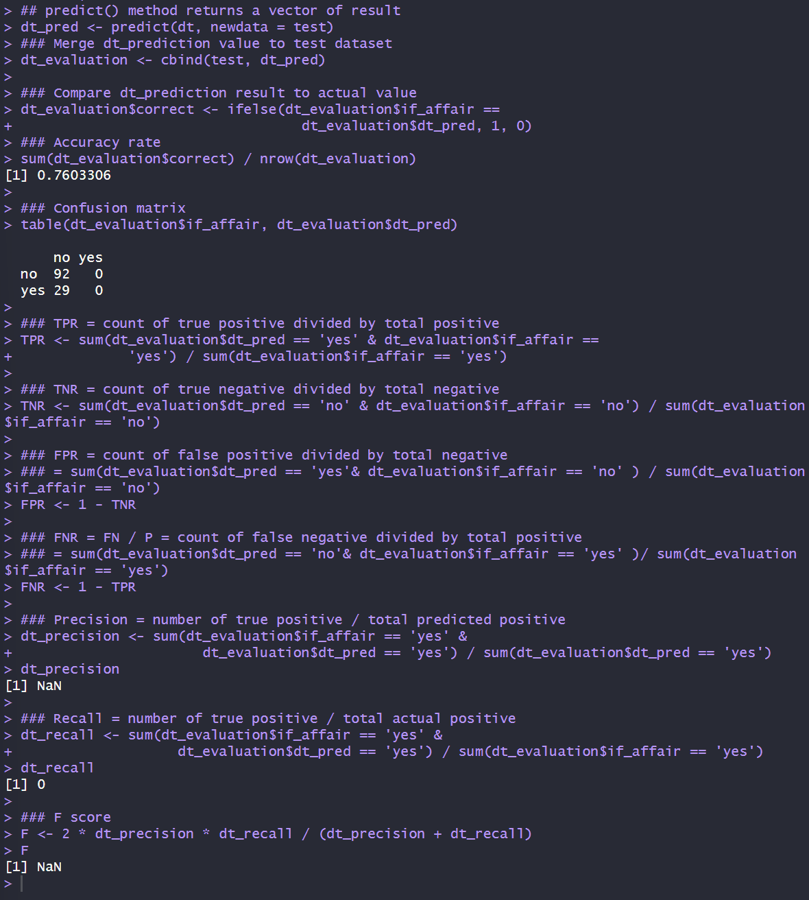
Precision is undefined (NaN) and Recall is 0. Because the default C5.0 tree never predicts the positive class, it produces no true positives and no false positives, which leaves the precision denominator at zero and recall at zero. Accuracy is 0.7603, but that is not a sign that the tree has learned anything useful.

Q3
3a.
### Baseline of positive result (if_affair == "yes")
count_affair <- nrow(subset(affairs, affairs$if_affair == "yes") )
baseline <- count_affair / nrow(affairs)
baseline
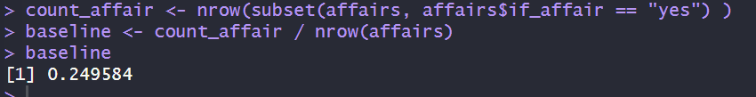
3b.
The logistic regression probabilities on the test set are fed into pROC::roc(), the curve is plotted, and the roc object is printed to read the AUC.
### Validate test dataset
evaluation <- test
evaluation$prob <- predict(reg, newdata = evaluation, type = "response")

### Baseline of positive result (if_affair == "yes")
count_affair <- nrow(subset(affairs, affairs$if_affair == "yes") )
baseline <- count_affair / nrow(affairs)
baseline

### Feed Sensitivity & Specificity to roc()
g <- roc(evaluation$if_affair ~ evaluation$prob, data = evaluation)
# ROC curve
plot(g)

g
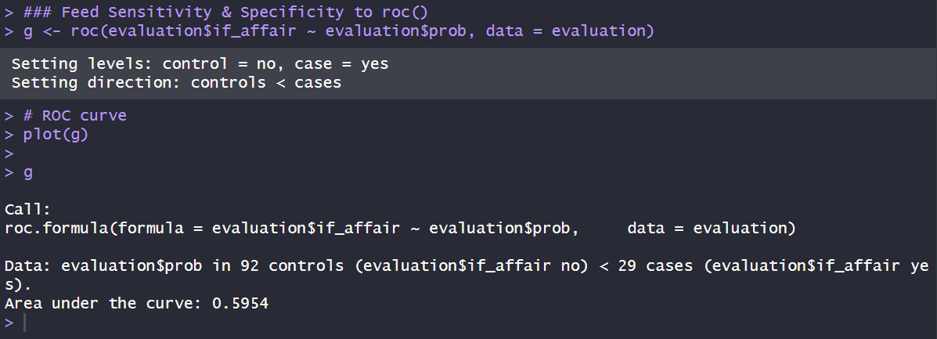
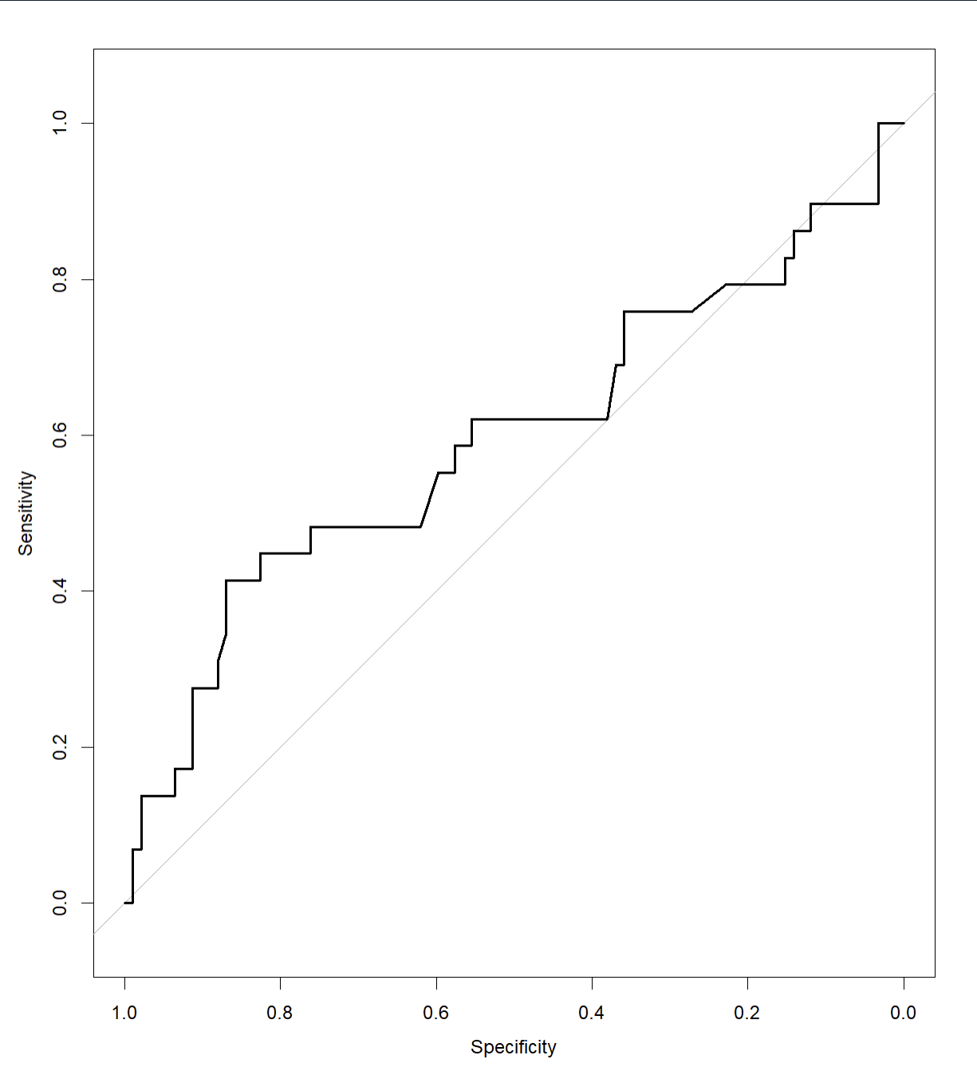
Area under the curve (AUC) = 0.5954. This is slightly better than random guessing (AUC = 0.5). And differs from the degenerate Decision Tree in Question 2, the logistic regression produces a proper probability score that separates "yes" from "no" cases well enough to be useful.

Q4:
Precision matters most here because a false accusation is far more damaging than a missed case. While recall is key for things like medical screenings, the personal stakes of infidelity make a false positive a total dealbreaker. The decision tree from Question 2 is a perfect example. It caught zero affairs, but it also made zero false accusations. In this scenario, silence is better than being recklessly wrong.

Q5:
# Assignment 7 - Chase Capron

setwd("C:/Users/chase/OneDrive/Documents/Desktop Materials/Classes/Spring '26/Bus Data Mining/R Files")

# Install packages
install.packages("C50")
install.packages("pROC")

library(C50)
library(pROC)

# Read in csv file affairs.csv.
affairs <- read.csv("affairs.csv", na.strings = "NA", stringsAsFactors = TRUE)

# Set if_affair as factor (per assignment instructions)
affairs$if_affair <- as.factor(affairs$if_affair)

# Set seed so the random 80/20 split is reproducible
set.seed(123)

################################################################
# Decision Tree
################################################################

# Partition dataset for training (80%) and testing (20%)
size <- floor(0.8 * nrow(affairs))
### Randomly decide which ones for training
training_index <- sample(nrow(affairs), size = size, replace = FALSE)
train <- affairs[training_index,]
test <- affairs[-training_index,]

# Names of variables that used for prediction (exclude target, column 5)
var_names <- names(affairs)[-5]

# Fit the model
dt <- C5.0(x = train[, var_names], y = train$if_affair,
control = C5.0Control(minCases = 5, CF = 0.5))
# See the summary of model
summary(dt)
### Now, validate test
## predict() method returns a vector of result
dt_pred <- predict(dt, newdata = test)
### Merge dt_prediction value to test dataset
dt_evaluation <- cbind(test, dt_pred)

### Compare dt_prediction result to actual value
dt_evaluation$correct <- ifelse(dt_evaluation$if_affair ==
dt_evaluation$dt_pred, 1, 0)
### Accuracy rate
sum(dt_evaluation$correct) / nrow(dt_evaluation)

### Confusion matrix
table(dt_evaluation$if_affair, dt_evaluation$dt_pred)

### TPR = count of true positive divided by total positive
TPR <- sum(dt_evaluation$dt_pred == 'yes' & dt_evaluation$if_affair ==
'yes') / sum(dt_evaluation$if_affair == 'yes')

### TNR = count of true negative divided by total negative
TNR <- sum(dt_evaluation$dt_pred == 'no' & dt_evaluation$if_affair == 'no') / sum(dt_evaluation$if_affair == 'no')

### FPR = count of false positive divided by total negative
### = sum(dt_evaluation$dt_pred == 'yes'& dt_evaluation$if_affair == 'no' ) / sum(dt_evaluation$if_affair == 'no')
FPR <- 1 - TNR

### FNR = FN / P = count of false negative divided by total positive
### = sum(dt_evaluation$dt_pred == 'no'& dt_evaluation$if_affair == 'yes' )/ sum(dt_evaluation$if_affair == 'yes')
FNR <- 1 - TPR

### Precision = number of true positive / total predicted positive
dt_precision <- sum(dt_evaluation$if_affair == 'yes' &
dt_evaluation$dt_pred == 'yes') / sum(dt_evaluation$dt_pred == 'yes')
dt_precision

### Recall = number of true positive / total actual positive
dt_recall <- sum(dt_evaluation$if_affair == 'yes' &
dt_evaluation$dt_pred == 'yes') / sum(dt_evaluation$if_affair == 'yes')
dt_recall

### F score
F <- 2 * dt_precision * dt_recall / (dt_precision + dt_recall)
F

################################################################
# Logistic Regression
################################################################

### Partition dataset for training (80%) and testing (20%)
size <- floor(0.8 * nrow(affairs))
### Randomly decide which ones for training
training_index <- sample(nrow(affairs), size = size, replace = FALSE)
train <- affairs[training_index,]
test <- affairs[-training_index,]

### Fitting regression model
reg <- glm(if_affair ~ . , data = train, family = binomial() )
### Model detail
summary(reg)

### Validate test dataset
evaluation <- test
evaluation$prob <- predict(reg, newdata = evaluation, type = "response")

### Baseline of positive result (if_affair == "yes")
count_affair <- nrow(subset(affairs, affairs$if_affair == "yes") )
baseline <- count_affair / nrow(affairs)
baseline

### Feed Sensitivity & Specificity to roc()
g <- roc(evaluation$if_affair ~ evaluation$prob, data = evaluation)
# ROC curve
plot(g)

g
# Area under the curve will print

