Chase Capron
ISTM – 650
Assignment 3
Q1:
install.packages("C50")
library(C50)

carseats <- read.csv('carseats.csv', stringsAsFactors = TRUE)

carseats
str(carseats)

sample_size <- floor(0.85 * nrow(carseats))
training_index <- sample(seq_len(nrow(carseats)), size = sample_size)
train <- carseats[training_index, ]
test <- carseats[-training_index, ]

predictors <- c('Advertising', 'Price', 'ShelveLoc', 'Age')
model <- C5.0(x = train[,predictors], y = train$Sales)
summary(model)
plot(model)
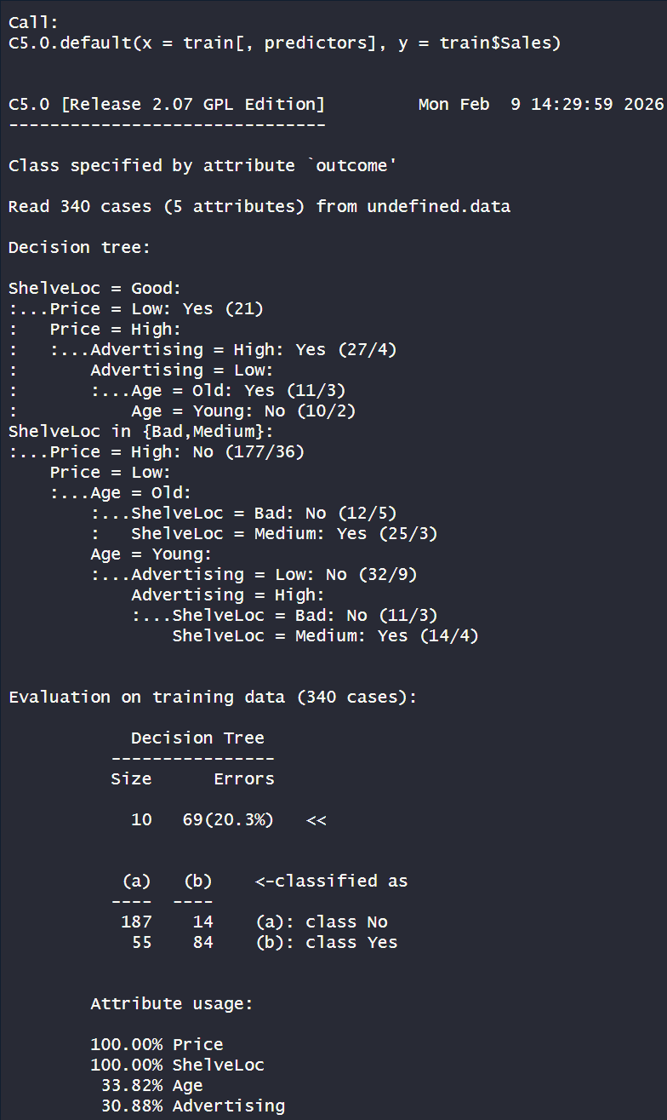
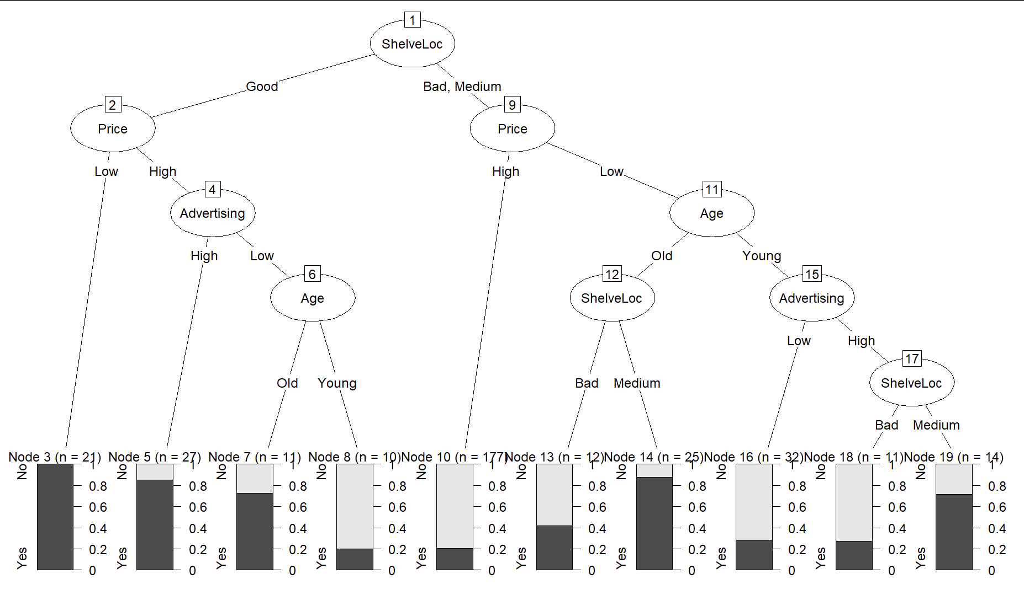
The most important variables to predict car sales are Advertising and ShelveLoc.
Q2:
pred <- predict(model, newdata = test)
head(pred)

evaluation <- cbind(test, pred)
evaluation

evaluation$correct <- ifelse(evaluation$Sales == evaluation$pred, 1, 0)
sum(evaluation$correct) / nrow(evaluation)


