Density Phase 0 Protocol Version 2
  - Revised research protocol with explained formulas
Revised October 5 2026

Read this first
Start with the small correctness test and the 12-prompt pilot. Use the pilot to check memory, masks, settings, and the allocation weight. Fix and record all settings before the main experiment.
This experiment asks whether face, hand, and interaction information helps a video generator preserve its full-compute output when it uses less computation. It compares two allocation rules inside the same HSA mechanism.
The main experiment uses 72 prompts and two planned seeds. A seed selects the starting noise. Both seeds run from the start, followed by one final analysis. The estimated generation budget is 558 reference equivalents, or about 32.6 GPU-hours under the planning assumption.
FREEZE means: select the setting using holdout prompts, record it in a dated registration, and keep it fixed during the main experiment. A setting marked FREEZE is not already selected by this document.
Term | Meaning in this protocol
ROI | Region of interest. The pixels we choose to protect, such as a face or a hand and held object.
Token | One unit of the model's latent video grid. Its annotation map covers a 16 by 16 pixel area and a group of video frames.
Need score | A number based on changes in the model's predicted denoising velocity. It estimates where cached predictions may be less reliable.
Importance weight | A multiplier that raises the priority of tokens covered by the selected ROI.
LPIPS | A perceptual difference score between two images. Lower means a closer match.
FLOPs | Floating-point operations. We use them to compare model computation separately from run time.
Confidence interval | A range that describes sampling uncertainty. A wide range means the result is less precise.
Reference equivalent | The planning cost of one dense 40-step video generation. It is abbreviated RE.

The formulas use subscripts to identify a token, frame, prompt, or condition. Read the short explanation after each formula before using the technical rule.

1 Question and scope
At matched Transformer computation, does privileged ROI importance improve HSA's velocity-based step allocation on Wan2.1-T2V-1.3B? The primary regions are faces, hands, hand-object contact, and the object held during contact.
A positive result establishes headroom for preserving the reference in these regions. It does not establish better anatomy, physics, or viewer preference. The masks come from a completed full-compute reference. They are privileged information that a production generator would not normally have.
Combining importance-like and need-like signals is already present in related work. ToCa combines token influence, text association, cache history, and spatial coverage. Foveated Diffusion includes saliency-guided generation. The contribution tested here is a controlled comparison of explicit human and interaction weights inside HSA step allocation.

2 Allocation rule
The video grid contains 32,760 tokens: 21 latent frames, 30 rows, and 52 columns. Token index i includes video time and position. Denoising iteration k is a different time axis. The need score uses the leading full-compute predictions only.
Equation 1. N is the total number of tokens in one video.

Guided velocity and need
Equation 2. The guidance scale a combines the unconditional and text-conditioned predictions. This is denoising velocity, not the physical speed of an object.
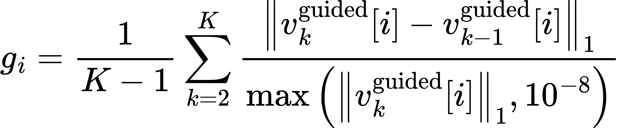
Equation 3. K is the number of leading iterations in which every token runs, read from the schedule: 5 for HSA-50, 10 for HSA-75B, and 9 and 12 for the two switch variants. Compare each available prediction with the previous one, divide by its size, then average. A larger g means the prediction changed more during warm-up. The small denominator floor prevents division by zero.
Use k = 2 through K, so the rule never requires an undefined prediction before the first step. The norm adds absolute component values. Each token vector is its predicted latent-velocity patch, rather than the Transformer hidden feature vector.
Convert velocity predictions to fp32 before guidance, subtraction, and norms. Stop the job on NaN or infinity. Calculate the score once, after iteration n = K − 1, the last in which every token runs, and before the first iteration that skips a token. For HSA-50 that last iteration is n = 4: it lies inside the reduced window, but 4 mod 4 = 0, so the low-budget group runs too. For C3 and C4, sort from largest score to smallest; resolve equal scores by ascending token ID.

Importance and ranking
Equation 4. Mask coverage m is between zero and one. Lambda controls the importance boost. HSA ranks by need alone. Density ranks by importance times need. Lambda equals zero must reproduce HSA.
Worked example: with lambda = 3 and full mask coverage, the importance weight is 4. A token with need 0.2 then has Density score 0.8. A token outside the mask keeps its original need score.
Equation 5. This example shows the arithmetic only. It is not an experimental result.
After ranking, fill the fixed HSA group sizes. Use the same cache mechanism, cached Euler update, step schedule, and full-compute windows in all matched conditions.
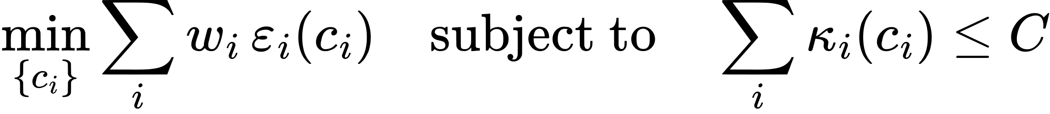
Equation 6. The motivating objective reduces weighted error under a total computation budget C. It assumes each token's error depends only on its own computation. Attention couples tokens, so importance times need is a heuristic to test, not a proven solution.

3 Conditions and ablations
C3 versus C4 is the primary comparison. These conditions use the same prompt, starting noise, negative prompt, guidance, shift, warm-up, cache handling, group sizes, and active-token counts. C1 and C2 use dense computation and their stated step counts.
ID | Rule | Purpose
C1 | Dense Euler with 40 steps | Full-compute reference for masks and fidelity scores
C2 | Dense Euler with 20 steps | Naive approximately 50 percent baseline
C3 | Rank by need score | Need-only HSA baseline
C4 | Rank by importance times need | Primary Density test
C5 | Rank by fractional mask coverage | Importance without need
C6 | Binary ROI first, then need | Alternative importance-first policy
A1 | C4 with hands and contact only | Test the contribution of the held object

C5 uses the same fractional coverage as C4. Sort by coverage from largest to smallest. Resolve equal coverage using a saved random permutation seeded from the prompt ID. The permutation must not depend on the need score. For a positive lambda, ranking by coverage is equivalent to ranking by importance weight.
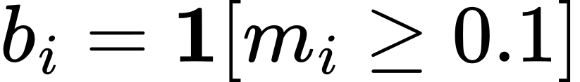
Equation 7. The binary mask b is one when at least 10 percent coverage remains after token mapping. Otherwise b is zero. Use this binary definition for C6 and token-set diagnostics.
C6 sorts first by b, then by need, then by token ID. C6 changes both the importance representation and the ranking policy. A C6 advantage therefore supports that alternative policy; it does not isolate the effect of importance dominance.
Compare C5 and C4 on the same selected prompts and seed. A C5 advantage suggests the need factor did not help under that comparison. A wide interval does not establish equality. For A1, score A1 and C4 on hands/contact and on the held object separately.

4 Regions and reference eligibility
The stratum is the prompt category. Its selected ROI supplies both the allocation prior and the primary measurement. Allocation and measurement use different stated dilation widths, but they begin from the same reference region.
Stratum | Role | Reference ROI
Face close-ups | Primary | Face F
Hand-object manipulation | Primary | Hands H, contact C, and held object O
Full-body motion | Secondary | Person B
Non-human controls | Code check | Explicit empty mask

Equation 8. The union symbol means include pixels from any listed region. Controls always use an empty region.

Construct the masks
- Face: InsightFace SCRFD boxes, then SAM 2.1 Hiera-small propagation.
- Hands: WiLoR boxes, then SAM 2.1 propagation.
- Object and contact state: Hands23 on keyframes spaced eight frames apart. Track the paired hand and object. Propagate the object's mask with SAM 2.1.
- Contact interval: retain an interval only when adjacent keyframes show contact with the same tracked object and the reference audit confirms uninterrupted contact and usable masks through the interval. Trim the interval if contact stops. Keep O and C only in these validated intervals. Do not extrapolate contact before or after them.
- Person: Detectron2 Mask R-CNN person boxes, then SAM 2.1 propagation.
- Re-prompt SAM when overlap with a fresh detection falls below 0.5 intersection-over-union. Record detector versions and thresholds.
Equation 9. On validated contact frames, expand each mask by 16 pixels and keep the overlap. The intersection symbol means pixels present in both expanded masks.

Audit before condition runs
Generate and audit both seed references for each primary prompt before any reduced-budget output for that prompt. A usable primary face or hand ROI must exist in at least 41 of the 81 frames. A manipulation reference must also have at least two adjacent sampled keyframes showing contact with the same tracked hand and object, with usable masks throughout the interval.
Both reference seeds must pass. Each primary reference must also have at least one frame with pixels outside its ROI expanded by 32 pixels, so the outside-ROI measurement is defined. Replace a failed prompt using the next item in the ordered reserve pool for its stratum, then generate and audit both seeds again. Judge mask validity; a target that isn’t visible counts as invalid. Do not reject a reference merely because its anatomy or image quality is poor. Log the reason and extra reference cost.
Judge each reference’s contact sheet against these registered audit criteria. Backfilled frames are the frames before a track’s first detection, where SAM’s backward propagation supplies the mask.
- Accept a reference if its stratum ROI is on the right target; covers the key parts in most frames (faces: eyes, nose, mouth; manipulation: the gripping hand, the held object, the contact band; body: the main person); has no major spill onto other things; and follows the same object across frames, including backfilled frames.
- Reject only for mask invalidity, with a written reason. Never reject for anatomy, image quality or appearance.
- Audit each seed separately, and before any reduced-budget output exists. Re-check the first ten sheets at the end of each session for drift.
FREEZE the eligibility thresholds, reserve order, accepted prompt list, reference hashes, masks, and audit log before condition runs. If a reserve pool is exhausted, stop and amend the registration before running comparisons. After comparisons start, rerun technical failures under the same settings. Do not replace or exclude prompts based on their appearance, detector scores, or measured results.

Map pixels to tokens
Pixel frames use f = 0 through 80. Latent frames use j = 0 through 20. Rows r use 0 through 29; columns c use 0 through 51. Average each binary ROI over its 16 by 16 pixel cell.
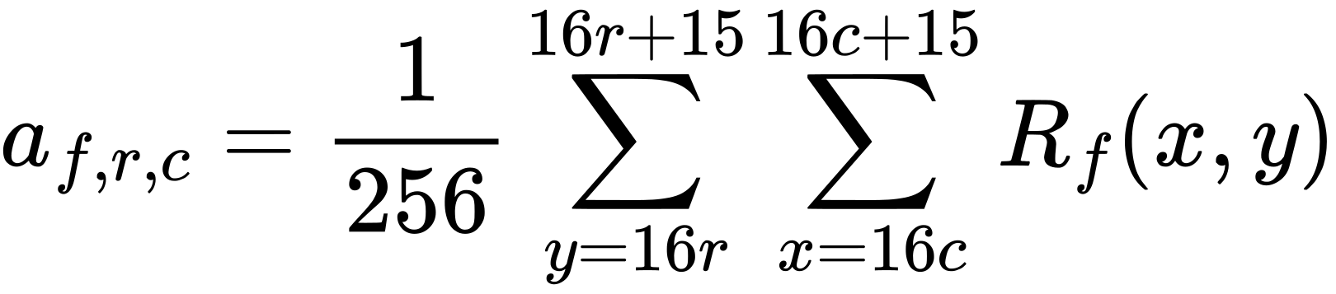
Equation 10. A cell that is half covered has coverage 0.5. Preserve fractional coverage.
Equation 11. Latent frame zero uses pixel frame zero. Each later latent frame uses the stated group of four pixel frames.
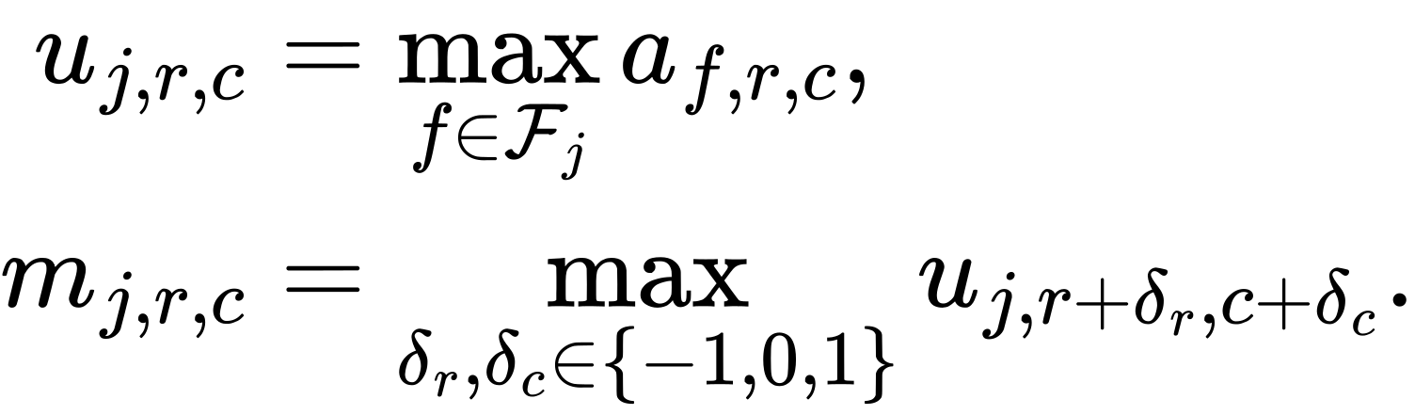
Equation 12. First take the largest coverage across the frame group. Then expand spatially by one token using a 3 by 3 maximum operation. Use zero outside the grid. Do not expand through time or convert this coverage to a binary mask. This is an annotation map, not the VAE's exact receptive field.

5 Model and schedules
Setting | Value
Generator | Wan2.1-T2V-1.3B Diffusers checkpoint with pinned revision
Video | 832 by 480 pixels and 81 frames
Sampler | Custom FlowMatch Euler with 40 global steps
Precision | bf16 Transformer and fp32 VAE decode
Negative prompt | Fixed Wan sample_neg_prompt
Shift and guidance | FREEZE during holdout pilot
Guidance handling | Same active-token IDs in both branches, separate KV caches, cached guided velocity

If the HSA authors provide settings before the pilot is frozen, use and record them. Otherwise test shift 8 / guidance 6 and shift 5 / guidance 5 on holdout references. Select the pair with the higher mean face/hand detection coverage. Give the two strata equal weight. Ties select 8 / 6. Record the exact timestep schedule and package revisions.
The schedule below uses zero-based code iteration n = 0 through 39. The mathematical need formula uses k = n + 1. These are two labels for the same denoising evaluations.
Equation 13. A token runs when the iteration is outside the reduced window, or when its regular schedule selects that iteration. The half-open window includes its start and excludes its end. The high-budget group runs on all 40 iterations.
Preset | High / low tokens | Window | Low stride | Actual fraction
HSA-50 primary | 5,242 / 27,518 | 4 to 35 | 4 | 0.496007
HSA-75B secondary | 10,811 / 21,949 | 10 to 29 | 4 | 0.748752
Switch 20 percent | 1,560 / 31,200 | 8 to 35 | 4 | 0.500000
Switch 30 percent | 1,560 / 31,200 | 12 to 35 | 8 | 0.500000

Actual low-group evaluation counts are 16, 25, 19, and 19, respectively. The nominal 10-step or 5-step group determines its stride. Forced full-compute windows add evaluations. Save the complete active-iteration arrays in the registration.
C2 uses 20 dense steps. Its token-step fraction is 0.5, slightly above HSA-50's 0.496007. C2 is a context baseline; the exact matched comparison is C3 versus C4. In the pilot, C2 also runs on the 12 holdout prompts as the HSA reproduction check (section 10). The 25 percent preset is omitted because the published HSA-25 uses random allocation rather than the velocity comparison tested here.

6 Prompts and fixed seeds
Block | Count | Source and use
Holdout pilot | 12 | 6 face and 6 manipulation prompts; tuning only
Primary faces | 36 | VBench human and VBench-2.0 Human Fidelity
Primary manipulation | 36 | T2V-CompBench interaction/action prompts and VBench human_action; then the Kinetics-400 classes VBench does not use (Section 14)
Secondary full body | 16 | VBench human_action and VBench-2.0 Human Anatomy
Controls | 16 | VBench scenery and architecture
Reserves | 10 per stratum | Ordered replacement lists only

Rewrite each prompt once into one or two sentences naming the subject, action, and framing. Freeze prompts.csv and the ordered reserve lists. Holdout prompts never enter the main analysis.
Equation 14. Each primary prompt has two planned seeds. A seed's conditions all reuse its saved starting noise. The two seeds have separate dense references and masks.
Generate starting noise on CPU with a seeded torch.Generator, save it, and record its hash. C1, C3, and C4 run for both seeds on all 72 primary prompts. C2 and the secondary blocks use seed 1 only. There is one final primary analysis after both seeds finish.

7 Measurements

Primary masked LPIPS
Use LPIPS version 0.1 with AlexNet and spatial output. Scale RGB to the range minus one to plus one. Use the native 832 by 480 frames without resizing. Calculate the perceptual difference map from the complete images against that seed's C1 reference. Average the map inside the reference ROI expanded by 8 pixels. Do not black out pixels before scoring.
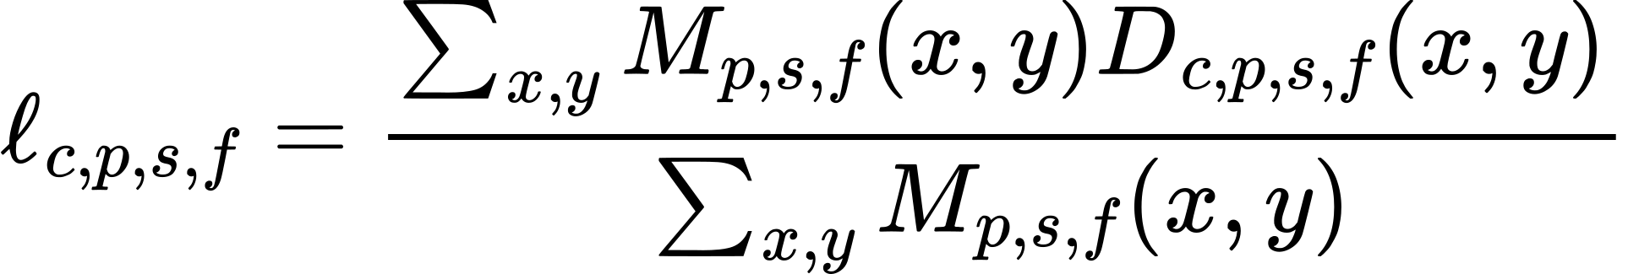
Equation 15. D is the spatial LPIPS difference map. M is the measurement mask. This formula averages differences over mask pixels for condition c, prompt p, seed s, and frame f.
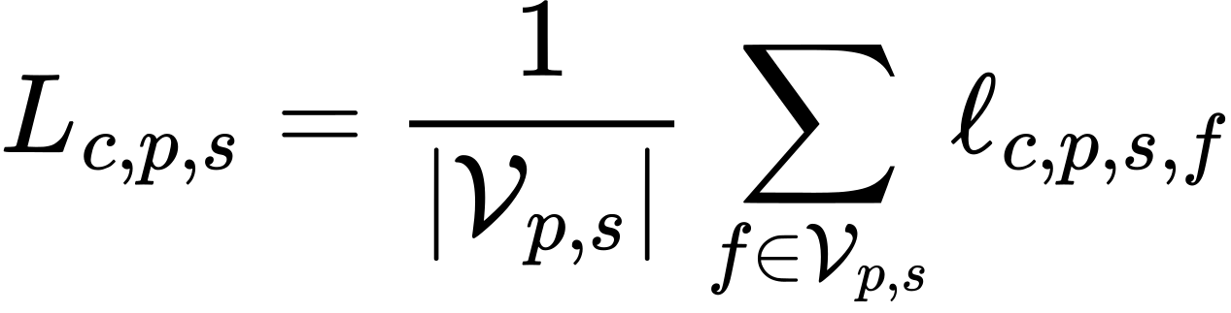
Equation 16. V is the set of reference frames with a non-empty measurement mask. Give each usable frame equal weight. Use the same reference mask and frame set for every condition.
Measure before lossy video compression, or use a fixed lossless frame representation. Save playback MP4s separately. LPIPS features also use nearby image context, so this is ROI-weighted reference fidelity rather than a perfectly isolated local score.

Guardrails for damage elsewhere
- Full-frame LPIPS against the same seed's C1 reference.
- Outside-ROI LPIPS on the complement of the reference ROI expanded by 32 pixels. Average only reference frames with a non-empty complement; reuse the same frame set for every condition. Reject a reference with no usable outside frames during the pre-run audit.
- Five VBench quality dimensions: subject consistency, background consistency, motion smoothness, aesthetic quality, and imaging quality. Use custom-input mode and record each prompt/seed score.
Convert quality scores to a documented 0 to 100 scale using the pinned implementation's units. Do not normalize with the observed data range. In particular, imaging-quality per-video MUSIQ values and its aggregate output have different scaling in the current implementation. Test the conversion explicitly.
VBench temporal flickering is not a guardrail for these moving clips. Its implementation compares adjacent frames and assumes static video. It may be reported descriptively on a static subset selected from the references before condition runs.

Descriptive checks
Report crop LPIPS, masked PSNR and SSIM, face identity consistency, hand detector success, and detector-box overlap with the reference. These help explain failures and do not determine GO. Select 30 C3/C4 pairs before inspecting results. Hide labels and randomize left/right order for a visual check. This checks metric failures and does not establish general viewer preference.
A missing required score is a technical failure that blocks the final decision. Rerun the same job or repair the scoring code for all affected cases. Do not silently drop a prompt. Empty primary masks should already have been rejected during reference eligibility.

Allocation diagnostics
For these set-based diagnostics only, define I as tokens whose binary mask b equals one. G1 is the full-step group. Use the same threshold in every condition.
Equation 17. Precision is the share of full-step slots inside the ROI. Recall is the share of ROI tokens in that group. Normalized recall accounts for the group's limited capacity. These quantities are undefined for an empty ROI; report them as not applicable on controls.
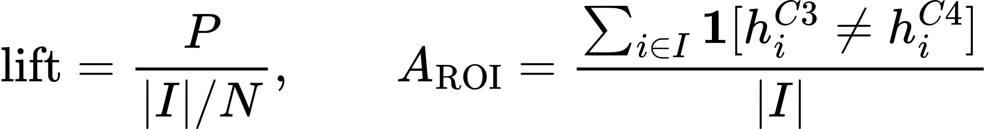
Equation 18. Lift compares full-step ROI allocation with random placement. A_ROI is the fraction of ROI tokens that change groups; h is a token's group label.
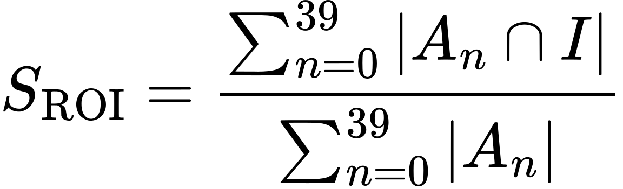
Equation 19. This is the share of all token evaluations spent inside the binary ROI. Report it for C3 and C4. A zero change count inside the binary ROI alone does not prove a no-op, because fractional weights outside that set can still alter allocation.
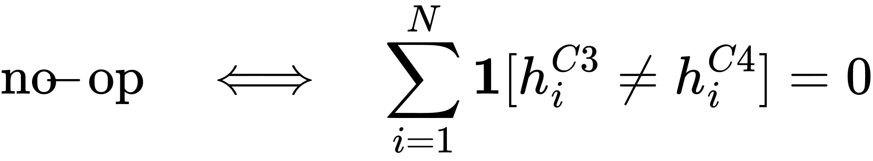
Equation 20. Density is a no-op only when every token keeps the same group label as HSA. Use this all-token definition for the holdout stop check. A small nonzero count is descriptive, not an automatic failure.
For A1, use the same C1 reference masks to report hands/contact fidelity and object fidelity separately. Phase 0 does not use FVD, Direct Motion, T2V-CompBench scoring, or a powered human study.

8 Compute and memory accounting
Matched computation means equal active-token counts, not identical token identities. Assert this for every iteration, Transformer layer, and guidance branch across available C3, C4, C5, C6, and A1 conditions with the same prompt, seed, and budget. A1 applies only to manipulation prompts. Identical group counts and schedules make the principal Transformer arithmetic equal even when the selected tokens differ.
Equation 21. A is the active-token set. Its size must match at iteration n, layer ell, and guidance branch b.
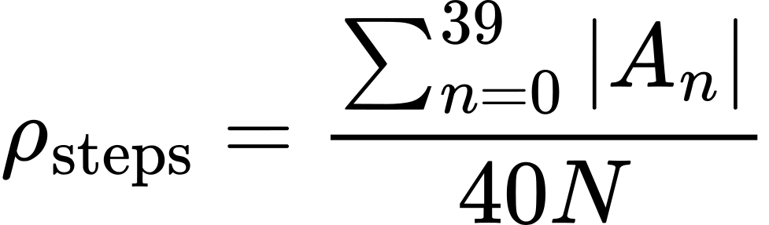
Equation 22. A fraction of 0.5 means half as many token evaluations as a dense 40-step run. It does not guarantee half the run time.
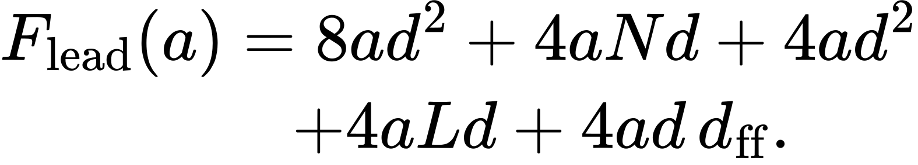
Equation 23. This is the leading per-layer operation estimate, with a active tokens, hidden width d = 1,536, feed-forward width d_ff = 8,960, and text length L. Sum over 30 layers, all iterations, and two guidance branches.
Include shared text K/V projections if they are recomputed: they add 4 L d squared operations per layer and branch. Record treatment of normalization, activations, patch operations, and output operations. Shared omitted operations do not alter the internal C3/C4 comparison, but the leading formula alone is not a complete profiler.
Report token-step fraction, measured denoising time, end-to-end time, and peak memory separately. Use CUDA events for denoising time; exclude the text encoder and VAE only from that timing field. Count their time in the end-to-end field. Disclose the privileged reference and mask costs separately.
Two guidance branches with full bf16 key/value caches require about 11.25 GiB for these dimensions. Caching only HSA-50's nonbaseline entries requires about 9.45 GiB. A 24 GB GPU is plausible, but the smoke test must verify total peak memory with efficient attention, unloaded text encoder, and released caches before VAE decoding.

9 Statistics and decision

One analysis with both seeds
The statistical unit is the prompt. Average the two losses for each condition and prompt before calculating relative improvement. Do not count two seeds as two independent prompts.
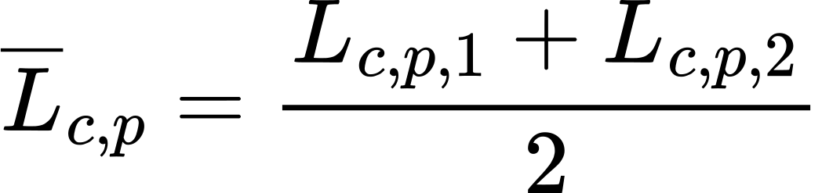
Equation 24. Each condition has one averaged loss for each primary prompt.
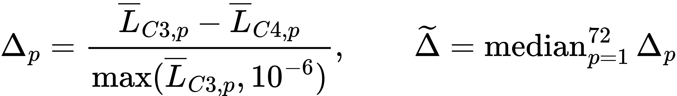
Equation 25. Positive relative improvement favors Density. The denominator floor prevents division by zero. Report how many prompts use the floor, keep them in the analysis, and report absolute loss changes as well.
Worked example: HSA loss 0.10 and Density loss 0.085 give relative improvement 15 percent and absolute improvement 0.015. This is an arithmetic example only.
Equation 26. The relative result states the fraction of HSA's reference error removed. It is not a percentage increase in general video quality.
Use a paired bootstrap with 100,000 resamples and fixed random seed 20261005. In each resample, draw 36 face prompts and 36 manipulation prompts with replacement. Keep both seeds and all conditions together for each selected prompt. Report the 2.5th and 97.5th percentiles for the primary 95 percent interval. This describes prompt variation for the two fixed seeds.
Also report median absolute improvement with its interval, ratio of mean losses, Wilcoxon signed-rank result, and prompt win rate. These are supporting statistics. Use the pilot to estimate precision, while keeping the registered main sample size at 72 prompts.

Define degradation with the correct sign
Equation 27. Positive degradation means damage in both formulas. LPIPS is lower-is-better. VBench quality Q is higher-is-better on the recorded 0 to 100 scale.
For each guardrail, estimate the mean paired degradation across prompts. The limits are 0.01 LPIPS for full-frame and outside-ROI fidelity, and 0.5 points for each of the five quality dimensions. These are research design limits, not established perceptual thresholds. FREEZE them before the main runs.

Separate a pass from uncertainty and damage
There are seven guardrails. Use conservative Bonferroni intervals to account for the family. Calculate each guardrail's bootstrap interval with the following endpoints. This gives approximately 95 percent simultaneous coverage for all seven, subject to the bootstrap approximation.
Equation 28. Q is a bootstrap quantile. The endpoints are about 0.003571 and 0.996429, giving 99.2857 percent coverage for each interval. Conservative intervals may leave a result uncertain.
Guardrail status | Exact rule | Meaning
Pass | Upper bound below its limit | Evidence supports acceptable mean degradation
Confirmed harm | Lower bound above its limit | Evidence supports degradation beyond the limit
Uncertain | Neither rule holds | The data do not resolve the guardrail

Outcome | Rule and next step
GO | Median relative improvement at least 10 percent, primary 95 percent lower bound above zero, and all seven guardrails pass. Begin a separately specified estimator phase.
NO-GO | Primary 95 percent upper bound below 5 percent, or any guardrail shows confirmed harm. Stop this tested implementation.
UNCERTAIN | All other results. Report the unresolved uncertainty. Do not start the estimator phase on this result. Plan any further data collection in a new registration.

Check confirmed harm before GO. A missing required metric is a technical blockage, not a scientific NO-GO. The 10 percent and 5 percent cutoffs are chosen development thresholds. A wide interval does not prove failure or safety.

Secondary results and interpretation
Report separate face and manipulation results, full-body results, 75 percent budget, switch points, C5/C6, A1, and quality diagnostics. Give effect sizes and intervals. If testing secondary hypotheses, apply Holm correction within each predeclared family: strata, budget/switch comparisons, and allocation/ROI ablations. Descriptive diagnostics receive no significance claims.
GO establishes reference-preservation headroom under these priors. NO-GO weakens this combination of regions, multiplier, model, and HSA-50 schedule. It does not rule out every importance estimator or compute-control method.
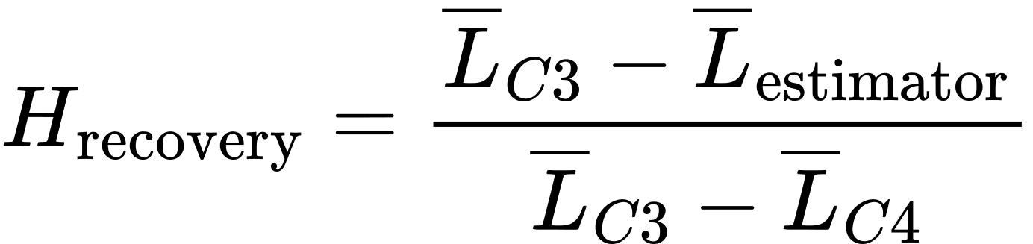
Equation 29. In Phase 1, this ratio describes how much oracle-policy gain an automatic estimator recovers. Use consistently aggregated losses. It can be negative or above one and is unstable when oracle gain is near zero. Report the underlying differences and uncertainty.

10 Pilot and registration
- Obtain the HSA authors' settings if available. Record the code status and the exact reference implementation used. Contacting an author is an optional researcher action; this protocol does not depend on a response.
- Generate both candidate shift/guidance settings on the 12 holdout prompts. Choose the setting using the stated detection rule.
- Build and audit the chosen references. Validate token mapping and interaction intervals.
- Run C3 and C4 with lambda values 1, 3, and 10 at HSA-50. Among candidates with mean outside-ROI LPIPS degradation below 0.01, select the lowest median masked LPIPS. Ties select the smaller lambda. If none qualifies, stop and revise the pilot plan before the main experiment.
- Run C2 on the 12 holdout prompts at the chosen setting as the HSA reproduction check, scored by full-frame LPIPS against the 40-step C1 reference, the metric the HSA paper reports. HSA-50's median over the 12 prompts should be at most about 70 percent of C2's median; if it is not, stop and investigate before the main experiment.
- Report how many holdout prompts have no changed allocation at each lambda. If more than half are unchanged at all three values, investigate the score and masks before proceeding.
- Freeze the question, settings, masks, lambda, seeds, score floors, eligibility rules, schedules, required metrics, bootstrap rules, guardrail limits, and secondary families in a dated registration.
- Generate and audit both main references, apply the registered replacement rule, and freeze the final prompt manifest and masks before reduced-budget main runs.
The pilot does not estimate a confirmatory effect. The main estimator and decision rules remain fixed after registration. No extra seed is triggered by the main result.

11 Correctness tests
Pass these checks before any scientific comparison. Use fixed input tensors. Establish the normal error of the chosen precision and attention backend before setting final numerical tolerances.
Test | Required result
Repeated dense run | Decoded PSNR at least 45 dB; record tensor errors and backend determinism
All HSA groups dense | Match the same dense Euler path; decoded PSNR at least 45 dB
All tokens active in cached attention | Match dense attention within the calibrated numerical tolerance; record relative error
Lambda zero versus C3 | Identical group labels and active-token IDs; output within baseline numerical tolerance
Explicit empty mask | C4 reproduces C3. Any unexplained difference is an implementation failure
Active-token counts | Equal for every iteration, layer, and guidance branch in matched conditions
Budget | Actual token-step fraction within 0.005 of the registered target
Manifest | Config hash, code SHA, checkpoint revision, seed, and input hashes recorded

For attention, compare tensor error against the dense-path numerical baseline. Do not accept an arbitrary 1 percent difference as proof of correctness. FREEZE the measured tolerance on smoke-test inputs before the pilot. Check that its induced LPIPS difference is small compared with the improvement the experiment seeks.
Investigate positional indexing, query/key normalization order, stale cache entries, guidance-branch mixing, and cached-velocity updates first. In an explicit zero-mask control, detector false positives cannot explain a C3/C4 mismatch.

12 Compute grid and storage
One RE is the approximate cost of one dense 40-step generation. The planning assumption is 3.5 minutes per RE on a 4090-class GPU. Calibrate actual time in the smoke test. The figures below are rounded planning values; exact token-step fractions give a slightly lower total and do not predict measured run time exactly.
Block | Prompts and conditions | RE
Smoke test | 2 prompts for determinism and equivalence | 6
Pilot settings | 12 prompts and 2 dense references each | 24
Pilot lambda | 12 prompts with C3 and 3 C4 values | 24
Pilot HSA reproduction | 12 prompts with C2 | 6
Primary seed 1 | 72 prompts with C1, C2, C3, C4 | 180
Primary seed 2 | 72 prompts with C1, C3, C4 | 144
C5 and C6 | 18 face and 18 manipulation prompts; seed 1 | 36
A1 | 36 manipulation prompts; seed 1 | 18
Full body | 16 prompts with C1, C3, C4; seed 1 | 32
Controls | 16 prompts with C1, C3, C4; seed 1 | 32
75 percent budget | 8 face and 8 manipulation prompts; C3/C4 | 24
Switch points | 8 face and 8 manipulation prompts; 2 switches, C3/C4 | 32
Total | Both primary seeds included from the start | 558

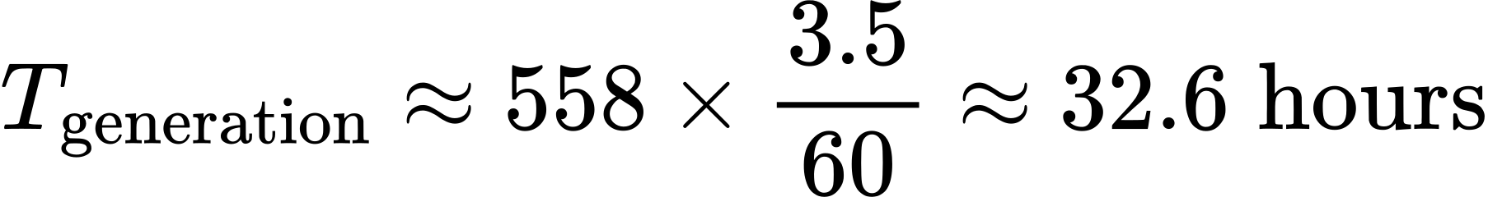
Equation 30. This is a planning estimate before mask extraction, metrics, failed-reference replacements, and debugging.
Equation 31. Use the provider's actual quoted hourly rate. The earlier fixed dollar estimate is not a verified current price. Masks take about 1.2 slice-hours for the pilot and 7.7 for the main run, measured in the smoke test on the 24 GB slice with the CPU thread pools at the pod's quota and the registered ROIAlign kernel (about 18 s per face reference, 346 s per manipulation reference and 94 s per body reference). Metric time is a placeholder until it is measured.
The 75 percent, switch, and ablation blocks reuse seed-1 primary references. Select their prompt subsets before results are inspected. Report additional cost for replacements separately. Do not run C2 on seed 2 unless this extension is registered and budgeted; it adds 36 RE.
Plan at least 50 GB for weights, text embeddings, starting noise, compressed playback videos, allocation maps, masks, and tables of scores. Measure the storage requirement for lossless scoring frames during the pilot and expand the volume if required. Do not save latent trajectories unless a later debugging plan requires them.

13 Execution order
- Build the Euler loop and HSA mechanics at a small supported resolution. Use the Mac where the required operations work; use the GPU smoke test for CUDA-specific behavior.
- Test masks and token mapping on a stock clip. Inspect the overlays and frame-group mapping.
- Pin versions on the GPU machine, download weights, and precompute text embeddings. Run full-resolution correctness and memory checks.
- Run the holdout pilot and freeze the registered settings.
- Generate all required main references, audit both primary seeds, apply replacements, and freeze masks and the final manifest.
- Run reduced-budget conditions from a resumable manifest. Reuse the saved starting noise. Save each result atomically and log active-token counts, timing, and memory.
- Score lossless frames in a separate resumable job. Validate per-video quality-score scaling.
- After all required jobs finish, perform the one registered primary analysis. Report GO, NO-GO, or UNCERTAIN with all guardrails and secondary results. Archive references, settings, masks, scores, and code revisions.

14 Changes in this revision
- Both primary seeds are planned from the start; there is one primary analysis. Total planning generation cost is 552 RE.
- VBench degradation has the correct sign and an explicit 0 to 100 scale. Static-video flickering does not gate action clips.
- Guardrails distinguish acceptable damage, unresolved uncertainty, and confirmed harm. Simultaneous intervals account for all seven guardrails.
- Need uses only available warm-up pairs, fp32 arithmetic, a denominator floor, and fixed tie rules.
- Both reference seeds must pass the mask audit. Manipulation requires a validated contact/object interval, not visible hands alone.
- C5 uses the same fractional importance representation as C4. C6 is described as a different binary policy.
- Pixel-to-token mapping, exact schedule counts, LPIPS equations, budget equations, and the interpretation of each formula are explicit.
- Empty-mask differences are implementation failures. Numerical tolerances must be calibrated before comparisons.
- The need score’s K is the number of leading iterations in which every token runs (5, 10, 9 and 12), consistent with the HSA paper’s averaging over the first 5 to 10 steps. Labels are assigned after the last of them.
- Mask-pipeline settings are registered in src/density/masks/registered.py at commit 971b8d86c980908a4c092dc7b03cee0219c9ac98: detectors and thresholds, SAM 2.1 precision and build, the detection-to-track association rule, Hands23 confirmation of hand tracks, sustained contact, the 256-pixel usable frame, the regions each stratum computes, and the GPU that computes the masks.
- Reference audits follow registered criteria (Section 4): the stratum ROI must be on the right target, cover the key parts in most frames, avoid major spill, and follow the same object across frames, including backfilled frames. Each seed is audited separately before any reduced-budget output, and the first ten sheets are re-checked for drift at the end of each session. A reference is rejected only for mask invalidity, and a target that isn’t visible counts as invalid. Every rejection carries one of three codes (target not visible, mask invalid, contact interrupted) and a written reason.
- Starting noise is registered in src/density/noise.py at commit 7b9b39b641b1957aa52ebc4aa65a66be258efdb5: each seed’s noise is generated once on CPU with a seeded torch.Generator, saved, and identified by the SHA-256 of its tensor bytes. Every run loads it from the saved file and checks that hash. Noise is never regenerated, because the same seed gives different noise on different CPUs; the smoke test found that x86 and ARM differ.
- Text encoding is registered in src/density/text_encoding.py at commit 4532149cdd1b70fc62c2073057bc04023cbe6f6b: the UMT5 encoder runs in bf16 with 512 tokens, as Wan2.1’s official configuration sets them, and the negative prompt is that configuration’s sample_neg_prompt (Wan2.1 commit 9737cba). ftfy is absent, so prompt cleaning applies only HTML unescaping and whitespace cleanup, and encoding refuses to run if ftfy is installed.
- Generation’s attention backend is registered in src/density/attention.py at commit 862b76b232c09b64f210cd8ca77a516596281c42: on CUDA every forward pass uses flash attention, and memory-efficient attention only where flash cannot run (fp32). Otherwise PyTorch chose cuDNN attention on the H100, which was bitwise within a process but not across processes and gave different results for different query counts. Flash attention is bitwise across processes, and with it the HSA fast path equals its oracle.
- The VAE’s fp32 convolutions are registered as TF32, CUDA’s default, in src/density/wan.py at commit 862b76b232c09b64f210cd8ca77a516596281c42. On the H100, strict fp32 added 13.1 seconds per video, 18 percent of a dense C1’s time and 33 percent of an HSA-50 run’s with the registered flash attention, and needed 41 GiB of memory instead of 8.7 GiB, beyond the 10 percent limit for choosing strict fp32. Decoded frames differed by 81 to 86 dB PSNR.
- SAM 2.1’s fp32 convolutions are registered as strict IEEE fp32 in src/density/masks/registered.py at commit c40523747be121ccd5824470895e4d38970ee033, within the same 10 percent limit: on the 24 GB slice, strict fp32 changed the per-reference mask time by −2 percent (face) and +0.8 percent (manipulation), and the masks by IoU 0.99972 to 0.99999. The detectors keep CUDA’s default.
- The smoke test’s numerical tolerances are frozen in src/density/tolerances.py at commit a8d6780bb4142615544016304dd4026058ce6cf9: bitwise for the repeated dense run, for all HSA groups dense against the dense loop, and for the fast path against the masked-dense oracle in C3 and in C4. They hold at 832 by 480 with 81 frames on the H100 with flash attention, comparing runs on the same device. They do not cover smaller sizes, where cuBLAS gives different results for different row counts, or comparisons across devices, which are reported, not judged. The section 11 check that the fast path’s induced LPIPS difference is small is met at zero for the registered configuration, because the fast path’s frames equal the oracle’s exactly; LPIPS of the smoke test’s frames under PyTorch’s default attention is not computed.
- Every H100 session starts with a canary, registered in src/density/canary.py at commit a8d6780bb4142615544016304dd4026058ce6cf9. Before any experiment job runs, smoke-1’s dense C1 is regenerated, and its final latents and decoded frames must match the hashes from the smoke test’s Session D bitwise. If either differs, the session stops and reports the pod’s host and driver.
- In the pilot and the main run, deterministic algorithms run in strict mode, registered in src/density/determinism.py at commit a8d6780bb4142615544016304dd4026058ce6cf9: an operation without a deterministic implementation, or any warning about deterministic algorithms, stops the job instead of being logged.
- The pilot adds C2 on the 12 holdout prompts, 6 RE, as the HSA reproduction check: by full-frame LPIPS against the 40-step reference, the metric the HSA paper reports, HSA-50’s median over the 12 prompts should be at most about 70 percent of C2’s, or the pilot stops for investigation before the main experiment. The total planning generation cost rises from 552 to 558 RE.
- Detectron2’s ROIAlign, in Mask R-CNN and Hands23, runs through torchvision’s kernel for inference, registered in src/density/masks/registered.py and src/density/masks/roi_align.py at commit 51a260d6ca50bd82530c9af64262c38fa1aa54a3. Under deterministic algorithms torchvision substitutes a pure-Python version that exists for a deterministic backward pass, and it took about 20 seconds an image on the slice. The kernel’s forward pass has no atomics: repeats were bitwise identical, its outputs differed from the Python version’s only in rounding, and every Mask R-CNN and Hands23 call checks that the kernel ran.
- Every mask session starts with a mask canary, registered in src/density/mask_canary.py at commit 36c50ca6853420be4e9c999c36b555285b34fb0b, with its hashes in configs/mask_canary.json at commit df38e742942c2900a9574f7667310025a6e39f44. Every model of the mask pipeline runs on the first 9 frames of the stock clips, and each model’s outputs must hash identically to the record from the smoke test’s mask-check rerun on the slice. If any differs, the session stops and reports the pod’s host, CPU and driver.
- Section 12’s mask time is the smoke test’s measurement: about 1.2 slice-hours for the pilot and 7.7 for the main run, with the CPU thread pools at the pod’s quota, which changed no output, and the ROIAlign kernel. Metric time stays a placeholder.
- Fidelity scores are registered in src/density/metrics/registered.py at commit b2da957d59b466b0acd2322d4ab3daebf2dff504. LPIPS is version 0.1 with AlexNet, loaded data-only from verified weight files, on the native 832 by 480 frames scaled to −1 to +1. Masked and outside-ROI LPIPS average the spatial map as Equations 15 and 16 state. Full-frame LPIPS, for both the full-frame guardrail and the C2 check, is scalar LPIPS of each frame averaged over the 81 frames, the HSA paper’s metric. Each H100 generation job computes these scores against its reference’s lossless frames.
- Quality scores come from VBench v0.1.5’s own per-video functions, vendored in third_party/vbench at commit aa7962e652c6085905cb0f1e0208e23bdfe4b3c9 with every change kept as a reviewed diff; their models load data-only from verified weight files. The 0 to 100 scale, registered in src/density/metrics/registered.py at commit b2da957d59b466b0acd2322d4ab3daebf2dff504, multiplies subject consistency, background consistency, motion smoothness and aesthetic quality by 100 and keeps imaging quality’s per-video MUSIQ value, which is already on that scale; VBench divides only its imaging aggregate by 100. A non-finite value stops the job, because VBench would turn a NaN into 0. Quality and detector checks run on the slice from each video’s lossless frames, and a prompt-seed’s reference and conditions are scored on the same host (src/density/run/score.py at commit be1c95614e20dd79a0461cd4b8805ef1cac9cc83).
- Every video’s playback copy is encoded once, in src/density/video.py at commit b2da957d59b466b0acd2322d4ab3daebf2dff504: libx264 at CRF 10 with yuv420p, 16 fps, one thread and cpu-independent, and the BT.709 limited-range conversion done in numpy. Each encode records the decoded video’s PSNR against its lossless frames. Before any H100 job, an encode canary must reproduce the decoded frames registered in configs/encode_canary.json at commit 33faed0f6b80c4a46815dc3b7e45706ba7359285, which were recorded on the Mac. If the first H100 pod’s decoded frames differ, the canary is registered again from that pod, and the new registration is committed before any job runs.
- Scoring runs in fp32 with IEEE convolutions and matmuls, except CLIP, which runs in fp16 on CUDA as VBench runs it; on CUDA, CLIP’s attention uses flash attention, or memory-efficient attention where flash cannot run.
- Prompt IDs are integers from 1 to 999, so the seeds of Equation 14, 1000 + ID and 2000 + ID, never collide (src/density/prompts.py at commit 4a2ce15610fdcc9279dad8d61ba21bc430f44d6b).
- The primary analysis is frozen by code hash in configs/analysis_freeze.json at commit e9e7fa798e711f0a824c98fd49a582580684ba77, recorded at code 98f4b9a45a9cfff80154555eaf495f314c223a24: the SHA-256 of src/density/analysis.py, of the registered values it reads (src/density/metrics/registered.py), and of the modules that read a run’s records for it (src/density/run/store.py, src/density/run/manifest.py and src/density/prompts.py), with numpy 2.2.6 and scipy 1.15.3. The analysis refuses to run if any of them changed, and a quality score not computed from lossless frames blocks the decision.
- Every score is measured before lossy compression, as Section 7 states, in the pilot and the main run, registered in src/density/metrics/registered.py, src/density/video.py and src/density/run/score.py at commit be1c95614e20dd79a0461cd4b8805ef1cac9cc83. A reference keeps its PNG frames. A condition keeps a lossless copy of its frames, FFV1 in Matroska with pixel format bgra and alpha 255, its channels reordered in numpy with no colour conversion, and its generation job completes only after the copy decodes bit for bit to the frames it stores. The scoring job checks each copy’s hash before it computes the five quality dimensions and the detector checks. The CRF 10 MP4s are kept for playback; their quality scores, and how far the encoding moves each quality guardrail’s paired degradation, are reported as a descriptive check.
- The density volume is 125 GB, and the volume stop moves from 90 GB to 112 GB, registered in src/density/volume.py at commit be1c95614e20dd79a0461cd4b8805ef1cac9cc83. Every session checks the volume with du before its first job and before each prompt’s batch of jobs, and stops at 112 GB. With the FFV1 copies, the volume after the main run is projected at about 86 GB, from the stock clips’ sizes.
- Every session on a pod also runs a metric canary, registered in src/density/metric_canary.py at commit be1c95614e20dd79a0461cd4b8805ef1cac9cc83, after the pod’s other canary and before any job. The H100 scores the first 17 frames of the face stock clip, CRF 10 MP4 against lossless, by spatial and scalar LPIPS, masked PSNR and SSIM, and crop LPIPS under a fixed box, and checks that the clip’s FFV1 copy decodes bit for bit. The slice scores the five quality dimensions of those frames and of their MP4, and the detector checks of SCRFD with ArcFace, WiLoR and Mask R-CNN on the first 9 frames of the face, hands and body clips. Each machine’s first pilot session records the scores from two fresh processes, which must agree exactly; the registration is then committed in configs/metric_canary.json, and every later session must reproduce it bit for bit in a fresh process, or it stops and reports the pod’s host.
- The pilot’s rules are registered in src/density/pilot.py at commit be1c95614e20dd79a0461cd4b8805ef1cac9cc83. Detection coverage, for choosing the setting, is the share of a reference’s 81 frames where SCRFD (faces) or WiLoR (hands) detects anything, averaged per stratum, with the two strata weighted equally. Holdout prompts that fail eligibility or the audit are excluded from the pilot’s conditions and reported, never replaced. The C2 check’s 70 percent tolerates floating-point rounding only. The reserve rule gives the size that covers 36 passing primary prompts on both seeds with 95 percent probability, failures following a negative binomial distribution in the square of the holdout’s one-seed pass rate, evaluated at the estimate. Chase sets the registered reserve sizes from that estimate after the pilot, because six holdout prompts per stratum make a lower bound unusable, and they take the place of Section 6’s 10 per stratum. A main run whose reserve list is exhausted stops until the registration is amended.
- The secondary subsets are drawn at the freeze, before any result exists, with seed 20261007 (src/density/run/plan.py at commit be1c95614e20dd79a0461cd4b8805ef1cac9cc83): one permutation of each stratum’s accepted primary prompts, of which C5 and C6 take the first 18 and the 75 percent and switch blocks the first 8, so the smaller subsets are nested in the larger. The visual check’s 15 face and 15 manipulation prompts are chosen at the freeze with seed 20261008 (src/density/visual_check.py).
- The descriptive checks are defined in src/density/metrics/registered.py at commit be1c95614e20dd79a0461cd4b8805ef1cac9cc83. Masked PSNR takes each frame’s mean squared error inside the measurement mask, averages the frames with equal weight, and is capped at 100 dB; masked SSIM is Gaussian SSIM averaged inside the mask; crop LPIPS compares a crop around each frame’s mask, widened to at least 64 pixels a side. The detector checks pair a condition’s detection with the reference’s at box IoU 0.5 or more: ArcFace identity for faces, the share of reference hand boxes WiLoR detects again for manipulation, and box overlap for the three human strata.
- Each secondary family’s Wilcoxon signed-rank p-values get Holm’s correction within the family, in src/density/analysis.py, frozen as above: the strata, the budget and switch blocks, and the ablations, where a positive effect of C5, C6 or A1 against C4 favours the ablation. Full-body references get audit sheets for information only, since Section 4 gates only primary prompts (src/density/run/masks.py at commit be1c95614e20dd79a0461cd4b8805ef1cac9cc83).
- The prompt file is checked in two scopes, registered in src/density/prompts.py and src/density/run/__main__.py at commit be1c95614e20dd79a0461cd4b8805ef1cac9cc83: the pilot’s init checks only the 12 holdout rows, so the pilot can start once Chase has approved them; the main run’s init checks the whole file, with at least the reserve sizes the registration records.
- The prompts are drafted by Claude under a registered procedure, and Chase reviews every row, replacing the plan that Chase writes them; the procedure and its seed, 20261009, were registered in src/density/prompt_draft.py at commit 5b903ba55355cc65db23ff9e1c16cdf5eeae630a before any draw. Each stratum’s candidates are its Section 6 lists, with a prompt that appears in several lists counted once and a prompt kept in an earlier stratum skipped, so no source prompt is used twice. The candidates are shuffled with the seed and judged in that order against the stratum’s eligibility rule; the first eligible ones fill the holdout, then the primary block, then the reserves: 6, 36 and 20 for faces, 6, 36 and 40 for manipulation, and 16 and 10 each for full body and controls. Every skipped candidate is logged with its reason in configs/prompt_draw_log.csv. Each draft is one or two sentences naming the subject, action and framing, keeps the source’s subject and object, adds no objects, actions, or style or quality words, and carries a rewrite note that records Chase’s review and any edit he makes. Each block’s IDs are fixed by its full count (commit 44703285c276ee39d03b99a113e4f98ad0cd4e55), so filling one block never moves another block’s IDs or seeds.
- Chase registered the eligibility readings in src/density/prompt_draft.py at commit 1325b80a924bf360c2b4368baa0743172a8b32ce, after the draw and before his review; every judgment of the draw stands. A reading is decided by the stratum’s purpose, not by which prompts it brings in. A face prompt with two successive actions is skipped, since one clear expression cannot fit both. Manipulation needs one person’s hands as the clear focus, in sustained contact with an object the source names, with nothing else the close-up would have to show: a second subject or an animal in the scene is skipped even when the hands do not touch it, since the rewrite keeps every source subject; two sequential actions are skipped; the object must be named in the source, so an action that only implies one, such as writing, is skipped; an animal is not an object; steering or riding is skipped, since the hands hold controls the source does not name; flying a kite is skipped, since the hands hold the line; an action that needs a second person counts as more than one person; and a toss and catch is a throw.
- Chase registered two more readings in src/density/prompt_draft.py at commit 1ee9487488d3aeb1bc55a495aa9b7b2d7cd88521. For manipulation, the action and its effect must stay at the hands and the named object, so an action at the mouth, such as tasting, eating or playing a wind instrument, or an effect elsewhere, such as hair a dryer blows, is skipped. For full body, there is no animal in the action and no vehicle motion.
- Manipulation also draws from a second pass, registered in src/density/prompt_draft.py and configs/prompt_sources.json at commit a4370cf773dd64e597373daf55e2a421525ff062 before its draw, because the first pass’s pool gave too few eligible prompts. Its candidates are the 300 Kinetics-400 classes that VBench’s human_action prompts do not use, written as VBench writes them, “A person is” and the class name, from the CVDF’s val.csv (SHA-256 358eaf47e7f80ebf9b17d49eb0635ad5e0fdab98a9cbd75ffdd2ee5d5e5b6944; CC BY 4.0, Kay et al. 2017; only the class names are used). They are shuffled with the registered seed in a fifth stream, [20261009, 4], and ranked after the first pass’s 500 manipulation candidates, so no earlier rank moves. A class that repeats a first-pass candidate, or the action and named object of a manipulation prompt kept in either pass, is skipped. The second pass’s draw, at commit 3b2bf78df7740082d847771444199f829b542eaa, found 38 eligible classes: the primary block is full at 36, with 27 reserves. Section 6’s manipulation sources change accordingly.
- Chase registered how a session measures the volume stop, in src/density/volume.py and src/density/run/session.py at commit 41906e681d2ee8d8c6b0d44fde4589c2a87f4a18: one full du at the session’s start; then, after each job, a running total that adds the allocated size (st_blocks × 512, du’s own measure, not the byte length) of every file the job wrote; and a full du every 30 minutes and whenever the running total reaches the 112 GB stop, which that du then decides. The running total can only overcount between full checks, and each full du records any undercount. A du of the volume took 52.5 s on the pilot’s first H100 pod, so a du before every prompt’s batch left the GPU idle for that long.
- An exploratory dose-response check, outside the confirmatory analysis and with the main run’s registration unchanged, was registered by Chase on 2026-10-08 in src/density/exploratory.py at commit 30f4e9712d7f8ae9732d672c28c56697c127d671, before it ran. Condition C7 inverts the allocation: the same HSA-50 group sizes and schedule as C3 and C4, but the full-step group holds only tokens outside the region (b = 0), ranked by need, so region tokens never get full steps. C7 runs on the 12 holdout prompts, seed 1, at the chosen setting, scored in-job as C3 and C4 are, and each condition’s region compute share is computed from the same need scores. The decision rule is fixed: with r = median C7 masked LPIPS ÷ median C3 masked LPIPS, r from 0.97 to 1.03 means step allocation is too weak a lever, so the main run is skipped and the project pivots; r above 1.10 means the lever is real and the main run is reconsidered; any other r, including C7 doing better than C3, is decided with outside input.

15 References
Use the papers for method claims and the pinned official implementations for settings and score units. Record exact source versions with the experiment.
1. HSA Not All Tokens Need 40 Steps
Chu and Patel 2026. Main step-allocation mechanism, warm-up score, caches, and presets.
2. Wan Open and Advanced Large Scale Video Generative Models
Wan Team 2025. Generator architecture and implementation.
3. Wan2.1 official repository
Checkpoint settings, negative prompt, and reference configuration.
4. ToCa Token wise Feature Caching
Zou and colleagues. ICLR 2025. Related token-selection signals and video caching.
5. Foveated Diffusion
Chao and colleagues 2026. Spatial allocation and saliency-guided generation.
6. Region Adaptive Sampling
Related selective regional sampling in image generation.
7. Token Radius Attention
Related attention-budget allocation.
8. HetA DiT Where Compute Matters
Related uncertainty-based attention allocation.
9. CoInteract
Related human-object structure and specialized generation.
10. LPIPS official implementation
Zhang and colleagues. CVPR 2018. Spatial perceptual distance maps.
11. VBench official implementation
Quality dimensions, custom-input support, and per-video scores.
12. VBench temporal flickering implementation
Static-video assumption for adjacent-frame differences.
13. VBench imaging quality implementation
MUSIQ per-video and aggregate score conversion.
14. VBench 2.0
Human fidelity and intrinsic-faithfulness prompt sources.
15. T2V CompBench
Interaction and action-binding prompt sources.
16. Hands23
Hand, object, and contact annotations.
17. SAM 2 official implementation
Reference mask propagation.
18. InsightFace official implementation
Face detection and identity features.
19. WiLoR
Hand localization and reconstruction. CVPR 2025.

