Title TBD

Abstract TBD

Jerry Shannon, Kim Skobba, Jermaine Durham (?), Chase Polak (?)

# Introduction

TBD

# Citizen Science and Volunteered Geographic Information

Aided by the development of interactive web platforms and applications for mobile data collection, citizen science has become a common method for field research (Curtis, 2018). Defined as “projects that engage both professional scientists and non-specialists in the process of gathering, evaluating or computing scientific data,” Curtis (2018, p. 1) describes two main strands of this research. The first is participatory action research, where community members themselves drive research into collectively identified problems (see also Kindon, Pain, & Kesby, 2007). The second is scientist driven research, where non-experts are enlisted in the process of data collection for already existing research projects. One of the most widely cited examples of this approach is the online project eBird, which collects data from bird watchers to create maps of species’ geographic distribution (Sullivan et al., 2014; The Cornell Lab of Ornithology, 2019).

A related term, volunteered geographic information (VGI), has been used to describe explicitly spatial data produced by ordinary citizens (Goodchild, 2007; Haklay, 2013). These data can be collected through both active or passive participation. The former includes research projects like eBird or online review platforms such as TripAdvisor. The latter includes services that collect data as background information, such as location services on cell phone applications, posts on social media that include geographic location, or surveillance footage (Haklay, 2013).

VGI is not synonymous with citizen science: VGI sometimes lacks the component of active engagement common to most citizen science projects, and not all citizen science includes explicitly spatial data. One of the most prominent examples of VGI is the web service OpenStreetMap, which provides user contributed global data on roads, buildings, and natural features (Bittner, 2016). While this dataset has been used within research projects or for social initiatives such as crisis mapping, it is not itself created to answer specific research questions (Haworth, 2017; Quinn & Yapa, 2015). Yet VGI and citizen science do overlap. For example, a website created to study the spread of disease between oak trees provided tools for concerned citizens to add nearly 2,000 observations to a research dataset (Connors, Lei, & Kelly, 2012). Another study used a participatory design to include both university faculty and community residents to collect, analyze, and report data on local watershed problems (Taki, Jelks, Hawthorne, Dai, & Stauber, 2018).

As crowdsourced tools for scientific inquiry, both VGI and citizen science have been credited with easing the process of data collection and increasing trust between scientists and the general public, though concerns about data quality and geographic sampling remain. A recent meta-analysis by Brown (2017) showed that data accuracy and participation rates have varied considerably in studies making use of a participatory citizen science model. To achieve better consistency, Brown argues for the use of techniques from survey design that are aimed at increasing motivations for participation as well as explicit attention to and systematization of the geographic distribution of community volunteers. These concerns are echoed by Brovelli, et al. (2015), who found that the effectiveness of mobile data collection projects was closely linked to intentional volunteer recruitment and clear project goals. Together, these studies show that while new technologies may help facilitate citizen science research, they do not replace the logistical and relational labor of recruiting researchers or developing and communicating clear project goals.

VGI and citizen science have played a prominent role in many smart city projects, which have incorporated data in bike sharing (Attard, Haklay, & Capineri, 2016), real time traffic data such as that provided by Google (Johnson & Sieber, 2013), or even emotional states (De Oliveira & Painho, 2015) into governance tools and decision making. Cardullo and Kitchin (2019) use Arnstein’s (1969) ladder of citizen participation as a way to classify the kinds of “digital citizenship” created though these projects. At one end of this spectrum, residents are merely passive providers of data or consumers for whom crowdsourced data supports more informed decisions. Traffic maps or energy use dashboards are two examples of this approach. At the other end of this spectrum, residents are empowered to rework existing policies and institutions through forums like hackathons or other meetups where new solutions to urban problems are identified and developed. In practice, Cardullo and Kitchin write, examples of these are rare, as communities tend “to organize their activities and activism around addressing social and environmental issues through political and policy solutions rather than technological ones” (p. 9-10). Still, they argue, the potential remains for something more than neoliberal, consumer focused models of smart citizenship.

Pragmatist models of inquiry provide a useful structure for active forms of citizen engagement. Based in the work of early 20th century thinkers such as John Dewey and William James, pragmatism is a non-foundationalist philosophy that emphasize the social situatedness of knowledge (Dewey, 1997; James & McDermott, 1967). As Barnes (2008) puts it, pragmatism views ideas and knowledge “like knives and forks, implements to accomplish particular tasks, and not transcendent truths” (p. 1544). Those “tasks” are the ongoing routines that constitute social practice, or alternatively, processes of inquiry meant to identify social problems and develop new, more equitable practices. Through a process of inquiry, a diverse set of stakeholders develop a shared understanding of social problems, one that draws upon their respective experiences and perspectives. This knowledge is constructed *through* the process of inquiry and is thus specific to that time and place—it does not predate it, like an artifact waiting to be unearthed. In this sense, pragmatism’s influence is evident in later work such as Kuhn’s (1962) discussion of paradigm shifts, work in science and technology studies (Latour, 1993), or feminist critiques of positivism (Haraway, 1988) all of which emphasize the socially situated nature of knowledge production.

The models of civic engagement provided by citizen science and VGI share this emphasis on inquiry as a social process, one in which various publics can play an active role. Yet, as Harney et al. write, describing their model of process pragmatism, rather than working with

pre-existing publics that are already assembled around the pre-existing agendas that the academic is able and willing to endorse, process pragmatism seeks to use the process of research and knowledge production to construct new publics, new understandings, and new capacity to act. Working in the spirit of pragmatism involves bringing together diverse groups of people with differing worldviews, to find common ground and to create new publics united around issues of common concern. (Harney, McCurry, Scott, & Wills, 2016, p. 9)

In the context of citizen science, this approach emphasizes how the research process can generate new connections between diverse stakeholders. Through an inductive, collaborative process, research teams can construct new understandings of their local neighborhoods and the issues that face them. In this sense, the use of VGI moves beyond a framing of “citizens as sensors” (Goodchild, 2007), as community members play an active role in identifying problems and interpreting the data they collect.

At the same time, the task of building this shared understanding requires time and logistical coordination, as well as the ability to nurture social connections between members of a research team. Our research examines this process through analysis of a community housing assessment program in x cities across rural Georgia. Specifically, we give attention to the ways that a community based process of VGI data collection provided new insights into housing conditions within these communities, as well as ways that communities sometimes struggled to coordinate this process. In doing so, we contribute to the growing literature on how the use of VGI for citizen science can effectively facilitate community engaged research.

# Community Housing assessments

Role of housing assessments in community development and planning (Kim)—or is this necessary if I summarize in methods?

# Setting and Methods

The communities we partnered with for this research were part of the Georgia Initiative for Community Housing (GICH), a program designed to facilitate community planning for affordable housing (University of Georgia, 2019). Each year, five communities enter this program, and these are most often small municipalities from rural parts of the state. As part of their application, communities assemble a housing team that includes a range of key stakeholders, including elected officials, members of community organizations, and housing professionals such as real estate agents or mortgage lenders. Over the course of GICH’s three year program, planning teams attend bi-annual retreats where they attend sessions on issues including techniques for managing heir properties, tools for identifying and reducing blight, and information for working with state housing authorities and their funding programs. Each community also is assigned a facilitator who helps them identify and plan for goals, which often included targeted redevelopment of a set of properties along with a successful application for state or federal funding. Over it’s 12 year history, GICH has enrolled 76 communities throughout the state.

In recent years, many GICH communities have included community housing assessments to provide data for redevelopment plans and funding applications. Community housing assessments, also called windshield surveys, provide a systematic approach to understanding exterior conditions of the local housing stock and other neighborhood issues. Housing assessments help communities focus their efforts on the most critical problems (White, Jensen, & Cook, 1992). These assessments use a windshield survey of properties in a targeted study area, going house by house to identify problems with the housing structure or lot conditions. In most cases, planning teams have opted to conduct this assessment themselves rather than hire an outside agency. Working with the city of Pembroke, one of the first communities in the GICH program to use this method, faculty at the University of Georgia (UGA), including one author of this paper (Skobba), developed a standardized data collection form for this process in 2013. It allowed survey teams to rate structural issues as either minor or major problems and created a three tier system of classification based on these classifications. Communities were given broad flexibility with this survey and often developed customized questions.

A second version of this survey was developed in 2017 based on a review of similar survey forms used in municipalities across the country as well as appraisal forms used for Fannie Mae and HUD FHA loans. The revised (?) survey was then reviewed by housing professionals with housing assessment or appraisal experience. It includes a foundation to roof assessment of built structures as well as questions on the condition of the lot (e.g., overgrown grass, trash/tires) (appendix A). Each issue listed on the survey has a point value, and the sum of these points is used to create a general classification from a list of six categories. Table 1 also provides a summary of categories included on each of these two surveys, though for version 1, not every community included each category. Table 2 summarizes the classification system of each survey.

|  |  |  |  |  |  |  |
| --- | --- | --- | --- | --- | --- | --- |
|  | ***Version 1*** | ***Version 2*** |  |  | ***Version 1*** | ***Version 2*** |
| **Property status** |  |  |  | **Roofing** |  |  |
| Occupancy | x | x |  | Swaying roof | x |  |
| **Property characteristics** |  |  |  | Gutter repair |  | x |
| Single family/ multifamily | x | x |  | Missing shingles | x | x |
| Height/stories | x | x |  | Partial re-roofing | x | x |
| **Foundation** |  |  |  | Complete re-roofing | x | x |
| Cracked | x | x |  | Replace roof structure | x | x |
| Partial replacement |  | x |  | **Lot assessment** |  |  |
| Complete replacement | x | x |  | Overgrown/weeds | x | x |
| **Exterior** |  |  |  | Missing ground cover | x | x |
| Exposed insulation | x |  |  | Dead/hazardous trees |  | x |
| Gutter repair | x | x |  | Inoperable vehicle | x | x |
| Repainting | x | x |  | Junk in yard/porch | x | x |
| Minor dry rot | x | x |  | Porch used as storage | x | x |
| Needs replacement |  | x |  | Graffiti |  | x |
| Chimney repair | x | x |  | **Tax records** |  |  |
| Missing siding | x | x |  | Homestead status | x | x |
| **Windows/doors** |  |  |  | Owner name | x | x |
| Uneven windows/doors | x |  |  | Owner address | x | x |
| Repainting |  | x |  | Parcel location | x | x |
| Dry rot | x | x |  |  |  |  |
| Cracked glass | x | x |  |  |  |  |
| Window replacement | x | x |  |  |  |  |
| **Stairs/rails/porch** |  |  |  |  |  |  |
| Repainting |  | x |  |  |  |  |
| Dry rot/missing railing | x | x |  |  |  |  |
| Repair needed | x | x |  |  |  |  |

**Table 1: Topics included on housing assessment surveys**

|  |  |
| --- | --- |
| **Survey 1 classification** |  |
| *Standard* | No more than one minor issue |
| *Substandard* | More than one minor issue and at least one major issue |
| *Dilapidated* | More than three minor issues and more than 2 major issues |
|  |  |
| **Survey 2 classification** |  |
| *Well maintained* | (Less than 3 points): New or in good condition. Does not need any repairs. |
| *Sound* | (3-9 points): In good condition but is in need of some maintenance work, such as repainting or minor repairs. |
| *Minor repairs needed* | (10-14 points): Housing unit has several deferred maintenance issues or one moderate repair project (i.e. replacement of several windows) |
| *Moderate rehabilitation needed* | (15-39 points): Requires multiple repairs, including the repair/replacement of one major component. |
| *Substantial rehabilitation needed* | (40-55 points): Requires the repair and replacement of most or all exterior components. |
| *Dilapidated* | (More than 55 points): Housing unit suffers from excessive neglect, appears structurally unsound and not safe for human habitation, and may not be feasible to rehabilitate. |

**Table 2: Structure classification system**

With support of a USDA funded grant, the UGA research team created a set of digitized data collection tools to support these GICH communities. This two part suite of tools includes online forms for VGI data collection and a web application to map and analyze survey results. Data collection is accomplished through one of two platforms: OpenDataKit (ODK), an open source software that is most functional on Android devices, or Fulcrum, a proprietary multiplatform data collection tool that requires a paid subscription. Both tools allow users to input data via smartphones or tablets, greatly reducing the need for volunteers to do manual data entry. Both also allow for data to be linked to existing parcel records based on address or parcel number, which reduces the risk of error and allows for the import of data on parcel ownership and tenure status for analysis. Lastly, these platforms include the ability to link photos of the properties to the survey records.

Once collected, these data are visualized through an online web application. Few of the GICH planning teams include members with expertise in Geographic Information Systems (GIS) software for mapping and analysis, and learning how to operate desktop or online software can be overly time intensive. To ease this process, one UGA faculty (Shannon) and research assistants developed an online web application using the open source Shiny platform, created by the company RStudio for the R programming language (RStudio, 2016). R include support for mapping and analysis of spatial data, and through this online platform, planning team members can view properties by their overall rating and by specific property issues. They can also download records of selected properties and identify the most common problems listed in the survey data (Figure 1).

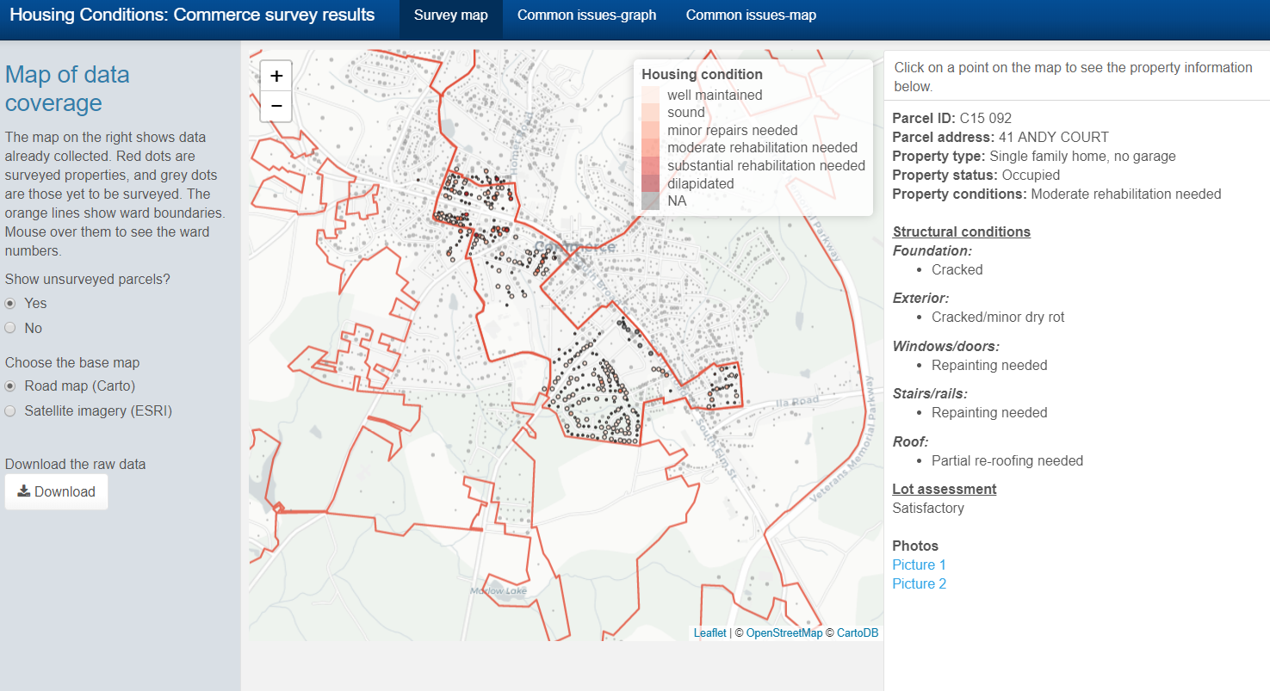

Figure 1: Screenshot from the online web application.

Since the creation of the housing assessment survey, ten Georgia communities have moved through this housing assessment process. We focus on seven communities that generated the most responses on this paper: Arlington, Marshalltown, Hancock, Benson, Stewart, Tyler, and Lewisville[1]. All but one of these communities—Lewisville (~25,000 residents)—have populations less than 15,000, and four have 5,000 or less. They are located throughout Georgia: Marshalltown and Arlington in the east near the South Carolina border, Hancock, Stewart, and Lewisville just outside the Atlanta suburbs, and Benson and Tyler in the central region of the state. Tyler is also home to a regional college.

Table 3 provides a demographic summary of these communities from the 2013-17 American Community Survey (United States Census Bureau, 2019), with values rounded to mask their identity. None of these communities have a median income more than 50% than Georgia’s ($52,977). The rate of renter-occupied housing ranges from 40%-65%, which is at or above Georgia’s statewide rate of 40.3%. The racial composition of these communities varies widely. Arlington is 80% African-American, while the rate Lewisville is only 15%. Similarly, 70% of the population in Hancock is classified as White, in contrast to only 30% of the population in Tyler. Housing structures are somewhat older than the statewide average, with a median construction dates ranging from 1965 to 1985.

|  |  |  |  |  |  |  |  |  |
| --- | --- | --- | --- | --- | --- | --- | --- | --- |
|  | Population | Median age | Median income | % rental households | % Hispanic | % African-American | % White | Median year for structures |
| Benson | 5,000 | 30 | $ 20,000 | 40% | 5% | 50% | 50% | 1975 |
| Hancock | 7,500 | 35 | $ 25,000 | 35% | 10% | 20% | 70% | 1980 |
| Lewisville | 25,000 | 30 | $ 25,000 | 65% | 25% | 15% | 40% | 1985 |
| Marshalltown | 5,000 | 40 | $ 15,000 | 45% | 10% | 35% | 50% | 1970 |
| Tyler | 3,000 | 40 | $ 18,000 | 40% | 5% | 60% | 30% | 1965 |
| Stewart | 15,000 | 35 | $ 20,000 | 65% | 5% | 40% | 50% | 1985 |
| Arlington | 2,000 | 40 | $ 15,000 | 55% | 0% | 80% | 20% | 1975 |
| |  | | --- | | **All of Georgia** | | 10,201,635 | 36.4 | $ 52,977 | 40.3% | 9% | 31% | 54% | 1988 |

**Table 1:** Demographic summary of study communities. Actual values are rounded to mask identity.

# Findings

## Community housing data

Drawing from work in all seven communities, our data contains ratings for 6,841 structures. Table 1 shows the overall classification of structural conditions based on collected responses. In all communities, a plurality of structures were classified as standard (v1) or well maintained (v2), and in five of the seven, a majority of structures received this classification. The notable exception to this trend is Marshalltown, where only 28% of properties were rated well maintained. This community had the one of the oldest median structure ages of all communities and also one of the lowest median incomes. Along with Lewisville, it was one of the two communities that was predominantly surveyed by students at [institution redacted for review], though structures in Lewisville were rated much better overall. On the high end, 27% of structures in Tyler were rated as dilapidated, and Stewart, Benson, Arlington and Marshalltown all had approximately 10% of structures rated as needing serious repair.

|  |  |  |  |  |
| --- | --- | --- | --- | --- |
| **Survey version 1** |  |  |  |  |
| **City** | **Lewisville** | **Stewart** | **Tyler** |  |
| **# of records** | 468 | 2,208 | 1,315 |  |
| **Standard** | 65.4% | 75.1% | 56.3% |  |
| **Substandard** | 26.9% | 15.2% | 16.5% |  |
| **Dilapidated** | 7.7% | 9.7% | 27.1% |  |
|  |  |  |  |  |
| **Survey version 2** |  |  |  |  |
| **City** | **Arlington** | **Benson** | **Hancock** | **Marshalltown** |
| **# of records** | 745 | 1,059 | 621 | 425 |
| **Well maintained** | 69.5% | 49.7% | 61.7% | 28% |
| **Sound** | 8.5% | 14.7% | 13.2% | 21.4% |
| **Minor repairs** | 3.9% | 7.9% | 6.3% | 10.4% |
| **Moderate rehab** | 8.7% | 16.9% | 11.3% | 22.4% |
| **Substantial rehab** | 2.8% | 4.2% | 1.3% | 5.6% |
| **Dilapidated** | 6.6% | 6.5% | 2.9% | 4.9% |
| **Not classified (e.g., vacant lot)** | 0% | 0% | 3.4% | 7.3% |

**Table 4: Housing classifications by city**

Submitted photos provided additional detail on property conditions in these communities. Figure 1 provides representative images from both survey versions of structures that were rated in the middle and bottom end of our classifications. The houses shown in the substandard and moderate rehabilitation images had significant damage to the exterior, though they both appeared structurally sound. The two buildings rated dilapidated had significant roof damage and in the case of the bottom image, the image also shows significant damage to the exterior and windows. For community teams, the ability to collect and browse through these images provides a holistic image of how multiple structural issues can contribute to unsafe housing environments and provide evidence to outside funders of the need for grant funding for housing rehabilitation or replacement.

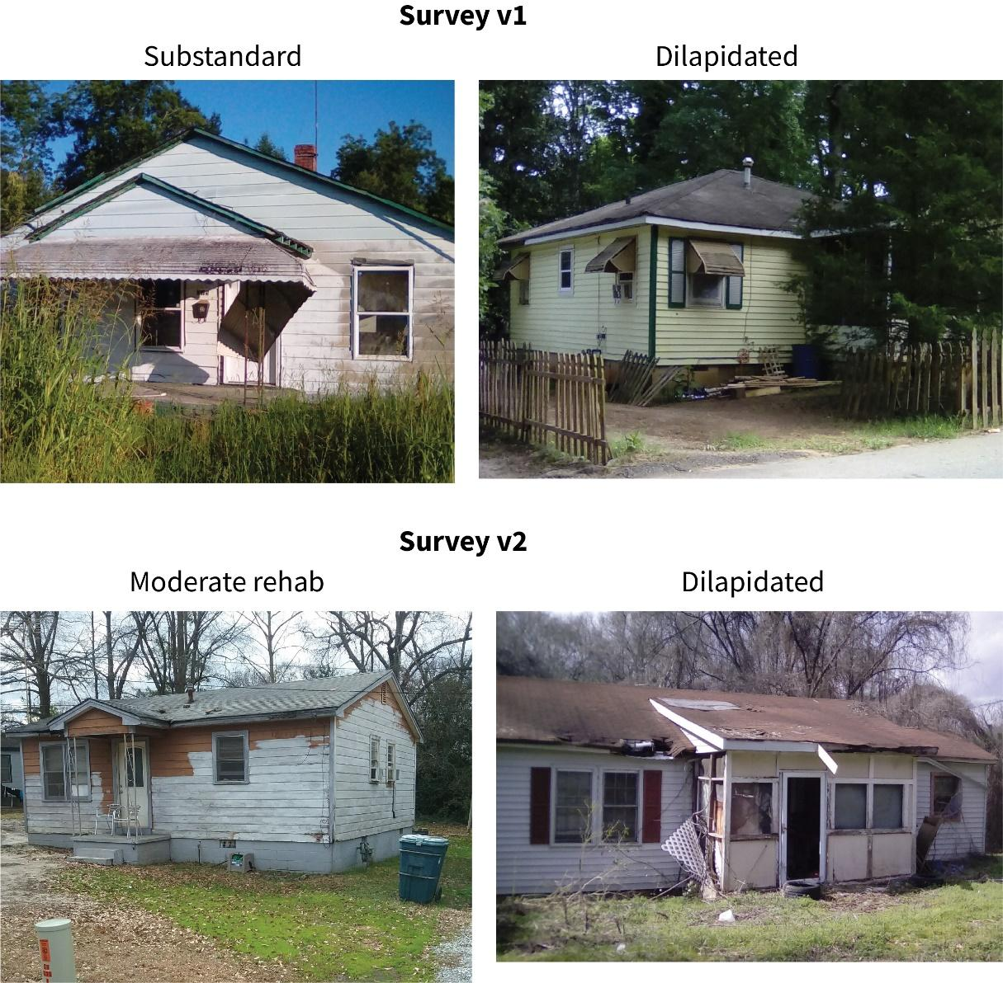

**Figure 1: Representative photos of structures rated as substandard or dilapidated**

While the two versions of our housing survey differ in question formatting and issues focused on, there are also a few areas of overlap. The communities using the first version of the survey often customized their questions, which did limit comparability. Using the crosswalk shown in Table 1, we matched many responses to survey 1 to similar areas in survey 2. We then analyzed the prevalence of these issues across communities, leaving off Lewisville because. Table 5 shows these rates for all issues present in at least 2% of survey responses.

|  |  |  |  |  |  |  |  |  |
| --- | --- | --- | --- | --- | --- | --- | --- | --- |
|  | **City** | **Tyler** | **Stewart** | **Benson** | **Hancock** | **Marshalltown** | **Arlington** | **All** |
| **Survey version** | **v1** | **v1** | **v2** | **v2** | **v2** | **v2** |  |
| **Exterior** | Cracked/minor dry rot | 29.6% | 16.6% | 12.9% | 7.6% | 25.2% | 7% | 16.1% |
| Repainting needed |  | 23.4% | 20.6% | 13% | 27.8% | 12.8% | 15% |
| Replace siding/exterior | 17.1% | 2.2% | 7.1% | 4.2% | 15.8% | 4.4% | 6.9% |
| **Foundation** | Cracked foundation | 10.7% | 1.3% | 13.1% | 7.1% | 22.8% | 9.4% | 7.6% |
| Partial replacement needed |  |  | 8% | 3.5% | 13.6% | 2.6% | 2.7% |
| **Roof** | Gutter repair |  | 5.1% | 5.2% | 6.6% | 26.8% | 1.1% | 3.2% |
| New roof structure | 12.7% | 3.4% | 5.9% | 2.6% | 13.4% | 4.4% | 6% |
| Partial re-roofing |  |  | 7.6% | 3.4% | 12.5% | 2.8% | 2.6% |
| Total re-roofing |  |  | 5.4% | 3.5% | 13.2% | 2.6% | 2.3% |
| Missing shingles | 29.3% | 11.7% | 5.8% | 6.8% | 20.2% | 8.7% | 13.1% |
| **Stairs/ porch** | Cracked/minor dry rot |  |  | 13.5% | 11% | 26.6% | 8.9% | 5.7% |
| Major repair/replacement | 17.2% | 2.8% | 7.4% | 3.4% | 13.6% | 9.8% | 7.6% |
| Repainting needed |  |  | 18.3% | 10.1% | 24.9% | 6.8% | 6.1% |
| **Windows/ doors** | Cracked panes | 10.5% | 6.6% | 12.7% | 8.1% | 18.6% | 6% | 8.6% |
| >3 windows replacement | 12.3% | 3.8% | 4.4% | 1.4% | 9.9% | 5% | 5.6% |
| <= 3 windows replacement | 12.3% | 4.8% | 5.7% | 2.3% | 13.2% | 2.3% | 6.1% |
| Repainting needed |  |  | 19.2% | 10.5% | 29.2% | 8.5% | 6.7% |
| **Yard** | Junk in yard |  | 8.4% | 0% | 2.1% | 9.4% | 0% | 3.5% |
| Missing ground cover |  | 16% | 0% | 6.8% | 12% | 0% | 6.5% |
| Porch used as storage |  | 8.1% | 0% | 4.3% | 6.1% | 0% | 3.4% |
| Overgrown/weeds |  | 16.8% | 0% | 8.4% | 12.7% | 0% | 7% |

**Table 5: Prevalence of top issues across communities**

Across all communities, the three most common issues reported were dry rot (16.1%), repainting on the exterior (15%), and missing shingles (13.1%). Most issues were present in less than 10% of surveyed properties, and the need for many major repairs such as re-roofing or foundation replacement was present in less than 3% of all properties. The specificity of these responses, combined with the geographic data shown in Figure 1, can help communities target requests for assistance and plans for housing renovation.

These rates varied widely between communities. Marshalltown specifically averaged 10.7% higher than the overall rates, and Tyler was 8.3% higher than the overall rates for the issues shown in Table 5. This was also apparent when examining specific issues. For example, looking at rates of minor dry rot present on stairs or porches, Marshalltown’s rate of 26.6% was more than 15% higher than Hancock (11%). Benson’s rate of 13.1% of properties with a cracked foundation was nearly twice as much as Hancock (7.1%), but less than half of Marshalltown (22.8%).

The variability in these rates across communities may indicate real differences in housing quality, or it may reflect differences in sampling within those communities. However, it may also indicate a lack of consistency among reviewers. For example, Marshalltown’s survey was largely done by students in a service-learning class at our institution, and our supervision may have influenced the higher rates in that community. Hancock was surveyed by a mix of our student and local officials, but in a different semester and over a smaller area. Benson was largely surveyed by students as well, as it is home to a regional university. Yet those students may not have received the same training at those at [institution redacted]. In Arlington, surveying was done largely by a single individual with past experience in housing evaluation, and this person did not collect data on yard conditions for any properties, resulting in a 0% rate for all categories. Addressing potential discrepancies across communities remains a work in progress and is one drawback of a community driven process.

## Connections to residents

Interview data and our observation: Value of the community assessment at finding unexpected outcomes:, Millen tire cleanup, Focus on landlords in Monroe; Contrast between communities that did data collection vs those who outsourced it

## Technology and process

The digital tools created for this project greatly improved each community’s capacity to collect and analyze housing data. Yet many housing teams focused on these tools to the exclusion of broader needs for planning, training, and community outreach. Once these teams had decided to start a housing assessment, they often wanted to begin data collection as quickly as possible, usually within a few weeks. It was often difficult for housing teams to develop a clear study area and a sustainable plan for data collection. As a result, after an initial burst of activity, many communities stalled out as volunteers moved on to other tasks and plans for where to go next were unclear.

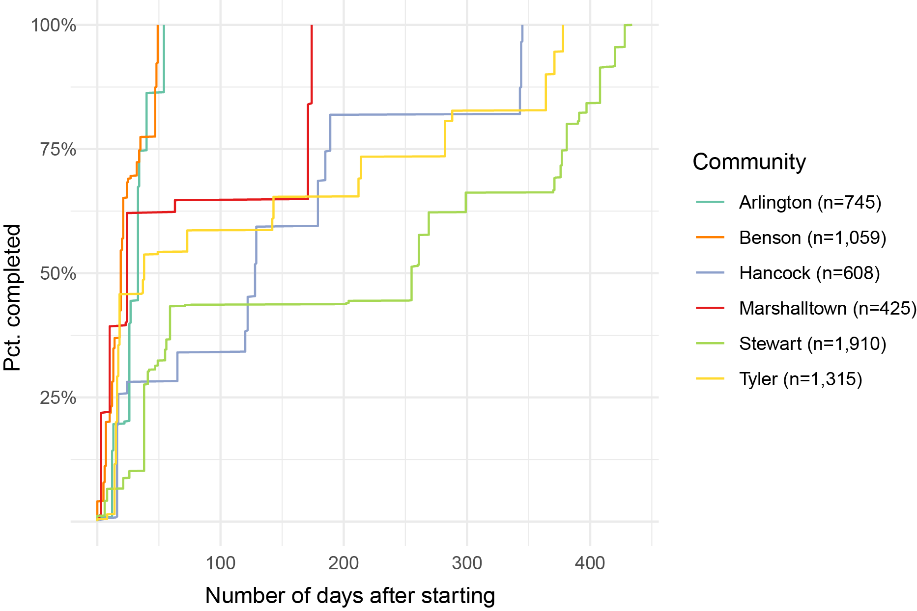

**Figure 2: Rate of survey completion among communities**

Figure 2 visualizes this process. In this graph, the x-axis shows the number of days after the first property was surveyed, and the y-axis shows the rate of completion based on the final count of survey records. Lewisville is not included on this graph, as they were one of the first to use this process and did not include dates for individual records. In all communities, the first 25% of records are collected in the first fifty days, and in four communities, more than half of all records were collected during this time period. Yet for most communities, there is a clear lull in data collection after this point, extending between 100 to 200 days, followed by shorter bursts of activity up until the completion of data collection.

The two exceptions to this trend were Benson and Arlington. In Arlington, data collection was done by a paid staff with previous experience in housing assessment. As noted earlier, local university students were responsible for data collection in Benson, and the short time frame for data collection in this case reflects the structured nature of their work, which was completed for course credit. It is worth noting that the leadership of the housing team in Benson hoped to collect additional data, but they were unable to facilitate further survey work.

Hancock and Marshalltown used students from [institution redacted] for data collection, and in both cases, faculty and a small number of other students returned periodically after initial data collection to complete the survey. Stewart and Tyler both relied on community volunteers and city staff for data collection. In both cases, data collection took a year or more, but for Stewart this also resulted in the largest sample of any community (1,910 records). Tyler was the second largest (1,315 records), and their timeline shows a steady pace for data collection, with multiple breaks of approximately 50 days between bursts of activity. In sum, all communities had quick starts to the survey process, but the process of completing data collection was difficult for most of them, and long breaks were not unusual.

-Interviews on process issues

-Community vs. student involvement  
  
***Putting the data to work***

Kim’s interviews--how do stakeholders talk about the outcomes of this process (or do they?). How is it being used by communities? Importance of leadership. Use of the data to prioritize interventions and make progress.

# Conclusions

Restate potential value of this approach and best practices we’ve identified for making it work. Effective at helping identify issues even if it heads in unexpected directions.

Importance of knowing what you’re looking for--why important to do the assessment.

# References

Arnstein, S. R. (1969). A Ladder Of Citizen Participation. *Journal of the American Planning Association*, *35*(4), 216–224. https://doi.org/10.1080/01944366908977225

Attard, M., Haklay, M., & Capineri, C. (2016). The potential of volunteered geographic information (VGI) in future transport systems. *Urban Planning*, *1*(4), 6–19. https://doi.org/10.17645/up.v1i4.612

Barnes, T. J. (2008). American pragmatism: Towards a geographical introduction. *Geoforum*, *39*(4), 1542–1554. https://doi.org/10.1016/j.geoforum.2007.02.013

Bittner, C. (2016). Diversity in volunteered geographic information: comparing OpenStreetMap and Wikimapia in Jerusalem. *GeoJournal*, *82*(5), 1–20. https://doi.org/10.1007/s10708-016-9721-3

Brovelli, M. A., Minghini, M., & Zamboni, G. (2015). Public participation in GIS via mobile applications. *ISPRS Journal of Photogrammetry and Remote Sensing*, *114*, 306–315. https://doi.org/10.1016/j.isprsjprs.2015.04.002

Brown, G. (2017). A Review of Sampling Effects and Response Bias in Internet Participatory Mapping (PPGIS/PGIS/VGI). *Transactions in GIS*, *21*(1), 39–56. https://doi.org/10.1111/tgis.12207

Cardullo, P., & Kitchin, R. (2019). Being a ‘citizen’ in the smart city: up and down the scaffold of smart citizen participation in Dublin, Ireland. *GeoJournal*, *84*(1), 1–13. https://doi.org/10.1007/s10708-018-9845-8

Connors, J. P., Lei, S., & Kelly, M. (2012). Citizen Science in the Age of Neogeography: Utilizing Volunteered Geographic Information for Environmental Monitoring. *Annals of the Association of American Geographers*, *102*(6), 1267–1289. https://doi.org/10.1080/00045608.2011.627058

Curtis, V. (2018). *Online Citizen Science and the Widening of Academia*. Palgrave Macmillan.

De Oliveira, T. H. M., & Painho, M. (2015). Emotion & stress mapping: Assembling an ambient geographic information-based methodology in order to understand smart cities. *2015 10th Iberian Conference on Information Systems and Technologies, CISTI 2015*, 1–4. https://doi.org/10.1109/CISTI.2015.7170469

Dewey, J. (1997). *Experience and education*. London: Free Press.

Goodchild, M. F. (2007). Citizens as sensors : the world of volunteered geography. *Geojournal*, *69*(4), 211–221. https://doi.org/10.1007/810708-007-9111

Haklay, M. (2013). Citizen Science and Volunteered Geographic Information: overview and Typology of Participation. In D. Z. Sui, S. Elwood, & M. F. Goodchild (Eds.), *Crowdsourcing Geographic Knowledge: Volunteered Geographic Information (VGI) in Theory and Practice* (pp. 104–122). Springer.

Haraway, D. (1988). Situated knowledges: The science question in feminism and the privilege of partial perspective. *Feminist Studies*, *14*(3), 575–599.

Harney, L., McCurry, J., Scott, J., & Wills, J. (2016). Developing “process pragmatism” to underpin engaged research in human geography. *Progress in Human Geography*. https://doi.org/10.1177/0309132515623367

Haworth, B. T. (2017). Implications of Volunteered Geographic Information for Disaster Management and GIScience: A More Complex World of Volunteered Geography. *Annals of the American Association of Geographers*. https://doi.org/10.1080/24694452.2017.1321979

James, W., & McDermott, J. J. (1967). *The writings of William James: A comprehensive edition*. New York: Random House.

Johnson, P. A., & Sieber, R. E. (2013). Situating the Adoption of VGI by Government. In D. Sui, S. Elwood, & M. F. Goodchild (Eds.), *Crowdsourcing Geographic Knowledge: Volunteered Geographic Information (VGI) in Theory and Practice* (pp. 65–81). https://doi.org/10.1007/978-94-007-4587-2

Kindon, S., Pain, R., & Kesby, M. (Eds.). (2007). *Participatory Action Research Approaches and Methods*. London: Routledge.

Kuhn, T. S. (1962). *The structure of scientific revolutions*. Chicago: University of Chicago Press.

Latour, B. (1993). *We have never been modern*. Cambridge Mass.: Harvard University Press.

Quinn, S., & Yapa, L. (2015). OpenStreetMap and Food Security: A Case Study in the City of Philadelphia. *The Professional Geographer*, *68*(2), 271–280. https://doi.org/10.1080/00330124.2015.1065547

RStudio. (2016). Shiny. Retrieved May 9, 2017, from https://shiny.rstudio.com/

Sullivan, B. L., Aycrigg, J. L., Barry, J. H., Bonney, R. E., Bruns, N., Cooper, C. B., … Kelling, S. (2014). The eBird enterprise: An integrated approach to development and application of citizen science. *Biological Conservation*, *169*, 31–40. https://doi.org/10.1016/j.biocon.2013.11.003

Taki, N., Jelks, O., Hawthorne, T. L., Dai, D., & Stauber, C. (2018). Mapping the Hidden Hazards : Community-Led Spatial Data Collection of Street-Level Environmental Stressors in a Degraded , Urban Watershed. *International Journal of Environmental Research and Public Health*, *15*(825). https://doi.org/10.3390/ijerph15040825

The Cornell Lab of Ornithology. (2019). eBird. Retrieved from https://ebird.org

United States Census Bureau. (2019). American FactFinder. Retrieved from http://factfinder2.census.gov/

University of Georgia. (2019). Georgia Initiative for Community Housing. Retrieved May 9, 2017, from http://www.fcs.uga.edu/fhce/gich/3

1. All city names are pseudonyms