# PROG2070–Quality Assurance: Assignment 1

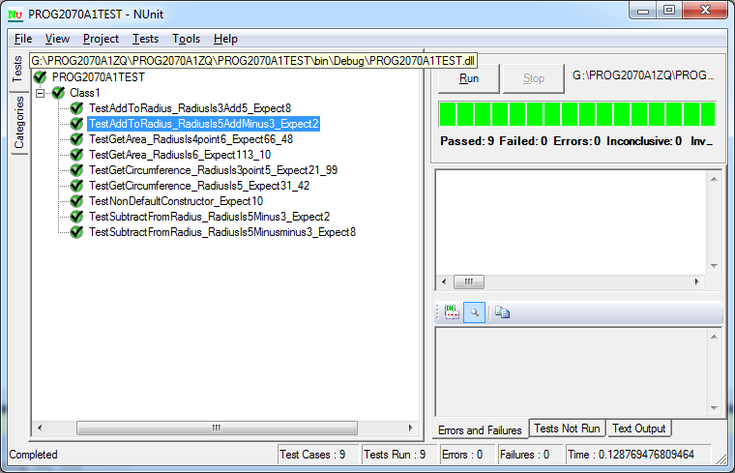

### TestAddToRadius_RadiusIs3Add5_Expect8()

Trying to test the normal input.

### TestAddToRadius_RadiusIs5AddMinus3_Expect2()

Testing if the program takes input that’s less than 0 and give the correct result.

### TestSubtractFromRadius_RadiusIs5Minus3_Expect2()

Trying to test the normal input.

### TestSubtractFromRadius_RadiusIs5Minusminus3_Expect8()

Testing if the program takes input that’s less than 0 and give the correct result.

### TestGetCircumference_RadiusIs5_Expect31_42()

Testing normal radius

### TestGetCircumference_RadiusIs3point5_Expect21_99()

Testing radius that has decimal places

### TestGetArea_RadiusIs6_Expect113_10()

Testing normal radius

### TestGetArea_RadiusIs4point6_Expect66_48()

Testing radius that has decimal places