**Python Installation**

While installing check the add to path option.

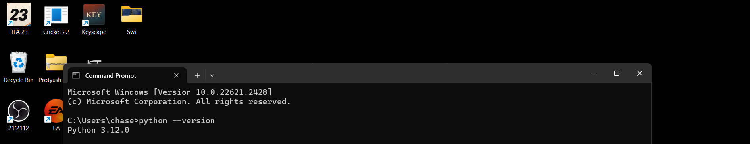Command to check the version after installing: python --version

Install anaconda from chrome.

**Install Jupyter notebook:**

Open cmd: command- pip install notebook

How to run a .py file in cmd:

1. Create a file and write your code in it
2. Save your file with a .py extension.(file.py)
3. Now open your cmd and run the command-

python file.py

How to run python code in Jupyter notebook:

1. Go to the required folder and open cmd there.
2. Run the command – jupyter notebook.
3. Then new jupyter notebook will open.