EU Stress Test Case

**Background:**

* Credit markets increasingly dysfunctional through 2009 as various public interventions removed risk from banks in the form of asset purchases, government guarantees of bank debt, and direct capitalization with state money. (Greece, Spain, Germany, UK)
* Banks had large sovereign exposures, and markets felt that banks and sovereigns “were in the same boat and that boat was sinking”
* Cost of protection on European banks and Western European sovereigns started moving in lockstep beginning in early 2010

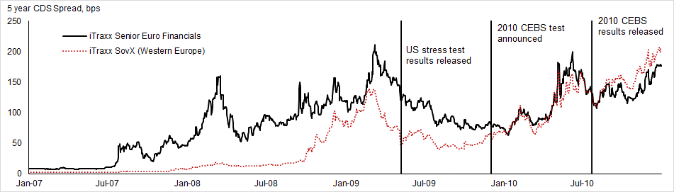

* A general lack of information about risks and exposures within the banking system made it difficult for investors to distinguish good from bad banks
* This combined with a background of falling real estate prices “and the sense that European banks never took the losses that UK and US banks did in 2009” [from barclays piece] due to:
  + More lenient stress tests with results not publicly disclosed
  + And party from accounting changes which allowed the transfer of distressed assets from mark-to-market trading books into banking books.
* Since little transparency in banks exposures, investors assumed the worst for all banks → hence systemically raised funding costs for everybody.
* The 2010 CEBS EU-Wide stress test was announced December 2, 2009 -- roughly 2 months after the 2009 CEBS EU-Wide stress test results were announced.[1]
* The 2009 test was not received well by markets due to three main reasons:
  + (1) the test’s results were only announced via a three page press release describing CEBS’ presentation of results to ECOFIN,
  + (2) the methodology was not released, and
  + (3) no bank-by-bank details were published.
* With the tests, authorities sought to allay investors “uncertainty and distrust” by capitalizing on the relative success of the SCAP released a year earlier
* **Although the 2010 test nominally aimed at “[assessing] banks’ ability to absorb further credit and market shocks...and their dependence on public support measures,” market participants felt the real value was in the clarity and transparency involved in the test (not unlike the 2009 SCAP)**

**Design:[2]**

* The 2010 CEBS stress test was the first time the results were published in such a detailed and public manner; like the SCAP, results were released bank by bank
* Banks included in the tested sample, amounting to 65% of total EU banking sector assets, were also designed to capture at least 50% of each national banking sector
  + In the cases when subsidiaries and branches of banks from other countries covered more than 50% of a country’s local market, that specific country would not have any additional testing. This applied to 7 Member states.
* Like SCAP, was a set of “what-if” scenarios
* Exercise done in year end 2009 figures and applied over a 2 year period[3]
* Incorporated some EUR 197 billion in government capital support provided until July 1, 2010 (approximately 1.2% of aggregate Tier 1)
* **Test Scenarios**
  + Two scenarios (like SCAP again): adverse and benchmark
  + The adverse scenario was then subjected to a sovereign risk, which amounted to mark-to-market losses equal to the May 2010 Greek stresses -- that is, it affected their trading book but not their banking books.
  + CEBS and ECB formulated EU-wide GDP, unemployment, inflation and interest rates forecasts, national supervisors came up with other more detailed assumptions (like real estate prices)
    - Adverse scenario used EU-specific shock to yield curve. All countries had a common upward shift of 125 bps for 3 month rates (reflecting tensions in interbank borrowing) and 75 bps for 10 year rates at year end 2011.
    - To this shift, then they added country specific haircuts which were then applied to all EU sovereign debt holdings in trading books across the sample.
* Hurdle Rate: 6% Tier 1

**Results**

* Announced July 2010
* As a result of the adverse scenario, 7 (7.7% of the 91 banks tested) banks had Tier 1 Capital fall below the 6% hurdle. Overall shortfall of EUR 3.5 billion of Tier 1 funds.
* Roughly 30 banks had stressed Tier 1 ratios between 6 and 8 percent.
* Simple way to look at it: In aggregate expected to face losses of 4.5% of RWA over 2 years, which would be essentially exactly offset by profits.
* Tests included sovereign support announced by July 2010; this support included capital injections, guarantees of assets, liabilities or funding, and government/central bank provided liquidity.
* 20 banks in the 91 bank sample “benefitted” from asset guarantees
* 34 banks benefited from EUR 170 billion of aggregate capital -- about 14% of aggregate Tier 1 Capital. That is, it increased stressed Tier 1 Capital by 1.2%[4]

Key Design Decisions

* Sovereign Support
  + Basically, CEBS assumed sovereigns would continue providing this support well past the test horizon because they had “a useful life extending beyond the horizon of the exercise.”
  + Many of the banks with the most public assistance are also relying on the weakest sovereigns (exception being Landesbanks):
    - Greek banks raise EUR 9.4 billion from government
    - Spanish cajas with FROB funding
    - Irish banks
* Sovereign debt haircuts were applied to trading books but not banking books
  + Sovereign debt scenario focused on exposures in trading book, although 83% of sovereign exposure in banking book. And the banking book was not subjected to haircuts. (Blundell wignall and slovik 2010 via Goldstein)
* Adverse forecast scenario called for double dip – mild recession; SCAP was very severe 🡪 2 year commercial loan loss rates were 9% for SCAP vs. 4% for CEBS 2010.
  + Forecast Assumptions varied: for example, commercial real estate prices were modeled to decline 55% in Spain compared to 7% in Greece.
* CEBS ran it, along with 27 national supervisors, the EU Commission and the ECB
  + Goldstein: CEBS was a new institutions with small staffs/budgets and little credibility compared to the US SCAP’s Fed and Treasury
* Sovereign exposures – in both trading and banking book – were published, so it was easy for people apply a sovereign shock to the banking book.
* Low hurdle rate – many expected 6% core Tier 1.

Reception:

* Before results announced:
  + After results announced
  + “Business Insider: It’s Official: The Stress Tests Were a Joke…”[5]
  + *“Alright, it's official. The stress tests were a joke.  
      
    Consider:  
      
    The adverse economic scenario was for a small decline.  
    The total capital needs of ALL the failed banks was just 3.5 billion eur.  
    Only 7 banks failed, and the two big ones are already nationalized.  
    Only one Greek bank failed.  
    Verdict: joke.”*
  + From the summary report: “Government support measures received by institutions in the sample as of end 2009 have been taken into account and subject to specific analysis.” Although it is peculiar to include sovereign support in a stress test caused by concerns about sovereign default.[6]
  + Interbank market got no relief -- following Monday’s rates were one-year highs. [SEE EXCEL EURIBOR]
  + LOTS OF MARKET REACTION PIECES HERE <http://discussions.ft.com/longroom/tables/the-wall-of-worry/european-stress-test-reax-round-up>
  + Really, not too much surprise design wise, although a lot more detail than expected. A nontrivial amount of information had been leaked through the various national supervisors in the weeks leading up to it, so less of a reaction.
  + DB from that link right above: We were disappointed with the stress test in three areas. First, we do not find a 6% stated tier 1 ratio target particularly challenging. Second, we have found it difficult to reconcile some banks’ assumptions (some banks have forecast that they will make more pre-provision revenue in an adverse scenario than they did in 2009; we believe that too much reliance has been placed on Q1 2010 run-rates). Third, we think that trading book shocks have not been sufficiently conservative, even before considering sovereign risk. In the adverse scenario, Euro 473bn of impairment (banking book) losses were included, and just Euro 26bn from trading losses, which does not match the experience of 2007 to 2009, in our eyes.
  + **BEST ONE HERE: final-stress-test.pdf from credit suisse. See** [**http://discussions.ft.com/longroom/tables/the-wall-of-worry/european-stress-test-reax-round-up**](http://discussions.ft.com/longroom/tables/the-wall-of-worry/european-stress-test-reax-round-up)
* **Unlike the US’s SCAP which marked the turning point in sentiment in the banking system’s health -- which is indeed difficult to quantifiably show, however Bernanke notes it was was a turning point -- the turning point in the EU did not come after any of three stress tests in 2009, 2010 nor 2011. Instead it came after ECB President Mario Draghi’s pledge to do “whatever it takes” to save the Euro in July 2012, and the beginning of the LTROs.[7]**

**Evaluation**

* **Morris:**
  + **1. CEBS and EBA were new institutions with small staffs/budgets and little credibility compared to the US SCAP’s Fed and Treasury**
  + **2. Unlike US, (as there was no critical mass formed on EU banking union) there was no agreement before June 2012 on bank resolution or EU wide funding of bank failures. Remember, SCAP had billions backing it from TARP, on the order of $200 billion remaining. Banking system in Euro is larger in the US too, relative to GDP.**
  + **3. Eu policies from 2007-2015 have broadly been seen as less successful in reducing tail risks than in the US**
  + **4. Outside estimates of capital shortfall have consistently been greater than** 
    - **NPL framework much worse than in the United States**
    - **Used Tier 1 rather than more demanding tier 1 common or core tier 1 ratios**
    - **Had lossesa ssumed in trading book been expanded to banking book, capital shortfall would have been 165 billion vs. 26 billion (from blundell wignall slovik (2010) via golstein)**
    - **Ireland’s banking system melted down in October 2010, just 3 months after CEBS 2010 passed Ireland’s 2 biggest banks -- Bank of Ireland and Allied Irish Banks**
  + **5.**
* **From Golstein: Bernanke’s reading of the reaction to 2010 EU-wide stress-test results (2015, p. 482) was representative: “European bank regulators conducted a stress test of the continent’s banks in July (2010). But, unlike the U.S. stress test of the previous year, investors did not see the results as credible, and Europe’s banks remained wary of lending, including to each other.”**
* **Candelon and Sly (2015) argue that the the generalized common view that all EU-wide stress tests were unsuccessful is not accurate, pointing in particular to the estimated positive impact of the 2010 test on returns -- with an estimated size roughly half that for the 2009 SCAP.**

Key Design Decisions

1. Why only stress sovereign exposures in trading books and not in banking (ie avaialbe for sale and hold to maturity) books?
2. Why a hurdle rate of Tier 1 at 6%?
3. Why include public assistance if sovereign default risk is a driving problem?
4. Why calculate pre-provision profits on a constant balance sheet?
5. The tests disclosed bank-by-bank exposures via government bond holdings by country in both their trading and banking books. Why not stress the banking book as well?
6. Why model the loss assumptions on a “mild recession” instead of a very severe scenario, aswas the case in the United States’ SCAP?

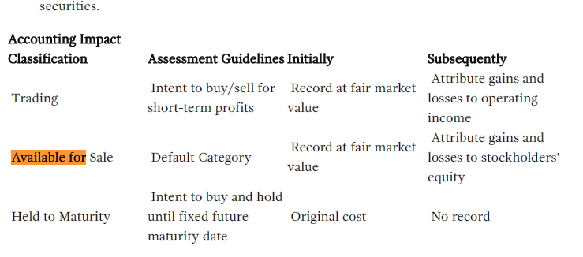

Purpose: “The EU-wide stress testing exercises aimed at examining the resilience of the banking sector, improving transparency, identifying vulnerabilities, and informing policy-makers about the current capacity of banks to absorb shocks and the banking system’s dependence on public support measures “

Chart ideas

* Close correlation of sovereign and bank CDS after 2009 but not before

Coverage:

* 91 banks in 20 countries
* 65% of total assets in EU banking system

Scenarios

* -3% growth deviation from the baseline for the EU as a whole
* Assets will be marked down, but not sovereign securities held to maturity
* [wrt sovereign securities] “As such, the stress tests may not go far enough, but the additional transparency coming out of the exercise will surely be welcome.” [gs]

Background: <http://ftalphaville.ft.com//2010/07/23/295781/the-stress-test-guide/>

From : <http://www.doc88.com/p-47630860174.html>

<http://www.fondsnieuws.nl/images/stories/pdf/Goldman_Sachs_European_Weekly_Analyst_300910.pdf>

EBA <https://web.archive.org/web/20120615110737/http://www.eba.europa.eu/EuWideStressTesting.aspx>

<http://scholarship.law.unc.edu/cgi/viewcontent.cgi?article=1312&context=ncbi>

<http://ftalphaville.ft.com/2010/07/23/>

Stress test event study from IMF: <https://www.imf.org/external/pubs/ft/wp/2015/wp1575.pdf>

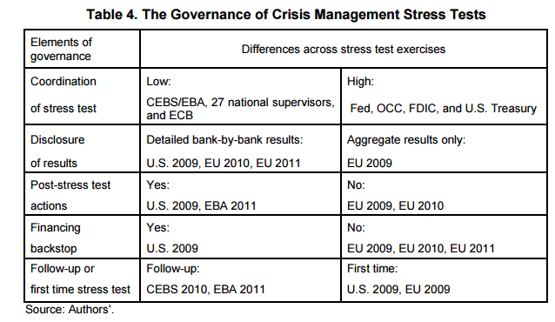

From IMF paper

Capital market consequencse of EU bank stress tests

<https://www.google.com/url?sa=t&rct=j&q=&esrc=s&source=web&cd=1&ved=0ahUKEwiRjcGX-dnLAhXFFz4KHUH_CToQFggdMAA&url=https%3A%2F%2Fwww.newyorkfed.org%2Fmedialibrary%2Fmedia%2Fresearch%2Fconference%2F2012%2FFinancialServices2012%2FEllahie.pdf&usg=AFQjCNGR_AVfhEJHsaPuYSG9lMCQkq42ZQ&cad=rja>

<http://www.dbresearch.com/servlet/reweb2.ReWEB?rwobj=cdscalc2.Start.class&rwnode=DBR_INTERNET_EN-PROD%24EM&rwsite=DBR_INTERNET_EN-PROD&cdsCountry=CDSC0000000000000146&cdsRecRate=20>

Db implied default from CDS

**Anticipation:**

* As the CEBS provided only limited information on the design and specifics of the test there was significant speculation.
* The main known facts before hand was that their forecasts saw a 3% decline in GDP in the following year, and that the hurdle rate would be 6%.
* Because of the low hurdle rate, it was clear that banks which were “successful” in the test were not *per se* actually solvent.
* UBS: “Stress tests are not a panacea. **Without a significant proportion, by assets and number, failing, the tests potentially amount to little more than an empty gesture.**”[8]
* “In US stress tests over half of participants failed. **The ‘successful’ US stress tests, which are commonly associated with a turning point in US bank equity prices and better fixed income markets, saw over half of participants fail.** The US$75 billion in common equity they raised in the following weeks was, in our view, the key to the exercise raising confidence.”[9]
* Significant discussion around haircuts on peripheral sovereign debt:
  + van Steenis: “**The guidance we have been given is the tests were not going to include any discussion of sovereign risks for all sorts of obvious reasons,** not least the massive EU/IMF support plan for Greece and back-up for other countries. We think that some investors will be disappointed by this. To be clear, one does not have to have a strong view on the outcome of the peripheral bonds either way to realize that a bank with a large concentration of Greek bonds as % of tangible equity may act in a far more risk averse fashion in extending credit than one with a much lower %, given the uncertainty on how this will play out over the coming years… This surely is an issue which macro-prudential policy should weigh up, independent of taking a view on what will happen on the debt itself.”
  + FT: “So again, it seems odd for pragmatic reasons not to simulate a Greek haircut, if the point is EU-wide disclosure.”[10]

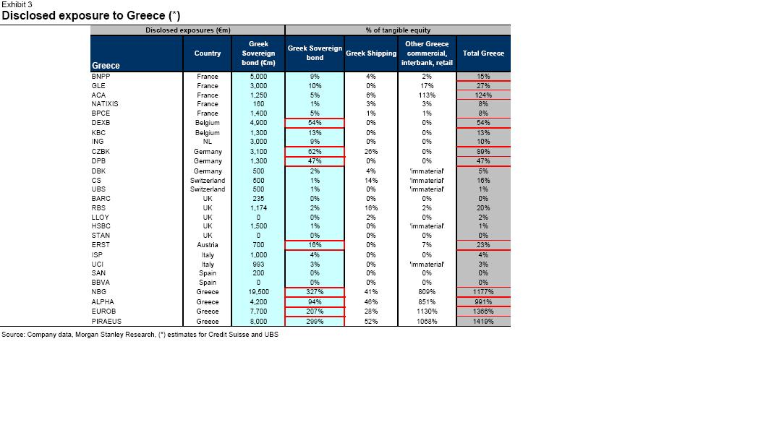

* Overall the main value was going to be the transparency and the general ability to parse out the extreme ends of the risk distribution -- “This ability to separate the clearly good from the clearly bad will be important in mitigating problems of adverse selection, and thus keep risk premia and funding costs for the system as a whole from rising.” GS Page 5
* But mixed messages leading up to the release: Spanish Minister of Finance said before hand that all 8 private banks and 18 cajas tested passed. Confusing as the IMF assumed EUR 22 billion in injections (in its worse case scenario). The difference came down the the Bank of Spain allowing banks to include funding from their “Funds for Orderly Bank Restructuring (FROB)” as Tier 1 capital (FROB were preference shares yielding >7.75% which, if the savings bank repaid the “loans” could then include FROB funding as capital. It was unclear how this would count as Tier 1 if the savings bank did not make the payments and defaulted on it.)
  + UBS’s Alastair Gray via the *FT*: “**We see little value in ‘stress test’ that major Spanish lenders all passed.** We consider banks on the basis of ‘stressed’ credit loss risks, but also more broadly to include margin trends, funding needs, market structure and the macro situation. With customer spreads falling rapidly, €650bn of wholesale funding needs, overvalued property and declining nominal GDP, we would see little value in a credit ‘stress test’ that major Spanish lenders all passed.”[11]
* In a sample of 365 European market institutional investors, a Goldman Sachs survey just days before the publication of the results suggested that only 35% “expect the stress test to be a credible reflection of bank resilience in a downturn.”[12]
* However, “The balance of news is still consistent with better-than--expected stress test results, and so far we have only heard of two banks as being reported to have failed -- the German bank HRE and the Slovenian bank NLB.”
* Thus, the 2010 test differed from the test a year earlier in a few key aspects:
  + (1) the 2010 exercise included a larger portion of the banking system
    - 2009: 26 major European border institutions
    - 2010: 91 banks (covering ~65% of banking sector assets) in 2011
  + (2) Provide “a detailed breakdown between trading and banking book exposures” rather than 2010’s goal of assessing the banking system’s resilience in aggregate
  + (3) The hurdle rate increased from 4% Tier 1 to 6% in 2010.

1. **Where is the CEBS link? Can’t find it. This is from:** Candelon and Sy (2015). “How Did Markets React to Stress Tests?” *IMF Working Paper.* <https://www.imf.org/external/pubs/ft/wp/2015/wp1575.pdf>
2. CEBS (July 23, 2010). “Aggregate Outcome of the 2010 EU Wide Stress Test Exercise Coordinated by CEBS in Cooperation with the ECB.” This document provides all relevant methodology.
3. CEBS (July 23, 2010). “Question and Answers: 2010 EU-Wide Stress Testing Exercise.” <https://web.archive.org/web/20120415042552/http://stress-test.c-ebs.org/documents/QAs.pdf>
4. Alloway (July 26 2010). “Stress Test’s Sovereign Support = Senseless.” *Financial Times.* <http://ftalphaville.ft.com/2010/07/26/296871/stress-tests-sovereign-support-senseless/>
5. Weisenthal (July 23, 2010). “It’s Official: The Stress Tests were a Joke.” *Business Insider.* [*http://www.businessinsider.com/its-official-the-stress-tests-were-a-joke-2010-7*](http://www.businessinsider.com/its-official-the-stress-tests-were-a-joke-2010-7)
6. Alloway (July 26 2010). “Stress Test’s Sovereign Support = Senseless.” *Financial Times.* <http://ftalphaville.ft.com/2010/07/26/296871/stress-tests-sovereign-support-senseless/>
7. Morris book pg 12
8. UBS via Financial Times (June 18, 2010). <http://ftalphaville.ft.com//2010/06/18/265236/must-europes-stress-tests-fail-in-order-to-succeed/>
9. Ibid.
10. Cotterill (June 18, 2010). “Sovereigns not included? More on Europe’s Stress Tests.” *Financial Times* <http://ftalphaville.ft.com/2010/06/18/265776/sovereigns-not-included-more-on-europes-stress-tests/>
11. UBS via Financial Times (June 18, 2010). <http://ftalphaville.ft.com//2010/06/18/265236/must-europes-stress-tests-fail-in-order-to-succeed/>
12. Goldman Sachs via Financial Times (July 23, 2010). “Market GIves Banks a ‘B’ Ahead of Stress Tests.”<http://ftalphaville.ft.com//2010/07/23/296596/market-gives-banks-a-%E2%80%98b-ahead-of-the-stress-tests/>