**Optical Data Transmission**

*\* This experiment is designed in partnership with the UW Physics Optics Laboratory.*

**1 Background**

With a theoretical foundation in energy quantization, the path towards Amplification by Stimulation of Emitted Radiation technology is paved by the interaction between energy and matter. Experimenting with the entropy of an irradiated resonator brought forth the idea that the total energy of the system must not be continuously divisible [1]. If it were, there would be infinitely many possible configurations for the constituent resonators. Instead, Planck establishes a step-wise approach to each particle’s energy in the following form…

$$E=hv$$

Blasting an atom with a single photon induces this very precise energy shift through absorption and excitation where the electron cloud is reconfigured and the atom is raised to a higher energy level. Very shortly thereafter, spontaneous emission [2] occurs: the atom returns to its lower energy state and releases a photon. However, when an atom already in its heightened energy state is struck by a photon, we observe stimulated emission where the atom drops to a lower energy state and an identical photon is released with the incident beam. This principle is what allows for amplification and is the most fundamental aspect of laser technology.

On a quantum scale, it turns out that this same phenomenon can be treated as a sinusoidal perturbation to a two-level system [3]. The incident photon acts as a sinusoidal perturbation and our atom serves as a two-level system: jumping from a heightened to a lower energy state on perturbation.

This experiment is divided into two parts. The first involves a single laser in tandem with an acousto-optic modulator: varying the drive frequency to determine the resulting diffraction pattern with a Fabry-Perot Interferometer output to a CCD array. In the second, the acousto-optic modulator is swapped out for a dichroic filter and another laser to perform the same spectroscopic analysis with combined beams.

**2 Apparatus**

The light in this experiment is sourced from two He-Ne lasers with differing wavelengths. The first with $λ=632.8nm$ and the second with $λ=XXXnm$. To modulate light, our signal can be altered with an acousto-optic modulator (AOM). The acousto-optic modulator applies frequency shift to the first order diffraction of our beam in accordance with the RF-drive. This frequency is to be analyzed through a Fabry-Perot Interferometer output to screen, CCD, and central spot scanner.

The latter half of the experiment constructs a beam combiner. This is to be achieved with the incorporation of a dichroic filter that allows the transmission of light in the red frequency range while reflecting light in the green. Frequency analysis shares the same procedure as in the former half of the experiment.

**Fabry-Perot Interferometer:**

**WARNING:**

**The Fabry-Perot mirror coatings are extremely fragile and will be permanently damaged by any contact whatsoever with the mirror surfaces. Move the mirror pieces by supporting the base and sides alone. Do not, under any circumstances, touch or contact in any way either the front or back surfaces of the mirror pieces.**

The Fabry-Perot Interferometer utilizes the constructive interference of beams undergoing reflection and transmission in a two-mirror setup.

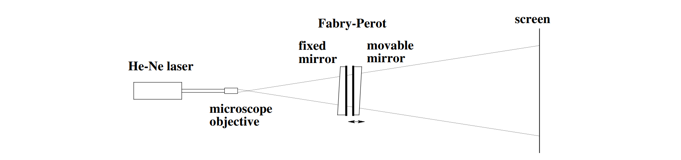  
Fig. 1: Fabry-Perot Interferometry setup.

The incident laser beam is diverged by the microscope objective to undergo multiple reflections and create an interference pattern on the screen. Each reflection acquires an additional phase $δ$ that depends on mirror spacing $d$, wavelength $λ$ and angle from optical axis $θ$ [4].

|  |  |  |
| --- | --- | --- |
|  | $$δ=\frac{4πd cosθ}{λ}$$ | (1) |

The dependence of $δ$ on $θ$ produces a ring pattern on the screen. An adjustment of $\frac{λ}{2}$ to the mirror spacing, $d$, will change the phase by a factor of $2π$.

**Acousto-optic modulator:**

**WARNING:**

**The Acousto-Optic Modulator is designed to operate in a particular frequency range. Do not exceed the maximum operational frequency set by the manufacturer.**

Acousto-optic modulator (AOM) is a piezoelectric crystal whose photoelasticity is modified by a transducer tied to a waveform generator. The transverse sound waves generate oscillations that traverse the crystal. Hence, the refractive index of the material changes due to the electron’s displacement from their equilibrium position.

An acousto-optic modulator takes advantage of Bragg’s law [5].

|  |  |  |
| --- | --- | --- |
|  | $$nλ=2dsinθ$$ | (2) |

Where $n$ is the material’s refractive index, $λ$ is the wavelength of incident light, $d$ is the plane spacing of the material, and $θ$ is the angle of incidence. Acousto-optic modulation is set apart because planes of reflection are sound waves. Since the planes are in motion, a frequency shift of first order diffracted light that corresponds to drive frequency is observed. The optical frequency shift is induced by a waveform input to the AOM and is represented by the following.

|  |  |  |
| --- | --- | --- |
|  | $$f_{out}=f_{in}+mF$$ | (3) |

Where $m$ corresponds to diffraction order and $F$ is the acoustic frequency. This frequency shift is evidence of the well-known Doppler Shift. A standard diffraction grating could be treated as a stationary point source of reflected light. However, the sound wave acts as a travelling source of reflected light. The sound waves travel an additional $Λf$ in the time it takes the photon incident on the next plane to travel the additional portion of $dsinθ$. $Λ$ being the acoustic wavelength in the piezoelectric.

To obtain accurate data on the change in diffraction pattern due to optical frequency shift induced by the AOM, the waveform generator is varied at equally spaced intervals. Further description of this process is outlined in Sections 3 and 4.

**Beam combiner:**

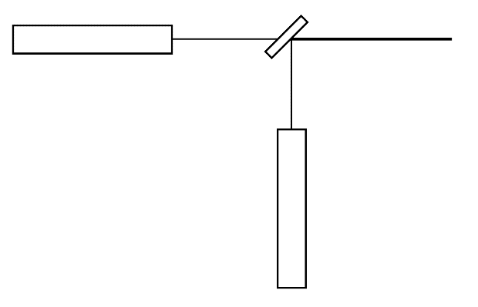

Fig. 2: Dichroic Combiner

A beam combiner is construed of an array of lasers lined up in order with an array of dichroic filters. By having each filter reflect a single beam and transmit all of the previous, the resultant beam becomes a combination of the inputs. Since waves of different frequencies are being added together, the diffraction pattern may be difficult to decipher. An overarching envelope travelling at one frequency containing wave packets travelling at another is the most probable observation.

The dichroic filters operate in a range of frequencies where close to 100% of light in one frequency range is transmitted and close to 100% of light in another frequency range is reflected. When analyzing combined beams, it’s ideal for the intensity of one not to overpower the other. Hence, limit the intensity of the red laser to enforce equal contribution to the overall diffraction pattern.

With beam intensities approximately equal to each other, addition of waves becomes simpler. In accordance with the wave equation [5], each beam is approximated as a harmonic wave in the following form.

|  |  |  |
| --- | --- | --- |
|  | $$Ψ\left(x,t\right)=Asin(kx-ωt)$$ | (4) |

Where $k=\frac{2π}{λ}$ and $ω=2πf$. Employ geometric identities to generate the following (Full derivation can be found in Hecht, p. 302).

|  |  |  |
| --- | --- | --- |
|  | $$Ψ=2Asin(k_{m}x-ω_{m}t)sin⁡(\overline{k}x-\overline{ω}t)$$ | (5) |

$\overline{ω}$ and $\overline{k}$ correspond to the average angular frequency and average propagation number while $k_{m}$ and $ω_{m}$ are the modulation frequency and modulation propagation number. ($ω_{1}>ω_{2}$)

|  |  |  |
| --- | --- | --- |
|  | $\overline{ω}=\frac{1}{2}(ω_{1}+ω_{2})$ $ω_{m}=\frac{1}{2}(ω_{1}-ω_{2})$ $\overline{k}=\frac{1}{2}(k_{1}+k_{2})$ $k_{m}=\frac{1}{2}(k_{1}-k_{2})$ | (6) |

**Exercise:** Generate wave equations for each laser, sum, and perform Fourier Analysis.

**3 Procedure**

1. **He-Ne laser alignment.**

Turn on the red laser. You can set the laser parallel to the table by adjusting the positioning screws located at the front and rear end of the mount. Place viewing screens as close and as far as possible – line the beam up with the close screen using the front screws and do the same for the far screen with the rear screws. Repeat this procedure until the beam is parallel with the table.

1. **Fabry-Perot Interferometry.**

Obtain a baseline diffraction pattern with no elements in the laser path. The following instructions come from the Pengra journals [4]. **Again, do NOT touch the mirror surfaces in any way.** Begin by setting the fixed mirror approximately 2m from the laser aperture such that the laser beam is focused on the center of the mirror. Aim the reflected laser as close to the aperture as possible by rotating the base, then clamp to the table. Check that the base does not rock. If there is motion, reposition slightly and repeat the previous steps. After the setup is stable, use the horizontal and vertical adjust screws to center the reflected beam on the laser aperture.

Adjust the micrometer drive to somewhere around the 12-13mm mark and position the movable mirror so that the separation is approximately 3mm. Coarsely align the brightest series of spots on the screen as close together as possible. Clamp the base and perform the same check for rocking motion. Now, use the horizontal and vertical adjust screws on the movable mirror assembly to bring the spots into coincidence. Using calipers, measure spacing between the mirror mounts and observe what should be approximately 3mm (0.12”). Adjust the separation to achieve precision and make sure to measure and record prior to any final alignment of the mirrors. Even light contact between the calipers and the mirror will shift mount position enough to disrupt alignment. Once separation is measured, use the vertical (upper) adjust screw on the movable mirror to create a series of spots that progress upward. Use the horizontal (lower) screw to orient the spots so they are as close to vertical or possible. Vertically adjust the spots to coincidence such that there is no trailing. Adjustments to horizontal positioning may be required through this process. Once alignment is achieved, you will observe faint rings surrounding the central spot. Bring the rings concentric to the center with very minor adjustments to the adjust screws.

Lastly, place the microscope objective in the beam path about 15cm prior to the fixed mirror and center the optical axis along the beam. Adjust the height and orientation so that the ring pattern is uniformly illuminated. Make slight adjustments to the adjust screws if the pattern is not symmetric in sharpness.

1. **Acousto-optic modulator setup.**

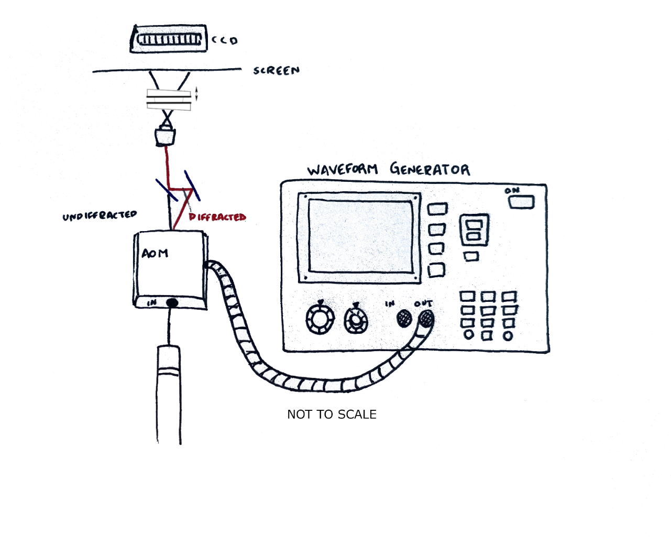

Fig. 3: Acousto-optic Modulator

Position the AOM in the beam path approximately 50cm ahead of the laser and supply radio-frequency with a waveform generator. When left off, the beam transmits directly through the modulator and ideally, the diffraction pattern remains the same. **Remember: do not exceed the manufacturer specified maximum frequency for the modulator.** Now, turning on the AOM should generate a first order diffraction at an angle determined by Bragg’s law. The diffracted beam is what we’re more interested in as the goal is to determine the strength of frequency shift due to modulation. The diffracted beam is the target for analysis. Design a block and a two-mirror system to fire the diffracted beam through the Interferometer. Position the first mirror to reflect the beam perpendicular to the original laser path and the second at a 45 degree angle to the initial path. This is to set the diffracted beam colinear to the 0th order. Once the diffracted beam is centered on the screen following the same alignment procedure as earlier (with screens as close and as far from possible), block the zeroth order diffraction and reposition the microscope objective.

Decide on a minimum of five or six equally spaced intervals of frequency and collect data in accordance with Section 4.

1. **Build a beam combiner.**

Remove the AOM and double mirror setup from the beam path. Select the dichroic filter that transmits frequencies in the **red** range while reflecting frequencies in the **green** range. Start by orienting the green laser further down the table, parallel to the table and, ideally, perpendicular to the red laser. Follow the same procedure of laser alignment for the green laser and set the dichroic filter at the intersection between the two beams. To collineate the beams, set the filter angle equal to half the angle between lasers (if the lasers are perpendicular, this should be 45 degrees). Set screens as close and as far from the approximately colinear beam as possible and make adjustments to the filter angle and laser alignment screws until colinear.

Aim to set the intensities as close as possible. Block the red and record the intensity of the green laser incident on the CCD. Now, block the green and take steps to align polarizers in the red laser’s path. First, record of the intensity (i.e. amplitude) of the red laser without any polarization. Then, add a single polarizer preceding the dichroic filter and set the red laser intensity equal to the green following the polarization equation.

|  |  |  |
| --- | --- | --- |
|  | $$I=I_{0}\cos^{2}{θ_{i}}$$ | (7) |

$I_{0}$ being the original intensity prior to polarization and $θ_{i}$ being the angle with respect to the light’s polarization prior to striking the filter. Using the measured green laser intensity, determine the polarization angle necessary to equalize the two intensities, set the angular difference to the calculated value, and observe the diffraction pattern.

Now, the two laser intensities should be very approximately equal and it’s almost time to start collecting data for each individual laser and the combined beam. However, there’s one aspect remaining – the waves are not very likely to be in phase with each other. Hence, incorporate a phase shifter to equalize the waves’ phases.

**4 Data Collection**

In each section of this experiment, observe the diffraction pattern on a screen and make measurements by hand. Then, remove the screen and work with the CCD.

**Isolated Beams (interferometer alone & AOM setup)**

Parts of the experiment require analyzing a single laser beam. Once there’s a good diffraction pattern as outlined in *3 Procedures*, go ahead and measure ring spacing. With the interference pattern incident on the screen, determine mirror spacing at the known wavelength without any modulation. Apply Bragg’s law to determine this spacing with the provided laser wavelength. After calculating this spacing by hand and eye, perform the same analysis using the CCD to support measurements.

If the AOM optical setup is satisfactory, supply radio frequency for laser modulation. Using the calculated mirror distance, measure the modulated ring spacing and apply Bragg’s law to determine the change in wavelength at each interval in response to the altered frequency. Plot the measured wavelength as a function of applied radio frequency. Confirm that the RF supplied to the AOM generates an acoustic frequency corresponding to the observed optical frequency shift.

**Combined Beams**

The beam combiner has a similar instruction set. Carry out the same steps for each laser by allowing only a single beam at a time. Collect data for the transmitted and then the reflected laser. Next, verify that mirror spacing is consistent with each measurement. With values in agreement, move on and collect data with the combined beams. Theory suggests that the pattern will not be entirely new, but a superposition of the two. Ideally, a measurement of ring spacing for each frequency matches the previously measured. Check that the ring spacing of each light wavelength agrees with previously obtained values. Make a central spot scan, taking note of the points at which fully destructive, fully constructive and partial interference occur. Be aware of the envelope widths and the distance between wavefronts in each packet.

**EXERCISE:** Generate wave equations for each laser and add to determine the resultant wave. Plot this side-by-side with the wavefront obtained by the central spot scan. Are the two in agreement?

**5 Analysis**

… To be completed …

Works Cited

[1] Planck, Maxwell. *On the Theory of the Energy Distribution Law of the Normal Spectrum*. Dtsch. Phys. Ges., 2, 237. 1900.

[2] Griffiths, David. *Introduction to Quantum Mechanics*. Cambridge University Press, 2018.

[3] Einstein, Albert. *The Quantum Theory of Radiation*. Physikalische Zeitschrift 18, 121. 1917.

[4] Pengra, David. *Fabry-Perot Interferometer*. UW Physics, 2009.

[5] Hecht, Eugene. *Optics, Fifth Edition*. Pearson, 2017