01 / PRODUCT VISION

Memory V2 for Crew users
  - Memory V2 executive vision
A researcher keeps source criteria, a delivery member retains rollout rules, and a communications member remembers audience guidance. In Crew Mode, the coordinator assigns their work and brings their findings together. Private Memory V2 gives each participating member a separate place to retain its role knowledge.
Implementation candidate f3f901e1. Historical retrieval and scoped UI evidence are separate. Current checks and reviews remain incomplete; this is not release approval.
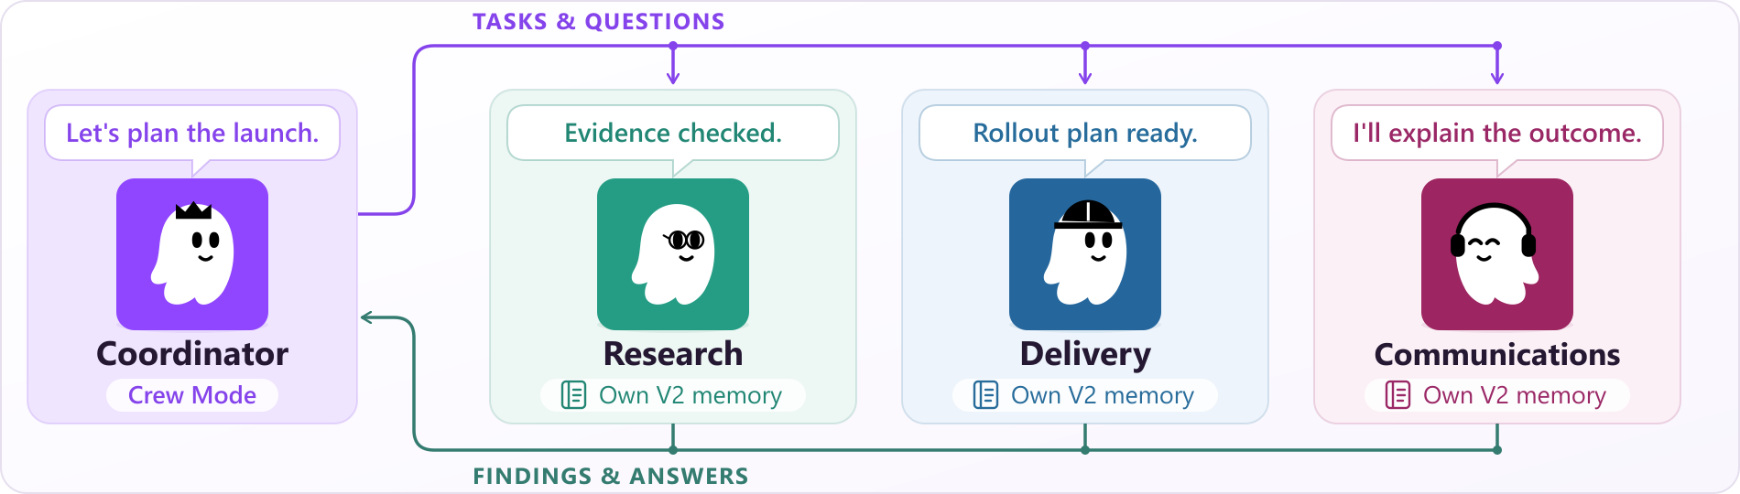
Illustrative V2 Crew: native Crew Members exchange assignments and findings through the coordinator. Their private memories remain separate; copying memories is an owner choice.

Working with a Crew
For a product launch, ask the coordinator to assemble the plan. Research checks the evidence, delivery prepares the rollout, and communications drafts the announcement. Members return findings, receive follow-up work and contribute to the combined result. Each participating V2 member keeps its own memory.

Working directly with one member
Open Chat with this member for a focused follow-up. Ask research to reassess a source or delivery to revise a checklist. A V2 member receives core guidance each turn and recalls relevant records when requested. You can use private member memory without assembling a Crew.

Adopt it when the role is ready
New members start with empty V2 on supported setups. Existing members, including the default agent, keep valid Global or named V1 until the owner confirms private memory. Copy selected memories when useful; members do not automatically share or move memory.
02 / MEMORY V2

From a role to a repeatable workflow
Use case | Member journey | Owner checks
Product launch · Crew Mode | Assign research, rollout and communications work. Collect results and issue follow-ups. | Did each role use the right guidance and sources? Did the coordinator combine the findings correctly?
Ongoing research · Crew Mode off | Chat with the research member. Revisit a prior source or decision and inspect the recalled evidence. | Is the relevant decision recalled and correctly applied to the new task?
Recurring review · Agent schedule | Schedule a supported Agent task from the member’s current conversation. | Does the task use the intended member and produce a useful, traceable result?
Correct a working rule | In Memories, select records, make an edit and review the preview before Apply. | Does the next relevant task respect the correction and its source?

An explicit change of memory
After finishing or stopping an existing V1 member's work and child tasks, choose Create private memory in Crew Manager. Confirmation explains the empty store, fresh next chat and no return to V1. Cancel preserves the current memory, conversation and unsaved edits. Old data, chats and scheduled identities remain; a conversation or schedule with a conflicting old binding is refused.

Control stays visible
Use Memories to inspect records and sources, Profile for essential guidance, and Recovery for backups. Search stored content and review any extracted email addresses. Preview changes before Apply; Cancel leaves the proposed Forget unapplied. Forget has no direct Undo; a suitable whole-memory backup can recover an earlier state after restart. V1 retains 20 accepted revisions per record; V2 does not automatically trim history.

Pilot conditions and evidence
Pilot on Linux or WSL, or supported macOS isolation. Native Windows and public Codex ACP are unsupported; macOS Kiro requires internal delegation off. Name an owner for backups, storage and recovery. The gateway owner can use kirocrew doctor for binding problems and pause new allocations during incidents. Active V2 has automatic backups; V1 backups are manual. Monitor storage growth and recall response time.
Test whether real work needs less repeated briefing and fewer corrections. Historical 44546 retrieval covered 49 of 50 authored English topics on the corpus used for calibration. Newer b38 receipts show 10 memory UI scenarios passing without retry. There is no held-out or V1/V2 A/B result, or measured answer, teamwork or productivity gain. Candidate checks remain incomplete. Sources and limits: source-evidence-manifest.json.

