01 / ENGINEERING

Memory V2 technical design
  - Ownership execution retrieval and recovery
New or opted-in Crew Members own unique V2 stores. Existing valid Global or named V1 bindings remain usable. This reviews candidate f3f901e1 against its owning contract and code. V1 retains established retrieval policies with targeted shared repairs and accepted-history retention. Historical measurements are separate. [T1, T7, T8]
Implementation candidate f3f901e1. Historical retrieval and scoped UI evidence are separate. Current checks and reviews remain incomplete; this is not release approval.
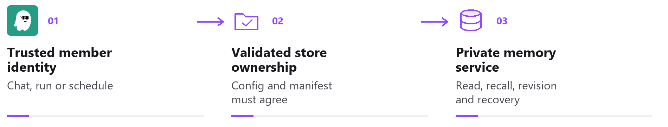
For a V2 member, verified identity resolves one owned store. Sharing gateway services does not share persisted memory.

Ownership and an explicit V1 choice
New members get empty V2. Existing members, including default_agent aliases, keep valid V1 until confirmed Create private memory. Opt-in refuses active work or attached children, then retires idle V1 context. Confirmation explains empty memory, a fresh next chat and no return to V1. Old data and recorded identities remain; conflicting old chats or schedules refuse the new binding. [T1, T2]
Data | Global V1 location | Private V2 location
Vector database | <home>/memory.db | <home>/memory_stores/<store>/memory.db
Core and history | <home>/workspace/memory/ | <home>/memory_stores/<store>/memory/
Text search index | <home>/memory_index.db | <home>/memory_stores/<store>/memory_index.db

Physical layout and algorithm version are separate. memory_items holds ID, kind, content, vector, source, timestamps, deletion state and optional provenance, alongside revision, event and proposal metadata. Compatibility views preserve legacy reader shapes. An unmarked crew-layout store can still run V1. Private V2 requires crew layout and matching durable ownership; a V2 manifest over legacy physical tables is refused. [T1, T4]

Failures preserve identity
Creation checks edit fields, chat backend and OS sandbox before allocation or V1 retirement. Failed publication retires only the exact new, undeclared, unreferenced generation under the config lock; files remain. Published, uncertain and existing V2 ownership is preserved. Safely retired failure permits retry from V1. Damaged V2 never falls back. Deletion retains files; reusing a name creates fresh identity. [T1, T6]
02 / MEMORY V2

Core guidance and trusted execution
Each private turn refreshes member identity, conduct and owner persona, including minimal context. Task instructions cannot replace that persona. V2 skips speculative prewarming and resume prefetch; ACP resolves private identity off the event loop and checks capability before launch. Global V1 may prewarm; no latency gain is established. [T2, T5]

A complete core envelope
Core guidance has a 64,000-character envelope including wrappers and identity. It is complete or the turn refuses; ordinary context yields space first. Profile saves validate before commit and external edits are revalidated next turn. This does not guarantee a fit in every model window. [T2]
Project essentials include root AGENTS.md and SOUL.md, default/always steering and declared template Markdown. Other steering keeps its triggers. Optional root files may be absent; unreadable declared sources and malformed templates fail with a named reason. Bounded reads reject linked or foreign memory. [T2]
Four guarded hooks.py readers check the opened regular-file descriptor kernel path against the canonical name and sensitive paths before reading. Unknown locations or swapped parents refuse. Nonblocking admission prevents FIFO opens from waiting for a writer. Inode-allowlist, internal, copy and export readers retain distinct checks. [T2, T5]
Execution surface | Identity contract
Private chat | Existing V1 members retain their exact binding. Private V2 uses protected assignment or owner action; restored labels grant no authority. Own-session callbacks remain. Opt-in starts a fresh conversation identity.
Crew and spawned work | Continue, steer, status, results and history authenticate protected store identity. Lists, cleanup and spawned work keep that scope. Owner coordination remains available.
Agent schedules | Private jobs retain their verified creating session. Owner aggregate cron routes refuse private callers. Trigger text gates automatic Crew matching; explicit owner and own-member scheduling remain available.
TaskRunner and webhooks | Planning, retries, result reads and continuations keep trusted scope. Hook names include store identity. Shared provider refinement, private file planning and command/script schedules are unavailable.

Execution requires an enforced boundary
Private execution requires Linux or WSL namespaces, or macOS outer Seatbelt with Kiro internal delegation off. Kiro, Claude Code and KAS provide direct MCP support; native Windows and public Codex ACP remain unavailable. Member chat uses its backend; assigned work, Agent schedules and consolidation use the default backend. Linux/macOS fences include configured workspace roots. On Linux, loose root files are read-only; new ones enter the view after provider recreation. Eligible child directories remain writable within existing fences. [T5]
Delegated proofs recheck process incarnation, session, store and isolation; legacy proofs retain expiry. Darwin inherited Global authority requires live kernel read permission. With private boundaries active, shared kiro-cli logs reject private/unverified readers; verified Global V1 remains supported. Every tools/list request supplies proof, since session policy may be cached. Owner attribution may require gateway-host login. A denial-audit write failure preserves typed 403 refusal and never grants access. [T5, T7]
03 / MEMORY V2

Retrieval and embedding work
Core assembly does not embed a query or search historical memory. An explicit memory_recall request resolves the trusted store, admits candidates and packs evidence. V1 retains its session start injection and original semantic conflict, decay and live capacity policies. [T3, T7]
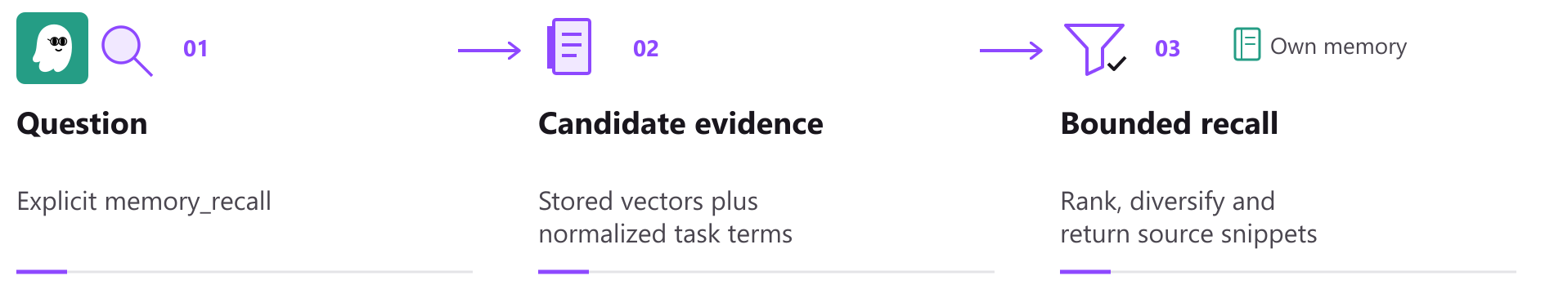
V2 scans the active episode population before final selection. Bounded responses do not imply bounded search cost.

Admission and ranking
Provisional cosine thresholds are 0.62 for short fragments and 0.57 above 300 characters. Lexical admission needs half the meaningful query terms and at least two distinct matches for queries with two or more terms. NFKC and casefold normalization, English function word filtering and adjacent CJK pairs support matching; JSON values are decoded. Diagnostics keep the operating point provisional and distinguish reference, custom and unknown embedding identities. [T3]
Episode rank combines 70 percent nonnegative cosine with 30 percent query coverage, then applies an importance multiplier from 0.85 to 1.0. Missing comparable vectors contribute zero cosine; coverage does not become the whole score. Optional MMR diversifies episodes. Facts use cosine plus coverage, with eligible pref.* keys bypassing query filtering. Age adds no penalty. [T3]

Packing records for HTTP and MCP
Member HTTP recall uses a 3,000-character body budget; the internal helper permits a caller cap up to 12,000. Transport has a separate 16 KiB limit. V2 may shorten a long result while retaining its full ID and truncation flag; V1 keeps its initial fitting policy. MCP text is normalized before counting, including NFC expansion. UTF-8 HTTP JSON and Unicode-escaped MCP frames are counted separately. The sole-result floor is one character; impossible wrapper budgets require omission. [T3]

Shared embedding capacity
Built-in native embedding backends share one worker, a bounded priority queue, cache and duplicate coalescing. Thread defaults are four interactive and one bulk, CPU-clamped when explicitly set. Signatures cover declared model_id and dimension, not weights. Equal dimensions do not establish comparability; a matching signature cannot prove identical weights. Changed signatures trigger vector repair. Copies omit vectors. [T3, T7]
Repair visits active Global and already-open named V1/V2 stores, at most 16 rows of each kind per sweep. Only Global waits for boot migration and full repair. The cursor advances before failure. No idle store opens or absent model loads; repaired rows append to resident indexes without full rebuilds per page. [T3, T7]
V1 bounds returned-hit filtering and batch-fetches bodies; a starved window falls back to full SQLite scoring. Flat-index search can still scan all entries, including deleted ones until rebuild. V2 scans active episodes. No latency, CPU or cost gain is measured. [T3, T7]
04 / MEMORY V2

Revisions learning and owner control
Opening V1 adds metadata and revision tables, backfills records and journals later changes by older binaries; SQLite bytes change. Fresh extension schemas omit has_email and its unused category/email index. Older schemas drop only that index, retaining the physical column and historical revision JSON. Current reads and writes ignore the obsolete flag. Extracted email_addresses remain visible and search matches stored content. No table rebuild or new SQLite requirement is introduced. [T4, T7]

Accepted history has a versioned policy
Global and named V1 keep the latest 20 accepted snapshots per record, ordered by monotonic revision-row ID, on accepted writes and startup catch-up. Current records, metadata, counters, CAS and all proposals remain. V2 never automatically prunes revisions or evicts for age/capacity. This V1 bound does not cap total storage or shrink SQLite files; removed snapshots disappear from live audits. Content hashes exclude updated_at; timestamp-only edits create no revision unless forced. [T4]

Compaction is an explicit offline procedure
memory compact-revisions can remove older accepted snapshots from one V1 or V2 store. Stop every writer on every host, disable auto-restart and verify a complete offline archive first. Preview reads SQLite without writing, but CLI config loading may perform normal migrations; archive the original config first. Apply requires the exact preview count, a new owner-restricted SQLite backup and --stopped. This acknowledgement does not detect live writers. [T4, T6]
Private-store admission, exclusive SQLite locks, backup comparison and one deletion transaction protect apply. Current content, metadata, counters, proposals and each latest accepted snapshot survive. The CLI does not coordinate remote hosts, run VACUUM, shrink files or securely erase history. The SQLite backup does not replace the full archive. [T4, T6]

Learning and edits require current evidence
Extraction freezes its transcript and rechecks generation, source and revisions before writing. V2 uncertain corrections become proposals; verified transcript corrections must match the current fact and revision. In both versions, extracted lessons use source consolidation and confidence 0.9. Semantic facts retain consolidation:<key> even at confidence 1.0; model confidence cannot confer user_explicit owner authority. V1 embedding-only near-duplicate learning preserves explicit owner or higher-confidence lessons; substring and topic rules remain source-blind. Distinct V2 lessons are not deleted merely for similarity. [T4, T7]
Bulk previews bind store, selection and operation for 15 minutes. Pages of 25 keep the digest and expiry; paging failure blocks Apply. Apply rechecks content and membership transactionally. Bounds are 500 explicit IDs or 10,000 filtered records and 32 MiB; restart invalidates previews. Redacted Profile sources are read-only. PUT checks do not reject every stale browser draft. [T2, T4]
Copy memories validates up to 50 selected source records, then commits each independently with provenance. Existing target identities are preserved; partial failure identifies completed, uncertain and unattempted items. Forget removes recall eligibility, not conversations or backups; retained revisions follow the policy above. There is no direct Undo. A suitable whole-store backup can recover an earlier state after restart. [T4, T6]
05 / MEMORY V2

Recovery and shared operations
A private backup contains an online SQLite backup and current memory documents. Its manifest records owner, store, time and file hashes; derived indexes are rebuilt. SQLite is transaction-consistent, but separate document reads do not form one atomic snapshot with it. [T6]
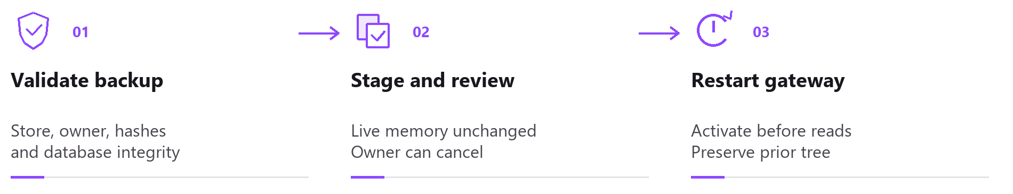
Restore is staged for a gateway restart. The activation journal preserves the previous tree; cancellation is only available where safe.

Validation before activation
Restore validates owner, inventory, hashes, SQLite integrity and limits of 8,192 files and 1 GiB. Unsafe paths, links and foreign content refuse. POSIX private vector/Markdown users hold a shared lifetime lock outside the replaced tree; restore holds the exclusive peer through validation and replacement. Arbitrary host writes are outside this protocol. Windows retains open-handle replacement refusal. [T6]

Recovery failures are tracked by store
Startup loads cron disarmed and publishes shared preparation before READY. Preparation gates Global restore/open and memory work. Agent turns wait up to 30 seconds before provider allocation or metadata; timeout requests retry without cancelling preparation or counting a session failure. Cron, heartbeat and migration follow preparation. Structural failure pauses memory work; a store failure fences that store. [T6]
Failed-store status, safe Cancel and another restore remain available; reopening requires restart. Record restore cannot directly undo Forget and invalidates Global query and episode/FAISS caches. Leaving the Memory panel prompts about unsaved work; declining preserves drafts. Creating status identifies only the current member request. [T2, T6, T7]
For unavailable or mismatched bindings, the editor points to kirocrew doctor on the gateway. It reports each member, configured store and refusal reason and continues with peers. The check does not initialize, allocate, rebind, repair or establish full database health or runtime capability. Normal CLI setup still applies. Read admission may create transient WAL coordination files while preserving the database and committed WAL content. [T2, T7]

Operations also affect Memory V1
V2 automatic backups default on with seven copies; V1 backups are manual. V1 same-time backups get unique names; older names still restore. Global restore requires V1 lineage; named V1 also accepts unowned crew schema. Source and staged copies reject private, empty or unrelated databases before journal publication. Activation preserves displaced database, WAL and SHM files for owner cleanup. [T6, T7]
Shared V1 changes include owner-authority checks, accepted-history retention, restore validation, named-store file fences and bounded embedding repair. V1 keeps FAISS/NumPy and remains outside V2 writer locks. Event responses redact nested secrets without rewriting stored events. Monitor records, revisions, recovery copies and scan work: bounded recall output is not bounded storage or execution cost. [T3, T4, T7]
06 / MEMORY V2

Evidence and release boundaries
The exact baseline is f3f901e143490e07acad12fec9fd391d08711a01, parent 256af4a69e4e298d9e918926f4a405137d5f438a. The supplied candidate snapshot records frontend lint and four frontend shards passing. Backend matrix, other checks and reviews remain incomplete; CodeQL is not approved. This source review ran no product checks and grants no release verdict. Source and evidence hashes are in the manifest. [T8]
memory.private_provisioning_enabled=false pauses new allocations and V1 opt-ins without restart; existing work retains checks and admitted work is not cancelled. PR9553 is one squashed feature commit. A full revert also removes private-identity interpretation and shared V1 repairs. Do not run a pre-V2 binary over the populated data home. The separate emergency-withdrawal maintenance draft is unapplied and unvalidated. [T1, T7]

Historical 44546 retrieval measurement
Historical run 34433763685 used source 44546ae46d5dd3b2f67c6db813c3473cd9dc617a through merge e74dbe6ec831747774c3906698ddef7a7d4c94b9. The retained audit verified 1,426 canonical Python seals. Five native-library hashes and the model pin remain CI provenance claims, not independently downloaded bytes in this review. [T8]
Original Qwen artifact 10135513019 uses Qwen3 Embedding 0.6B at 1,024 dimensions, NumPy active and FAISS absent. All 150 selected-context rows and 600 metric values were recomputed for this review. The authored English corpus has 50 topics, 100 fragments and 5,000 pairs per mode. It also informed provisional thresholds; there is no held-out set. [T8]
Measurement mode | Topics hit | Relevant fragments | Irrelevant selections | Context nDCG@8
Full vectors | 49 / 50 | 93 / 100 | 5 | 0.931972
Short vectors absent | 48 / 50 | 73 / 100 | 5 | 0.769785
No embeddings | 37 / 50 | 56 / 100 | 5 | 0.596207

Full-vector micro precision is 94.9 percent and recall 93 percent. Maximum reported context is 1,296 characters. Two oversized fixtures each pass eight predicates within 200 context characters; estimated MCP size is 2,762/16,384 bytes. These are fixture results, not independent production trials. [T8]

Scoped interface evidence
Fresh b38 UI artifact 10143446991, run 34454095201, records 10 memory scenarios passing with zero retries; the outer pytest wrapper has 18 passes and two warnings. Capture fe52d611 shares the b38 feature tree. Rendering components are unchanged at f3f, but these are not f3f execution results. Only three original frames were inspected: consistent V1 Semantic/Episodic counts and mobile V1/V2 Forget Cancel controls. [T8]
The remaining 33 images and 10 videos were not visually rereviewed. Screenshots do not establish action effects; synthetic data and stub ACP do not establish live-provider quality or restart activation. There is no V1/V2 A/B or measured gain in answer quality, task success, teamwork, productivity, CPU, latency or cost. Growing V2 stores still increase retained history and recall scan work. [T3, T8]
Sources T1 ownership; T2 core and UI; T3 retrieval; T4 editing; T5 execution; T6 recovery; T7 shared V1; T8 evidence. Exact candidate references, hashes and qualifications: source-evidence-manifest.json.

