import numpy as np
import matplotlib.pyplot as plt
x=np.arange(-5.0,5.0,0.01)
y1=np.cos(x)
plt.figure(1)
plt.subplot(211)
plt.plot(x,y1)
plt.show() 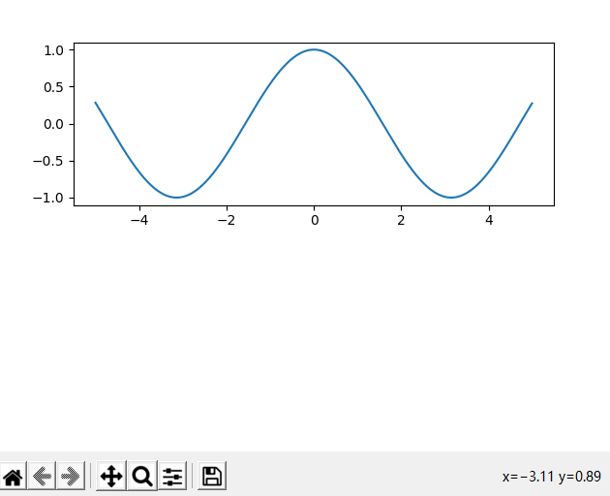

import numpy as np
import matplotlib.pyplot as plt
x=np.arange(-5.0,5.0,0.01)
y1=np.exp(x)
plt.figure(1)
plt.plot(x,y1)
plt.show()
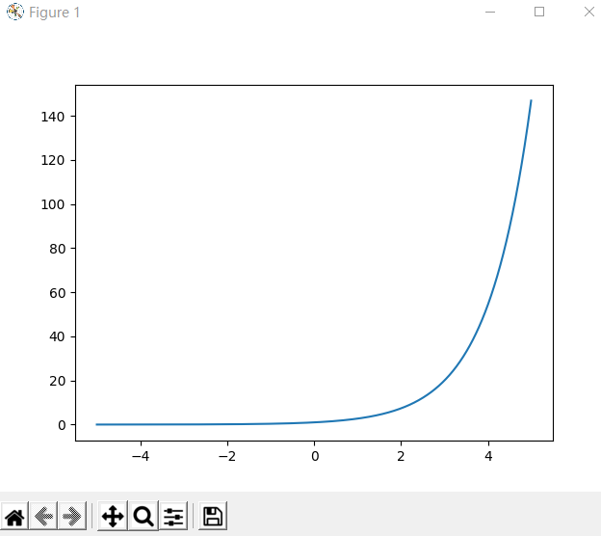

import numpy as np
import matplotlib.pyplot as plt
x=np.arange(-100.0,100.0,0.01)
y1=np.exp(0.01*x)*np.cos(x)
plt.figure(1)
plt.subplot(211)
plt.plot(x,y1)
plt.show()
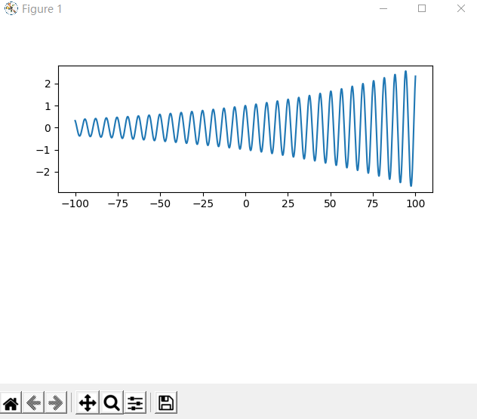

import numpy as np
import matplotlib.pyplot as plt
x=np.arange(-100.0,100.0,0.01)
y1=np.exp(-0.01*x)*np.cos(x)
plt.figure(1)
plt.subplot(211)
plt.plot(x,y1)
plt.show()
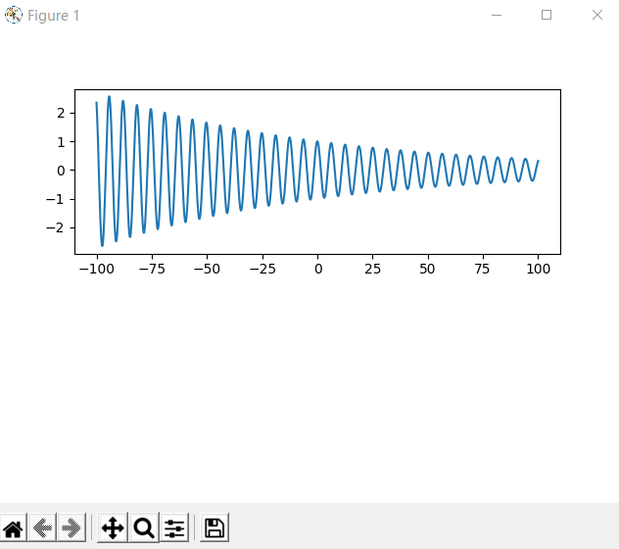

import numpy as np
import matplotlib.pyplot as plt
x=np.arange(-1.0,1.0,0.01)
y1=np.exp(x)
y2=np.exp(-x)
y3=np.exp(0*x)
plt.figure(1)
plt.plot(x,y1)
plt.plot(x,y2)
plt.plot(x,y3)
plt.show()
