The Labyrinth: Milestone 2 Prototype Report
GE1501 Cornerstone of Engineering, Group 1
Chase Y (Draftsperson), Chase C (Constructor), Benny (Electronics: Actuation), Filippo (Electronics: Score Keeping)
[Date]

1. Game Summary
The Labyrinth is a tilting ball maze. The player uses a joystick to tilt the maze board in any direction and rolls a 5/8 in ball from the START pocket in the front-left corner toward the prize holes in the back. Two servo motors, controlled by a Raspberry Pi Pico, tilt the board: the outer servo tips the outer box and board front to back, and the inner servo, mounted in the outer box, tips only the board left to right. Pressing the joystick down tilts the board toward one corner so that a dropped ball rolls out of the collection tray.
Players win Ecuadorian Sucres depending on which hole the ball drops into: the 1-coin hole is the easiest and closest, the 3-coin hole is further, and the 5-coin hole is the smallest and furthest, at the end of the full route. Dark red loss holes and a servo-driven trapdoor in the middle of the main corridor end the turn with no prize. Every hole sits over a sloped tray under the board, so the ball always returns to the same corner and the result is clear to everyone watching.
For this milestone the maze, walls and outer box were built from cardboard as a rough draft of the laser-cut parts. The joystick control of both tilt axes and the trapdoor servo were working, and the game operator recorded results and paid coins by hand.

2. Playtesting
We ran the game during the in-class playtest. [Name] stayed with the game, reset the ball after each turn, and recorded every play. Table 1 summarizes the results; the full log is in Appendix A.
Table 1. Playtest results
Result | Number of plays | Coins paid
5-coin hole | [#] | [#]
3-coin hole | [#] | [#]
1-coin hole | [#] | [#]
Loss (hole or trapdoor) | [#] | 0
Total | [#] | [#]

Playtesters responded very positively. Every player rated the game 15 out of 15, with comments such as “it’s sick and works well” and “this is amazing and really fun.” Players described the joystick controls as smooth. They also gave useful suggestions and pointed out problems:
- The cardboard frame wobbled, especially at full tilt.
- Over a session, the board slowly lost its level position, so players had to correct for a lean that was not there at the start.
- Players wanted a housing for the joystick so that its orientation always matches the board.
- Players suggested using the joystick press (L3) to open a door, for example to release the ball or reset the game.
During testing we also found an electrical problem. With the joystick and the servos sharing a ground wire, the servos’ current pulses shifted the joystick readings, so the board twitched on its own. Giving the joystick its own ground connection to the Pico’s analog ground pin fixed this. We also found that the servos were weak in one direction when powered through USB, because the USB cable and connectors could not supply enough current.

3. Remaining Work

Finishing the game
- Laser-cut the floor, walls and rim from 1/8 in plywood (three sheets in the current layout; we will try to fit it into two).
- Drill the prize and loss holes on the drill press with Forstner bits (our auxiliary tool).
- Build the outer box and posts from wood, with screwed horn mounts and bearings for both pivots.
- Power the servos from a dedicated 5 V, 6 A supply instead of USB.
- Add ball sensors under the prize holes so the Pico keeps score automatically.

What the data tells us
Our results show [the game was too easy / too hard / about right: X of Y players won, and Z coins were paid]. We therefore plan to make the game [easier / harder / keep it the same]. We can tune the difficulty with the maximum tilt angle and speed in the code, the hole sizes, and the position of the loss holes. We have already moved one loss hole and added two more based on playtesting.

Acting on feedback
- Wobble: replacing cardboard with plywood and screwing the horns into wood will make the frame stiff.
- Losing level: a counterweight on the outer box, firmer horn mounts, and the new power supply should keep the board level for a whole session.
- Joystick housing: we will build a controller box that fixes the joystick’s orientation.
- Door on L3: we will look at using the joystick press to work the trapdoor or a ball-release door.

Biggest roadblocks
Our biggest risks are keeping the board level and responsive over many plays, which depends on solid mounts and enough servo current, and fitting the laser-cut parts into the class sheet budget. Automatic score keeping with sensors under every hole is the largest electronics task still to do.

Appendix

A. Playtest data
Play # | Result | Coins paid | Time (s) | Notes
1 | [ ] | [ ] | [ ] | [ ]
2 | [ ] | [ ] | [ ] | [ ]
3 | [ ] | [ ] | [ ] | [ ]
4 | [ ] | [ ] | [ ] | [ ]
5 | [ ] | [ ] | [ ] | [ ]

B. Drawings
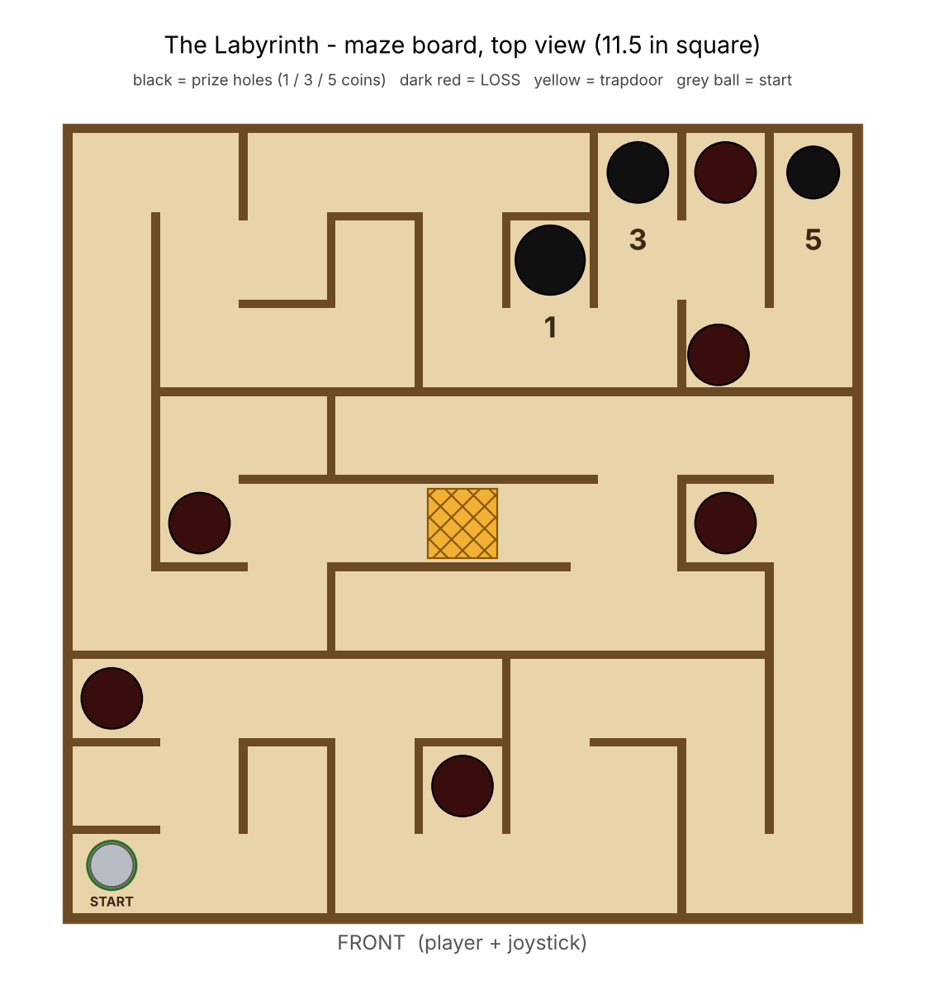
Figure 1. Maze board, top view
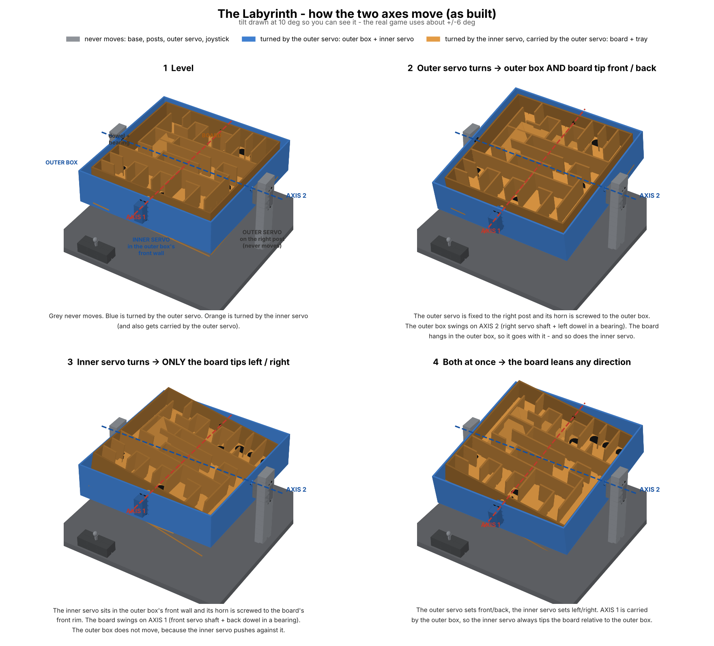
Figure 2. How the two tilt axes move

C. Photos
[Paste prototype photos here]

D. Code (Pico, MicroPython)
Joystick control of both tilt servos (excerpt; the full program also runs the trapdoor on a second thread):
xJoy = ADC(27)
yJoy = ADC(26)
DEADZONE = 3000
xMid = xJoy.read_u16()
yMid = yJoy.read_u16()
while True:
xValJoy = xJoy.read_u16()
yValJoy = yJoy.read_u16()
if abs(xValJoy - xMid) < DEADZONE:
xValJoy = 32768
if abs(yValJoy - yMid) < DEADZONE:
yValJoy = 32768
angleX = round(83 + ((xValJoy / 65535) * 10))
angleY = round(83 + ((yValJoy / 65535) * 10))
servoX.duty_u16(int((6553 / 180) * angleX + 1638))
servoY.duty_u16(int((6553 / 180) * angleY + 1638))

