AAPL — Worked Example
End-to-end trace from Excel ingest through rule firing to the final action (snapshot_date = 2026-05-07)

Reading guide
This document follows one ticker, AAPL, on a single snapshot_date (2026-05-07) through the entire pipeline. The numerical values are illustrative — exact values depend on actual market data — but the columns, table writes, and rule evaluations match what the code does. The ingestion stage differs between the two load paths; from Stage 4 (drv_ma) onward the two paths converge.

Trace overview
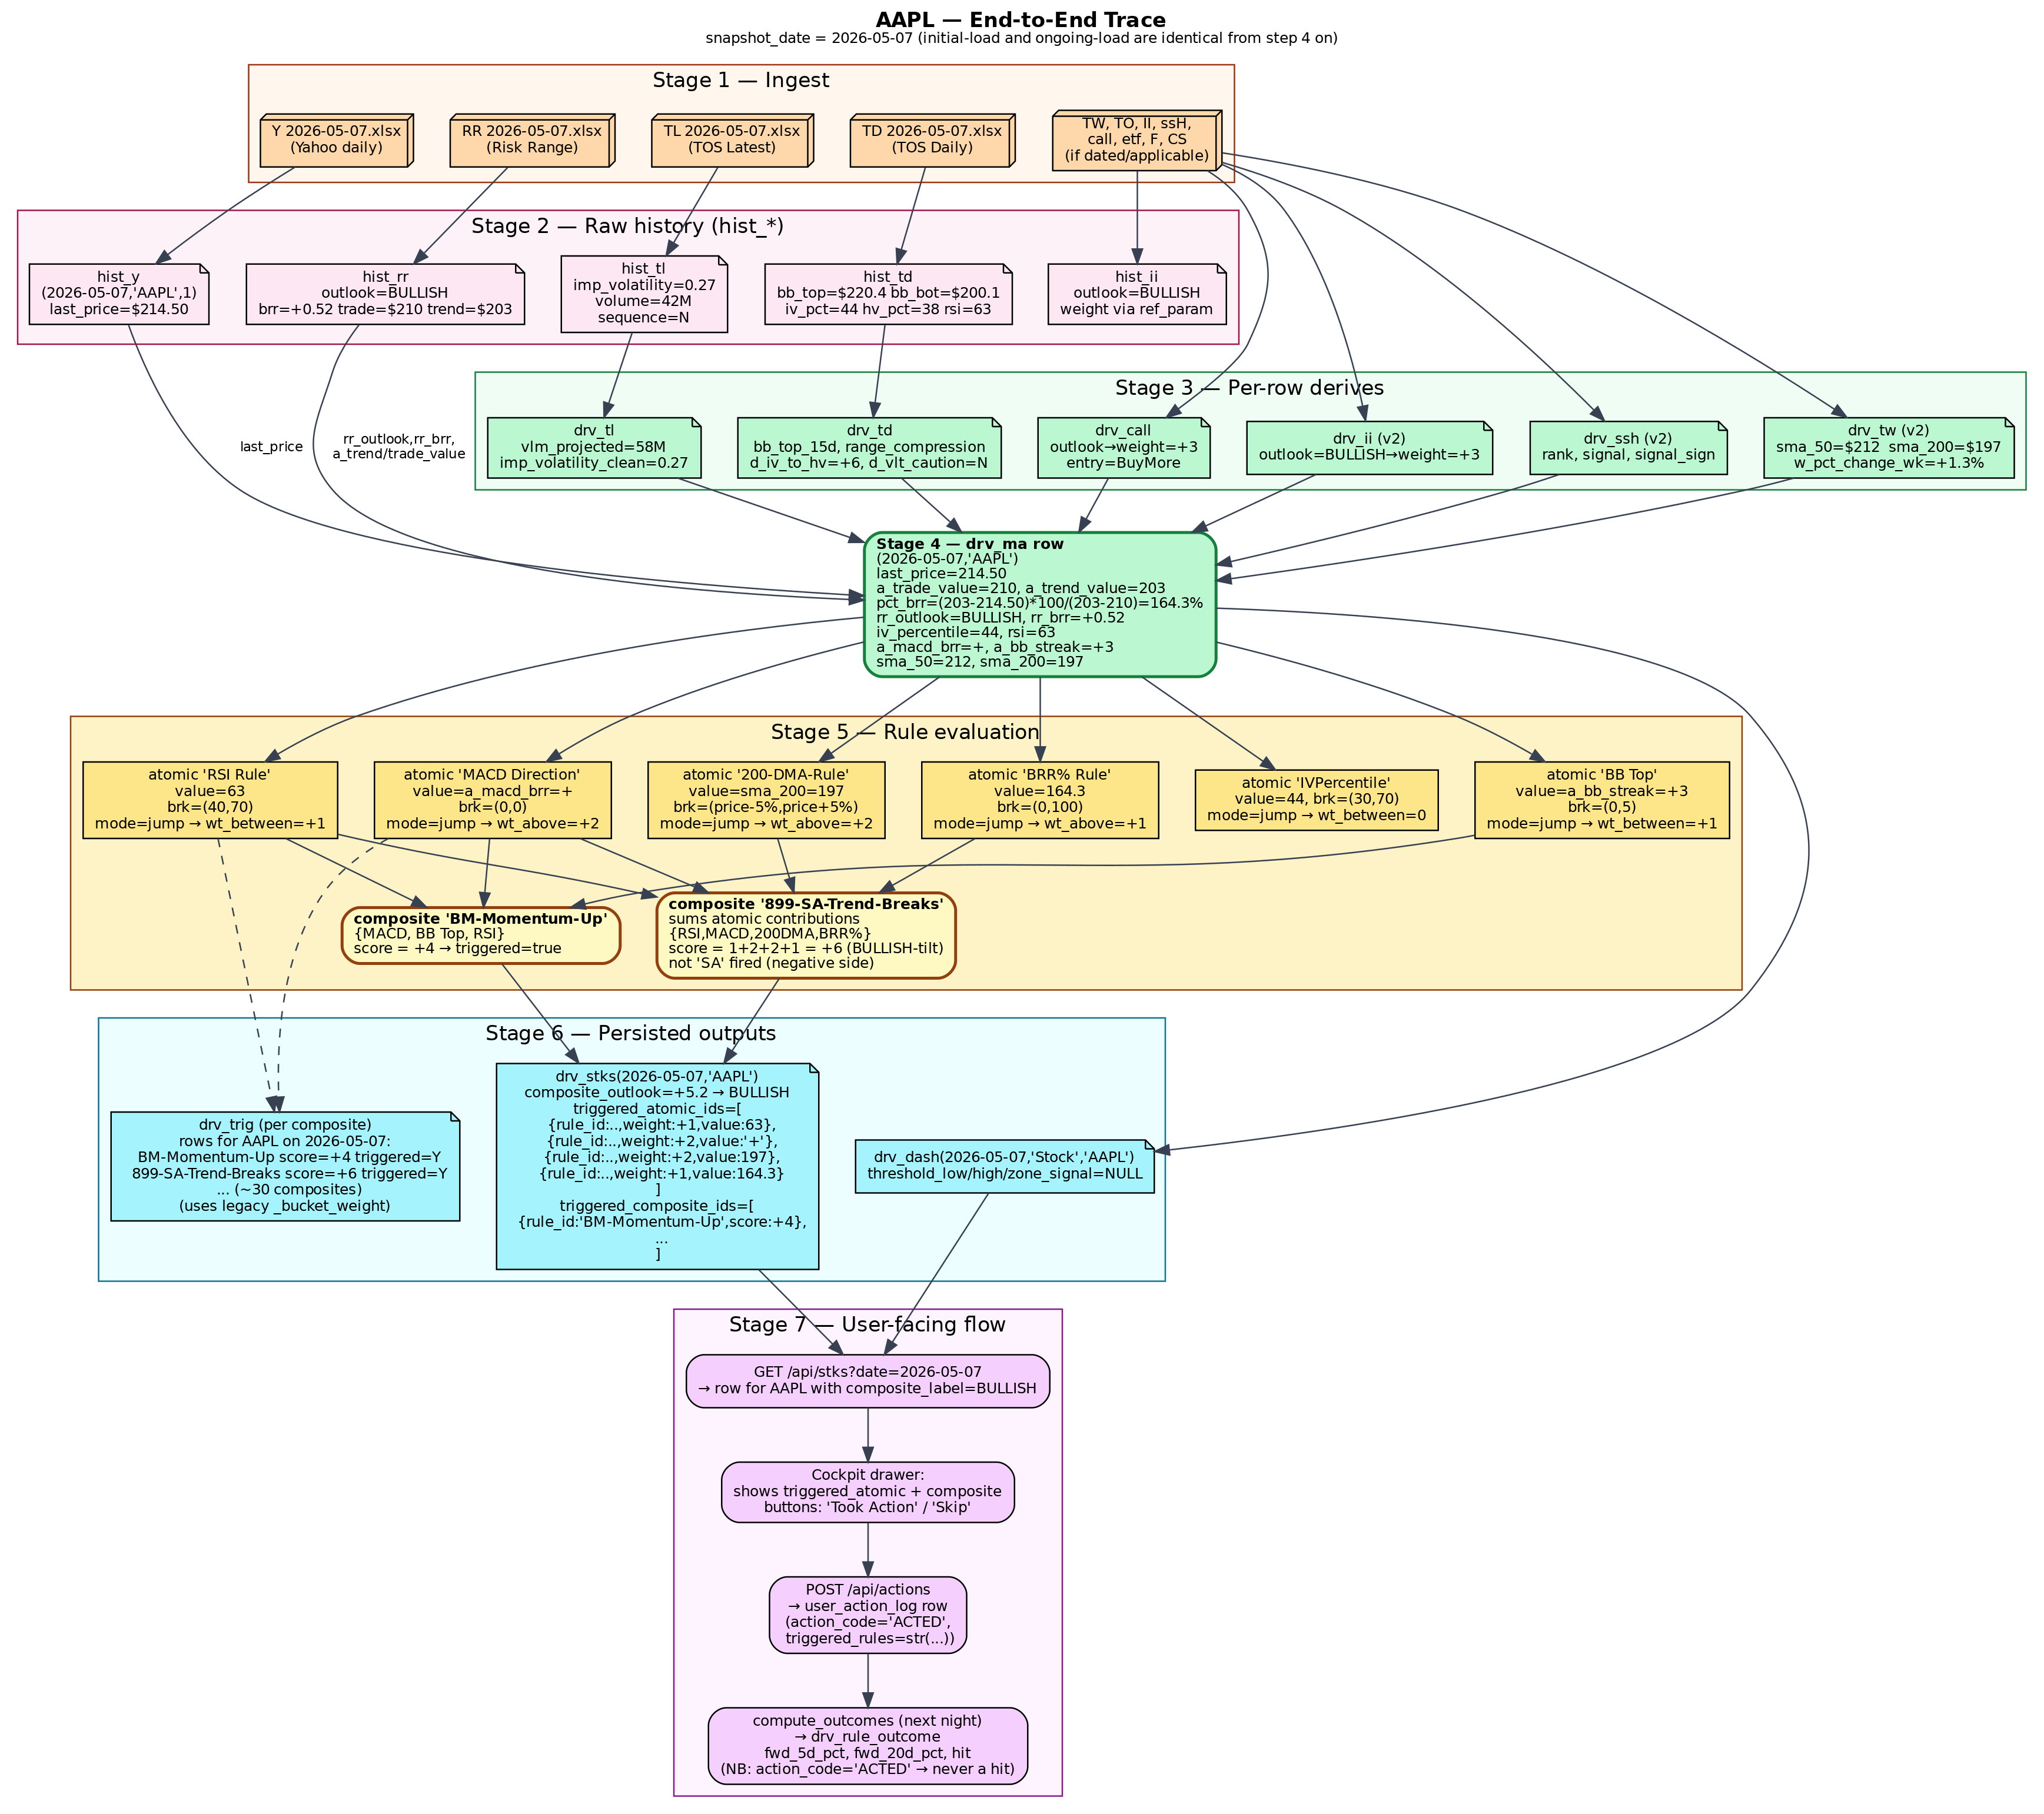

Initial load (one full Tickers workbook)

Stage 1 — ingest
`python -m etl.tickers_initial_load` opens `Tickers 2026-05-07.xlsx`. The orchestrator parses `2026-05-07` from the filename, computes a SHA-256, registers a `meta_file_processed` entry, and runs Step A across REF_MAPS, the data-tab loaders, the Trig loader, and HIST_MAPS. AAPL appears in roughly a dozen tabs (Y, TL, TD, TW, TO, RR, II, ssH, call, etf, ps5/psRk/psTn if the workbook captured the prior Friday).

Stage 2 — hist_* rows for AAPL on 2026-05-07
Table | AAPL row (illustrative)
hist_y | (2026-05-07,'AAPL',1) last_price=$214.50, volume_y=42M
hist_tl | (2026-05-07,'AAPL',N) imp_volatility=0.27, sequence=N (final intraday print)
hist_td | (2026-05-07,'AAPL',1) bb_top=$220.4, bb_bot=$200.1, iv_pct=44, hv_pct=38, rsi=63
hist_rr | (2026-05-07,'AAPL') rr_outlook=BULLISH, rr_brr=+0.52, a_trade_value=$210, a_trend_value=$203
hist_ii / hist_call / hist_etf / hist_ssh | weekly export rows; outlook fields filled per source
hist_to / hist_tw / hist_ps* / hist_f / hist_cs | as the workbook captured them; F/CS only if AAPL is held

Stage 3 — per-row derives
After Step A, derive_all(2026-05-07) runs in dependency order. Per-row derives compute:
drv_tl vlm_projected = volume * 390 / mins_since_open (≈ 58M)
imp_volatility_clean = 0.27 (NaN scrubbed)
drv_td bb_top_15d, bb_bot_15d, range_compression
d_iv_to_hv = iv_pct - hv_pct = +6
d_vlt_caution = 'N'
rsi family: rsi_overbought_streak = 0
drv_tw (v2)
sma_50 = $212, sma_200 = $197
w_pct_change_wk = +1.3%
a_macd_brr = +, a_macdh_d_brr = +
drv_call outlook = BULLISH → ref_param('outlook','BULLISH').weight = +3
entry/cont via ref_param_lookup('buysell', ...)
drv_etf (v2)
drv_ii (v2) outlook = BULLISH → weight = +3
drv_ssh (v2) signal_sign computed
drv_ssl AAPL row from hist_ssh on 2026-04-30 (lag 7d)
drv_sss (v2) wk/mn/3m deltas, sss_entry/sss_cont

Stage 4 — drv_ma master row
`_derive_ma_impl` joins ref_sector with the latest hist_* and drv_* values ≤ 2026-05-07 for every symbol. For AAPL, the row contains roughly:
(2026-05-07, 'AAPL')
description = 'Apple Inc.'
sector = 'Information Technology'
asset_class = 'Equity'
last_price = 214.50
a_trade_value = 210.00 a_trend_value = 203.00
pct_brr = (203.00 - 214.50) * 100 / (203.00 - 210.00) = 164.3
rr_outlook = 'BULLISH' rr_brr = +0.52
call_outlook = 'BULLISH' call_modifier = '+1'
etf_outlook = 'BULLISH' ii_outlook = 'BULLISH'
ssh_signal_sign= +1
iv_percentile = 44 hv_percentile = 38
rsi = 63 range_compression = 0.18
a_macd_brr = + a_macdh_d_brr = +
a_bb_streak = +3 a_bb_top = 220.4 a_bb_bottom = 200.1
sma_50 = 212 sma_200 = 197
earnings_days = 28 volume = 42_000_000 vlm_projected = 58_000_000
All ~50 columns of drv_ma are filled this way; columns absent from the source data are NULL.

Stage 5 — rule evaluation in `_derive_stks_impl`
The function loads non-deprecated atomic rules and the composite mapping once. For AAPL on 2026-05-07, six representative atomic rules (real names, drawn from the migration table in db/12_atomic_rule_name_migration.sql):
Rule | ma_column | value | thresholds (lo / hi) | scoring_mode → weight
RSI Rule | rsi | 63 | (40, 70) | jump → wt_between = +1
MACD Direction | a_macd_brr | + | (0, 0) sign-test | jump → wt_above = +2
200-DMA-Rule | sma_200 | 197 | (price-5%, price+5%) ≈ (203.8, 225.2) | jump → wt_below = +2 (price > sma_200 by 8%)
BRR% Rule | pct_brr | 164.3 | (0, 100) | jump → wt_above = +1
IVPercentile | iv_percentile | 44 | (30, 70) | jump → wt_between = 0
BB Top | a_bb_streak | +3 | (0, 5) | jump → wt_between = +1
These atomic results are summed per composite rule. Two illustrative composites are reached by AAPL on this date:
- `BM-Momentum-Up` ← {MACD Direction, BB Top, RSI Rule}: score = +2 + +1 + +1 = +4 → triggered = true (positive momentum).
- `899-SA-Trend-Breaks` ← {RSI Rule, MACD Direction, 200-DMA-Rule, BRR% Rule}: score = +1 + +2 + +2 + +1 = +6 → on the bullish side of the rule, so the SA action does not fire (an SA composite fires when its score is sufficiently negative).

Stage 6 — persisted outputs
`_derive_stks_impl` writes one row to drv_stks for AAPL on 2026-05-07:
drv_stks (2026-05-07, 'AAPL')
composite_outlook = +5.2 composite_label = 'BULLISH'
triggered_atomic_ids = [
{rule_id: <RSI Rule's ID>, weight: +1, value: 63 },
{rule_id: <MACD Dir's ID>, weight: +2, value: '+' },
{rule_id: <200-DMA's ID>, weight: +2, value: 197 },
{rule_id: <BRR% Rule's ID>, weight: +1, value: 164.3},
{rule_id: <BB Top's ID>, weight: +1, value: +3 } ]
triggered_composite_ids = [
{rule_id: 'BM-Momentum-Up', score: +4},
{rule_id: '899-SA-Trend-Breaks', score: +6}, ... ]
source_run_id = <FK to meta_derived_run>
`_derive_trig_impl` runs separately and writes one drv_trig row per (composite, symbol) — about 30 rows for AAPL on this date. The score there is computed with the legacy `_bucket_weight`; for AAPL, all of the sample rules are jump-mode so the scores agree with drv_stks. For a non-jump rule, drv_stks and drv_trig will diverge.
`_derive_dash_impl` projects drv_ma into drv_dash, classifies AAPL as section='Stock', and writes threshold_low/high/zone_signal as NULL (currently unwired).

Stage 7 — user-facing flow
The browser hits `GET /api/stks?date=2026-05-07&limit=5000`. The Cockpit row for AAPL shows last_price=214.50, composite_label=BULLISH, and chips for the top 3 contributing composite rules. Clicking the row opens the right-hand drawer — the JSONB columns provide everything the drawer needs:
- Triggered atomic rules table (rule, category, value, weight).
- Triggered composite rules table (rule, score, contributors).
Pressing 'I Took This Action' calls `POST /api/actions { as_of_date: 2026-05-07, symbol: 'AAPL', action_code: 'ACTED' }`. The endpoint reads triggered_atomic_ids/triggered_composite_ids from drv_stks and INSERTs a row into user_action_log with `triggered_rules = str(...)` (current code; should be json.dumps).
Five trading days later (≈ 2026-05-14), the next nightly `python -m etl.compute_outcomes` finds the user_action_log row, pulls AAPL's last_price on 2026-05-07 ($214.50) and on 2026-05-14 from drv_ma, computes fwd_5d_pct (e.g. +1.6%), pulls 20d as well, calls `_determine_hit('ACTED', 1.6)` — which falls through to `return False` because 'ACTED' isn't one of the recognized codes. One drv_rule_outcome row is inserted for each rule in the triggered list with hit=False. v_rule_performance picks up the data on its next read; the Rule Performance UI shows AAPL's ACTED-flagged rules with hit-rate 0% until either the action codes are unified or `_determine_hit` is taught to score 'ACTED'.

Ongoing load (single source-file)
If on 2026-05-08 a new `RR 2026-05-08.xlsx` lands in `C:\Ashok\Investing\Stocks\RR\Archive\`, the watchdog scheduler picks it up, debounces 3s, waits 2s for the file to quiesce, and calls `etl_load.load_one_file`. Differences from the initial-load path:
- Only one tab is loaded — the one whose `target_tab` matches the file_type ('RR' → hist_rr).
- File hash is checked first against meta_file_processed; identical content = silent skip.
- After load, `derive_all(2026-05-08)` runs and rebuilds drv_* for that date, including AAPL (assuming AAPL data exists on or before 2026-05-08 — the latest hist_y, hist_tl, hist_td, etc. ≤ 2026-05-08 are picked up).
From `derive_all(2026-05-08)` onward, the trace through Stages 4–7 is identical to the initial load: drv_ma → atomic eval → composite aggregation → drv_stks + drv_trig → API → Cockpit → user_action_log → compute_outcomes.

Summary table — AAPL on 2026-05-07
Stage | Where it lives | Result for AAPL
Ingest | filesystem → workbook | Tickers 2026-05-07.xlsx parsed; SHA-256 noted
Raw history | hist_y, hist_tl, hist_td, hist_rr, hist_ii, hist_call, hist_etf, hist_ssh ... | One row per source per (date, symbol)
Per-row derives | drv_tl, drv_td, drv_tw, drv_call, drv_etf, drv_ii, drv_ssh, drv_ssl, drv_sss | Cleaned and computed columns
Master join | drv_ma | (2026-05-07, AAPL) wide row, ~50 columns
Rule eval | _derive_stks_impl + eval_atomic_rule | 5 atomics fire, 2 composites trigger
Per-(symbol,date) actions | drv_stks, drv_trig | composite_label = BULLISH; triggered_* JSONB
UI | /cockpit drawer | AAPL row + drawer breakdown
Action log | user_action_log | ACTED / SKIP click captured
Outcome | drv_rule_outcome → v_rule_performance | Computed 5 trading days later

