Trading Dashboard
Data Flow Diagrams
Initial load (Tickers workbook) and Ongoing load (watchdog scheduler).

Notation
These diagrams use Gane–Sarson DFD notation:
- Squares (yellow) — external entities (User, browser, source files, source folders).
- Rounded rectangles — processes (Python functions, FastAPI handlers).
- Cylinders — data stores (database tables grouped by family).
- Solid arrows — primary flows; dashed arrows — control / status flows.
- Edge labels describe the data being passed and the persistence semantics (ON CONFLICT DO NOTHING / DELETE-then-INSERT).
PNG files are embedded for inline reading; the matching SVG files live next to this document and import cleanly into Microsoft Visio (File → Insert → SVG) or any modern diagramming tool.

1. Initial load — DFD
Triggered by `python -m etl.tickers_initial_load`. One Tickers YYYY-MM-DD.xlsx workbook produces one full ref_* + hist_* + drv_* refresh for that date.
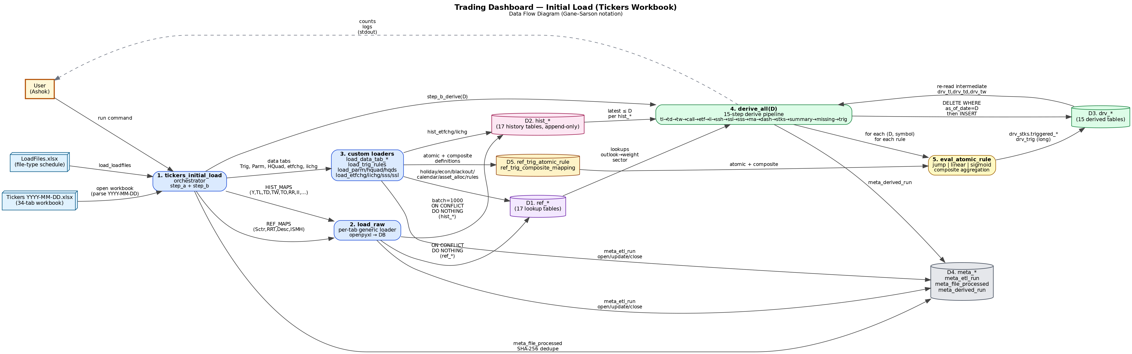
Process narrative:
- (1) The orchestrator opens the workbook, parses the date from the filename, registers in meta_file_processed, and decides which sub-loaders to run (gated by meta_etl_run).
- (2) The generic loader maps Excel columns to ref_* and hist_* columns via REF_MAPS / HIST_MAPS in `etl/mappings.py` and inserts in 1000-row batches.
- (3) Custom loaders handle non-rectangular tabs (Data, Parm, HQuad, HQds, Trig, etfchg, iichg).
- (4) derive_all(D) runs 15 derive_* functions in dependency order. Each is `DELETE WHERE as_of_date=D` then `INSERT`.
- (5) Atomic rules are evaluated against drv_ma columns; composite rules sum their contributions.

2. Ongoing load — DFD
Triggered automatically by `python -m etl.scheduler` (watchdog) or manually with `python -m etl.etl_load <file>`. One source-file produces one hist_* table refresh for that file's date plus a single derive_all rebuild for that date.
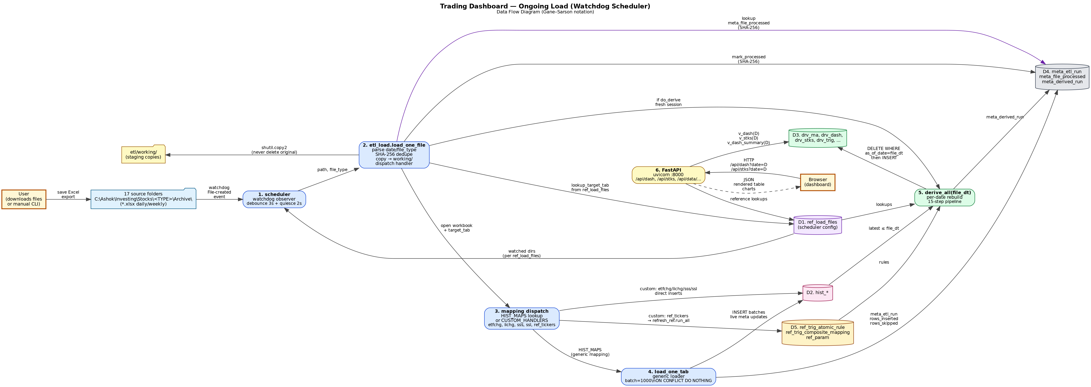
Key persistence and idempotency contracts:
- File dedupe by SHA-256 — same content, same path = no-op (status='skipped').
- Original files are never deleted or moved; only copied to etl/working/.
- Step-A inserts use ON CONFLICT DO NOTHING. Step-B derives use DELETE+INSERT scoped to as_of_date.
- FastAPI reads through SQL functions (v_dash, v_stks, v_ma, v_dash_summary, v_available_dates, v_rule_performance) so a date-locked snapshot is the contract between API and DB.

3. Component view (for context)
