Trading Dashboard
Design Document
Local web app + PostgreSQL replacement for the Tickers Excel workbook
Owner: Ashok (chashok@yahoo.com) · Version: code state of 2026-05-08 · Single-user, local

1. Purpose and scope
This document describes the design of the Trading Dashboard, a local-only web application that replaces a 34-tab Excel workbook (Tickers YYYY-MM-DD.xlsx) used to track daily stock data, run dozens of trading rules, and present a dashboard of recommended actions. It is the up-to-date authoritative description of how the system is built today — every behavior described matches what is in the source code as of 2026-05-08.
The intended audience is the project owner (operator), any future developer (or future AI session) picking up the project, and reviewers asked to evaluate the rule engine. Everything described here is implemented; deviations between this document and CLAUDE.md are explicitly called out at the end of each section.

2. Architectural overview
The system is a four-layer pipeline: ingest → normalize/derive → serve → present. Excel files arrive in 17 source folders. A Python ETL parses them into PostgreSQL hist_* tables. A second Python derive layer rebuilds the drv_* aggregates for the affected date. FastAPI exposes the drv_* and ref_* tables over JSON. A vanilla-JS frontend renders seven distinct views over those endpoints. There is no auth; the API binds to 127.0.0.1 only.

2.1 Component diagram
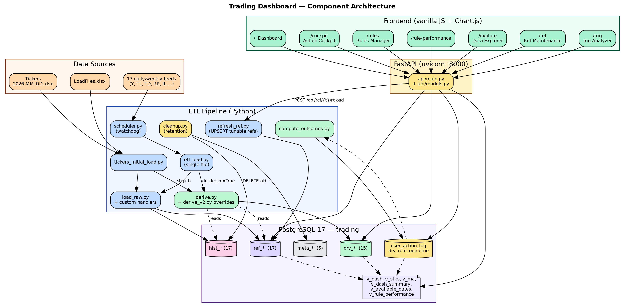

2.2 Technology stack
Layer | Component | Notes
Database | PostgreSQL 17 — `trading` | localhost:5432; ~60 tables across ref_*, hist_*, drv_*, meta_*, plus rule-engine-v2 additions
ETL | Python 3.11, openpyxl, SQLAlchemy 2 + psycopg v3, watchdog | Per-batch (1000-row) commits; ON CONFLICT DO NOTHING for hist_* and ref_*; DELETE+INSERT for drv_*
API | FastAPI 0.x + uvicorn | 127.0.0.1:8000; CORS=*; pydantic models in `api/models.py`
Frontend | Vanilla JS + Chart.js 4 (CDN) | Seven HTML pages served from `web/`; no build step
Config | pydantic-settings + .env | PG credentials, paths, retention; .env is gitignored
Scheduling | watchdog + Windows-style batch entry points | scheduler.py monitors 17 folders; setup.bat / start.bat are the operator UX

3. Source-code layout
Top-level structure of `C:\Ashok\Invest\Projects\trading-dashboard`:
api/ FastAPI app — main.py (~870 lines), models.py
config/ pydantic settings; reads .env
db/ 11 SQL DDL files (01..13) + init_db.py + reset_db.py
etl/ tickers_initial_load, etl_load, scheduler, load_raw,
derive (+derive_v2 overrides), refresh_ref, cleanup,
compute_outcomes, casters, db, mappings, excel_io
web/ index/cockpit/rules/rule_performance/trig/explore/ref
.html + .js (one page each), styles.css
docs/ this document, DFDs, AAPL trace, rules-engine design,
recommendations (generated 2026-05-08)
.env(.example), setup.bat, start.bat, README.md, CLAUDE.md, requirements.txt

4. Data model
Four families plus the rule-engine v2 additions. Naming is consistent: ref_* lookup data, hist_* raw history (append-only), drv_* derived (idempotent rebuild per as_of_date), meta_* operational/audit.

4.1 ref_* (16 lookup tables)
Table | Source / role | Notes
ref_sector | Sctr tab → ticker → sector / asset class | ~822 rows; PK=ticker
ref_rrt | RRT tab → RR-name ↔ Y-ticker ↔ TOS-ticker | PK=rr_name
ref_rule_desc | Desc tab → rule_code → description | ~45 rows
ref_holiday | US market holidays | PK=holiday_date
ref_econ_indicator | CPI / GDP / etc. | PK=indicator_date+indicator
ref_fed_blackout | Fed blackout windows | PK=start_date
ref_calendar_event | 31 categories of calendar events | PK=category+event_date
ref_quad_outlook / ref_quad_periods | Hedgeye-style Quad regime | two tables
ref_param | Simple key/value pairs from Parm tab | PK=sheet+param_name
ref_param_lookup | Multi-column lookups (W Vol Rule, BB Range, IV Action, BuySell, …) | PK=table_name+code
ref_asset_allocation | Per-asset-class targets | PK=category
ref_load_files | Drives ETL scheduler (17 file types) | PK=file_type+week_day+file_time
ref_ismh | ISM PMI history | ~10K rows; PK=for_month+index_name
ref_trig_atomic_rule | 115 atomic rule definitions (extended in v2) | PK=atomic_rule_id (Trig row #)
ref_trig_composite_mapping | Which atomics feed which composite | PK=composite_rule_code+atomic_rule_id
ref_settings | Seeded outcome thresholds (added in v2) | PK=setting_name; not currently consulted by code

4.2 hist_* (17 raw history tables)
Append-only. Each row is keyed by (snapshot_date, symbol[, sequence|account]). Loaded via `etl/load_raw.py` with `ON CONFLICT DO NOTHING`, batched 1000 rows. Includes `loaded_at` and `source_file` for traceability.
hist_y (snapshot_date, symbol, sequence) Yahoo daily quote
hist_tl (snapshot_date, symbol, sequence) TOS Latest (intraday)
hist_td (snapshot_date, symbol, sequence) TOS Daily
hist_tw (snapshot_date, symbol, sequence) TOS Weekly
hist_to (snapshot_date, symbol, sequence) TOS Other (Sunday)
hist_rr (snapshot_date, symbol) Risk Range
hist_call (snapshot_date, symbol) "Call" workbook (trimmed)
hist_etf (snapshot_date, symbol) ETF (trimmed)
hist_etfchg (event_date, symbol) ETF entry change history
hist_ii (snapshot_date, symbol) II indicator (trimmed)
hist_iichg (event_date, symbol) II change history
hist_ssh (snapshot_date, symbol) Signal Strength current week (trimmed)
hist_psrk / hist_ps5 / hist_pstn Friday rank/percent inputs
hist_f (snapshot_date, account_number, symbol) Fidelity holdings
hist_cs (snapshot_date, account, symbol) Schwab holdings
hist_call, hist_etf, hist_ii, hist_ssh are deliberately trimmed to raw imported columns; their derived columns live in drv_call, drv_etf, drv_ii, drv_ssh.

4.3 drv_* (15 derived tables)
Populated by `etl/derive.py` (with `etl/derive_v2.py` overriding tw/etf/ii/ssh/ps/sss). Idempotent: each derive function does `DELETE WHERE as_of_date=D` then `INSERT`. Each row carries `computed_at` and `source_run_id` for audit.
Table | Built from | Concept
drv_tl | hist_tl | vlm_projected, imp_volatility_clean
drv_td | hist_td history | BB band family, IV/HV percentiles, RSI variants, d_iv_to_hv, range_compression
drv_tw | hist_tw + history (v2) | weekly vol projection, MACD signals, weekly change
drv_call | hist_call + ref_param | outlook → weight → entry/cont action
drv_etf | hist_etf + ref_param (v2) | weekly + entry/cont action
drv_ii | hist_ii + ref_param (v2) | outlook → weight → entry/cont action
drv_ssh | hist_ssh (v2) | rank/signal/signal_sign + extras
drv_ssl | hist_ssh lag −7d | Signal Strength last week
drv_sss | hist_ssh + drv_ssl (v2) | Signal Strength Series with deltas
drv_ps | hist_ps* (v2) | Rebuilt percent-rank rollup
drv_ma | EVERYTHING above + ref_sector | ★ central wide row per (as_of_date, symbol). ~50 cols. Read by everything below.
drv_dash | drv_ma + section classifier | Dashboard rows. threshold_low/high/zone_signal currently NULL.
drv_stks | drv_ma + atomic + composite eval | Mirrors Stks tab. Adds composite_outlook, composite_label, triggered_atomic_ids JSONB, triggered_composite_ids JSONB.
drv_dash_summary | drv_ma + ref_econ + ref_holiday | KPI cards: BULL%, BEAR%, next econ, next holiday
drv_missing_symbols | hist_* − drv_ma | Tickers in some source but not in MA
drv_trig | drv_ma × ref_trig_* | ~70 composites × every symbol × date. Uses LEGACY bucket scoring (see §6).

4.4 meta_* (5 audit / operational tables)
Table | Purpose
meta_etl_run | One row per (file × table) load — started/finished, rows_read/inserted/skipped, status. Updated live during load.
meta_file_processed | Dedup by (file_path, file_hash). SHA-256.
meta_cleanup_policy | Per-table retention rules; consulted by cleanup.py.
meta_cleanup_history | Audit of every cleanup run.
meta_derived_run | One row per derive_* invocation.
Caveat: db/init_db.py truncates meta_etl_run, meta_file_processed, meta_cleanup_history, meta_derived_run on every run. Until that is changed, the dedup contract on subsequent ETL is broken (every file looks new again).

4.5 Rule-engine v2 additions
Table / column | Role
ref_trig_atomic_rule.scoring_mode / score_params / category / intent_text / deprecated_at | Per-rule metadata for jump | linear | sigmoid scoring and lifecycle
ref_trig_composite_mapping.precondition_expr / category / intent_text / deprecated_at | Per-composite metadata; precondition is read but not yet evaluated
drv_stks.triggered_atomic_ids JSONB / triggered_composite_ids JSONB | Per-row trace of which rules contributed and how much
user_action_log | User-clicked Cockpit decisions
drv_rule_outcome | Per-rule forward-return result (5d/20d, hit boolean)
v_rule_performance (view) | Rolling 180-day hit-rate aggregation
ref_settings | Seeded but unused threshold settings

5. ETL — initial load
Triggered by `python -m etl.tickers_initial_load`. The orchestrator opens the Tickers workbook, parses the YYYY-MM-DD from the filename as `snapshot_date`, computes a SHA-256, and registers a `meta_file_processed` entry. It then runs Step A (load raw) and Step B (rebuild derives for that date).

5.1 Step A — load raw
Step A is a sequenced dispatch over four collections:
- REF_MAPS — Sctr → ref_sector, RRT → ref_rrt, Desc → ref_rule_desc, ISMH → ref_ismh.
- Data-tab special cases — load_data_tab_holidays, load_data_tab_econ, load_data_tab_blackout, load_data_tab_calendar_events; load_parm (writes ref_param + ref_param_lookup + ref_asset_allocation); load_hquad; load_hqds.
- load_trig_rules → ref_trig_atomic_rule (PK = Trig row number 4..118) + ref_trig_composite_mapping.
- HIST_MAPS — Y, TL, TD, TW, TO, RR, II, ssH, psRk, ps5, psTn, F, call, etf, CS via the generic loader.
- Custom history loaders — load_etfchg → hist_etfchg, load_iichg → hist_iichg, seed_sss → drv_sss, seed_ssl → drv_ssl.
Each loader runs inside its own session_scope, opens a meta_etl_run record, commits per 1000-row batch, and closes the run with rows_read / rows_inserted / rows_skipped counters. _already_loaded() consults meta_etl_run so the script is resumable for individual tabs.

5.2 Step B — derive_all(D)
derive_all calls 15 derive_* functions in dependency order: tl → td → tw → call → etf → ii → ssh → ssl → sss → ma → dash → stks → dash_summary → missing_symbols → trig. Each function does `DELETE WHERE as_of_date = D` then `INSERT`, so re-running for date D produces the same numbers and never touches earlier dates.

5.3 Initial-load DFD
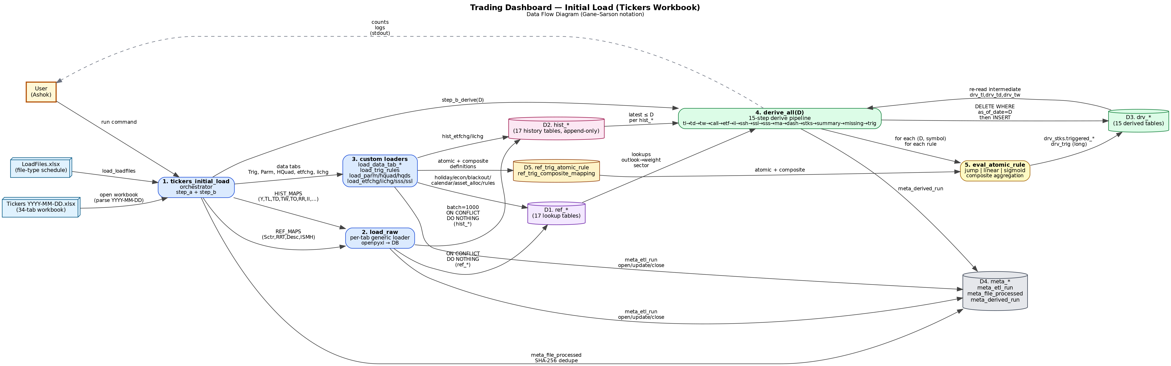

6. ETL — ongoing load
`python -m etl.scheduler` starts a watchdog observer over the 17 directories listed in `ref_load_files`. When a new .xlsx appears, the scheduler debounces 3 seconds, waits 2 seconds for the file to quiesce, then calls `etl_load.load_one_file(path)`.
`load_one_file`:
- Parses the file_dt and file_type from the filename; checks the file exists.
- Computes SHA-256 (`file_hash`).
- Looks up `target_tab` in `ref_load_files WHERE LOWER(file_type)=:ft AND enabled=TRUE`.
- Calls `already_processed(path, file_hash)` against `meta_file_processed`. If matched, returns status='skipped' silently.
- Copies the file to `etl/working/` (`shutil.copy2`); the original is never moved or deleted.
- Opens the working copy and dispatches: CUSTOM_HANDLERS for etfchg/iichg/sss/ssl/ref_tickers; otherwise scans HIST_MAPS for the matching `sheet == target_tab` and calls `load_one_tab`.
- Closes the meta_etl_run and `mark_processed`s in `meta_file_processed`.
- If `do_derive=True` and `file_dt` is non-null, opens a fresh session and calls `derive_all(s2, file_dt)`.

6.1 Ongoing-load DFD
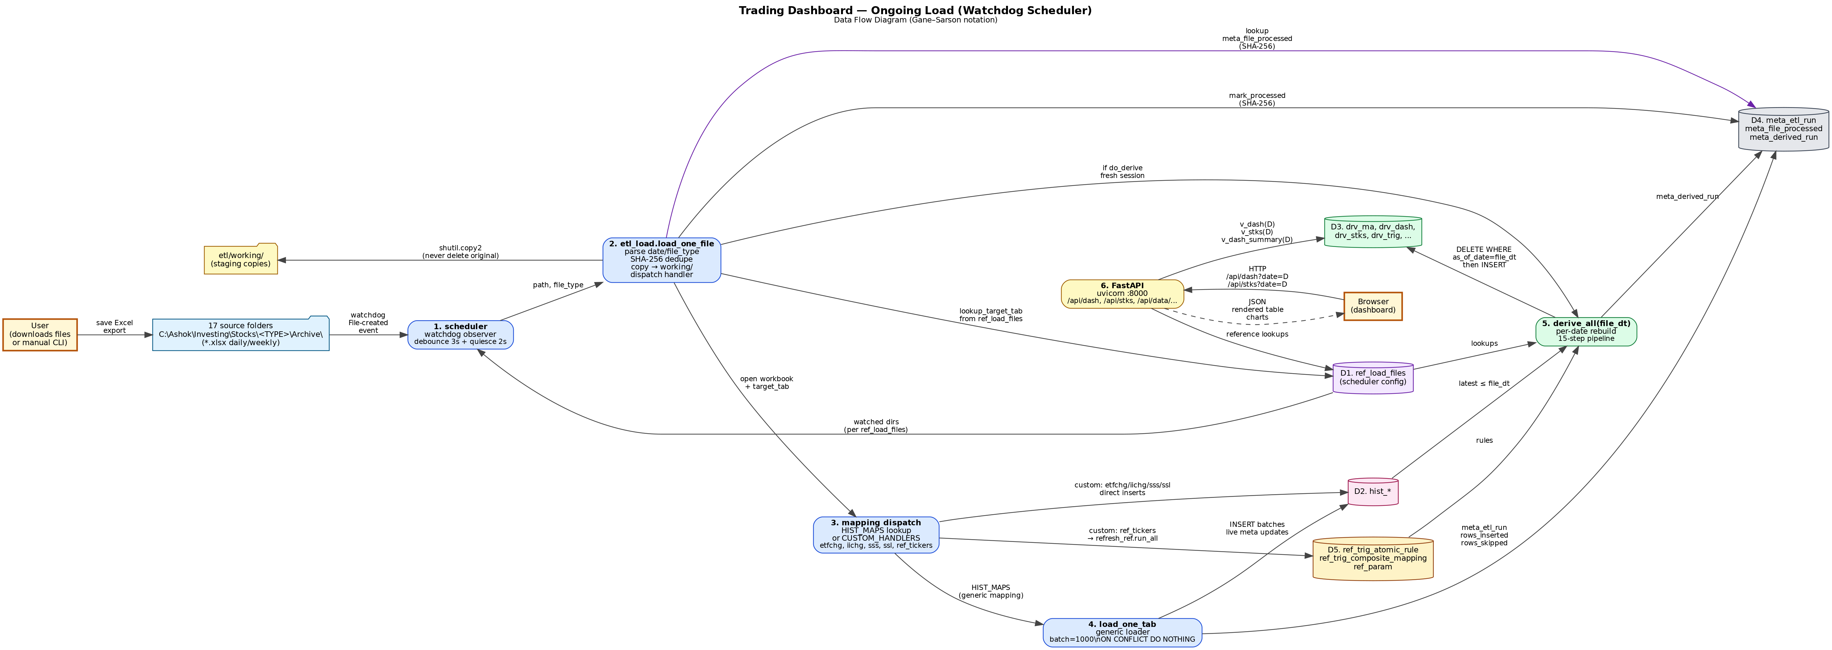

7. API surface
FastAPI app in `api/main.py`. CORS is wide-open (allow_origins=["*"]) and there is no authentication. Public surface today:
Method | Path | Backing source
GET | /health | SELECT 1
GET | /api/dates | v_available_dates
GET | /api/sectors | DISTINCT sector FROM drv_ma
GET | /api/dash | v_dash(:d) + section filter
GET | /api/dash/summary | v_dash_summary(:d)
GET | /api/stks | v_stks(:d) + sector/asset_class/min_brr/max_brr/outlook/limit
GET | /api/symbol/{sym}/history | drv_ma WHERE symbol=:sym
GET | /api/ref/tables | Counts each table in ALL_REF_TABLES; flags tunable from REFRESH_HANDLERS
GET | /api/ref/{table} | SELECT * with reflection metadata
PATCH | /api/ref/{table}/row | UPDATE with PK validation + bumps loaded_at
POST | /api/ref/{table}/reload | Excel upload; dispatches refresh_ref.run_one
POST | /api/ref/{table}/insert | pg_insert ON CONFLICT DO NOTHING; 409 on dup
GET | /api/data/tables | Table counts from DATA_TABLE_DATE_COL
GET | /api/data/{table} | Reflection-driven SELECT * with date filter family
GET | /api/rules/atomic | ref_trig_atomic_rule WHERE deprecated_at IS NULL
GET | /api/rules/atomic/{id} | Single atomic rule
GET | /api/rules/composite | DISTINCT ON(composite_rule_code)
GET | /api/rules/composite/{id} | Single composite rule
GET | /api/rules/composite/{id}/atomics | JOIN composite mapping + atomic
GET | /api/rules/performance | v_rule_performance, sortable
POST | /api/actions | Reads triggered_* from drv_stks → INSERT INTO user_action_log
GET | /, /cockpit, /rules, /rule-performance, /trig, /explore, /ref | FileResponse to web/<page>.html
— | /static/* | Static mount of web/
Known surface gaps: PUT/DELETE on /api/rules/atomic and /api/rules/composite are not implemented even though `web/rules.js` calls them. The Cockpit POST /api/actions writes Python repr() into the JSONB column and `compute_outcomes.py` later eval()s it back — both ends should be JSON, not Python literals.

8. Frontend pages
Path | Page | Key endpoints
/ | Dashboard | /api/dates, /api/sectors, /api/dash/summary, /api/stks
/cockpit | Action Cockpit | /api/dates, /api/sectors, /api/stks, POST /api/actions
/rules | Rules Manager (atomic + composite) | /api/rules/atomic, /composite[/atomics]
/rule-performance | Rule performance leaderboard | /api/rules/performance
/trig | Trig Rules Analyzer | /api/data/drv_trig
/explore | Generic table browser | /api/data/tables, /api/data/{name}
/ref | Ref-table maintenance | /api/ref/* (CRUD + upload)
Visual design uses a flat white-card system: background #f7f7f5, accent blue #1d4ed8, bull #15803d, bear #b91c1c, neutral #6b7280, warn #b45309. The `highlightKeywords()` helper colorizes long/short/bench and Bullish/Bearish phrases inside cells using six CSS classes (hl-long-primary/secondary/tertiary, hl-short-primary/secondary/tertiary, hl-bullish, hl-bearish).

9. Configuration and deployment
All credentials and paths come from `.env` (gitignored). The pydantic Settings class in `config/settings.py` exposes:
PG_HOST=localhost PG_PORT=5432
PG_DATABASE=trading PG_USER=postgres PG_PASSWORD=...
TICKERS_FILE=C:\Ashok\Invest\Cluade\Cluade\Tickers 2026-04-30.xlsx
LOADFILES_FILE=...\LoadFiles.xlsx
ETL_WORKING_DIR=C:\Ashok\Invest\Projects\trading-dashboard\etl\working
DEFAULT_RETENTION_DAYS=365
API_HOST=127.0.0.1 API_PORT=8000
Operator UX is two batch files: `setup.bat` (creates `.venv`, installs requirements.txt, runs `python -m db.init_db`) and `start.bat` (activates venv, starts uvicorn on 127.0.0.1:8000, opens the browser). The scheduler is its own long-running process: `python -m etl.scheduler`.

10. Non-functional requirements

10.1 Reproducibility
Every persisted row carries a snapshot/as_of_date. Re-running ETL or derives for date D never touches earlier dates. `meta_derived_run` records every rebuild, so the data lineage of any drv_* row can be retraced.

10.2 Resilience
Per-batch (1000-row) commits bound the worst-case loss on a crash to one batch. `ON CONFLICT DO NOTHING` on hist_* and ref_* makes loaders idempotent. `meta_file_processed` (SHA-256) prevents duplicate work — but `db/init_db.py` truncates that audit table, defeating the dedupe contract until the next ETL rebuilds it.

10.3 Performance
Read latency is dominated by the FastAPI handler executing a parameterized SELECT against a small (single-date) slice of drv_dash or drv_stks. With ~1,200 symbols and ~60 composite rules, a typical /api/stks call returns ~2,000 rows in well under 200 ms locally. Initial load runs in single-digit minutes; ongoing per-file loads are seconds.

10.4 Security
Localhost-only bind, no auth. CORS=* is benign because the API is loopback-only, but it would be a serious problem if the bind address ever changed. There is no rate limiting, no secrets manager (PG_PASSWORD lives in .env), and no audit of who edited a ref table — all CRUD writes attribute to a single user.

10.5 Observability
stdout for ETL (per-batch progress lines), `meta_etl_run`/`meta_derived_run` for structured audit, and FastAPI auto-docs at /docs. There is no centralized log file; the README mentions a `logs/` directory but it is not used.

11. Known divergences from CLAUDE.md (now reconciled)
CLAUDE.md was updated in this same workstream. The following discrepancies were found in the previous version and have been corrected:
- derive_v2 is the active implementation for tw/etf/ii/ssh/ps/sss; the original derive.py functions for those concepts are dead code (rebound at module load).
- drv_trig uses legacy `_bucket_weight`, while drv_stks uses `eval_atomic_rule` (jump | linear | sigmoid). The two tables can disagree on score for non-jump rules.
- Composite `precondition_expr` is read but the evaluator is a TODO (`pass`).
- Rules Manager UI calls PUT/DELETE endpoints that don't exist.
- POST /api/actions stores `str(triggered)` (Python repr) into a JSONB column; compute_outcomes.py uses `eval()` to read it back.
- Cockpit logs `'ACTED'/'SKIP'`, but `_determine_hit` only knows SA/STM/SS/BM/HOLD/SKIP. ACTED falls through to `hit=False`.
- compute_outcomes ignores ref_settings; thresholds are hard-coded.
- drv_dash threshold_low/threshold_high/zone_signal are always NULL.
- db/init_db.py truncates audit + dedup tables on every run.
- The old `00_migrate_split.sql` is gone; current DDL set is 01..13.

12. References
- Source: `C:\Ashok\Invest\Projects\trading-dashboard` (this design reflects code state of 2026-05-08).
- CLAUDE.md — operator quick reference.
- DESIGN_RULE_ENGINE_V2.md — original v2 design proposal (this document supersedes it for current state).
- FORMULA_AUDIT.md, FORMULA_FIXES_SUMMARY.md, TRIG_UI_GUIDE.md — narrative companions.

