Your Recycled Computer

Introduction

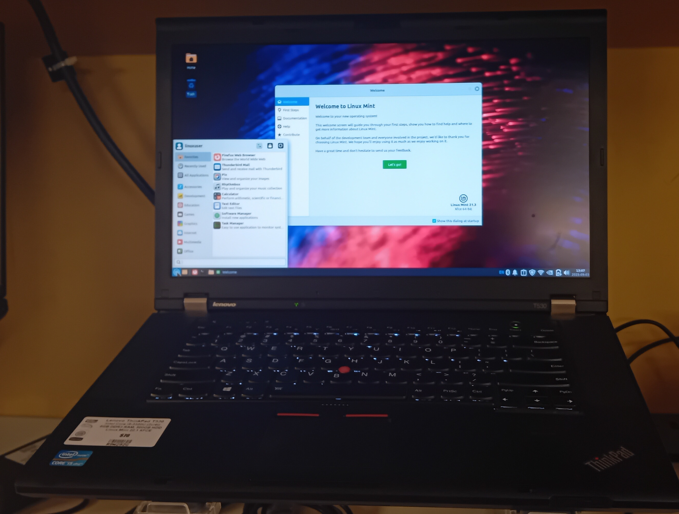Figure 1: Photograph of recycled Lenovo ThinkPad running Linux Mint 21.3 XFCE

The Password is...
Your computer has a Linux Mint login username, linuxuser, and a password of i<3Ubuntu. You don’t need to know these when you first turn on your computer, but you may need to know the password if the screensaver kicks in, when you install new software, or when you upgrade the software on your system. Again, the password is:

i<3Ubuntu

Note: it is important you type this password exactly as it is, with a capital U and small characters for the rest of the password.

Changing your password
You can change your password by clicking on the XFCE menu at the bottom left and typing Users into the menu search area. Click on the linuxuser user name, then click Change beside the password setting. You will be asked the current password, i<3Ubuntu, and then have to type the new password twice, once in new password, and once in confirmation. Click on OK to accept the new password. It’s important you write down the new password if you change it. Here’s space for a new password:

_______________________________________________

Quickstart
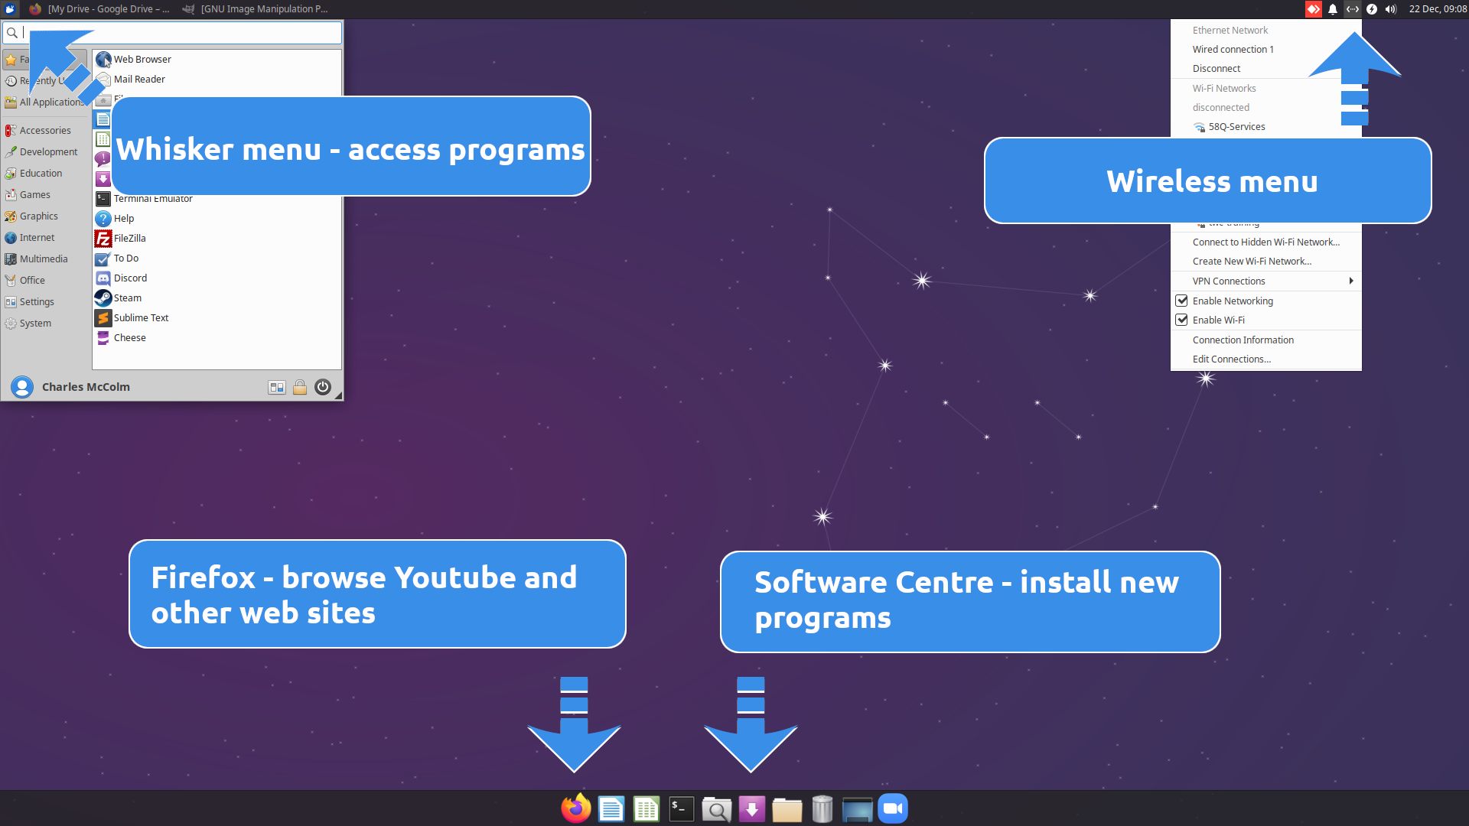
To access programs click the XFCE menu icon in the bottom left corner of your screen or click one of the programs on the panel at the bottom left of the screen (Firefox for example).
To connect to a wireless access point click the greyed-out icon that looks like up and down arrows in the top right of the panel at the top, then select your wireless access point and enter the password for your wireless access point. Secured wireless access points have a small lock on the wireless icon display. Once you are connected to a wireless access point the up and down arrows change to what appears to be a radio wave pointing up.
To browse the Internet first connect to your wireless access point (above) then click the Firefox (orange) browser button on the left of the panel at the bottom of the screen.
To add new programs and software to your computer first connect to the Internet, click the XFCE menu in the bototm left of the screen, then click Software Manager. (If you don’t see it, click Favourites in the XFCE menu first.) When you install a program through the Software Manager you will be asked for a password, this is the password mentioned at the beginning of this book, or if you’ve changed it, the new password you’ve set. Please be patient as software installs from the Internet. For more information about installing new software see Adding New Software – The Software Manager in this book.
Table of Contents
Introduction 1
The Password is... 2
Changing your password 2
Quickstart 3
Thank You! 5
Publishing Information 6
About Your Computer 6
Dispelling Myths 7
This is different 7
Some hardware may not be compatible 8
Linux Mint and XFCE 9
What is Linux? 9
Getting Started 10
The Desktop 10
Icons 11
Panel(s) 11
Workspace(s) 12
The Mint Menu 12
Users and Passwords 14
Folders and Files 14
File Manager – Thunar 15
File Manager – Devices and Places 16
My USB drive, CD/DVD won’t eject? 16
Adding New Software – The Software Manager 17
System Packages vs. Flatpaks 18
Other ways to install new software 18
Software from web sites. 18
Apt – via terminal / command line 18
Other methods for installing software 20
Flatpaks and AppImages 21
Common Software 21
We’ve added some additional software 21
LibreOffice 21
LibreOffice Writer - Create Stories, Résumés, and Books 22
LibreOffice Calc 23
LibreOffice Impress 24
Other LibreOffice programs 24
OnlyOffice - * extra 25
Firefox Web Browser 26
GNU Image Manipulation Program 26
Catfish – File Search 27
Cheese – Web cam tool - * extra 28
Dictionary – standalone Internet dictionary 28
Keyboard – Edit keyboard settings and application shortcuts 29
Steam – video game distribution / store - * extra 29
Xfburn – CD/DVD burning 31
Zoom – Online meeting tool - * extra 31
Explore Software Manager 32
Helpful Linux Resources 32
Youtube 32
Program Help Menu Option 32
KWLUG - Kitchener Waterloo Linux User Group 32
Paperback Books 33
Photographers & Writers 33
Programmers 33
Musicians 34
You 34

Thank You!
Thank you for buying a computer from The Working Centre’s Computer Recycling Project. By buying a computer from the project you are supporting a local, not-for-profit organization. Proceeds from your computer go to support community tools projects like:
- Computer Recycling
- Commons Studio
- Community Gardening
- The Green Door
- Recycled Cycles
- Worth A Second Look
- The Queen Street Commons.
Your computer has been prepared by volunteers, many of whom at one time were looking for a computer just like you. We hope you enjoy your computer and feel free to contact us with any questions you might have at: cr@theworkingcentre.org

Publishing Information
This book last updated: June 26, 2025.

About Your Computer
The first time you start your computer you might notice something different from previous computer experience you might have. Starting November 2020 Computer Recycling stopped installing and supporting Microsoft Windows on all our computers. Your computer comes with a distribution (flavour/type) of the Linux operating system called Linux Mint.

XXX FIXME: New screenshot with XFCE and Software Manager.
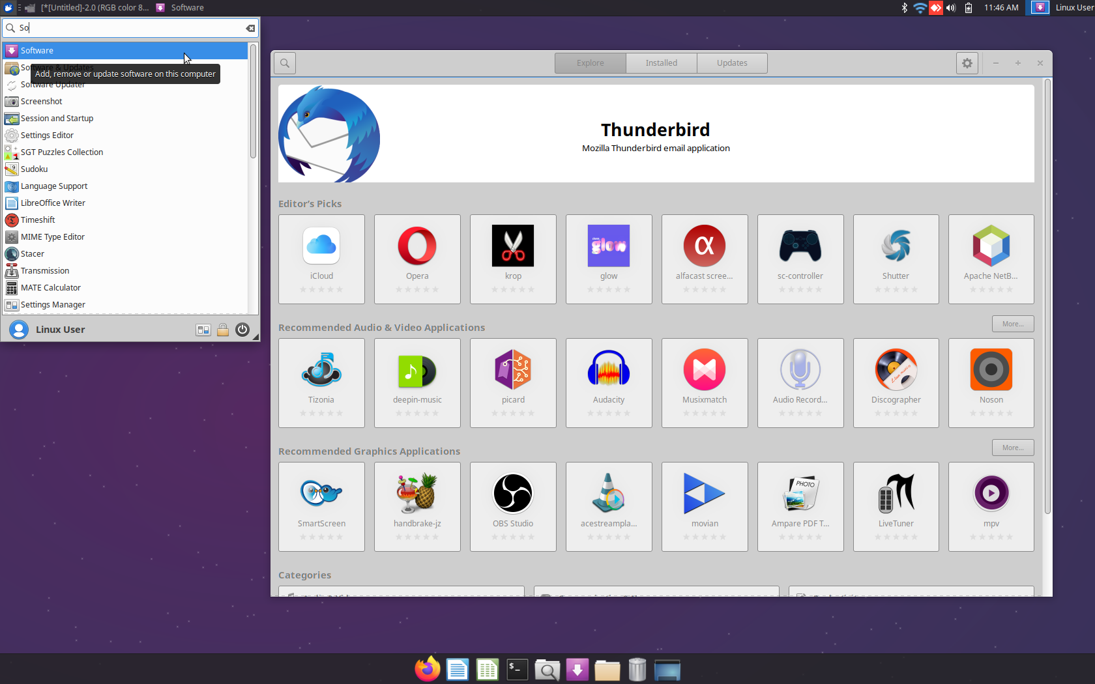Figure 2: Xubuntu 20.04 with the whisker menu and software centre open

There are many reasons why we chose to move away from Microsoft Windows, but a few of the reasons include: Microsoft’s trend towards offering software that needs to be paid for every month/year (Office 365 for example), Windows 11 doesn’t work on older hardware, and Windows updates seem to take longer and longer to install year after year.

But these are negative reasons not to use Microsoft Windows, and we really want to focus on the positive things that Linux Mint has to offer such as:
- When you update your computer, you update almost all the software on your computer (not just the core components).
- A lot of free software that you don’t have to pay for. (Not all software on Linux is free, but a lot of it is)
- Freedom, if you’re a programmer, or just want to know how a program works, you can often find the programming “source code” and make changes. You’re also free to share a lot of this free software with friends, and do so legally (unlike a Windows license, which cannot be legally shared).
- If you mess up your Linux Mint computer to the point you can’t use it anymore you can download Mint for free from https://www.linuxmint.com/download.php.
- You can install Linux Mint on as many computers as you want and you won’t be breaking the law, in fact you’ll be helping the community grow.
- The software, developers, and community are often more accessible than software written by a giant corporation – developers and community help is often available through email, Internet relay chat (IRC), or other methods.
- Linux Mint works well, even on old hardware, and supports a variety of hardware (scanners, printers, and miscellaneous cards) not supported by Microsoft’s Windows.
- Linux Mint is extremely customizable, you can make modify your desktop to look very different from the way it looks now.
- Prefer to work in another language? Linux Mint supports 79 languages!

Dispelling Myths

If you’ve heard of Linux, you may have heard it’s difficult to use, or made for experts. You may have even used a distribution of Linux before and found it difficult. The truth is that with a bit of effort and some customization Linux Mint can be very easy to use. Consider the following are true life example from our shop:

Several years ago a gentleman in his eighties came into Computer Recycling with a computer running Windows XP. The gentleman wanted to use Skype to communicate with his children overseas, but the version of Skype available for Windows XP would no longer work correctly on the Skype network. The gentleman also wanted to type in Russian and switch back to English easily. Windows 10 was not an option since his computer could not run Windows 10. He also didn’t have a large enough budget to buy a new computer.

Computer Recycling was able to help the gentleman by installing Linux, Skype, and adding an option to the panel/toolbar to allow the gentleman to switch languages just by clicking on a flag in the right hand corner.

After he tried the system he was in tears because he’d been so frustrated taking his computer to different computers stores, only to be told it wasn’t possible with his computer. He was finally able to communicate with his family after months of trying. Other places had told him his computer was too old, or that he’d have to spend several hundred dollars to fix the problem. In the end, Linux, free software, and a bit of help from us solved his problem.

This is different

Linux Mint is not Microsoft Windows. Although both operating systems sometimes have the same software installed (Firefox, Thunderbird, LibreOffice, for example) you cannot easily run a program from one operating system to another. In other words, Windows programs are designed to run on Windows, not Linux, and Linux programs are designed to run on Linux, not Windows.

Technically, there are ways to run Windows software on Linux, and vice versa, but it’s usually not an easy process (with the exception of Steam games) and the experience is often less than positive. It’s normally best to run software designed for one particular operating system on that operating system.

There’s a general exception to this rule: software designed to run on the world wide web (https://www.office.com/ for example) works well regardless of weather you’re running Microsoft Windows, Linux, or MacOS. Web apps normally just need a compatible web browser.

Some hardware may not be compatible

Linux Mint is actually pretty amazing with hardware, particularly old hardware. Sometimes perfectly good older hardware is thrown away simply because Windows doesn’t support it anymore. That hardware if often supported by Linux Mint and can be re-used, keeping one more piece of electronics out of the landfill.

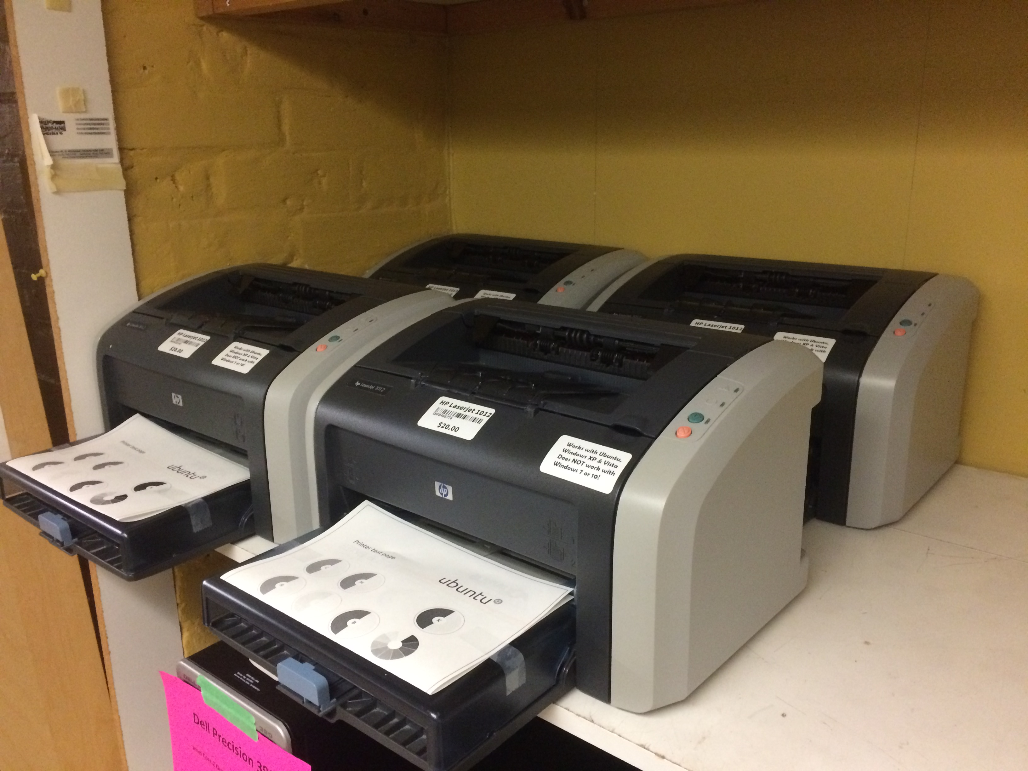Figure 3: Linux Mint compatible Laserjet printers

New hardware, and certain printers can sometimes be problematic to install, or just not work at all. Before you buy a new printer, scanner, or major hardware investment, you should check online to see if your hardware is supported by Linux Mint, or send us and email: cr@theworkingcentre.org.

Linux Mint and XFCE

You may have heard of Linux Mint before. Linux Mint is a distribution, a collection of software packaged and shared in a particular way, of the Linux operating system. Mint, Ubuntu, Fedora and Manjaro are all also distributions of Linux, but they include different software to make the system look, work, and feel different. Many of the tasks you can do in one of these distributions can be done in another. Often the biggest difference is the look.

The Computer Recycling Project chose Linux Mint over other distributions because it seems to work best with the combination of hardware we tend to get. Mint is also very customizable, it can be tailored to better suit specific needs.

The Computer Recycling Project uses the XFCE edition of Linux Mint. This means that the menu, windows, icons, and general look are from the XFCE project. This edition was chosen for its speed, range of hardware, and ease-of-use.

What is Linux?

“Linux is a family of open-source Unix-like operating systems based on the Linux kernel.” There are many, many, distributions (family members) of Linux. The fact that distrowatch.com has a top 100 of active Linux distributions shows just how many families of Linux there are. You might think this amount of fragmentation is a bad thing, but consider the following: most Internet routers run a distribution of Linux, many phones run Android (another distribution of Linux), there are distributions of Linux created for Medical professionals, Geographic Information System professionals, Internet Security Specialists, and many more specific-case use scenarios. Having a finely tuned system is often very good.

Getting Started

The Desktop
The desktop is the space in the centre of the screen where programs appear. Right clicking on an empty desktop space brings up a menu with several options. Some of the menu options have sub-options. If you want to change the wallpaper/background image right click on the empty desktop and select the Desktop Settings menu option.

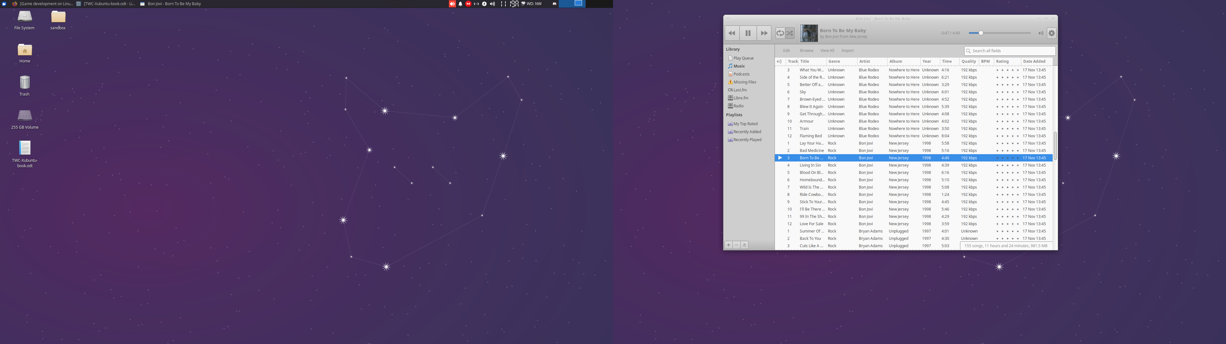Figure 4: Xubuntu Linux on across 2 monitors XXX FIXME: Replace with screenshot of Mint

If you right click on an empty space of the desktop you’ll get a menu similar to the menu shown below.

Options in this menu include:
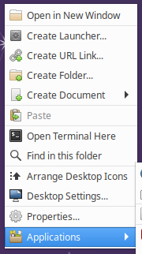Figure 5: Desktop menu
- Create Launcher – this option lets you create an icon that will let you launch a particular program stored on your system.
- Create URL Link – this option lets you create a shortcut on your desktop (or current directory) to a particular web site. When you click on the URL Link it will open Firefox, or whatever your default web browser is, and open the web site you’ve put in the URL Link.
- Create Folder – this option lets you create other folders on the desktop (or current directory).
- Create Document – this option lets you create specific types of documents. For Computer Recycling computers this includes LibreOffice Calc spreadsheets, LibreOffice Writer documents, plain text files, or an empty file.
- Paste – this option is normally greyed out unless you’ve copied something from another directory/folder. Paste, as the name suggests, lets you paste something copied from another folder.
- Open in Terminal – this option opens a Terminal command prompt in the current directory/folder.
- Search – this option lets you search the current directory/folder for files or other directories.
- Open in New Window – this option opens the desktop (or current directory) in the file manager.
- Arrange Desktop Icons – this option sorts your icons neatly.
- Desktop Settings – this option lets you adjust the Background image, menus and icons displayed on the desktop.

You can store files, folders, and links on the desktop. The background of the desktop can be changed by right clicking on an empty space on the desktop, choosing Desktop Settings, and then picking a different background image. This is also the space programs open up to.

Icons

Icons are pictorial representations of something on the desktop or in a folder. On systems from Computer Recycling there are a few Icons on the desktop including: Home, Trash, and any removable storage media. Double-clicking on an icon usually activates the icon. Right clicking on an icon normally gives you more options for the icon (for example: right clicking on the trash lets you empty the trash – if there are items in the trash).

Panel(s)
If you're used to Microsoft Windows you might have heard the term "Task bar" used to refer to the long strip at the bottom of the screen where the "start menu" and applications appear. XFCE refers to this kind of object as a "panel." In Mint there is a panel at the bottom of the screen for launching programs, switching between programs, and the "systray".
Like Microsoft Windows there is a start menu in Linux Mint, and when you open programs they appear in the panel.
Linux Mint is very customizable. It's possible to move a panel from the bottom to one of the sides or the top (you have to "unlock" the panel in Panel Preferences), change the look of the panel or add more panels.
XXX FIXME add image of bottom panel:
Figure 6: Bottom panel
To create a shortcut icon in a panel simply drag the icon for a program out of the XFCE menu and drop it on an unused area of a the panel. You should see a red line and a pop-up window that asks "Create a new launcher from 1 desktop file." Click "Create Launcher." Right clicking on the icon in the panel lets you look at the properties, move the icon, remove the icon (if you don't want it in the panel - this doesn't delete the program), or access other Panel options.
Panels are bars either across the top, bottom, or on the left or right of the screen. The version of Mint Computer Recycling installs includes a tpanel across the bottom of the screen. Panels hold menus, icons, information, and open applications. They can be customized to show only some or all of menus, icons, information, and open applications.

The bottom panel in the default installation of Linux Mint shows the XFCE menu icon, open applications, several icons that represent features (networking, power management, sound), and information (current date and time).

You can add more features to any panel by right clicking on an empty space in the panel, selecting panel, then selecting Add new Items and picking the feature you want. (in screenshot below: System Load Monitor, Weather, and Dictionary added)

Workspace(s)
It might seem difficult to understand at first, but a workspace is the combination of all the elements on the screen: the panel, icons, and desktop. Why mention workspace? It’s possible to have multiple virtual workspaces by adding a Workspace Switcher to the panel. The default Computer Recycling implementation of Linux Mint uses 4 workspaces. Switching between workspaces is easy, just press CTRL+ALT+LEFT or RIGHT ARROW.

The XFCE Menu
In the default installation of Linux Mint XFCE the applications menu is activated by clicking the round LM logo in the bottom left corner of the screen in the panel (You can also access the XFCE menu holding down the CTRL key and pressing the ESC key). The XFCE menu is organized into a number of elements:
At the bottom of the menu is a search field. You can type the name of programs installed on the system to quickly find them in the menu (for example: Firefox). Normally Linux treats capital letters much different from lower case letters, but in the case of the XFCE menu you can type the name of the program using either case.
FIXME: Replace with new Mint image.
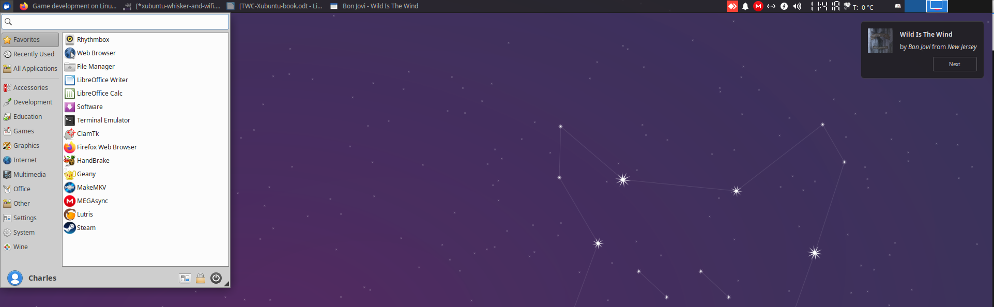Figure 7: Whisker menu
Above the search field on the left side are programs. When you first click on the XFCE menu it shows programs that are considered "Favourites" on the left side. If you move over slightly to the right of the listed programs you'll see that "Favourites" is selected from the menu. Below Favourites are the following categories:
- Recently Used - programs that have recently been launched
- All - all the programs the interface recognizes, this won't list every program installed on Linux Mint (it doesn't show command-line programs and may not show programs designed for other interfaces such as KDE/Plasma or Window Maker), but shows all the programs available in the XFCE menu system.
- Accessories - programs that are useful utilities such as compression programs, the file manager, a calculator, and text editor.
- Education - educational software, particularly useful for children, but also shows some advanced educational programs like LibreOffice Math.
- Games - Linux-native games of various types and qualities. On the Computer Recycling version of Linux Mint we've included 16 different games.
- Graphics - programs for viewing, editing, and transforming graphics of different types.
- Internet - web browsers, email clients, and other programs that are Internet-centric.
- Multimedia - programs for viewing, editing, and creating videos
- Office - office-related programs such as LibreOffice Writer, a calendar, PDF viewer, and dictionary.
- Settings - programs used to adjust different Linux Mint desktop settings.
- System - programs related to system operation such as a task manager and a script we included to easily change your password (you need to know the old password to change the password).
Your list of programs in each menu might vary depending on what other software has been added to the system through the Software Manager (or through the terminal/command line interface). Computer Recycling includes a different set of programs than the default installation of Linux Mint from https://www.linuxmint.com/ (so if you reinstall from linuxmint.com your list of programs may be different).
At the top right of the Mint menu are 3 small icons with the following functions:
- Logout
- Lock Screen
- All Settings
To the left of these icons is the full name of the user who is currently logged in (normally this says Linux User in our installation of Linux Mint. If you've set up your own user account this will say whatever you entered for the user's full name).

Users and Passwords
Before talking about the concept of users and passwords it’s helpful to have a bit of historical context about Linux. Linux is modelled after UNIX, a collection of software that started in 1969 as a system many people could work on. In order to keep separate work done by different people the concept of computer users was born. Every user has their own space on the system where they can store their files, access their own email, web bookmarks, and make their own customizations (wallpaper, themes, keyboard shortcuts, etc.).
In multi-user environments not all users should will have access to the same information. An accountant might store payroll information about a company that a graphic designer doesn’t need to know. In order to protect this information data is stored in separate directories (sometimes called folders) and users protect their user data by logging in with a password.

Folders and Files
Every user on a Linux system has a “home” folder. Folders are more commonly known as directories in computer lingo. A directory, or folder, is simply a structure that contains files and can contain other directories (folders). Files are normally organized with like files in the same folder. Photographs, for example, might be stored in a folder/directory called Photos.
On your Linux Mint system the home folder for each user typically contains a number of sub-folders:
- Desktop
- Documents
- Downloads
- Music
- Pictures
- Public
- Templates
- Videos
Files don’t automatically transfer to a folder based on the file type. If you download a photograph from the Internet it won’t necessarily end up in Pictures, normally items downloaded through Firefox end up in the Downloads folder, but this can be changed in the Firefox settings. The program creating or saving the file normally determines which folder/directory the file ends up in. For example: LibreOffice Writer, a document creation program, by default saves all documents to the Documents folder within each user’s home folder.

File Manager – Thunar
If you double click on the Home folder on your desktop a window opens up with a bunch of folders inside. If you look at the top of the opened window you’ll see your user name (linuxuser) followed by – File Manager. The File Manager is a program to organize files. In XFCE the File Manager is actually called Thunar (but this doesn’t appear at the top, the developers felt it simpler to call it File Manager).
You can click on the top of the File Manager and move the window by holding down the left mouse button and draging the window around. When you drag a window the mouse pointer changes to a closed hand. Drag the File Manager somewhere on the desktop so you can see the icons on the left of your system. Double click on the Home folder again and it opens up a second File Manager window. (If it appears there is only 1 File Manager window, drag the top of the File Manager window somewhere else, often the second File Manager window is behind).
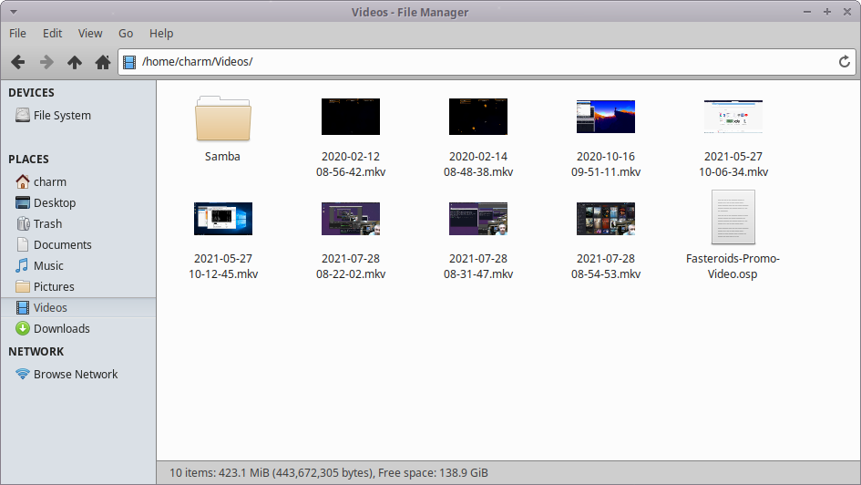Figure 8: Thunar – the main file management program in XFCE
With 2 File Managers open you can drag files and folders between them in order to reorganize your home folder. As with the Home folder, if you double click on a folder, like Downloads, the File Manager will open that folder.

File Manager – Devices and Places
On the left side of the File Manager is a side panel showing different shortcuts on the system. The shortcuts are organized under the titles Devices and Places. Devices list drives plugged into the system (including external USB storage drives, CD and DVDs put in the CD/DVD tray, and phones and tablets). Phones and tablets may not display if they’re not in a “mode” (usb mode) the File Manager recognizes.
An eject symbol (a line with an arrow pointing up) beside the name of a device indicates that the device is a device that can be “ejected” (safely removed) by clicking on the eject symbol beside the device name. Devices that can be ejected typically include external USB drives, CDs, DVDs, and any externally connected device that has storage.

My USB drive, CD/DVD won’t eject?
Sometimes the File Manager indicates that a device is busy and cannot be ejected. This often happens if a file on the device is open with another program. For example: you have a document stored on a USB drive that you currently have open in LibreOffice. To eject the USB drive you would first need to close the file in LibreOffice (or close LibreOffice) before the file manager would let you eject the USB drive.
When you click the eject button beside a CD/DVD the tray normally opens so you can grab the CD/DVD. Clicking the eject button beside a USB drive doesn’t physically eject it out of the USB port, it simply tries to close all files on the drive so it can be removed without damaging any files on the USB drive.
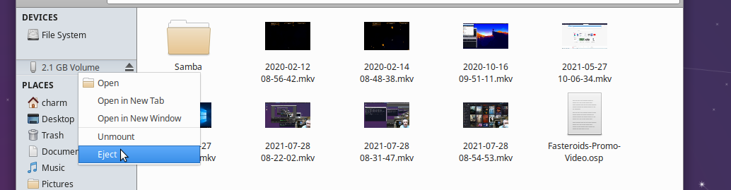Figure 9: Right click and select eject to safely remove a USB key or DVD
If you pull a USB drive out without using eject there’s a chance files or the drive may be corrupted. Always eject a USB drive before removing it. If after all this you cannot eject the drive, try restarting the computer and then ejecting the drive.
For more information on how to use Thunar, the File Manager in Linux Mint XFCE see this video on Youtube: https://youtu.be/k2lHzOHGz1w

Adding New Software – The Software Manager

Just as Apple’s MacOS has the Mac App Store and Windows 11 has the Microsoft Store, Linux Mint’s primary way of adding new software is through a program called Software Manager. Clicking the XFCE menu and typing software into the search bar displays Software Manager icon in the applications area. Clicking on the Software Manager icon brings up Software Manager. The Software Manager is dependent on an active Internet connection. You should be connected to the Internet before you start the program.

Software Manager displays an array of different programs when first loaded. An important part of Software Manager that often gets overlooked is the top half inch of the program where the search box and a menu are.
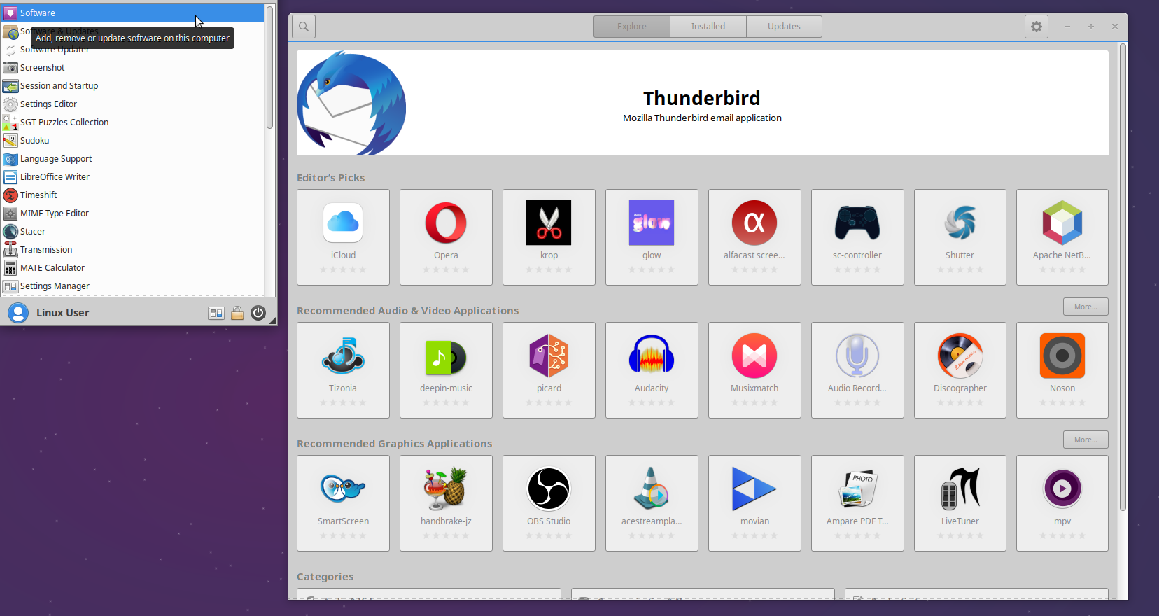Figure 10: Software Centre XXX FIXME: Update for Mint Software Manager

Clicking on the search icon in the top left of the Software Manager window opens up a search bar below where you can type in the name or concept of a program (accounting for example). Results will be displayed below.

When the Software Manager is loaded it displays 3 sections, Featured, Categories and Top Rated. The featured software shows popular and easy to use applications you may want to enjoy on your Linux Mint Recycled Computer. The categories section is where you can find thousands of free and open source applications and games organised to be easy to find. The Top Rated section shows packages that have been top-rated by the Linux Mint community, to help you find quality software that others find useful.

To install a program, click on the program’s icon, you’ll be re-directed to a screen containing information about the program (often screen shots, a brief description which sometimes contains helpful information about setting up a program), and an install button. Clicking on the install button brings up a dialog box that asks you to Authenticate. Authenticate in this case means enter your password in order to install the program. Entering a password ensures you really want to install the program and prevents software from just getting installed on your computer without your input (for example, via a malicious web page).

System Packages vs. Flatpaks
Software Manager lets you install both system packages and Flatpaks. System packages are packages that are integrated with the Linux Mint system and may be slightly more reliable. Flatpaks are less formal and often have newer versions, but generally use more disk storage space. (That’s generally not an issue.) It’s okay to install either or both.
Snaps do not work on Linux Mint.

Other ways to install new software

There are several other ways to install software on Linux, Mint but the best way is often through Software Manager. Installing through Software Manager ensures that when the system gets updated, any pending updates for other programs also happen.

Software from web sites.
Some web sites have versions of programs that you can install on your Linux Mint system. If the software is available in a .deb (Debian) package format it can be installed in Linux Mint. (Skype for example is available in Linux DEB format) Many programs on the Internet are not available in .deb format, and are only available for Microsoft’s Windows, but increasingly more and more software packages are available for Linux.

We generally don’t recommend installing programs from web sites unless you absolutely trust the web site. Another problem with .deb packages is that the programs offered by web sites through .deb packages sometimes depend on other programs (called dependencies). While .deb packages can be configured to install those other packages programmers sometimes get very lazy and don’t set up this part of a deb package, so it ends up not installing correctly. If a program is available in Software Manager it’s best to use the Software Manager version than a web version (unless you absolutely need the latest version of a program).

Apt – via terminal / command line
A terminal is a window that opens to a text screen where you can enter commands to give to your Linux Mint system. At first the terminal might seem scary, but once you learn a few tricks (and sometimes break a few things) you find it’s a really fast way to update your computer, install new programs, or automate tasks. To open a terminal window click the XFCE menu icon in the bottom left, and click the Terminal Emulator icon in the Favourites section of the XFCE menu. (tip: you can also hold down the Windows key and press T to open a Terminal window). In the terminal window you will see a prompt – the command line. The command line is, as you might expect, where you enter commands. One of the commands you can use in the terminal is a program called apt. Apt can be used to search for software:

apt search accounting

Apt can be used to install software

sudo apt install homebank

In the above example we have to put the word sudo (think super user do) in front of apt because we are going to make a change that affects the system (installing a program).

XXX FIXME: Check to see if above image is up-to-date.
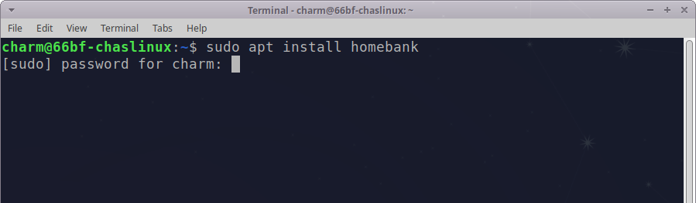Figure 11: Installing Homebank software from a terminal using the apt program

The command above installs homebank, a program for managing personal finances. In order to install any software on your computer you have to enter your password. On systems sold by the Computer Recycling Project this will be the password noted near the front of this book. You might also notice the prompt says password for linuxuser instead of password for charm. Charm is simply the username I gave my account when setting up Linux from an original disk. Don’t worry about the difference for now as it doesn’t affect how you install software.

After you enter the password and press enter you may see another prompt asking if you want to continue. This happens when a program you install, like homebank, needs to install other programs or “libraries” in order to install. For homebank apt tells us “The following additional packages will be installed: homebank-data libofx7 libosp5.” If we say yes to the continue prompt apt will install 4 things: homebank, homebank-data, libofx7, and libosp5. Homebank is our main progra, homebank-data contains some data files used by homebank, and libofx7 and libosp5 are “libraries” homebank needs to provide compatibility with some standard banking formats. What’s important to know is that sometimes a program needs a few other programs in order to install. These other programs are sometimes called dependencies.

Some programs have 0 dependencies, while others may have many dependencies. If you install programs through Software Manager you don’t see the dependencies a program needs to install, Software Manager just installs the dependencies in the background.
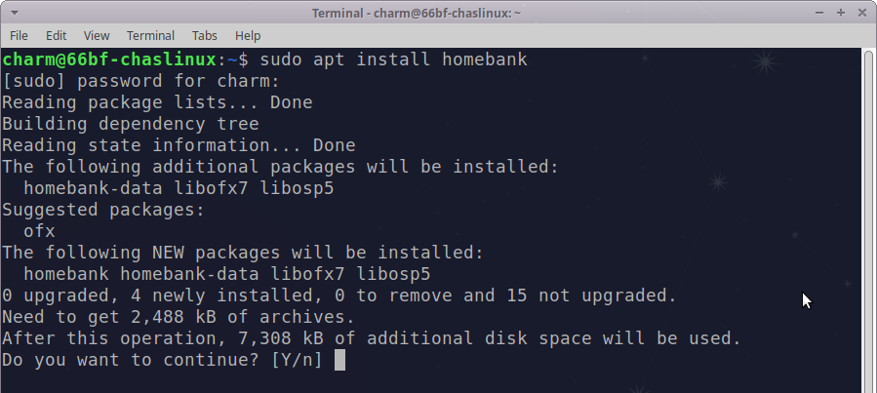Figure 12: Homebank needs other programs to continue the installation

If you just type apt on the command line and press enter apt will display other commands that can be used with apt. Another handy option for apt is the show option. Show will display similar types of information about a program that you might see in Software Manager. Try typing the following into the terminal:

apt show homebank

If you’ve typed this correctly you should see that the maintainers are Ubuntu Developers, the original maintainer was Francesco Namuri (along with email addresses), the size of Homebank when installed, programs Homebank depends on (apt installs these automatically), as well as the web site, a description of Homebank and several other details.

Apt can also be use to update your whole system with two separate commands:

sudo apt update
sudo apt upgrade

The first command goes to the Internet and updates the system with information about what updates are available currently. The second command actually does the updates.

When you’re done with apt you can just close the terminal by clicking on the x in the top right corner of the terminal window or typing exit on the command line.

Other methods for installing software

There are several other methods to install programs that we won’t mention in-depth here. Compiling from source code involves getting the actual code for a program and turning that code into a run-able program. Why would you want to do this? If you have some programming skill you can add features to a program, or change something you don’t like about the program. Compiling a program is complicated and beyond the scope of this document, but it’s possible on Linux Mint.

Flatpaks and AppImages

Flatpaks and AppImages require a bit more effort to get going. More information about Flatpaks and AppImages are available from:
- https://flatpak.org/
- https://appimage.org/

Software is also sometimes distributed by PPA, Personal Package Archive, which usually involves adding a new “source” to the “software repositories” (where Linux Mint looks for software). Software Repositories are normally strictly controlled by the Mint and Ubuuntu teams. PPAs, or Personal Package Archives, are repositories controlled by individuals. It’s important that you trust the individual before you add a PPA to your software repositories because software added through a PPA has heightened access to the system areas of your Mint installation.

Common Software

We’ve added some additional software
If you download and install Linux Mint from https://www.linuxmint.com/ you’ll notice some differences from the version of Linux Mint the Computer Recycling Project installs on systems. Besides some simple visual differences we’ve added a few extra programs that are not included with Mint “out of the box.” We do this so people who get computers from our project have software that better helps them accomplish the tasks they need. Where we’ve added extra software we’ve noted it by adding * extra to the end of the title. This list isn’t a comprehensive list of all the software, but software most commonly used.

LibreOffice
LibreOffice is a suite of several programs:
- LibreOffice Writer – useful for creating long documents, or short documents like résumés. LibreOffice Writer is an alternative program to Microsoft Word. Using the save as feature you can save LibreOffice Writer documents in Microsoft Word-compatible format. LibreOffice Writer can also create PDF documents simply by clicking on a PDF icon.
- LibreOffice Calc – useful for creating spreadsheet documents. LibreOffice Calc is an alternative program to Microsoft Excel. Like LibreOffice Writer you can create PDFs with one click on a PDF icon within the program.
- LibreOffice Impress – useful for creating presentation documents. LibreOffice Impress is an alternative program to Microsoft PowerPoint.
- LibreOffice Draw – useful for drawing diagrams, or creating vector-based artwork. LibreOffice Draw combines some of the features of Microsoft’s Visio program, but it also adds a stronger drawing element, and can be used to edit PDF documents. We sometimes use LibreOffice Draw to create PDF forms (forms that can be filled in).
- LibreOffice Math – useful if you need to add complex math to your documents. LibreOffice Math has no Microsoft equivalent.
- LibreOffice Base – not installed by default, LibreOffice Base is available in Software Manager and is similar to Microsoft Access (but they are not very compatible). If you need to create database applications quickly and visually LibreOffice Base is a good place to start.

LibreOffice Writer - Create Stories, Résumés, and Books
LibreOffice Writer is for creating text documents such as résumés, stories, advertisements, and books (this document was put together using LibreOffice Writer). LibreOffice Writer has some handy tools like the ability to create and update a table of contents with relative ease.

LibreOffice Writer is also great for copying and pasting content from world wide web pages. Sometimes a web page doesn’t print very nicely, by selecting all the content on the web page and pasting it into LibreOffice Writer you can clean up the web page before printing, save it as a PDF, or change the look of the document before printing.

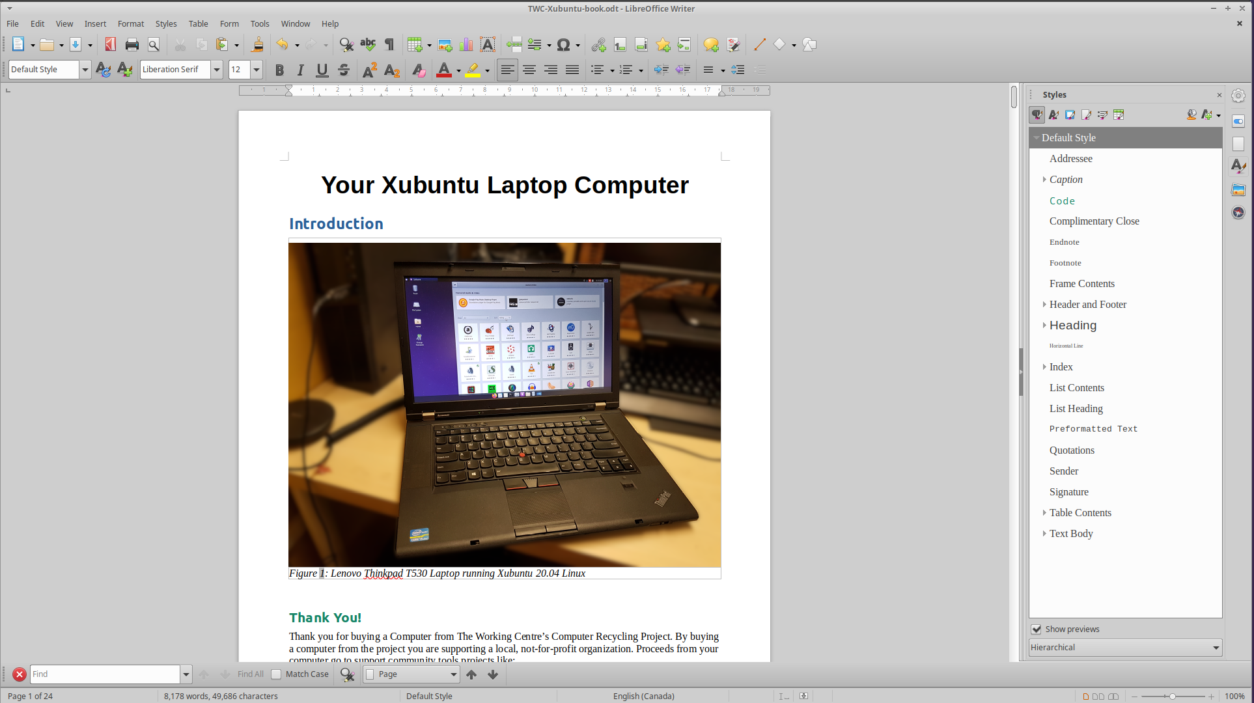Figure 13: LibreOffice Writer
LibreOffice Writer looks a bit like an old version of Microsoft Word. While it’s possible to make recent versions of LibreOffice Writer look more like Microsoft Word (follow this video if you want to change to the ribbon look: https://www.youtube.com/watch?v=5jKuz4sNugo) we find the old look less complicated.

Want a quick start introduction to LibreOffice Writer, check out Nerd On The Street’s Getting Started With LibreOffice Writer: https://www.youtube.com/watch?v=4RiUYjIZEug&t=252s.

One important difference between LibreOffice Writer and Microsoft Word is the format these two programs save files in. LibreOffice Writer saves in OpenDocument Format. Files saved with LibreOffice Writer normally end it .odt (opendocument text). The OpenDocument Format is important in that the format is an “open format” which guarantees long term access to data without legal or technical barriers. Practically this means that no company or organization can simply cut off your access to your data by restricting the format.

In the past Microsoft Word used the proprietary binary .doc format. The format was developed by Microsoft and initially quite restrictive. As with other proprietary binary formats it was possible for the developer (Microsoft in this case) to close off the format to other developers, and to restrict its use by users. Later versions of Microsoft Word use a .docx format, also developed by Microsoft, but as a less restrictive Office Open XML format. (Note: this is NOT the same as the Apache Open Office software which also uses the OpenDocument Format).

Both modern formats are open, however they differ in the implementation of XML. For more information on each format you can refer to their Wikipedia pages:
- OpenDocument - https://en.wikipedia.org/wiki/OpenDocument
- Office Open XML - https://en.wikipedia.org/wiki/Office_Open_XML

LibreOffice Writer can also save to PDF format, however it’s important to know that PDF documents are normally not meant to be edited. The advantage of sending a file in PDF format, over .odt or .docx is that the PDF will look the same on any computer it’s sent to. Fonts, styles, and borders in a PDF document will look identical. PDF is a good format to send in if you’re sending a final document, like a résumé, to an organization.

LibreOffice Calc
LibreOffice Calc is the spreadsheet component of LibreOffice. It resembles Microsoft Excel, and contains many similar features.

For a thorough comparison between LibreOffice and Microsoft Excel see the Document Foundation’s comparison at: https://wiki.documentfoundation.org/Feature_Comparison:_LibreOffice_-_Microsoft_Office.

If you’ve never used LibreOffice Calc or spreadsheets before check out DCP Web Designers’ LibreOffice Calc Tutorial (this tutorial is done on the Microsoft Windows version of LibreOffice Calc, but everything done in the video can be done in the Mint version): https://www.youtube.com/watch?v=9VSdwWRrx8k&list=PLRpn_0jbcintTnKYPFW8D7Lg4UgAoX8kZ&index=17.

DCP Web Designers have created several other LibreOffice Calc tutorials on their Youtube channel. Check out the playlist for a complete list of LibreOffice Calc tutorials covering topics such as creating bar charts, pie charts, sorting columns, removing duplicates, adding borders to cells, calculating averages and more: https://www.youtube.com/playlist?list=PLRpn_0jbcintTnKYPFW8D7Lg4UgAoX8kZ.

At the Computer Recycling Project we regularly use LibreOffice Calc to create spreadsheets of equipment and resources.

LibreOffice Impress
LibreOffice Impress is the LibreOffice answer to Microsoft PowerPoint.

For a quick introduction to LibreOffice Impress see The Frugal Computer Guy’s series of LibreOffice Impress tutorials on Youtube: https://www.youtube.com/playlist?list=PLy7Kah3WzqrHun-wvFV7hGO-Tyeh2w686.

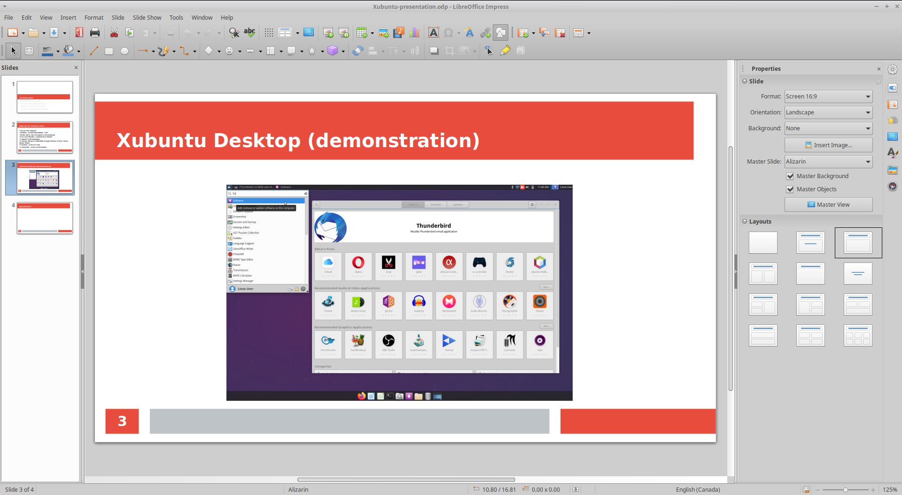Figure 14: LibreOffice Impress with a small presentation

Other LibreOffice programs
The LibreOffice suite contains a number of other programs: Draw, Math, and Base. These programs are less commonly used than the programs listed above. Draw is commonly used to draw vector-based graphics and create work-flow charts. Math is for creating complex math equations. LibreOffice Base is for creating visual databases. For the sake of brevity we’re leaving you to discover these programs.

OnlyOffice - * extra
Starting February 2022 the Computer Recycling Project started adding OnlyOffice to Linux Mint computers we build. Since this is a new installation it may not be on every computer purchased from Computer Recycling. OnlyOffice looks a lot closer to Microsoft Office “out of the box” and it also saves in OOXML (.docx, .xlsx, etc.) by default, making it easier for people to share documents with people using Microsoft Office. OnlyOffice lacks some of the programs and features of LibreOffice, but the user interface is simpler and should feel more familiar to those with Microsoft Office experience. Unlike LibreOffice the suite of OnlyOffice applications are integrated into one runnable program called OnlyOffice Desktop Editors.
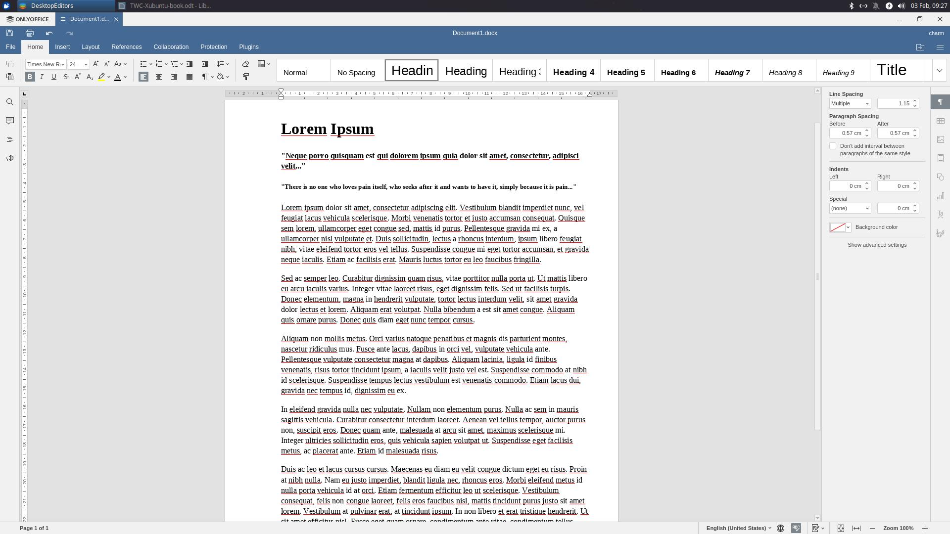

Firefox Web Browser
Firefox is the main web browser in Linux Mint. Recent versions of Firefox include enhanced tracking protection to protect end users from company trackers.
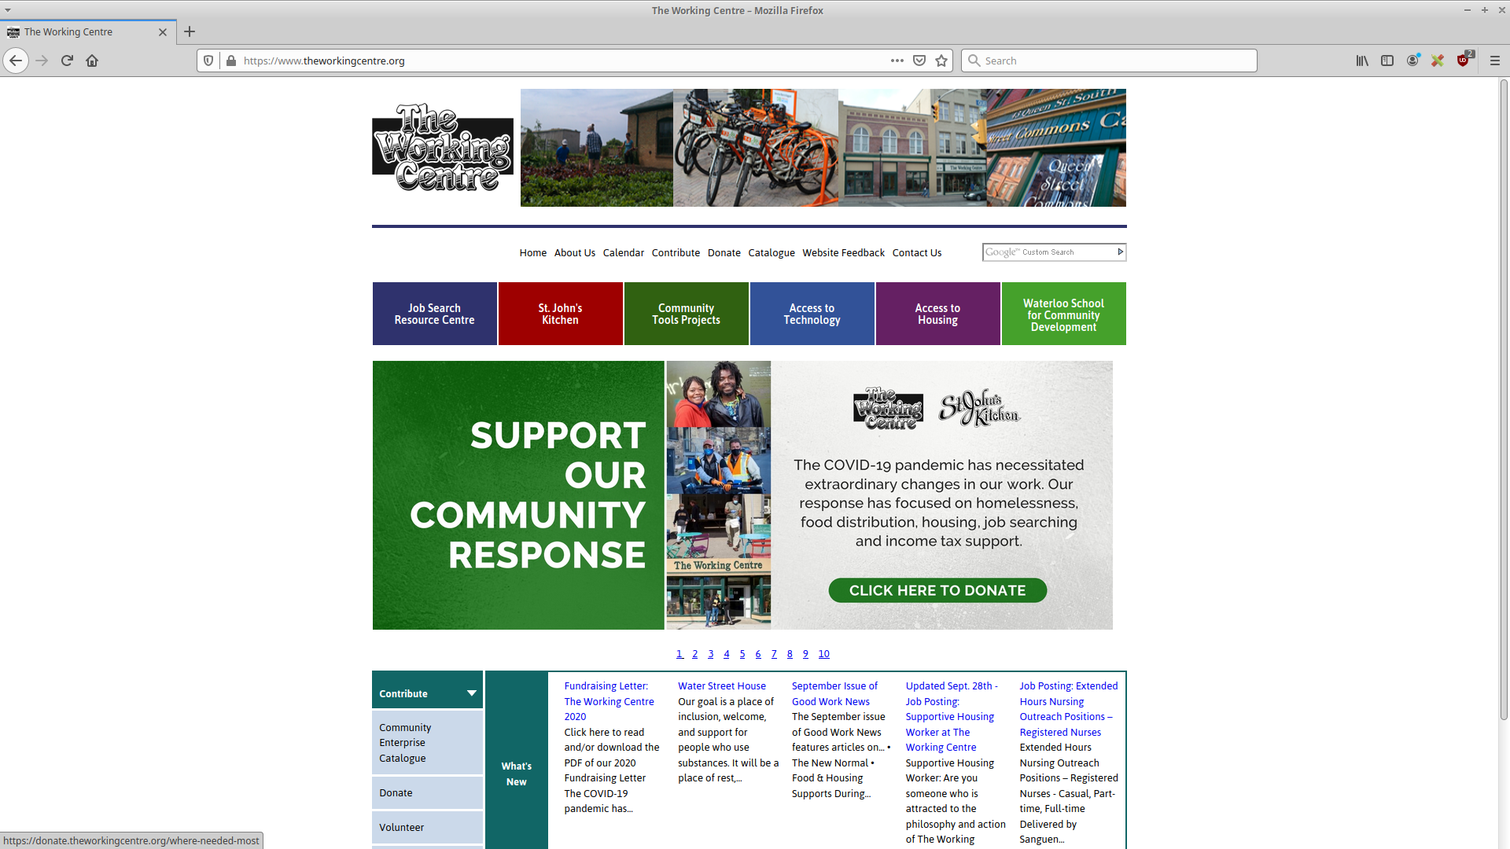Figure 15: The Firefox web browser

The latest versions of Firefox also include Firefox Lockwise, a password manager that makes it simpler to have a wide variety of different passwords for different web sites. Firefox Lockwise can autogenerate long passwords, so you don’t have to come up with complicated passwords for every site.
As with other Linux software, Firefox is customizable with man add-ons and themes. Prefer to work in a dark mode? There’s a theme for that.

While Google Chrome is available for Linux Mint, security experts generally recommend against using Chrome because large parts of Google Chrome are proprietary closed source software and Google uses user data to shape advertising. For more information about concerns over Google Chrome see the ProPrivacy article Can you trust Google Chrome with your data? https://proprivacy.com/guides/can-you-trust-chrome

GNU Image Manipulation Program
The GIMP, or GNU Image Manipulation Program, has been the #1 image editing program on Linux for many years. GIMP is the closest Linux alternative to Adobe’s PhotoShop.
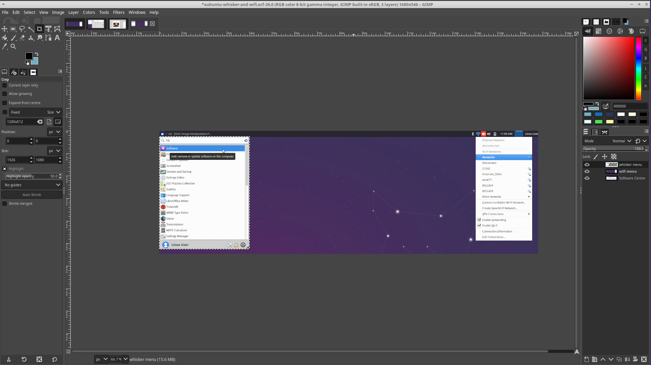Figure 16: The GIMP - The GNU Image Manipulation Program

While GIMP is missing some of the functionality of Adobe’s PhotoShop, there is no fee to use GIMP, and GIMP is powerful enough that it’s usable in a professional capacity.

One of the best resources to learn GIMP are the Youtube videos produced by Davies Media Design: https://www.youtube.com/user/DaViesMediaDesign

We’ve used GIMP at the Computer Recycling project for over 15 years. With a bit of skill and practice GIMP can be used to transform photographs into amazing pictures, or create professional works of art.

Catfish – File Search
Catfish is a simple file search program. You don’t have to know the entire name of a file in order to find it, you can search by entering part of the name of the file and pressing enter. Catfish searches recursively, meaning that it will search any directories/folders below the “top level folder.” The top level folder is the folder name to the left of the search bar. When Catfish starts the top level folder is usually the current user’s home folder. In The Working Centre installation of Linux Mint this is normally the linuxuser folder.

Cheese – Web cam tool - * extra
Cheese is a simple tool for taking pictures and creating simple videos with a web cam. Cheese is not compatible with all web cams. If you find your web cam doesn’t work with Cheese we recommend trying the more advanced guvcview tool.
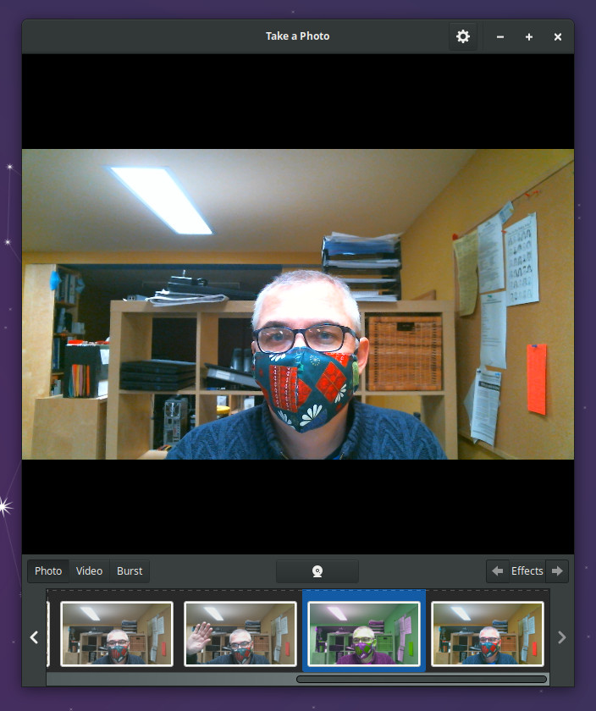Figure 17: Cheese webcam software

Cheese can take photos in photo or burst mode. Burst mode takes several photograms (you can set the amount by clicking on the cog wheel in the top right of the Cheese window) over a few seconds.

You can also add Effects, filters that apply on top of a photograph, by clicking the Effects button near the bottom right, and selecting an effect (Hulk for example). Photos taken by Cheese are shown in a photo strip along the bottom of the Cheese interface.

Right clicking on any photograph lets you open the photograph in the default image editor (ristretto image viewer), save the image as some other name or format, move the image to the Trash, or delete it completely off the system (without moving it to the Trash).

Dictionary – standalone Internet dictionary
The dictionary program is exactly as it sounds, a program to look up definitions of words on the Internet. To look up a word simply enter it into the search field and click the Find button.

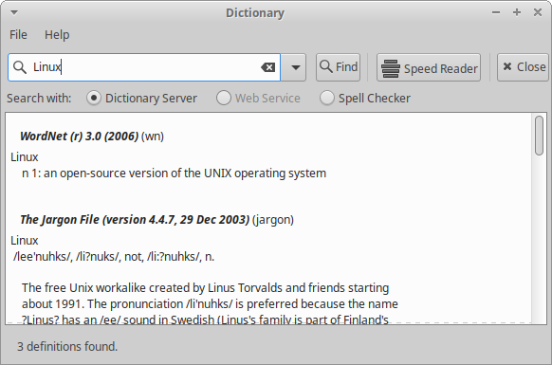Figure 18: Dictionary
Dictionary can also help you learn to read faster. If you click the Speed Reader button beside the Find button dictionary will open a dialog box where you can paste in text and set how many words per minute you’d like to display as well as how many words get displayed on the screen at one time. The font size can also be adjusted to be smaller or larger. Paste any text into the open field, or click the Folder icon beside the open field to import a text file. Files need to be in plain text format (LibreOffice formatted or Microsoft Word-formatted documents need to be converted to plain text before they will work with Dictionary).

We recommend checking out the many free texts at Project Gutenburg: https://www.gutenberg.org/

Keyboard – Edit keyboard settings and application shortcuts
The keyboard application lets you adjust the characteristics of the keyboard and cursor, set the application shortcuts, and adjust the style of keyboard (this comes in handy if you have an unusual keyboard such as the Happy Hacking keyboard).

The Application Shortcuts tab is particularly useful as it displays key combinations that can be used to launch programs (without going to the menu). The “Super” key referred to the key with the Windows symbol on it. Hold down the Super/Windows key and press W – Firefox launches.

Steam – video game distribution / store - * extra
Steam is an online video game distribution program. When you first run Steam you will be prompted to create a Steam account. Once you’ve created an account and verified the account you will be able to buy paid Steam games or install some of the free Steam games. It’s worth mentioning that you don’t have to buy a Steam gift card, or add a credit card to use Steam, as long as you’re only installing free Steam games you don’t have to worry about adding money to your Steam Wallet. If you want to buy a paid game various stores sell “Steam gift cards” that can be used to add money to your Steam virtual wallet. It’s also possible to add money through a credit card. This document won’t go over how to add money to a Steam Wallet since there are many Youtube videos on the topic.

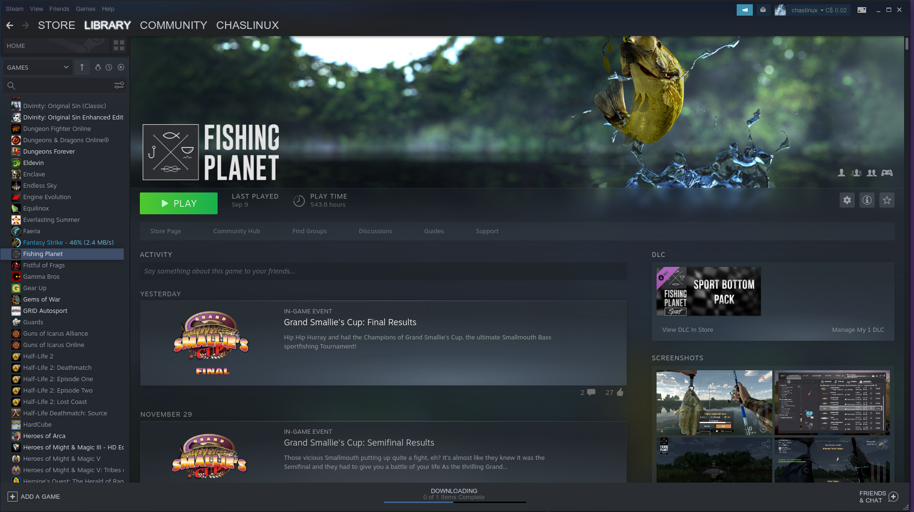Figure 19: Steam - Fishing Planet (game)
Some important things to keep in mind when using Steam with Linux. First, you should buy or download games that are made for Steam or Linux. While it is possible to play Windows steam games under Linux Mint, the process is a bit more complicated, and not every Windows game will work under Mint. Games with the Steam logo are compatible with Linux. Second, be sure to check each game’s system requirements, a game might be compatible with Mint, but if your hardware is too old, or not supported, the game may not work. The System requirements are normally further down on the game page. There are normally two sets of system requirements, minimum and recommended. It’s a good idea to make sure you have at least the recommended system requirements to run a game.

Examples of popular games on Steam that run under Linux are: Dota 2, Stardew Valley, Cities: Skylines, Hollow Knight, Civilization VI, and XCOM 2. (It’s worth mentioning that most of these games are graphically intensive and are designed for computers with very good graphics cards).

For a free to play game on Steam that should run on most laptops check out Adventure Capitalist: https://store.steampowered.com/app/346900/AdVenture_Capitalist/

Note: The people who created Adventure Capitalist make money by selling extra downloadable content. You don’t need to buy the content to download and run Adventure Capitalist.

Xfburn – CD/DVD burning
Xfburn is a simple CD/DVD burning program. There are 4 main options in Xfburn: Burn Image, Blanc disc, New Data Composition, and Audio CD.

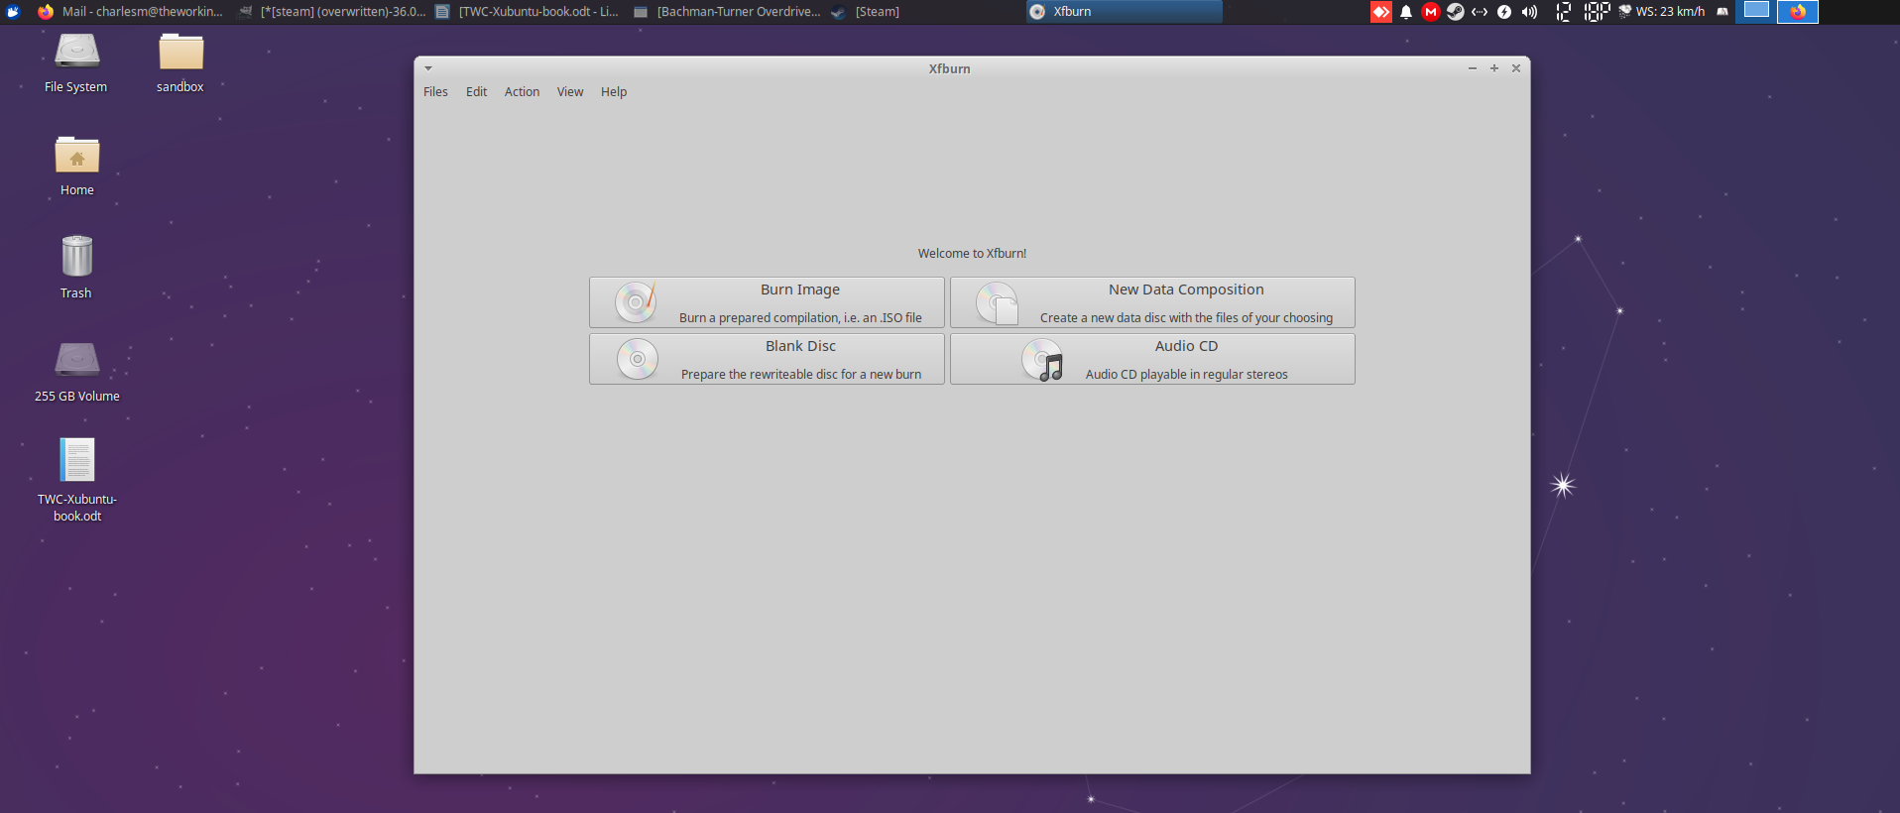Figure 20: Xfburn DVD burning software

Burn Image – this is the option you want to choose if you have an .ISO image you want to burn to disc. ISO images are a bit like a zip file, they often contain many files in the .ISO file, but in a special format that programs like Xfburn know how to handle. ISO images are commonly used to distribute Linux distributions like Mint. If you wanted your own copy of Mint you would go to https://www.linuxmint.com/download.php, click the country that’s closest to yours, then click the file that ends in .iso. That file can then be opened with Xfburn and burned to DVD.

Blank Disc – this option is normally used for rewriteable discs. Note that most DVD discs are only writable once. This feature is used with rewritable discs to wipe the existing content off the discs. Discs that are rewritable normally have a DVD+RW or DVD-RW marking on them. Not all drives can read rewritable discs, so it’s also important to check the side of your DVD drive to see which standard it is compatible with.

New Data Composition – Use this option to create DVDs with data files on them. For example: you want to copy a bunch of LibreOffice documents and photographs to DVD so you can bring them to another computer, or store a backup copy of them.

Audio CD – This option lets you create CDs that can be used in CD music players. Note that you must use CD-R discs, DVD discs will not play as an audio disc in most audio players.

Zoom – Online meeting tool - * extra
Zoom has quickly become a popular video and web conferencing tool used to communicate with people around the world.

If you wish to host Zoom meetings you will have to create a Zoom account. Creating a basic zoom account is free, and you can get video training on how to use Zoom directly from the Zoom support page: https://support.zoom.us/hc/en-us.

Explore Software Manager
We encourage you to explore software in the Software Manager. If you install a program through Software Manager that you don’t like you can always use the software centre to remove the program. There is a vast array of software in the software centre that ranges from programs to create motion-picture 3D animation (Blender) to software designed to help children to touch type (Tux Typing).

Even if you “mess up” your computer and install programs that don’t work, Linux Mint is a free operating system, you can always download and install it again yourself. Don’t forget we’re here to help by email: cr@theworkingcentre.org or by appointment for virtual consultations.

Helpful Linux Resources
There are a lot of resources on the Internet to get help with Linux Mint, but the 3 official methods are documentation at https://linuxmint-user-guide.readthedocs.io/en/latest/, the forums at https://forums.linuxmint.com/, the IRC (Internet Relay Chat) channel #linuxmint-help on SpotChat IRC (start Hexchat from the menu, it goes right there), and the Discord at https://discord.gg/mint. (Please be patient on IRC and Discord and remember that people in the channel are volunteers, not paid staff.)

Youtube
Youtube is also an excellent source for help. Youtube is great for when you have questions about specific software. You may have to experiment a bit with wording. For example: typing “cheese” in the Youtube search field turns up a lot of videos about the delicious food. Typing “cheese linux” or “cheese linux mint” displays results showing the cheese software.

Program Help Menu Option
Another potential source for help is the Help menu option in particular programs. The Help option in LibreOffice Writer shows a menu of options including LibreOffice Help, What’s This (turns your cursor into a ? mark so you can learn which icons do which tasks), User Guides (which includes some impressive looking guides), Show Tip of the Day, Get Help Online, Send Feedback, Restart in Safe Mode (restarts LibreOffice Writer in a safe mode), Get Involved, Donate to LibreOffice, License Information, and About LibreOffice (which shows information about the version of LibreOffice and some system information). Other programs will have less help information, but sometimes just a little is enough to point you in the right direction.

KWLUG - Kitchener Waterloo Linux User Group
If you just want to learn more about Linux and Linux Mint you might also consider joining the Kitchener Waterloo Linux User Group – KWLUG. KWLUG meets virtually the first non-holiday Monday of each month at 7pm. Topics are usually posted on the group’s web site a couple of months in advance. The group consists of a lot of experienced Linux users, but beginners are welcome as well. See the KWLUG web site for more information: http://www.kwlug.org/.

Paperback Books
While there is currently no Linux Mint-specific paperback book there are 2 technical Linux books we’ve found helpful: Matthew Helmke’s Ubuntu Unleashed 2021 (we have an older version, the 2021 covers recent changes to the Ubuntu operating system and its cousins, which include Mint), and the Official Ubuntu Book by Matthew Helmke, Elizabeth Joseph, and Joseph Rey. The second book is a bit dated and covers the Ubuntu desktop, but many of the principles in the book apply to Linux Mint.

Photographers & Writers
For photographers we recommend following Stefan Chirila’s blog: http://www.stefanchirila.com/blog/. Stefan is a professional photographer local to Kitchener/Waterloo who uses Linux to do all his photography. Stefan has put together a number of videos on his blog along with fellow photographer Marko covering different aspects of photography.

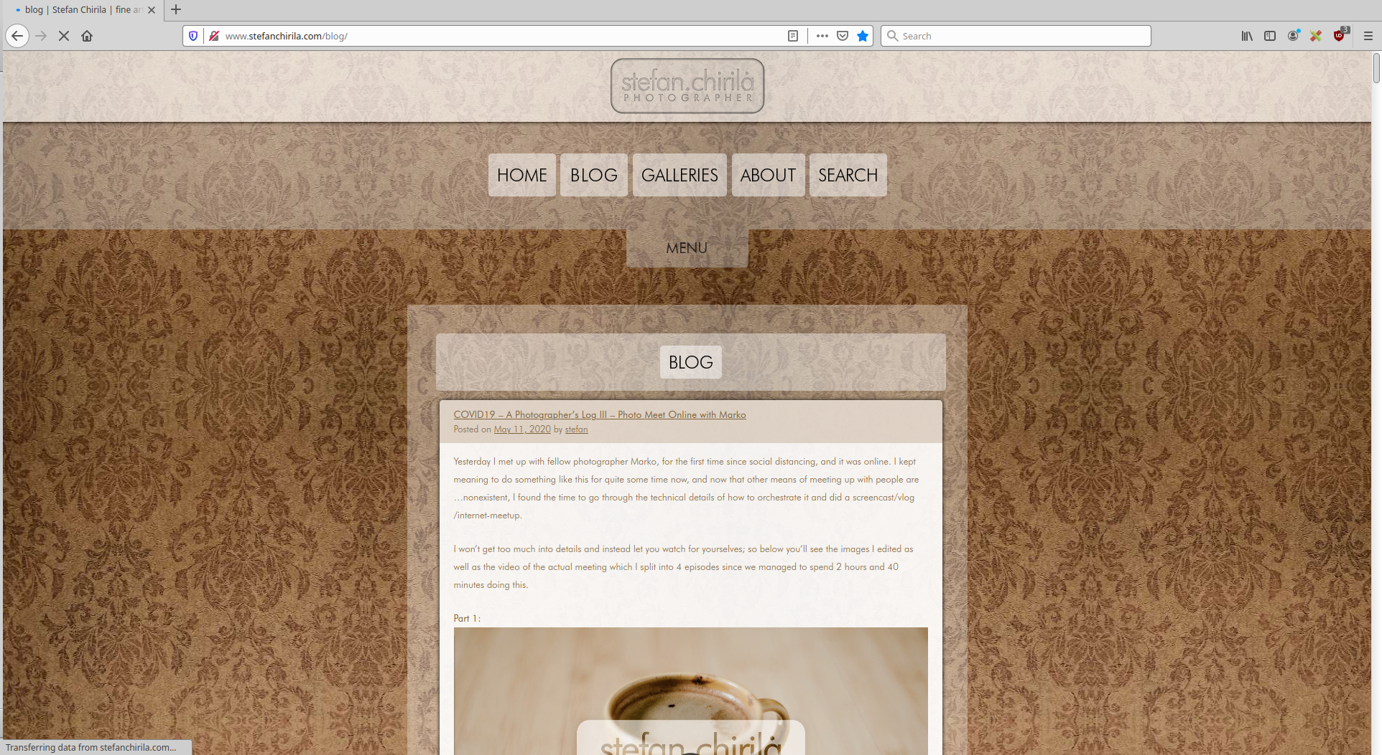Figure 21: Stefan Chirila's photography blog

Writers and photographers may want to check out Laurel Russwurm’s free culture blog: https://laurelrusswurm.wordpress.com/. On the blog Laurel provides many links to free culture and writing resources. Laurel is the author of the book Inconstant Moon and is actively involved in writing, politics, and photography.

Programmers
Linux is a very programmer-friendly system. Because most programs in Linux fall under one of the free software licenses the source code is available for a huge number of programs. There are dozens of programming languages, Integrated Development Environments (IDEs), and supporting tools available for programmers on Linux.

If you’ve ever wanted to develop a video game, the Unity, Unreal, and Godot game engines are just a few of the most popular game engines available on Linux. Supporting this are hundreds of other free tools for other aspects of game design. For game graphics, Krita, Aseprite, GIMP, Inkscape, and Blender are all popular choices. Linux features a number of Digital Audio Workstations (DAWs), along with dozens of other audio tools for those serious about game music. If you’re interested in making games for Linux (and other operating systems) check out Linux Hint’s article on How to Develop a Game on Linux: https://linuxhint.com/develop_game_linux/. The article mostly covers game engines available for Linux. Michael Bethencourt, a software developer in San Francisco, also has written a great article about game development on Linux. In Game development on Linux: Using Linux at every step of the process http://michaelb.org/getting-started-with-linux-game-development/ Michael gives an overview of software including: game engine, 2D graphics, 3D graphics, sound effects, music, and everything else.

If you’re choice is mainstream programming, you may want look to the Waterloo Region Python Group (WatPy). Meetings are held virtually. See the WatPy Meetup group for more details: https://www.meetup.com/WatPyMeetup/.

Linux is also great for web development, because not only are there many development tools, but you can run and host your own web servers, all the tools are there free.

Musicians
Linux has a lot of music software covering different aspects of music production. There are simple recording programs, metronome software, sequencers, music trackers, sheet music software, waveform visualization software, Digital Audio Workstation (DAW) software, synthesizer, sampler, and effect plug-ins, delays, reverbs, EQs and filters, pitch shifters, distortion tools, dynamics processing and more.

A good place to start is the following video by unfa, a Polish musician who’s created several albums using Linux software: Free and open-source software I use for music production: https://www.youtube.com/watch?v=qistxioVgMw.

You
You are perhaps one of the best sources of knowledge. You know what you want to do. Knowing what you want to accomplish is as important as the method of doing so. If you need help figuring out how to do something you want to do with Linux Mint we’re here to help via email: cr@theworkingcentre.org or reach out to a job counsellor to set up an appointment with Computer Recycling.

Your computer specifications
This page is reserved for the specifications of each computer:

There are exceptions, some web applications are made with Microsoft Windows in mind, but this is very rare since a lot of the code is obsolete. (But you may find difficulties with Flash-based web pages since even Adobe, creators of Flash, have stopped supporting it).
Wikipedia Linux definition: https://en.wikipedia.org/wiki/Linux

