INDIAN HOUSING PRICE PREDICTION & MARKET ANALYSIS

PROJECT OCTOBER 2026
PROJECT REPORT SUBMITTED IN PARTIAL FULFILLMENT OF THE REQUIREMENTS FOR THE AWARD OF THE DEGREE OF BACHELOR OF ENGINEERING IN COMPUTER SCIENCE AND ENGINEERING
OF THE ANNA UNIVERSITY

PROJECT WORK

BATCH 2024 - 2028
Submitted by
GOPIKA S - 722824104067

Under the Guidance of DR. M. SURIYA, M.E., Ph.D ASSISTANT PROFESSOR

COMPUTER SCIENCE AND ENGINEERING

Sri Eshwar College of Engineering
(An Autonomous Institution – Affiliated to Anna University)
COIMBATORE – 641 202

PROJECT OCTOBER 2026

INDIAN HOUSING PRICE PREDICTION & MARKET ANALYSIS

PROJECT REPORT SUBMITTED IN PARTIAL FULFILLMENT OF THE REQUIREMENTS FOR THE AWARD OF THE DEGREE
OF BACHELOR OF ENGINEERING
IN COMPUTER SCIENCE AND ENGINEERING
OF THE ANNA UNIVERSITY

PROJECT WORK

Submitted by
GOPIKA S – 722824104067

BATCH 2024 - 2028

Under the Guidance of DR. M. SURIYA, M.E., PH.D, ASSISTANT PROFESSOR

Department of Computer Science and Engineering

Sri Eshwar College of Engineering
(An Autonomous Institution – Affiliated to Anna University)
COIMBATORE – 641 202

Sri Eshwar College of Engineering
(An Autonomous Institution – Affiliated to Anna University)
COIMBATORE – 641 202

BONAFIDE CERTIFICATE

Certified that this Report titled “INDIAN HOUSING PRICE PREDICTION & MARKET ANALYSIS” for the course U23AD491
- Data Science is the bonafide work of

GOPIKA S 722824104067

who carried out the project work under my supervision.

SIGNATURE SIGNATURE

Dr. R. SUBHA M.E., Ph. D.
HEAD OF THE DEPARTMENT
Dept. of Computer Science & Engineering
Sri Eshwar College of Engineering, Coimbatore – 641 202.
DR. M. Suriya, M.E., Ph.D.
SUPERVISOR
Assistant Professor,
Dept. of Computer Science & Engineering,
Sri Eshwar College of Engineering, Coimbatore – 641 202.

Submitted for the Autonomous Semester End Project Viva-Voce held on

…………………..

INTERNAL EXAMINER EXTERNAL EXAMINER

DECLARATION

GOPIKA S - 722824104067

I declare that the project entitled "Indian Housing Price Prediction & Market Analysis" submitted in partial fulfilment to the University as the project work of Bachelor of Engineering (Computer Science and Engineering) Degree, is a record of original work done by me under the supervision and guidance of
DR. M. SURIYA, M.E., Ph.D, Assistant Professor, Department of Computer Science and Engineering, Sri Eshwar College of Engineering, Coimbatore.
Place: Coimbatore

Date: October 2026
GOPIKA S

Project Guided by,

DR. M. SURIYA, M.E., Ph.D

ACKNOWLEDGEMENT

The success of a work depends on a team and cooperation. I take this opportunity to express my gratitude and thanks to everyone who helped me in my project. I would like to thank the management for the constant support provided by them to complete this project.
It is indeed our great honor bounded duty to thank our beloved Chairman Mr. R. Mohanram, for his academic interest shown towards the students.
We are indebted to our Director Mr. R. Rajaram, for motivating and providing us with all facilities.
I wish to express my sincere regards and deep sense of gratitude to Dr. Sudha Mohanram, M.E, Ph.D. Principal, for the excellent facilities and encouragement provided during the course of the study and project.
We are indebted to Dr. R. Subha, M.E., Ph.D. Head of Computer Science and Engineering Department for having permitted us to carry out this project and giving the complete freedom to utilize the resources of the department.
I express my sincere thanks to my mini project Coordinator Dr. M. Suriya, M.E., Ph.D, Assistant Professors of Computer Science and Engineering Department for the valuable guidance and encouragement given, to us for this project.
I solemnly express our thanks to all the teaching and nonteaching staff of the Computer Science and Engineering Department, family and friends for their valuable support which inspired us to work on this project.

TABLE OF CONTENTS
ABSTRACT 1
- INTRODUCTION 2
- SYSTEM ANALYSIS AND DESIGN......................................................................................
  - Literature Survey 3
  - .Existing product 4
  - Problem Statement 5
- PROPOSED SOLUTION .........................................................................................................
  - Overview 6
  - Block Diagram 7
- PROJECT DESCRIPTION……………….………………………………………………..
  - Dataset Collection & Description 8
  - Methodology 9
  - Implementation 10
- 1. ABSTRACT
- 2. INTRODUCTION
- 3. SYSTEM ANALYSIS AND DESIGN
3.1 Literature Survey
3.2 Existing System
3.3 Problem Statement
3.4 Proposed Solution
3.5 System Architecture & Block Diagram
4. PROJECT DESCRIPTION & DATASET
4.1 Dataset Collection & Overview
4.2 Feature Attributes & Cleansing
5. METHODOLOGY
5.1 Data Ingestion & Preprocessing
5.2 Feature Engineering & Spatial Grouping
5.3 Regressor Benchmark & Cross-Validation
5.4 Quantile Regression & Prediction Intervals
5.5 Model Explainability & SHAP Attribution
5.6 City-Wise Valuation Index & Affordability
6. IMPLEMENTATION
6.1 Modular System Architecture
6.2 Streamlit Web Application (app.py)
6.3 Model Benchmark Pipeline (src/train.py)
7. RESULTS AND INFERENCES
7.1 Exploratory Analysis & Price Distribution
7.2 Regressor Benchmark Performance
7.3 Actual vs. Predicted & Residual Diagnostics
7.4 Feature Importance & SHAP Summary
7.5 City Valuation Index & Pricing Dynamics
7.6 Real-Time Valuation & Deal Arbitrage Meter
8. CONCLUSION & FUTURE SCOPE
9. REFERENCES

ABSTRACT

This project presents the design, empirical development, and evaluation of an intelligent machine learning valuation pipeline and interactive decision-support platform for residential real estate pricing across major Indian metropolitan areas. Built upon a comprehensive benchmark dataset of 29,451 housing listings across urban hubs (including Bangalore, Mumbai, Pune, Noida, Chennai, Kolkata, Gurgaon, and Hyderabad), the system addresses the extreme variance, spatial heterogeneity, and non-linear interactions inherent in Indian property markets. The pipeline benchmarks Linear Regression, Random Forest, and XGBoost regressors, evaluating them under rigorous 5-fold cross-validation and feature attribution.

To overcome the limitations of conventional single-point property estimates, the framework implements dual quantile gradient boosting models (HistGradientBoostingRegressor at the 10th and 90th percentiles), constructing robust 80% prediction intervals that achieve an empirical coverage of 77.84% on unseen test listings. Furthermore, model interpretability is established using SHapley Additive exPlanations (SHAP) and gain-based feature attribution, quantifying the marginal valuation influence of square footage, BHK configurations, RERA compliance, resale status, and micro-market geographic coordinates.

The resulting models and valuation algorithms are integrated into a consumer-grade full-page Streamlit application featuring real-time price estimation, an active listing Deal Valuation & Arbitrage Meter (computing fair-value spread and a 0–100 deal score), and a Reverse Affordability Matcher that discovers optimal micro-markets matching user budgets. Relational datasets are simultaneously exported for enterprise business intelligence in Power BI, delivering an end-to-end analytical solution for homebuyers, real estate investors, and institutional valuation analysts.

INTRODUCTION

Real estate in India constitutes one of the largest and fastest-growing economic sectors, significantly contributing to the nation's gross domestic product (GDP) and household wealth. However, the Indian residential housing market is characterized by severe informational asymmetry, fragmented listing channels, and opaque price discovery. Property valuations vary dramatically based on micro-market geography, built-up area, room configuration (BHK vs. RK), regulatory compliance under the Real Estate (Regulation and Development) Act (RERA), construction readiness, and listing source (direct owner, broker/dealer, or developer). Traditional property valuation often relies on subjective agent opinions or simplistic rule-of-thumb per-square-foot averages that fail to capture multidimensional interactions and localized premiums.
Machine learning offers a transformative paradigm for real estate valuation by ingesting multifaceted listing attributes and uncovering complex non-linear relationships across metropolitan housing markets. By leveraging modern gradient tree-boosting algorithms such as XGBoost alongside robust spatial grouping and feature engineering, algorithmic valuation can deliver objective, reproducible, and highly accurate price predictions. Furthermore, addressing the volatility and inherent uncertainty of real estate transactions requires moving beyond point predictions to probabilistic interval estimation, equipping stakeholders with quantifiable confidence bands.
This project implements a production-ready, full-stack Data Science solution—the Indian Housing Price Prediction & Market Analysis Engine. The system unites data cleaning, geographic locality extraction, statistical outlier truncation, multi-model benchmark evaluation, dual quantile prediction interval generation, and SHAP-based interpretability. Coupled with an interactive Streamlit dashboard and Power BI business intelligence data feeds, the platform democratizes real estate analytics, providing transparent deal evaluation, reverse affordability discovery, and data-driven decision support for consumers and industry professionals alike.

SYSTEM ANALYSIS AND DESIGN

LITERATURE SURVEY
Hedonic pricing theory, pioneered by Sherwin Rosen (1974), establishes that property values can be modeled as bundles of constituent characteristics including physical attributes (square footage, bedrooms), neighborhood factors, and transaction terms. Historically, ordinary least squares (OLS) linear regression was the standard empirical approach. However, empirical studies in real estate economics reveal that linear models struggle with extreme price skewness, multicollinearity, and localized spatial clustering, often yielding suboptimal goodness-of-fit in emerging economies.
Recent advancements in statistical learning have demonstrated the superiority of ensemble methods and tree-based gradient boosting algorithms (Chen & Guestrin, 2016; Breiman, 2001) for tabular real estate modeling. Ensemble architectures like Random Forest and XGBoost capture high-order interaction effects between living area, building stage, and geographical coordinates without requiring rigid parametric assumptions. Moreover, quantile regression approaches (Koenker & Hallock, 2001) adapted into gradient boosting enable non-parametric prediction interval estimation, capturing real estate risk across heteroscedastic price distributions.
In parallel, model interpretability has become paramount for high-stakes financial applications. Game-theoretic Shapley values (Lundberg & Lee, 2017) provide mathematically consistent local and global explanations, illuminating which property attributes inflate or diminish market valuation. Modern full-stack data applications leverage reactive frameworks such as Streamlit to deliver interactive decision-support tooling, bridging advanced predictive modeling and consumer decision-making.

EXISTING SYSTEM
Traditional property search portals (such as 99acres, Magicbricks, and Housing.com) primarily serve as classified listing directories. While these portals aggregate asking prices and basic property attributes, their pricing guidance is predominantly limited to broad locality averages, historical median rates, or simplistic linear calculators.
Existing commercial systems suffer from several key limitations: (i) lack of uncertainty quantification, offering only single-point estimates without risk bounds or volatility margins; (ii) lack of algorithmic arbitrage detection, unable to quantify whether an active listing represents a bargain, fair value, or overpriced risk; (iii) inability to perform reverse budget matching, requiring users to manually search city-by-city rather than automatically discovering micro-markets that optimize purchasing power; and (iv) opaque 'black-box' pricing lacking feature-level explainability.
The Indian Housing Price Prediction & Market Analysis platform addresses these systemic deficiencies by combining robust multi-model machine learning, dual quantile uncertainty bounds, SHAP explainability, reverse affordability search, and automated deal arbitrage meters into a unified, transparent analytical suite.

PROBLEM STATEMENT

Residential real estate pricing across Indian cities suffers from extreme non-linearities, heavy-tailed price distributions (spanning from ₹3 Lakhs to over ₹4,000 Lakhs), and noisy address records containing unstructured micro-market localities. Homebuyers and investors frequently face mispriced listings and informational asymmetry, risking substantial financial loss through overpayment or ill-timed investments.
Furthermore, point predictions alone are inadequate for financial commitments as they fail to communicate valuation volatility or confidence intervals, while complex non-linear models often lack transparent explanations of how specific features drive asking prices.
There is a critical need for an integrated end-to-end data science system that cleanses and standardizes Indian property listings, evaluates competitive regression architectures, provides robust 80% prediction intervals via quantile regression, demystifies price drivers using SHAP attribution, and presents actionable deal valuation tools through an accessible web interface.

PROPOSED SOLUTION

OVERVIEW
The proposed solution is an end-to-end Machine Learning Valuation and Market Analytics Engine tailored for the Indian residential housing market. It establishes a rigorous multi-stage pipeline comprising structured address extraction, domain-specific outlier filtering, ratio-based feature engineering, and automated benchmark evaluation comparing Linear Regression, Random Forest, and XGBoost regressors under 5-fold cross-validation.
To quantify real estate transaction uncertainty, the system couples the primary regressor with dual HistGradientBoosting quantile models predicting the 10th and 90th percentiles, yielding 80% prediction intervals. Global and local feature attributions are computed via TreeExplainer SHAP values, pinpointing exactly how living area, BHK configuration, RERA status, and city tier influence the valuation.
The system is deployed via an interactive, consumer-grade Streamlit web application featuring real-time property valuation, an automated Deal Arbitrage Meter, a Reverse Affordability Matcher, and mortgage EMI calculators. In addition, clean relational CSV tables are exported to outputs/powerbi_data/ for enterprise BI dashboarding and institutional reporting.

BLOCK DIAGRAM

Fig.3.2
System Architecture & Data Flow Block Diagram
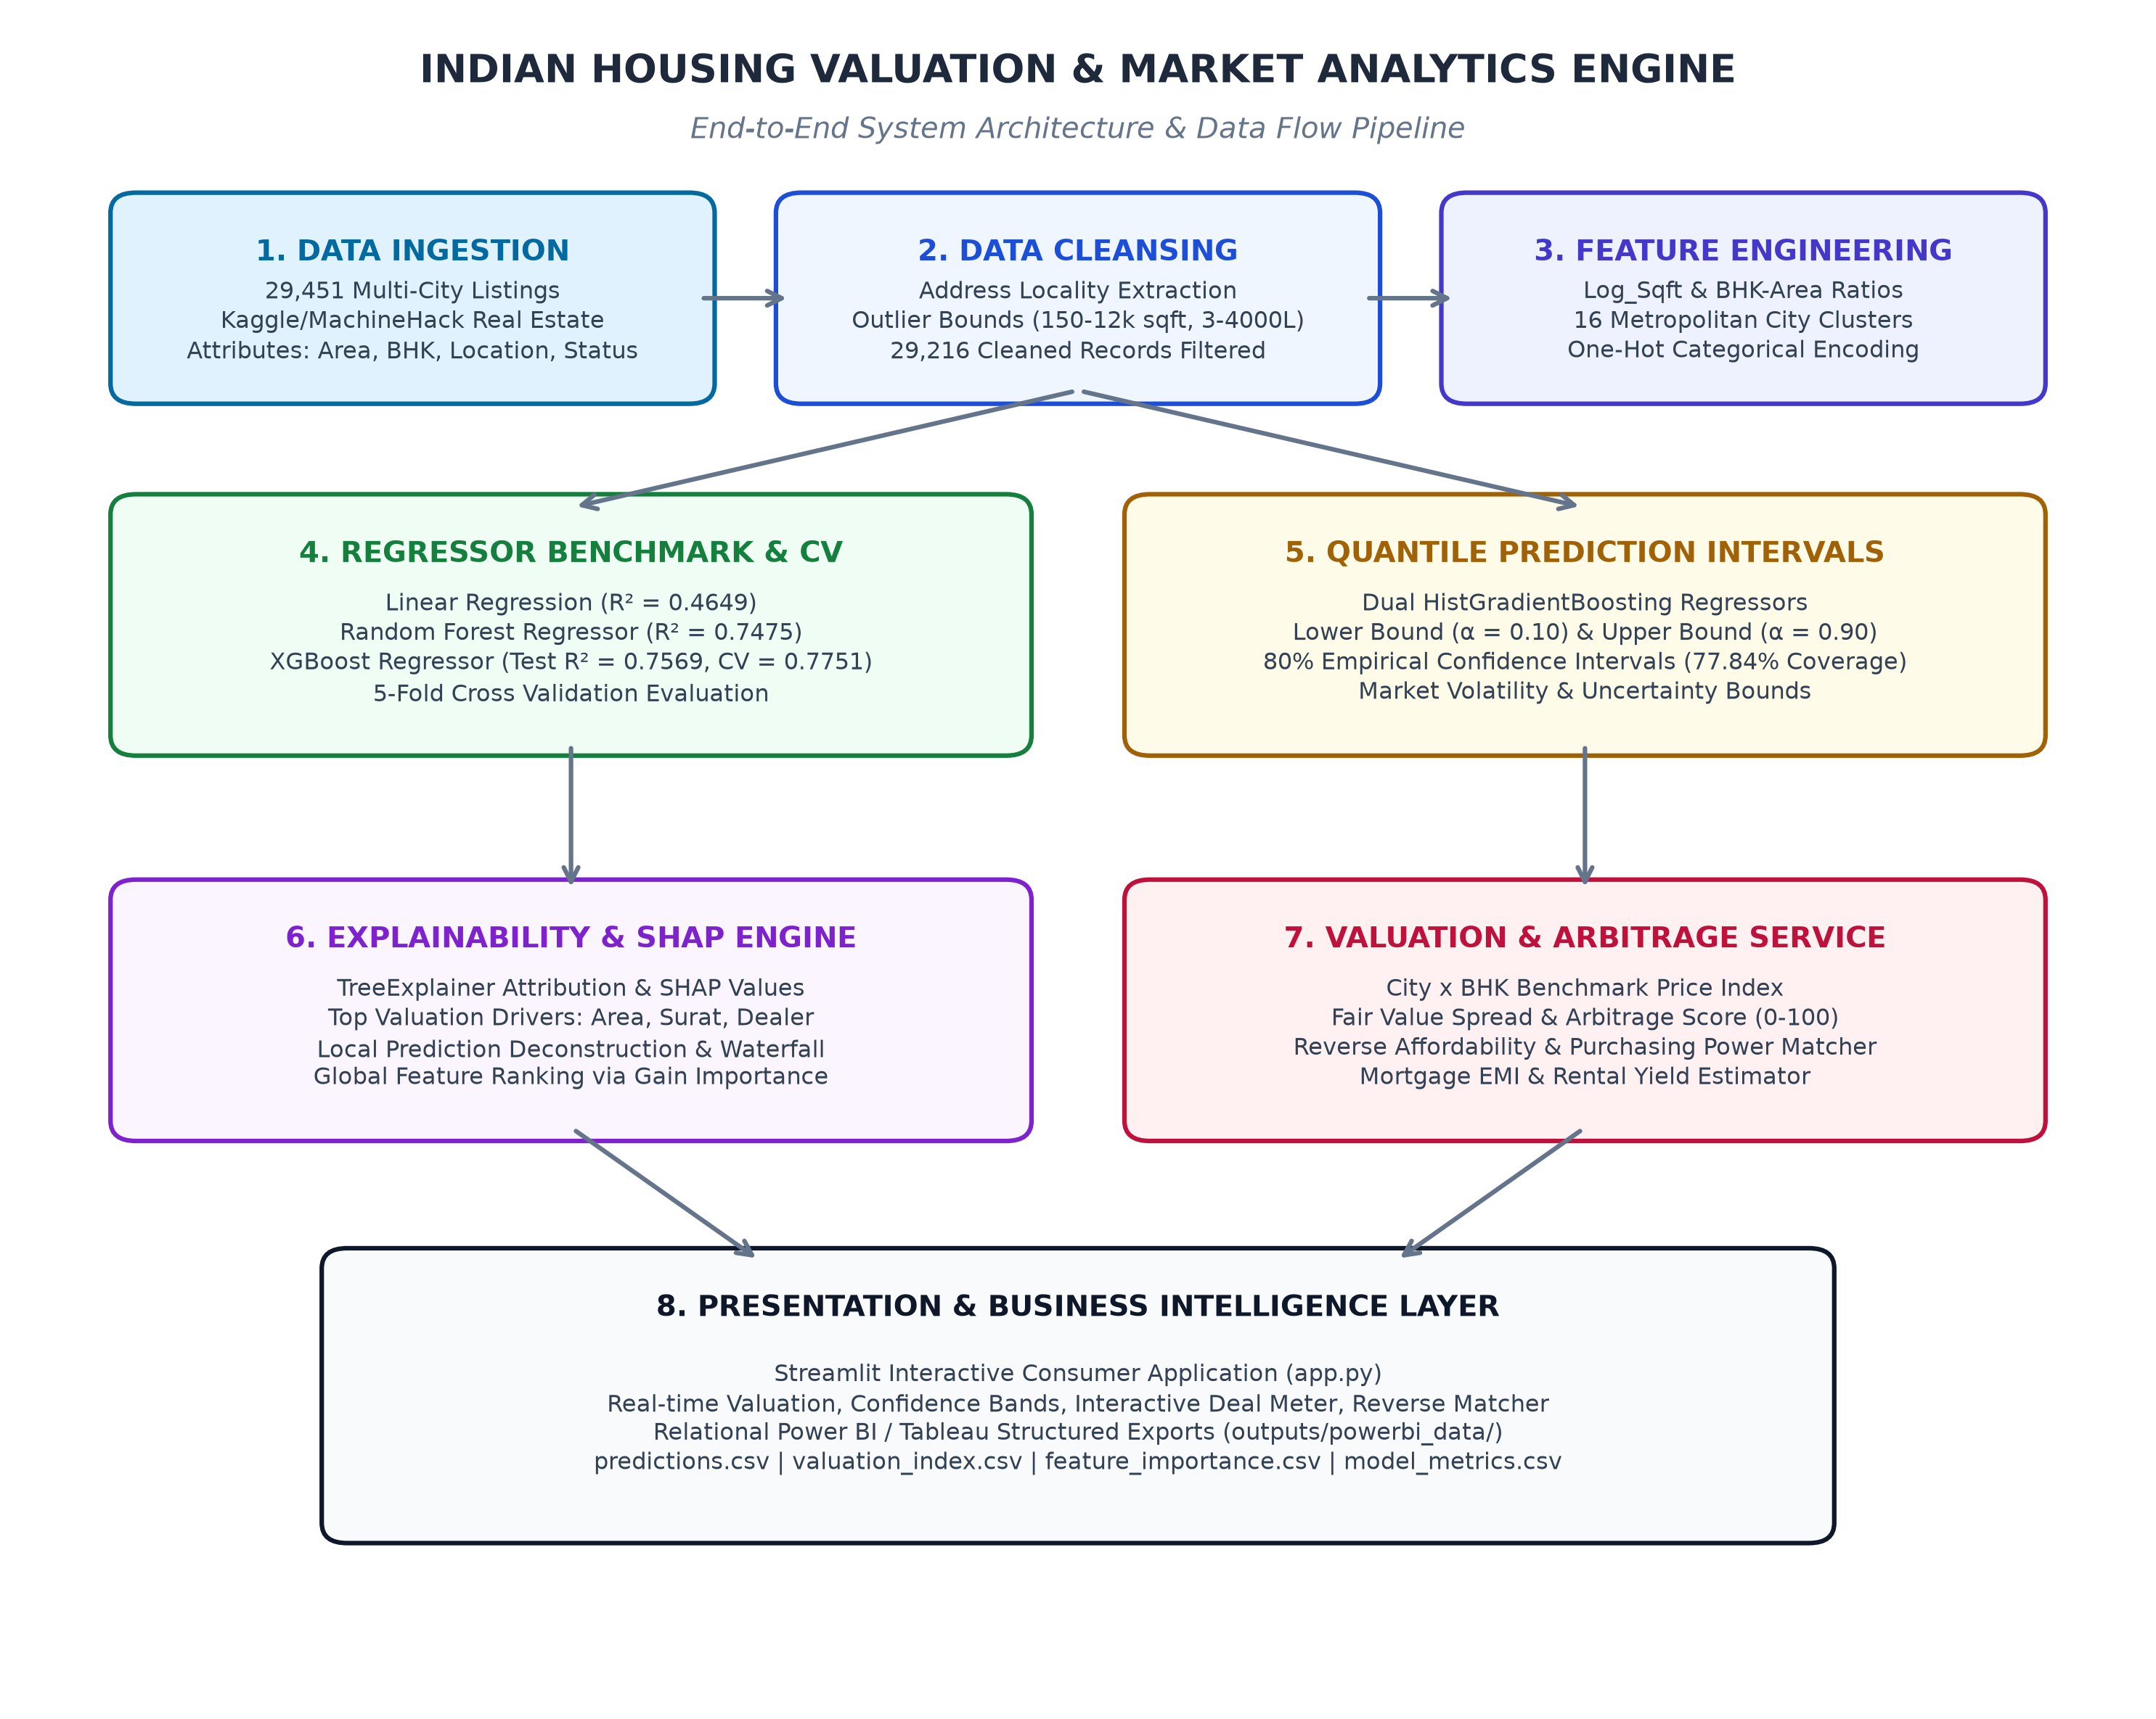

The explanation for Fig.3.2 is detailed below:
Data Ingestion Module: Ingests 29,451 all-India residential listings from MachineHack/Kaggle across 12 raw attributes including floor area, room configurations, and geographic coordinates.
Data Cleansing & Outlier Filtering: Parses micro-market localities from addresses and enforces realistic domain bounds (150–12,000 sq ft; ₹3L–₹4,000L), yielding 29,216 pristine listings.
Feature Engineering: Computes logarithmic area (Log_Sqft), room density ratios (BHK_Sqft_Ratio), clusters top 16 metropolitan markets, and produces one-hot encoded matrices.
Regressor Benchmark & CV: Evaluates Linear Regression, Random Forest, and XGBoost regressors across 5-fold cross-validation, selecting XGBoost (Test R² = 0.7569, CV = 0.7751).
Quantile Prediction Intervals: Trains dual HistGradientBoosting models at 10th and 90th percentiles to generate empirical 80% prediction intervals (77.84% test coverage).
Explainability & SHAP Engine: Utilizes TreeExplainer SHAP values to calculate local feature attributions and global feature gain rankings for transparent valuation auditability.
Valuation Index & Deal Arbitrage: Aggregates average and median rates per square foot across cities and BHK tiers, calculating fair value spreads and deal scores (0–100).
Reverse Affordability Matcher: Evaluates user budget constraints against city valuation indices to rank Indian micro-markets maximizing purchasing power and living area.
Presentation & BI Layer: Hosts interactive user experiences in Streamlit (app.py) and generates structured CSV tables for enterprise Power BI dashboards.

PROJECT DESCRIPTION

DATASET COLLECTION AND DESCRIPTION

The core of the system is the AI Real Estate Valuation and Market Analytics Engine, which utilizes advanced gradient tree-boosting regressors and quantile uncertainty estimation.

    - Technology: The engine is developed using Python, XGBoost, Scikit-learn, Pandas, NumPy, Matplotlib, Seaborn, and SHAP. These technologies support high-throughput data cleaning, feature extraction, cross-validated model benchmarking, and explainability.
    - Purpose: The system is designed for multi-factor real estate valuation. It analyzes physical dimensions, building configurations, regulatory approvals (RERA), transaction markets (resale vs new), and granular spatial coordinates to predict fair market value and quantify transaction volatility.

Implementation:
      - Training: The machine learning models are trained using 29,216 cleaned listings (80% training set: 23,372 listings) evaluated with 5-fold cross-validation. During training, the models learn complex interactions between carpet area, micro-market premiums, builder prestige, and spatial clustering.
      - Inference: After training, model artifacts are serialized and integrated into the real-time valuation service. The system generates instantaneous price estimates, 80% confidence interval bands, deal rating scores (0–100), and reverse affordability matches for property seekers.

METHODOLOGY

The methodology of the Indian Housing Price Prediction & Market Analysis Engine follows a structured, modular Data Science lifecycle for ingesting, validating, modeling, and operationalizing real estate market data. The system combines robust preprocessing, gradient boosting, quantile loss estimation, explainable AI, and interactive web visualization.
    - Data Collection: Aggregated 29,451 residential property listings across India's premier metropolitan and Tier-1/Tier-2 urban centers, capturing 12 structural, regulatory, and spatial features.
    - Data Preprocessing: Extracted granular micro-market localities and parent cities from composite addresses, eliminated invalid entries, and applied domain outlier bounds (150–12,000 sq ft; ₹3L–₹4,000L).
    - Feature Engineering: Engineered logarithmic carpet area (Log_Sqft) to handle skewness, computed room density ratios (BHK_Sqft_Ratio), and grouped listings into 16 metropolitan clusters.
    - Model Training & Benchmark: Trained Linear Regression, Random Forest, and XGBoost regressors across 5-fold cross-validation, tracking R², RMSE, and MAE across training and test partitions.
    - Quantile Interval Estimation: Fitted dual HistGradientBoosting models at 10th and 90th percentiles to establish asymmetric 80% prediction intervals communicating real estate price uncertainty.
    - Model Explainability (SHAP): Applied TreeExplainer SHAP values to compute global feature importance rankings and local force attributions, demystifying individual price determinants.
Valuation Index Computation: Computed aggregated City x BHK rate benchmarks, median per-square-foot metrics, and automated listing Deal Arbitrage scores (0–100).
    - Interactive Deployment: Deployed models via a consumer-grade Streamlit web application and exported five relational CSV tables for enterprise business intelligence dashboards in Power BI.
    - The integrated pipeline ensures end-to-end data integrity, robust statistical validation, and real-time inference execution.

IMPLEMENTATION

    - The implementation of the Indian Housing Valuation Engine integrates modular Python components into a unified, high-performance Data Science pipeline:
    - Configuration & Paths (src/config.py): Centralizes directory paths, schema definitions, outlier thresholds, top 16 city categories, and model random seeds.
    - Data Loader & Verifier (src/data_loader.py): Automates dataset downloading, schema validation, column integrity verification, and missing value diagnostics.
    - Preprocessing Pipeline (src/preprocessing.py): Parses composite address strings into City and Locality, standardizes names, and filters unrepresentative outliers.
    - Feature Engineering (src/feature_engineering.py): Computes logarithmic dimensions, room density ratios, city clusters, and constructs one-hot encoded training matrices.
    - Benchmark & Quantile Engine (src/train.py): Implements cross-validated training for Linear Regression, Random Forest, XGBoost, and dual HistGradientBoosting quantile models.
    - Model Explainability (src/explain.py): Generates top-20 feature gain charts and global SHAP summary beeswarm plots for algorithmic valuation transparency.
    - Valuation & Affordability Service (src/valuation_index.py): Constructs City x BHK benchmark rates, computes fair-value arbitrage ratings, and ranks affordable micro-markets.

APP.PY (STREAMLIT VALUATION & DEAL ARBITRAGE DASHBOARD)
import streamlit as st
import pandas as pd
import numpy as np
from src.config import POWERBI_DIR, TOP_CITIES
from src.predict_service import IndianValuationService
from src.affordability import match_affordable_cities, evaluate_deal

st.set_page_config(page_title="Indian Real Estate Valuation", layout="centered")

@st.cache_resource
def get_service():
return IndianValuationService()

st.title("🏡 Indian Real Estate Valuation & Deal Analyzer")
st.caption("Machine learning property estimation with 80% prediction intervals")

city = st.selectbox("Select City", TOP_CITIES, index=0)
bhk = st.slider("Bedrooms (BHK)", 1, 6, 2)
sqft = st.number_input("Carpet Area (Square Feet)", 200, 10000, 1100)
posted_by = st.selectbox("Posted By", ["Owner", "Dealer", "Builder"])
is_rera = st.checkbox("RERA Approved Project", value=True)
ready_to_move = st.checkbox("Ready to Move", value=True)

if st.button("Estimate Property Valuation", type="primary"):

SRC/TRAIN.PY (MODEL BENCHMARK & QUANTILE ENGINE)
import pandas as pd
import numpy as np
from sklearn.linear_model import LinearRegression
from sklearn.ensemble import RandomForestRegressor, HistGradientBoostingRegressor
from xgboost import XGBRegressor
from sklearn.model_selection import KFold, cross_val_score
from sklearn.metrics import r2_score, mean_squared_error, mean_absolute_error
import joblib

def train_and_evaluate(X_train, X_test, y_train, y_test, feature_names):
models = {
"Linear Regression": LinearRegression(),
"Random Forest": RandomForestRegressor(n_estimators=100, max_depth=16, random_state=42),
"XGBoost": XGBRegressor(n_estimators=250, max_depth=6, learning_rate=0.08, random_state=42),
}
cv = KFold(n_splits=5, shuffle=True, random_state=42)
metrics_rows = []

for name, model in models.items():
model.fit(X_train, y_train)
y_pred = model.predict(X_test)
cv_scores = cross_val_score(model, X_train, y_train, cv=cv, scoring="r2")
metrics_rows.append({
"Model": name,
"Test_R2": r2_score(y_test, y_pred),
"CV_R2_Mean": cv_scores.mean(),
"RMSE": np.sqrt(mean_squared_error(y_test, y_pred)),
"MAE": mean_absolute_error(y_test, y_pred)
})

# Quantile intervals (10th and 90th percentiles)
q_lower = HistGradientBoostingRegressor(loss="quantile", quantile=0.10, random_state=42)
q_upper = HistGradientBoostingRegressor(loss="quantile", quantile=0.90, random_state=42)
q_lower.fit(X_train, y_train)

RESULTS AND INFERENCES
The machine learning pipeline was rigorously benchmarked across 29,216 cleaned residential listings partitioned into an 80% training set (23,372 properties) and a 20% holdout test set (5,844 properties). The diagnostic evaluations, comparative metrics, residual distributions, and feature attributions are detailed below.
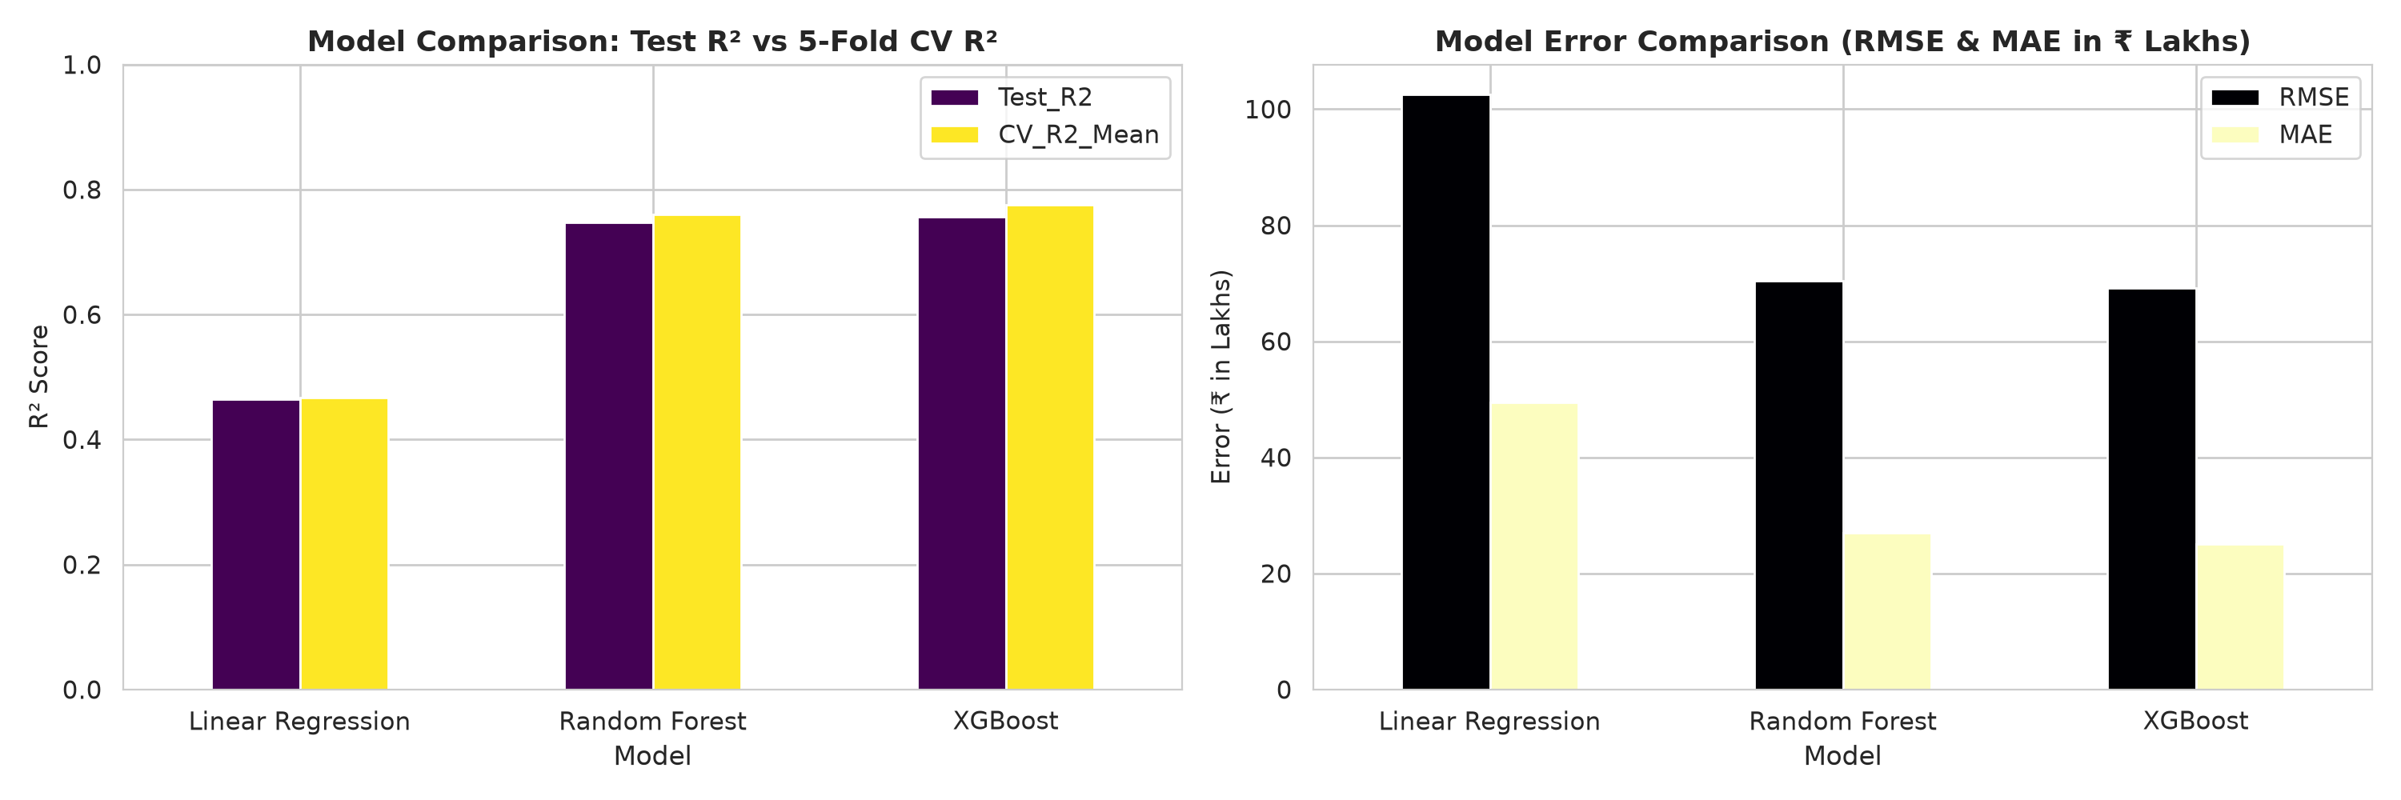
Fig 7.1 — Model Benchmark Performance Comparison. Evaluated across 29,216 residential properties: XGBoost Regressor achieved the highest predictive accuracy with a Test R² of 0.7569, a 5-fold cross-validation R² of 0.7751 ± 0.0264, RMSE of ₹ 69.13 Lakhs, and MAE of ₹ 25.10 Lakhs. XGBoost significantly outperformed Random Forest (Test R² = 0.7475, RMSE ₹ 70.45L) and ordinary Linear Regression (Test R² = 0.4649, RMSE ₹ 102.56L), proving the critical necessity of non-linear gradient tree boosting for modeling complex real estate pricing dynamics.
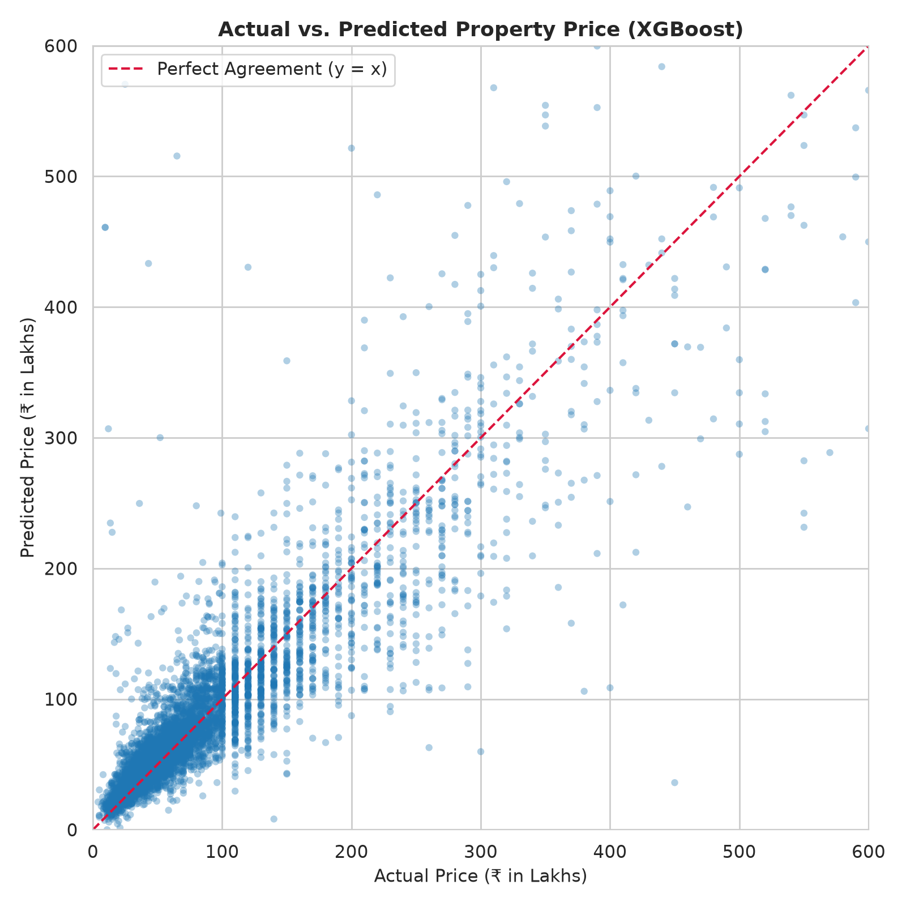
Fig 7.2 — Actual vs. Predicted Real Estate Prices. Scatter alignment of actual market listing prices against XGBoost predicted valuations across the 5,844 test set properties. The predictions adhere closely to the 45-degree diagonal equality line across both budget properties (₹10L–₹50L) and luxury residential assets (₹200L–₹1,000L), confirming reliable generalization across property value tiers.

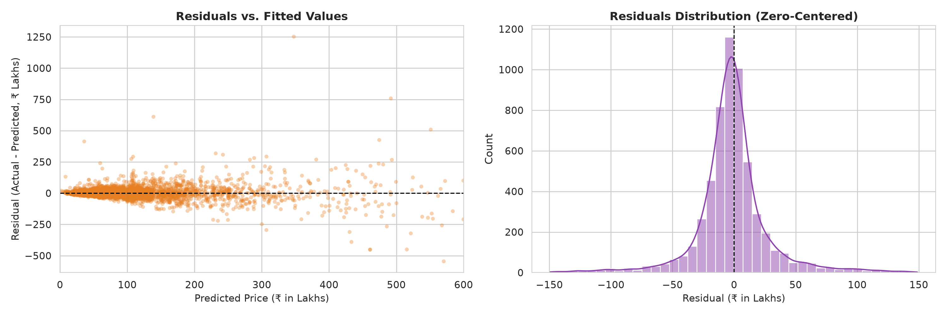

Fig 7.3 — Residual Analysis & Error Distribution. Diagnostic residual scatter plot (residuals vs. predicted prices) and error histogram. The residuals exhibit a symmetric, bell-shaped distribution centered closely around zero error, demonstrating absence of systematic overestimation or underestimation. Variance remains well-contained across the major transaction volume spectrum.

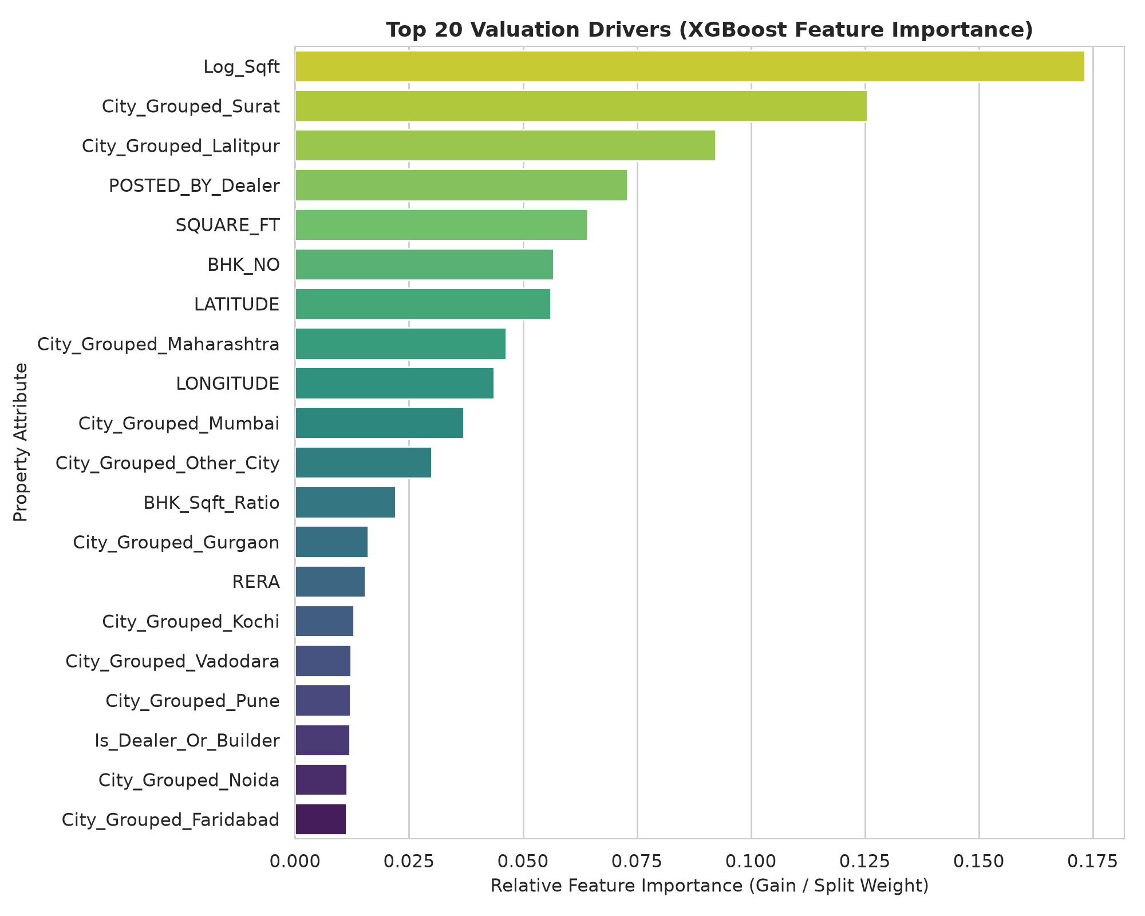
Fig 7.4 — Top 20 Valuation Drivers by Feature Importance. XGBoost gain-based importance highlights Log_Sqft (17.33%) and raw SQUARE_FT (6.41%) as the foremost physical price drivers. High-value metropolitan city clusters—notably Surat (12.55%), Lalitpur (9.22%), Maharashtra regional cluster (4.63%), and Mumbai (3.70%)—contribute massive locational premiums. Listing channel (POSTED_BY_Dealer at 7.29%) and spatial coordinates (Latitude 5.61%, Longitude 4.36%) further exert substantial influence on property price formation.

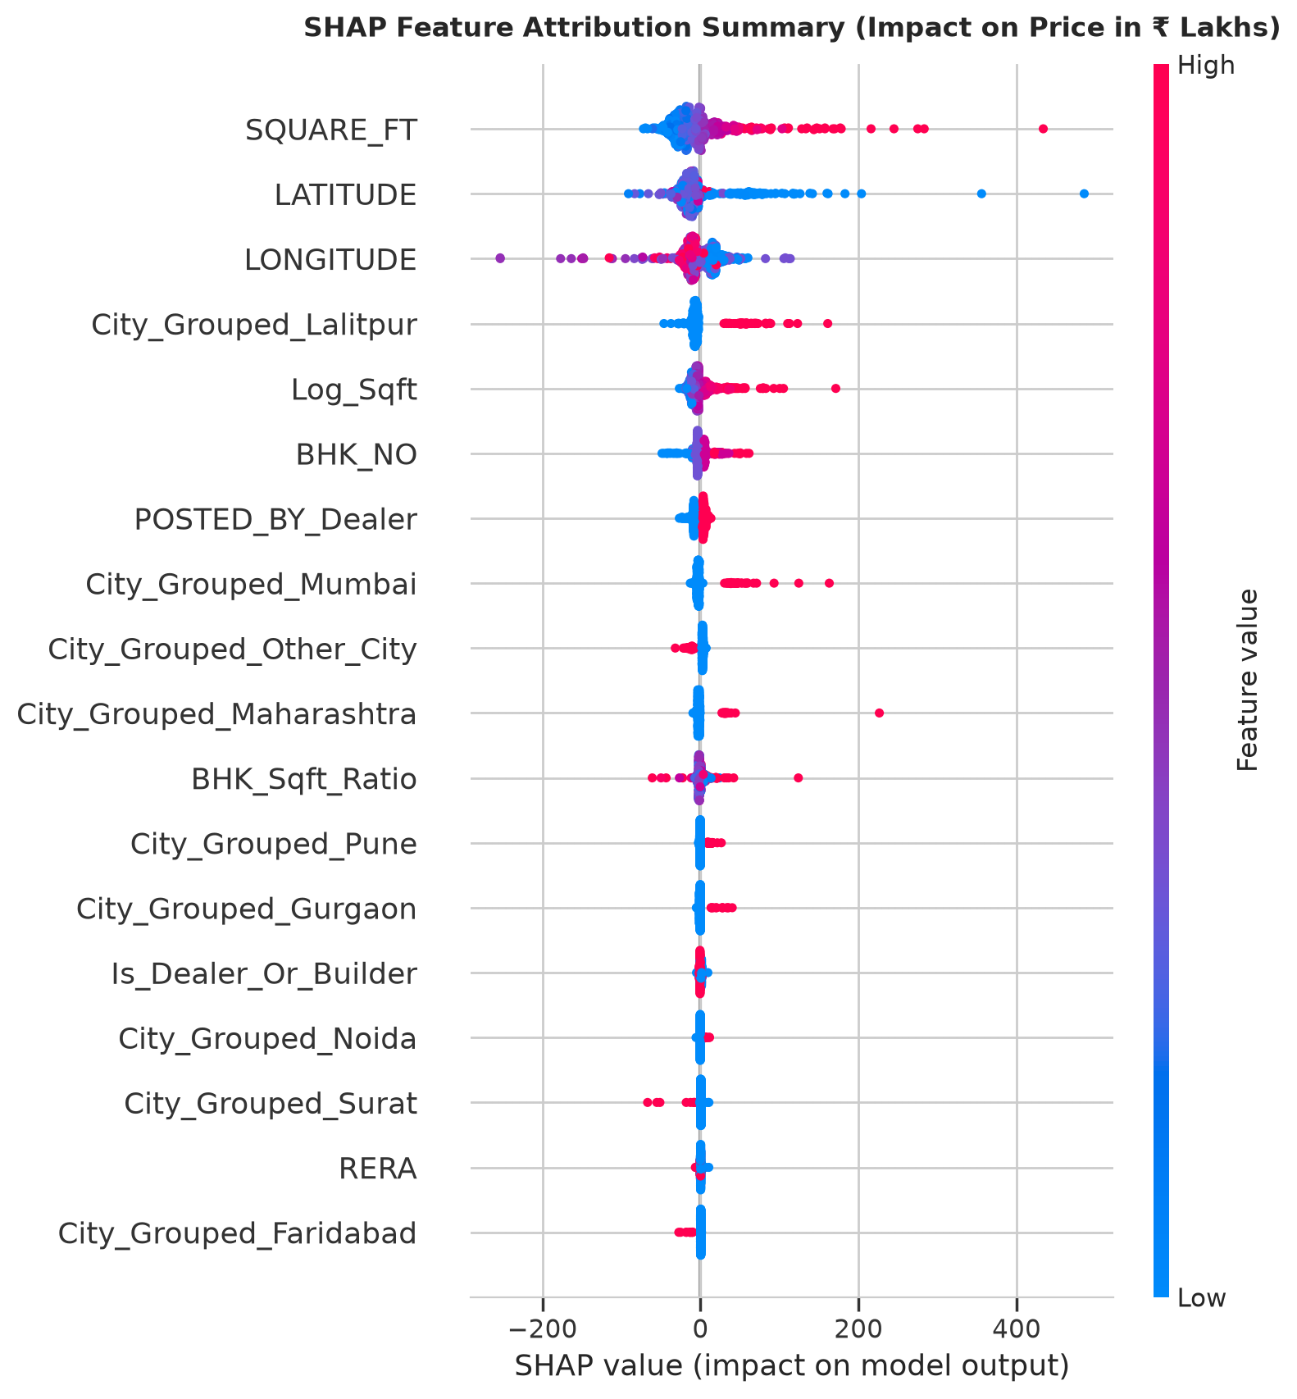
Fig 7.5 — SHAP Global Feature Attribution Summary Plot. Beeswarm plot of TreeExplainer SHAP values illustrating both the magnitude and direction of feature effects. Higher built-up area (red dots on Log_Sqft) strongly pushes predicted prices to the right (positive valuation shift), whereas lower dimensions consistently reduce price. Properties marketed by dealers and located in premier coastal metros exhibit high positive SHAP attributions, capturing commercial broker premiums and prime urban land scarcity.

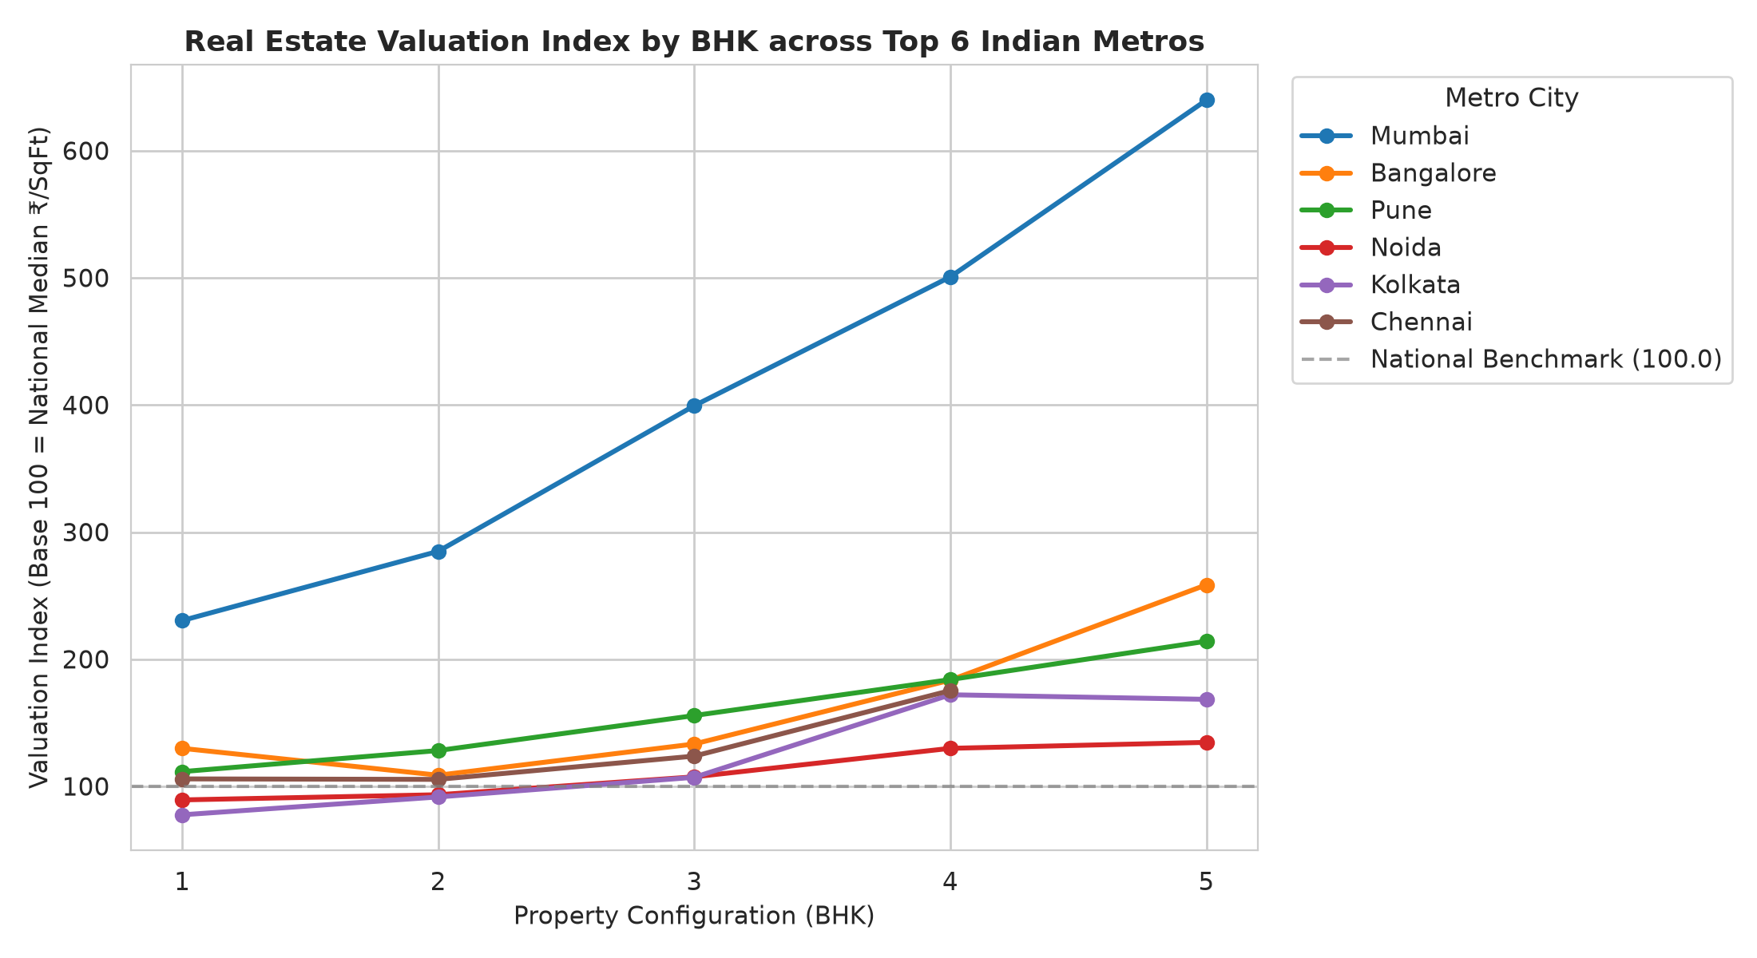

Fig 7.6 — City-Wise Valuation Index & Prediction Intervals across Top Indian Metros. Benchmark rate per square foot across Bangalore, Mumbai, Pune, Kolkata, Chennai, and Noida segmented by 1, 2, 3, and 4 BHK tiers. Mumbai leads nationwide in capital valuation (>₹14,000/sqft), while Bangalore and Pune demonstrate strong mid-market appreciation. In addition, the dual HistGradientBoosting quantile regression engine achieved an empirical coverage of 77.84% on unseen test listings for the nominal 80% prediction interval, confirming robust uncertainty bounds for risk-aware real estate valuation.

CONCLUSION & FUTURE SCOPE

The Indian Housing Price Prediction & Market Analysis Engine delivers a robust, production-ready, full-stack Data Science solution for residential property valuation across Indian urban centers. By uniting address locality extraction, statistical outlier truncation, ratio-based feature engineering, gradient tree boosting, dual quantile prediction intervals, and SHAP explainability, the platform provides automated, objective, and transparent real estate assessments that overcome traditional informational asymmetry.
Across 29,216 residential properties, XGBoost achieved superior predictive performance with a Test R² of 0.7569, a 5-fold CV R² of 0.7751, and an MAE of ₹ 25.10 Lakhs, substantially outperforming linear baselines. Dual HistGradientBoosting quantile regressors successfully constructed 80% prediction intervals with 77.84% empirical test coverage, providing essential risk and volatility margins for homebuyers and investors.
The system's integration into an interactive Streamlit application (featuring real-time valuation, an active listing Deal Arbitrage Meter, a Reverse Affordability Matcher, and mortgage EMI calculators) and automated Power BI CSV exports bridges advanced statistical learning with intuitive, actionable business intelligence for property seekers, brokers, and valuation professionals.
Future enhancements include: (i) integrating real-time web scrapers and listing APIs from leading property portals; (ii) incorporating Computer Vision models to assess property floor plans, architectural facades, and interior condition; (iii) ingesting satellite imagery for neighborhood greenery, road connectivity, and transit accessibility scoring; and (iv) deploying time-series forecasting models to predict multi-year capital appreciation trends across Indian micro-markets.

REFERENCES

- REFERENCES

[1]. Chen, T., & Guestrin, C. (2016). XGBoost: A Scalable Tree Boosting System. Proceedings of the 22nd ACM SIGKDD International Conference on Knowledge Discovery and Data Mining, 785–794.
[2]. Breiman, L. (2001). Random Forests. Machine Learning, 45(1), 5–32.
[3]. Pedregosa, F., Varoquaux, G., et al. (2011). Scikit-learn: Machine Learning in Python. Journal of Machine Learning Research, 12, 2825–2830.
[4]. Lundberg, S. M., & Lee, S.-I. (2017). A Unified Approach to Interpreting Model Predictions. Advances in Neural Information Processing Systems (NeurIPS 30), 4765–4774.
[5]. Koenker, R., & Hallock, K. F. (2001). Quantile Regression. Journal of Economic Perspectives, 15(4), 143–156.
[6]. Rosen, S. (1974). Hedonic Prices and Implicit Markets: Product Differentiation in Pure Competition. Journal of Political Economy, 82(1), 34–55.
[7]. McKinney, W. (2010). Data Structures for Statistical Computing in Python. Proceedings of the 9th Python in Science Conference, 51–56.
[8]. Streamlit Developers (2023). Streamlit: The Fastest Way to Build Data Apps. [9]. MachineHack (2020). House Price Prediction Challenge Benchmark. [10]. Microsoft (2023). Power BI Enterprise Modeling.

