CHASTITY HEIGHTS
A Young Adult Supernatural Drama • 16+ • Mystery, Romance, Dark Academia, Social Satire
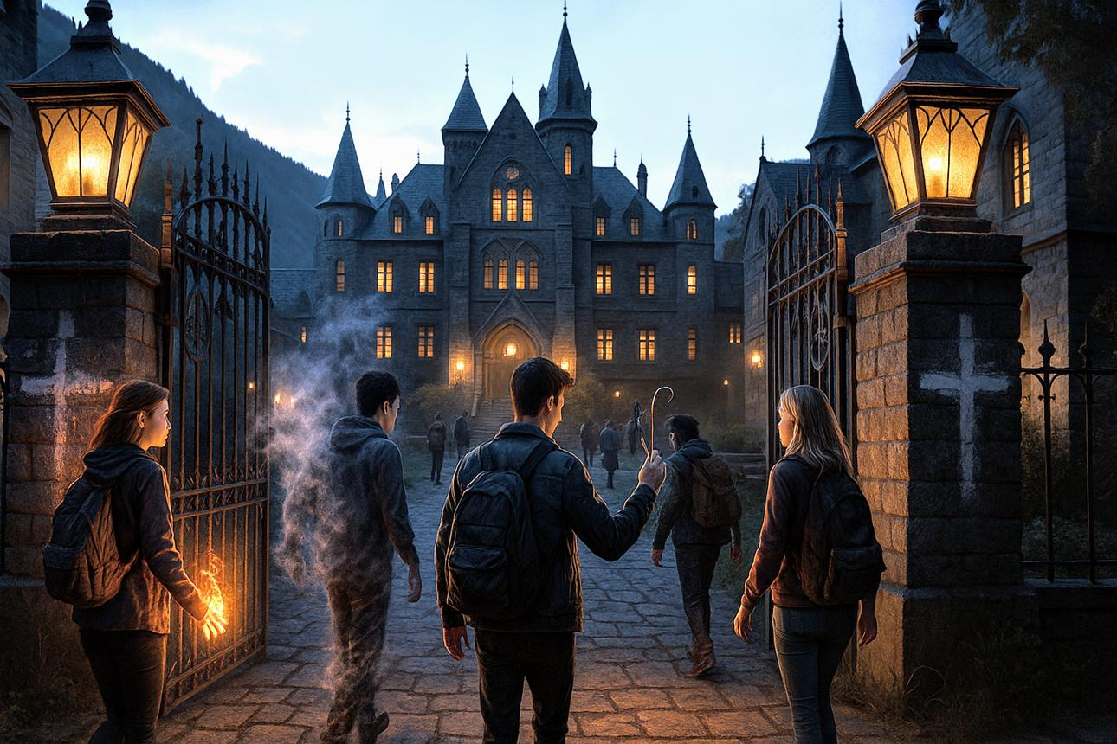
medium.com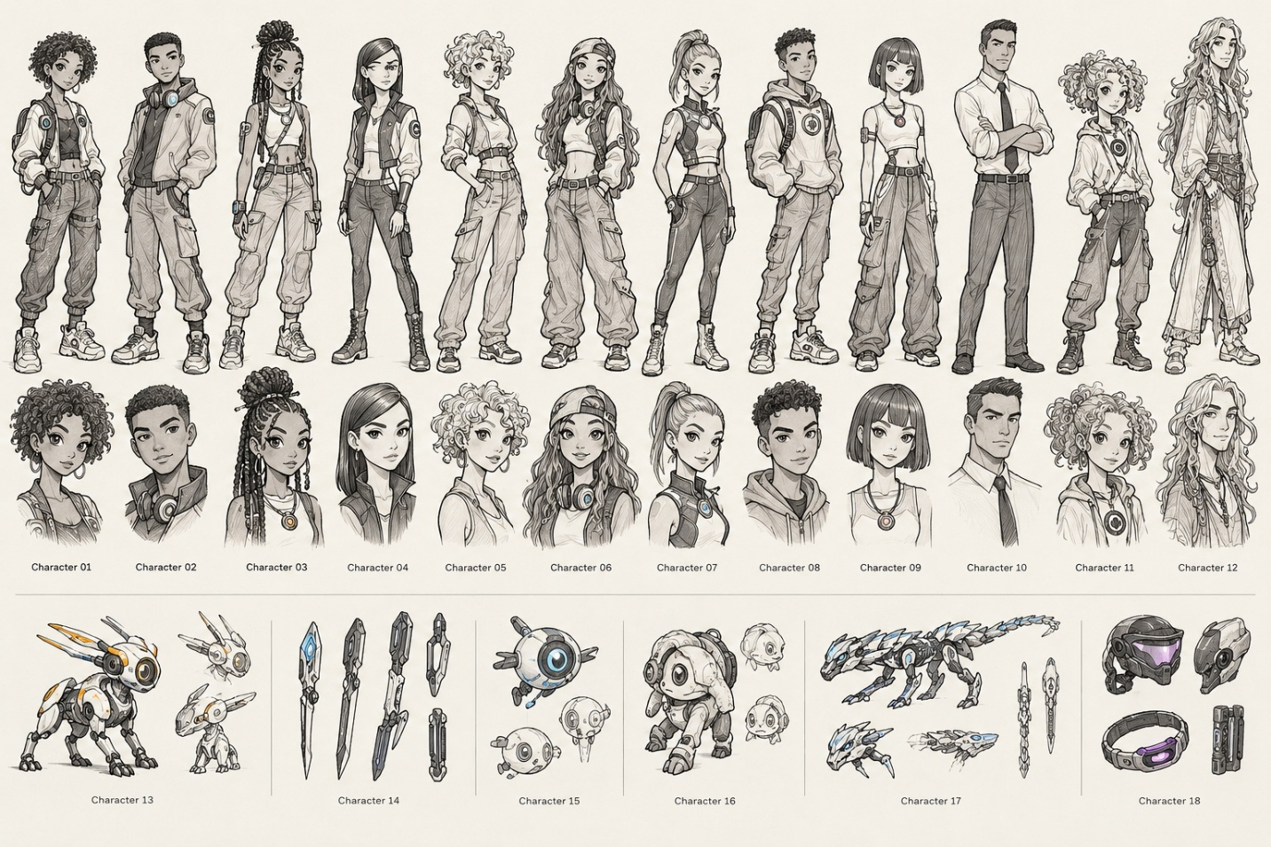
Tagline: Everyone has a reputation. Everyone has a secret. Some secrets refuse to stay buried.
1. The series concept
Chastity Heights is an elite private academy perched above a sprawling, restless city. Its reputation is immaculate: extraordinary graduates, influential families, prestigious scholarships, and a carefully cultivated culture of excellence.
Behind its iron gates, however, the school's real curriculum is survival.
Students navigate messy relationships, sexual identity, forbidden crushes, anonymous gossip accounts, class warfare, demanding jobs, family expectations, and the exhausting performance of maintaining a perfect online persona. Friendships become transactions. Romantic relationships become public property. A single screenshot can destroy a future.
But Chastity Heights has another problem.
Beneath its historic library lies a sealed collection of spell books, zoological specimens that should not exist, and techno-arcane artifacts catalogued by generations of students who were never supposed to discover them. The school's urban legends aren't simply stories. They're warnings disguised as entertainment.
When an anonymous social media account begins publishing students' deepest secrets alongside cryptic references to missing alumni, a group of unlikely classmates discovers that the academy's polished reputation conceals a centuries-old pact.
And the pact is coming due during their final year.
Chastity Heights blends the emotional intensity of contemporary YA drama with the seductive atmosphere of dark academia, supernatural mystery, romantic tension, and technological fantasy. Its characters aren't chosen heroes. They're teenagers and young adults trying to graduate, pay their bills, figure out who they are, and avoid becoming the next cautionary tale.
The central question is not simply Who is exposing everyone's secrets?
It's what happens when the people controlling your reputation also control your future?
2. The setting: a school divided into worlds
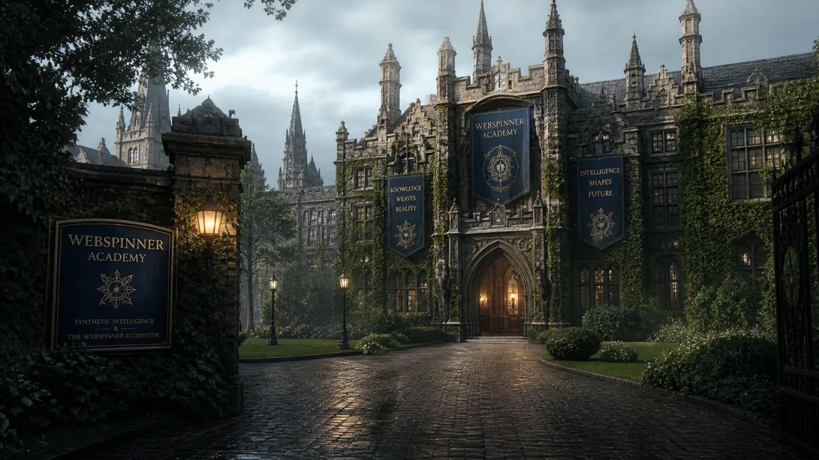
The Heights
Privilege • Tradition • Reputation
The academy's upper campus houses legacy students, scholarship candidates competing for limited opportunities, immaculate dormitories, exclusive clubs, and a student council with surprising political power. Wealth determines who gets second chances—and who gets quietly expelled.
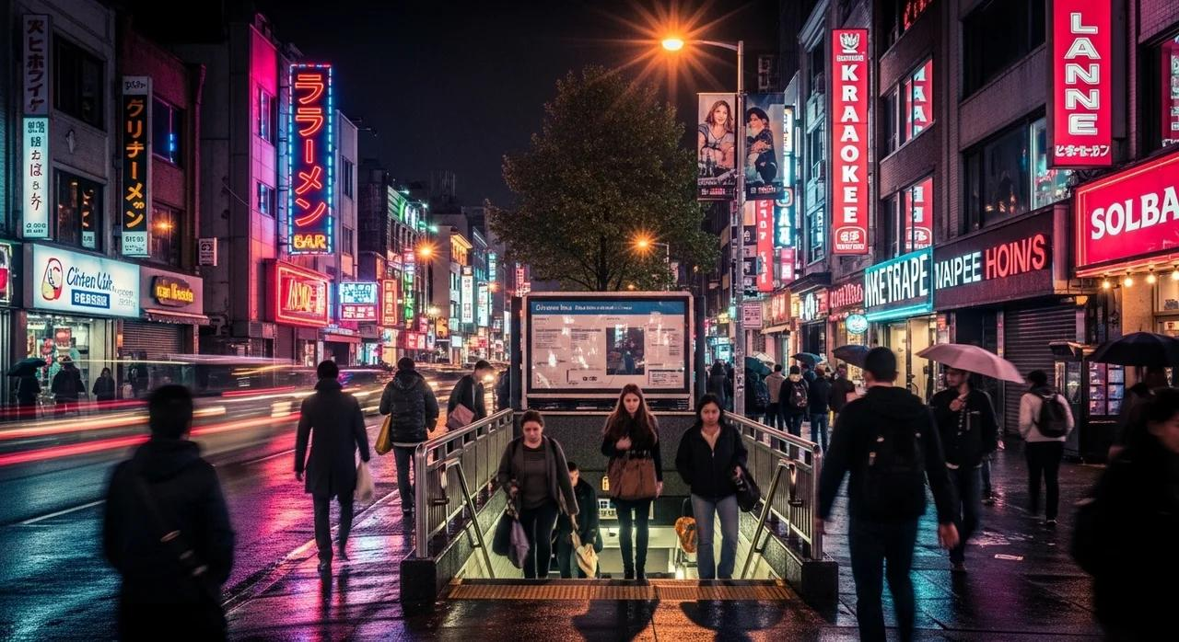
The City Below
Work • Family • Consequences
Beyond the campus walls, students work restaurant shifts, help in family businesses, commute from crowded apartments, care for siblings, and build creative careers. Their lives outside school rarely fit the elegant stories they tell online.
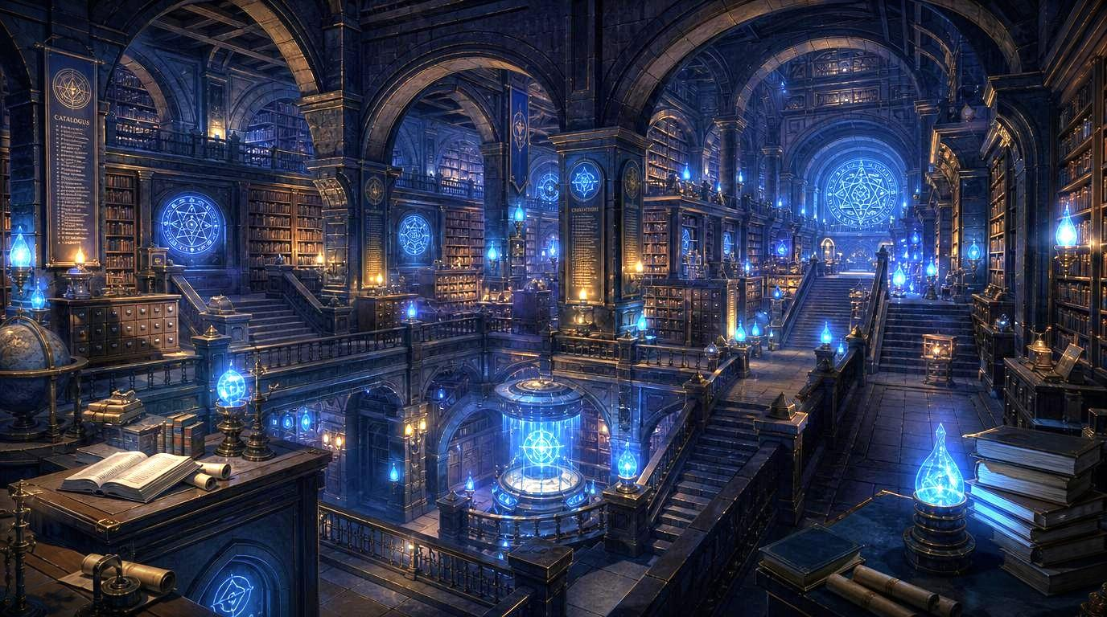
The Undercroft
Arcana • Experiments • Forbidden History
Beneath the original school building lies a restricted archive of enchanted manuscripts, preserved magical creatures, sentient mechanisms, and artifacts that combine old spellcraft with modern electronics. The archive seems to react to the emotional conflicts unfolding above it.
The school is built around a contradiction: it calls itself Chastity because its founders claimed to value purity of purpose, discipline, and restraint. Students have reclaimed the name as a joke, a meme, and occasionally a weapon. In their world, everyone is expected to be authentic—as long as their authenticity remains marketable.
3. The principal cast
The character sheet becomes the visual foundation for the ensemble: distinctive hairstyles, silhouettes, streetwear, jewelry, academic uniforms, cybernetic accessories, and personal devices. Each character should retain their own recognizable design while sharing one cohesive illustrated aesthetic.
The following names and personalities are proposed for the characters in the reference sheet; they can be changed as the project develops.
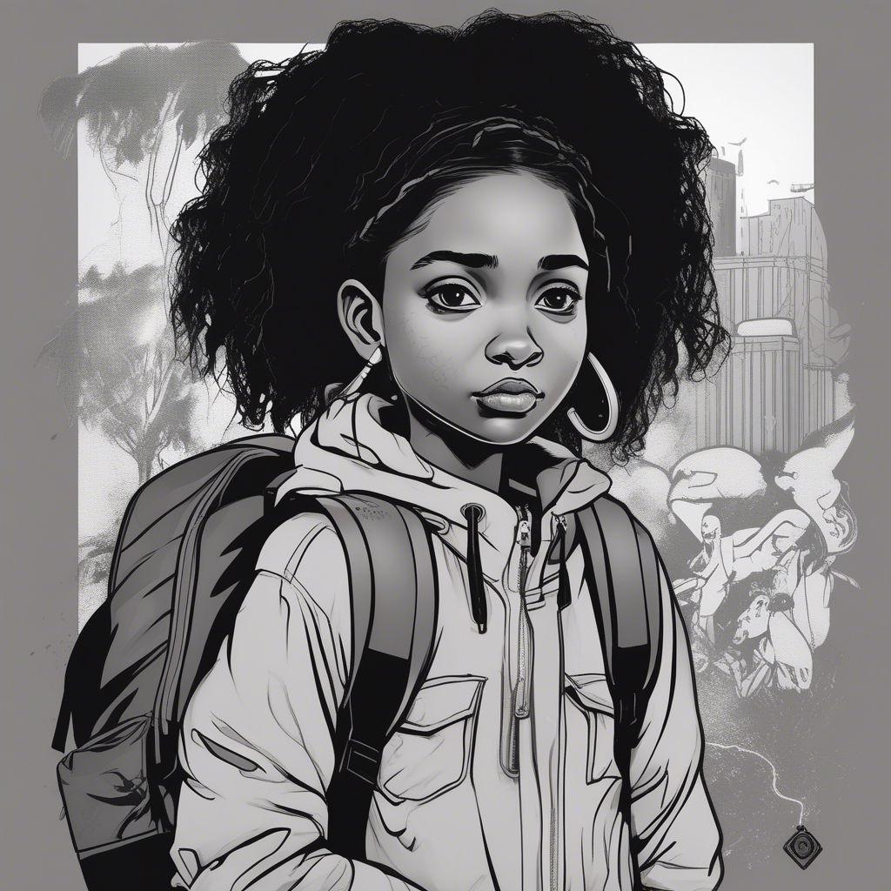
01 — Amara Brooks
The Observer • Scholarship Student • Protagonist
Clever, perceptive, and difficult to impress, Amara documents school life for the student paper. She notices the discrepancies between what people post and how they actually live. Her scholarship depends on maintaining excellent grades and a spotless disciplinary record.
Secret: Her late mother once attended Chastity Heights and left behind a notebook containing references to the Undercroft.
Arc: She must decide whether exposing the truth is worth destroying the lives of people she has come to love.

02 — Julian Cross
The Golden Boy • Legacy Student • Social Chameleon
Julian is the charming son of a powerful donor family. He can talk his way into almost any room, but he cannot convince his parents that his future belongs to him.
Secret: He runs an anonymous advice account that has accidentally become a channel for blackmail and rumor.
Arc: He learns that being liked by everyone is not the same as being known by anyone.
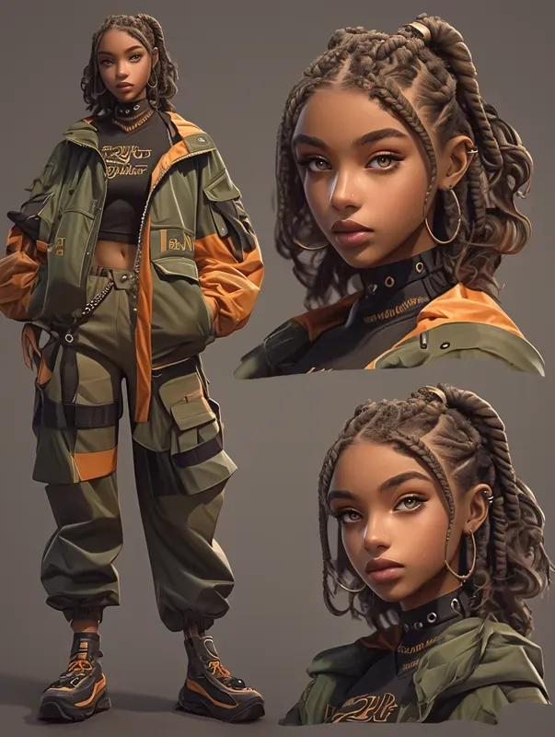
03 — Imani Vale
The Strategist • Debate Captain • Social Architect
Imani treats the school's social hierarchy like a chessboard. She understands influence, knows everyone's alliances, and rarely speaks without considering the consequences.
Secret: She has been trading information with the student council to protect her family's precarious financial position.
Arc: Her carefully engineered control begins to collapse when the people she manipulates become the people she cares about.
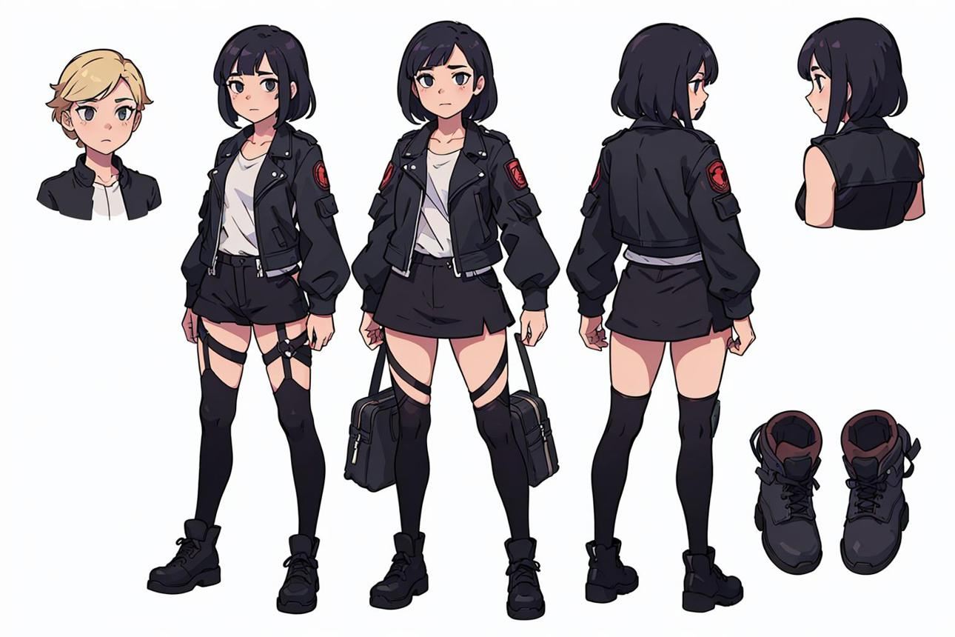
04 — Celeste Park
The Perfectionist • Student Council • Secret Romantic
Celeste is immaculate, disciplined, and intimidatingly competent. She has built her identity around never making a mistake. Privately, she is questioning the future and relationship her family has selected for her.
Secret: She has been meeting someone after hours in the old astronomy wing—and that person is connected to the anonymous account.
Arc: She must separate her own desires from the life she has been trained to perform.
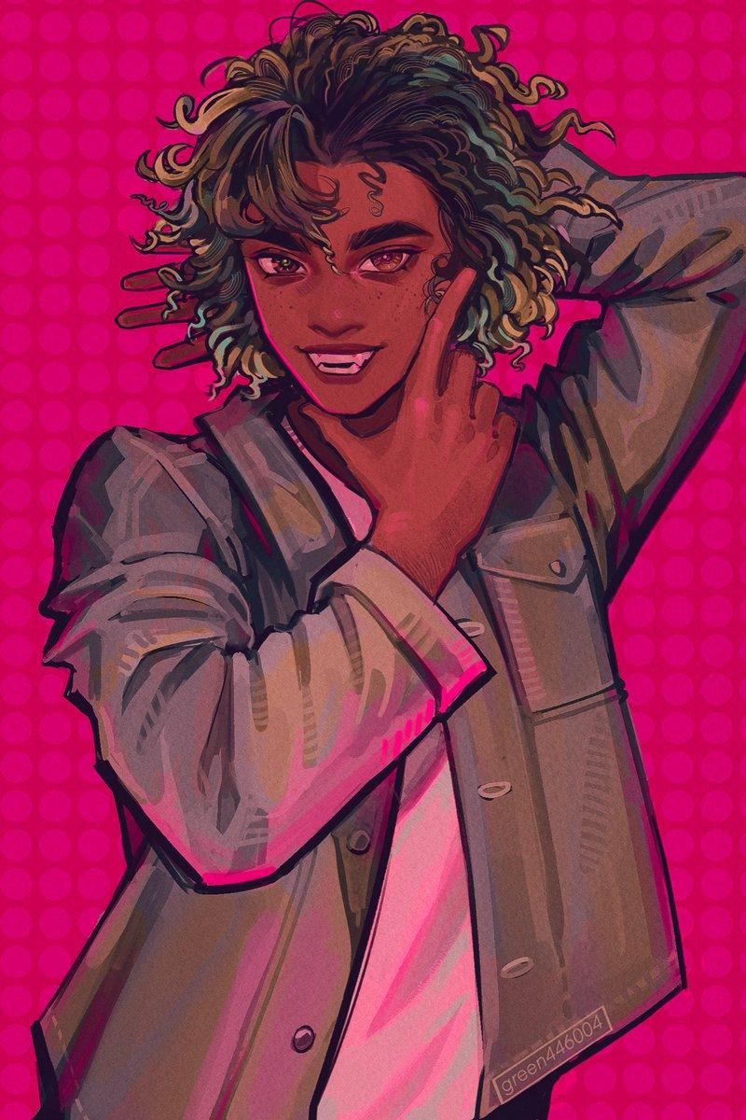
05 — Remy Flores
The Chaos Magnet • Theatre Society • Amateur Occultist
Remy is funny, flamboyant, and seemingly immune to embarrassment. They collect old rumors, experiment with questionable spell books, and turn every awkward situation into a performance.
Secret: A spell copied from a damaged manuscript has started revealing things Remy never intended to know.
Arc: Remy discovers that the truth can be dangerous when it arrives without context.
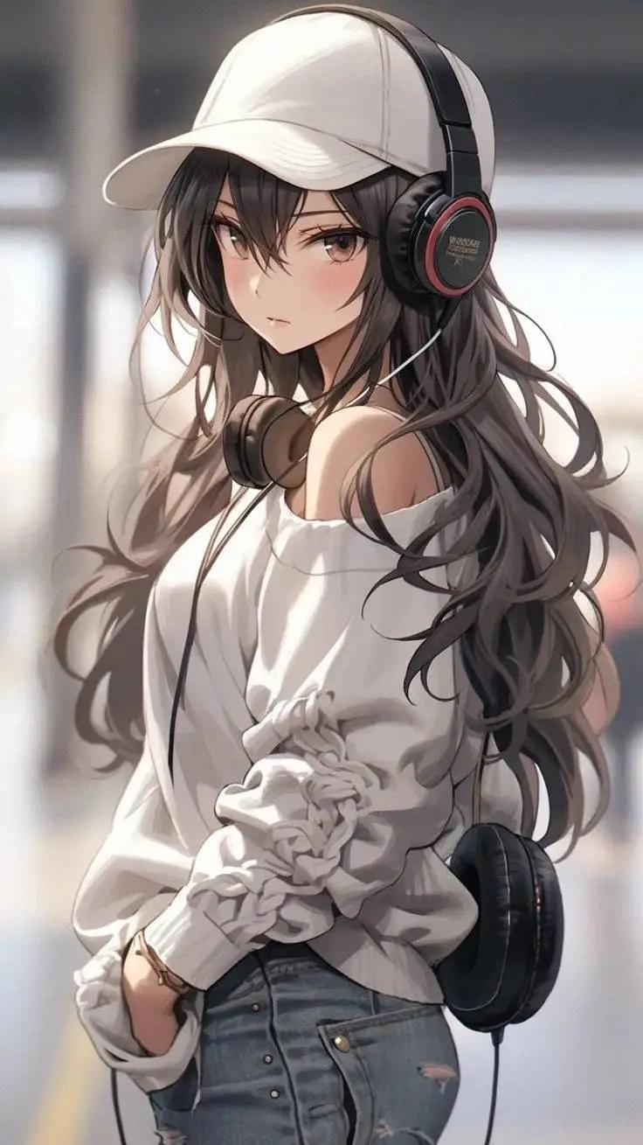
06 — Sloane Mercer
The Influencer • Musician • Brand in Crisis
Sloane has thousands of followers and a meticulously curated lifestyle account. Her videos turn ordinary school events into viral moments, and her family expects her online success to become a business.
Secret: Her most successful content is partly staged, and the person who helps manufacture it has begun threatening to reveal everything.
Arc: She learns to distinguish the audience that consumes her from the friends who actually see her.
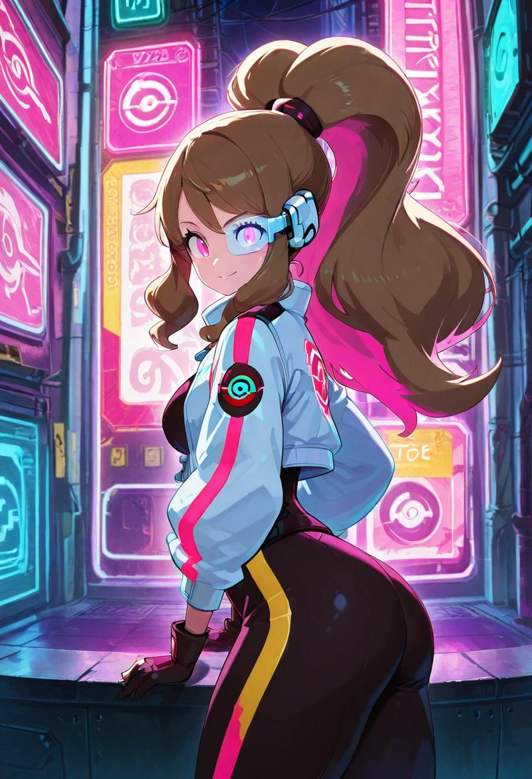
07 — Nadia Reyes
The Athlete • Overachiever • Burnout in Progress
Nadia is a star athlete balancing training, exams, family obligations, and a part-time job. Everyone praises her work ethic while quietly taking advantage of it.
Secret: Her performance-enhancing training device is powered by an artifact she does not understand.
Arc: She must confront the difference between ambition and self-destruction—and learn that rest is not failure.
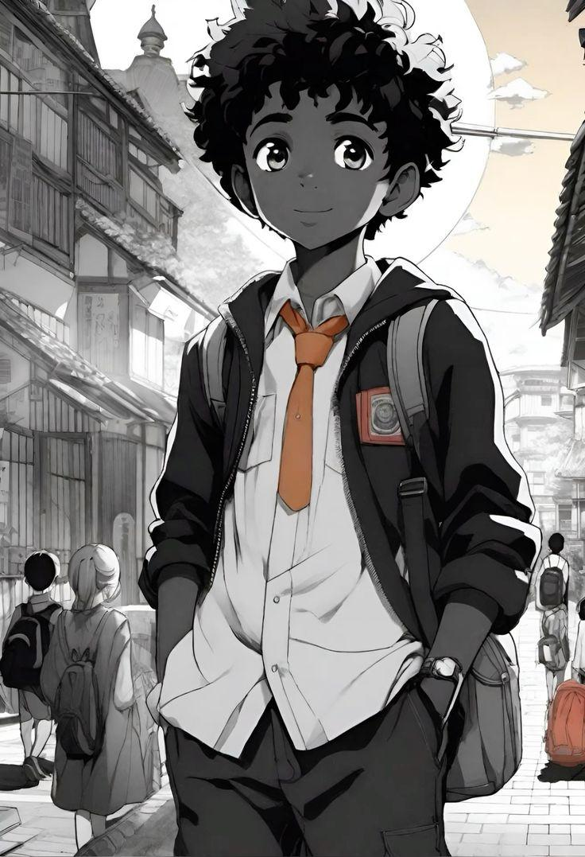
08 — Micah Bell
The Everyman • Part-Time Worker • Accidental Investigator
Micah works evenings at a neighborhood electronics repair shop. He understands hardware better than social politics and has little patience for students who confuse money with character.
Secret: A broken device brought into the shop contains recordings from a supposedly abandoned section of the school.
Arc: He finds himself at the center of a mystery he never wanted, forcing him to decide how much risk he can afford.
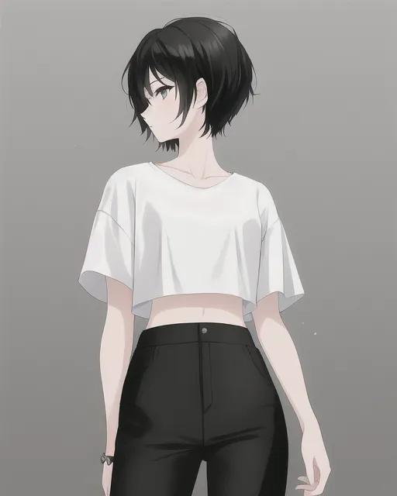
09 — Yuna Cho
The Archivist • Academic Prodigy • Pattern Hunter
Yuna knows the school's records better than some of its teachers. She catalogs artifacts, researches alumni, and quietly corrects the historical inaccuracies in official school publications.
Secret: The archive contains two versions of the same school history, and someone has been altering the newer one.
Arc: She learns that preserving the truth sometimes means challenging the institutions that entrusted it to her.
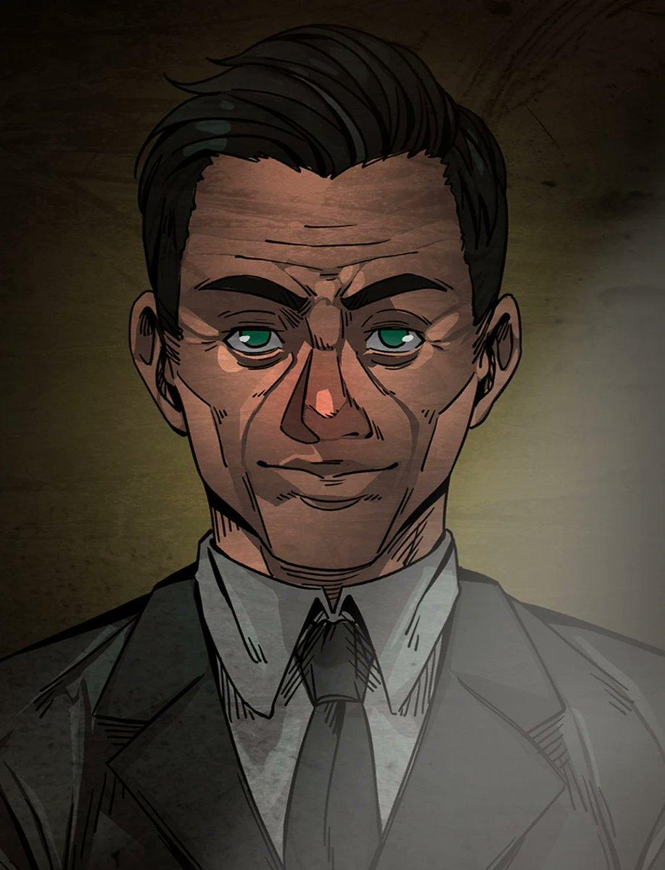
10 — Dr. Adrian Voss
The Faculty Insider • Ethics Instructor • Unreliable Mentor
Voss teaches ethics and technology governance. He warns students about digital permanence, coercion, and the misuse of power, yet seems strangely knowledgeable about the school's oldest legends.
Secret: He was once part of a student research group that investigated the Undercroft—and one of its members disappeared.
Arc: He must decide whether protecting students means telling them the whole truth or keeping the institution's most dangerous secret buried.
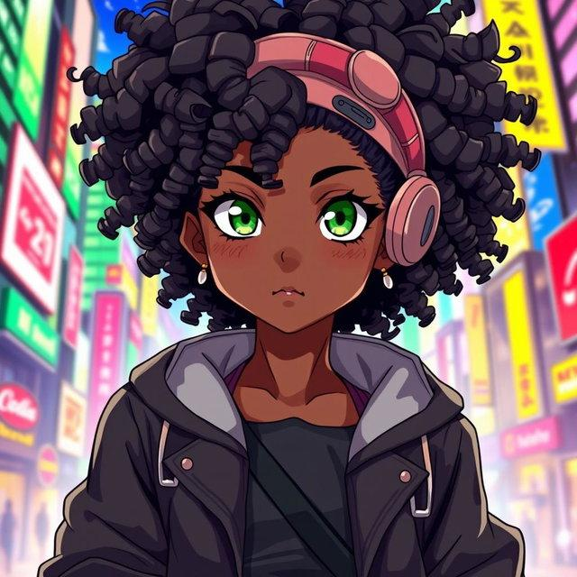
11 — Kit Bellamy
The Meme Queen • Digital Sleuth • Reluctant Conscience
Kit turns school gossip into sharp, hilarious commentary. Her anonymous parody account is beloved by students and despised by administrators.
Secret: She knows more about the original gossip network than she admits, including why it was created.
Arc: She must face the difference between punching up at privilege and humiliating someone who cannot fight back.
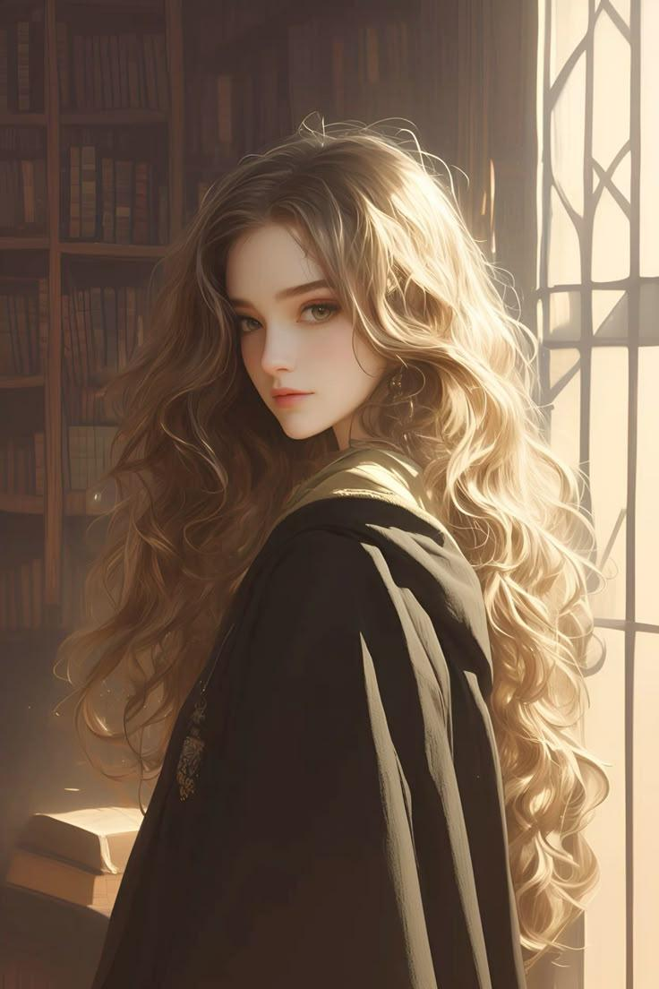
12 — Vivienne Ashcroft
The Heiress • Occult Traditionalist • Keeper of the Pact
Vivienne belongs to a family whose name is engraved on the oldest buildings at Chastity Heights. Elegant and enigmatic, she knows which doors open after midnight and which names are forbidden in the archive.
Secret: Her family has been guarding the school's pact for generations. She has been raised to inherit the responsibility, whether she wants it or not.
Arc: She must choose between loyalty to her family and the freedom to define her own future.
The supernatural companion designs
The additional creature and artifact concepts from the character sheet can become recurring elements of the school's hidden ecosystem.

13 — Rook
The Archive Hound
A mechanical zoological companion that tracks traces of spell energy. It bonds with Micah and develops an inconvenient habit of stealing restricted objects.
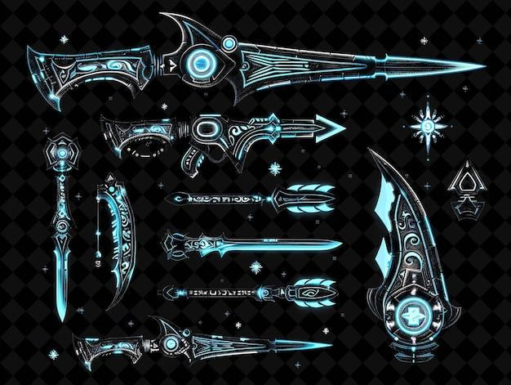
14 — The Sigil Keys
Access Artifacts
Bladed-looking instruments that unlock sealed mechanisms by matching the user's intent to a particular magical frequency. They are not ordinary weapons.

15 — Pip
The Surveillance Familiar
A floating orb that can record events, detect invisible creatures, and occasionally replay footage that was never recorded.

16 — Button
The Living Relic
A seemingly harmless creature whose shell contains a dormant artifact. It responds to lies by changing color, making it both invaluable and a terrible companion for anyone with secrets.
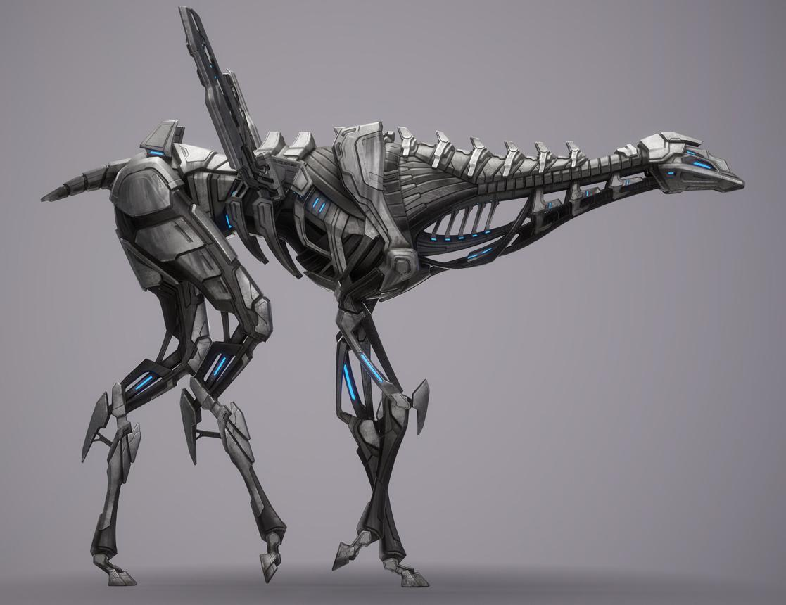
17 — The Glasswyrm
The Forbidden Specimen
A rare techno-zoological creature capable of moving through the school's wired infrastructure. It appears whenever someone tampers with the archive.
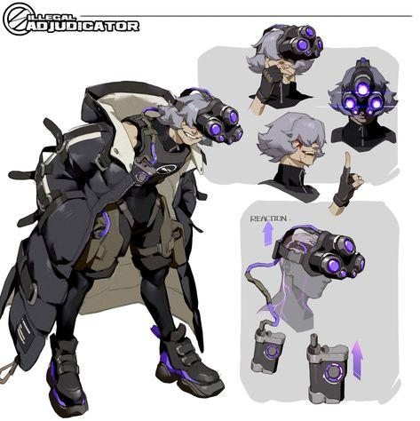
18 — The Veil Set
Identity Artifacts
A collection of wearable devices that can conceal a user's magical signature, distort their digital presence, or project an artificial persona. Their effects are powerful, but never entirely reliable.
4. The romantic web: desire, intimacy, and reputation
The romantic drama should be emotionally messy, sometimes funny, sometimes painful, and occasionally scandalous. The 16+ rating allows mature themes, sexual identity, flirtation, innuendo, relationship conflict, and non-graphic intimacy without turning the characters into caricatures or relying on explicit sexual scenes.

Amara × Julian — The truth versus the fantasy
She distrusts his privilege. He envies her independence. Their attraction grows through late-night investigations, arguments, and moments when their public masks slip. But Julian's anonymous account threatens to expose the very secrets that bring them together.
Celeste × Vivienne — The forbidden alliance
Two carefully controlled young women begin meeting in secret to investigate their families' involvement with the school. Their connection forces them to confront the difference between privacy and shame, and between genuine affection and inherited expectations.
Sloane × Nadia — The almost-relationship
Their chemistry is obvious to everyone except the people involved. One fears public scrutiny; the other is exhausted by being expected to excel at everything. Neither wants their feelings converted into online entertainment.
Remy × Kit — Flirting with disaster
Their teasing, pranks, and competing anonymous accounts conceal a growing attachment. But when one of their jokes causes real harm, they must decide whether the thrill of being untouchable is worth losing someone who knows them offline.
Micah — The outsider's dilemma
Micah's complicated connection with the school community challenges his belief that remaining uninvolved is the safest choice. A developing romance with someone from the Heights tests whether a relationship can survive vastly different financial realities.
The romantic web is not a collection of neat pairings. Crushes can be unrequited, people can change their minds, and some relationships will end. Queer identities are treated as ordinary parts of the cast's lives, not mysteries that must be solved or scandals that must be punished.
The dramatic engine comes from emotional consequences: jealousy, mixed signals, incompatible expectations, betrayal, consent, vulnerability, and the temptation to make private feelings public.

5. The central mystery: The Chastity Pact
One hundred years ago, a group of students at the original academy discovered an artifact known as the Mnemonic Engine. It could preserve memories, bind promises, and record the emotional residue of significant events.
The founders believed they could use it to preserve the school's legacy forever.
They were wrong.
The Engine began collecting not only memories but secrets: concealed identities, broken promises, private betrayals, and events its owners wished to erase. The school's governing families constructed the Undercroft around it and established a pact requiring every generation to conceal the artifact's existence.
Over time, the pact became a mythology of its own. Students spoke of a ghost in the old observatory, a book that writes the names of the unfaithful, and a bell that rings before someone disappears.
Most students dismissed these stories.
Then, during the opening week of senior year, a new anonymous account appears:
@THEHEIGHTSREMEMBERS
Its first post contains a photograph of a student who graduated decades ago—and a message claiming that the school erased their existence.
The next post reveals a secret no living person should know.
The third contains a photograph taken inside a locked room.
The account is not merely collecting gossip. It is reproducing memories stored inside the Mnemonic Engine, including memories that the students themselves cannot recall.
The more the students investigate, the more the Engine begins responding to their relationships, fears, and conflicts.
Someone is using the school's history to manipulate its present.
But is the account controlled by a student, a faculty member, a family dynasty—or the artifact itself?

6. Season One: The Last Bell
10 episodes • Serialized mystery • Character-driven ensemble drama
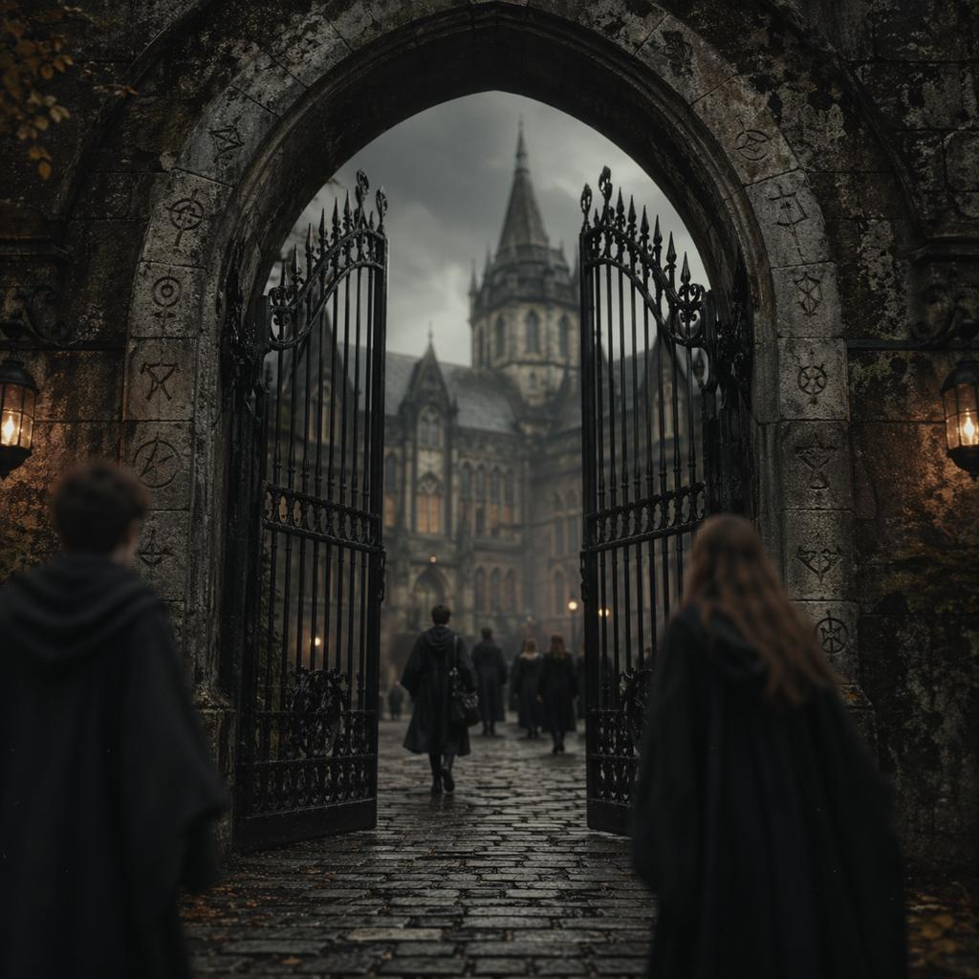
Episode 1 — Orientation
Amara arrives determined to protect her scholarship. Sloane livestreams the school's opening ceremony, Julian charms the incoming class, and Remy dares Kit to enter a supposedly haunted corridor. That night, @THEHEIGHTSREMEMBERS publishes its first post.
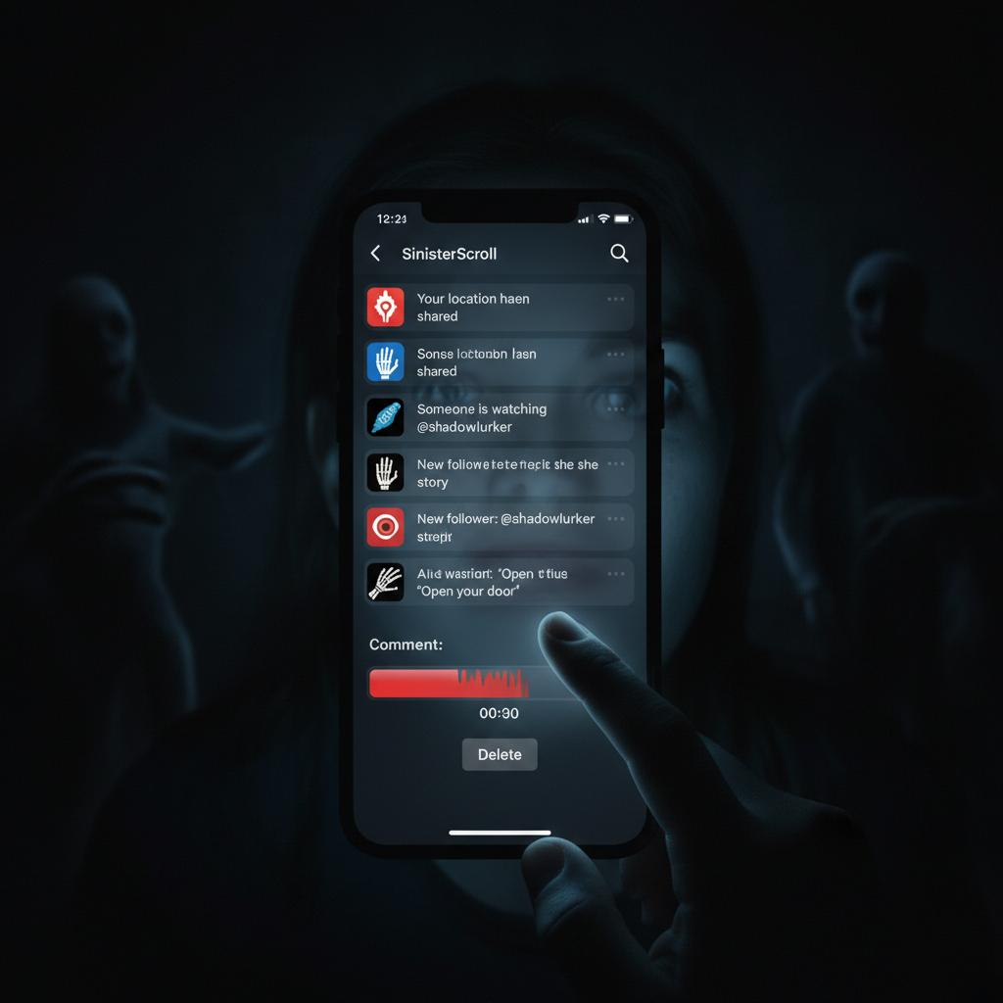
Episode 2 — Receipts
A leaked private conversation fractures a friendship group. Students accuse one another of betrayal while the administration launches a disciplinary investigation. Micah discovers a corrupted memory file on a device brought into his repair shop.
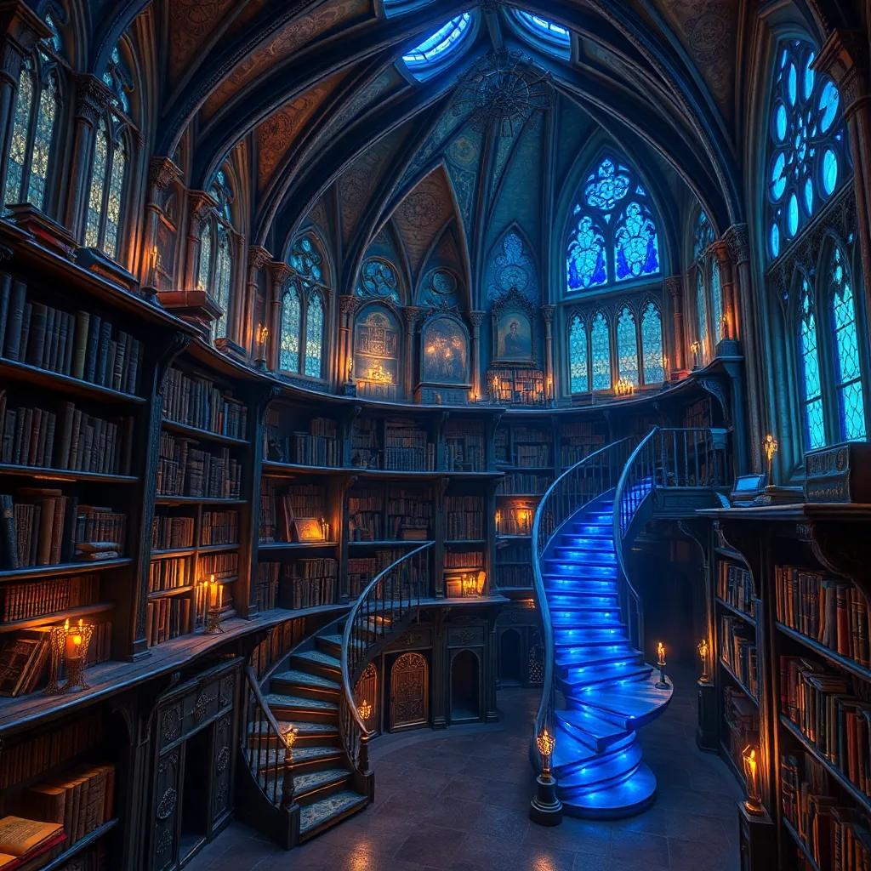
Episode 3 — Extra Credit
Yuna discovers a discrepancy in the school's archival records. Remy experiments with a spell that reveals concealed writing, uncovering a map to the Undercroft. Meanwhile, Amara and Julian's investigation begins to blur the line between suspicion and attraction.
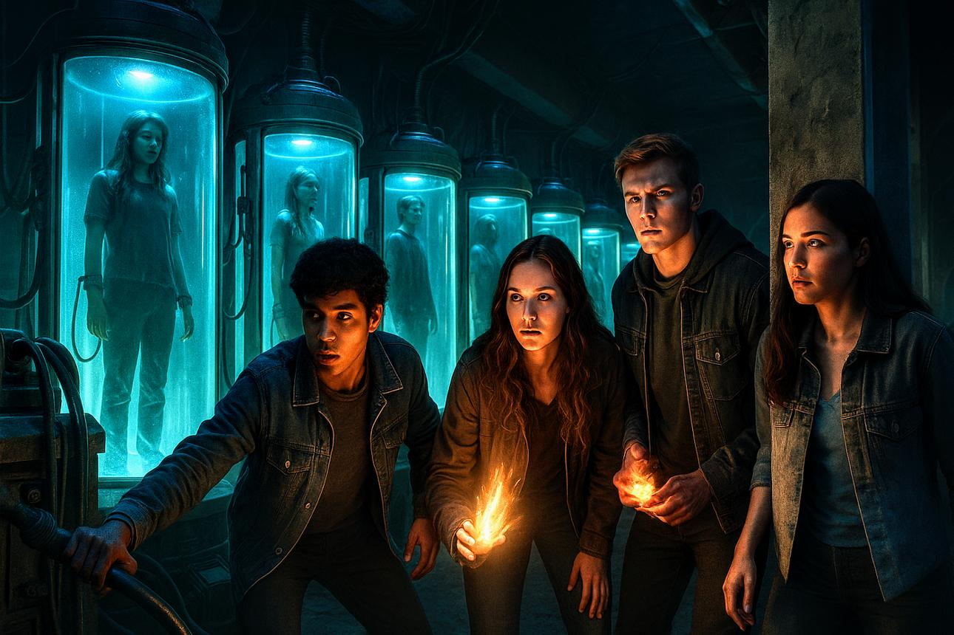
Episode 4 — Show and Tell
During a school showcase, a supposedly extinct zoological creature escapes its enclosure. Nadia's mysterious training device activates, and a mechanical hound leads Micah to a sealed door. The students realize that the legends have a physical basis.
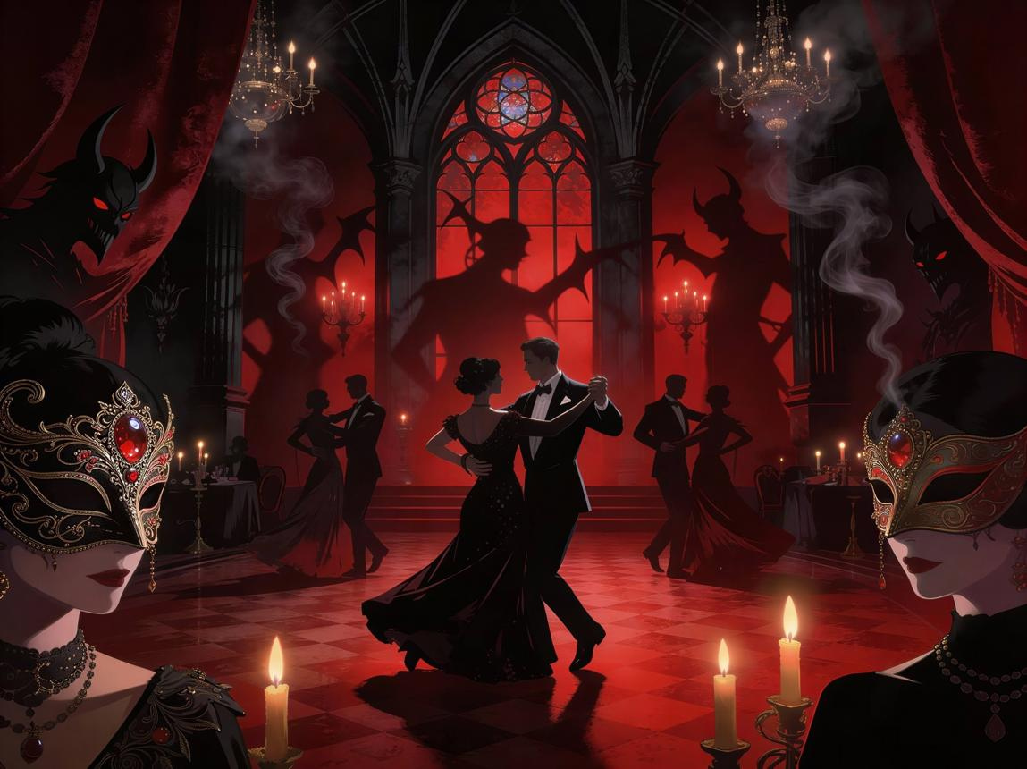
Episode 5 — Dress Code
A formal gala exposes the divide between wealthy legacy families and scholarship students. An anonymous confession account triggers a scandal, and Vivienne discovers that her family has been financing the school's secret archive. A romantic betrayal changes the balance of power.
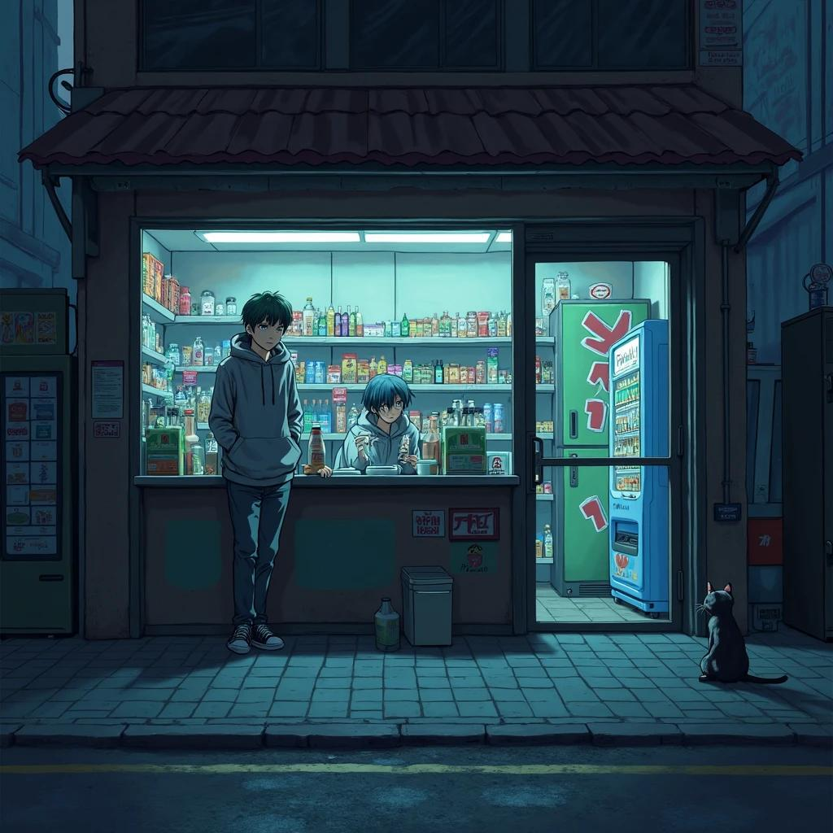
Episode 6 — Clocked Out
Exams, work shifts, family emergencies, and extracurricular commitments push the group to breaking point. Amara misses an important deadline while investigating the mystery. Nadia's performance suffers. For once, the students cannot solve their problems by posting about them.
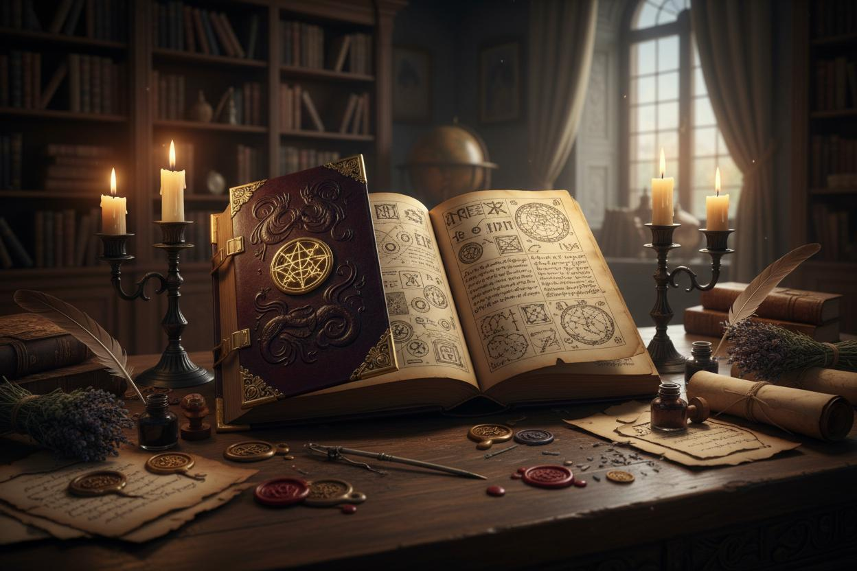
Episode 7 — Terms and Conditions
The group finds a spell book describing the original pact. Each signature represents a promise that cannot be broken without a consequence. Kit discovers that the anonymous account has been active for far longer than anyone suspected.
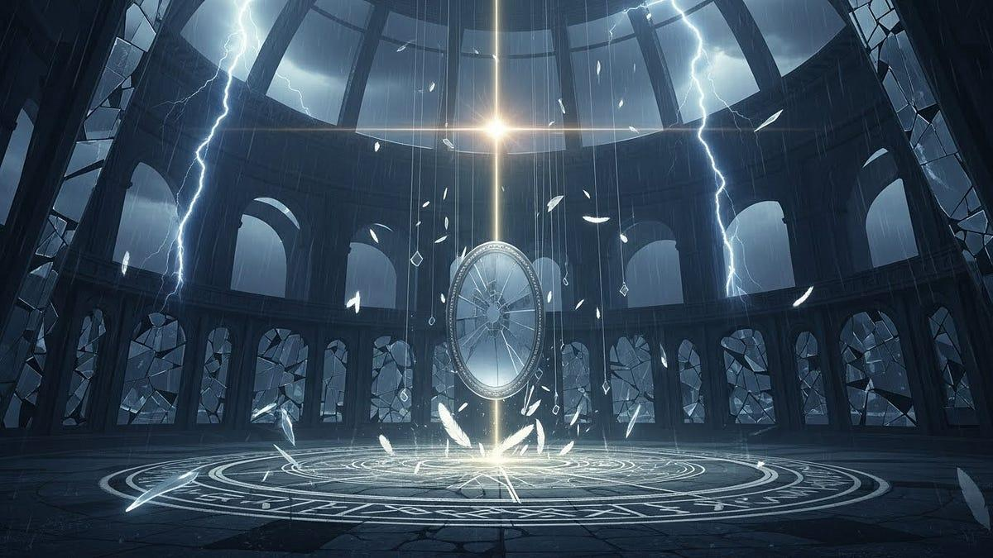
Episode 8 — The Unperson
A former student appears in an old recording, despite having no official enrollment history. Voss finally admits that a student disappeared during his own time at the academy. The group suspects that the Mnemonic Engine can alter more than records—it can distort collective memory.
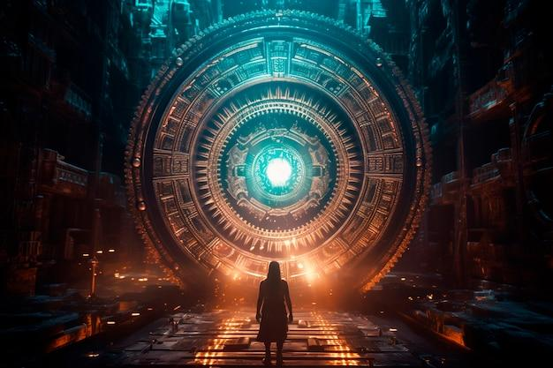
Episode 9 — Senior Privilege
Julian's involvement in the anonymous account comes to light. Amara feels betrayed, and the group fractures. Vivienne learns that her family intends to activate the Engine during graduation, preserving the academy's influence by sacrificing the memories of someone connected to the original pact.
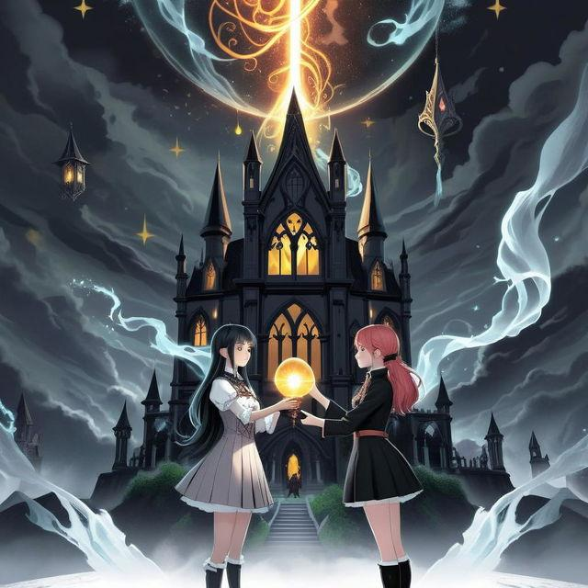
Episode 10 — The Last Bell
On graduation night, the Engine awakens beneath the school. The students must decide whether to destroy it, expose it, or risk using it to recover the erased student's identity. They interrupt the ceremony and release a fragment of the school's hidden history.
The immediate threat ends—but the Engine displays a new message: THE PACT WAS NEVER THE ORIGINAL AGREEMENT.
In the final scene, a previously unknown account posts a photograph of another academy, revealing that Chastity Heights is only one node in a much larger network.
7. The story's themes and tone
Theme | How it drives the drama
Social media personas | Online popularity conflicts with private identity; viral posts become instruments of control.
Classism | Wealth buys privacy, legal protection, and second chances, while poorer students face disproportionate consequences.
Sexuality and intimacy | Students navigate attraction, identity, boundaries, rejection, and the pressure to disclose private relationships.
Work-life balance | Jobs, caregiving, academics, and extracurricular demands create genuine stakes beyond school gossip.
Friendship and betrayal | The group must learn whether trust can survive when everyone has something to hide.
Urban legends | Folklore offers clues to the school's hidden past, but not every legend tells the truth.
Spell books and artifacts | Magic functions through rules, costs, and unintended consequences rather than solving every problem conveniently.
Zoological creatures | Strange creatures serve as companions, threats, clues, and evidence that the supernatural world is real.
The tone should move between sharp comedy, intimate coming-of-age drama, romantic tension, eerie supernatural suspense, and occasional action. The characters can be vain, impulsive, ambitious, selfish, funny, vulnerable, and wrong without being reduced to stereotypes.
For a 16+ audience, intimacy and sexuality should be treated with emotional maturity and non-graphic presentation, with consent and privacy central to the story. The supernatural mystery should intensify the human conflicts rather than replace them.

8. Visual identity and production direction
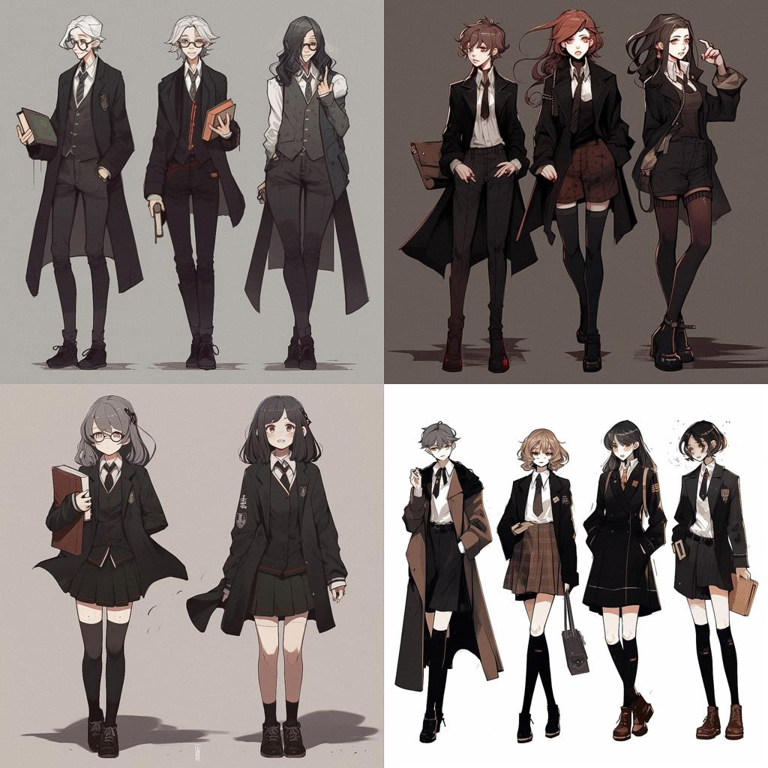
Character continuity
Preserve the reference sheet's distinctive hairstyles, facial features, clothing silhouettes, and accessories. Amara, Julian, Imani, Celeste, Remy, Sloane, Nadia, Micah, Yuna, Voss, Kit, and Vivienne should each remain recognizable in every scene.
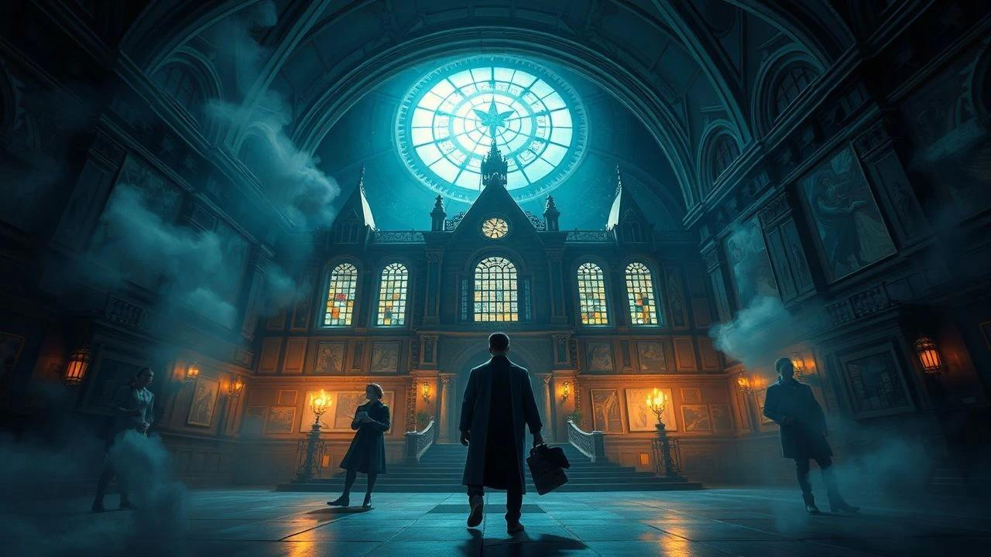
Art direction
Use expressive inked linework, nuanced grayscale shading, and selective color accents. Keep the everyday school scenes grounded in charcoal, ivory, muted blue, and burgundy; let the Undercroft introduce luminous cyan, violet, and antique gold.
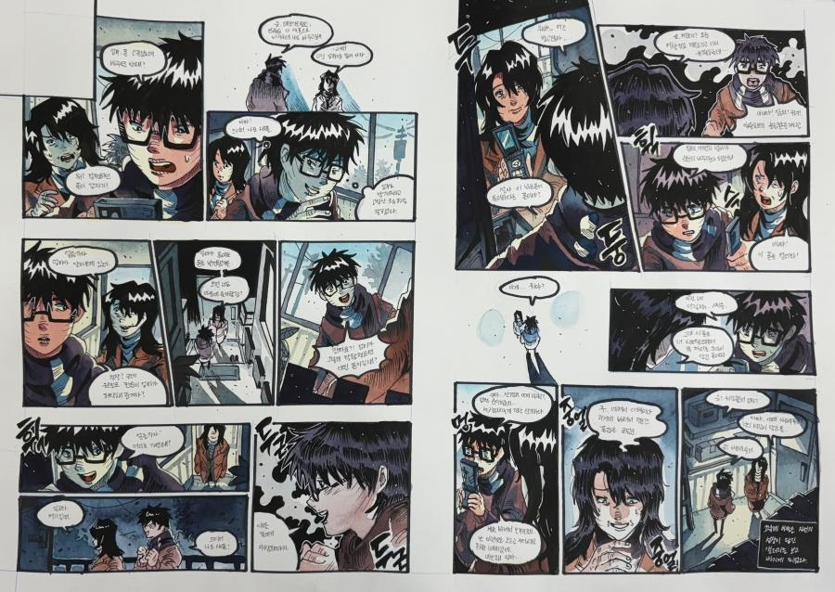
Storytelling language
Use split-screen social feeds, message overlays, anonymous posts, unreliable recordings, and tightly framed facial expressions. When the supernatural intrudes, let the page composition become less orderly—as if the world itself is breaking its own rules.
9. Where the story can go next
The first season resolves the immediate mystery while opening three larger storylines:
- Season Two — The Other Heights: The group investigates other institutions connected to the Mnemonic Engine and learns that the pact may have been designed to protect something far more dangerous than a school's reputation.
- Season Three — The Archive War: Families, alumni, students, and supernatural factions compete to control the recovered records and the creatures bound to them.
- The Endgame — Graduation Is Not Escape: The characters discover that leaving Chastity Heights does not free them from the system. They must decide whether to dismantle the network or transform it into something fundamentally different.
The series' emotional destination should remain personal. Amara needs to choose who she wants to become; Julian needs to earn trust without manipulating it; Vivienne needs to break with inherited expectations; and the ensemble must learn that growing up means accepting responsibility for what they do with the truth.
The defining promise of Chastity Heights: everyone arrives trying to protect their future. They leave understanding that the future cannot be protected by sacrificing everyone else's freedom.

