# Chastity’s Chess Chapters

## Table of Contents

Chapter 0: Introduction

Chapter 1: The Basic Rules of Movement

Chapter 2: Chastity’s Recommended Openings

Chapter 3: Chess variants

* [Crazyhouse](https://www.pychess.org/variants/crazyhouse)
* [Atomic](https://www.pychess.org/variants/atomic)
* [Shogi](https://www.pychess.org/variants/shogi)
* [Xiangqi](https://www.pychess.org/variants/xiangqi)

Chapter 4: Chess Software

* [Stockfish Strong open-source chess engine](https://stockfishchess.org/)
* [Fairy-Stockfish Strong open source chess variant engine](https://fairy-stockfish.github.io/)
* [XBoard/WinBoard](http://hgm.nubati.net/)
* [En Croissant](https://encroissant.org/)
* [pgn-extract](https://www.cs.kent.ac.uk/people/staff/djb/pgn-extract/help.html)
* [ChessX](https://chessx.sourceforge.io/)

Chapter 5: The Best Chess websites

* [lichess](https://lichess.org/) is the main site for standard Chess and variants like Crazyhouse
* [lishogi](https://lishogi.org/) has Shogi, also known as Japanese Chess
* [pychess](https://www.pychess.org/) has more variants than lichess, including Duck Chess
* [pychess_alternates](https://pychess-alternates.onrender.com/) is the place for Coffeehouse and Coffee Shogi!
* [playstrategy](https://playstrategy.org/) has not only chess but also games like draughts and go
* [chessvariants](https://www.chessvariants.com/) for learning more about Chess variants.

Chapter 6: How to Improve at Chess

* The Meaning of Chess Ratings
* Keep a Database
* Take Notes

Chapter 7: The Value of Chess Notation

* Names of the Squares
* Letters of the Pieces

Chapter 8: Too Long Didn’t Read

Chapter 9: The Making of the Paperback

Chapter 10: The Making of the Ebook

# Copyright

[Chastity’s Chess Chapters](https://chastitychesschallenge.com/chastitys-chess-chapters/) © 2025 by [Chastity White Rose](https://chastitywhiterose.com/) is licensed under [Creative Commons Attribution-NonCommercial-ShareAlike 4.0 International](https://creativecommons.org/licenses/by-nc-sa/4.0/)

What this means in plain English is that although Chastity White Rose, which is known as Chandler Klebs legally, is the author of all the text and artwork in this book (except for Chess pieces from the public domain). She has the final say in what went into this book and future editions.

At the same time, you have the right to share this book, copy it, or reformat or convert it to whatever digital or print form is easy for you to read. Chastity stands opposed to DRM (Digital Rights Management) because the game of Chess is free to play for everyone. In the same way, this book should be free (libre) for everyone!

This license means that while you certainly can buy copies of this print and/or digital book to support the author, your rights to read it never expire. Chastity wants people to learn to play and enjoy Chess. This book is merely a means to that end.

What you may not do is try to sell it as if it were your book because Chastity put her time, energy, and money into making this book with the goal of helping people play Chess and teaching it in her style. You can share and adapt it to help others learn, including translating it into other languages, but you must make it clear that it is not the original work.

# Chapter 0: Introduction

This chess book is an ongoing project for those who have falsely heard that chess is hard to learn. It will be updated as needed for the most effective teaching! This book, Chastity’s Chess Chapters, is the official guidebook of what my business, Chastity’s Chess Challenge, is all about. I will be a chess teacher to the LGBTQIA+ community and people with disabilities.

By meeting in person, recording videos, or through some Creative Writing, I will do my best to make sure that nobody goes through life never learning how to play chess, the world’s most popular board game sport!

I learned to play chess when I was 9 years old. My friend Patrick taught me, and I won the third game. He said he created a monster. Up to that point, I had always heard that chess was complicated. After learning the game, I struggled to find other people to play with. You have to remember that at that age I didn’t have the internet.

The internet changed the game because you no longer need to wait for another human in your town to play with. You can set up matches with random people on lichess.org, chess.com, and even Facebook. If all else fails, you can download a chess program and play against the computer using some of the best chess engines available.

However, I will warn you that playing against a computer comes with pros and cons. Most computer programs will tear apart a player new to the game unless they are set to the lowest level AI. It can be discouraging to new players who lose twenty games in a row and then think, “I guess I am really bad at chess,” and then get discouraged and quit playing.

Chess is a game where you are going to lose half the time because it’s a game of pure skill where anyone can win if they can outsmart their opponent. You don’t need to be a genius to play chess, and you certainly don’t have to know math or memorize opening theory to get started playing today. You only need to know the rules of chess, which can be learned in less than half an hour.

The book you are reading now is meant to teach the rules and be a reference to look back on if you forget. I will also include some common suggestions on a few good ways to get started playing and what your first moves should be as a beginner.

In Chapter 4 I provide a list of the best Free and Open-Source Software that allow you to play Chess against your computer by training against Stockfish or manage databases of your games.

In Chapter 5, I list my favorite websites where I play Chess and its many variants almost daily. I am very active on there and it is quite possible that you will find me under the username [chastitywhiterose](https://lichess.org/@/chastitywhiterose) on most of the websites listed there.

# Chapter 1: The Basic Rules of Movement

Hello, I am Chastity White Rose and I am a chess player. I am one of many people who love the game of chess because it is one of the best games for playing with other people and understanding how their mind works.

The actual rules of chess are not very hard to learn. There are 6 types of pieces, and they have very specific rules of how they move that never change. Compared to the complexity of most video games that people play, chess is actually very simple because there is a lot less to learn and remember. If you have played Pokemon, Final Fantasy, or Tetris, then you are smart enough for chess!

But chess is not specifically a video game. It’s a board game that has only recently turned into a video game because there are chess programs for every machine you can imagine. You can play from a regular Personal Computer or a Smart Phone these days and play with other people all over the world through the internet. Later on, I will talk about some of the best sites to play chess online.

But first, a basic explanation of the goal of chess. The way to win the game of chess is to checkmate the opponent’s king. Checkmate means that you are attacking the king and it has nowhere to move to escape and would be captured on the next turn. I will show examples of what this looks like later on.

For now, I intend to teach you the basic rules of how each piece moves by isolating them from the other pieces and highlighting the empty squares by coloring those squares in green. Just think “green means go,” as in a traffic light.

Below is a picture of what the chessboard typically looks like if you are playing a computer chess program. This picture shows how the pieces are arranged. The chess set used is called Merida, and it is one of the piece sets available on lichess.org, where I play chess online.

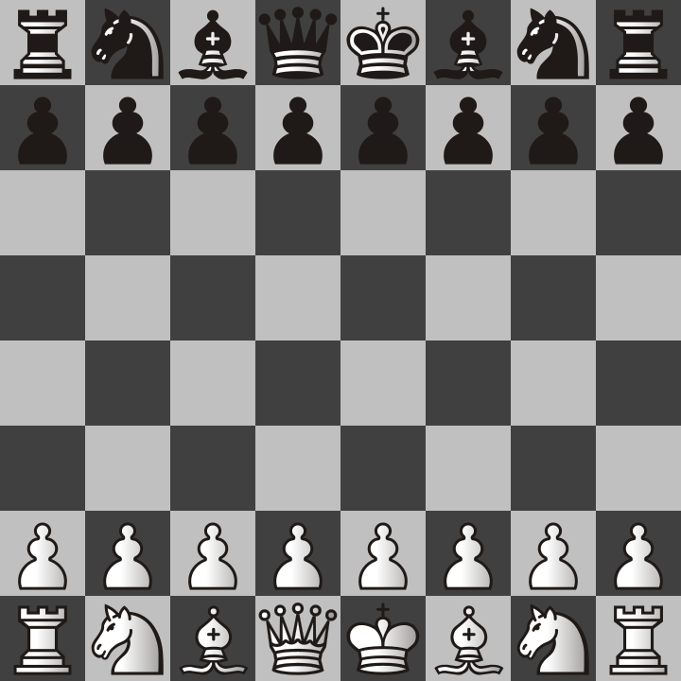

Chess_Start.png

I will next explain the names of each of these pieces and how they move.

The first piece that you will want to learn is the pawn. The pawns are the most abundant piece on the board, and each side (black and white) has 8 of them to start with. They only move in one forward direction (away from the side they started on)

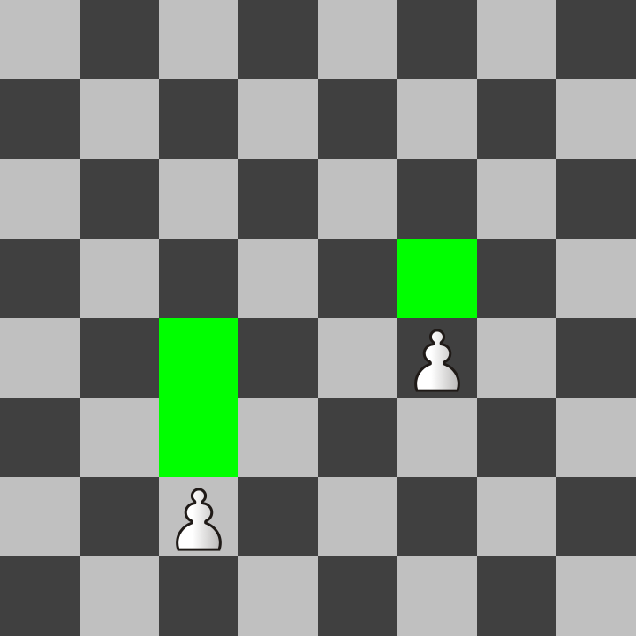

Chess_Pawn_Move.png

Pawns can move one square forward, except that they can also move two spaces on their first move. Notice that the left pawn is in its starting position and has not moved yet. Because of this, it can move to either square in front of it highlighted in green, but only on this first move.

Pawns capture other pieces differently than the way they move onto empty spaces. They capture only one space diagonally forward. Consider the following image:

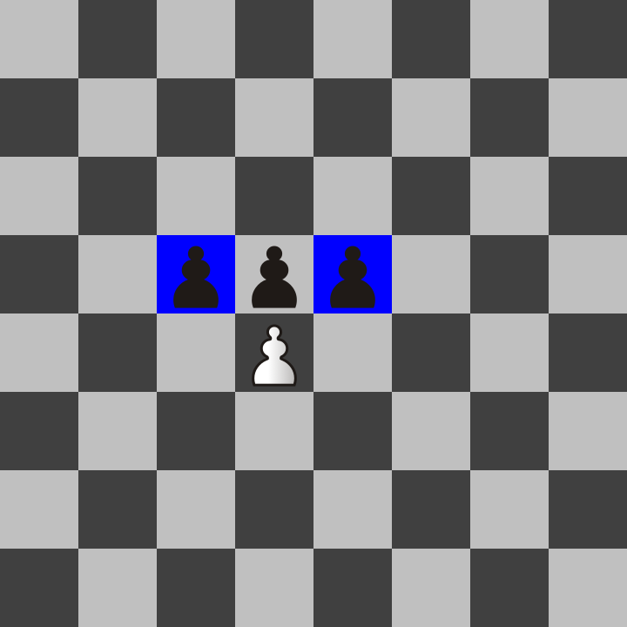

Chess_Pawn_Capture.png

The white pawn can capture either of the two black pawns on the blue squares because they are diagonally one space in front. Notice that the white pawn cannot capture the pawn exactly one space in front. It can only move that way if the square is empty.

The previous two pages contain everything you need to get started with moving pawns. There is another rule called en passant that I will cover later in the special rules at the end of this chapter because it is quite rare to see. The main thing right now is to learn how each piece moves. Also, I want to explain my convention of how I use color in this book.

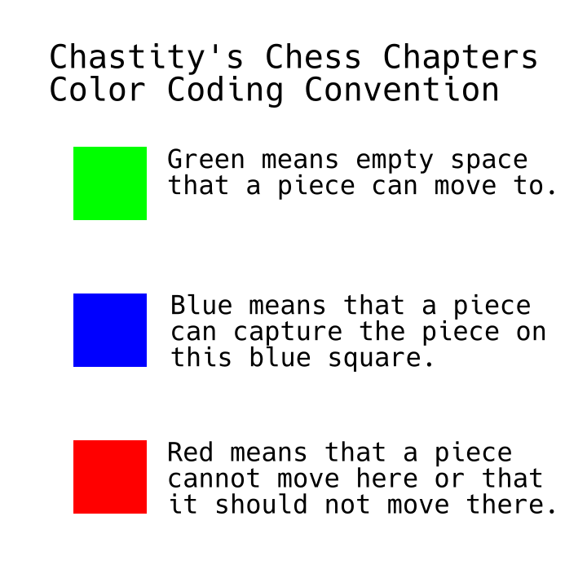

Chastity Chess Color Coding.png

Green Squares are for empty spaces which a piece can move onto. I will use them as illustrations of how each piece moves.

Blue squares are for showing when a piece can capture other pieces on those squares.

Red squares may be later used to explain spaces that a king cannot move onto because he would be in check and could be captured. Remember, if the king is captured, then the game is over, and whoever captured him wins. I am also considering the use of red squares for examples of bad moves in future examples.

Unlike the pawns which have a special capturing rule different than how they move onto other spaces, every other piece moves and captures the same way. So take comfort in knowing it gets easier from here once you understand pawns.

For these next examples, I will show the movement rules using a single piece on the board and highlight all the squares in green where that piece can move.

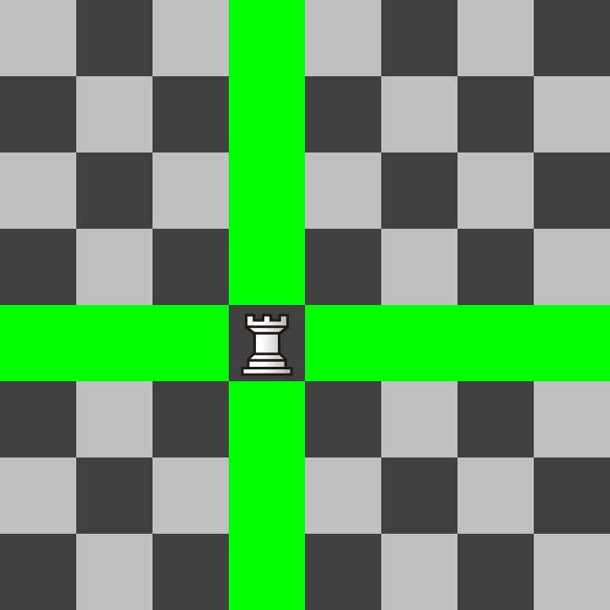

Chess_Rook_Move.png

The rook moves orthogonally. That means it can move up/down and left/right as many squares as it wants. If there are any pieces on those squares, it captures the first one it hits and then stops.

The bishop is the opposite of the rook because it moves diagonally.

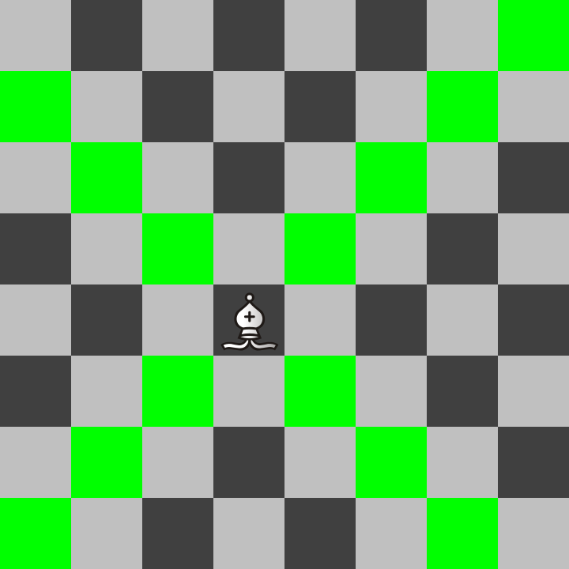

Chess_Bishop_Move.png

Notice that because of this, a bishop can only move onto 32 of the 64 squares on the chess board and always remains on the same color as what it started on. Remember, all official chessboards have light and dark squares of the checkerboard pattern.

Next, I will introduce my favorite chess piece. It is called the knight, but it actually looks like a horse. It moves in a way that is called hippogonally. As it turns out, hippo actually means horse, and the hippopotamus means river horse. The knight is called a knight because knights often rode horses in battle. In older chess versions, it was simply called a horse.

The knight has an unusual form of hippogonal movement. It jumps over other pieces but in a shape that looks like an L Tetris block. It may seem odd to describe it, but I will have a picture on the next page that includes an example of how a knight moves. But before that, I want to give my answer to the ancient debate between chess players over whether the knight or the bishop is a more powerful piece. If you are going to lose one or the other, each player has their preference of which to protect.

My personal opinion is that the knight is more valuable. It is not as easy to checkmate with as other pieces, but I protect mine religiously because it is the ONLY piece that can simultaneously attack 8 pieces at one time. Because this piece is special, I will have to show some examples later on of how to use it effectively.

See the image below to get an example of all the places a knight can jump to. It can move to 8 spaces if it is near the center of the board. It moves 1 square orthogonally and then one square forward diagonally from that direction.

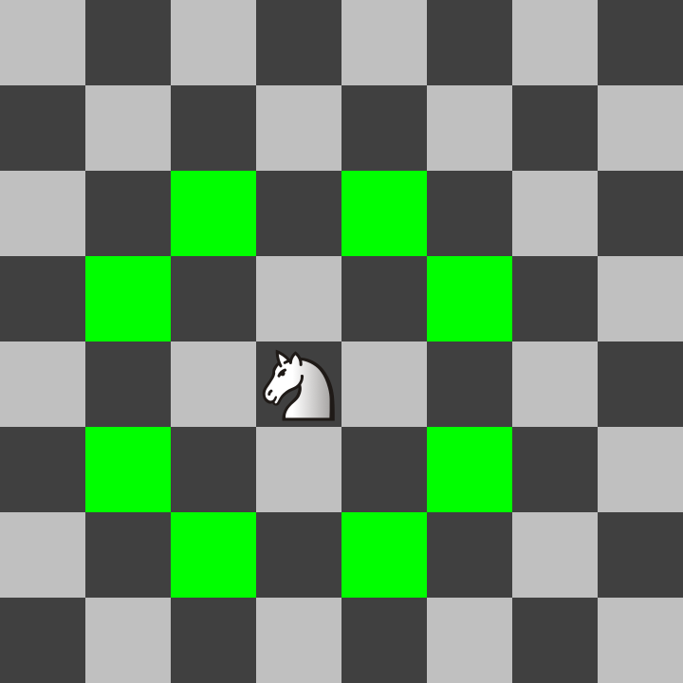

Chess_Knight_Move.png

This movement of jumping over other pieces is unique to the knight. Using it effectively is a challenge because it is harder for new players to visualize it. Consider coming back to this page for a visual reminder of it.

The queen is the most powerful piece in the game because she has the combined powers of a rook and a bishop! See below the example of all the places that the queen can move to!

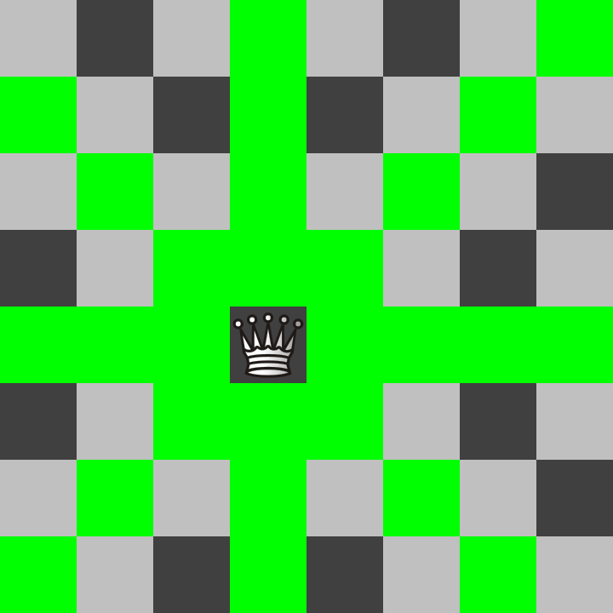

Chess_Queen_Move.png

As you might guess, the queen is what most people rely on to win the game because she is so powerful. Players try to avoid losing the queen. She may only be a single piece but can wipe out an army unless the opponent has a plan to stop her!

The king is exactly like a queen, but it can only move one square in any of the 8 directions. It is also the most important piece that decides who wins or loses the game. If the king is being attacked and cannot move to a legal square, the player who owns the king loses the game.

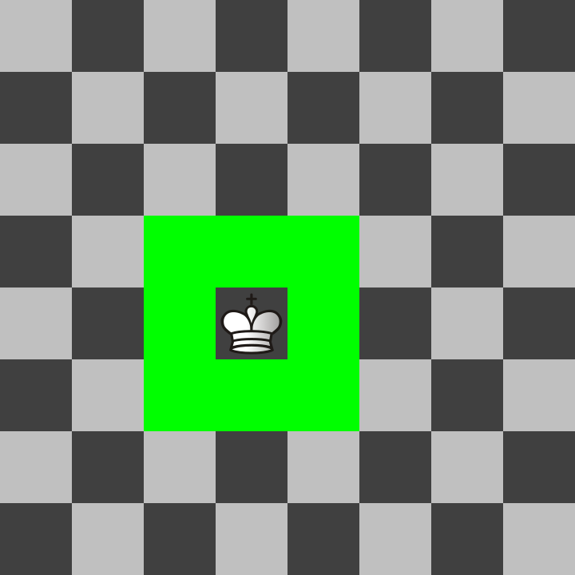

Chess_King_Move.png

In this next image, we see that the white queen is directly next to the black king. The black king has only one empty square that it could move to, but the queen attacks that square too and would still capture the king. That means it is checkmate! The white player wins in this example.

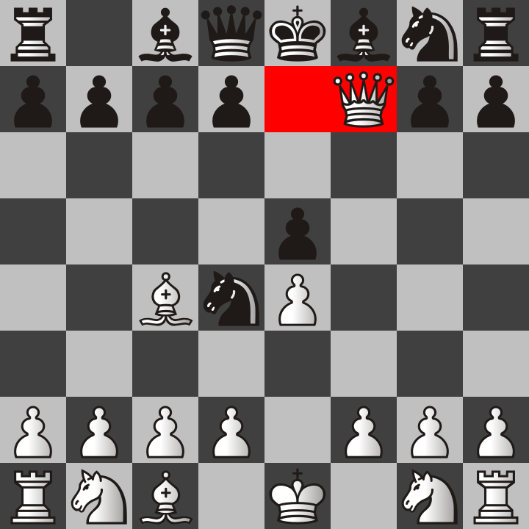

Chess_Checkmate_Example_1.png

You may wonder why the king can’t simply capture the queen. That is because then the bishop would then capture the king. Two or more pieces can easily gang up on a king and then it is game over. There are times, however, when only one enemy piece can checkmate the king if that king is blocked by its pieces.

Consider the following image of a checkmate that is shown from the black player’s perspective. If you are playing the black pieces, they will be closer to you. That is to simulate what it would look like from above on a real chessboard.

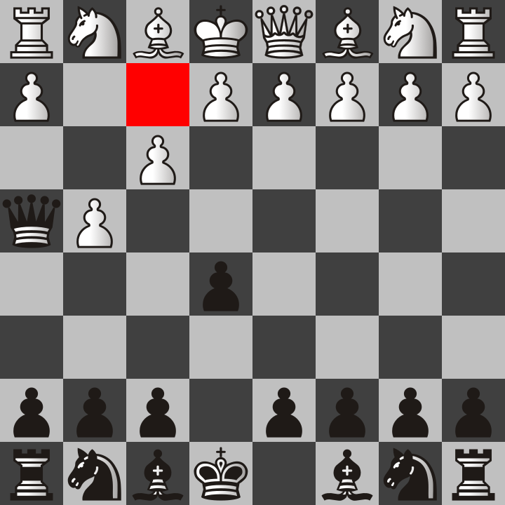

Chess_Checkmate_Example_2.png

In this picture, you can see that white moved two of its pawns, and black also moved its queen over so that it is in a direct diagonal direction from the king. This position is checkmate because the other white pieces block the white king from moving to a safe spot. It also cannot move anything in the way.

This form of checkmate is called the fool’s mate. It only happens if the white player is being a fool and traps themselves. Normally, you would not want to move those pawns unless you had already given yourself an escape route or moved other pieces that could resist the queen’s attack. The fool’s mate is more common than you think, and I include it so that you don’t fall into it.

Now you know all of the most important rules of chess to get started with. There are two more rules called castling and en passant. However, I think it is best to get started playing chess and then learn about those rare cases later on. In the next chapter, I plan to show examples of what your first moves might be to get the game started. You can choose any legal move while it is your turn in the game of chess, but some moves are more likely to be successful than others. The previous example of the fool’s mate shows what pawns you may not want to move right at the start of the game.

For now, remember that you can get started playing chess today! To get started playing online, I recommend lichess, the world’s best free chess server with no ads. Go to the following link and there are interactive lessons that allow you to practice moving the chess pieces.

https://lichess.org/learn

In fact, the depth of learning tools they offer you is far beyond what I have included in this chapter. However, I wish to point you in the right direction to a site you can use that will not scare you away by telling you to buy a premium membership or show ads constantly advertising products like Viagra, Burger King sandwiches, or laundry detergent. Nothing is worse than being distracted when you are trying to learn the number one board game in the world.

And on that note, that is precisely why I paid for an upgraded plan on my wordpress blogs for the purpose of removing ads. I want to teach chess without my students or followers exposed to anything I find unethical and that I don’t have control over.

Playing chess online is a good way to get started because it is unlikely that you will have another person available 24/7 willing to play with you at a time that is convenient for you.

Also, lichess does have a mobile app for cell phones, but I recommend starting on a regular desktop or laptop PC because using a mouse is much easier than tapping on a tiny cell phone screen. It can be done, but the chance of mistakes is higher. However, I have had great success playing on my iPad because it has a much larger screen size.

Try practicing playing a few games and then continue to the next chapter to see my suggestions on starting moves to help you have a chance at winning more often.

Also, if you find yourself liking the game of chess, I do recommend creating an account on lichess because then you can challenge anyone or add them as a friend. Lichess is not just a site for playing chess. Lichess is an entire social network that also keeps track of all your games so that you can look back and see what went wrong. You can also follow other players and add them to your friends list to challenge them to a game conveniently.

Below is the link to my profile:

https://lichess.org/@/chastitywhiterose

Send me a challenge any time and I will respond when I am available. My challenge is to teach people about the game of chess and help them improve so that they can beat me. That way, even if I lose the game, I still win as a teacher.

I will finish this chapter by explaining the en passant and castling rules. These tend to confuse new players. It does not help that they conflict with normal pawn and king movement as previously described.

En Passant

Because a pawn can move two squares on its first turn, there is a special rule called en passant, which allows capturing the opponent’s pawn AS IF it had moved only one. Consider the following picture. The black pawn just moved two squares from its starting position. The blue square is where the white pawn can move to and capture the pawn “in passing” (which is what “en passant” means in French).

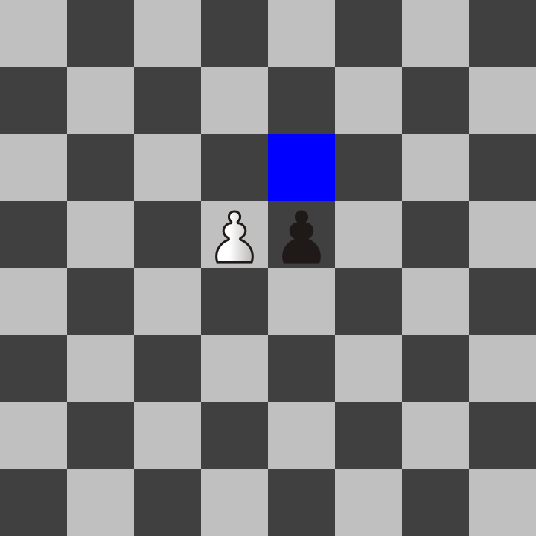

Chess_en_passant.png

The idea is that the pawn would have captured the pawn while it was moving through that square. The En Passant rule helps compensate for the limitations of a turn-based game. This rule only applies to pawns and only on the turn immediately after a pawn has moved two squares on its last turn.

Castling

Remember when I said a king only moves one square at a time? Most of the time, this is true. Although this makes no sense, there is a rule that allows a king to move two squares in one turn. Consider the setup below.

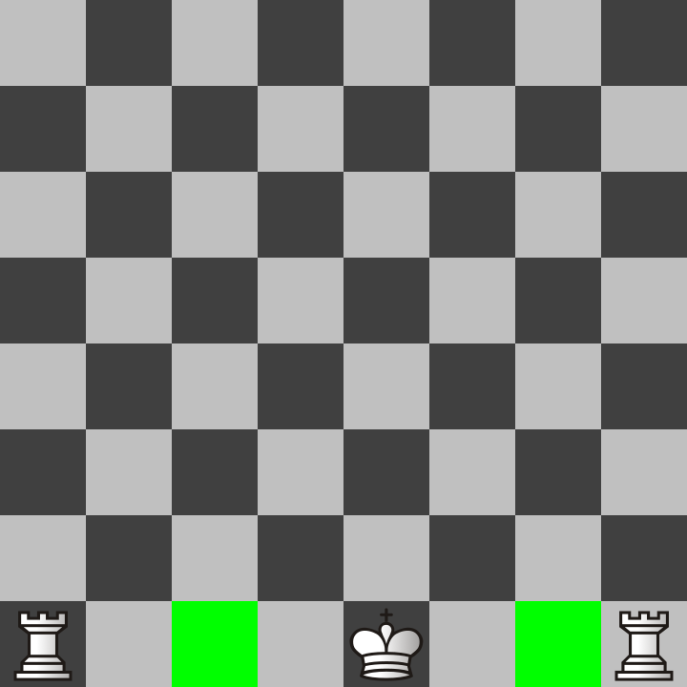

Chess_Castle_Setup.png

Because there are no pieces in between the king and rooks and because the king and rooks have not moved in this game, they are allowed to do a one-time “castle” move where the king and the rook both move. The king moves two spaces towards the rook, and then the rook goes to the square the king skipped over!

King side castle

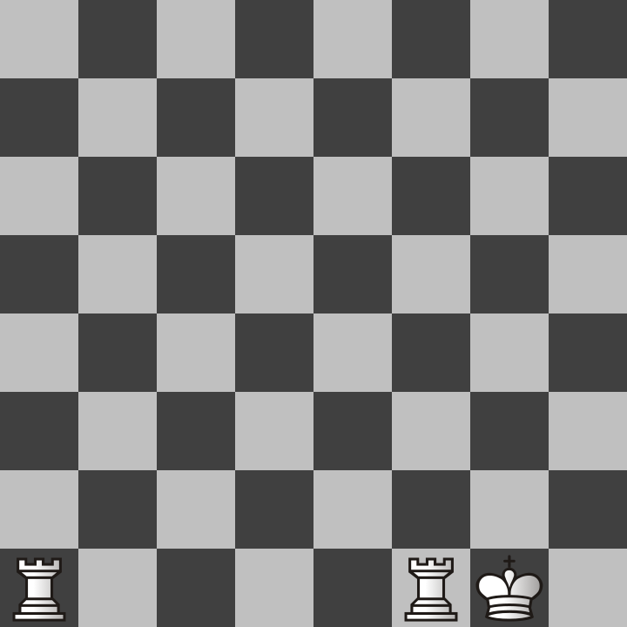

Chess_Castle_Right.png

Queen side castle

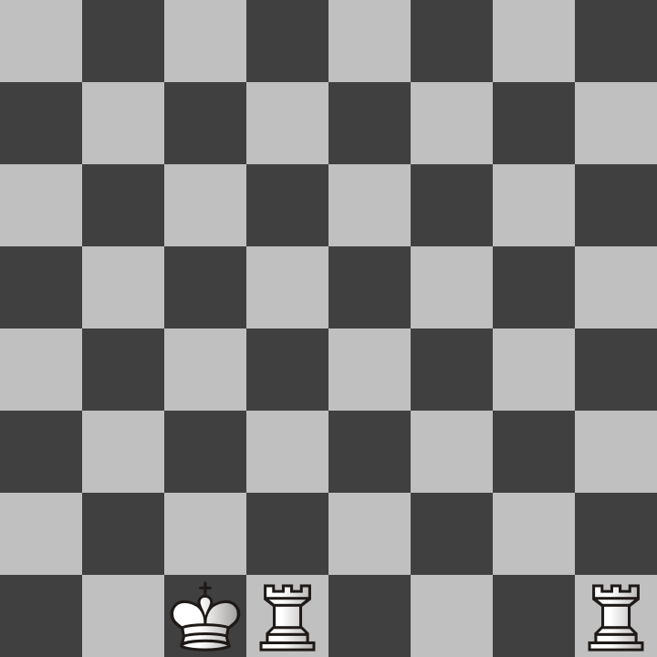

Chess_Castle_Left.png

Don’t let these special rules confuse you too much. They are a bit nonsensical. In fact, I would compare them to the T spin triple rules in Tetris. On a related note, Tetris is actually a really good game, too. Tetris is my favorite video game, but it is not as easy to play as chess because Tetris requires quick reflexes and planning in mere seconds.

Chess is more of a game for slow, careful thinkers. Although some play speed chess, I don’t recommend trying to play fast for beginners. Focus on the quality of moves rather than how many moves you can make in a minute. Also, play without time limits or choose reasonable time limits. I play 30-minute live games against other people online, and my rating for classical chess is higher than rapid, blitz, or bullet chess because I am slow to move and prefer to think and make the best move.

Time limits are artificial inventions made for the convenience of society. Don’t rush through chess the same way everyone in society forces you to be fast and cause accidents in the real world. I work at Walmart, so I know what happens when employees are rushed. Products get put in the wrong spot, and injuries happen if people value only speed and forsake everything else.

Chess, or any game for that matter, should be for fun, not as a job you do because someone else is forcing you to. No matter what, you must remember that!

# Chapter 2: Chastity’s Recommended Openings

For the sake of keeping this book short, I will not be trying to teach all details about chess notation. Part of this is because I don’t want to explain it wrong. However, all the major chess sites including lichess do keep track of the moves you play in every game and will show you the chess notation. It’s actually very easy to pick up just by looking at examples from your own games. I will be calling moves by their chess notation name but almost every move will also have a picture with it so that there will be no confusion as to what it means.

White takes their turn first in the game of chess. This means that if you are playing as white, you have the unique opportunity to pick the first move that will set the course for the rest of the game! However, there are only a few moves that are considered to be very good. I will show you the two most popular choices that white players use to start the game.

But first, I have an example image that shows the names of all the squares in chess notation.

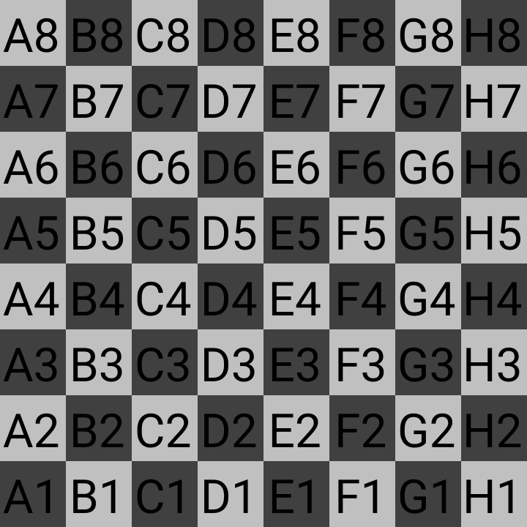

Chess_Coordinates_White.png

That image has all the letters and numbers of each square from the white player’s perspective. Look back at this picture because it will help explain a lot of what I mean in the pages after it. The image has the letters in capitals because it looks cool, but when Chess notation is written, capital letters usually refer to which piece is moving while lowercase letters refer to the file (which vertical column a square is on). The numbers are which rank (horizontal row) the square is on. See more on the topic of chess notation in [Chapter 7](https://chastitychesschallenge.com/2025/03/23/chapter-7-the-value-of-chess-notation/).

Square e1 is where the white king starts the game and e8 is where the black king starts the game. Also look at squares f2 and f7 because those are the squares most vulnerable to attacks that put the king in check. Moving those pawns at the beginning of the game is asking for trouble! The most popular first move for white is e4 (white’s king pawn two squares forward).

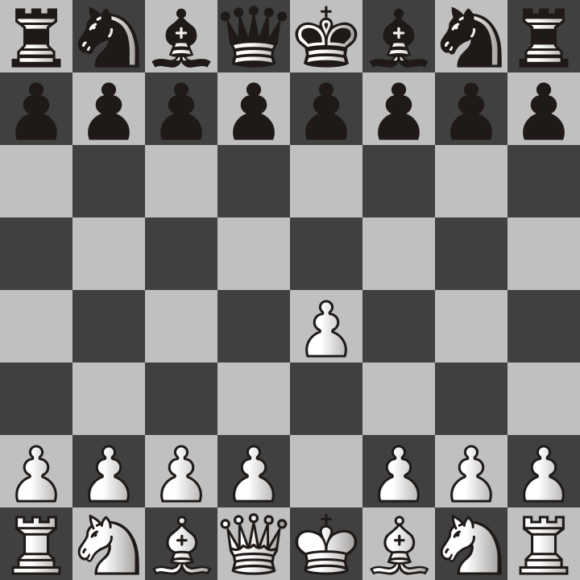

e4.png

The main reason e4 is a popular move is because it allows white’s queen or bishop to get out on the next turn white plays. Most chess masters consider it to be the best move and it is also commonly played by chess engines. But it’s not the only popular move. The second is d4 (white’s queen pawn two squares forward)

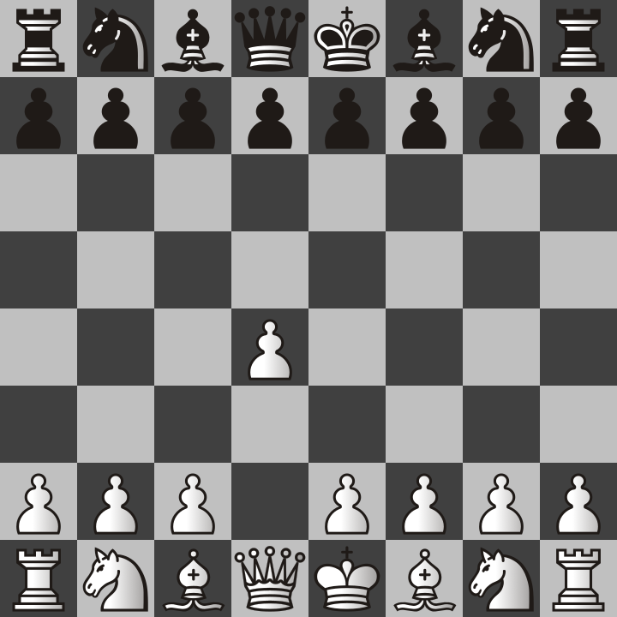

d4.png

Moving this pawn to d4 is popular because it is the start of many different openings that involve getting the dark squared bishop out early in the game. This could be the start of the Queen’s Gambit, Trompowsky Attack, or the London System.

But that isn’t to say there aren’t countless openings that begin with the first and most popular choice I mentioned earlier. If you are playing white, you should decide which of these moves to start with and then you should start with it every time until you get used to seeing how your opponent moves and how they respond to each of your moves. That’s not just my advice but is the advice of chess coach Levy Rozman (GothamChess) who I learned a lot from!

Although studying openings is fun, don’t rely on them so much that you find yourself lost as soon as your opponent does something unexpected. That being said, you should probably have a plan for the first 4 moves at least. Planning ahead requires some experience of playing, winning, and losing games to see what worked and what didn’t.

I find that I win my games more often when I start with e4, but I find myself having more fun when I play d4 as my first move and then try for the Queen’s Gambit, which is my favorite. I will be explaining the Queen’s Gambit opening later on but first I am going to show you the most generic ways to start the game. This will mostly be from white’s perspective but you will find that this method is flexible enough to be mirrored for both players.

The Bishop’s Opening

First, both white and black move their e file pawns two squares for their first move.

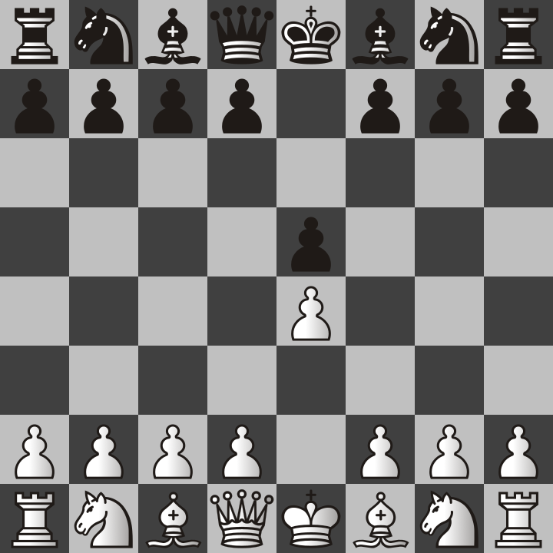

e4-e5.png

This is equally good for both of them because that allows both of them to get their bishops or queens moved out diagonally. Keep in mind that at the beginning of the game, diagonal moves are faster than orthogonal moves. The rooks can’t get out because the pawns in front of them are blocking their movement. For this reason, your early attacks will depend on bishops.

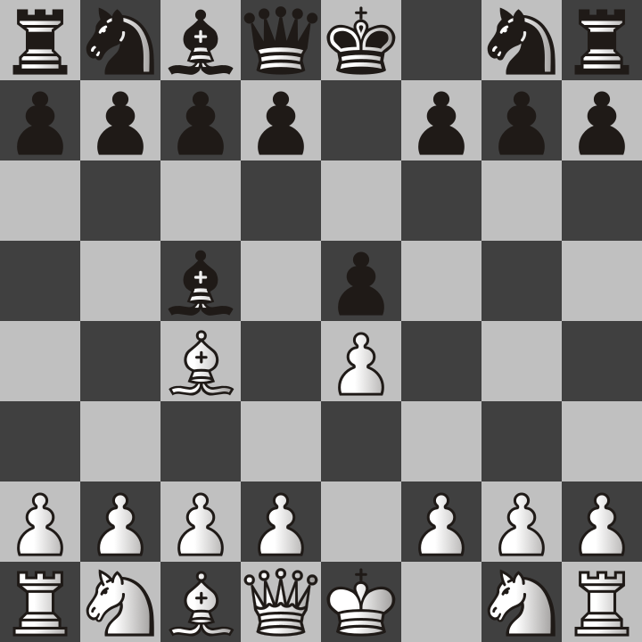

e4-e5-Bc4-Bc5.png

Next, the bishops come out. This means they are both attacking the weak f2 and f7 squares I mentioned earlier. This position is called the bishop’s opening for obvious reasons. If you find yourself in the bishop’s opening position, you have some serious options to consider. If you are playing white, you already have an advantage in this position because it is your turn. You could move the knight to f3 and attack the e5 pawn or you might want to move the queen to h5 and try a scholar’s mate. Keep in mind that the possible moves your opponent can do are endless and that to a certain extent, to show an example, I have to make up possible moves of only one of them just to prove the point I am showing. There is no way of knowing if you will end up in the mirrored bishop setup as shown in the previous image. With that being said, if you EVER DO find yourself in this exact position, I will show you some great possibilities that can come from it. I recommend knight to f3.

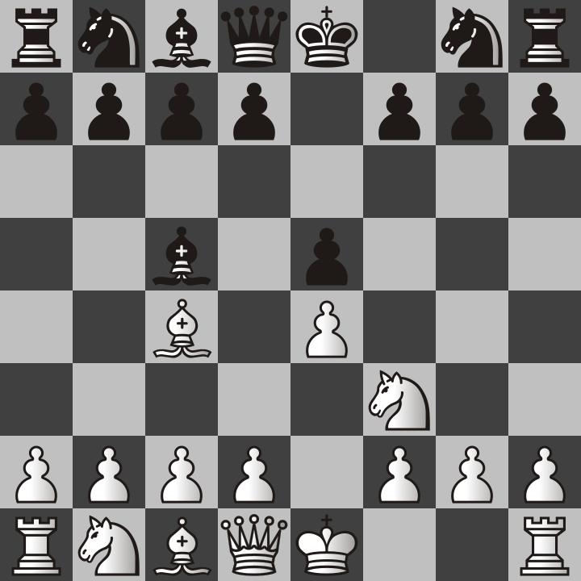

e4-e5-Bc4-Bc5-Nf3.png

Why is this position good for white, you may ask. That’s because this knight move accomplishes several things at once. 1. It attacks the e5 pawn 2. It gets the knight out of the way so the king can castle 3. It prevents the black queen from going to h4 and trying to scholar’s mate white king on f2. Based on my experience, what usually happens after this is that black will move their queen’s pawn to d6 and defend the e4 pawn. Then white will do the reverse and move their queen pawn to d3.

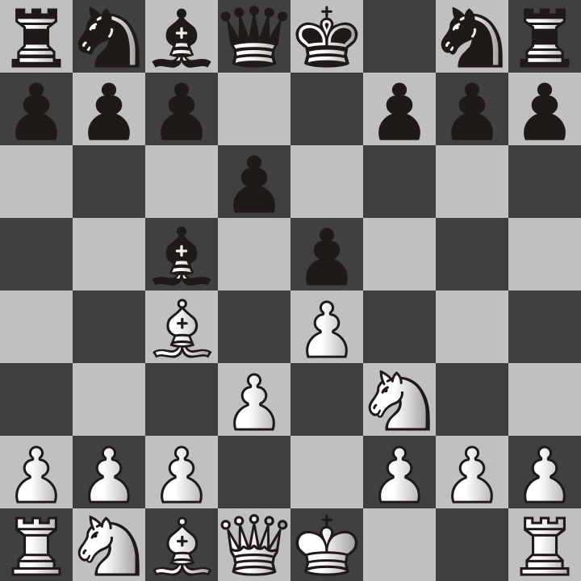

e4-e5-Bc4-Bc5-Nf3-d6-d3.png

This also allows the bishops to move out that were previously blocked by those pawns. Black will most likely move the bishop to G4 and attack the knight.

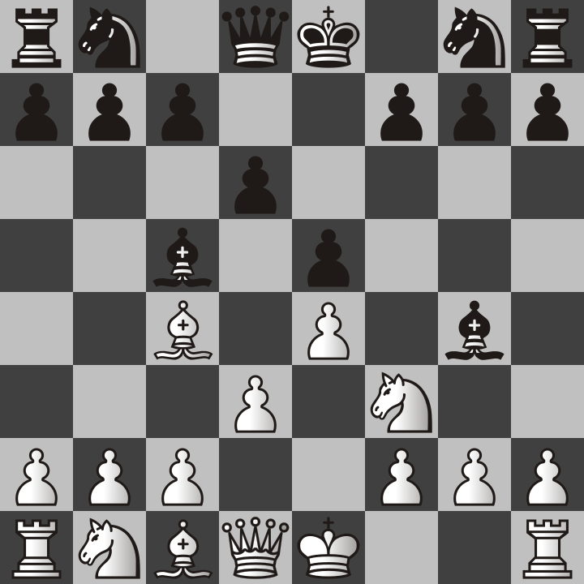

e4-e5-Bc4-Bc5-Nf3-d6-d3-Bg4.png

This creates a problem for white because if they move the knight, the queen behind it will be captured. Because I value knights more than bishops, I recommend the following. After the bishop attacks the knight, sacrifice your bishop on f7 and put the king in check.

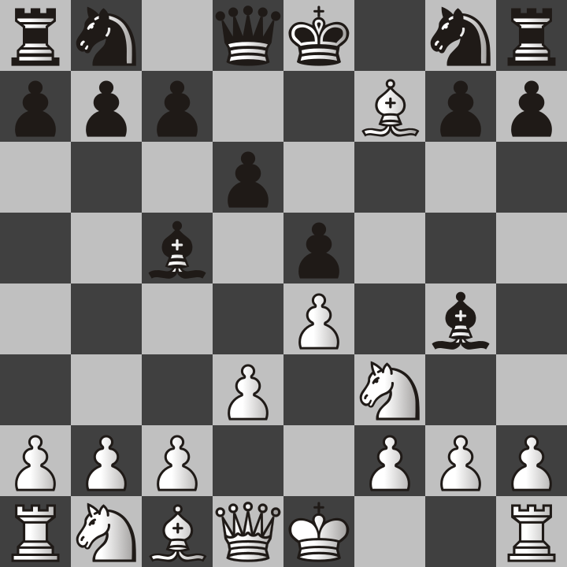

e4-e5-Bc4-Bc5-Nf3-d6-d3-Bg4-Bf7.png

You may wonder why we would sacrifice a bishop. The idea behind this is for the king to capture it so that we lure the king to where the knight can put it in check!

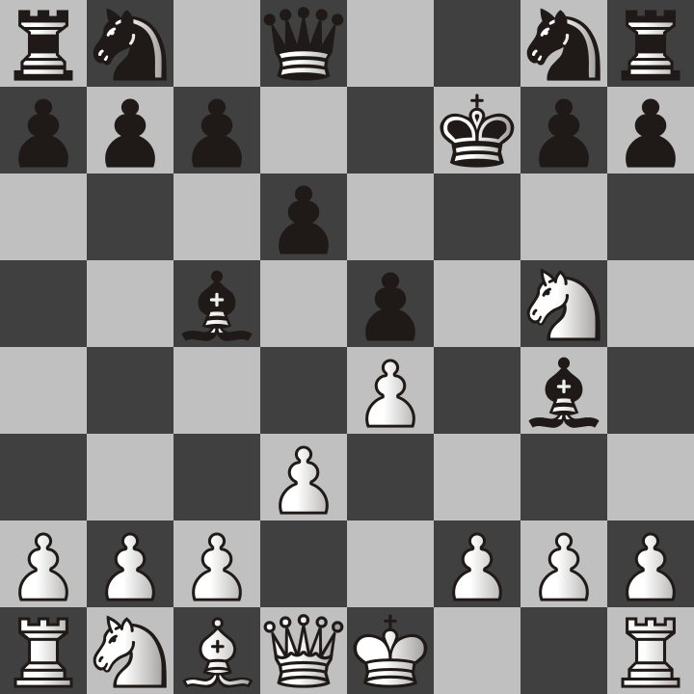

e4-e5-Bc4-Bc5-Nf3-d6-d3-Bg4-Bf7-Kf7-Ng5.png

At this point, the king is forced to move again. No matter where the king moves to, it will be white’s turn again and the white queen can capture the black bishop!

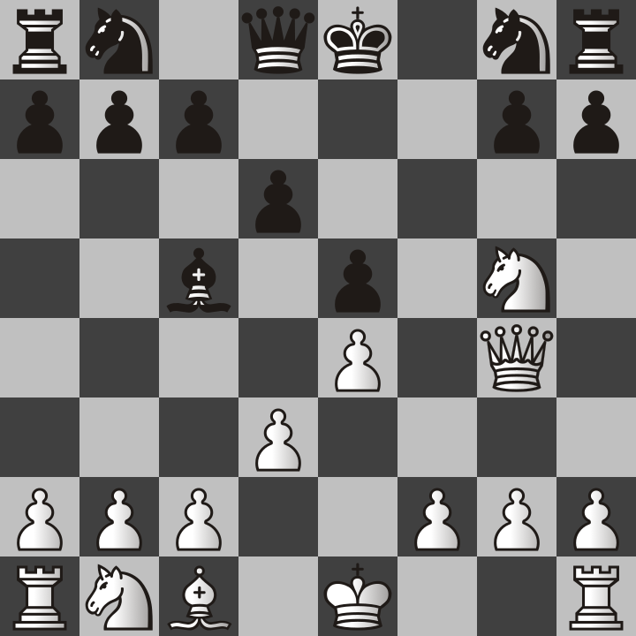

e4-e5-Bc4-Bc5-Nf3-d6-d3-Bg4-Bf7-Kf7-Ng5-Ke8-Qg4.png

At this point, white has lost a bishop but they have also taken a bishop and a pawn. This strategy of sacrificing pieces to gain an advantage is one of my favorite things to do. It highlights the importance of being able to plan ahead in chess. With that being said, I will next teach you my favorite opening for white, the Queen’s Gambit!

# The Queen’s Gambit

The Queen’s Gambit sounds like a fancy name, and this name was used for a Netflix show as well. However, this opening was well known before people had televisions, computers, or the internet. The word “gambit” means sacrifice. In this opening white sacrifices a pawn with the hope of getting an advantage later. To some people, it also means a gamble because there is no way of knowing if it will work out the way you want depending on what your opponent does.

The opening starts with each side moving the pawn in front of their queen. Then white moves the pawn on c2 to c4.

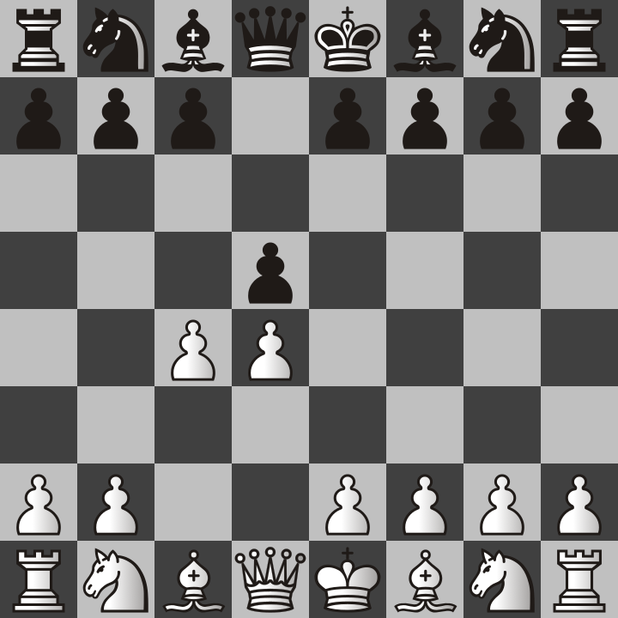

d4-d5-c4.png

In this position, black’s pawn can capture the white pawn and yet it doesn’t appear that white can capture it back, at least not yet. If it does take the pawn, this is known as accepting the gambit. New players will more likely than not take this pawn if they don’t see the trap.

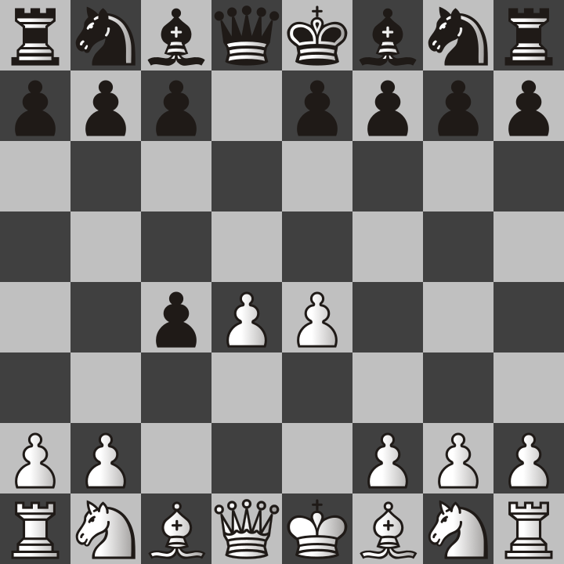

d4-d5-c4-dxc4-e4.png

You see, the idea was to distract the pawn and move it away from the center so that white’s king pawn could move two squares forward. Also notice that the white bishop on f1 could also capture the black pawn on c4 next turn, but not so fast, first, black has to choose their next move. The only problem is that there really is no good way for black to stop white from taking their pawn with the bishop. If they try to protect it with another pawn, things can turn out badly. Sooner or later white will capture back the c4 pawn with the bishop and if black tries to stop it, they will only lose more pieces.

My best advice is that if you accept the Queen’s Gambit, also accept that you will lose this pawn and don’t try to defend it by moving the b7 pawn to b5. This has never worked out well for my opponents. Do not let the sequence of the following images happen to you!

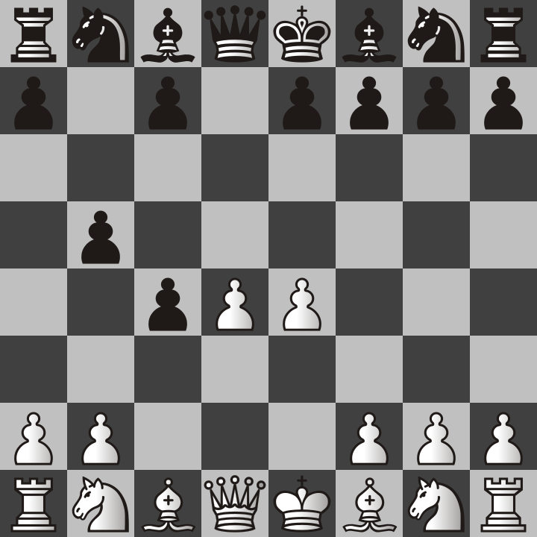

d4-d5-c4-dxc4-e4-b5.png

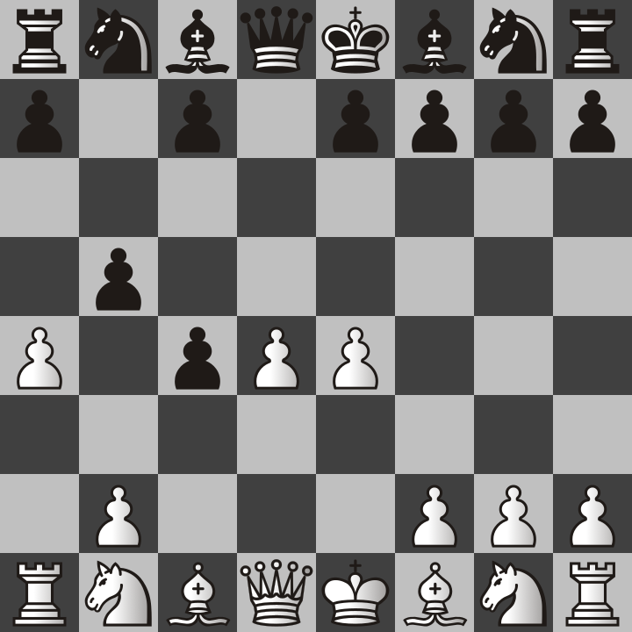

d4-d5-c4-dxc4-e4-b5-a4.png

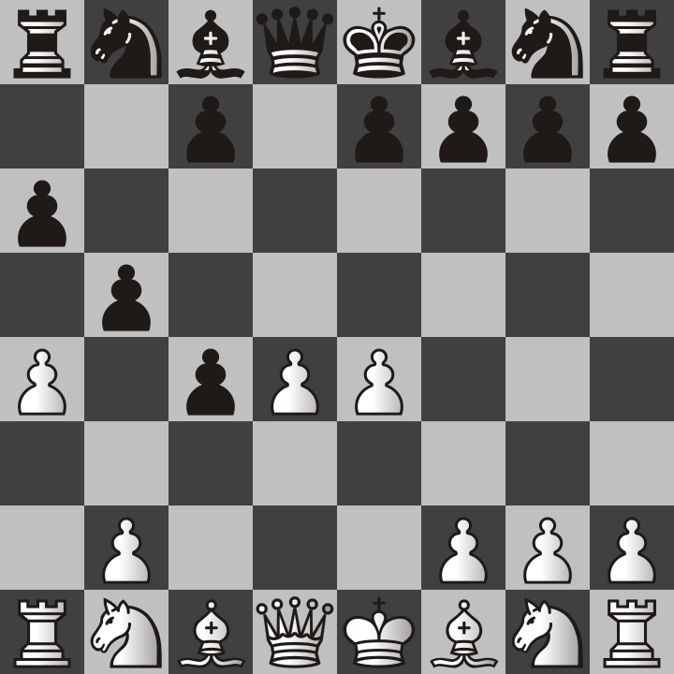

d4-d5-c4-dxc4-e4-b5-a4-a6.png

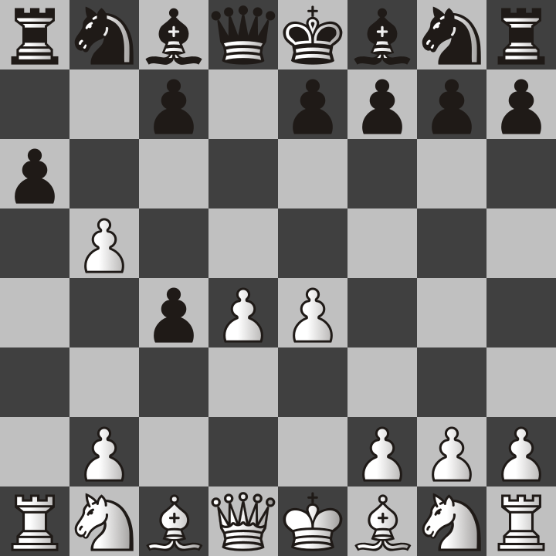

d4-d5-c4-dxc4-e4-b5-a4-a6-xb5.png

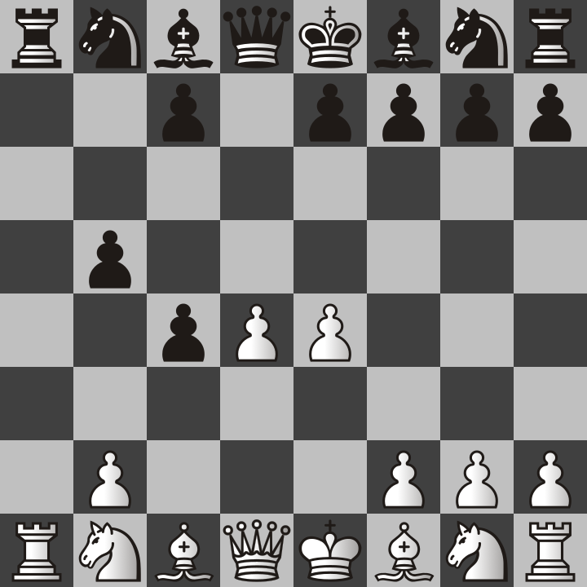

d4-d5-c4-dxc4-e4-b5-a4-a6-axb5-axb5.png

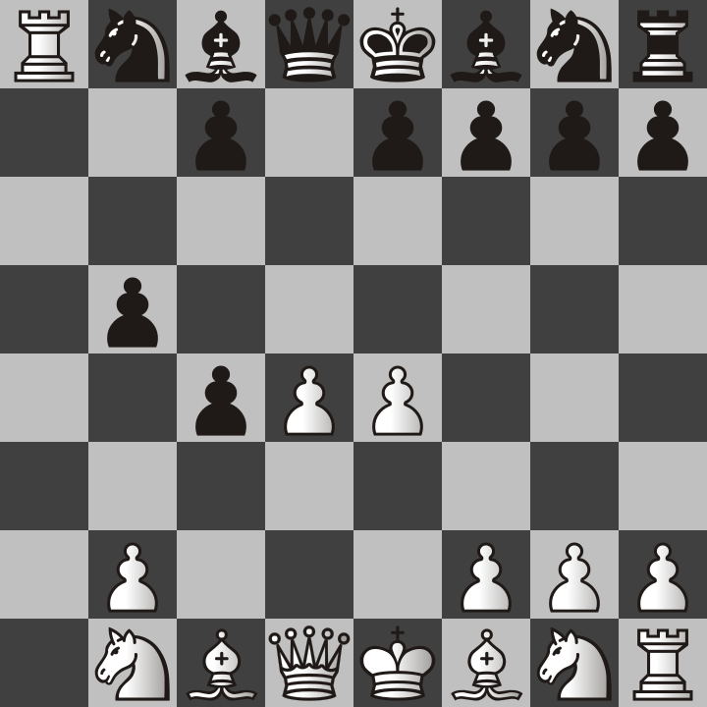

d4-d5-c4-dxc4-e4-b5-a4-a6-axb5-axb5-Ra8.png

I also want you to notice that the previous sequence of moves would still be just as bad if white had decided to move their king’s pawn only one space to e3. There are valid reasons they might do so to add extra protection to the d4 pawn. The d4 pawn is only protected by the queen right now so beware of this in all your games.

If you are the black player, I would recommend against accepting the Queen’s Gambit entirely. It leads to many traps by white. If you do accept it, you will lose your pawn anyway. Don’t waste time with that and instead move out other pawns depending on what pieces you plan to move. Below are the two most common responses to the Queen’s Gambit.

## Queen’s Gambit Declined

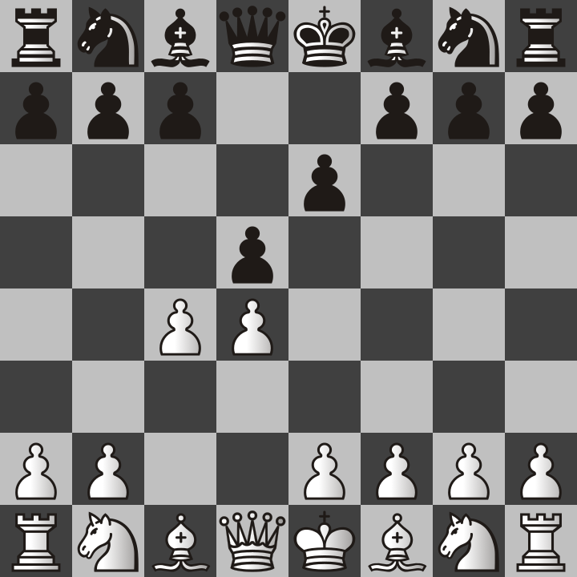

d4-d5-c4-e6.png

## Slav Defense

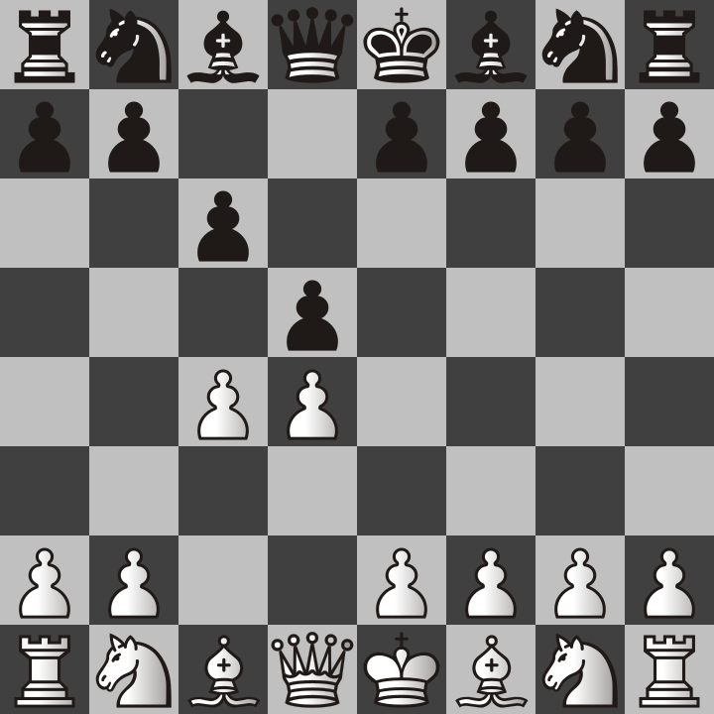

d4-d5-c4-c6.png

Both of these responses allow you to capture the white pawn back if it captures your d5 pawn. More importantly, you are getting pawns out of the way of your other pieces so that they can start attacking white. The Queen’s Gambit Declined is probably slightly better than the Slav Defense because moving the king’s pawn is just generally a great move because then black’s queen and dark squared bishop can move out diagonally and try to attack white.

But a final note is that accepting or declining the Queen’s Gambit does not lose for black by any means, but accepting it allows white to get both of their center pawns and allows them to start moving both bishops out very quickly. White already has the advantage, don’t give them more help if you are the black player. But if you are the white player, I have plenty of advice on what to do. However I may have to add more to this book later.

Now one thing you may have noticed is that the Queen’s Gambit started with moving the Queen’s Pawn (d4) instead of the King’s Pawn (e4) like in the previous example with the elaborate bishop sacrifice. Queen pawn openings are just far more fun to play because the game takes longer and my opponents get frustrated. e4 is better for quicker wins but is so cliché that I got tired of playing it and became a d4 player for my first move.

## The London System

I am not the first person to say that the London System is a solid opening. In fact, it’s probably the best opening to teach a beginner for playing the white pieces. The first move will always be d4. The London System is actually quite different than the Queen’s Gambit because your goal is not an early attack nor sacrificing pieces. The goal is to build a defensive structure. Look at the following picture.

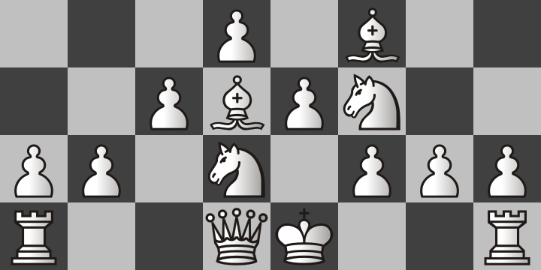

7 move london white only.png

It takes a total of 7 moves to achieve this setup but it can usually be done quite easily no matter what black does. If your opponent makes bad moves and you can capture their pieces then that should take priority over arranging the pieces like this picture. For example, if your opponent moves their king’s pawn two squares forward to e5, then just take it with your d4 pawn!

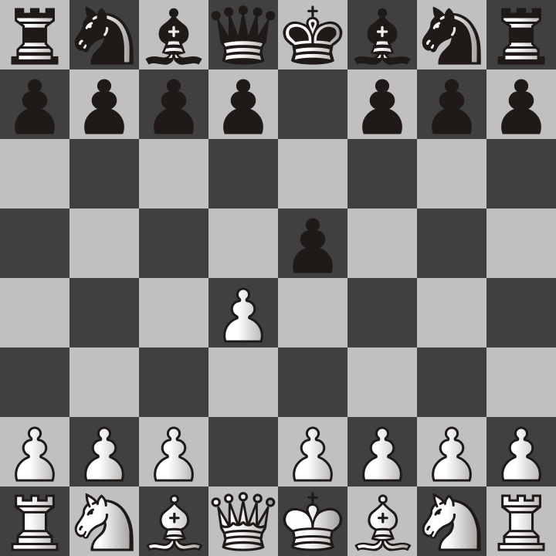

d4-e5.png

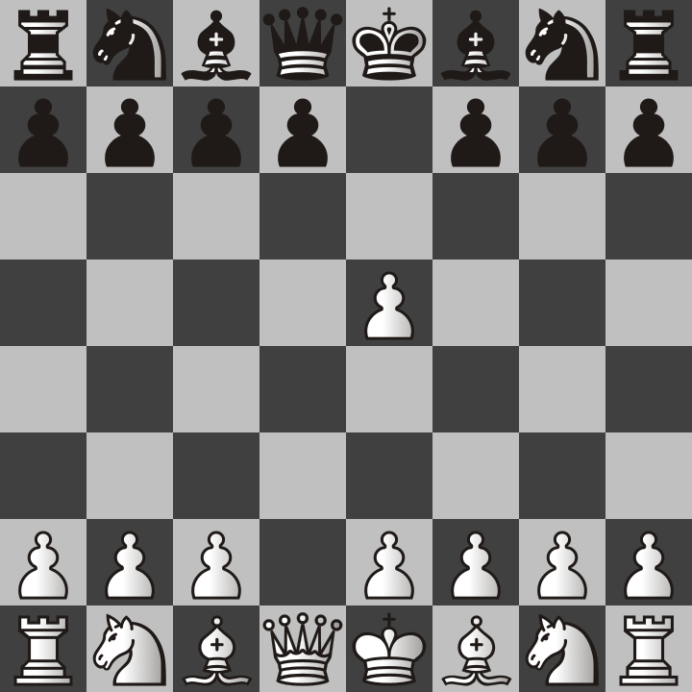

d4-e5-dxe5.png

It’s totally easy to see how a player might be used to moving their king’s pawn two squares and might mistakenly let white’s d4 pawn take it. This completely disables black’s development besides costing them a pawn. They can’t move their knight to f6, nor can they move the pawn in front of their queen either one or two spaces (because of en passant rule). If black makes this mistake, then they already have a huge disadvantage. This is not like the Queen’s Gambit because there is no advantage to offering white a free pawn. If black does this, then take that pawn and then build the rest of the London Fortress even though there will be a missing pawn at the head of the pyramid of pawns. But most of the time, your opponent will not make a mistake as bad as the previous example. They will most likely do something smarter such as knight to f6.

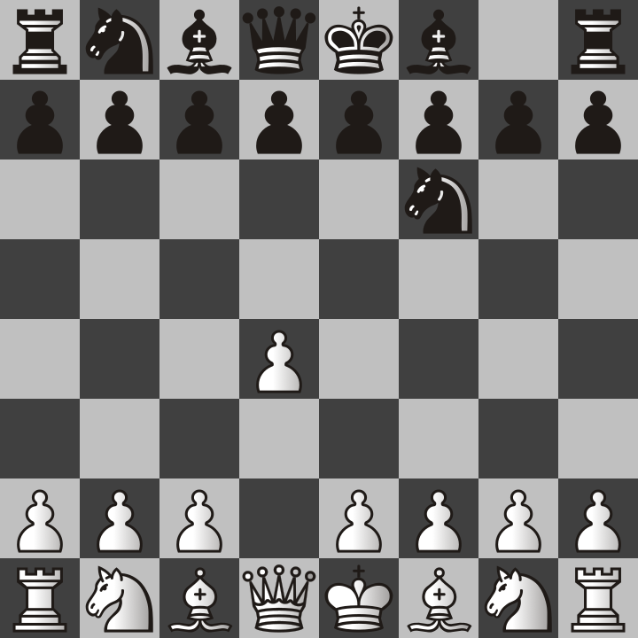

d4-nf6.png

In this position, we see that the black knight is trying to prevent our king’s pawn from going to e4. That’s totally fine because that is not what we will do in the London system. We will continue to build our setup. In this position we should next move the bishop to f4.

It’s worth mentioning that bishop to f5 would also be a good move, and would be called the Trompowsky attack. However, since I am teaching the London System, we will stick with bishop to f4 for now.

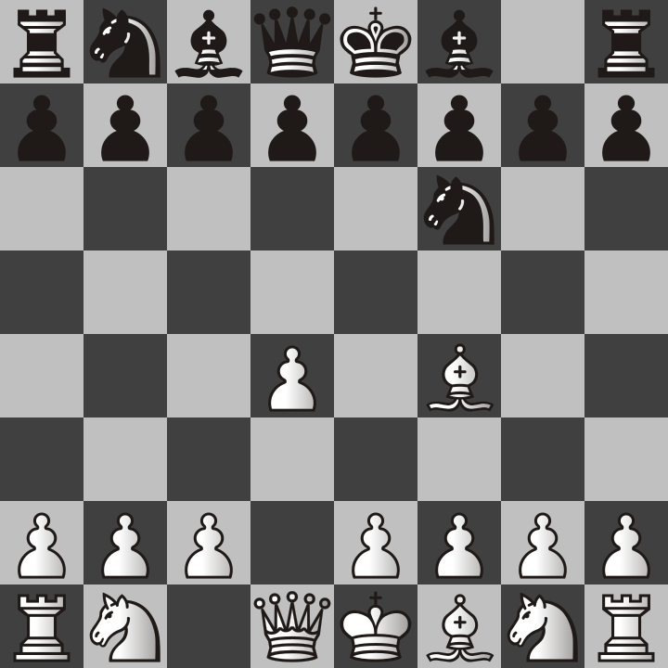

d4-nf6-bf4.png

Because of the fact that we have disabled the enemy king’s pawn from moving two squares, most players will instead move their queen’s pawn two squares instead. Remember, moving the pawns in front of the king or queen is almost always a good idea. With that in mind, our next move should be pawn to e3 because this is the next step in building the pawn pyramid, and it also adds an extra defender to the e4 pawn and Bishop.

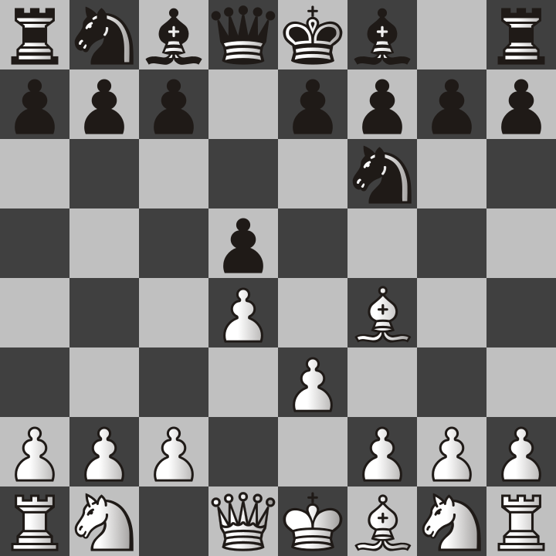

d4-nf6-bf4-d5-e3.png

Keep in mind that this is still early in the game and that chess openings only take you so far. However, white has a really good winning chance in this setup. For example, black may try to offer the black version of the Queen’s Gambit by pawn to c5. However, doing so allows us to take their knight on b8!

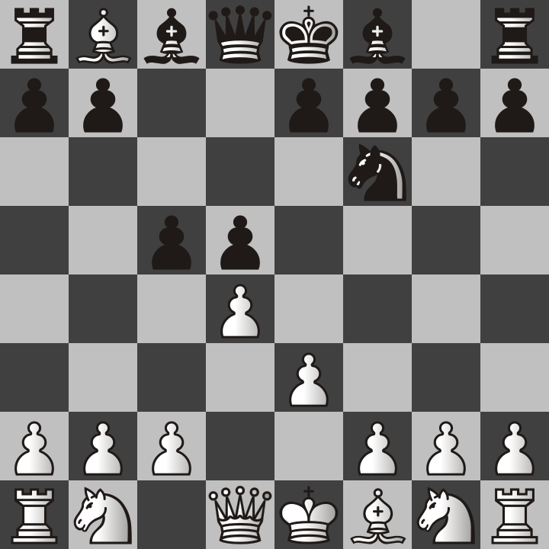

d4-nf6-bf4-d5-e3-c5-bxb8.png

The rook can take our bishop but we have eliminated one of the enemy knights. You may be wondering, why sacrifice the bishop to take down a knight? The reason I do this is because in my experience, knights are better than bishops. Each chess player has different opinions on this, but here is my own reasoning on why knights are more powerful than bishops.

1. Two knights can defend each other, unlike bishops which are always on different colored squares.
2. Knight attacks cannot be blocked, they are therefore better for checkmating in many cases I have seen.
3. Knights look like horses, which are my favorite animal. I prefer to protect my horses.

Maybe you disagree with my advice. However, the main point is that to play the London System, you should get your pieces out similar to the picture of the 7 moves.

All of what I have talked about so far is openings that white chooses to play. If you are the black player, what should you do? For one thing, you can expect that white will most likely play e4 for their first move, so I will next cover the French Defense.

## The French Defense

The French Defense is my main opening when playing as the black player. I will make the case for why it deserves more credit as an opening even though it is less popular than the Caro Kann (which may be covered later)

This is the start of the French Defense. White has moved king’s pawn to e4 and we are moving our king’s pawn only one square instead of the usual two.

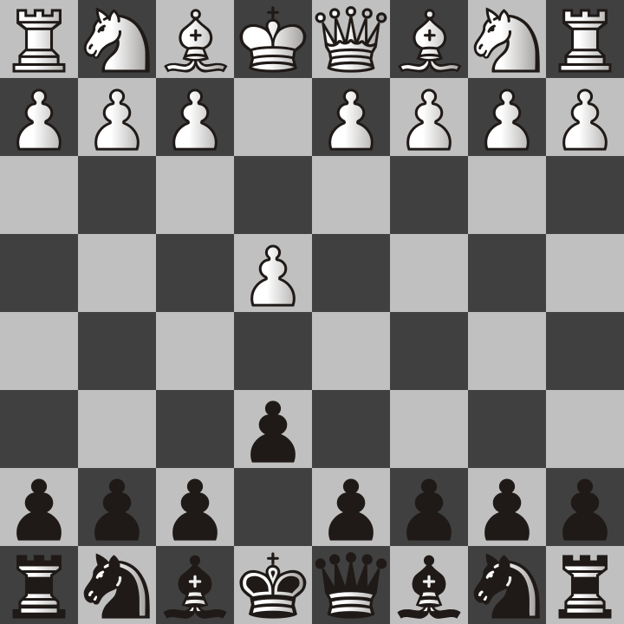

e4-e6.png

I know it looks weird and uncomfortable to move a pawn only one square when it could have moved two, but the reason for this will become clear very soon.

Almost all the time, white will move their queen’s pawn two squares and in this case you will copy them.

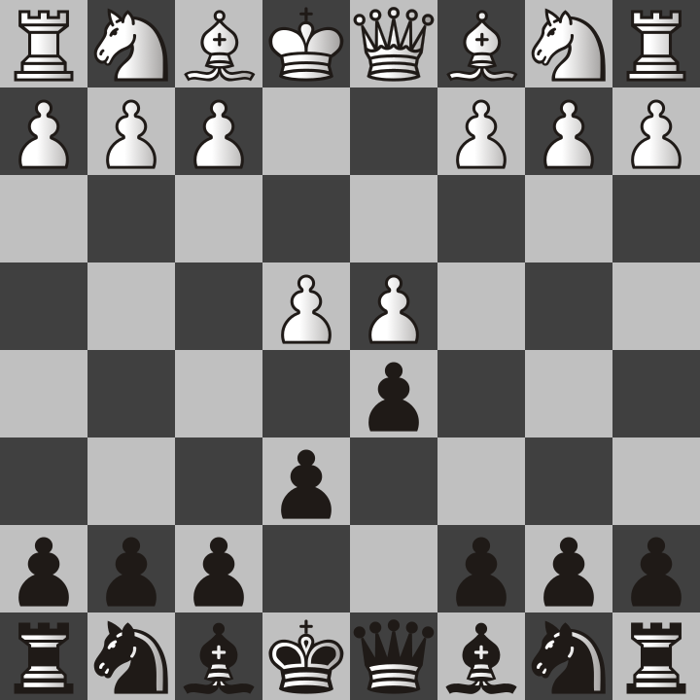

e4-e6-d4-d5.png

In this position, white has the option of capturing the d5 black pawn. If they take it, it is called the exchange variation of the French Defense. White will capture the pawn but then we capture it right back. Then the board will look like this.

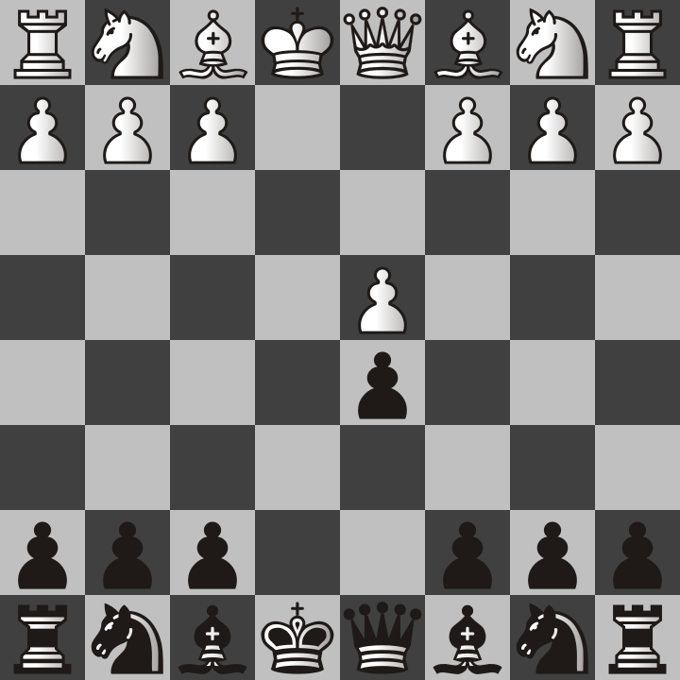

e4-e6-d4-d5-exd5-exd5.png

As the black player, this is precisely what you wanted to happen because now the path is open for you to move either of your bishops or your queen out if you need to.

The other alternative is when white does not take the pawn and instead advances it to e5.

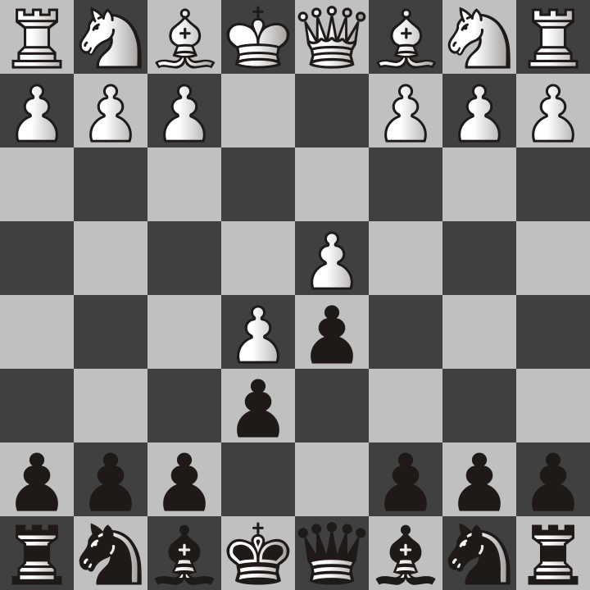

e4-e6-d4-d5-e5.png

This is called the advanced variation of the French Defense, not because it is advanced in the sense of complicated but because the white pawn has advanced instead of capturing. When this happens, the best thing to do is to move a pawn to c5 and offer the “black queen’s gambit” and hope that white takes it so you can capture back with the bishop. From that point the game continues like normal and it follows much of the same logic as I use when I play the Queen’s Gambit.

For example, the following sequence of images shows exactly how a checkmate can happen quickly if white does not defend the weak f2 square next to their king.

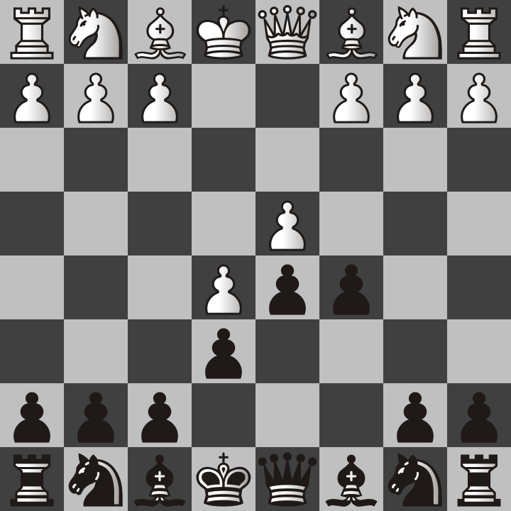

e4-e6-d4-d5-e5-c5.png

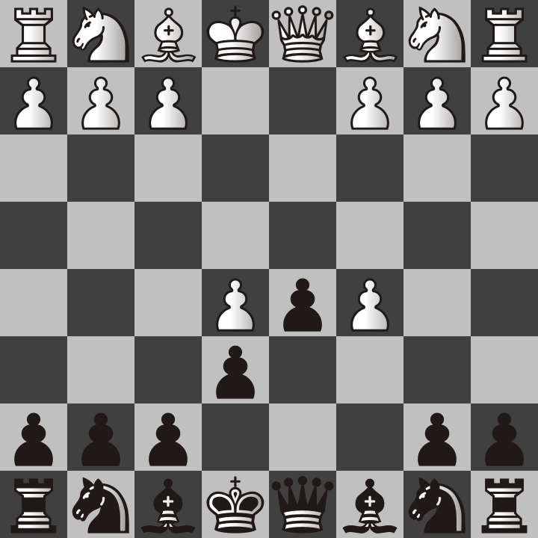

e4-e6-d4-d5-e5-c5-dxc5.png

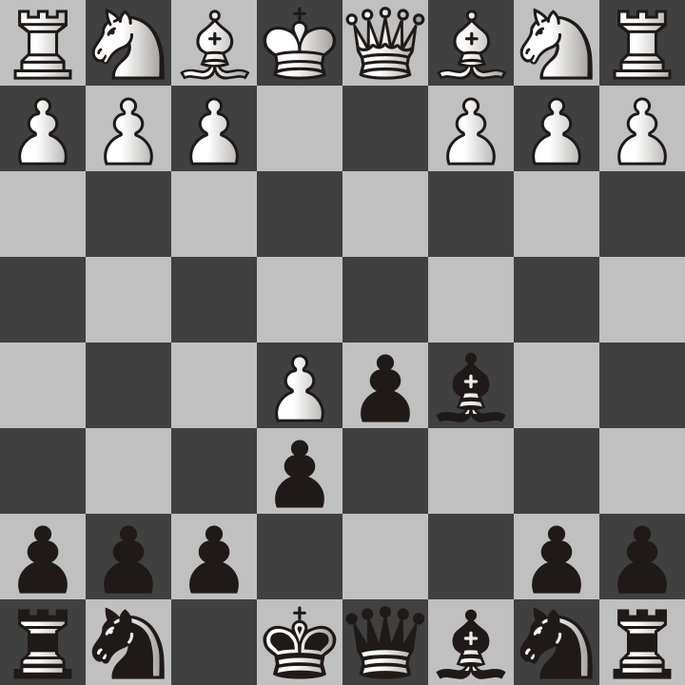

e4-e6-d4-d5-e5-c5-dxc5-Bxc5.png

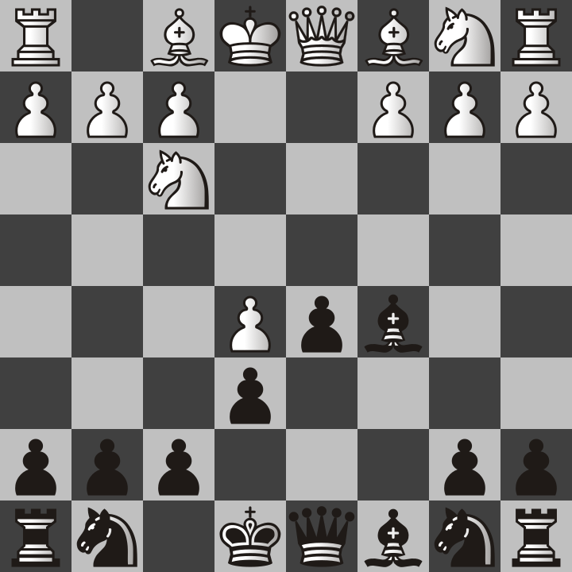

e4-e6-d4-d5-e5-c5-dxc5-Bxc5-Nf3.png

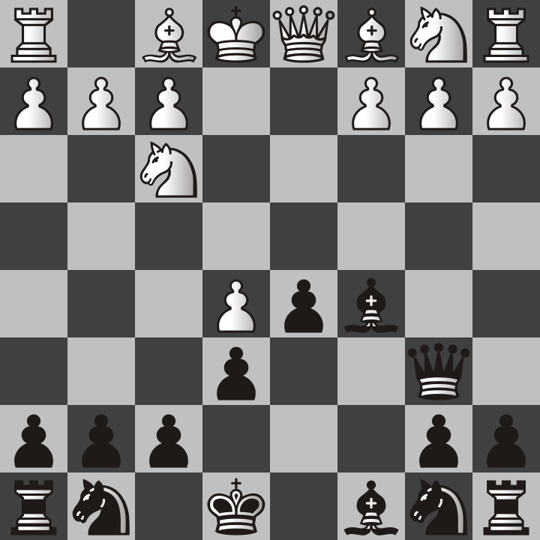

e4-e6-d4-d5-e5-c5-dxc5-Bxc5-Nf3-Qb6.png

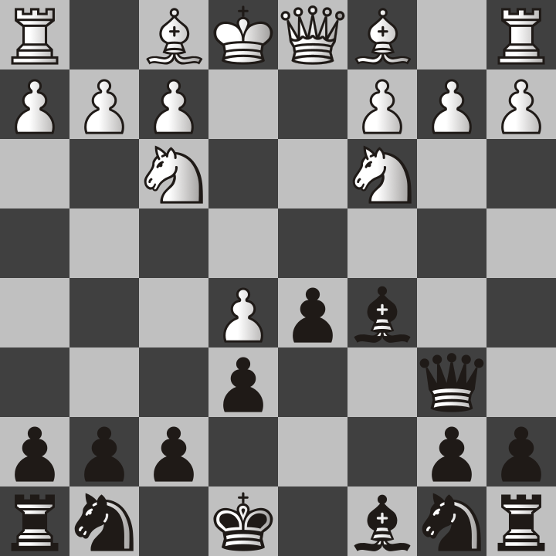

e4-e6-d4-d5-e5-c5-dxc5-Bxc5-Nf3-Qb6-Nc3.png

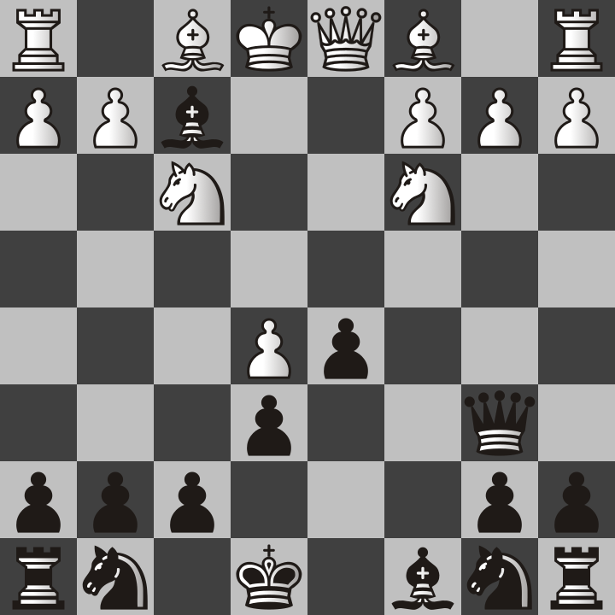

e4-e6-d4-d5-e5-c5-dxc5-Bxc5-Nf3-Qb6-Nc3-Bxf2+.png

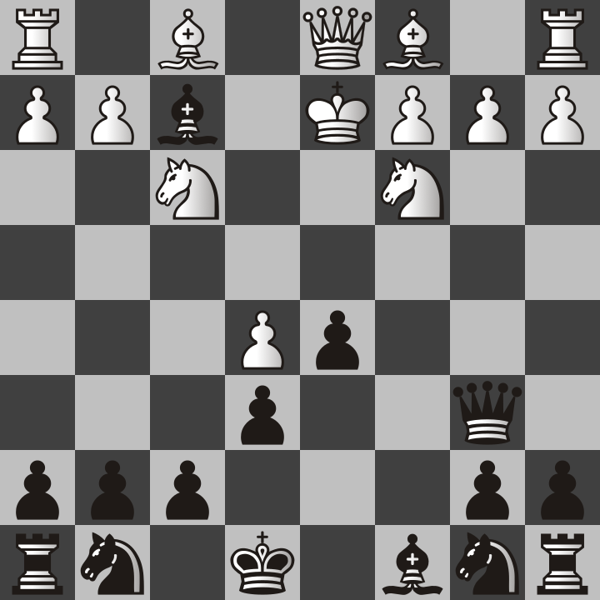

e4-e6-d4-d5-e5-c5-dxc5-Bxc5-Nf3-Qb6-Nc3-Bxf2+-Kd2.png

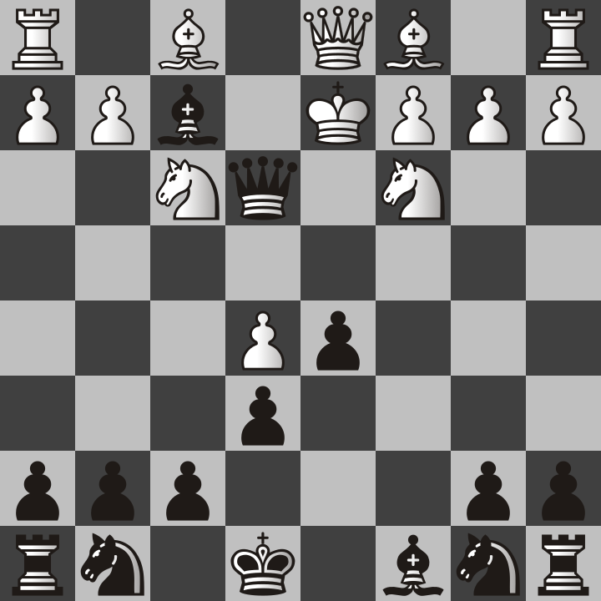

e4-e6-d4-d5-e5-c5-dxc5-Bxc5-Nf3-Qb6-Nc3-Bxf2+-Kd2-Qe3.png

Obviously, the game doesn’t always end this quickly but as you see the French Defense is based on the same logic as the Queen’s Gambit by offering a pawn with the hope of lining the bishop and the queen up to attack the weak square. At the least, this will put the king on the run, and sometimes even a checkmate if your opponent doesn’t defend correctly.

In this chapter, I have shown my favorite openings to play. Don’t think that you know everything about how these will turn out for you in your games because the possibilities are infinite. You may find your own style and even invent a new opening no one has seen before!

But the openings I have recommended are those that I have had the most success with and I have an advantage with them from practice. That’s why I am qualified to teach them. I also have videos on my YouTube channel where I have gone more in depth with them.

# Chapter 3: Chess variants

As if learning standard Chess wasn’t enough fun, there are historical and modern variants of Chess. I can’t cover them all because there are literally hundreds. What I can do is tell you about some of my favorites and how they differ from Standard/Western Chess as described by most of this book.

## Crazyhouse

Crazyhouse is a variant available on lichess where captured pieces are not simply gone from the board but instead convert to the color of the player who captured them to be dropped back on the board at a later turn! As you might guess, games in this variant tend to be longer because it is possible to escape a checkmate what you could not get out of in standard Chess.

There are some special rules that you should be aware of.

* Drops resulting in immediate checkmate are permitted.
* Pawns may not be dropped on the players’ 1st or 8th ranks.
* Promoted but captured pawns are dropped as pawns.

The notation for Crazyhouse is the same as Chess except for the addition of the @ symbol to say that a previously captured piece is dropped back on the board.

For example, consider the position of the Queen’s Gambit Declined from the previous chapter.



d4-d5-c4-e6.png

In this position, white decides to capture the d5 pawn with the c4 pawn.

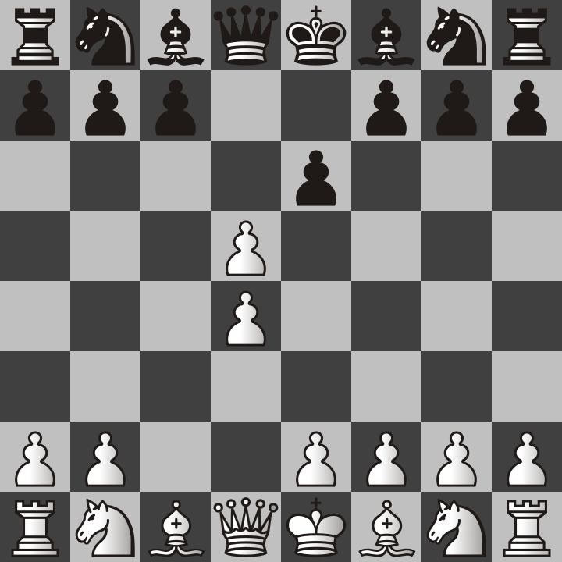

1. d4 d5 2. c4 e6 3. cxd5.png

Next, black tried to put white’s king in check by moving bishop to b4.

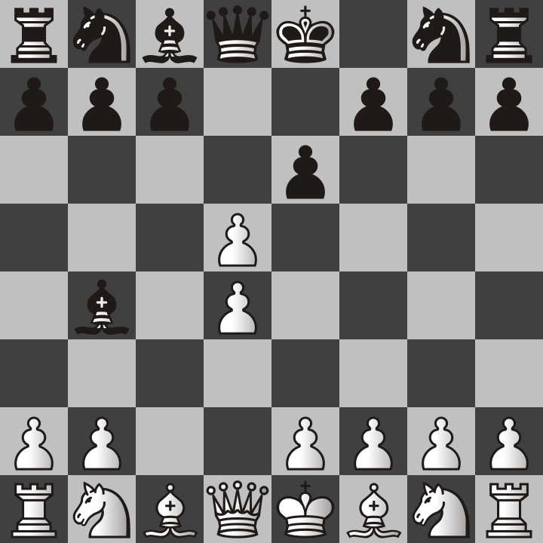

1. d4 d5 2. c4 e6 3. cxd5 Bb4+.png

If this were regular Chess, white would not be able to move the king and would have to put a bishop or knight in the way to block the check. However, white previously captured a pawn and so they can drop one to the c3 square.

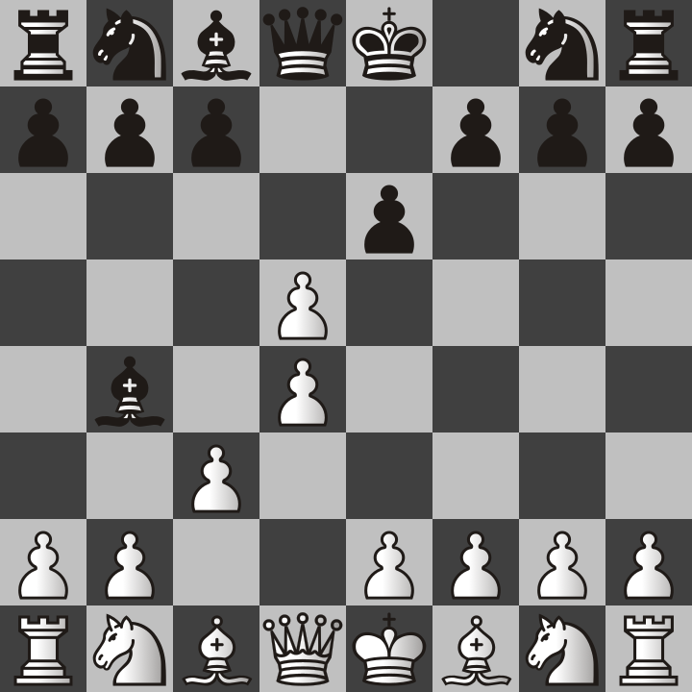

1. d4 d5 2. c4 e6 3. cxd5 Bb4+ 4. @c3.png

This means that the bishop is on the run and white has 9 pawns on the board. The situation is already looking like it will lead to a win for white.

## Atomic

Another variant which is available on lichess is Atomic. In this game, whenever a piece is captured, it creates an explosion that blows up the surrounding 8 squares! However, pawns on those 8 squares do not explode for some reason. They must be made of Minecraft obsidian or something like that. However, when a pawn makes a capture, it does explode. For example, the following position shows that white has moved their king’s pawn two squares and black has moved their queen’s pawn two squares.

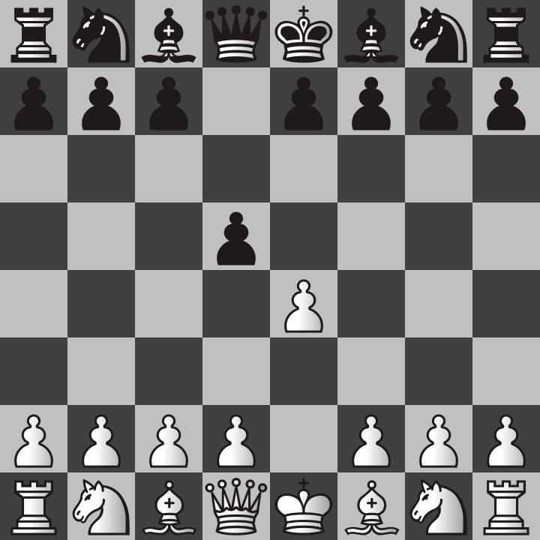

1. e4 d5.png

White can capture, however, when it does, both pawns disappear!

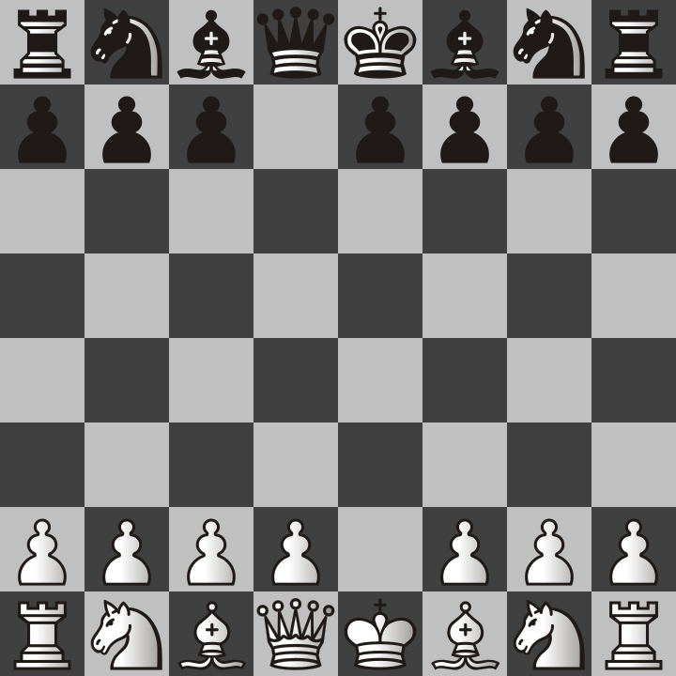

1. e4 d5 2. exd5.png

And now that there is nothing in the path of the black queen, they capture the d2 pawn and blow up white’s king, queen, and bishop because all of them were on the adjacent squares to the d2 pawn.

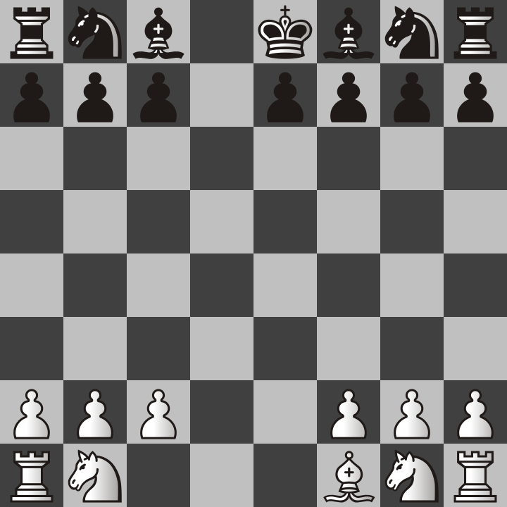

1. e4 d5 2. exd5 Qxd2.png

Black’s queen is also gone but black has already won this game of atomic chess! The king wasn’t just checkmated, it was actually destroyed in an explosion!

So as you can see, atomic games don’t last very long because it doesn’t take many moves before pieces are destroyed. That doesn’t mean it is simple to win it though because I am not very good at it despite my experience in normal Chess. Still, it is my second favorite variant of standard Chess, right behind Crazyhouse!

But there are more Chess variants available on other websites. Some of them are very different from the standard Chess but they have many things in common.

## Shogi

For example, let me show you the board for Japanese Chess, which goes by the official name of Shogi!

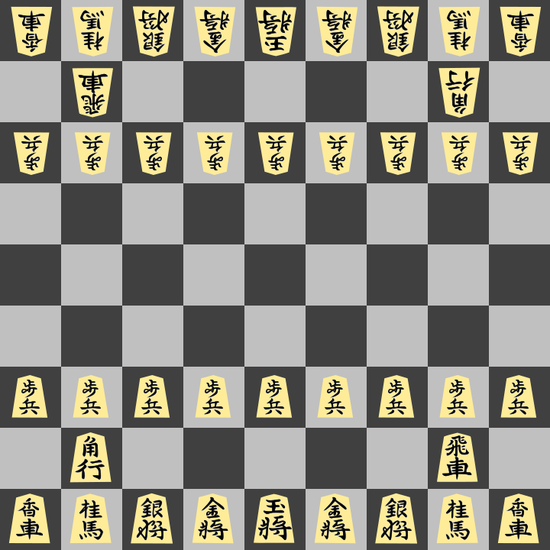

Chastity SVG Kanji Shogi Set.png

It looks very fancy but unless you can read Japanese, these symbols probably make no sense to you. I can read them because I am experienced at playing Shogi enough in apps that force me to read their pieces. But for most people, the following image will make more sense.

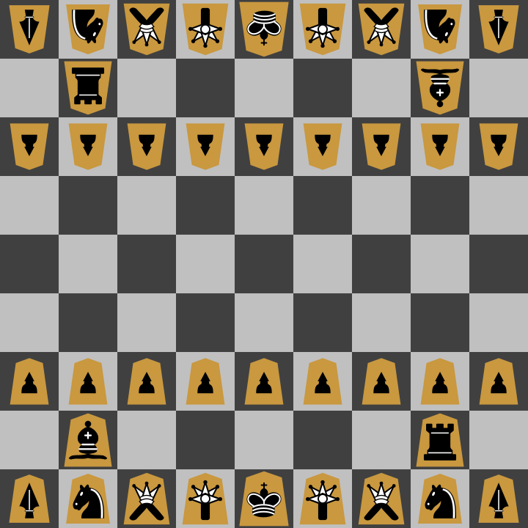

Chastity SVG Western Shogi Set.png

Shogi is very much like Chess despite the difference in appearance. Shogi has pawns, kings, rooks, bishops, and knights. However, their some of their rules for movement are slightly different. However, the rook, bishop, and king are still identical to Western Chess.

But there are new pieces, the Lance, the Silver General, and the Gold General. You need a tutorial on Shogi to learn how to play it. I may consider writing a tutorial later on but I have also been known to record videos on it and demonstrate how I play.

Also, you can play Shogi anytime on [lishogi.org](https://lishogi.org/). It allows you to choose either the traditional Japanese pieces like the first picture or the westernized pieces from the second picture.

## Xiangqi

After you learn Chess and Shogi, I recommend Chinese Chess known as Xiangqi. You can learn and play it on [xiangqi.com](https://www.xiangqi.com/). Usually the game is played with pieces represented by Chinese Characters. However, many sites and programs allow you to select a westernized set similar to what was available for Shogi.

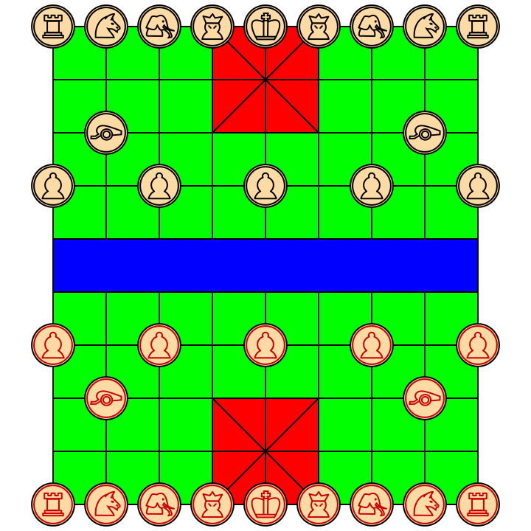

chastity-svg-xiangqi-set.png

You will find that Xiangqi is harder to learn because there are different rules for pawn movement depending on whether they have crossed the river. The game also has elephants which move two spaces diagonally but can never cross to the other side of the river. Because of this, you will find that the rooks, knights, and cannons are the important pieces.

Cannons are actually one of the more bizarre pieces because nothing quite like them exists in Chess or Shogi. They move like a rook but cannot capture unless there is a piece in the way to jump over!

I like Xiangqi almost as much as Chess and Shogi, but I am really bad at it and I always lose because I am usually playing online against Chinese people who actually know how to play it well!

After you learn the rules of Xiangqi, then you might want to play it on [pychess](https://www.pychess.org/). Pychess supports Chess, Shogi, and Xiangqi. It is probably the best site if you want to play the most variants possible.

In the next chapter, I will be listing websites and which Chess variants they allow you to play. This chapter was merely a brief introduction so that you know that other games like Chess exist! I could never list them all, but I recommend at least learning Chess, Shogi, and Xiangqi. Once you know these three, then all other Chess variants will have similar rules to at least one of them.

# Chapter 4: Chess Software

In this Chapter, I will go over the best Free and Open Source software that is available for either playing or analyzing Chess. There are two command-line Chess Engines that I will recommend, two Graphical User Interface Programs that can use those engines, and two more utility programs that are specifically about managing Chess databases. Finally, I will mention how you can use these tools to analyze the games you have played.

## Stockfish

I will not be covering how to install Stockfish because that is a separate matter, depending on your operating system. However, I will explain how Stockfish can be used from the command line once it is downloaded and placed in your path.

However, you can easily download [Stockfish](https://stockfishchess.org/) and find a detailed [guide](https://official-stockfish.github.io/docs/stockfish-wiki/Download-and-usage.html) for installing it on your platform.

## Usage at the command line

Although the official stockfish documentation is very good at helping people to set up Stockfish with most GUI software, there is a way to play directly by running commands from a terminal or command prompt.

After downloading and installing the engine by whatever means you used, just type “stockfish” at the command line or adjust the name to whatever your executable is named. You will probably see a message similar to “Stockfish 17 by the Stockfish developers (see AUTHORS file)”.

Simply type d and press enter. You will probably get something like this:

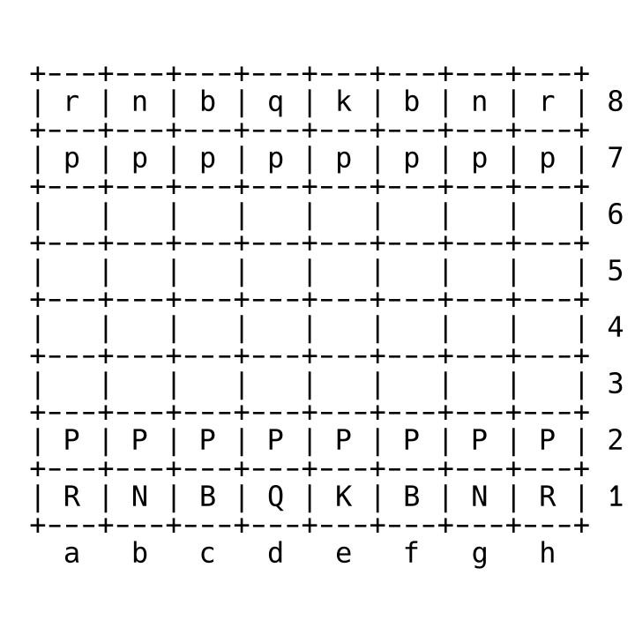

position startpos.png

That is because d is the display command and it will show a text representation of the Chess board. The position can be changed with a certain format. For example

position startpos moves d2d4

will move the pawn from d2 to d4. This is my favorite starting move. So if you use the d command again, you will see that the pawn has now moved!

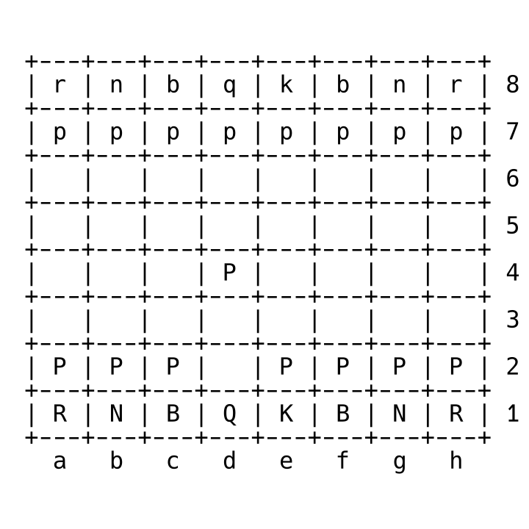

position startpos moves d2d4.png

Now that we have made our first move as white, we need to tell the computer to search for a move to reply with. For that we can enter go depth 1 and it will come up with a quick response. For example if we get the result “bestmove d7d5”. This means that the engine has decided that moving black’s Queen pawn is the best move. So we add this result to the end of our last command.

position startpos moves d2d4 d7d5

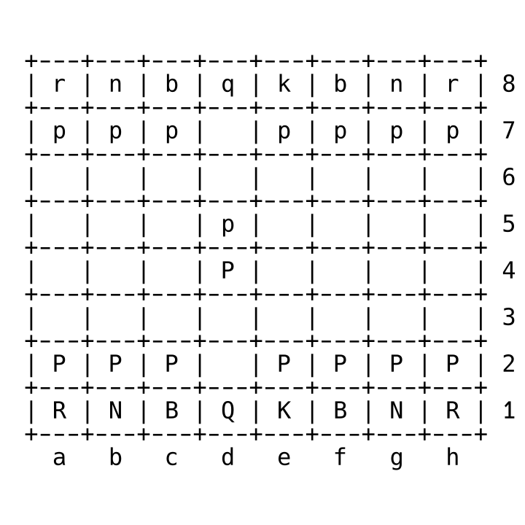

position startpos moves d2d4 d7d5.png

As you can see, both pawns have moved. However, this is not the preferred way for most people to use the engine. However, I did this as an example to show you what a Chess GUI has to do behind the scene to operate the engine and get back moves from it.

## Fairy Stockfish

I would like to mention briefly that [Fairy-Stockfish](https://fairy-stockfish.github.io/) is a version of Stockfish that supports all of the Chess variants available on lichess.org and even more. I have not mastered the use of it from the command line, but I have confirmed that it works with Xboard, which is the next program I am recommending.

## Xboard

You can use [XBoard/WinBoard](http://hgm.nubati.net/) to run not only Stockfish, but many other Chess engines that are less popular. I find the interface of the program to be a little bit confusing. However, I have created convenient commands to use which allow me to play Chess, Shogi, or Xiangqi with it on my Windows 11 laptop.

winboard -fcp "C:\stockfish\fairy-stockfish.exe" -variant normal -xclock -depth 1

winboard -fcp "C:\stockfish\fairy-stockfish.exe" -variant shogi -xclock -depth 1

winboard -fcp "C:\stockfish\fairy-stockfish.exe" -variant xiangqi -xclock -depth 1

If you are playing XBoard, the Linux version, you can change winboard to xboard and change the path of fairy-stockfish to wherever you have it installed.

Although I have less experience using Xboard than the other recommended software in this book, XBoard when combined with Fairy Stockfish allows you to play more types of Chess Variants than any other program that I know about.

Also, if you beat Fairy Stockfish at depth 1 using commands similar to the above, then try changing that number to something higher and then then the computer will search deeper and find even better moves to play against you. Beating it at full strength is impossible for a human player.

## En Croissant

I recommend [En Croissant](https://encroissant.org/) for people who are only interested in playing standard Chess and want to analyze the games they have played on lichess.org or chess.com. It has a feature which can download all the rated games of a username of a player on those sites specifically. This means that if you play online on these sites, you can instantly obtain a database of your own games. You can use this to see how often you win or lose and what mistakes you are making.

It also allows you to download larger databases of games like Caissabase which are full of games from the top Chess Masters of the world. This allows you to see how really good Chess players can play and maybe learn some things from them! That’s what I try to do!

## pgn-extract

Once you have a database of your own games, or perhaps games of other people, you may want to filter them by certain criteria. The program [pgn-extract](https://www.cs.kent.ac.uk/people/staff/djb/pgn-extract/help.html) is exactly what you can do this with. It is a command line only program. You will have to read the documentation to know all of its options but here are some commands that I commonly use to keep track of my best wins.

These commands use the file “lichess_chastitywhiterose.pgn” which I downloaded directly from lichess.org. There is a built in export feature that allows you to select games of different time controls and/or variants and decide which ones to export to pgn file. pgn-extract can only handle standard chess games but it can sort them extremely fast. For example

This first command takes all of the games where chastitywhiterose was the white player and won the game by checkmate.

pgn-extract -Twchastitywhiterose -Tr1-0 lichess_chastitywhiterose.pgn -ochastitywhiterose_white_wins_lichess.pgn --checkmate

The second does the reverse and finds every time that chastitywhiterose played as black and then black won the game by checkmate.

pgn-extract -Tbchastitywhiterose -Tr0-1 lichess_chastitywhiterose.pgn -ochastitywhiterose_black_wins_lichess.pgn --checkmate

I have said for years that only games ending in a checkmate are reliable information. If your opponent timed out because they fell asleep or got distracted, that doesn’t really feel like a win, does it?

## ChessX

The best currently available free and open source Chess database management program is [ChessX](https://chessx.sourceforge.io/). It allows you to open a pgn file and actually play through all the games with a graphical user interface. This is the best way to analyze your games and see visually where you made the mistakes. I have not fully explored everything that the program can do but I read that it also has filtering capabilities similar to what you could have done with pgn-extract which I previously mentioned.

### Possible Updates

I know there are infinitely more open-source Chess related programs out there that I have not had time to use or write about. If you know of any really good programs that are also open source, let me know and I can probably include them the next time I update this chapter!

# Chapter 5: The Best Chess Websites

There are more websites to play Chess on than you can possibly imagine. However, only a few of them support variants beyond just standard Chess. In Chapter 2, I mentioned Crazyhouse, Atomic, Shogi, and Xiangqi. These are only 4 out of hundreds of variants. In this chapter, I will go over the top websites that I play on regularly and which variants I usually play on those sites.

## Lichess.org

[lichess](https://lichess.org/) is the first website you will want to visit and create an account if learning Standard Chess and variants based directly off of it. It supports Chess960, Crazyhouse, Atomic, Three-Check, AntiChess, King of the Hill, Horde, and Racing Kings. This is more than most people can master.

It’s also important to mention that the site is entirely free and made with open source software. This is a big deal philosophically for me and for many other people who do not like the corruption of big companies that try to claim ownership over what can be done with a game. The site is financially funded by people who voluntarily donate because they want to help keep the developers paid and keep the site hosted, which is probably not easy considering that it manages billions of Chess games every month!

Lichess is the second most popular Chess website in the world. Chess.com is still number one but it does not support all the variants that Lichess does. It also does not allow correspondence Chess for anything besides Standard Chess or Chess960. Because I like Crazyhouse the most, I started playing on lichess almost exclusively.

## Lishogi.org

Just as Lichess is built around Standard Chess and a few variants, [lishogi](https://lishogi.org/) is a fork of Lichess with everything changed to be about Shogi, which is the name for Japanese Chess. You will find that Shogi is even harder to master than Standard Chess and there are a lot more rules to remember, especially when it comes to promotion of pieces that reach the other side. The goal may still be to checkmate the king, but it is still a different game than Standard Chess. However, if you have played Crazyhouse Chess and you enjoy dropping captured pieces back on the board, I can’t recommend a better site than lishogi. It also has variants of Shogi that I haven’t even learned how to play.

## Pychess.org

[pychess](https://www.pychess.org/) has more variants than any other site mentioned in this chapter. However, there are 4 variants that I particularly play on there than I must recommend.

### Duck Chess

Just like Chess, except that there is also a duck! I know it sounds insane but this is one of the funniest but also most challenging variants. There is only one duck but after each player makes their regular Chess move, they are required to move the duck to a new empty square ANYWHERE on the board. The duck cannot capture anything but it also cannot be captured or moved through. This means that the duck can block even a checkmate temporarily if no other pieces can stop it.

### Grand Chess

Grand Chess is played on a 10x10 board and has two new pieces in addition to the standard chess pieces. The cardinal moves like a Bishop and a Knight. The Marshal moves like a Rook and a Knight. If you think about the fact that the Queen in Chess is like a combined Bishop and Rook, these piece combinations really don’t seem unusual. Even so, pychess is one of the few sites you can play this variant on.

### Fog of War

In this variant, players cannot see their opponents pieces unless they have a piece that can legally move to that square. This variant is unique to playing on a computer because there is no way to simulate this experience on a regular chessboard that I can think of.

### Alice Chess

Alice Chess is a variant based on “Through the Looking-Glass” by Lewis Carroll. The game involves pieces moving between two different Chess boards or perhaps opposite sides of a single chessboard made of glass in the way that Pychess renders it on the site. I am really bad at this variant but because I am a fan of the Alice in Wonderland series, I think it is worth exploring more in detail and eventually I shall master it!

## pychess-alternates.onrender.com

The [pychess_alternates](https://pychess-alternates.onrender.com/) website is an alternate site for Pychess.org users which has more variants that have not been merged into the main site. I have to recommend it because it has two games not available anywhere else!

### Coffeehouse

Just like Crazyhouse except that captures are mandatory. If you can take an opponents piece, you are forced to even if it is a bad idea. I am bad at this variant but I love playing it and can never get enough people to play with because few people know the site exists..

### Coffee Shogi

Just like Coffeehouse except that it is based on Shogi instead of Standard Chess. This is probably the most psychologically challenging Chess variant that I have ever played! If nothing else, this would make the site worth a visit for the serious player who doesn’t think Shogi is hard enough!

Those are only two of the variants that are only available on that site. However, few people know about the site because it isn’t talked about much. I only know about it because it was mentioned in a Pychess blog post.

## playstrategy.org

Playstrategy has a lot more than Chess and its variants. It also has Draughts, which is usually called Checkers in America, and Go, another really popular board game in Japan. I visit this site specifically to play those games even though it also has Chess, Shogi, and Xiangqi.

## chessvariants.com

The [chessvariants](https://www.chessvariants.com/) site is a great resource for learning about the rules of Chess variants that you have probably never heard of. Usually lichess and Pychess do a good summary of the rules and can be accessed directly on their site, but chessvariants can tell you a lot more information about the variants including their history which is useful for nerds like me. I don’t just want to play the games, I want to know everything about them too.

## Other sites

[Chess.com](https://www.chess.com/) is usually the first site where people begin playing online Chess. Although lichess.org is better in my opinion, chess.com existed before lichess.org and has even more users. There is nothing to stop people from playing on both sites and see which they like better.

[Xiangqi.com](https://www.xiangqi.com/) is probably the best resource for learning about Chinese Chess for a new player. I prefer playing on Pychess.org but that’s because I already know how to play and because Pychess supports correspondence games which fit into my busy lifestyle better. But if you want to get a quick real time game of Xiangqi, then Xiangqi.com has the most users who are specifically looking to play this variant which is popular in China.

# Chapter 6: How to Improve at Chess

In this chapter, I give some advice that I believe will help players improve.

## The Meaning of Chess Ratings

At some point, a Chess player will notice the numbers of their rating or their opponents on Chess websites. The ELO rating system is a very controversial and confusing tradition, which I believe can lead to problems. To avoid these problems, I want to explain some things.

When you win a rated game, your rating goes up, and when you lose, your rating goes down. However, the amount by which it changes depends on the rating of your opponent. So, for example, if a 500-rated player beats a 2500-rated player, their rating would go up by a lot more than if they beat a 300.

But the most important thing is that ratings are only a measurement of how smart of a player you are; they do not represent actual differences in strength or that one player has an unfair advantage. Chess is not like a physical sport where one person is stronger and can always win. The 500 and 2500 player each could win the game theoretically if they outsmart their opponent with the right moves.

But what I am about to tell you is that players with high ratings are often cowards. They are afraid to play with lower rated players because if they lose, they lose more rating points than if they lose against another player rated closer to their rating.

I believe this problem comes from the fact that having a high Chess rating is seen as a status symbol for bragging rights. My own opinion is that they are meaningless, however. You don’t have to just take my word for it. I have links to two games to show an example of what I am talking about. The fact that every game in lichess is stored permanently on the server means that anyone in the world can play through it and see how it all happened.

In this first game, I was rated 1763 but I beat someone rated 1926.

https://lichess.org/lz2BBrn2

If you browse through that game, you will see that they allowed me to fork their king and queen at the same time, and I captured their queen and then proceeded to checkmate them in a few moves after that.

In the second game, I was rated 1913, but my opponent got a pawn to the other side and checkmated me with the new queen. I also made several mistakes, like allowing their bishop to fork both my rooks at the same time.

https://lichess.org/5tnccreY

Basically, the takeaway from this is that I go into each game knowing that I can theoretically win. Both sides have the same pieces at the start, and the only difference between me and my opponent is the moves we decide to make. I don’t take Chess ratings seriously at all.

That being said, as a player naturally improves and makes fewer mistakes, their rating will probably rise accidentally! So ignore what your opponent’s rating is and instead look at where all their pieces are! That is what you should focus on. Do not be psychologically intimidated by what ratings you see.

## Keep a Database

One of the benefits of lichess is that every single game is stored on their website. Also, it is possible to export all of your games into a text file and then analyze it with the software of your choice, including those that I mentioned in [Chapter 4](https://chastitychesschallenge.com/2025/03/11/chapter-4-chess-software/).

By downloading the database and loading it into software like ChessX or En-Croissant, you can see how often you are winning or losing with certain openings and see what moves you might be making that cost you the game. Keeping and studying a database of your games is the single most awesome way that you can learn from your losses and be encouraged by your past wins as well.

## Take Notes

Normally, a person cannot take notes during a chess game. In fact, it might be considered cheating in over-the-board tournaments. However, something that can be done is to take notes during correspondence games. Sometimes, you have to wait a few days before your opponent takes their turn. When this happens, you may totally forget what moves you planned to respond with when they captured that bishop or knight you sacrificed to set up a trap.

Writing things down on paper or perhaps digitally on your phone or computer, which you normally use to play online Chess, can be a really good idea. It will keep you organized because correspondence Chess is harder on the brain than ordinary classical Chess. However, I find the lack of time limit to be quite relaxing. Having a ticking clock during live games can distract my eyes from the board and lead to mistakes. Therefore I recommend taking notes and trying correspondence instead if you also have this same problem.

These notes can also be useful for planning your future games as well. If something worked well for you in a game, maybe try that same technique in the next game. If you don’t write it down, you will probably forget!

If you are looking for a good application to take notes on for PC, iPhone, or Android, I highly recommend [Joplin](https://joplinapp.org/). It allows you to take notes and organize them by folders or tags. Using Joplin could be useful for making a personal database of Chess games by tagging them according to wins, losses, and draws, as well as reasons for why the games were won or lost. Was it a checkmate or a resignation?

If you are the writer, you can include as much or as little information as you want. One of the reasons I recommend installing the Joplin app over just having a bunch of text files on the computer is that my poor memory means that I can’t remember where the files on my computer are. Having the notes in Joplin means that I can type in a search and find what I am looking for instantly!

But the most important thing is that no matter what tools you use, you are in charge of your Chess improvement. You can do it according to your style and enjoy the journey.

But remember, if you ever want a real person to help analyze your games from a human perspective, you can always ask me! I love to stream and record videos about Chess just for fun. I will gladly analyze your games, and you only need to ask!

And the best part is, I don’t charge money. I just want people to play Chess with me. That is why I must teach them the ancient ways of this game!

# Chapter 7: The Value of Chess Notation

As I have said before, you don’t have to learn Chess notation in order to play Chess. You could even be a Grandmaster without learning Chess notation. However, learning Chess notation does have some benefits that you should know about.

1. If you know Chess notation, you can write down any sequence of moves on paper that you play over the board. If this information is not written down, you will probably forget what happened in the game and why you won or lost. This is extremely frustrating for someone who wants to improve.
2. Most Chess websites will automatically keep track of the notation for you. In fact it is quite possible to look at the notation and figure out what it means because it is very simple.

## Names of the Squares

If you are viewing the board from the white player’s perspective, the names of the squares are as shown in the following picture.



Chess_Coordinates_White.png

The letters are called files and the numbers are called ranks. If you are familiar with the name of the squares, then you can know what piece starts on that square and where it can move. For example, the white queen will start on d1 and the black queen will start on be on d8. The kings are on the e file instead of the d file. The 8 white pawns are on rank 2 and the black pawns are on rank 7.

However, if you are the black player, you will have to remember that the view is flipped from the previous image. This means that all your major pieces are along rank 8 instead of rank 1.

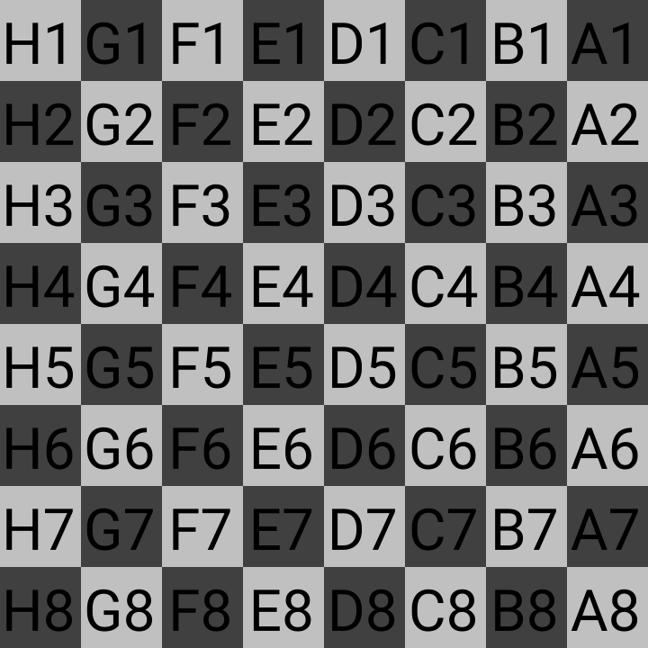

chess_coordinates_black.png

Many Chess boards have the letters and numbers printed on the sides of the board to help people remember the names of the squares by reading it like a map.

If learning the names of the squares is too much for you, just remember that it’s not required. However, if you understand the names of the squares, then you can write down from the beginning of the game where a piece moves. For example, if white moved their knight from g1 to f3, then the notation would be written as “Nf3”.

## Letters of the Pieces

Each Chess piece, except for pawns, is represented by a letter.

K = King

Q = Queen

N = kNight (second letter used because K is already used for King)

B = Bishop

R = Rook

Pawns moves are simply written as the name of the square the pawn moved to.

If a piece moves to a square at the same time as capturing something already on that square, then you add an x to the notation For example, if the notation says

1. d4 d5 2. c4 dxc4

Then we know that we have reached the Queen’s Gambit Accepted position as described in chapter 2. Black has captured the pawn on c4 that white was trying to sacrifice.

Suppose that a pawn gets all the way to the other side and promotes to a queen. Then the notation would be

d8=Q

If any move results in putting the king in check, we add a plus sign to that move. For example if white’s bishop were to capture the pawn on f7 and put the black king in check, it would be written as

Bxf7+

Once you know how to write the notation for the moves, it is possible to record any Chess game and even make notes for yourself. This is especially helpful in Correspondence games. Of course most people don’t write the notation because we have computers to do it for us. I think the main benefit of learning Chess notation is being able to read it.

For example, consider the following notation:

1. f3 e5 2. g4 Qh4#

If you play those moves on the board or in your head, you will get something that looks like this picture of the fool’s mate from chapter 1.



Chess_Checkmate_Example_2.png

The # is the symbol for a checkmate, the check where there is no escape for the king. If you are searching a large text file database of games, you can conveniently search for this character to find the games that ended in a checkmate to separate them from games that ended because somebody gave up and resigned.

As someone who plays a lot of online Chess, I accidentally became fluent in Chess notation because I read the notation as I play the games and see it written on the side. As a result, I often speak in Chess notation to describe moves while playing with people.

Unfortunately, people don’t know what I am talking about. For this reason, I felt like it was necessary to at least include this chapter which serves as a basic introduction. Other Chess games have their own notation. For example, Shogi notation is often written in Japanese and Xiangqi notation is written in Chinese. I can’t read their notation systems at all but there are westernized versions of them as well.

A person can also make up their own notation entirely. If you can think of a better system to help you remember what moves you made, then it’s not wrong as long as it helps you.

# Chapter 8: Too Long Didn’t Read

There will be many people who did not make it past even the first chapter of this book. This book about Chess is necessarily long because I am sharing all the information I possibly can from my years of experience playing Chess and games similar to Chess. At this point, you might be thinking, “This book is too long! I am not going to read all this!” And you would not be the first to think like this.

The truth is that most people, especially in these modern times no longer have the time nor patience to get as deep into Chess as I have. This world is built around a system of instant gratification as people are bombarded with advertising about movies, toys, First Person Shooter video games, and sex. Most people never dedicate their lives to anything with much devotion. They have short attention spans, and they want to feel happy and feel it NOW.

And I think that is what is wrong with the world. I don’t just promote Chess because it is a board game that I happen to enjoy and am pretty good at. I think Chess is actually good for the world. Although you will probably not take the time to read this, I have compiled a list of the benefits of Chess and why I have such loyalty to an ancient board game that almost nobody will play with me outside of nerds on the internet.

1. Chess teaches people to think before they act. Relying on impulse or your first guess is almost certainly wrong. We could all use a little more hesitation in all of our decisions. A person who moves without looking at all the pieces on the board will make huge mistakes. Chess reminds you to look at your surroundings and think of the cause and effect that could take place.
2. Chess teaches you to understand the mind of your opponent. By trying to anticipate what moves your opponent is planning, you are entering their thought process. Many times, I have come to respect someone’s intelligence based entirely on how I see them play Chess. It is the one game where someone’s thought process is evident. Chess is not like Monopoly, where a lucky dice roll can make someone win without really knowing how to play the game. The process of winning is much more satisfying in Chess because you know that you actually outwitted your opponent.
3. Chess is entirely free to play. Although there are many computer programs that you can buy, the original form of Chess is a board game. If you first buy a Chess set, or someone gives you one, you can play with your friends or even play against yourself. There is no limit to how many games you can play. You could play once a week against your friend or you might be obsessed and have played over 5,000 Chess games online like I have. Because there is no punishment or reward for winning or losing, you do it as much as you want, when you want, limited only by your goals.
4. Chess is a game of equality. Race, gender, financial status, religion, or political affiliation have nothing to do with Chess. Being in one category or another does not make you win or lose. It is the one game where you can be considered a loser by society’s constantly changing standards, but you can still win at Chess against someone who is too overconfident and doesn’t have the intelligence to stop you.
5. Learning Chess is easy. Learning to play Chess is really not hard. [Chapter 1](https://chastitychesschallenge.com/2025/03/03/chapter-1-the-basic-rules-of-movement/) covered all the rules that you need to know. A person can begin playing Chess and even win a few games on the same day. It’s not nearly as hard as learning to play most other board, card, or video games.
6. Chess is tough to master. Although it may be easy to learn the rules, getting experienced enough to win 75% or more of the time can take years. By constantly playing and training yourself to avoid mistakes, you can improve. Most people simply don’t have this much time, nor are they willing to sacrifice other things in their lives that they spend time doing. But I honestly think that if Chess were easy to master, then I would have already achieved everything I could do, and then the fun would be over. Chess provides me with enough challenge that I never get bored.
7. Chess can help you make friends. Many people are not physically inclined for other activities. Some of them can’t play sports or participate in what is popular for most people. However, Chess is something that many people can find community in. There are groups, Chess clubs, meetups, and no shortage of online websites, such as lichess.org. Over time, you might meet people who can become good friends over a shared activity like Chess or whatever else you may have in common.
8. Chess is also a game for the solitary. There are hermits like me who can spend much time alone and meditate on the possible moves that can be made. The fact that I can play Chess against a computer when no human is available allows me to test my mind against the artificial intelligence of Chess engines like Stockfish. Chess can help you be social when you want to, but it does not require it if you would rather be left alone. I sometimes play entire Chess games in my head because it brings me comfort for something to make sense when life can be so unpredictable.

If you have made it this far, you can consider yourself above average. Although anyone can play Chess, not everyone sees the beauty of it like I do. My hope is that because I wrote this book, there will be at least one person who has never heard of Chess but comes to learn to play and understand the joy of Chess as much as I have.

If my writing causes even one person to find happiness or relaxation by playing Chess, then I have succeeded in my mission. If you are that person, please let me know.

# Chapter 9: The Making of the Paperback

Because this Chess book was originally written in [Markdown](https://www.markdownguide.org/) and posted as a series of chapters to my WordPress blog, it did not have any concept of pages or margins because this is not needed to view it on the web. Making a paper book, on the other hand, is different because a physical book is a real physical object of a certain width and height. Some adjustments were needed to submit it to Kindle Direct Publishing.

Therefore, I came up with a process to convert the text into a form that Amazon would accept for an 8.5-inch by 11-inch size book. The following are the exact steps I used with a combination of [Pandoc](https://pandoc.org/) and [LibreOffice](https://www.libreoffice.org/)

1. I created the default odt file that Pandoc uses for style reference. This command came straight from the Pandoc documentation.

pandoc -o custom-reference.odt --print-default-data-file reference.odt

1. I opened the custom-reference.odt file in LibreOffice and modified the left and right page margins to 0.5 for left and right. The images are exactly 7.5 inches wide, so this makes them perfectly centered to fit within the width margins of a page that is 8.5x11 inches. The top and bottom margins are not quite as important, but I set them to 0.5 for consistency.
2. I also changed the style of “Heading 1” to automatically include a page break before the heading so that each chapter would start on a new page.
3. Finally, I used the reference doc after modification as an input when making a new odt conversion of the book.

pandoc ChastityChessChapters.md -o book.odt --reference-doc custom-reference.odt

This file should look good enough to export directly as a PDF in LibreOffice. Although this may seem overly complicated, this process is more useful than you might expect. For one, it bypasses the use of “Industry Standard” tools like Microsoft Word that most writers think they need. Pandoc and LibreOffice are the only two software programs you need to create good-looking documents from Markdown files.

However, this process is unnecessary for most books that contain only text. It was precisely because my Chess book had a lot of pictures that I used Markdown. I used this method because it allowed better control of the images than I could do in LibreOffice alone.

I would also like to mention that several note-taking apps were useful to me as I was writing the book. Below are my top 3 favorite programs out of the many I installed and tried out.

* [Joplin](https://joplinapp.org/)
* [Simplenote](https://simplenote.com/)
* [ghostwriter](https://ghostwriter.kde.org/)

All 3 of those apps are useful for their ability to preview the output of what the source Markdown code will look like. For Mobile devices, Joplin and Simplenote are the best. For a PC with Windows, Mac, or Linux, ghostwriter is especially helpful because it works directly with plain text files on your system just like Notepad does, but it also allows a preview just like Joplin and Simplenote do. Testing the images was essential for making sure my pictures were linked correctly!

In case you were wondering, all of the artwork was made using the program [Inkscape](https://inkscape.org/). The Chess, Shogi, and Xiangqi pieces are either under a GPL or Public Domain license and came from open-source projects like [lichess](https://lichess.org/), [lishogi](https://lishogi.org/) and [pychess](https://www.pychess.org/).

# Chapter 10: The Making of the Ebook

This is a bonus chapter that was not in the originally published paperback. Specifically in the ebook, a few things were modified. First, the links in the table of contents were changed to internal links for easier navigation in the ebook. They no longer point to the blog posts because the idea is that the ebook can be downloaded and read without requiring an internet connection once downloaded.

In the paperback, the links cannot be clicked because the book is literal paper and ink instead of a computer. However, they are exceptionally helpful to me as the author because it means I can quickly go to the post for that chapter and check to see if there are any new comments! However, I did not want the links to remain the same for the ebook because it is meant to help you jump to the chapter on whatever device you are reading it on.

Once I read the Pandoc documentation on the rules for linking to existing headings within a document, I used this command to test it as HTML in a web browser.

pandoc ChastityChessChapters-ebook.md -o ebook.html

Once I confirmed that the links worked correctly, I then converted to an epub file.

pandoc -t epub --metadata title="Chastity's Chess Chapters" ChastityChessChapters-ebook.md -o ebook.epub

Then I tested the epub by opening it in [Calibre](https://calibre-ebook.com/) to see how it looked. To my surprise, the conversion worked very well.

These technical details about software and formatting may not mean much to you as the reader, but this is useful information worth sharing for other authors who may have the desire to write a publish a book. They may already even have a manuscript typed up but don’t know how to get it published as a paperback (the original and true form of a book) or an ebook (the modern convenience of reading a book on your phone, iPad, Kindle, Nook, Kobo, etc).

The process of publishing my first Chess book has taught me more than I would have ever thought was possible. I hope reading my book has helped you understand why I love Chess. If you are an author who wants some help publishing your book, I can also probably guide you with a few tools and tricks I have learned.